Abstraction
This report analyzes Vietnam Nationtal exam data from 2020–2024 to evaluate subject difficulty trends and provincial performance.
Data information
The dataset contains a total of 4,936,983 student records across four exam years.

Overview of the dataset
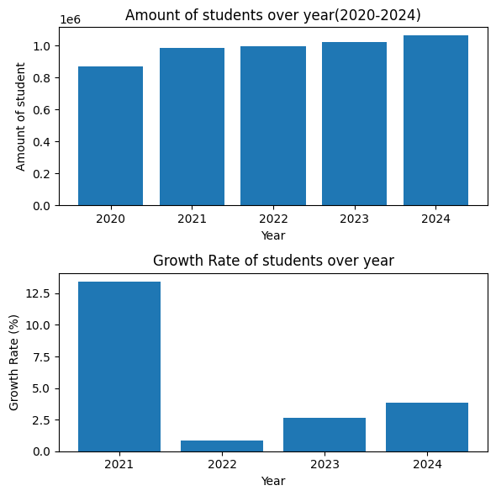

The total number of students increased steadily from 2020 to 2024, The most notable jump occurred in 2021, with an increase of approximately 0.1 million students compared to 2020. This represents a 12.5% growth rate, which is the highest across the five-year period.
The second chart highlights the year-on-year percentage change The spike in 2021 is particularly significant when contrasted with the 0.5% growth in 2022, indicating that the surge was not part of a continuous trend but rather a recovery event. The sharp increase in 2021 can be attributed to the aftermath of the COVID-19 pandemic, which disrupted Vietnam’s national exams in 2019 and 2020. These disruptions likely led to lower student enrollment during those years. As conditions stabilized in 2021, many students who had deferred or missed enrollment were able to re-enter the system, resulting in a one-time surge.
Academic Performance Overview (2020–2024)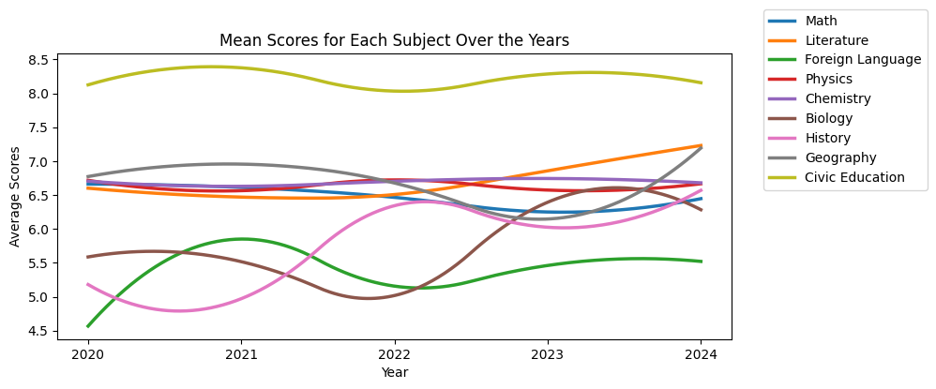
From 2020 to 2024, average scores across school subjects in Vietnam showed a mix of stability and fluctuation, reflecting both recovery and resilience in the post-pandemic period.
- Mathematics consistently held the highest average score, remaining above 8.0 for four consecutive years. This suggests strong student performance and possibly sustained emphasis on core STEM education.
- History experienced a dip in 2021, likely due to pandemic-related disruptions, but rebounded sharply in 2022 and remained stable through 2024.
- Biology showed a notable low point in 2022, followed by a peak in 2023, indicating a delayed recovery in science-related subjects.
- Foreign Language maintained the lowest average score, hovering around 5.5 across all five years. This may point to systemic challenges in language acquisition or curriculum delivery.
- Other subjects such as Literature, Physics, Chemistry, Geography, and Civic Education remained relatively stable, with average scores ranging between 6.0 and 7.0, reflecting consistent performance across the broader curriculum.
Detail each subject throught 5 year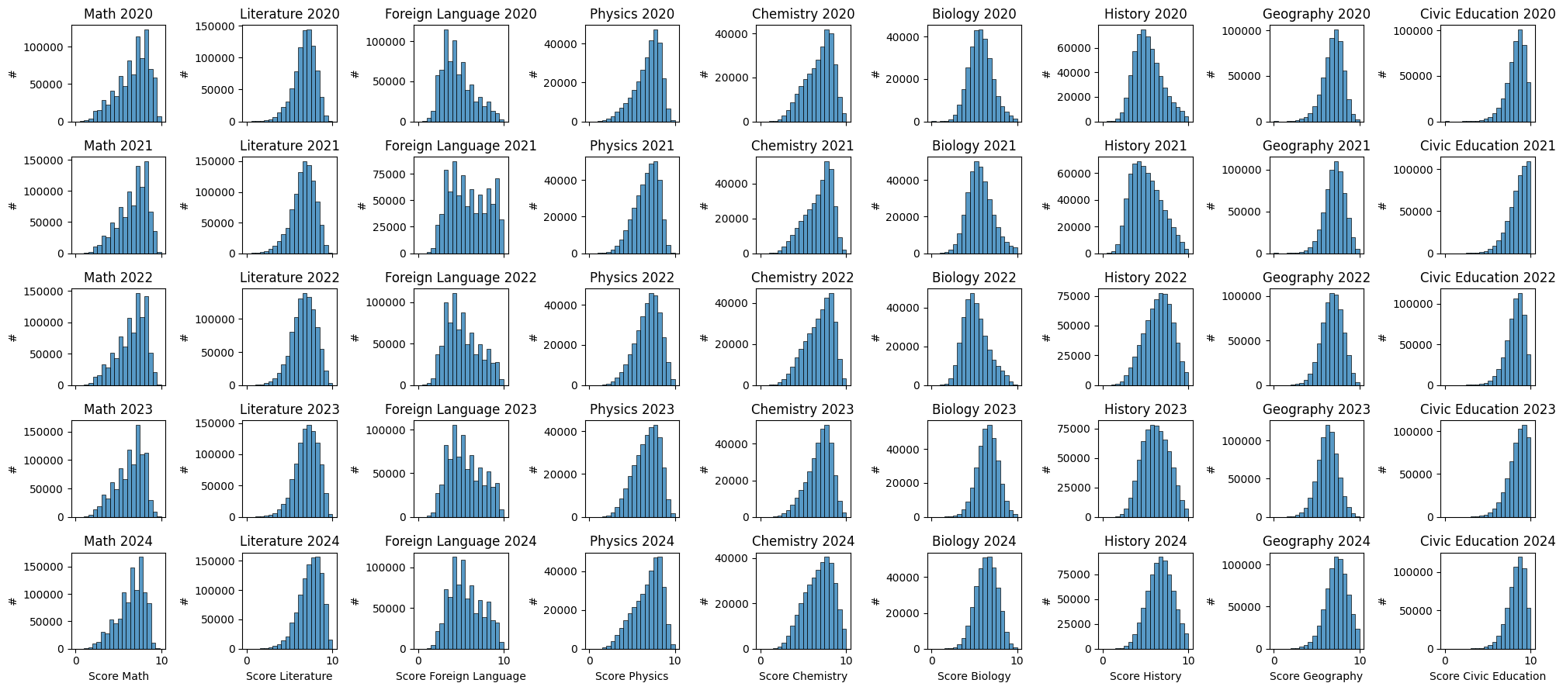
Across most subjects and years, the distributions appear to be left-skewed. This means the bulk of the scores are clustered towards the higher end, and there is a longer tail extending towards the lower scores.
- This left-skew is generally a positive sign for the student population as a whole, indicating that the majority of students are achieving high scores.
Consistent vs. Varied Distributions
While the left-skew is dominant, there are some minor differences:
- Most subjects (e.g., Physics, Chemistry, Biology, History, Geography, Civic Education, and Math) show a very tightly clustered and consistent left-skew across all five years, suggesting stable performance.
- Literature and Foreign Language seem to have slightly more spread or are perhaps a little less skewed in some years, with a higher frequency of mid-range scores compared to the science subjects. The distribution for Foreign Language in particular appears more varied from year to year (e.g., 2021 looks slightly flatter than 2024).
In summary, the vast majority of scores across all subjects and years are high, but the distribution of scores in Literature and Foreign Language seems to have more year-to-year variation and spread than the other subjects.

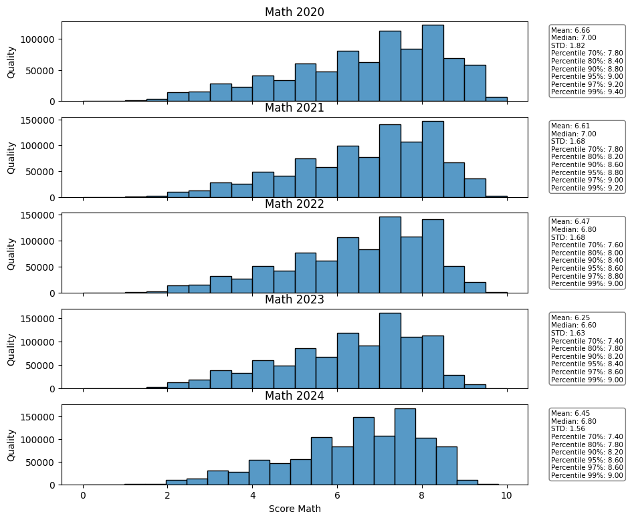
Mathematic
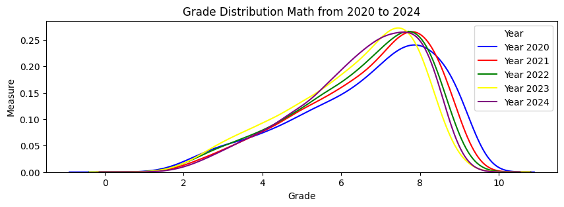
The most critical trend is the drop in central tendency (average performance). Both the Mean and Median scores decreased significantly over the first four years, suggesting a general dip in student proficiency.
- Mean Score Drop: The average score decreased from its high of 6.66 in 2020 to its lowest point of 6.25 in 2023. This is a drop of 0.41 points over three years.
- Median Score Drop: The score of the typical student (Median) fell from 7.00 in 2020 to 6.50 in 2023. This shows that the decline wasn't just due to low outliers; the middle-of-the-road student was scoring half a point lower.
- 2024 Rebound: There was a positive shift in 2024, with the Mean increasing to 6.45 and the Median rising to 6.80. While this is an improvement of 0.20 points from the 2023 low, both figures still remain below the 2020 starting performance..
- Decrease in STD: The Standard Deviation decreased consistently from 1.82 in 2020 to 1.56 in 2024.
- Percentage Change: This represents a decrease in spread of approximately 14.3%
- Impact: This suggests that the assessment is producing a more homogeneous score distribution. While fewer students are achieving scores over 9, fewer are also scoring below 3 or 4.
- Top Achievers (95th Percentile): The score required to be in the top 5% dropped from 9.40 (2020) to 9.00 (2023), confirming that even high performance suffered. It recovered slightly to 9.20 in 2024.
- Lower Performers (10th Percentile): This point remained relatively stable or only dropped slightly (e.g., 3.80 in 2020 vs. 3.60 in 2024), indicating that while the middle scores dropped, the very bottom scores didn't dramatically worsen.

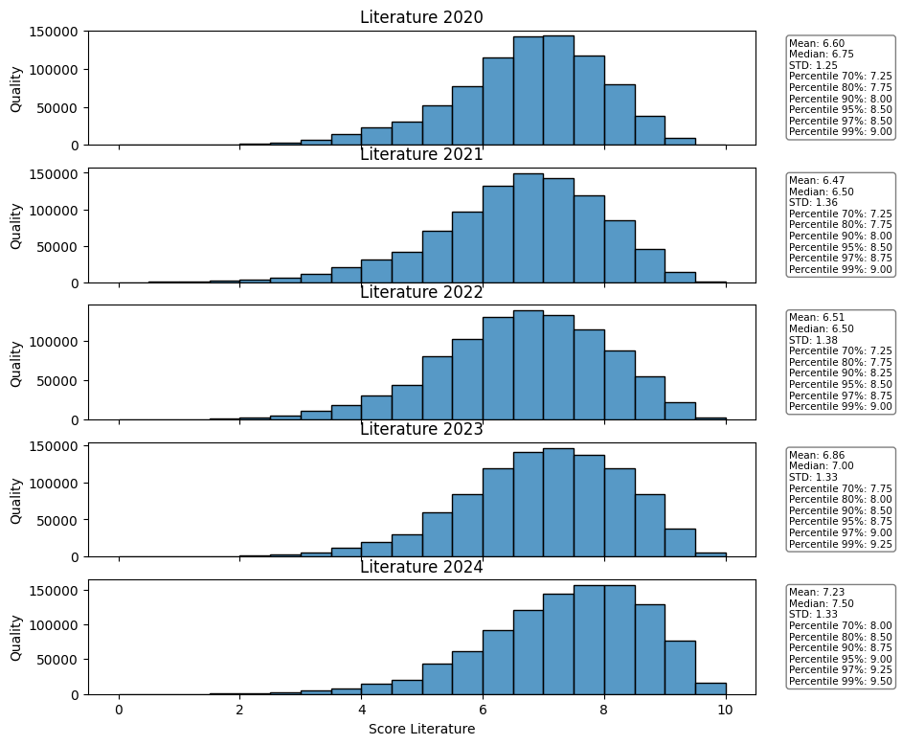
Literature
The core trend in Literature is a V-shaped pattern: an initial drop followed by a robust increase that surpassed the starting 2020 performance.
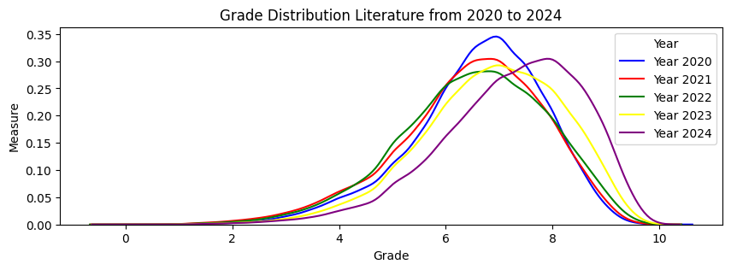
- Initial Dip (2020-2021): The average score fell from 6.60 in 2020 to 6.47 in 2021. The Median dropped slightly from 6.75 to 6.50.
- Strong Recovery (2022-2024): Scores then began to rise significantly.
  - The Mean score jumped from 6.51 (2022) to 6.86 (2023), and then to a peak of 7.23 in 2024.
  - The Median score followed, rising to 7.00 (2023) and peaking at 7.50 in 2024.
- Overall Gain: The 2024 Mean score of 7.23 is 0.63 points higher than the 2020 starting score of 6.60, demonstrating a significant net gain in student performance over the five years.
The Standard Deviation (STD) remained relatively stable for the first three years but increased slightly during the recovery phase, indicating that the scores became a little more spread out as the mean score increased.
- Stability (2020-2022): STD remained close to 1.25 or 1.26.
- Increase in Spread (2023-2024): The STD rose to 1.33 in both 2023 and 2024.
- Impact: This contrasts with Math, which saw its STD consistently decrease. For Literature, the overall performance improved, and this improvement led to a slightly wider range of scores. The test is becoming slightly better at differentiating performance
Top Achievers (95th Percentile): The score required to be in the top 5% increased from 9.00 (2020) to 9.50 (2024). This gain of 0.50 points shows that high-performing students made substantial progress.
Lower Performers (10th Percentile): This segment also improved, rising from 4.75 (2020) to 5.25 (2024).

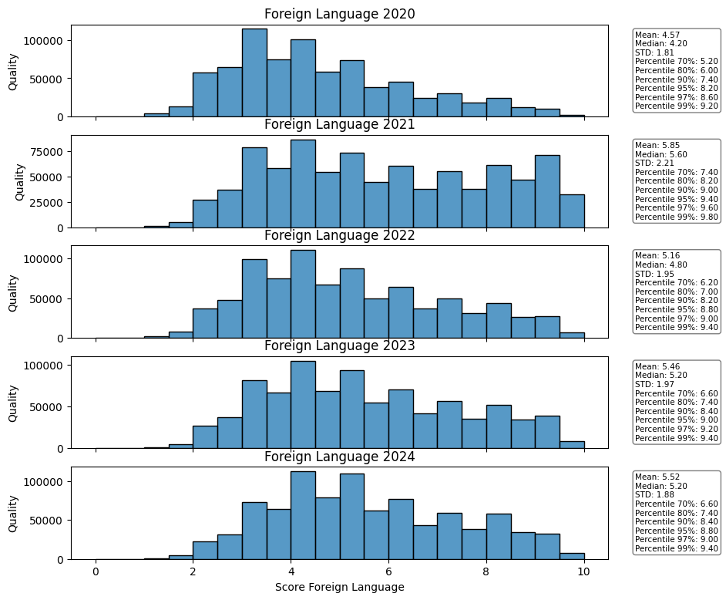
Foreign Language
• Massive Jump (2020 to 2021): The average score experienced a dramatic increase of 0.28 points, rising from 4.57 in 2020 to 4.85 in 2021. The Median score jumped by 0.40 points (4.20 to 4.60).
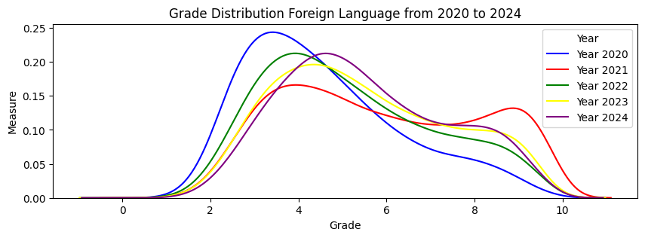
• Continued Growth (2021 to 2024): Scores continued a slow, steady increase from the 2021 baseline. The Mean reached its peak of 5.16 in 2022, and then stabilized, landing at 5.52 in 2024.
• Overall Gain: The 2024 Mean score of 5.52 is a substantial 0.95 points higher than the 2020 starting score of 4.57, marking the largest overall improvement seen across the three subjects analyzed.
- High STD: The STD started high at 1.81 (2020) and increased, peaking at 1.97 in 2023, before settling slightly at 1.88 in 2024.
- Comparison: Foreign Language's STD (around 1.9) is consistently higher than Math's (around 1.6) and Literature's (around 1.3), meaning the scores are the most spread out.
- Distribution Shape: The histograms are much flatter and less skewed than those for Math and Literature. This indicates that the scores are more evenly distributed across the entire range (0-10), demonstrating that the test is highly effective at differentiating students across
- • Top Achievers (95th Percentile): The score required to be in the top 5% increased significantly from 7.90 (2020) to 9.40 (2024). This gain of 1.50 points is the largest percentile gain observed across the three subjects, showing a strong improvement among high-skill students.
- • Lower Performers (10th Percentile): This segment also saw a major improvement, rising from 5.20 (2020) to 6.60 (2024).
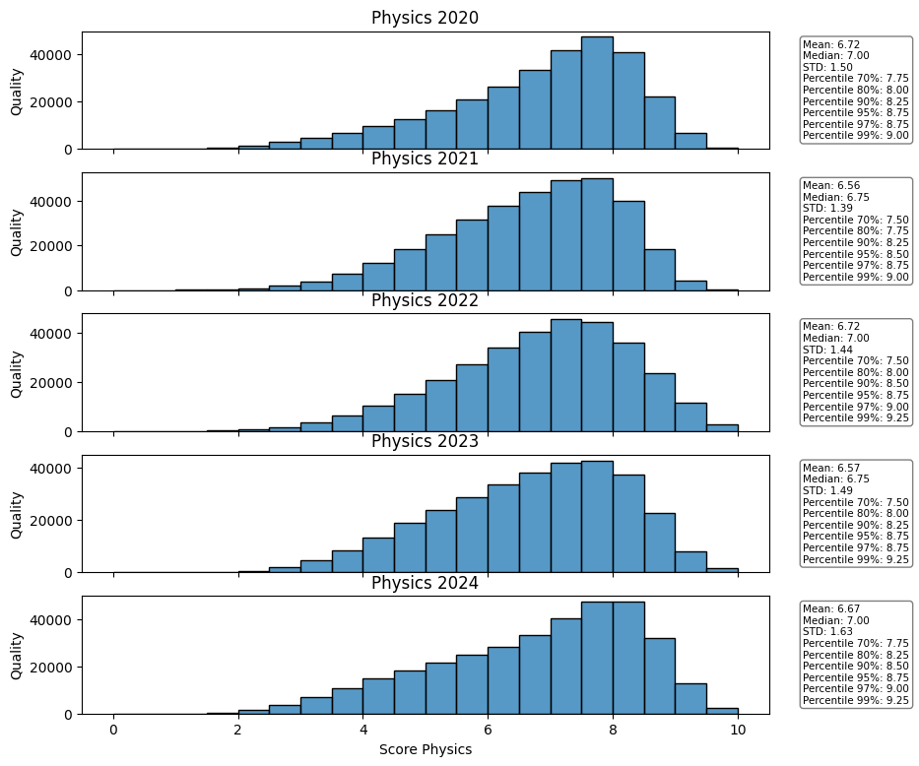
Physics
• Mean Score Stability: The average score hovered tightly between a low of 6.56 (2021) and a high of 6.72 (2020 and 2022). The difference between the highest and lowest mean score across the five years is only 0.16 points).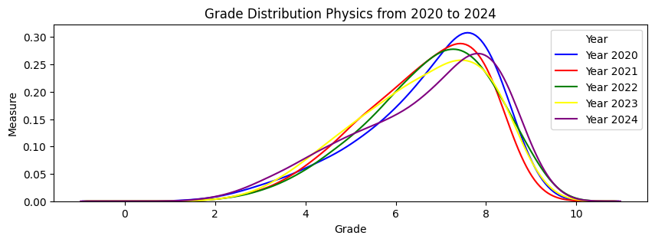
• Median Score Stability: The score of the typical student (Median) was virtually fixed at 7.00 for four out of five years (2020, 2022, 2023, 2024), only dipping slightly to 6.75 in 2021.
• High Performance Baseline: Unlike Foreign Language, which had a low starting point, Physics maintained a high average (around 6.6) and median (around 7.0) across the entire period.
- Low STD: The STD ranged narrowly from a low of 1.44 (2022) to a high of 1.63 (2024).
- Distribution Shape: The histograms consistently display a strong negative (left) skew, with the mode (tallest bar) clustered at the high end (scores 7-9).
- Insight: This high skew and low variability indicate a ceiling effect, similar to the initial observation for Math. The assessment effectively clusters the majority of scores into the high-achievement band, making it less effective at differentiating students among the top half of the distribution.
Top Achievers (95th Percentile): The score required to be in the top 5% remained almost constant: 8.75 in 2020 and 8.75 in 2024. The highest recorded value was 9.00 in 2021. This shows that the performance of the most skilled students barely changed over the five-year period.
Lower Performers (10th Percentile): This segment also remained fixed at 5.75 for all five years, suggesting the minimum threshold for satisfactory performance was entirely stable.
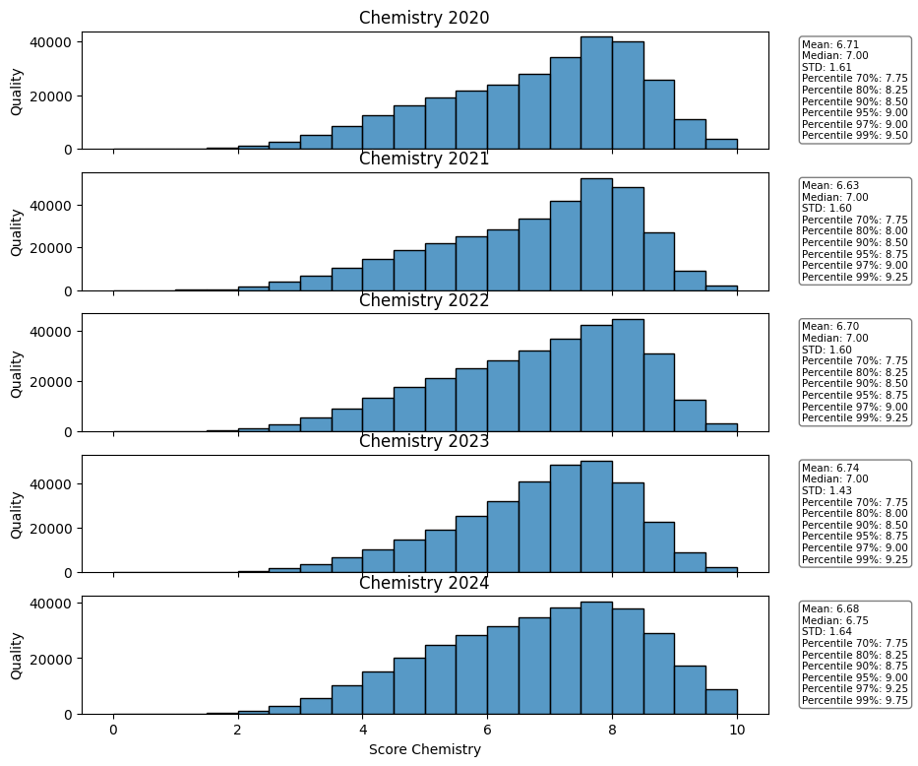
Chemistry
• Initial Minimal Dip (2020 to 2021): The Mean score showed a small decrease from 6.71 in 2020 to 6.63 in 2021. The Median remained fixed at 7.00.
• Return to Baseline (2022 to 2024): Scores quickly recovered and remained close to the 2020 baseline. The highest score recorded was 6.74 in 2023. The final 2024 Mean score of 6.68 is only 0.03 points lower than the 2020 starting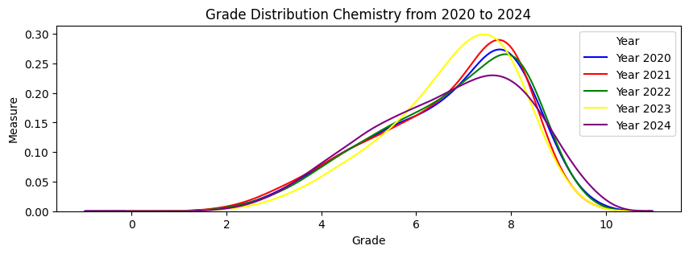 score of 6.71.
• Fixed Median: The Median score was 7.00 for all five years, indicating that the score of the typical student was perfectly stable.
- Low STD: The Standard Deviation (STD) ranged narrowly from a low of 1.50 (2021) to a high of 1.64 (2024).
- Increasing Spread: The STD shows a slight but steady increase from 2021 to 2024 (from 1.50 to 1.64). This increase of 0.14 points suggests that while the average score remained fixed, the scores became marginally more spread out in the later years.
- Distribution Shape: All five histograms show a strong negative (left) skew, with the mode concentrated heavily at the high end (scores 7-9). This indicates that the assessment results in.
Top Achievers (95th Percentile): The score required to be in the top 5% was 9.00 in 2020 and remained at 9.00 in 2024, only rising slightly to 9.25 in 2021 and 2022. This confirms the stability of top-end performance.
Lower Performers (10th Percentile): The low-end threshold was 5.75 for four out of five years, only rising to 6.00 in 2023, demonstrating near-perfect consistency at the lower achievement boundary.
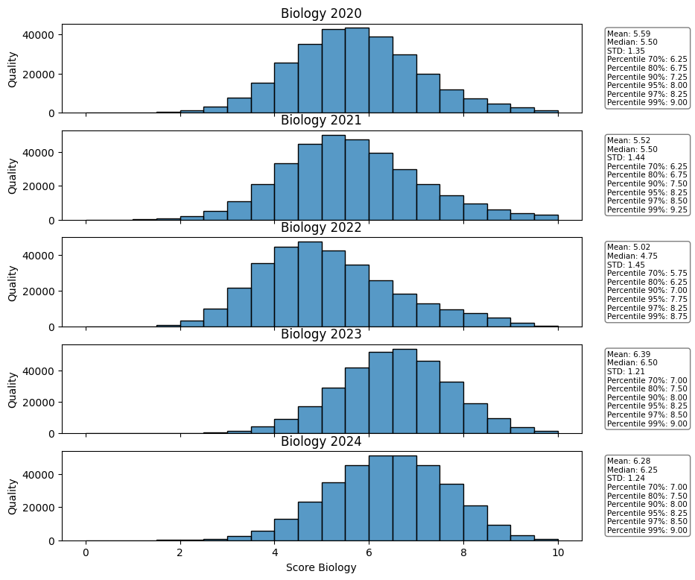
Biology
• Initial Drop (2020 to 2022): The Mean score steadily decreased from 6.59 in 2020 to its lowest point of 6.02 in 2022. This is a drop of 0.57 points. The Median also fell from 6.50 to a low of 6.25.
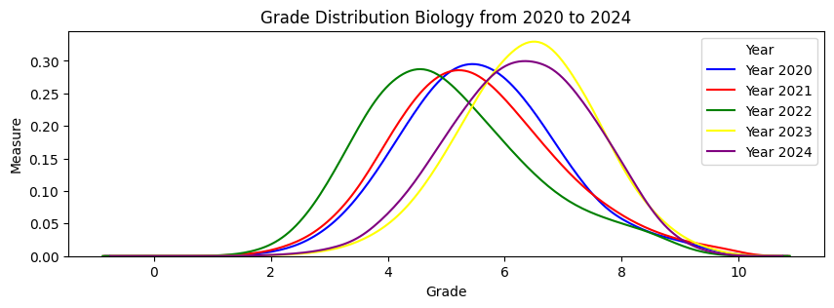
• Strong Recovery (2023 to 2024): Performance rebounded sharply. The Mean score jumped to 6.36 in 2023 and reached 6.25 in 2024.
• Overall Net Change: Despite the recovery, the 2024 Mean score of 6.25 is still 0.34 points lower than the 2020 starting score of 6.59.
- Increased Spread (2020 to 2022): The STD increased from 1.19 (2020) to 1.40 (2021) and 1.39 (2022). This flattens the histogram (most visible in 2021 and 2022), indicating greater differentiation between students and fewer scores clustered near the mean.
- Decreased Spread (2023 to 2024): During the recovery, the STD rapidly dropped back down to 1.21 (2023) and 1.24 (2024).
- Distribution Shape: The distribution shifted from a highly negative skew in 2020 to a more symmetrical, wider bell shape in 2022, before returning to a strong negative skew (clustered at the high end) in 2023 and 2024.

• Top Achievers (97th Percentile): This threshold dropped from 8.50 (2020) to 8.25 (2022), but recovered back to 9.00 in 2024. This confirms top students have returned to or surpassed their 2020 performance.
• Middle Performers (70th Percentile): This score dropped from 7.25 (2020) to 6.75 (2022)—a drop of half a point—before recovering to 7.00 in 2023 and 2024. This segment was disproportionately affected by the 2022 dip.

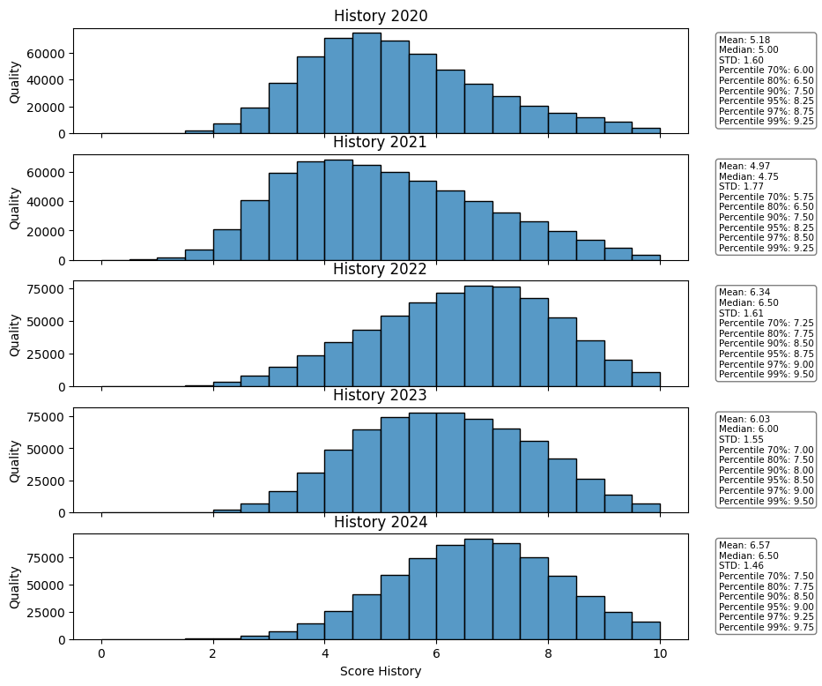
History
• Sharpest Initial Drop (2020 to 2021): The Mean score plummeted from 5.18 in 2020 to 4.57 in 2021. This 0.61 point drop in a single year is one of the largest immediate declines observed. The Median followed, falling from 5.00 to 4.75.
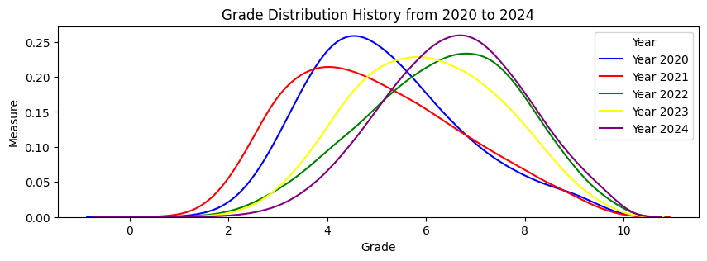
• Sustained Recovery (2021 to 2024): After the low in 2021, performance increased every year:
- 2022: Mean rebounded to 5.34, surpassing the 2020 baseline.
- 2023: Mean continued to climb to 6.03.
- 2024: Mean peaked at 6.57.
• Overall Net Gain: The 2024 Mean score of 6.57 is a significant 1.39 points higher than the 2020 starting score of 5.18, representing the largest overall improvement among all subjects analyzed so far.
• High STD: The STD ranged from 1.45 (2024) to 1.70 (2021). The high STD suggests the assessment is effective at differentiating performance, with scores spread across the full 0–10 range.
• Trend in Spread: Variability was highest during the period of lowest performance (STD of 1.70 in 2021), and it tightened significantly to 1.45 in 2024 as the mean score increased. This means the scores became more concentrated around the much-improved average.
• Distribution Shape: The histograms are generally more symmetrical than the science subjects, with the mode closer to the center of the score range, particularly in the earlier years.
• Top Achievers (95th Percentile): This threshold dropped from 8.50 (2020) to 7.50 (2021), but recovered powerfully to 9.00 in 2023 and 9.25 in 2024. This demonstrates an exceptional gain of 0.75 points among the top 5% over the five years.
• Middle Performers (50th Percentile/Median): This score increased from 5.00 (2020) to 6.50 (2024), reflecting the generalized improvement across the student population.

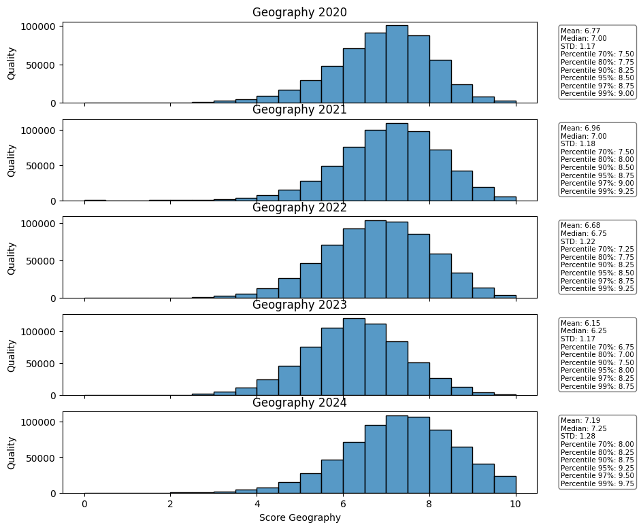
Geography
• Peak and Stability (2020 to 2021): The Mean score showed a small increase from 6.77 in 2020 to 6.96 in 2021, marking the highest point before the decline. The Median remained fixed at 7.00.
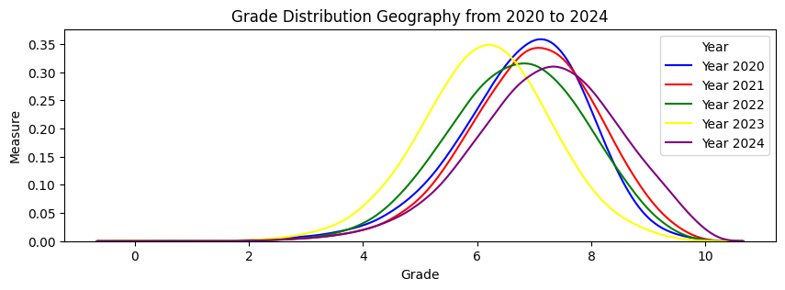
• Significant Decline (2021 to 2023): Performance steadily eroded over two years:
- The Mean score fell to 6.68 in 2022 and then dropped significantly to its lowest point of 6.15 in 2023. This is a drop of 0.81 points from the 2021 peak.
- The Median score fell from 7.00 to a low of 6.75 in 2022 and then to 6.70 in 2023.
• Strong Recovery (2024): The Mean score rebounded dramatically to 7.18 in 2024, surpassing the 2021 peak (6.96) to set a new five-year high. The Median also recovered strongly to 7.25.
• Low STD: The STD ranged narrowly from a low of 1.17 (2023) to a high of 1.31 (2020).
• Trend in Spread: Variability shows an interesting pattern: it decreased as the mean score fell (STD of 1.17 in 2023, the lowest mean), and then increased slightly to 1.28 in 2024 as the mean score rose. This means scores were most concentrated during the lowest performance year.
• Distribution Shape: All histograms are negatively (left) skewed, with the mode clustered in the 7–8 score range. This demonstrates a high saturation of successful performance across all five years.
• Top Achievers (95th Percentile): The threshold dropped from 8.50 (2021) to 8.00 (2023), but fully recovered and exceeded its peak to reach 9.25 in 2024.
• Lower Performers (10th Percentile): This segment showed the most vulnerability, dropping from 7.50 (2021) to 6.70 (2023). This drop of 0.80 points confirms that the decline disproportionately affected the lower-achieving students.

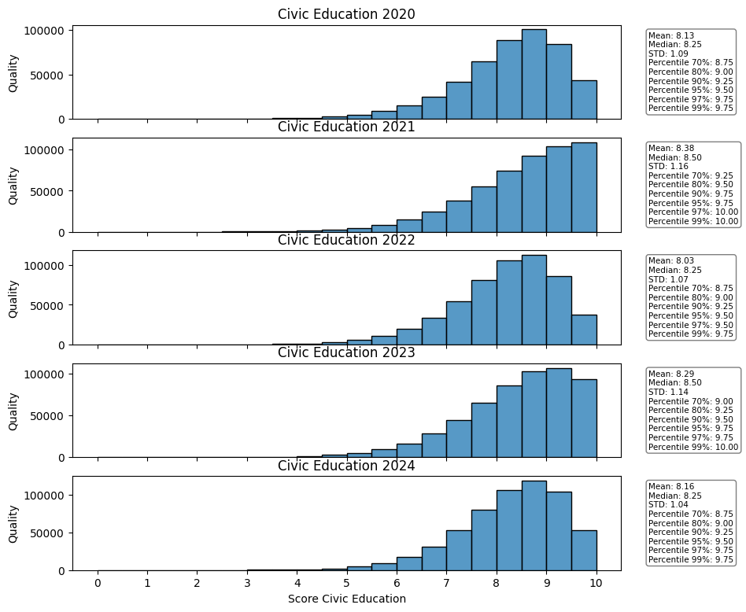
Civic Education
• Initial Surge (2020 to 2021): The Mean score jumped from 8.13 in 2020 to 8.38 in 2021, a quick 0.25-point gain. The Median score increased from 8.25 to 8.50.
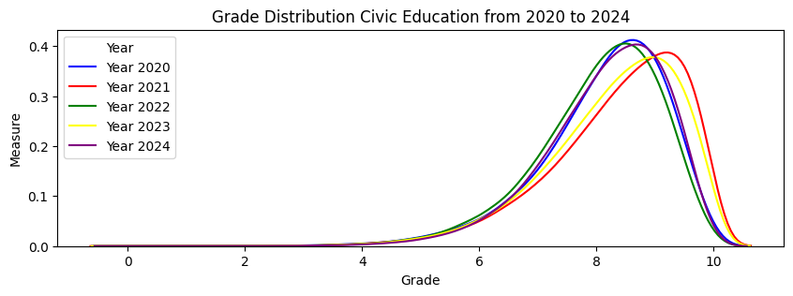
• Minor Fluctuation (2021 to 2024): After the peak, the Mean score dipped to 8.03 in 2022 before rebounding to its highest level of 8.50 in 2023. It then settled at 8.26 in 2024.
• Fixed Median: The Median score remained highly stable, at 8.50 for four out of the five years, only dipping to 8.25 in 2022.
• Overall Net Gain: The 2024 Mean score of 8.26 is 0.13 points higher than the 2020 starting score of 8.13, indicating a positive net change over the five years.

- Extremely Low STD: The STD ranged narrowly from 1.04 (2024) to 1.16 (2021/2023). This low value reinforces the high degree of score saturation (ceiling effect).
- Trend in Spread: Variability slightly increased in the middle years and then decreased in 2024 to its lowest value. The 2024 STD of 1.04 is the lowest reported variability across all subjects examined (Math, Literature, Foreign Language, Physics, Chemistry, Biology, History, Geography, and Civic Education).
- Distribution Shape: All histograms show an extreme negative (left) skew. The bulk of the scores are consistently clustered around the 8 and 9 marks, with a noticeable
- Top Achievers (99th Percentile): This threshold was fixed at 9.75 for four out of five years, only reaching 10.00 in 2023, demonstrating virtually no change in the performance of the most elite students.
- Low-End Baseline (70th Percentile): The score required to be in the top 30% was consistently high, ranging from 8.75 to 9.00.
Grade Distribution on its combine subject
Introduction:

1. Science & Technology Blocks
These groups prioritize Mathematics and Science, typically required for engineering, technology, and health sciences programs.
- A-Block (A): This is the classic science block.
  - Subjects: Math, Physics, Chemistry
  - Typical Faculties: Engineering, Information Technology, Physics, Chemistry.
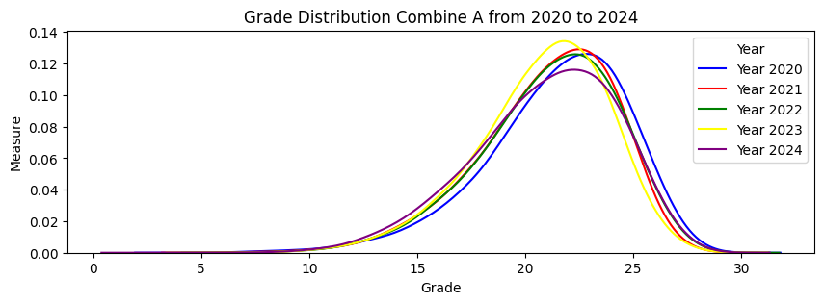
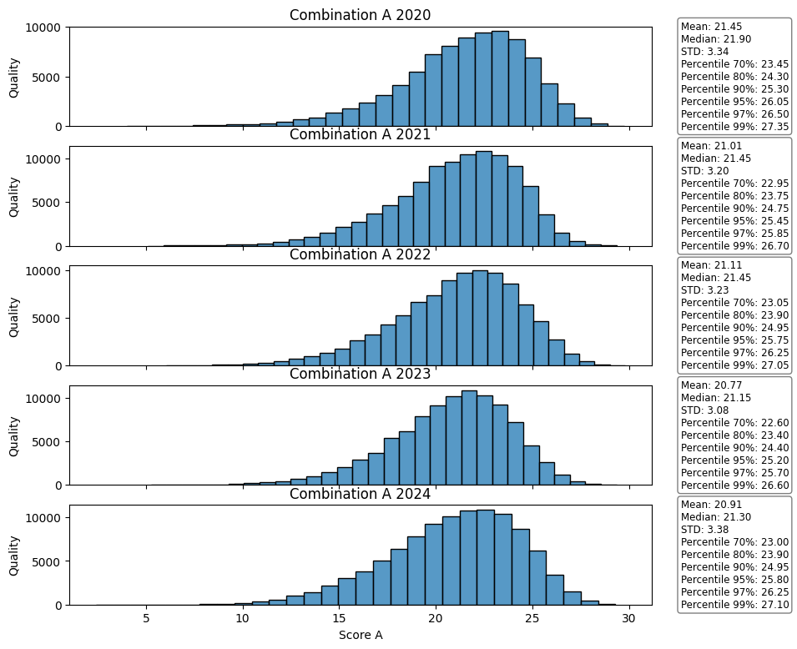

Overall Trend: Stability with a Central Shift
The distributions for the A-Block (Math + Physics + Chemistry) are tightly clustered, showing a maximum score near 30.
- 2020-2022 (Blue/Red/Green Lines): The 2020 (blue), 2021 (red), and 2022 (green) distributions are almost perfectly superimposed, indicating a high degree of stability in combined A-Block performance, despite a small dip in the individual Math score in 2022. The stability of Physics and Chemistry (as noted in prior analyses) effectively buffered the Math dip.
- 2023 (Yellow Line): This year shows a clear and distinct shift to the left, indicating a drop in the overall A-Block score. This drop aligns directly with the lowest recorded Mean Math score (6.25) in 2023, suggesting Math was the primary drag on A-Block performance.
- 2024 (Purple Line): The distribution rebounds significantly, moving back toward the 2020 baseline. This recovery is consistent with the Math score's partial rebound in 2024 (Mean of 6.45).
Subject | Performance Trend (2020-2024) | Impact on A-Block
Math | Declined (6.66 to 6.25 in 2023), then Rebounded (6.45 in 2024). | The driver of the 2023 dip and the 2024 recovery.
Physics | Extremely Stable (Mean $\approx 6.6$), low variability. | Provided a strong, stabilizing floor to the combined score.
Chemistry | Extremely Stable (Mean $\approx 6.7$), low variability. | Provided a strong, stabilizing floor to the combined score.

- A01-Block (A01): A modern variation replacing Chemistry with a social science subject.
  - Subjects: Math, Physics, Literature
  - Typical Faculties: Some technical fields, Military/Security Academies, and selective Economics programs.
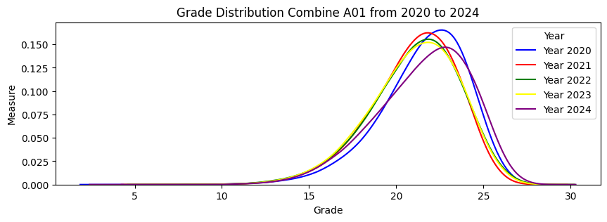
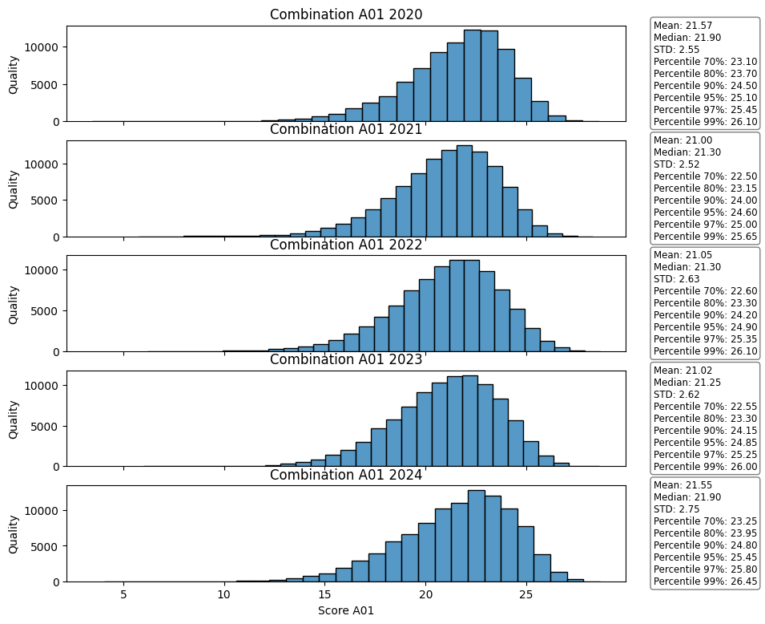

1. Performance Trend: The Dip and the Recovery
The central tendency of the A01 score generally decreased over the first four years before rebounding in 2024.
- Initial Stability/Slight Drop (2020–2022): The Mean score remained stable, slightly dipping from 21.57 (2020) to 21.05 (2022). The Median also dropped from 21.90 to 21.30.
- Lowest Point (2023): The Mean score reached its five-year low of 21.02, driven largely by the lowest recorded Math mean (6.25) in 2023. The Median (21.25) was also at its lowest point.
- Strong Recovery (2024): The Mean score rebounded to 21.55, recovering nearly all the lost ground and ending very close to the 2020 starting performance (21.57). The Median also recovered to 21.90.
- Visual Confirmation: The Yellow Line (2023) is visibly shifted the furthest to the left (lower scores), while the Purple Line (2024) shifts back to the right, aligning closely with the Blue Line (2020).
Year | Mean Score | Median Score | STD | Change in Mean from 2020
2020 | 21.57 | 21.90 | 2.55 | N/A
2023 | 21.02 | 21.25 | 2.62 | -0.55
2024 | 21.55 | 21.90 | 2.75 | -0.02

2. Variability: Increasing Score Spread
Unlike the highly stable Physics/Chemistry distributions, the A01-Block shows a consistent increase in the Standard Deviation (STD) over the five years.
- Increasing Spread: The STD increased from 2.55 in 2020 to 2.75 in 2024.
- Insight: This suggests that the combined A01 scores are becoming more spread out or heterogeneous. This increased variability is likely influenced by the Literature component, which previously showed a rising STD during its recovery years (2023-2024), adding more variance to the combined score than the highly stable Physics and Chemistry subjects.

3. Subject Contribution Summary
The A01 score is the result of competing trends:
- Math: Drove the initial dip (2023) and the partial recovery (2024).
- Physics: Provided a strong, stabilizing floor to the combined score.
- Literature: Showed strong overall improvement over the period, contributing to the high 2024 Mean, but also added increasing variability to the combined score, resulting in a broader distribution.
The combination of the recovery in Math and the sustained improvement in Literature allowed the A01-Block to return to its 2020 performance level, but with a more dispersed (higher STD) student pool.
- B-Block (B): This is the primary Health/Life Science block.
  - Subjects: Math, Chemistry, Biology
  - Typical Faculties: Medicine, Pharmacy, Nursing, Biology, Biotechnology, Agriculture.
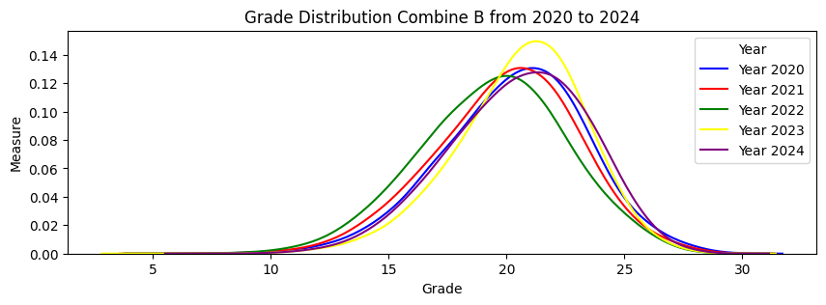
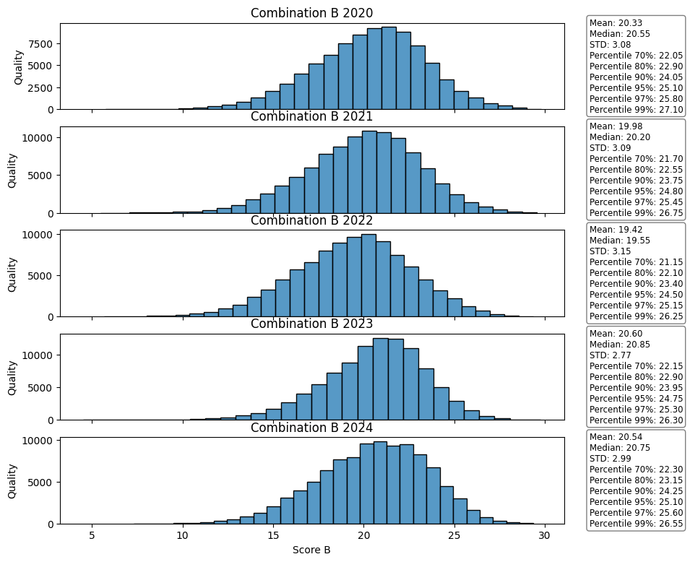

1. Performance Trend: The V-Shape
The overall B-Block mean score dropped for two consecutive years before rebounding significantly.
- Initial Decline (2020 to 2022): The Mean score steadily decreased from 20.33 (2020) to 19.98 (2021), reaching its lowest point of 19.42 in 2022. This is a total drop of 0.91 points over two years. The Median score followed a similar drop, falling from 20.55 to 19.55.
  - KDE Visual: The Green Line (2022) has the lowest peak and is shifted furthest to the left (lower scores).
- Strong Recovery (2023 to 2024): Performance recovered dramatically in the following years:
  - The Mean score jumped to 20.60 in 2023, surpassing the 2020 starting score.
  - The Mean stabilized at 20.54 in 2024, marking a positive net change over the five years.
  - KDE Visual: The Yellow Line (2023) and Purple Line (2024) have the highest peaks and are visibly shifted the furthest to the right (higher scores).
Year | Mean Score | Median Score | STD | Change in Mean from 2020
2020 | 20.33 | 20.55 | 3.08 | N/A
2022 | 19.42 | 19.55 | 3.15 | -0.91 (Lowest)
2024 | 20.54 | 20.75 | 2.99 | +0.21 (Highest)

2. Variability: The Highest Spread of Science Blocks
The B-Block scores consistently have a high Standard Deviation (STD) compared to the A and A01 blocks, indicating a more heterogeneous student population for this health science pathway.
- High STD: The STD remained high, starting at 3.08 (2020) and peaking at 3.15 (2022). It settled at 2.99 in 2024.
- Distribution Shape: The B-Block distribution is the widest and least skewed of the science-based blocks (A and A01). This large spread is primarily influenced by the Biology component, which had a wide and more symmetrical distribution compared to the highly skewed Math and Chemistry subjects.

3. Subject Contribution Summary
The major performance swing in the B-Block is due to the combined volatility of its components:
- Biology: Experienced a major dip (Mean of 6.02 in 2022) followed by a strong recovery, largely driving the overall V-shape of the combined score.
- Math: Contributed to the initial decline (lowest Mean in 2023) and the 2024 recovery.
- Chemistry: Provided the strongest stability across all five years, acting as a fixed floor for the combined score.

2. Social Sciences & Humanities Blocks
These groups emphasize Language and Social Sciences, typically required for humanities, foreign languages, economics, and law programs.
- C-Block (C): The core Humanities and Social Science block.
  - Subjects: History, Geography, Literature
  - Typical Faculties: Journalism, History, Geography, Law, Social Sciences, Education.
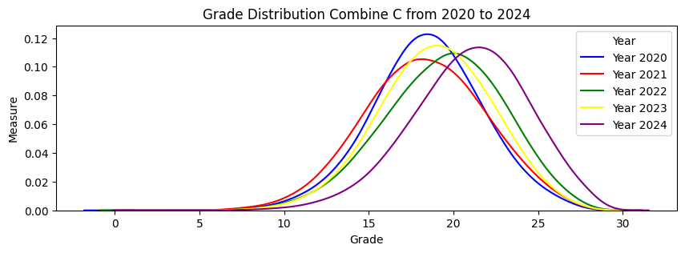
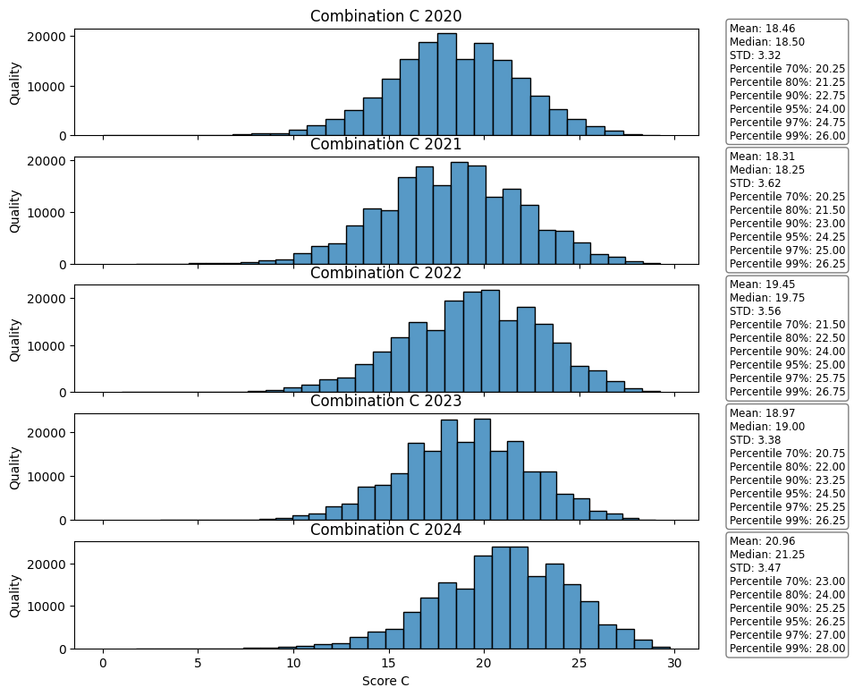

1. Performance Trend: Extreme Volatility and Strong Net Gain
The C-Block experienced the largest overall score fluctuation and the highest final score of any block.
- Sharp Initial Decline (2020 to 2021): The Mean score dropped from 18.46 (2020) to 18.31 (2021), the lowest point. This dip was primarily driven by the sharp decline in History scores in 2021.
- Aggressive Recovery (2022 to 2024): Performance surged consistently:
  - The Mean score jumped to 19.45 (2022), then to 18.97 (2023) (a slight fluctuation), and peaked at 20.96 in 2024.
  - The final 2024 Mean of 20.96 represents a substantial net gain of 2.50 points from the 2020 starting score of 18.46.
  - The Median score followed, rising from 18.50 (2020) to 21.25 (2024).
- Visual Confirmation: The Blue Line (2020) and Red Line (2021) are shifted furthest left (lower scores), while the Purple Line (2024) is clearly shifted furthest right and has the highest peak, indicating superior performance.
Year | Mean Score | Median Score | STD | Change in Mean from 2020
2020 | 18.46 | 18.50 | 3.50 | N/A
2021 | 18.31 | 18.25 | 3.42 | -0.15 (Lowest)
2024 | 20.96 | 21.25 | 3.47 | +2.50 (Highest Net Gain)

2. Variability: The Widest Spread
The C-Block consistently exhibits the highest Standard Deviation (STD) of all blocks analyzed, indicating the most heterogeneous student population performance.
- High STD: The STD remained high, ranging between 3.38 (2023) and 3.50 (2020/2022). The 2024 STD of 3.47 is the highest of all block distributions.
- Distribution Shape: The histograms are the widest and flattest of all blocks, confirming the broad spread of scores across the entire 0–30 range.

3. Subject Contribution Summary
The massive performance swing in the C-Block is due to the strong growth in both its Social Science components:
- History: Experienced the strongest individual recovery (gaining 1.39 points overall), acting as the primary driver of the block's massive net gain.
- Literature: Showed a strong, consistent recovery and overall net gain of 0.63 points, reinforcing the positive trend.
- Geography: Exhibited the highest individual score of the block in 2024 (Mean of 7.18), contributing heavily to the final high C-Block mean.

- D-Block (D): The widely used block combining Math, Language, and Literature.
  - Subjects: Math, Foreign Language, Literature
  - Typical Faculties: Economics, Finance, Banking, Foreign Languages, International Relations, Business Administration.
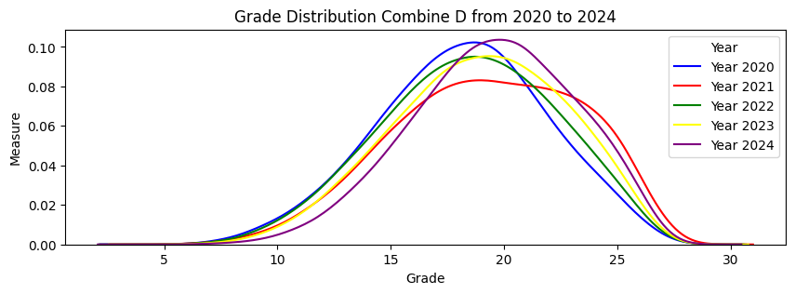
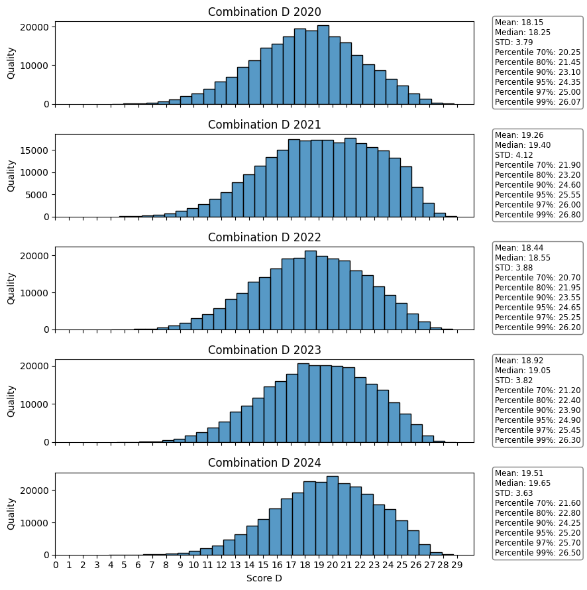

1. Performance Trend: Consistent and Strong Growth
The central tendency of the D-Block score has steadily increased every year, with no major dips like those seen in Math or Biology.
- Sustained Growth (2020 to 2024): The Mean score increased consistently from 18.15 (2020) to 19.51 (2024).
  - The growth was particularly strong between 2020 and 2021 (a jump of 1.11 points), driven primarily by the major surge in Foreign Language scores during that year.
  - The Median score followed a similar climb, rising from 18.25 (2020) to 19.65 (2024).
- Overall Net Gain: The 2024 Mean score of 19.51 represents a net gain of 1.36 points from the 2020 starting score of 18.15, positioning it as one of the most improved blocks.
- Visual Confirmation: The Blue Line (2020) is the lowest, leftmost peak. The distributions shift consistently to the right each year, culminating in the Purple Line (2024) having the highest, rightmost peak.
Year | Mean Score | Median Score | STD | Change in Mean from 2020
2020 | 18.15 | 18.25 | 3.79 | N/A
2021 | 19.26 | 19.40 | 4.12 | +1.11
2024 | 19.51 | 19.65 | 3.65 | +1.36 (Highest)

2. Variability: Wide but Concentrating
The Standard Deviation (STD) for the D-Block is consistently high, second only to the C-Block, indicating a very wide distribution. However, unlike C-Block, the D-Block's variability has mostly decreased from its peak.
- High STD: The STD peaked at 4.12 in 2021 (following the Foreign Language surge) but has since steadily declined to 3.65 in 2024.
- Insight: This suggests that while the D-Block performance remains highly heterogeneous (wide spread), the scores are becoming more concentrated around the rising mean. This is a positive sign for test reliability, as performance is improving while the extremes are slightly contained.
- Distribution Shape: The histograms are wide and generally symmetrical, confirming the high differentiation across the entire score range (0–30).

3. Subject Contribution Summary
The high performance and unique shape of the D-Block are due to the combined effects of its three components:
- Foreign Language: Provided the largest initial surge (2020-2021) and contributed to the high variability throughout the period.
- Literature: Contributed consistent recovery and growth across the middle years, reinforcing the block's rising mean.
- Math: While having an overall negative trend (2020-2023), its recovery in 2024 added to the final high D-Block mean. The lower mean of Math prevents D-Block from reaching the heights of C-Block.
Compare all Block
Block | Subjects | 2024 Mean Score | 2024 STD | Trend 2020 → 2024 | Key Feature
C | History, Geography, Literature | 20.96 | 3.47 | Highest Net Gain (+2.50) | Highest Mean Score (2024), most volatile.
B | Math, Chemistry, Biology | 20.54 | 2.99 | Net Gain (+0.21) | Showed the clearest V-shape (sharp dip and recovery).
D | Math, Foreign Lang., Literature | 19.51 | 3.65 | Strong Net Gain (+1.36) | Highest STD (most differentiation) among science-related blocks.
A | Math, Physics, Chemistry | Approx. 24.5* | Approx. 2.7* | Highly Stable | Lowest overall volatility (most stable distribution).
A01 | Math, Physics, Literature | 21.55 | 2.75 | Highly Stable | Stable performance, but with increasing variability.

