Summary

I use an 800\*600 grey image “apple” as an example:

Before Hog: After Hog:  
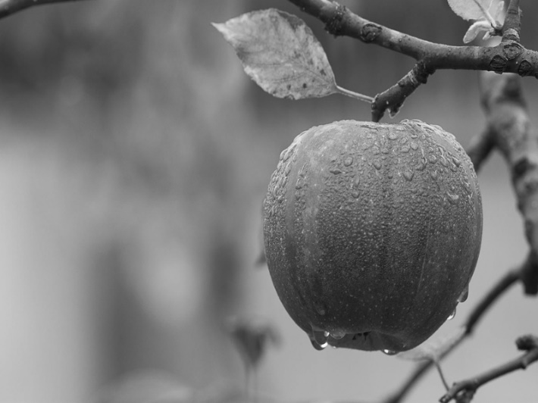 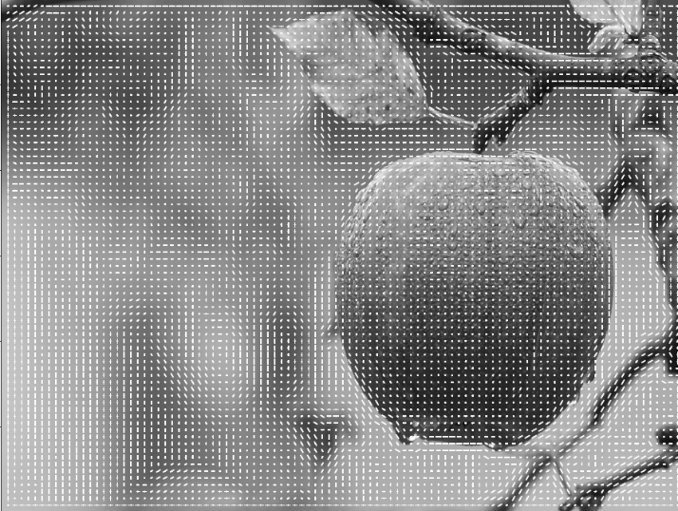

Step Processing:

Since my algorithm takes some time, I write a progress bar to show:



I use the upper 100 \* 100 pixel in order to reflect more details:

The normalized image: The filtered image across x axis: The filtered image across y axis:  
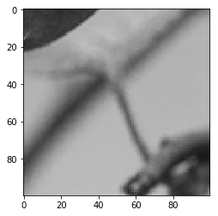 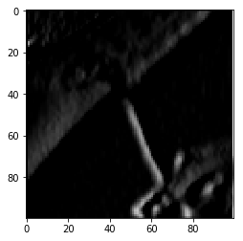 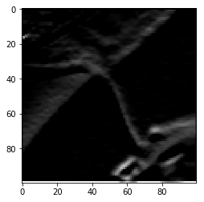

The magnitude of image: The angle of image: The gradient of image:

