private static uint ConvertMantissa(int i)

{

uint m = (uint)(i << 13); // Zero pad mantissa bits

uint e = 0; // Zero exponent

// While not normalized

while ((m & 0x00800000) == 0)

{

e -= 0x00800000; // Decrement exponent (1<<23)

m <<= 1; // Shift mantissa

}

m &= unchecked((uint)~0x00800000); // Clear leading 1 bit

e += 0x38800000; // Adjust bias ((127-14)<<23)

return m | e; // Return combined number

}

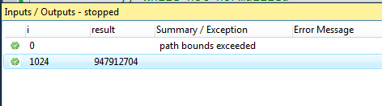

0.8 ms