public static double Linear(double t, double t1, double p1, double t2, double p2)

{

return ((t2 - t) \* p1 + (t - t1) \* p2) / (t2 - t1);

}

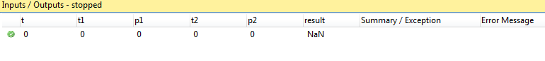geçen zaman :0.5 ms