public static void cGemm(ScalarValue[] aStore, int aOffset, int aRowStride, int aColStride,

ScalarValue[] bStore, int bOffset, int bRowStride, int bColStride,

ScalarValue[] cStore, int cOffset, int cRowStride, int cColStride,

int rowsA, int colsB, int length)

{

int aIndex = aOffset;

int cStart = cOffset;

for (int n = 0; n < rowsA; n++)

{

int bIndex = bOffset;

int cIndex = cStart;

for (int m = 0; m < colsB; m++)

{

cStore[cIndex] = BlasL1.cDot(aStore, aIndex, aColStride, bStore, bIndex, bRowStride, length);

bIndex += bColStride;

cIndex += cColStride;

}

aIndex += aRowStride;

cStart += cRowStride;

}

}

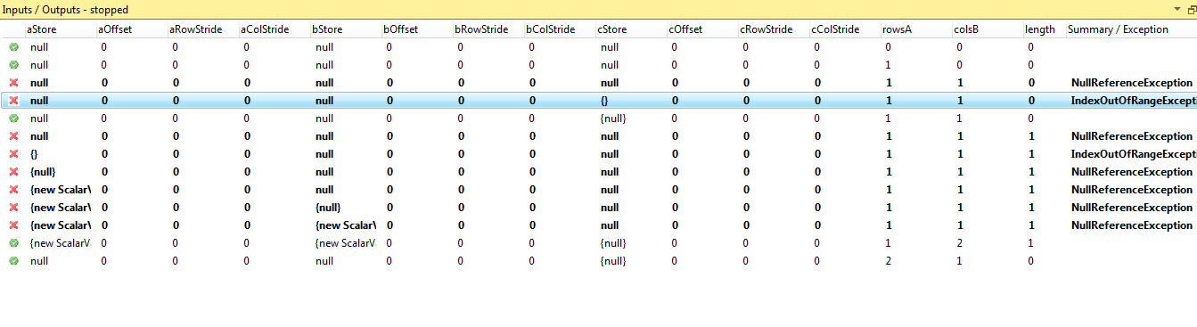

4ms