第一題

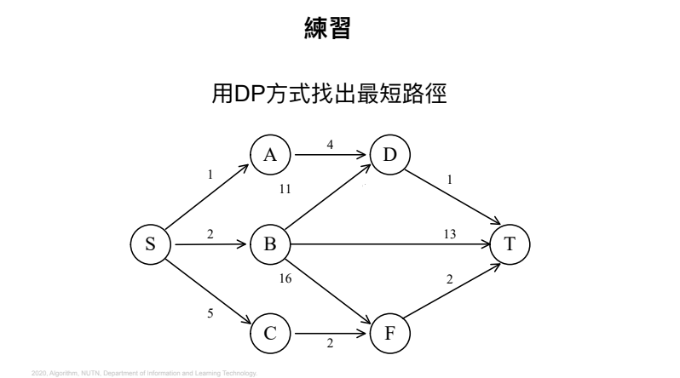d (S, T) = min {d(S, D)+d(D, T), d(S, B)+d(B, T), d(S, F)+d(F, T)}

= min {5+1+, 2+12, 7+2}

= 6

第二題

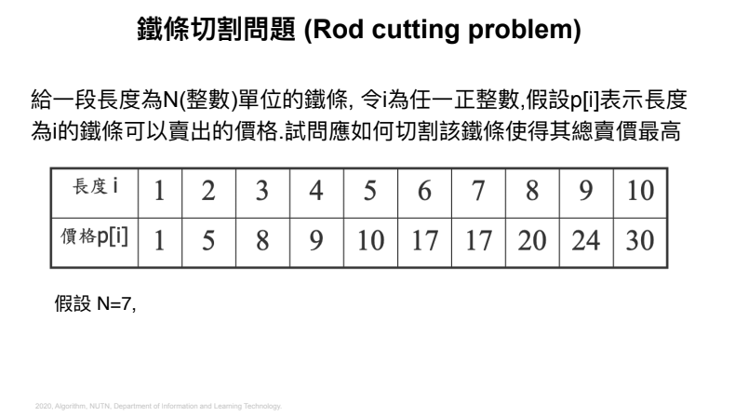N = 7($17)

= 1+6($18) = 1+3+3($17) = 1+2+2+2($16)

= 2+5($15) = 1+1+5($12) = 2+2+3(18)

= 3+4($17) = 1+2+4($15) = 1+1+1+4($12) = 2+2+3($18)

= 4+3 ……