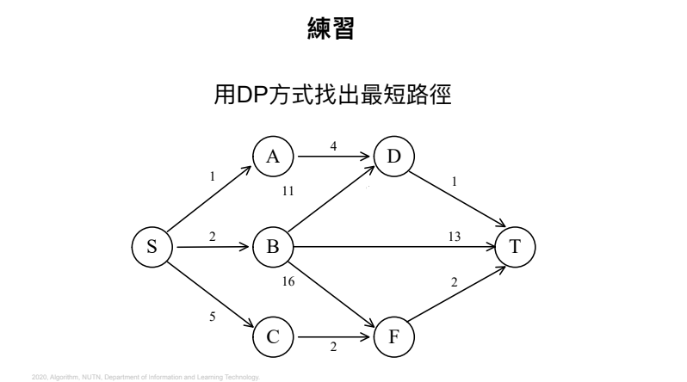

d (S, T) = min {d(S, D)+d(D, T), d(S, B)+d(B, T), d(S, F)+d(F, T)}

= min {5+1+, 2+12, 7+2}

= 6