|  |  |  |
| --- | --- | --- |
|  |  | G1405班家校同心桥 第十四周 |

二〇一五年十一月二十日星期五

# 班主任寄语

天道酬勤

 天道酬勤：是指一分耕耘,一分收获。已故著名的数学家华罗庚说，勤能补拙是良训，一分辛苦一分才。那些勤勉的人,一定会有所收获。有梦,才有希望，有梦并且能够坚定不移脚踏实地地坚持下去，才能把梦变成现实。

天道酬勤， 机遇总是青睐那些刻苦勤学的人， “有志者,事竟成,破釜沉舟百二秦关终数楚；苦心人,天不负，卧薪尝胆，三千越甲可吞吴。” “闻鸡起舞早耕耘，天道酬勤有志人。”    
 高中是每一人人生最宝贵的年华，天才使你如虎添翼，勤奋将使你赢得一切。命运就掌握在自己手中，推动世界前进的往往不是那些天资卓越，才华四射，人中豪杰的天才，而是那些智力平平而又非常勤奋、勤勤恳恳、劳作不息，埋头苦干的人。只有付出相应的劳动和汗水，才能懂得智慧硕果是多么的来之不易，梦想是多么璀璨，生活是多么美好。    
       不想辛苦的人一定平庸，不想付出的人一定平庸，不想有所作为的人一定平庸。苦难是成功途中的考验，是成功途中的历练，是成功途中的先驱。怯懦的人必然在苦难之中被淘汰，必然看不到成功的曙光，必然看不到人生的辉煌。要谨记：痴思长绳系日，须知天道酬勤。

人间桑海朝朝变，莫遣佳期更后期，莫等闲白了少年头，人生的伟业，不在于能知，而在于能行，勤奋、励志、修身、养性。让我们不断锤炼，不断开拓，不断进取，不断超越，不断升华！

# 一周回放

1. **常规分**

|  |  |  |  |  |  |  |  |  |  |  |  |  |  |  |
| --- | --- | --- | --- | --- | --- | --- | --- | --- | --- | --- | --- | --- | --- | --- |
| **团队名称** | **学号** | **语文** | **数学** | **英语** | **物理** | **化学** | **生物** | **寝室** | **迟到** | **纪律** | **卫生** | **奖励发** | **总分** | **团分** |
| **一团** | 28 |  |  |  |  |  |  |  | **-1** |  |  |  | **-1** | **0.5** |
| 12 |  | **-1** | **1** |  |  |  | **1** |  |  |  |  | **1** |
| 52 |  |  | **1** |  |  |  | **4** | **-2** |  |  | **3** | **6** |
| 5 |  |  |  |  |  |  |  |  |  |  | **3** | **3** |
| 21 | **-3** |  |  |  | **-2** |  |  |  |  |  |  | **-5** |
| 36 | **-1** | **-3** |  |  | **-1** |  |  |  |  |  |  | **-5** |
| 45 |  |  |  | **-1** | **-1** |  | **5** | **-2** |  |  |  | **1** |
| 51 |  |  |  |  |  |  | **5** | **-1** |  |  |  | **4** |
| **二团** | 57 |  |  | **2** | **-2** | **-1** |  |  |  |  |  | **3** | **2** | **-2** |
| 47 |  |  |  | **-1** | **-1** | **-1** |  |  |  |  | **3** | **0** |
| 53 | **-4** | **-2** |  | **-2** | **-2** | **-1** | **5** |  |  |  | **3** | **-3** |
| 40 |  |  |  | **-1** | **-1** |  |  |  |  |  | **2** | **0** |
| 32 | **-5** |  |  |  | **-1** | **-1** | **1** |  |  |  |  | **-6** |
| 16 |  |  |  |  | **-1** | **-1** |  |  |  |  |  | **-2** |
| 1 | **-3** | **-2** |  |  | **-3** | **-1** |  |  |  |  |  | **-9** |
| 17 |  |  |  |  | **-1** |  |  |  |  |  | **2** | **1** |
| **三团** | 39 | **-7** | **-3** |  |  | **-2** | **-1** | **-2** | **-1** |  |  |  | **-16** | **-2** |
| 46 |  |  | **2** |  |  |  |  |  |  |  |  | **2** |
| 56 |  |  | **2** |  |  |  | **5** |  |  |  |  | **7** |
| 35 |  | **-4** |  |  | **-1** | **-1** |  |  |  |  |  | **-6** |
| 23 |  |  |  |  |  |  | **1** |  |  |  |  | **1** |
| 27 |  | **-1** |  |  |  |  | **-1** |  |  |  |  | **-2** |
| 11 |  | **-2** |  |  |  |  |  |  |  |  | **2** | **0** |
| 6 |  | **-1** | **1** | **-1** | **-1** | **-1** | **3** |  |  |  |  | **0** |
| **四团** | 49 |  | **-1** |  | **-1** | **-2** | **-1** | **4** |  |  |  |  | **-1** | **-1** |
| 48 |  | **-1** |  |  | **-1** |  | **5** |  |  |  |  | **3** |
| 55 |  | **-1** |  |  | **-1** |  | **4** |  |  |  |  | **2** |
| 50 | **-2** |  |  |  | **-1** |  | **4** |  |  |  |  | **1** |
| 31 |  |  |  |  | **-1** |  |  |  |  |  |  | **-1** |
| 18 |  | **-1** | **2** |  | **-2** | **-1** |  |  |  |  |  | **-2** |
| 15 |  | **-3** |  |  | **-3** | **-1** |  |  |  |  | **3** | **-4** |
| 2 |  | **-2** | **1** |  | **-1** |  |  |  |  |  |  | **-2** |
| **五团** | 60 |  | **-2** |  |  | **-3** | **-1** | **2** | **-2** |  |  | **3** | **-3** | **-4** |
| 59 |  |  |  |  |  |  | **4** |  |  |  | **3** | **7** |
| 43 |  |  | **1** |  | **-1** |  | **4** | **-2** |  |  | **3** | **5** |
| 34 |  | **-4** |  |  | **-2** | **-1** | **-1** |  |  |  |  | **-8** |
| 26 | **-5** | **-3** |  |  | **-3** | **-1** |  | **-1** |  |  |  | **-13** |
| 22 | **-3** | **-1** |  | **-1** | **-2** | **-1** |  |  |  |  |  | **-8** |
| 7 |  | **-2** |  |  | **-1** |  |  | **-1** |  |  |  | **-4** |
| 10 |  | **-1** |  | **-1** | **-2** |  |  | **-1** |  |  |  | **-5** |
| **六团** | 58 |  | **-1** |  |  |  |  | **5** |  |  |  |  | **4** | **-1** |
| 54 |  | **-1** | **1** |  | **-1** |  | **5** |  |  |  |  | **4** |
| 30 | **-2** | **-2** |  |  |  |  | **1** |  |  |  |  | **-3** |
| 44 |  | **-2** | **2** |  |  |  | **4** |  |  |  |  | **4** |
| 19 | **-3** | **-5** |  | **-1** | **-3** |  |  |  |  |  |  | **-12** |
| 14 | **-1** | **-3** |  |  |  |  |  |  |  |  |  | **-4** |
| 3 | **-2** |  |  |  |  |  | **1** |  |  |  |  | **-1** |
| 38 |  | **-1** |  | **-1** | **-2** |  | **1** |  |  |  |  | **-3** |
| **七团** | 8 |  | **-3** |  |  | **-1** |  | **10** |  |  |  |  | **6** | **-5** |
| 33 |  | **-3** |  |  | **-1** | **-1** |  |  |  |  |  | **-5** |
| 9 | **-4** | **-5** | **1** | **-2** |  | **-1** |  |  |  |  |  | **-11** |
| 24 | **-2** | **-5** |  |  |  | **-1** |  |  |  |  |  | **-8** |
| 25 | **-3** | **-4** |  |  | **-1** |  | **-4** |  |  |  | **2** | **-10** |
| 63 | **-2** | **-4** |  |  | **-2** |  |  |  |  |  |  | **-8** |
| 64 | **-2** | **-4** |  |  | **-3** |  |  |  |  |  | **6** | **-3** |
| 41 |  | **-4** |  |  | **-3** |  | **5** | **-1** |  |  |  | **-3** |
| **八团** | 4 |  | **-2** |  |  | **-1** |  |  |  |  |  |  | **-3** | **-1** |
| 13 | **-5** | **-2** |  |  | **-2** |  |  | **-1** |  |  | **3** | **-7** |
| 20 | **-2** | **-1** |  |  | **-1** |  | **8** |  |  |  |  | **4** |
| 29 |  | **-1** |  |  |  |  | **2** | **-1** |  |  |  | **0** |
| 37 | **-2** | **-3** |  |  | **-2** |  |  |  |  |  |  | **-7** |
| 42 |  |  |  |  |  | **-1** |  |  |  |  |  | **-1** |
| 61 | **-3** | **-3** |  |  | **-1** | **-1** | **4** |  |  |  | **6** | **2** |
| 62 | **-2** | **-1** |  |  | **-1** |  | **4** | **-1** |  |  | **3** | **2** |

1. **班级活动照片**

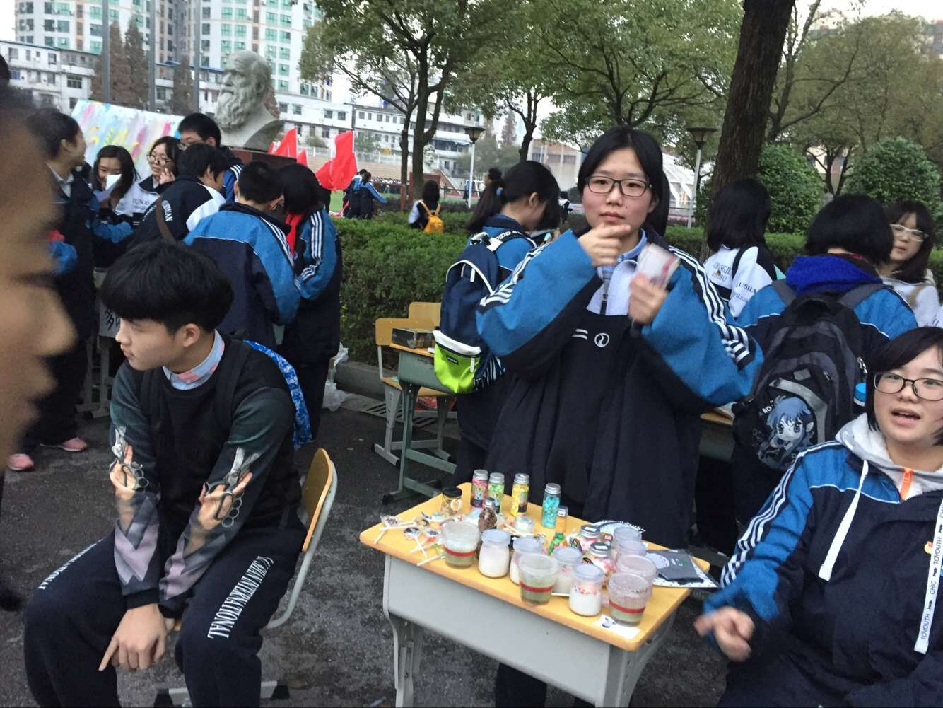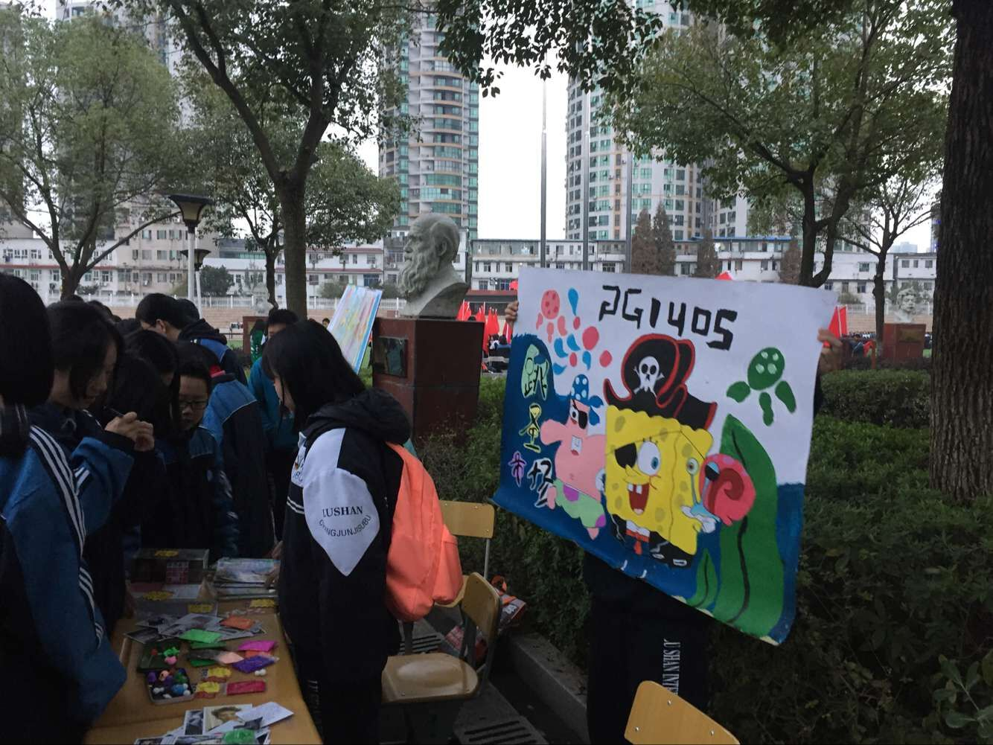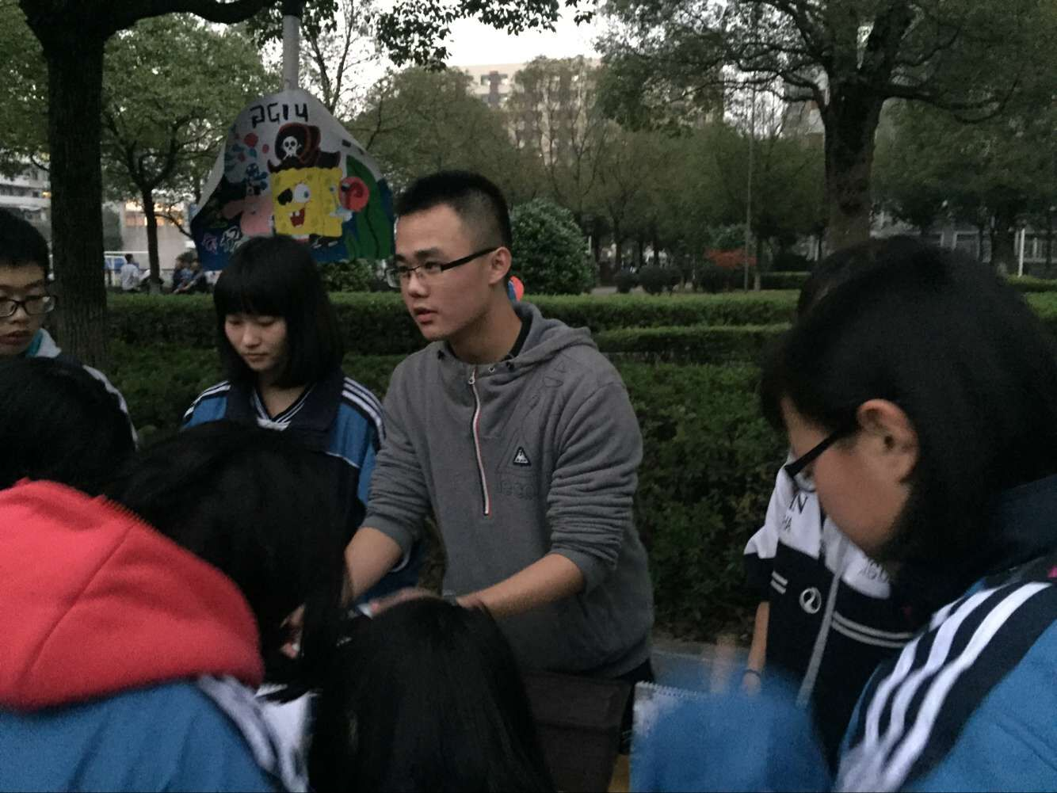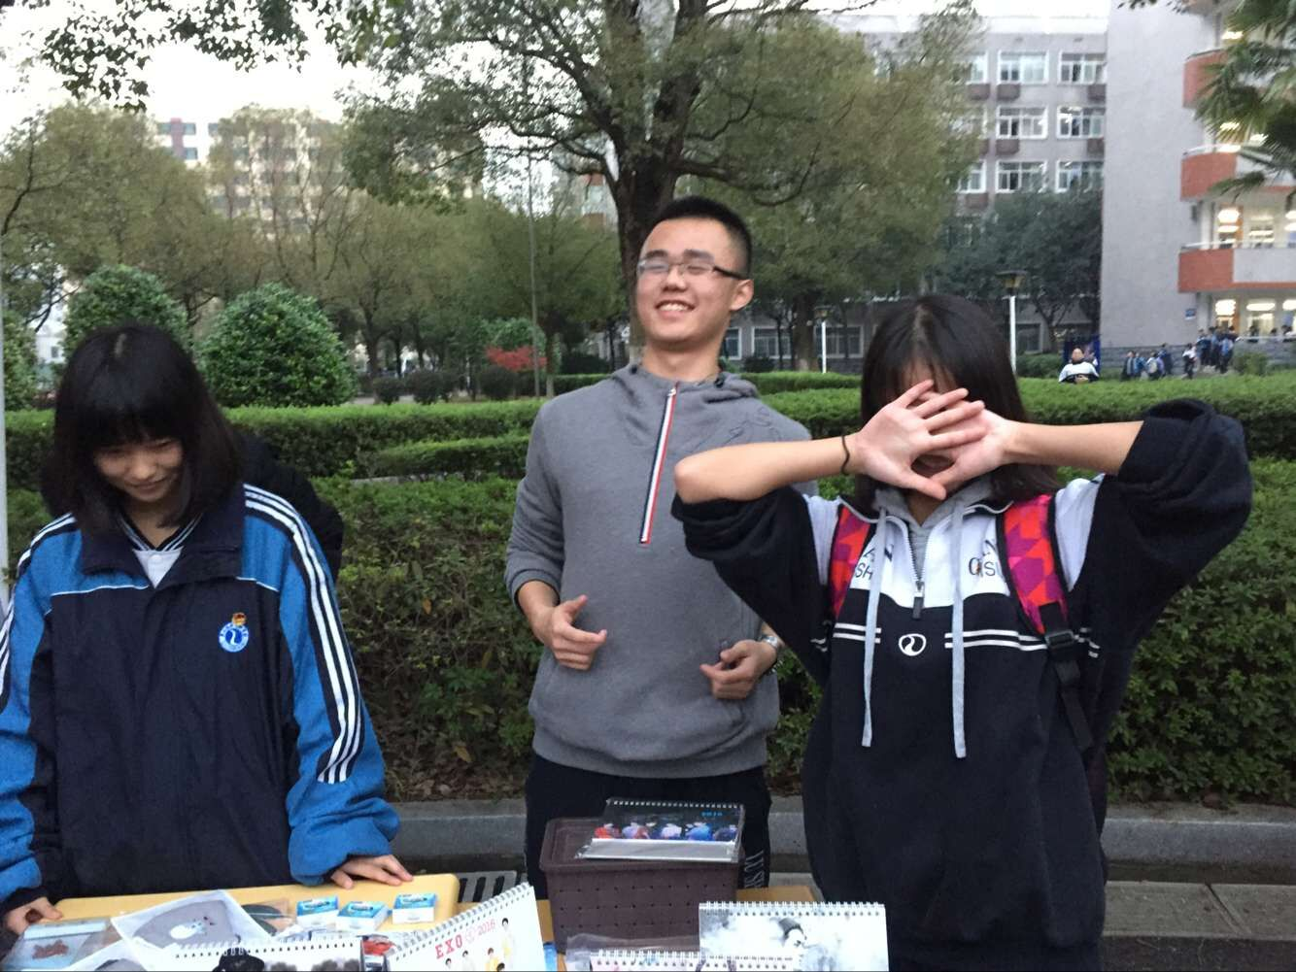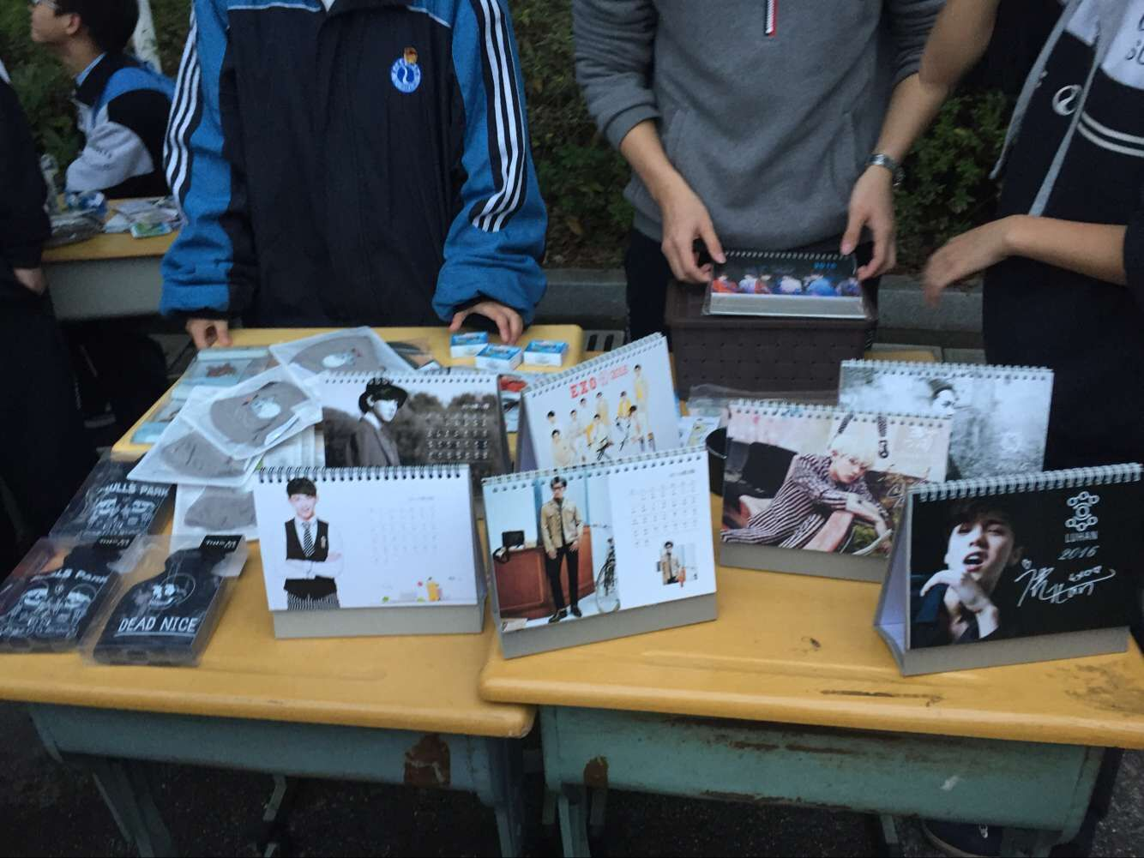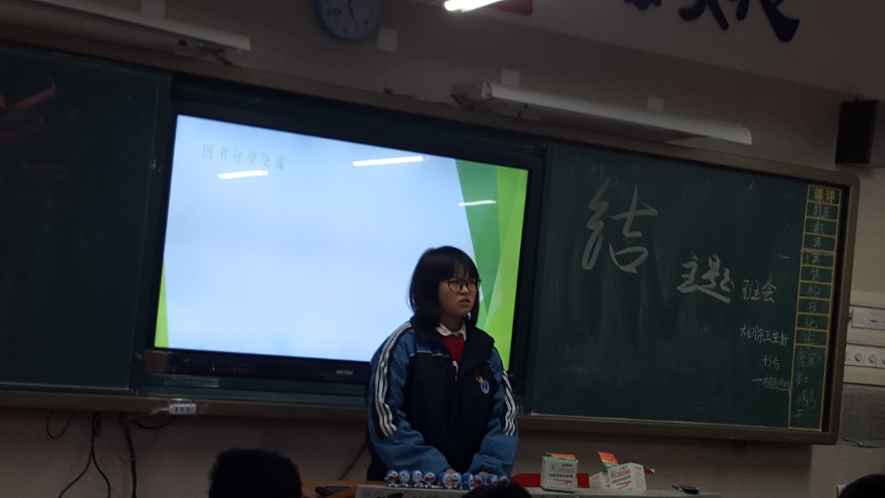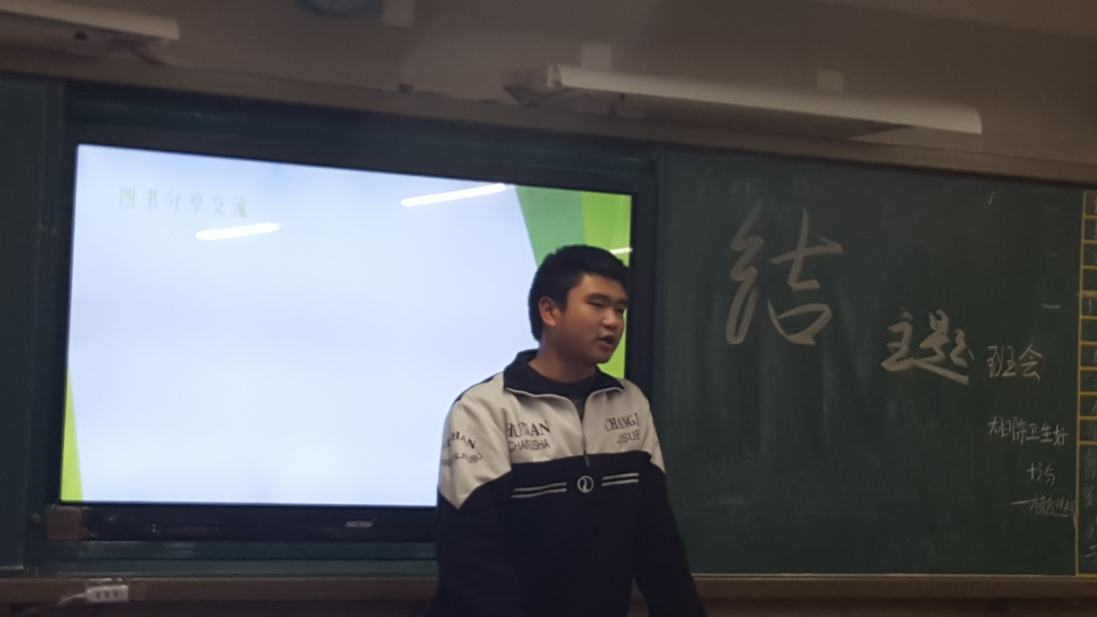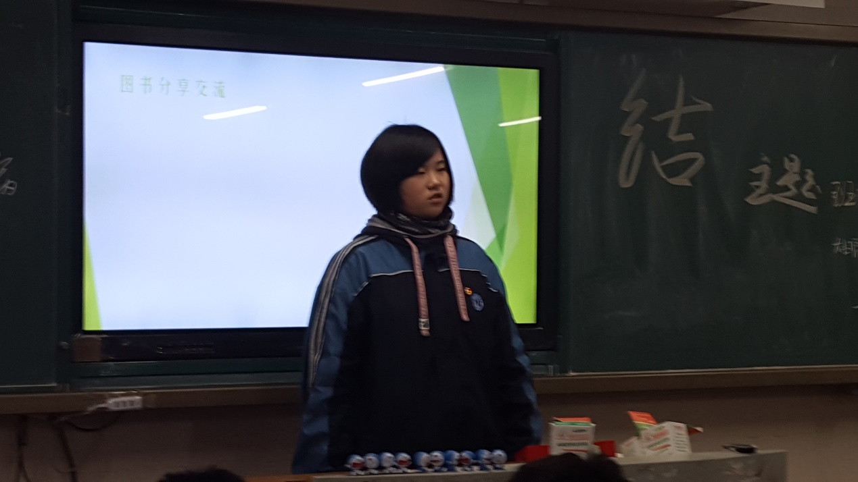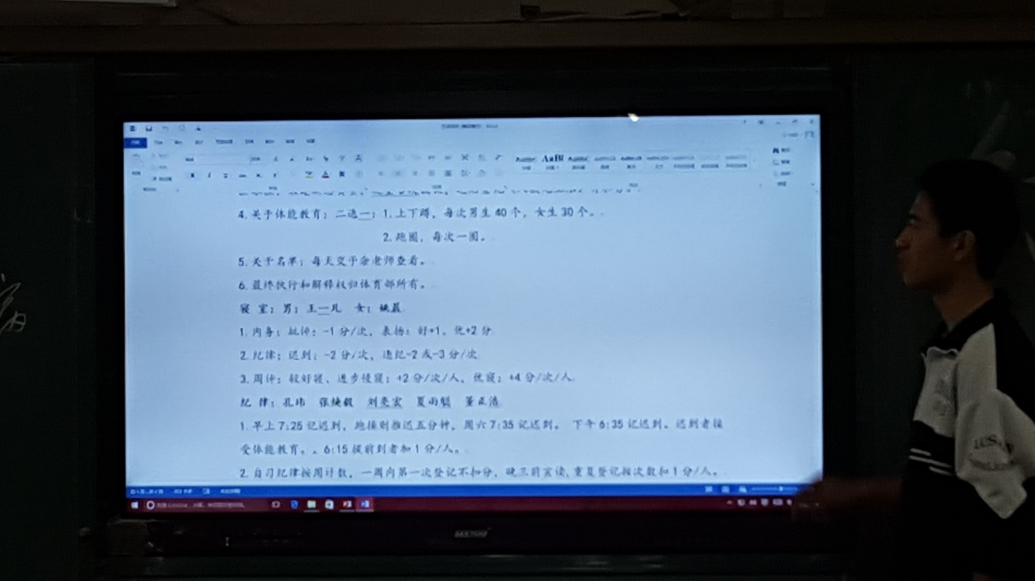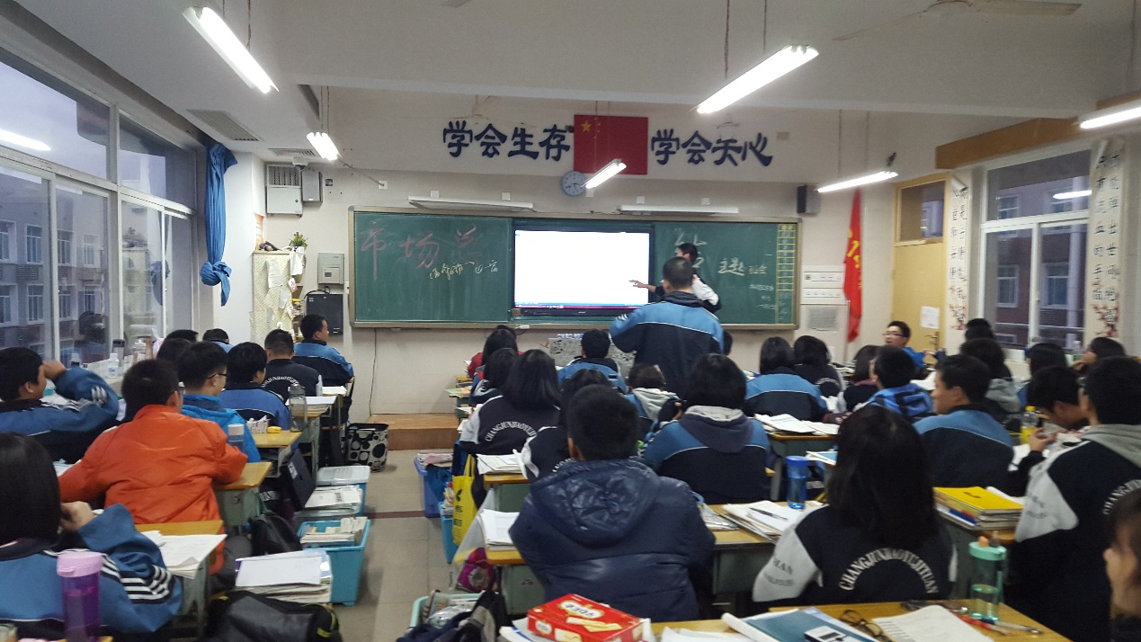

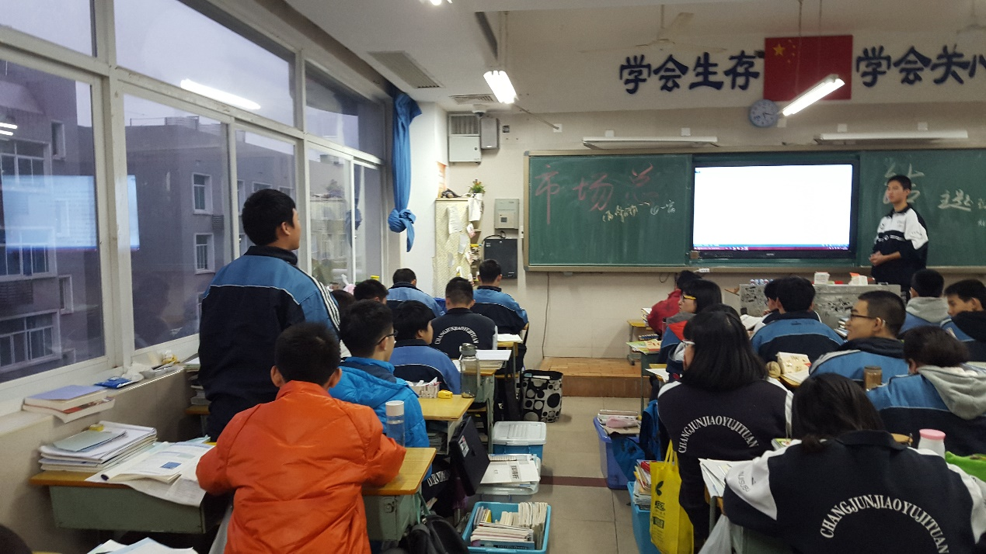

1. **学习总结**

**数学:表扬:刘雨祺,杨绍金林,宋建新,贺子亮，余果,李晶,董正浩,刘亮宏,黄源祺**

# 温馨提示

**交手机及留校生名单**

|  |  |  |  |  |  |  |  |
| --- | --- | --- | --- | --- | --- | --- | --- |
| 学号 | 姓名 | 交手机 | 留校生 | 学号 | 姓名 | 交手机 | 留校生 |
| 1 | 谭廷江 |  |  | 33 | 龙昭 |  |  |
| 2 | 何顺 |  |  | 34 | 黄扬基 | 1 |  |
| 3 | 何泽洋 | 1 |  | 35 | 宋建新 |  |  |
| 4 | 梁宇智 |  |  | 36 | 姜越 |  |  |
| 5 | 郭志文 | 1 |  | 37 | 熊亚军 |  |  |
| 6 | 张恬铭 |  |  | 38 | 钟梓鸣 | 1 |  |
| 7 | 袁民智 |  | 1 | 39 | 吴劼远 | 1 |  |
| 8 | 王一凡 |  |  | 40 | 李彬迪 |  |  |
| 9 | 李子璐 |  |  | 41 | 王清荷 |  | 1 |
| 10 | 谢志浩 | 1 |  | 42 | 莫依颖 |  |  |
| 11 | 孔玮 | 1 |  | 43 | 李思云 |  | 1 |
| 12 | 阎逸 |  |  | 44 | 张玮彤 | 1 |  |
| 13 | 何孟宇 | 1 | 1 | 45 | 毛燕菲 | 1 |  |
| 14 | 欧阳铭 |  |  | 46 | 李敏静 |  |  |
| 15 | 佘科宇 | 1 |  | 47 | 白芳雯 |  |  |
| 16 | 陈俊廷 | 1 |  | 48 | 许薇梓 |  |  |
| 17 | 张焕毅 |  |  | 49 | 罗依柳 |  |  |
| 18 | 黄智 | 1 | 1 | 50 | 舒晴 | 1 |  |
| 19 | 蒋少康 |  |  | 51 | 陈乐鹏 | 1 | 1 |
| 20 | 李岩松 |  |  | 52 | 丁文瑾 | 1 |  |
| 21 | 徐梓轶 |  | 1 | 53 | 刘亦迅 |  |  |
| 22 | 朱宇轩 |  |  | 54 | 雷佳欣 |  |  |
| 23 | 谭毅 |  |  | 55 | 姚晨 | 1 |  |
| 24 | 董正浩 |  |  | 56 | 李璇 |  |  |
| 25 | 刘亮宏 |  |  | 57 | 李钰涵 |  |  |
| 26 | 王豪捷 |  |  | 58 | 张缤尹 |  | 1 |
| 27 | 周志宇 | 1 |  | 59 | 曹茜媛 | 1 | 1 |
| 28 | 刘雨祺 |  |  | 60 | 余果 |  | 1 |
| 29 | 张宇东 |  |  | 61 | 夏雨聪 |  |  |
| 30 | 李晶 | 1 |  | 62 | 黄源祺 |  |  |
| 31 | 贺子亮 | 1 |  | 63 | 尹琦钰 |  |  |
| 32 | 杨邵金林 |  |  | 64 | 罗悦菲_ |  |  |

**作业**

* 语文：试卷+片段
* 数学：无
* 英语：17期报纸，套题部分
* 物理：试卷
* 化学：分层训练
* 生物：试卷