An Anti-forgetting Transfer Learning Method for Cross-power Fault Diagnosis Based on Knowledge Distillation
PHM conference paper draft (English version)

Abstract
In practical prognostics and health management (PHM), rotating machinery frequently operates under different power or load conditions, which induces remarkable distribution shifts in vibration signals. Deep fault diagnosis models trained under a single condition therefore suffer from severe performance degradation when deployed in a new power domain. Transfer learning and domain adaptation can improve the target-domain accuracy, but standard fine-tuning usually causes catastrophic forgetting, where the model quickly loses its diagnostic ability on the source domain. To address this problem, this paper proposes an anti-forgetting transfer learning framework for cross-power bearing fault diagnosis. A dual-stream CrossViT network is first constructed to fuse temporal vibration signals and time-frequency spectrograms. The model is pretrained on the labeled 1.0 kW source domain and then adapted to the 3.0 kW target domain with a teacher-student strategy. Knowledge distillation and Learning without Forgetting (LWF) replay are introduced to preserve source-domain knowledge during target adaptation. Furthermore, EWC, DANN, MMD and pseudo-labeling are compared as ablation methods. A Balance Score is designed to jointly evaluate source-domain retention and target-domain transfer accuracy. Experiments show that knowledge distillation with T=1.8 and alpha=0.3 achieves the best trade-off, with 60.0% source retention, 70.0% target accuracy and a Balance Score of 80.0, substantially alleviating forgetting compared with standard fine-tuning.
Keywords: PHM; fault diagnosis; transfer learning; catastrophic forgetting; knowledge distillation; continual learning; domain adaptation

1. Introduction
Prognostics and health management aims to detect incipient faults, assess health conditions and support maintenance decisions before catastrophic failures occur. Bearings are critical components in rotating machinery, and their vibration signals contain informative impulses, modulation patterns and fault-related frequency bands. Deep learning models, including convolutional neural networks, residual networks and transformers, have been widely studied for end-to-end bearing fault diagnosis because they can learn discriminative features directly from raw signals or time-frequency representations.
Most supervised deep diagnosis methods implicitly assume that training and testing data follow the same or similar distributions. In real PHM scenarios, however, machines work under varying power, speed, load and sensor conditions. Such changes lead to domain shifts between the source and target domains. In a cross-power bearing diagnosis task, for example, a model trained at 1.0 kW may fail when directly tested at 3.0 kW, indicating that single-domain supervised learning is insufficient for industrial deployment.
Transfer learning provides a natural solution by reusing fault knowledge learned from a labeled source domain and adapting it to a new target domain with limited annotations or unlabeled samples. Existing studies mainly rely on feature distribution alignment, adversarial learning, pseudo-labeling and multi-modal feature fusion. MMD-based methods minimize statistical distances between domains, DANN-based methods learn domain-invariant features through a domain discriminator and a gradient reversal layer, and attention-based networks further enhance local-global feature representation.
However, target-domain accuracy is not the only requirement in industrial PHM. A machine may switch between multiple power conditions during its life cycle, so the source-domain diagnosis ability remains valuable after adaptation. Standard fine-tuning can improve the target-domain accuracy but may erase the previously learned source-domain knowledge, resulting in catastrophic forgetting. Continual learning strategies such as knowledge distillation, EWC and replay have been studied in other fields, but their effectiveness for cross-power fault diagnosis has not been systematically evaluated.
This paper studies the dual objective of target-domain adaptation and source-domain retention. The main contributions are threefold. First, an anti-forgetting transfer framework based on a dual-stream CrossViT and knowledge distillation is proposed for cross-power fault diagnosis. Second, KD, LWF, EWC, DANN, MMD and pseudo-labeling are compared under a unified experimental setting to reveal their target-forgetting trade-offs. Third, a Balance Score is introduced to evaluate both target accuracy and source retention, and attention-based activation visualization is used to interpret the learned fault-sensitive regions.

2. Related Work and Background

2.1 Deep Learning for Fault Diagnosis
Traditional data-driven PHM pipelines include data acquisition, feature engineering, model training and performance evaluation. Deep learning reduces the dependence on handcrafted features by learning hierarchical representations from raw signals. CNNs are effective for local impulse and frequency-band patterns, ResNets improve the training of deeper networks, and transformers capture long-range dependencies via self-attention. For bearing signals, temporal branches preserve impact periodicity and amplitude variations, while spectral branches highlight fault-related frequency components. Combining both modalities is beneficial under complex operating conditions.

2.2 Transfer Learning and Domain Adaptation
Let Ds={(x_i^s,y_i^s)} be the source domain and Dt={(x_j^t,y_j^t)} or Du^t={x_j^t} be the target domain. When P_s(x,y) differs from P_t(x,y), a source-trained model h_s usually generalizes poorly to the target domain. Domain adaptation aims to learn a feature extractor f such that f(x^s) and f(x^t) are aligned in the latent space while retaining class discriminability. MMD and MK-MMD align distributions through kernel mean embeddings, DANN learns domain-invariant features with adversarial training, and pseudo-labeling uses high-confidence target predictions as additional supervision.
L_DA = L_cls + lambda_mmd * MMD(f(X_s), f(X_t)) + lambda_adv * L_adv

2.3 Continual Learning and Knowledge Distillation
Continual learning focuses on preserving old knowledge when a model learns new tasks or domains. EWC estimates parameter importance with the Fisher information matrix and penalizes the drift of important source-domain parameters. Learning without Forgetting uses the output distribution of a teacher model to constrain the student model during adaptation. Replay mixes a small number of source-domain samples into target-domain training. Knowledge distillation is computationally simple and stable, making it suitable for small-sample industrial diagnosis.
L_KD = T^2 * KL( softmax(z_teacher/T) || softmax(z_student/T) )

3. Proposed Method

3.1 Overall Framework
The proposed framework follows a closed loop of source pretraining, teacher preservation, target adaptation, anti-forgetting regularization and dual-objective evaluation. Each input sample contains a three-channel temporal signal x_timeinR^(1024×3) and a three-channel STFT spectrogram x_specinR^(3×128×128). A dual-stream CrossViT encodes the two modalities and fuses them with cross-modal attention before classification.
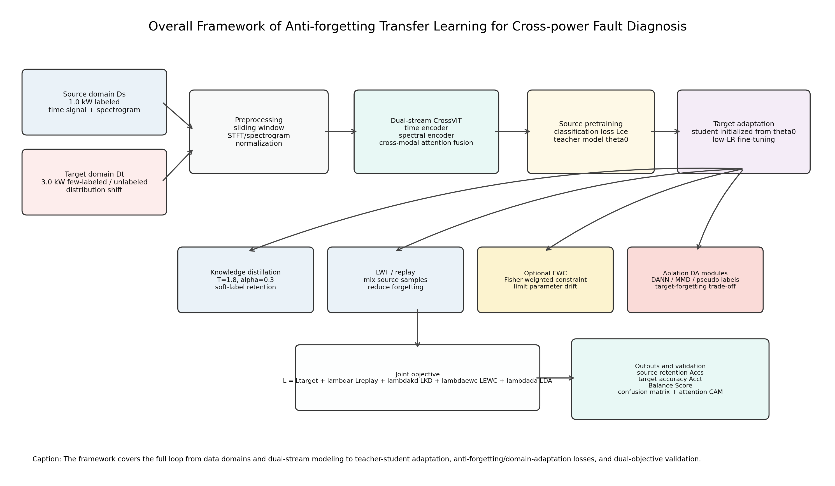
Fig. 1. Overall framework of the proposed anti-forgetting transfer learning method.

3.2 Dual-stream CrossViT Backbone
The backbone consists of a temporal encoder, a spectral encoder, a cross-modal attention fusion module and a classifier. The temporal encoder captures local impacts, periodic modulation and multi-sensor correlations. The spectral encoder captures fault frequency bands and energy changes. The fusion module models complementary relations between the two modalities. The model output is formulated as
z_t = E_t(x_time), z_f = E_f(x_spec), z = Fusion([z_t,z_f]), p = softmax(C(z)).
During source pretraining, the model is optimized with cross-entropy on Ds to obtain theta0. A frozen copy of theta0 is used as the teacher during target adaptation.

3.3 Anti-forgetting Target Adaptation
The student model is initialized from theta0. With few labeled target samples, the target cross-entropy loss improves the new-domain classification ability. Meanwhile, the teacher output distribution and replayed source samples constrain the student to preserve source-domain knowledge. The main objective is
L = L_CE^t + lambda_r L_CE^s + lambda_kd L_KD, L_KD = T^2 KL(p_teacher^T || p_student^T).
Here, T is the temperature, lambda_kd controls the strength of the distillation term, and lambda_r controls the replay contribution. EWC, DANN, MMD and pseudo-labeling are further used as ablation modules.

3.4 Training Algorithm
Algorithm 1 Anti-forgetting cross-power transfer diagnosis
Input: Source data Ds, target data Dt/Du, model Ftheta, temperature T, distillation weight lambdakd, replay ratio r
Output: Adapted model Ftheta and predictions on the target domain
1: Preprocess signals: construct time windows and STFT spectrograms
2: Train Ftheta on Ds with cross-entropy; save the source parameters theta0
3: Freeze a copy Ftheta0 as the teacher model
4: Initialize the student with theta ← theta0
5: for each adaptation epoch do
6: Sample a target mini-batch Bt and a replay source mini-batch Bs
7: Compute the target supervised loss L_CE^t when labels are available
8: Compute the replay source loss L_CE^s on Bs
9: Obtain teacher logits z0 and student logits z
10: Compute L_KD = T^2 KL(softmax(z0/T), softmax(z/T))
11: Optionally compute EWC, MMD, DANN or pseudo-label losses for ablation
12: Update theta by minimizing L = L_CE^t + lambdar L_CE^s + lambdakd L_KD + optional losses
13: end for
14: Evaluate Accs, Acct, Balance Score, confusion matrices and attention activation maps

4. Experimental Setup

4.1 Dataset and Task
The experiment is conducted on a cross-power bearing fault diagnosis task. The source domain is collected at 1.0 kW and the target domain at 3.0 kW. Each domain contains 394 samples. Each sample includes a temporal vibration signal and a spectrogram. Ten classes are considered, including normal condition and bearing faults with different locations and severities.
Domain | Samples | Temporal input | Spectrogram input | Classes | Usage
Source 1.0 kW | 394 | (1024, 3) | (3, 128, 128) | 10 | pretraining, replay, source retention evaluation
Target 3.0 kW | 394 | (1024, 3) | (3, 128, 128) | 10 | fine-tuning/adaptation and target evaluation

4.2 Baselines and Ablations
The compared methods include single-domain training, cross-domain testing without adaptation, standard fine-tuning, layer freezing, EWC, KD+LWF, DANN, MMD, pseudo-labeling and KD+pseudo-labeling. The ablation study focuses on three questions: whether anti-forgetting constraints are necessary, how the distillation temperature affects the balance, and whether domain adaptation sacrifices source retention.
Group | Mechanism | Expected effect | Potential risk
Fine-tuning | target cross-entropy | fast target adaptation | severe source forgetting
EWC | Fisher-weighted parameter constraint | limit important parameter drift | over-regularization
KD+LWF | teacher soft labels and replay | balance transfer and retention | sensitive temperature and weights
DANN/MMD | adversarial/statistical alignment | learn domain-invariant features | may remove power-related diagnostic cues
Pseudo-labeling | high-confidence target self-training | use unlabeled target data | noisy labels under large shifts

4.3 Metrics
Both target accuracy Acct and source retention Accs are reported. To reflect the dual objective of industrial deployment, the Balance Score is defined as
Balance = Acc_t + 0.5 * max(0, min(Acc_s − 40, 20)).
This metric uses the target accuracy as the base score and adds a bounded reward when the source retention is higher than 40%.

5. Results and Analysis

5.1 Verification of Domain Shift
The single-domain baseline reaches about 90.0% average test accuracy on the 1.0 kW source domain, indicating that the dual-stream CrossViT is effective for in-domain diagnosis. However, when the source-trained model is directly tested on the 3.0 kW target domain, the target accuracy drops to 10.0%, demonstrating a severe cross-power distribution shift.

5.2 Ablation Results
Experiment / configuration | Accs | Acct | Balance | Observation
EXP1 single-domain baseline | 90.0% | - | - | effective backbone
EXP2 no adaptation | 85.0% | 10.0% | - | severe domain shift
EXP3 V3 standard fine-tuning | 17.5% | 77.5% | 77.5 | high target accuracy but severe forgetting
EXP3 V3 KD+LWF (T=2) | 77.5% | 65.0% | 75.0 | best source retention
EXP3 V4 KD (T=1.8, alpha=0.3) | 60.0% | 70.0% | 80.0 | best overall trade-off
Representative DANN/MMD | <=12.5% | 72.5–75.0% | 65.0–75.0 | good target performance but strong forgetting
Pseudo-labeling | 70–85% | 7.5% | 17.5 | failed target adaptation

Standard fine-tuning achieves high target accuracy but reduces the source accuracy to 17.5%, which is unsuitable for multi-condition deployment. KD+LWF substantially improves source retention with a moderate loss of target performance. The configuration T=1.8 and alpha=0.3 achieves the best Balance Score. DANN and MMD improve target performance but severely forget the source domain, suggesting that aggressively learning domain-invariant features may remove power-related diagnostic information. Pseudo-labeling fails in this task due to low-confidence or noisy target predictions under large domain shifts.

5.3 Attention-based Activation Visualization
For interpretability, transformer attention weights can be stored and projected back to temporal windows and spectrogram regions by attention rollout or Grad-CAM. If the model focuses on impact intervals, fault frequency bands and modulation sidebands, the learned representation is consistent with mechanical fault mechanisms. If the activation concentrates on irrelevant noise regions, the model may overfit domain-specific noise.
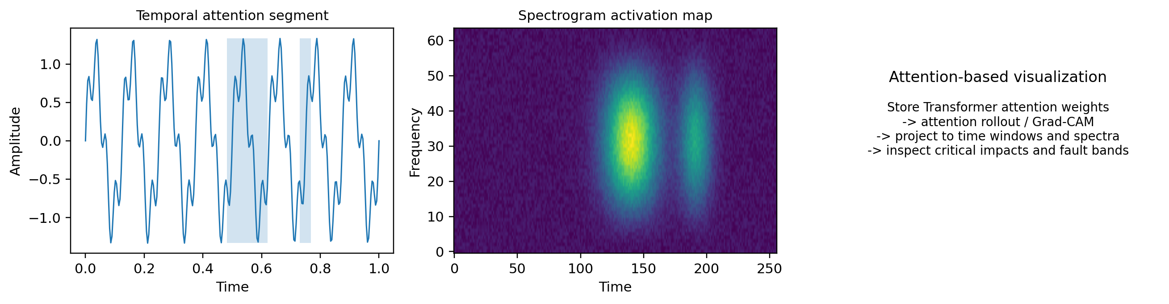
Fig. 2. Illustration of attention-based activation visualization.

6. Discussion
The proposed method inherits ideas from transfer learning, domain adaptation and continual learning rather than claiming a completely new backbone module. Its contribution lies in integrating these ideas into a PHM-oriented cross-power diagnosis framework and converting the evaluation from a target-only objective into a dual objective of target adaptation and source retention. The results suggest that knowledge distillation is more stable than pure domain alignment when source-domain knowledge must be preserved.
The results also indicate that not all domain differences should be fully removed in mechanical diagnosis. Power-induced vibration energy changes may contain both operating-condition information and fault-discriminative cues. Overly strong domain-invariant constraints may therefore damage the old-domain representation. In practice, DANN/MMD can be used when only the new domain matters, while KD and replay are preferable for multi-power continuous deployment.

7. Conclusion
This paper proposes a knowledge-distillation-based anti-forgetting transfer learning framework for cross-power fault diagnosis. Based on a dual-stream CrossViT backbone, temporal signals and spectrograms are fused for fault representation. A source-domain teacher, a target-domain student, knowledge distillation and LWF replay are used to achieve target adaptation while retaining source knowledge. Experiments show that the distillation configuration with T=1.8 and alpha=0.3 achieves the best Balance Score and outperforms standard fine-tuning, EWC, DANN, MMD and pseudo-labeling in the dual-objective evaluation. Future work will extend the framework to multi-power continual transfer, fully unlabeled target adaptation and physics-guided interpretability.

References
[1] Y. Zhang and Y. F. Li, “Prognostics and health management of Lithium-ion battery using deep learning methods: A review,” Renewable and Sustainable Energy Reviews, 2022.
[2] H. Wang, Y. F. Li, and Y. Zhang, “Bioinspired spiking spatiotemporal attention framework for lithium-ion batteries state-of-health estimation,” Renewable and Sustainable Energy Reviews, 2023.
[3] T. Han and Y. F. Li, “Out-of-distribution detection-assisted trustworthy machinery fault diagnosis approach with uncertainty-aware deep ensembles,” Reliability Engineering & System Safety, 2022.
[4] T. Han, Y. F. Li, and M. Qian, “A hybrid generalization network for intelligent fault diagnosis of rotating machinery under unseen working conditions,” IEEE Transactions on Instrumentation and Measurement, 2021.
[5] H. Wang, C. Li, and Y. F. Li, “Large-scale visual language model boosted by contrast domain adaptation for intelligent industrial visual monitoring,” IEEE Transactions on Industrial Informatics, 2024.
[6] X. Yu et al., “An adaptive domain adaptation method for rolling bearings fault diagnosis fusing deep convolution and self-attention networks,” IEEE Transactions on Instrumentation and Measurement, 2023.
[7] Y. Xiao et al., “Novel joint transfer network for unsupervised bearing fault diagnosis from simulation domain to experimental domain,” IEEE/ASME Transactions on Mechatronics, 2022.
[8] H. Wang, Y. F. Li, and J. Ren, “Machine learning for fault diagnosis of high-speed train traction systems: A review,” Frontiers of Engineering Management, 2024.

