BIOS For TF Website Team Page

Directions:
- Convert each photo into a line drawing with AI.
  - Similar to the Lynne example.
  - Do a close crop on the faces - again like Lynne’s photos
- Underneath each person include a one liner (like you have it in the mock-up website)
- When users hover over the one-liner their full bio pops up in a pop-up box.
- LinkedIn symbol below each linking to person’s LinkedIn page.



Content:

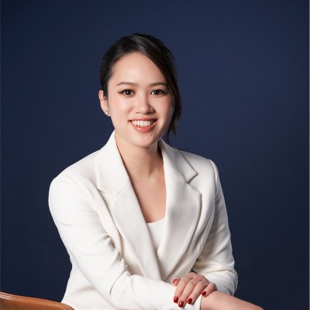

Serena Wei | Cofounder

Bringing vision, strategy, and compassion to lead and scale the business.
https://www.linkedin.com/in/serra-angel-wei-63118216/

Full bio for pop up:

Serra’s entrepreneurship journey started when she was approached by a VC and given millions to start Aegis Trust, a SEC qualified custodian while she was investing at a San Francisco-based fund. Before that, she worked at Goldman Sachs and got her MBA from Stanford Business School.
Serra founded Digital Asset Clearing Center, which provides seamless connections to the world's leading payment systems, blockchain networks, and compliance infrastructure delivering end-to-end Clearing-as-a-Service (CaaS) for financial institutions. To align her vision, she took a partnership integration strategy and brought several publicly traded companies on the cap table. By truly listening to perspectives from people in Hong Kong, Chinese mainland and the globe, she navigates a nascent market with openhearted compassion, leading to new cooperation between parties for business growth and that benefits everyone.
At Tokenization Foundation, Serra integrates human values into technology infrastructure to embrace a more holistic vision of progress that honors the complexities of our shared humanity. Her ability to use resources to heal, uplift, and meet the urgent challenges of our time uncovers new ways to drive systemic change and contribute to the collective good.

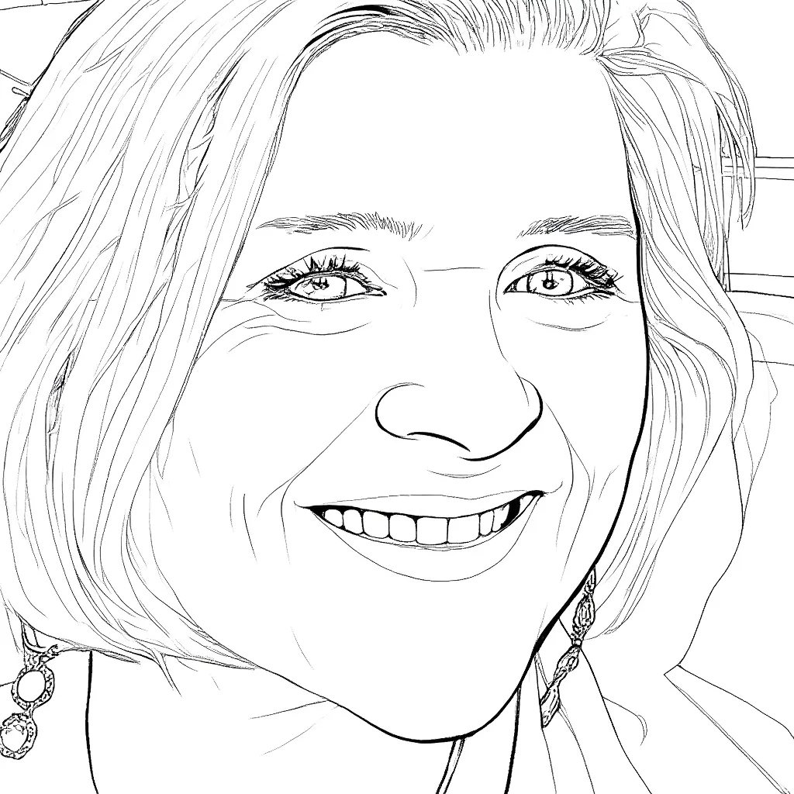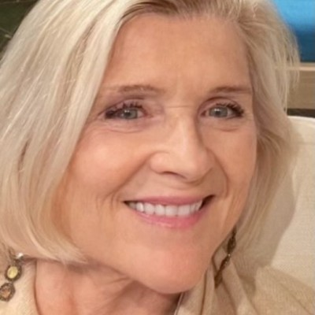

Lynne Marlor | Cofounder

Driving capital strategy, financial structuring, and investor relationships to create ecosystem value.
https://www.linkedin.com/in/lynne-marlor-23a741a/

Full bio for pop up:
Lynne Marlor is a capital markets, fintech, and asset management expert who transitioned from traditional finance into blockchain and digital assets after completing the Oxford Blockchain Strategy Programme in 2018. She brings deep expertise across digital assets, AI, tokenization, and Web3, and has built leading industry platforms including the Women in Digital Assets® Forum and the Boston Blockchain Association.
Currently, Lynne serves on the boards of Aegis Trust, South Dakota, and the Digital Asset Clearing Centre, Hong Kong, and leads Transformational Strategies, LLC, advising financial institutions globally. She previously served as a Managing Director at BNY Mellon, overseeing non-bank financial services across capital markets infrastructure.
At the Tokenization Foundation, Lynne is redesigning the humanitarian aid infrastructure using AI, blockchain, and digital assets to address massive fragmentation, inefficiency, and delays in global crisis funding systems.
Connect on LinkedIn.

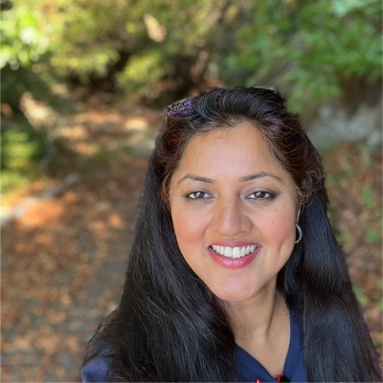

Anitha Vadavath | AI & Investor Relations
Driving ground-breaking AI, exceptional technologies, and tokenization.
https://www.linkedin.com/in/anivadavath/

Full Bio for pop up screen:
Driving AI, biotech, and exponential technologies and tokenization at the intersection of deeptech, capital, and global impact.
Anitha Vadavatha brings over 20+ years of deep and hyphenated career across technology, venture capital, financial services, and global affairs. She is Founder and Managing Partner of AB Plus Ventures and Misu Labs, investing and building at the convergence of AI, biotech, and next-generation markets. She currently serves as Venture Partner at Sync.vc and Republic, Senior Advisor at Popstar Ventures and Kudish Family Office.
Formerly a Partner at Urth Capital Advisors (Fund of Funds), a member of the Strategic advisory council of Shadow Ventures (Proptech VC), Managing Director of Emerging Star Capital, and an early and growth stage operator in two exited tech unicorns (EdCast, acquired, PartyGaming, IPO), her experience includes GE Capital, Big 4 payments/banking consulting, and advisory roles with AI, biotech and deeptech companies.
An alumna of Singularity University with executive education across global management and emerging markets, she was recognized as a “Top Ten Frontier Woman” by the UN–Fifth Element Group in partnership with Thomson Reuters and Morningstar. A global speaker and thought leader at 'Innovation, Science and Technology’ forums, she was an invited delegate at the UN SDG, UNGA, IMF and World Bank Annual Meeting, and Davos. She led the India China America Institute (a research think tank on emerging markets) and was an esteemed member of Andhra Pradesh (India) FinTech Core (an independent advisory to the state).
At the Tokenization Foundation, Anitha is designing groundbreaking AI humanitarian aid infrastructure (Precision and Practitioner Adaptive Intelligence, or PPAI) and accelerating strategic capital and stakeholder development, interfacing with capital, organizations, and participants who are moving capital and capability together.
https://www.linkedin.com/in/anivadavath

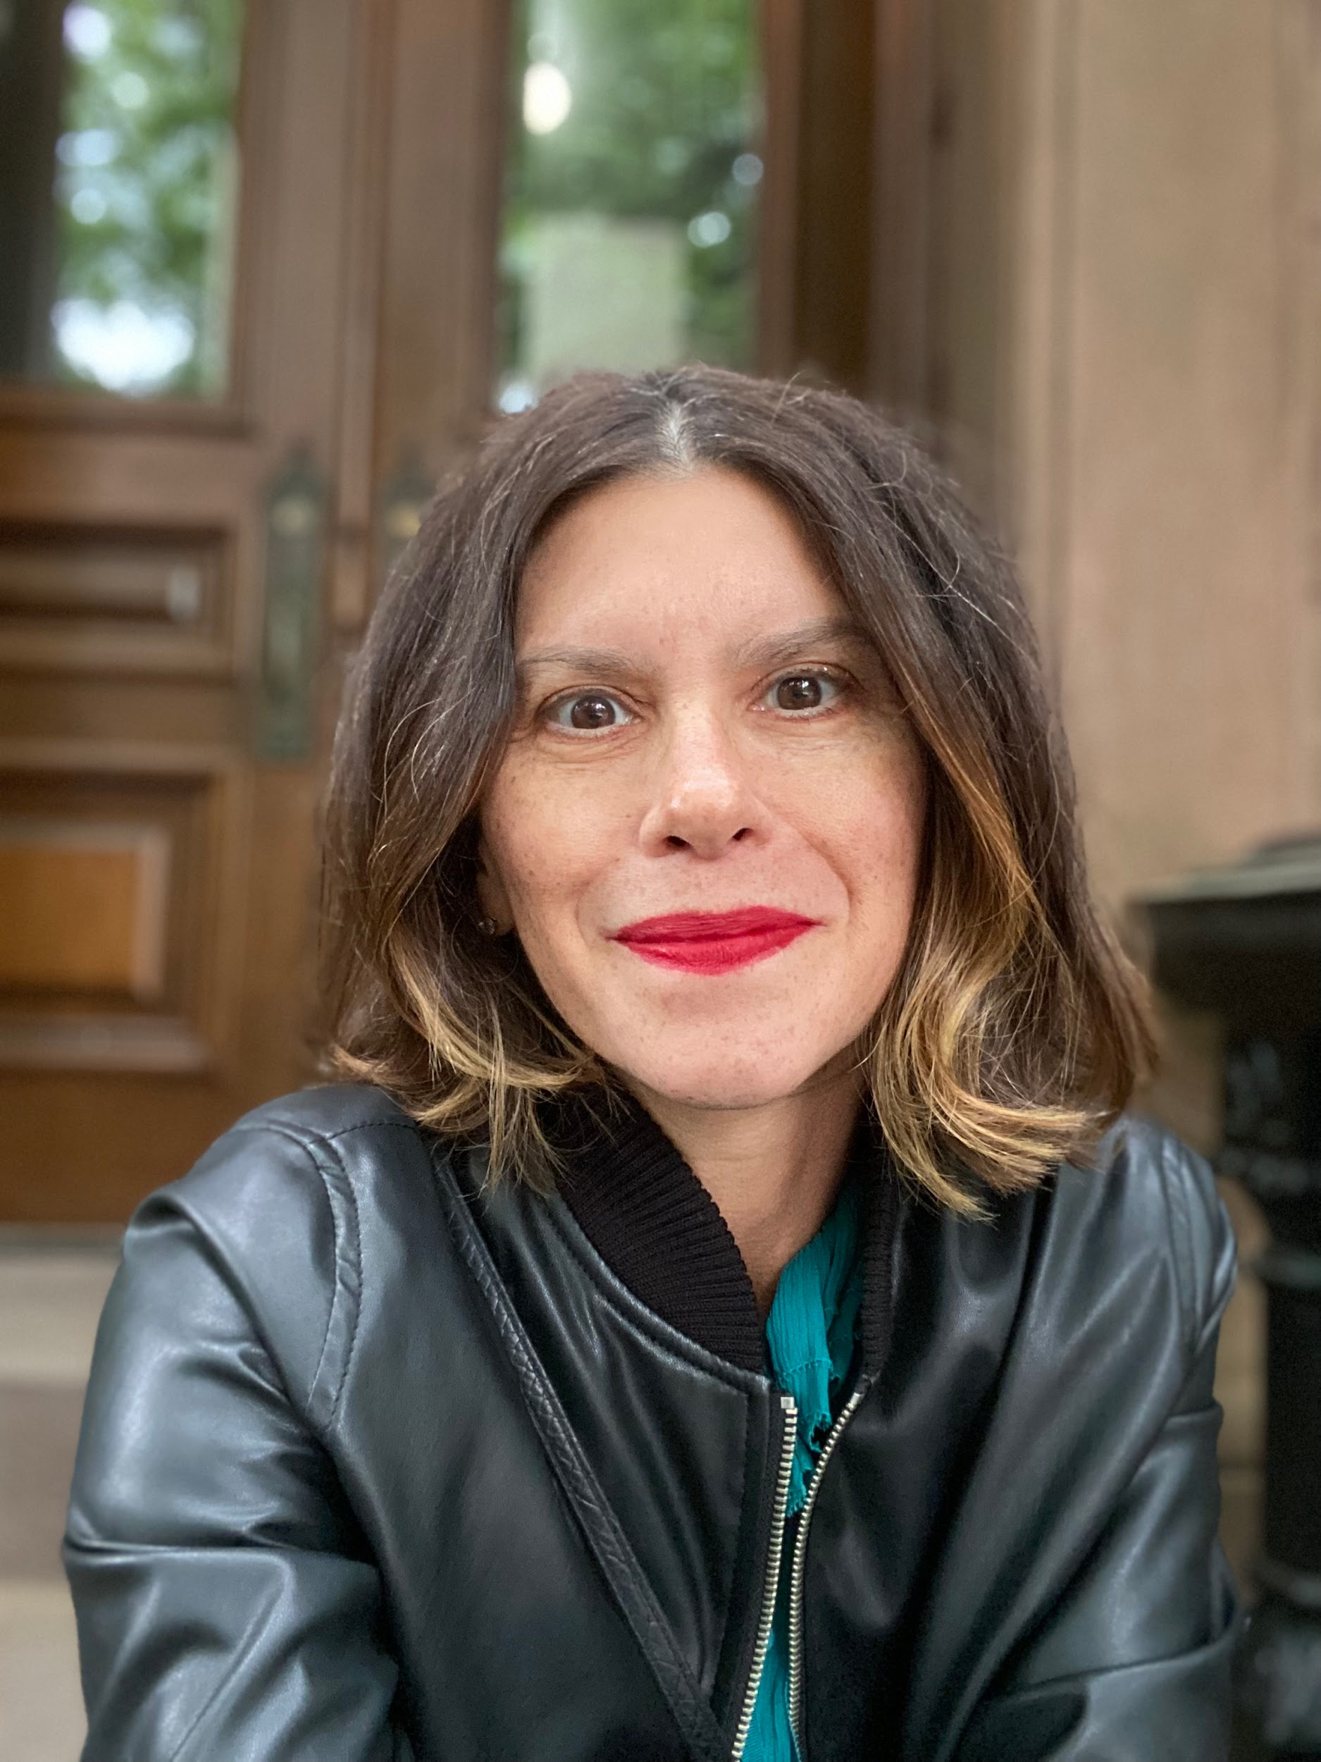

Kerstin Krall Walz | Marketing

Shaping strategy, building brand, and generating leads to accelerate awareness and engagement.
https://www.linkedin.com/in/kerstin-krall-walz-00066415b/
Full Bio for pop up screen:
Kerstin is a marketing executive with deep experience in brand building and digital assets focusing on building awareness and procuring qualified leads.
She spent the first part of her career at“Madison Avenue” agencies including Saatchi & Saatchi and Young & Rubicam, working across megabrands such as Campbell’s Soup Company, International Olympic Committee (IOC), The Star Alliance Network, Lufthansa Airlines, Smirnoff Vodka, and the United States Tennis Association/U.S. Open.
More recently, as Chief Marketing Officer at Digital Asset Research, Kerstin led global marketing strategy, positioning the firm as a leader in institutional-grade crypto data and driving partnerships with organizations such as FTSE Russell and Bloomberg. She has also contributed to strategic initiatives across the digital asset ecosystem, including work with Vigil Markets and Digital Ascension Group.
She brings a unique blend of brand strategy and growth execution, while translating complex cryptocurrency concepts into actionable insights for institutional audiences—including asset managers, custodians, index providers, hedge funds, and HNWIs.
At the Tokenization Foundation, Kerstin leads marketing to scale awareness and engagement for the world’s first crisis capital infrastructure—where capital flows automatically fund disaster response and humanitarian relief.
Connect on LinkedIn.

