|  |
| --- |
|  |
| The Documentation |
| [Type the document subtitle] |
|  |
| **[Your Name]** |
| **[Pick the date]** |

[Type the abstract of the document here. The abstract is typically a short summary of the contents of the document. Type the abstract of the document here. The abstract is typically a short summary of the contents of the document.]

Table of Contents

[To update the table of contents, right click the message below and select Update Field (F9 on PC, ⌥⌘U on Mac).]

**No table of contents entries found.**

1. Pages
   1. Page Tree

Home  
 my  
 login  
 register  
 edit  
 new  
 detail

* 1. Home
     1. User Interface

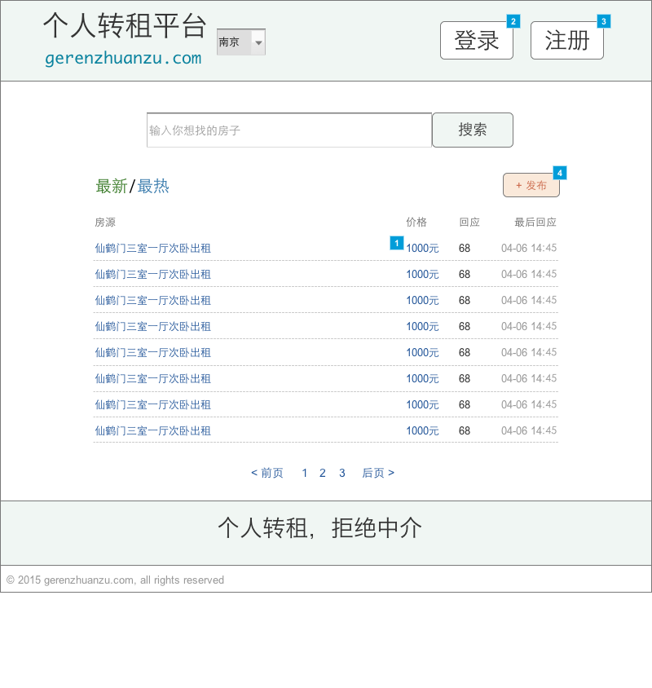

* + 1. Widget Table

| Footnote | Interactions |
| --- | --- |
| 1 | 鼠标单击时:  Case 1:  在 当前窗口 打开 detail |
| 2 | 鼠标单击时:  Case 1:  在 当前窗口 打开 login |
| 3 | 鼠标单击时:  Case 1:  在 当前窗口 打开 register |
| 4 | 鼠标单击时:  Case 1:  在 当前窗口 打开 new |

* 1. my
     1. User Interface

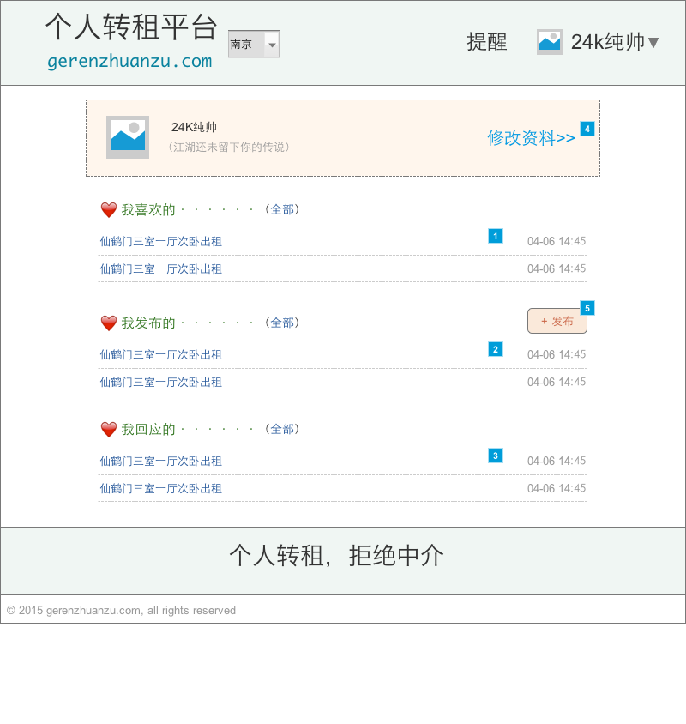

* + 1. Widget Table

| Footnote | Interactions |
| --- | --- |
| 1 | 鼠标单击时:  Case 1:  在 当前窗口 打开 detail |
| 2 | 鼠标单击时:  Case 1:  在 当前窗口 打开 detail |
| 3 | 鼠标单击时:  Case 1:  在 当前窗口 打开 detail |
| 4 | 鼠标单击时:  Case 1:  在 当前窗口 打开 edit |
| 5 | 鼠标单击时:  Case 1:  在 当前窗口 打开 new |

* 1. login
     1. User Interface

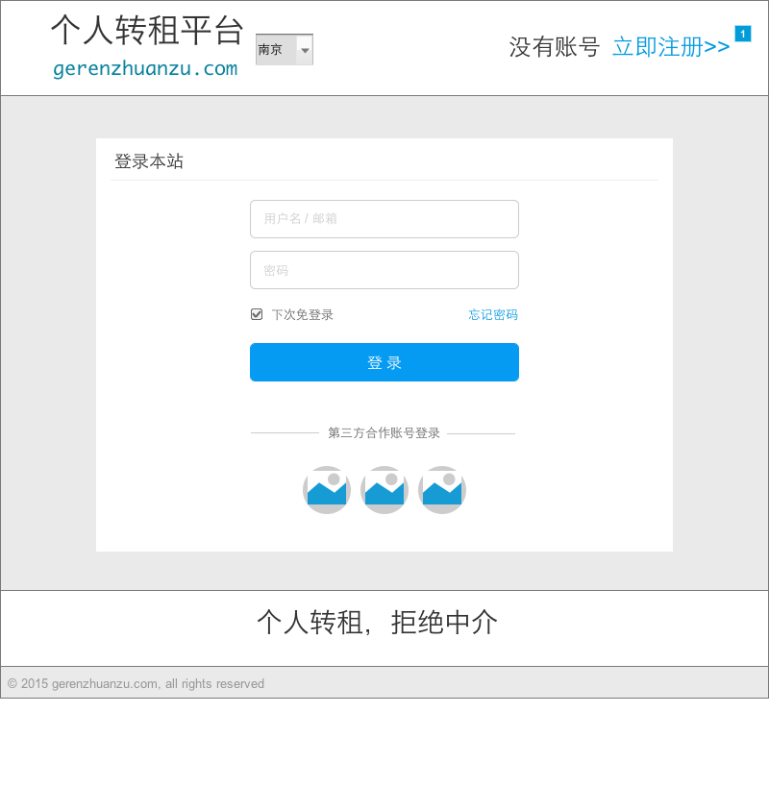

* + 1. Widget Table

| Footnote | Interactions |
| --- | --- |
| 1 | 鼠标单击时:  Case 1:  在 当前窗口 打开 register |

* 1. register
     1. User Interface

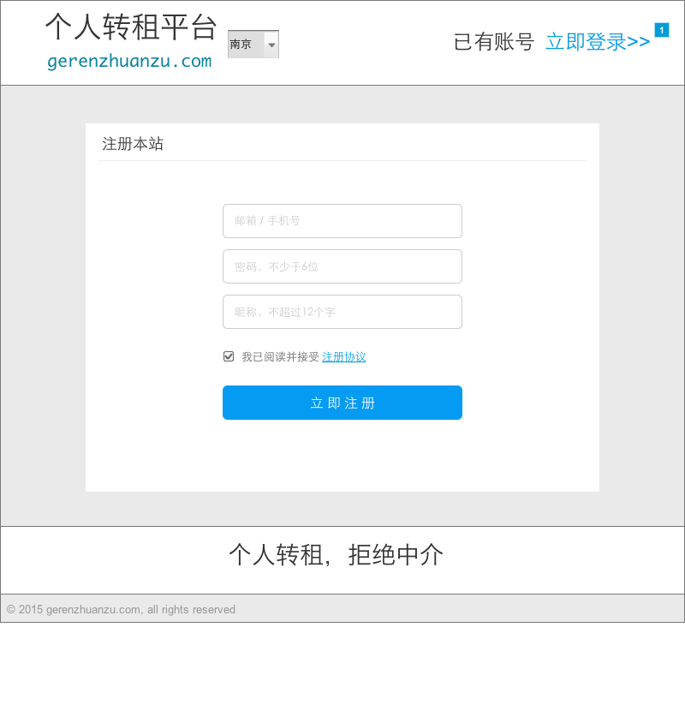

* + 1. Widget Table

| Footnote | Interactions |
| --- | --- |
| 1 | 鼠标单击时:  Case 1:  在 当前窗口 打开 login |

* 1. edit
     1. User Interface

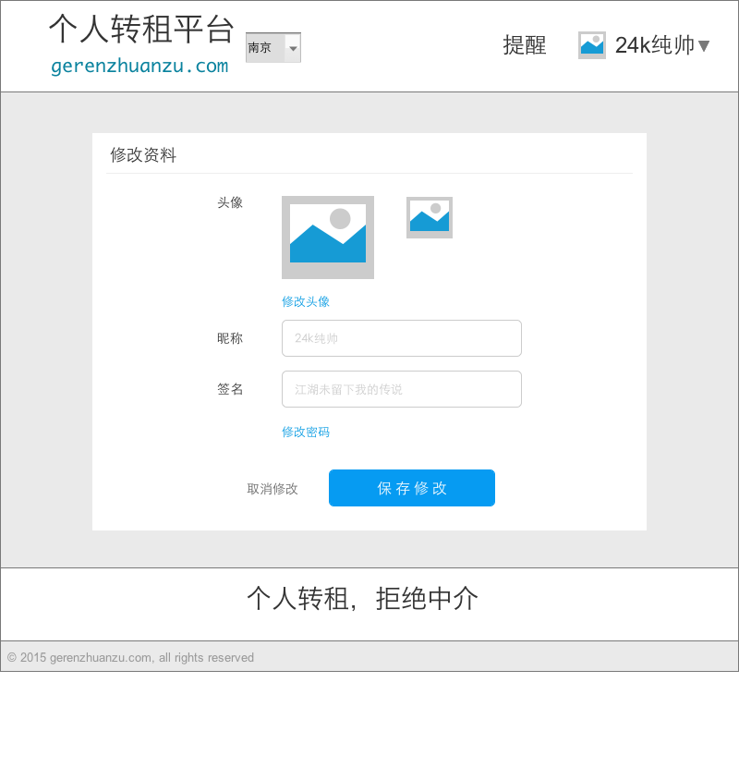

* 1. new
     1. User Interface

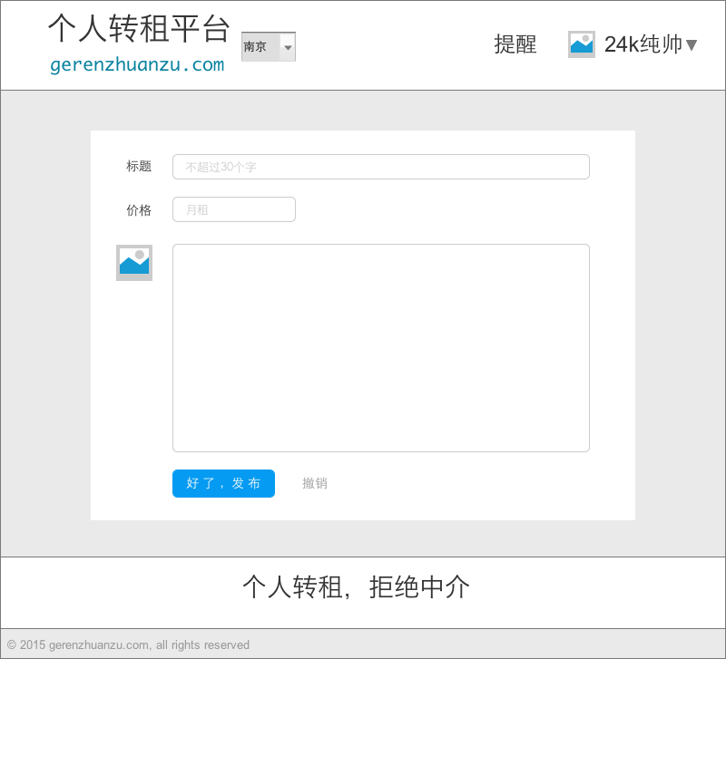

* 1. detail
     1. User Interface

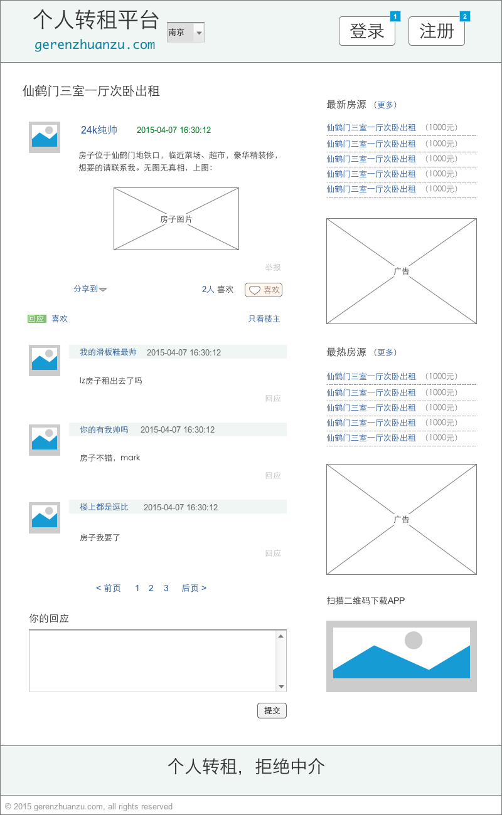

* + 1. Widget Table

| Footnote | Interactions |
| --- | --- |
| 1 | 鼠标单击时:  Case 1:  在 当前窗口 打开 login |
| 2 | 鼠标单击时:  Case 1:  在 当前窗口 打开 register |