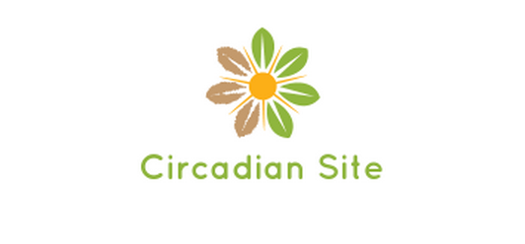

Have you ever wondered why some people sleep later or earlier than others or why your sleep times are seasonal? Did you know that even fungi make spores earlier or later than their relatives each day? Daily rhythms – from gene expression to behavior – are everywhere in nature and they form a web of rhythmic interactions. In this website offering, you will be taught about the science on daily or circadian clocks. We will discuss a variety of biological clock systems from bacteria to humans and will explain how circadian systems are organized and the many ways that circadian clocks control our lives.

Quick Links:

How circadian works?

What we know about the clock?

Animation

Test yourself

Diurnal tools

About the author:

The ability of an organism to measure time is the product of a cellular biological clock. My goal is to introduce and explain the mechanisms by which an organism measures time to general public, giving people more idea about what progress we are making recently.

UT Austin

Email: [huangty@utexas.edu](mailto:huangty@utexas.edu)

TienYu Huang 10/04/1015