Market Research on Experimenters of Recipes

# Goal:

Looking for users who would want to experiment with recipes

* ID dishes that encourage experimentation
  + Must be complex enough to require recipes
    - Good Example: Braised short-ribs
    - Bad Example: Pizza, most people don’t follow recipes.
  + Must require some level of precision
    - Good Example: Any baking good
    - Bad Example: Stir Fry.
  + ID dishes that have variations
    - Good: Ramen, there are so multiple types
    - Bad:
* There needs to be an active enough “market” to sustain UGC
  + Dish has high search volume
  + Dish has passionate followers

## Potential Survey Question:

Home cook?

What types of dishes do you like trying with new recipes for?

What types of recipes do you like experimenting with?

* Pasta Dish
  + Tomato based
  + Carbonara
* Chicken Dish
  + Chicken wings
  + Fried chicken
  + Chicken breast
* Alcoholic beverage
  + Margarita
* Ribs
  + Braised short ribs
  + BBQ Ribs
* Baking
  + Cupcakes
  + Cakes
  + Bundt cakes
* None of the above

# Facebook Pulse:

## Vince:

To all the cooks out there, how many of you guys experiment with recipes? Is there a good place to source and play with recipes?

*  [Lilikoi Amy](https://www.facebook.com/amytsutsumi?fref=ufi) [Food52](https://www.facebook.com/food52)
* [Michelle Lin](https://www.facebook.com/mplin?fref=ufi) <http://flip.it/ucncG>
* 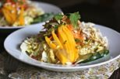
* [Paleo Eats](http://l.facebook.com/l.php?u=http%3A%2F%2Fflip.it%2FucncG&h=oAQFYN-OjAQFKe7-KgPyhnTQcyMkq7Ppsipo1ON2twSSO5w&s=1)
* flipboard.com
* By mplin | Paleo recipes to explore and inspire, with a focus on savory and a hint of sweet
*  [Cynthia Magpayo Legaspi](https://www.facebook.com/cmlegaspi?fref=ufi) Love this site for Korean recipes. [www.maangchi.com](http://www.maangchi.com/)
* 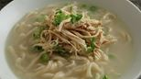
* [Cooking Korean food with Maangchi: Korean cooking, recipes, videos, and blog](http://l.facebook.com/l.php?u=http%3A%2F%2Fwww.maangchi.com%2F&h=RAQHu2R-sAQFZLUWmouofVqupL3nwrouhWayXyQSYacmdnA&s=1)
* [www.maangchi.com](http://l.facebook.com/l.php?u=http%3A%2F%2Fwww.maangchi.com%2F&h=KAQEeEb9PAQHBg6L5HfLN0KBqOeIxgXRg4WvhCJRbX7U6Fw&s=1)
* Korean cooking, recipes, videos, food photos, and blog
*  [Murtuza Banglawala](https://www.facebook.com/mbanglawala?fref=ufi) [www.epicurious.com](http://www.epicurious.com/) [www.sanjaykapoor.com](http://www.sanjaykapoor.com/)
*  [Han Xu](https://www.facebook.com/han.xu.353?fref=ufi) Yummly.com
*  [Jason Lee](https://www.facebook.com/profile.php?id=535656026&fref=ufi) <http://www.masa.tw/>
* 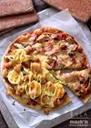
* [MASAの料理ABC](http://l.facebook.com/l.php?u=http%3A%2F%2Fwww.masa.tw%2F&h=JAQGUEJBUAQEFUoq4SnrpCK5gL9zE36fg-BzeZVIdUyMMsw&s=1)
* [www.masa.tw](http://l.facebook.com/l.php?u=http%3A%2F%2Fwww.masa.tw%2F&h=kAQGSDFLuAQFF3RZA3VK9_WWyLFRUyZtm9jTpsuQguBf7ag&s=1)
*  [Carol Chao](https://www.facebook.com/chaoquattrosurfriders?fref=ufi) Epicurious if i have to use a recipe. Otherwise just use your foodie palette and recreate what you love!

## TED:

# Quick question to anyone who cooks a lot at home or likes to play around with recipes. What your go-to sites/resources to find recipes and what tools do you use when experimenting with recipes? Any input would be greatly appreciated...

# [**Lee Springer**](https://www.facebook.com/pyrabot?fref=ufi) Read Ratio by Michael Ruhlman, it gives you flexible base recipes that you can extend.

# [**Lucy Bartlett**](https://www.facebook.com/lucy.bartlett.16?fref=ufi) BBC food

# [**Joy Tenhagen**](https://www.facebook.com/joy.tenhagen?fref=ufi) Epicurious always has delicious stuff

# [**Matt Camuto**](https://www.facebook.com/mattcamuto?fref=ufi) Teddy... I always try to go to the sites where they have a lot of pictures step by step. I love the way the stuff looks at the end but never can reproduce it Plus I never go where the star rating is less the 4.5. I am high brow like that. Epicurious is great for variety.

# [**Courtney Schroeder**](https://www.facebook.com/profile.php?id=100006256141602&fref=ufi) Simplyrecipes.com has lots of easy tasty dishes

# [**Lissa Critz**](https://www.facebook.com/lissa.critz?fref=ufi) Alton Brown's show, Good Eats, taught me lots about the science behind ingredients which is the basis for understanding how you can play around with substitutions and change recipes you find. He might have a book you can dig into.

# [**Patrick Irvine**](https://www.facebook.com/profile.php?id=23442628&fref=ufi) I use this one. Its a delivery service which tells you how to prepare these preset menus and will deliver it to you. I only use the recipe part of it though. [www.blueapron.com](http://l.facebook.com/l.php?u=http%3A%2F%2Fwww.blueapron.com%2F&h=HAQHUbl_SAQHgjMuUIgJC5S0ZEfLBO8o1bHb2x5a8CTwgVQ&s=1)

# [**Ron Tenhagen**](https://www.facebook.com/ron.tenhagen?fref=ufi) I just check your Instagram then try to copy it.

# [**Erica Meyers Carter**](https://www.facebook.com/ericamcarter?fref=ufi) foodily.com. it's pinterest for food.

# [**Lara Gold**](https://www.facebook.com/lara.gold?fref=ufi) Old ladies.

# [**Amy Chantasirivisal**](https://www.facebook.com/aachanta?fref=ufi) Kingarthurflour.com if you're baking. Read the reviews as well.[See Translation](https://www.facebook.com/tedlin182#)

# [**Lisa Oda**](https://www.facebook.com/lisa.oda.18?fref=ufi) Yummly

# [**Jeff Ferris**](https://www.facebook.com/jeff.ferris?fref=ufi) I have never had a recipe turn out badly from smittenkitchen.com

# 

# Keyword: Recipe

Understanding what users search for **recipes.** Looking back over the past 5 years, search traffic for “recipes” tend to be highest during winter months. [1]

Perhaps more interesting than the seasonality of the word, is that regions in the US that tend to include *recipe* in their search term. 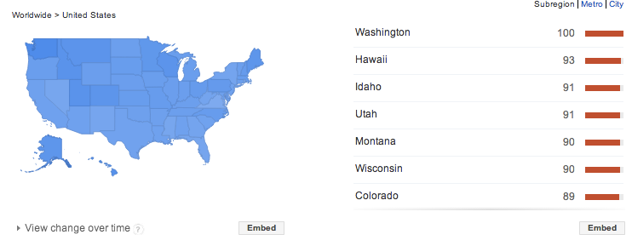

While Washington and the North-Mid-West has always consistently searched *recipe*, it’s interesting to see growth in California.

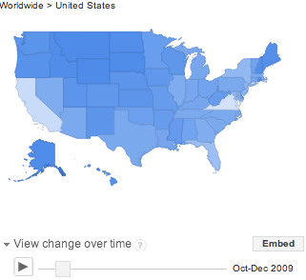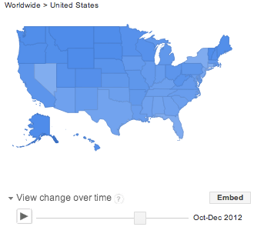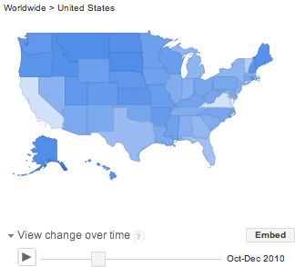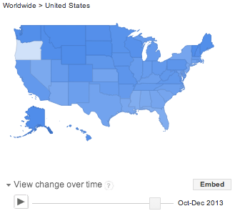

Dialing into metro, regions, we find great representation in the Pacific/Northwest: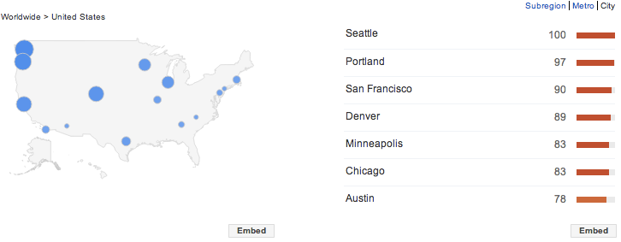

### Comparing Recipe vs. Recipes

Nuanced differences between *recipe* and *recipes.*

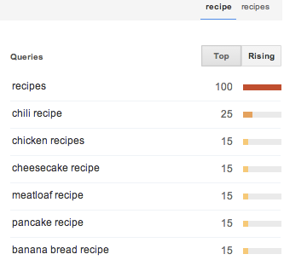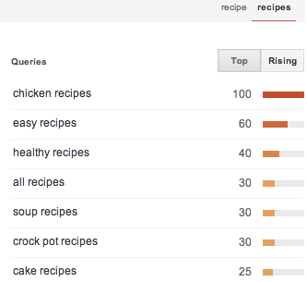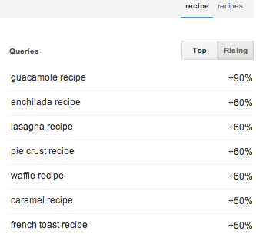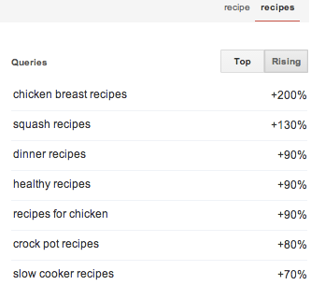

* Top terms
  + Chicken reigns supreme
  + **Chili recipe is a top search trend**.
* Cooks search for a specific “recipe” while searching for genres of “recipes”
  + Cooks will search for “crock pot” or “dinner” or “healthy” *recipes.*

## 

## 

## Different Dish Genres

Comparing chili, pasta, ribs, chicken wings:

<http://www.google.com/trends/explore#q=chili%20recipe%2C%20pasta%20recipe%2C%20ribs%20recipe%2C%20chicken%20wings%20recipe&geo=US&date=4%2F2009%2061m&cmpt=q>

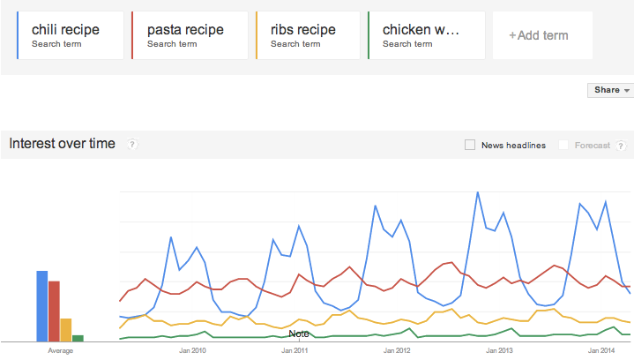

Chicken

<http://www.google.com/trends/explore#q=chicken%20wings%20recipe%2C%20buffalo%20wings%20recipe%2C%20roasted%20chicken%20recipe&geo=US&cmpt=q>

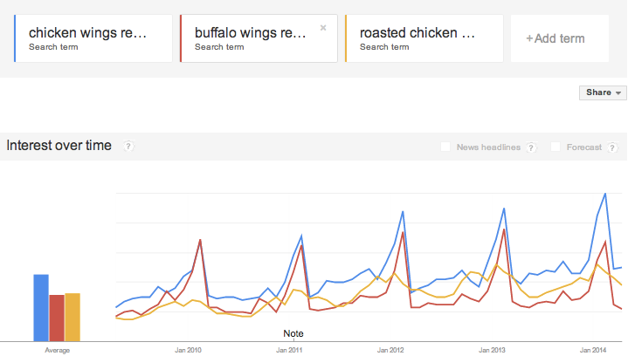

Pasta: <http://www.google.com/trends/explore#q=pasta%20recipe%2C%20spaghetti%20recipe%2C%20cabonara%20recipe&geo=US&date=4%2F2009%2061m&cmpt=q>

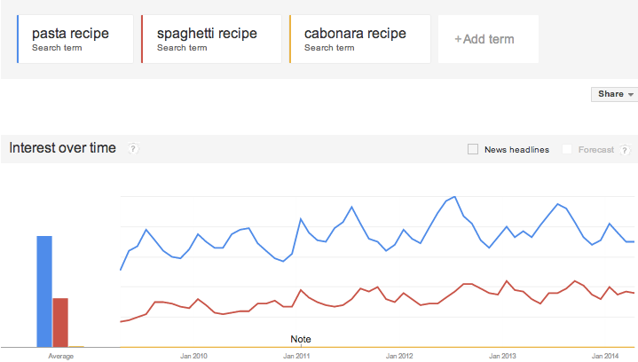

Short Ribs

<http://www.google.com/trends/explore#q=Ribs%20recipe%2C%20short%20ribs%2C%20short%20ribs%20recipe%2C%20braised%20short%20ribs%2C%20braised%20short%20ribs%20recipe&geo=US&date=4%2F2009%2061m&cmpt=q>

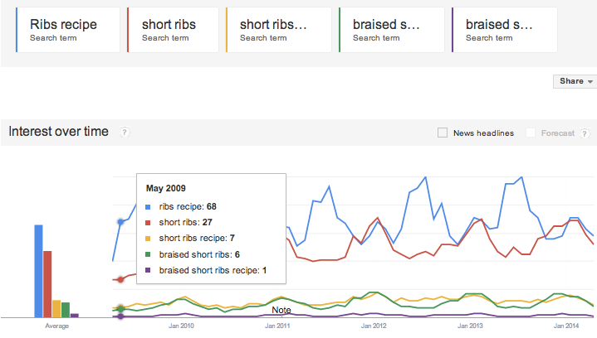

1. http://www.google.com/trends/explore#q=recipes&geo=US&date=4%2F2009%2061m&cmpt=q