

数字集成电路设计实践报告

|  |  |
| --- | --- |
| 题目： | **SPI技术文档** |

|  |  |
| --- | --- |
| 姓 名： |  |
| 学 号： |  |
| 院 系： |  |
| 专 业： |  |
| 研究方向： |  |
| 导师姓名： |  |

二〇一 年 月

目录

1 前端设计 4

1.1 整体结构图 4

1.2 外部接口 4

1.3 内部寄存器介绍 5

1.3.1 控制寄存器1 5

1.3.2 控制寄存器2 6

1.3.3 分频寄存器 7

1.4 代码解析 8

1.4.1 spi_master 8

1.4.2 spi_slave 13

1.4.3 spi_ms 17

1.5 Testbench 22

1.5.1 整体框架 22

1.5.2 代码解析 22

1.5.3 测试波形 28

1.5.4 覆盖率测试 28

2 DC综合 29

2.1 约束参数 29

2.2 时序报告 30

3 后端 31

组内成员：孙海宁（组长），黄晓崇，欧泽宏，贾金宇，张承译，孙岩，王倩

分工：

|  |  |  |  |  |  |
| --- | --- | --- | --- | --- | --- |
| Coding | Pre-sim | DC | Layout | Post-sim | Summary(PPT,Word) |
| 孙海宁 | 孙海宁 | 孙海宁 | 孙海宁 | 黄晓崇 | 孙海宁 |
| 黄晓崇 | 黄晓崇 | 黄晓崇 |  |  | 黄晓崇 |
|  |  |  |  |  |  |
|  |  |  |  |  |  |
|  |  |  |  |  |  |
|  |  |  |  |  |  |
|  |  |  |  |  |  |
|  |  |  |  |  |  |

# 前端设计

## 整体结构图

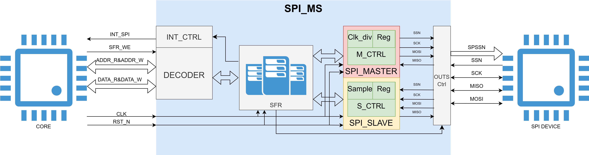

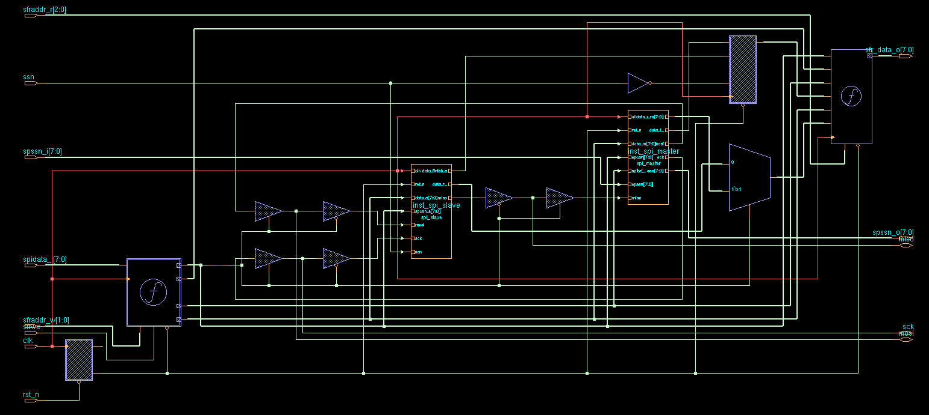

简述一下数据的传输途径：首先通过外部总线来对内部的SFR进行读写，同时传入clk与rst_n信号，写入的地址与数据通过内部译码器来对寄存器进行读写，而内部的master与slave模块有两个，通过读写SFR来进行工作模式的选择，两个模块分别连接三态门，最后与外部进行数据交换。

## 外部接口

|  |  |  |
| --- | --- | --- |
| **input** | **width** | **function** |
| clk | 1 | system clock |
| rst_n | 1 | reset(active low) |
| sfraddr_w | 2 | write addr |
| sfrwe | 1 | write enable |
| spidata_i | 8 | write data |
| sfraddr_r | 3 | read addr |
| spssn_i | 8 | spi slave select |
| ssn | 1 | slave select |
| **output** | **width** | **function** |
| sfr_data_o | 8 | output register |
| spssn_o | 8 | spi slave select |
| **inout** | **width** | **function** |
| mosi | 1 | master output |
| slave input |
| miso | 1 | master input |
| slave output |
| sck | 1 | spi clock |
|  |  |  |

这里需要注意的是inout接口实际是通过三态门与外界进行连接的。

## 内部寄存器介绍

### 控制寄存器1

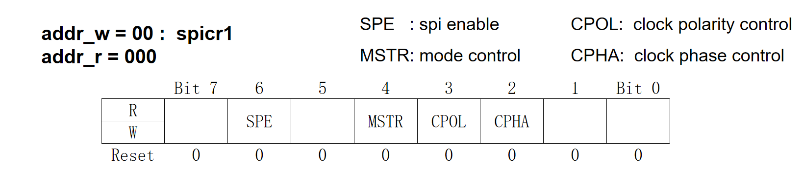

SPE 为1时代表SPI开始工作

为0时代表不处于传输状态

MSTR 为1时代表处于slave模式

为0时代表处于master模式

CPOL 为1时代表sck非工作状态为高电平

为0时代表sck非工作状态为低电平

CPHA 为1时代表sck为上升沿锁存数据

为0时代表sck为下降沿锁存数据

（实际情况如下图所示）

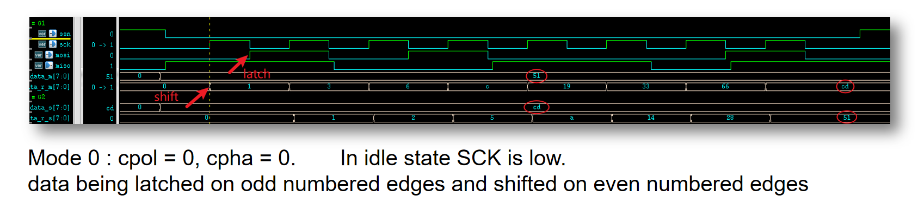

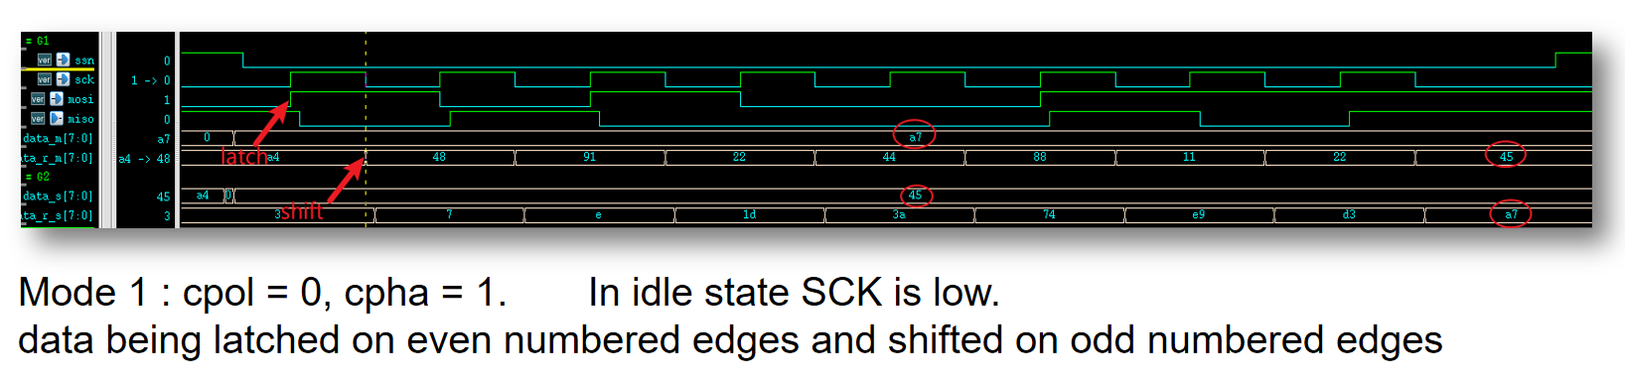

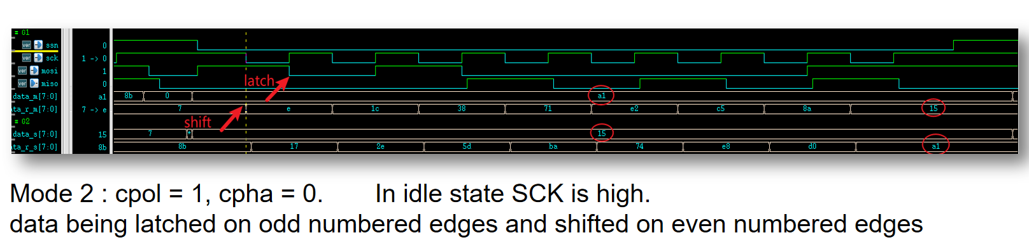

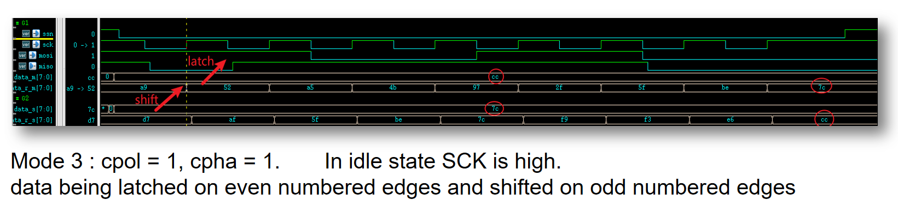

### 控制寄存器2

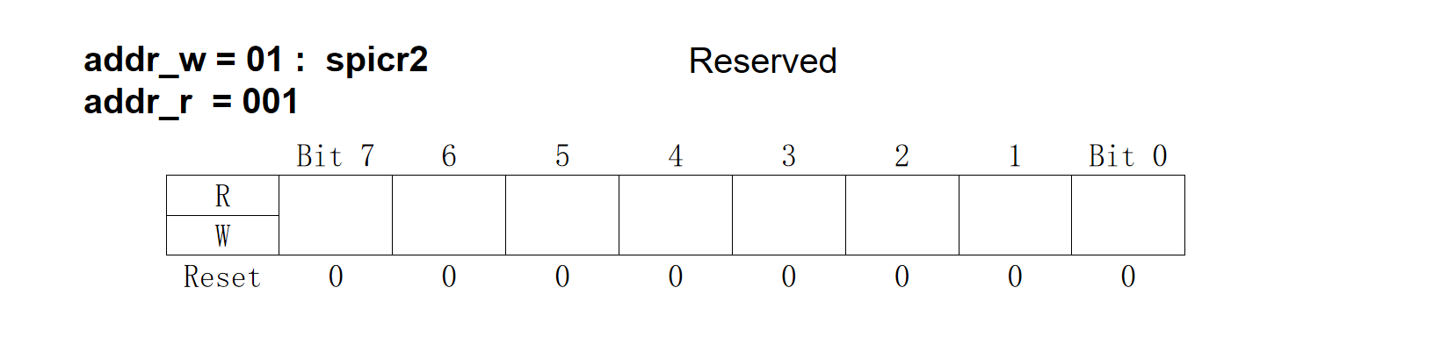

本寄存器可以用来存储状态等参数，可用于后续规划。

### 分频寄存器

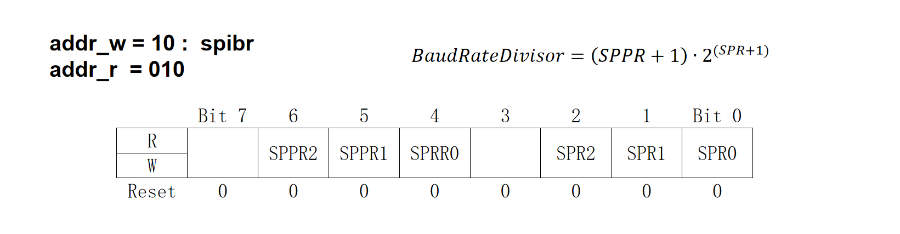

主要用于生成或接收sck时对于clk的分频选择。（计算公式如图所示，共支持64个频率模式）

数据寄存器1：

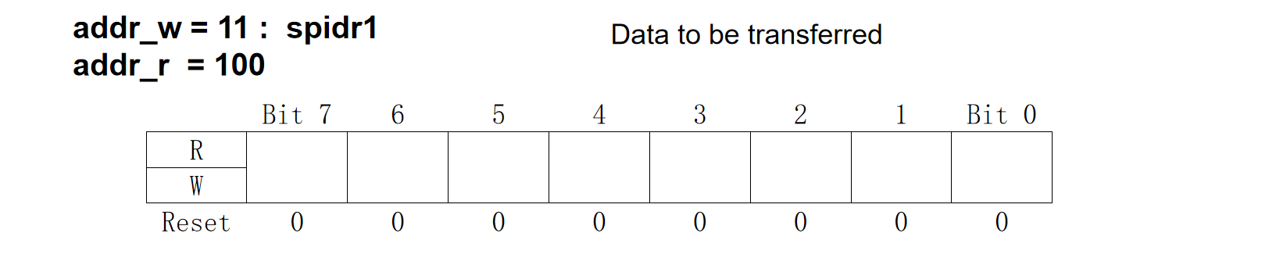

作为SPI的数据传输寄存器。

数据寄存器2：

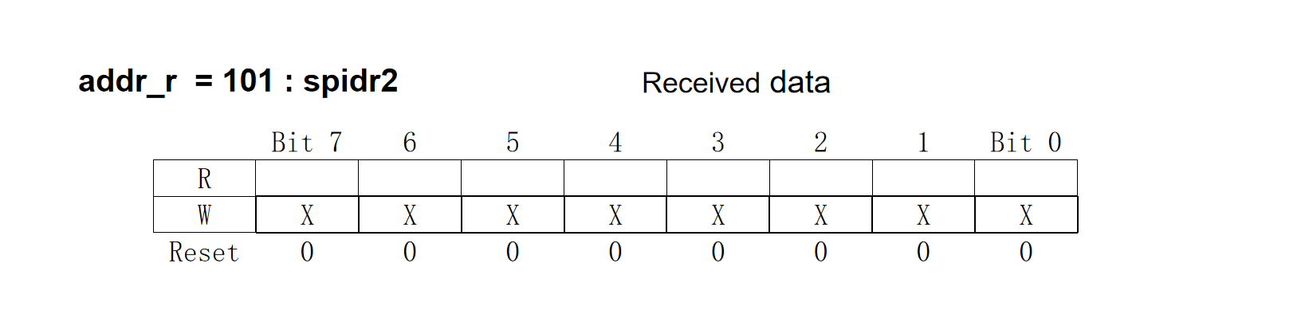

作为SPI的数据接收寄存器。

状态寄存器：

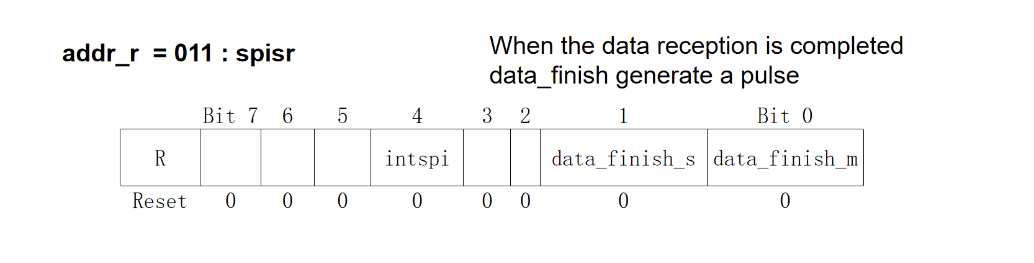

用于存储中断信号与主从模式的数据传输完成信号。

## 代码解析

### spi_master

#### input变量声明

|  |  |
| --- | --- |
| clk | 系统时钟 |
| rst_n | 系统复位，低电平有效 |
| data_m [7:0] | 主机需要发送的数据 |
| spcon [7:0] | spi 控制寄存器1输入 |
| spibr [7:0] | spi 分频寄存器输入 |
| spssn [7:0] | spi 片选信号输入 |
| miso | 主机输入，从机输出，接收从机数据 |

#### output变量声明

|  |  |
| --- | --- |
| data_r_m [7:0] (reg) | 主机接收到的数据 |
| data_finish_m (reg) | 主机接收8bit数据完成信号 |
| mosi (reg) | 主机输出，从机输入，发送主机数据 |
| sck (reg) | spi 时钟，分频产生 |
| ssn [7:0] (wire) | spi 片选信号输出 |

#### 内部变量声明

wire型变量声明

|  |  |
| --- | --- |
| tr_en | 传输使能，为1时开始传输数据 |
| cpol | spi 极性控制信号 |
| cpha | spi 相位控制信号 |
| clk_div [7:0] | spi 分频数，由分频寄存器计算得出 |
| sppr_add1 [3:0] | 计算分频数的中间信号 |

reg型变量声明

|  |  |
| --- | --- |
| clk_cnt [7:0] | spi 分频计数器 |
| sck_edge_cnt [4:0] | 记录sck边沿数 |
| sck_edge_level | sck边沿电平，sck发生跳变时为1 |
| tr_done | 传输结束信号 |
| tr_done_dly1 | 传输技术信号延时1拍 |
| bit_count [2:0] | 用于发送数据时计数 |

#### 各模块简介

* 变量声明及wire型变量赋值

wire tr_en ;   
 assign tr_en = ~(&spssn) && spcon[6] ; // tx or rx enable   
 assign ssn = spssn ;   
   
 // cpol = 1, Active-low clocks selected. In idle state SCK is high.   
 // cpol = 0, Active-high clocks selected. In idle state SCK is low.   
 // cpha = 1, data being latched on even numbered edges and shifted on odd numbered edges   
 // cpha = 0, data being latched on odd numbered edges and shifted on even numbered edges   
 wire cpol, cpha ;   
 assign {cpol, cpha} = spcon[2:1] ;   
   
 reg [7:0] clk_cnt ;   
 wire [7:0] clk_div ; // div the clk to generate the spi clk   
 wire [3:0] sppr_add1 ;   
   
 assign sppr_add1 = spibr[6:4] + 3'b001 ;   
 assign clk_div = sppr_add1 << spibr[2:0] ;   
   
 reg [4:0] sck_edge_cnt ; // trace the sck edge   
 reg sck_edge_level ; // trace the sck level   
   
 reg tr_done ; // when tx or rx done , set it   
 reg tr_done_dly1 ;   
   
 reg [2:0] bit_count ; // bit count to transfer data

* 时钟计数模块，用于分频

// clk count for div   
 always @(posedge clk or negedge rst_n) begin   
 if(~rst_n) begin   
 clk_cnt <= 8'd1;   
 end   
 else begin   
 if (tr_en) begin   
 if (clk_cnt == clk_div) begin   
 clk_cnt <= 8'd1 ;   
 end   
 else begin   
 clk_cnt <= clk_cnt + 1'b1 ;   
 end   
 end   
 else begin   
 clk_cnt <= clk_cnt ;   
 end   
 end   
 end

* 分频产生sck，记录sck边沿电平及边沿数

// sck_edge_level = 1 to generate sck edge and data transfer   
 // sck_edge_cnt counts the number of sck edge   
 always @(posedge clk or negedge rst_n) begin   
 if(~rst_n) begin   
 sck_edge_level <= 1'b0;   
 sck_edge_cnt <= 5'd0 ;   
 end   
 else begin   
 if (tr_en) begin   
 if (clk_cnt == clk_div) begin   
 if (sck_edge_cnt == 5'd16) begin   
 sck_edge_level <= 1'b0 ;   
 sck_edge_cnt <= 5'd0 ;   
 end   
 else begin   
 sck_edge_level <= 1'b1 ;   
 sck_edge_cnt <= sck_edge_cnt + 1'b1;   
 end   
 end   
 else begin   
 sck_edge_level <= 1'b0 ;   
 end   
 end   
 else begin   
 sck_edge_level <= 1'b0 ;   
 sck_edge_cnt <= 5'd0 ;   
 end   
 end   
 end

* 数据发送与接收模块

always @(posedge clk or negedge rst_n) begin   
 if(~rst_n) begin   
 sck <= cpol ;   
 data_r_m <= 8'd0 ;   
 bit_count <= 3'b111 ;   
 mosi <= 1'b0 ;   
 end else begin   
 if (tr_en) begin   
 if (sck_edge_level) begin   
 case (sck_edge_cnt)   
 1, 3, 5, 7, 9, 11, 13, 15:begin   
 sck <= ~sck ;   
 if (cpha) begin   
 mosi <= data_m [bit_count] ;   
 bit_count <= bit_count - 1'b1;   
 end   
 else begin   
 data_r_m <= {data_r_m[6:0], miso} ;   
 end   
 end   
 2, 4, 6, 8, 10, 12, 14, 16:begin   
 sck <= ~sck ;   
 if (cpha) begin   
 data_r_m <= {data_r_m[6:0], miso} ;   
 end   
 else begin   
 mosi <= data_m [bit_count] ;   
 bit_count <= bit_count - 1'b1 ;   
 end   
 end   
 endcase   
 end   
 end   
   
 // idle state   
 else begin   
 sck <= cpol ;   
 if (cpha) begin   
 bit_count <= 4'd7 ;   
 end   
 else begin   
 mosi <= data_m[7] ;   
 bit_count <= 4'd6 ;   
 end   
 end   
 end   
 end

* 数据传输完成信号产生模块

always @(posedge clk or negedge rst_n) begin   
 if (rst_n == 1'b0) begin   
 tr_done_dly1 <= 1'b0 ;   
 end   
 else begin   
 tr_done_dly1 <= tr_done ;   
 end   
 end   
   
   
 // if tr_done = 1, 8 bits data_m is being transfer   
 always @(posedge clk or negedge rst_n) begin   
 if(~rst_n) begin   
 tr_done <= 1'b0;   
 end else begin   
 if (tr_en && sck_edge_cnt == 5'd16) begin   
 tr_done <= 1'b1 ;   
 end else begin   
 tr_done <= 1'b0 ;   
 end   
 end   
 end   
   
 always @(*) begin   
 data_finish_m = tr_done && ~tr_done_dly1;   
 end

### spi_slave

#### input变量声明

|  |  |
| --- | --- |
| clk | 系统时钟 |
| rst_n | 系统复位，低电平有效 |
| data_s [7:0] | 从机需要发送的数据 |
| spcon_s [7:0] | spi 控制寄存器1输入 |
| mosi | 主机输出，从机输入，接收主机数据 |
| sck | spi 时钟，主机产生，从机接收 |
| ssn | spi 片选信号 |

#### output变量声明

|  |  |
| --- | --- |
| data_r_s [7:0] (reg) | 从机接收到的数据 |
| data_finish_s (reg) | 从机接收8bit数据完成信号 |
| miso (reg) | 主机输入，从机输出，发送从机数据 |

#### 内部变量声明

wire型变量声明

|  |  |
| --- | --- |
| tr_en | 传输使能，为1时开始传输数据 |
| cpol | spi 极性控制信号 |
| cpha | spi 相位控制信号 |
| sck_edge_level | sck边沿检测，sck发生跳变时为1 |

reg型变量声明

|  |  |
| --- | --- |
| sck_edge_cnt [4:0] | 记录sck边沿数 |
| sck_dly1 | sck延时一拍，用于边沿检测 |
| sck_dly2 | sck延时两拍 |
| bit_count [2:0] | 用于发送数据时计数 |

#### 各模块简介

* 变量声明及wire型变量赋值

// cpol = 1, Active-low clocks selected. In idle state SCK is high.   
 // cpol = 0, Active-high clocks selected. In idle state SCK is low.   
 // cpha = 1, data being latched on even numbered edges and shifted on odd numbered edges   
 // cpha = 0, data being latched on odd numbered edges and shifted on even numbered edges   
 wire cpol, cpha ;   
 assign {cpol, cpha} = spcon_s[2:1] ;   
   
 reg [4:0] sck_edge_cnt ; // trace the sck edge   
 wire sck_edge_level ; // trace the sck level   
 reg sck_dly1 ;   
 reg sck_dly2 ;   
   
 wire tr_en ;   
 assign tr_en = ~ssn ; // tx or rx enable   
   
 reg [2:0] bit_count ; // bit count to transfer data

* sck边沿检测并计数

always @(posedge clk or negedge rst_n) begin   
 if(~rst_n) begin   
 sck_dly1 <= 1'b0 ;   
 sck_dly2 <= 1'b0 ;   
 end else begin   
 sck_dly1 <= sck ;   
 sck_dly2 <= sck_dly1 ;   
 end   
 end   
   
 // detect the edge signal of sck and count it   
   
 assign sck_edge_level = sck_dly1 ^ sck ;   
   
 always @(posedge clk or negedge rst_n) begin   
 if(~rst_n) begin   
 sck_edge_cnt <= 0;   
 end else begin   
 if (tr_en) begin   
 if (sck_edge_cnt == 5'd16) begin   
 sck_edge_cnt <= 0 ;   
 end else begin   
 sck_edge_cnt <= sck_edge_level ? sck_edge_cnt + 1 : sck_edge_cnt ;   
 end   
 end else begin   
 sck_edge_cnt <= 0 ;   
 end   
 end   
 end

* 数据发送与接收模块

// data transfer between master and slave   
 always @(posedge clk or negedge rst_n) begin   
 if(~rst_n) begin   
 data_r_s <= 8'd0 ;   
 bit_count <= 3'b111 ;   
 miso <= 1'b0 ;   
 end else begin   
 if (tr_en) begin   
 if (sck_edge_level) begin   
 case (sck_edge_cnt)   
 1, 3, 5, 7, 9, 11, 13, 15:begin   
 if (cpha) begin   
 data_r_s <= {data_r_s[6:0], mosi} ;   
 end else begin   
 miso <= data_s[bit_count] ;   
 bit_count <= bit_count - 1'b1 ;   
 end   
 end   
   
 0, 2, 4, 6, 8, 10, 12, 14:begin   
 if (cpha) begin   
 miso <= data_s[bit_count] ;   
 bit_count <= bit_count - 1'b1 ;   
 end else begin   
 data_r_s <= {data_r_s[6:0], mosi} ;   
 end   
 end   
 // default : data_r_s <= data_r_s ;   
 endcase   
 end   
 end   
 else begin   
 if (cpha) begin   
 bit_count <= 3'b111 ;   
 end else begin   
 miso <= data_s[7] ;   
 bit_count <= 3'b110 ;   
 end   
   
 end   
 end   
 end

* 数据传输完成信号产生模块

// grnerate tr_finish signal   
 always @(posedge clk or negedge rst_n) begin   
 if(~rst_n) begin   
 data_finish_s <= 1'b0;   
 end else begin   
 if (tr_en) begin   
 if (sck_edge_cnt == 5'd16) begin   
 data_finish_s <= 1'b1 ;   
 end else begin   
 data_finish_s <= 1'b0 ;   
 end   
 end else begin   
 data_finish_s <= 1'b0 ;   
 end   
   
 end   
 end

### spi_ms

#### input变量声明

|  |  |
| --- | --- |
| clk | 系统时钟 |
| rst_n | 系统复位，低电平有效 |
| sfraddr_w [1:0] | sfr写地址 |
| sfrwe | sfr 写使能 |
| spidata_i [7:0] | 写数据输入 |
| sfraddr_r [2:0] | sfr 读地址 |
| spssn_i [7:0] | 作为主机时ssn输入 |
| ssn | 作为从机时ssn输入 |

#### output变量声明

|  |  |
| --- | --- |
| sfr_data_o [7:0] (reg) | sfr读数据输出 |
| spssn_o [7:0] (wire) | 作为主机时ssn输出 |

#### inout变量声明

|  |  |
| --- | --- |
| mosi | 作为主机时为输出，从机时为输入 |
| miso | 作为主机时为输入，从机时为输出 |
| sck | 作为主机时为输出，从机时为输入 |

#### 内部变量声明

* wire型变量声明

|  |  |
| --- | --- |
| spidr2 [7:0] | spi 数据寄存器2 |
| spidr2_m [7:0] | 主机数据寄存器2 |
| spidr2_s [7:0] | 从机数据寄存器2 |
| data_finish_m | 主机传输完成信号 |
| data_finish_s | 从机传输完成信号 |
| miso_m | 主机miso |
| miso_s | 从机miso |
| mosi_m | 主机mosi |
| mosi_s | 从机mosi |
| sck_m | 主机sck |
| sck_s | 从机sck |
| intspi | 中断信号 |
| mstr | 主机从机选择信号，为1选择主机 |

* reg型变量声明

|  |  |
| --- | --- |
| spicr1 | spi 控制寄存器1 |
| spicr2 | spi 控制寄存器2 |
| spibr | spi 分频寄存器 |
| spisr | spi 状态寄存器 |
| spidr1 | spi 数据寄存器1 |
| rst_n_sync_pre | 异步复位，同步释放前信号 |
| rst_n_sync | 异步复位，同步释放信号 |

#### 各模块简介

* 三态门缓冲模块

wire mstr = spicr1[4] ; // mstr = 0 means slave model, mstr = 1 means master model   
   
 assign sck = mstr ? sck_m : 1'bz ;   
 assign sck_s = mstr ? 1'bz : sck ;   
   
 assign mosi = mstr ? mosi_m: 1'bz ;   
 assign mosi_s = mstr ? 1'bz : mosi ;   
   
 assign miso_m = mstr ? miso : 1'bz ;   
 assign miso = mstr ? 1'bz : miso_s;

* 同步复位，异步释放模块

reg rst_n_sync_pre ;   
 reg rst_n_sync ;   
   
 always @ (posedge clk or negedge rst_n) begin   
 if (rst_n == 1'b0) begin   
 rst_n_sync_pre <= 1'b0 ;   
 rst_n_sync <= 1'b0 ;   
 end else begin   
 rst_n_sync_pre <= 1'b1 ;   
 rst_n_sync <= rst_n_sync_pre ;   
 end   
 end

* 例化主机和从机

spi_master inst_spi_master   
 (   
 .clk (clk ),   
 .rst_n (rst_n_sync ),   
 .data_m (spidr1 ),   
 .spcon (spicr1 ),   
 .spibr (spibr ),   
 .spssn (spssn_i ),   
 .data_r_m (spidr2_m ),   
 .data_finish_m (data_finish_m),   
 .miso (miso_m ),   
 .mosi (mosi_m ),   
 .sck (sck_m ),   
 .ssn (spssn_o )   
 );   
   
 spi_slave inst_spi_slave   
 (   
 .clk (clk ),   
 .rst_n (rst_n_sync ),   
 .data_s (spidr1 ),   
 .spcon_s (spicr1 ),   
 .data_finish_s (data_finish_s),   
 .data_r_s (spidr2_s ),   
 .mosi (mosi_s ),   
 .miso (miso_s ),   
 .sck (sck_s ),   
 .ssn (ssn )   
 );

* 寄存器读写模块

assign spidr2 = mstr ? spidr2_m : spidr2_s ; // mstr = 1, master model   
   
 always @(posedge clk or negedge rst_n_sync) begin   
 if (rst_n_sync == 1'b0) begin   
 spisr <= 8'b0 ;   
 end   
 else begin   
 spisr[0] <= data_finish_m ;   
 spisr[1] <= data_finish_s ;   
 spisr[4] <= intspi ;   
 end   
 end   
   
 always @(posedge clk or negedge rst_n_sync) begin   
 if (rst_n_sync == 0) begin   
 spicr1 <= 8'b0;   
 spicr2 <= 8'b0;   
 spibr <= 8'b0;   
 spidr1 <= 8'b0;   
 end else if (sfrwe) begin   
 case (sfraddr_w)   
 2'b00: spicr1 <= spidata_i;   
 2'b01: spicr2 <= spidata_i;   
 2'b10: spibr <= spidata_i;   
 2'b11: spidr1 <= spidata_i;   
 default:;   
 endcase   
 end   
 end   
   
   
/*-----------------------------------------------\   
 -- sfr_data_o : sfr output data --   
\-----------------------------------------------*/   
   
 always @(posedge clk or negedge rst_n_sync)begin   
 if (rst_n_sync == 1'b0) begin   
 sfr_data_o <= 8'b0000_0000 ;   
 end else begin   
 case(sfraddr_r)   
 3'b000 : sfr_data_o <= spicr1 ;   
 3'b001 : sfr_data_o <= spicr2 ;   
 3'b010 : sfr_data_o <= spibr ;   
 3'b011 : sfr_data_o <= spisr ;   
 3'b100 : sfr_data_o <= spidr1 ;   
 3'b101 : sfr_data_o <= spidr2 ;   
 default: sfr_data_o <= 8'b0000_0000 ;   
 endcase   
 end   
 end

## Testbench

### 整体框架

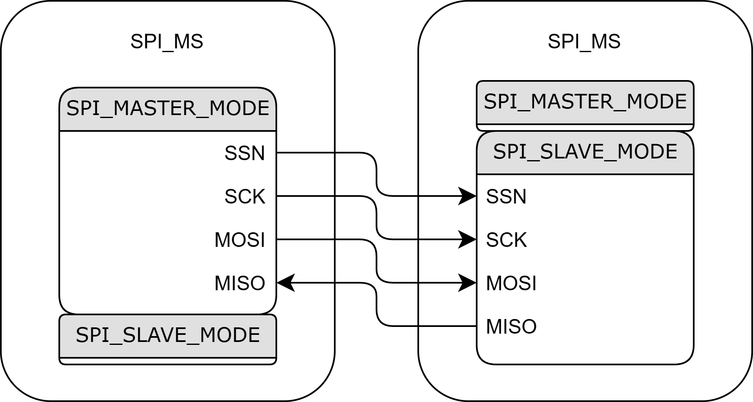

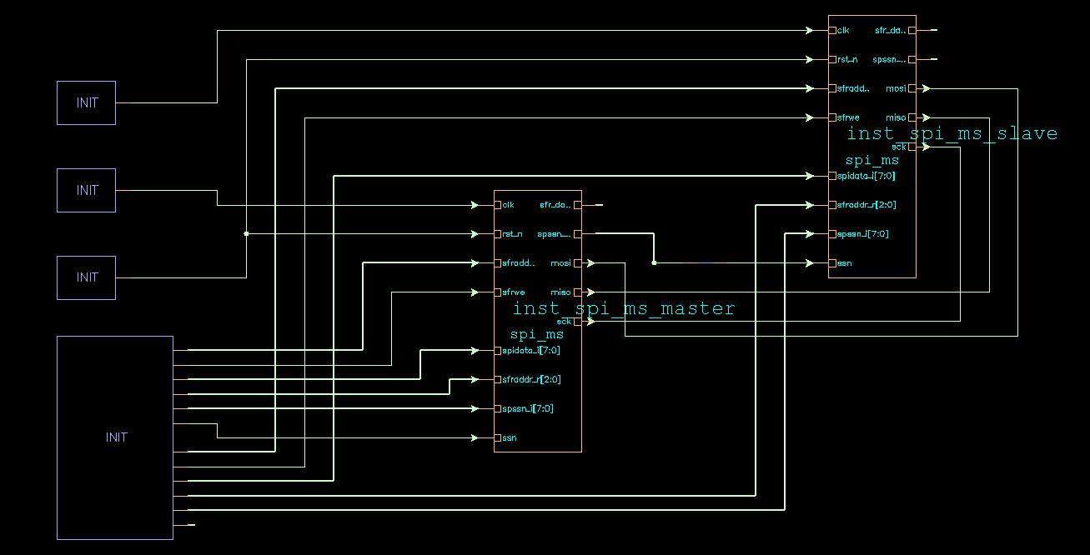

### 代码解析

* 时钟及复位

// clock   
 logic m_clk;   
 initial begin   
 m_clk = '0;   
 forever #(20) m_clk = ~m_clk;   
 end   
   
 logic s_clk;   
 initial begin   
 s_clk = '0;   
 #2   
 s_clk = '1;   
 forever #(20) s_clk = ~s_clk;   
 end   
   
 // asynchronous reset   
 logic rst_n;   
 initial begin   
 rst_n <= '0;   
 #80   
 rst_n <= '1;   
 end

* 例化模块并连接主机和从机

logic [1:0] m_sfraddr_w;   
 logic m_sfrwe;   
 logic [7:0] m_spidata_i;   
 logic [2:0] m_sfraddr_r;   
 logic [7:0] m_sfr_data_o;   
 logic [7:0] m_spssn_i;   
 logic [7:0] m_spssn_o;   
 logic m_ssn;   
   
 wire mosi;   
 wire miso;   
 wire sck;   
   
 logic [1:0] s_sfraddr_w;   
 logic s_sfrwe;   
 logic [7:0] s_spidata_i;   
 logic [2:0] s_sfraddr_r;   
 logic [7:0] s_sfr_data_o;   
 logic [7:0] s_spssn_i;   
 logic [7:0] s_spssn_o;   
   
 logic s_ssn;   
   
 spi_ms inst_spi_ms_master   
 (   
 .clk (m_clk),   
 .rst_n (rst_n),   
 .sfraddr_w (m_sfraddr_w),   
 .sfrwe (m_sfrwe),   
 .spidata_i (m_spidata_i),   
 .sfraddr_r (m_sfraddr_r),   
 .sfr_data_o (m_sfr_data_o),   
 .spssn_i (m_spssn_i),   
 .spssn_o (m_spssn_o),   
 .mosi (mosi),   
 .miso (miso),   
 .sck (sck),   
 .ssn (m_ssn)   
 );   
   
 assign s_ssn = m_spssn_o[0] ;   
   
 spi_ms inst_spi_ms_slave   
 (   
 .clk (s_clk),   
 .rst_n (rst_n),   
 .sfraddr_w (s_sfraddr_w),   
 .sfrwe (s_sfrwe),   
 .spidata_i (s_spidata_i),   
 .sfraddr_r (s_sfraddr_r),   
 .sfr_data_o (s_sfr_data_o),   
 .spssn_i (s_spssn_i),   
 .spssn_o (s_spssn_o),   
 .mosi (mosi),   
 .miso (miso),   
 .sck (sck),   
 .ssn (s_ssn)   
 );

* 初始化及寄存器测试

task init();   
 m_sfraddr_w <= '0;   
 m_sfrwe <= '0;   
 m_spidata_i <= '0;   
 m_sfraddr_r <= '0;   
 m_spssn_i <= 8'hff;   
 m_ssn <= '1;   
 s_sfraddr_w <= '0;   
 s_sfrwe <= '0;   
 s_spidata_i <= '0;   
 s_sfraddr_r <= '0;   
 s_spssn_i <= 8'hff;   
 endtask   
   
 task spssn_test();   
 for (int i = 0; i < 256; i++) begin   
 m_spssn_i <= i ;   
 s_spssn_i <= i ;   
 @(posedge m_clk) ;   
 end   
 endtask   
   
 task sfr_data_o_test();   
 for (int i = 0; i < 8; i++) begin   
 m_sfraddr_r <= i ;   
 s_sfraddr_r <= i ;   
 end   
 endtask

* 配置主机和从机

task set_mode_m(int mode_sel_m, int m_spibr);   
 m_sfrwe <= '1;   
 @(posedge m_clk);   
 m_sfraddr_w <= 2'b00;   
 m_sfraddr_r <= 3'b000;   
 // spidata_i <= 8'b0101_0000; // spi enable, master mode, mode 00   
 m_spidata_i <= mode_sel_m; // [6]:SPE, [4]:MSTR, mode 00 [3]:cpol, [2]: cpha   
 repeat(2)@(posedge m_clk);   
 m_sfraddr_w <= 2'b01;   
 m_sfraddr_r <= 3'b001;   
 m_spidata_i <= 8'b0000_0001;   
 repeat(2)@(posedge m_clk);   
 m_sfraddr_w <= 2'b10;   
 m_sfraddr_r <= 3'b010;   
 m_spidata_i <= {1'b0, m_spibr[5:3], 1'b0, m_spibr[2:0]}; // m_clk / 16   
 repeat(2)@(posedge m_clk);   
 m_sfraddr_w <= 2'b11;   
 m_sfraddr_r <= 3'b011;   
 m_spidata_i <= 8'b0000_0000; // ready to transfer data   
 @(posedge m_clk);   
 read_sfr();   
 endtask   
   
 task set_mode_s(int mode_sel_s);   
 s_sfrwe <= '1;   
 @(posedge s_clk);   
 s_sfraddr_w <= 2'b00;   
 s_sfraddr_r <= 3'b000;   
 // spidata_i <= 8'b0101_0000; // spi enable, master mode, mode 00   
 s_spidata_i <= mode_sel_s; // [6]:SPE, [4]:MSTR, mode 00 [3]:cpol, [2]: cpha   
 repeat(2)@(posedge s_clk);   
 s_sfraddr_w <= 2'b01;   
 s_sfraddr_r <= 3'b001;   
 s_spidata_i <= 8'b0000_0001;   
 repeat(2)@(posedge s_clk);   
 s_sfraddr_w <= 2'b10;   
 s_sfraddr_r <= 3'b010;   
 s_spidata_i <= 8'b0000_0011; // clk / 16   
 repeat(2)@(posedge s_clk);   
 s_sfraddr_w <= 2'b11;   
 s_sfraddr_r <= 3'b011;   
 s_spidata_i <= 8'b0000_0000; // ready to transfer data   
 @(posedge s_clk);   
 read_sfr();   
 endtask   
   
 task read_sfr();   
 m_sfraddr_r <= 3'b101 ;   
 s_sfraddr_r <= 3'b101 ;   
 repeat(2)@(posedge m_clk);   
 endtask

* 主从间传输数据

int m_spibr_post2 ;   
 task transfer_data_master_slave(int iter_ms, int m_spibr);   
 for(int it = 0; it < iter_ms; it++) begin   
 m_spidata_i <= $urandom_range(0,255);   
 s_spidata_i <= $urandom_range(0,255);   
 repeat(2)@(posedge m_clk);   
 m_spssn_i <= 8'hfe;   
 m_spibr_post2 = m_spibr[2:0] ;   
 repeat((m_spibr[5:3]+1) * $pow(2,m_spibr_post2+1) * 8 + 3)@(posedge m_clk);   
 m_spssn_i <= 8'hff;   
 repeat(10)@(posedge m_clk);   
 end   
 endtask

* 任务调用

init();   
 repeat(10)@(posedge m_clk);   
 for (int m_spibr = 0; m_spibr < 64; m_spibr++) begin   
   
 set_mode_m(8'b0101_0000, m_spibr);   
 set_mode_s(8'b0100_0000);   
 transfer_data_master_slave(2, m_spibr);   
   
 set_mode_m(8'b0101_0010, m_spibr);   
 set_mode_s(8'b0100_0010);   
 transfer_data_master_slave(2, m_spibr);   
   
 set_mode_m(8'b0101_0100, m_spibr);   
 set_mode_s(8'b0100_0100);   
 transfer_data_master_slave(2, m_spibr);   
   
 set_mode_m(8'b0101_0110, m_spibr);   
 set_mode_s(8'b0100_0110);   
 transfer_data_master_slave(2, m_spibr);   
 end   
   
 repeat(10)@(posedge m_clk);   
 spssn_test();   
 sfr_data_o_test();   
 repeat(10)@(posedge m_clk);   
 $finish;

* dump 波形

initial begin   
 $display("random seed : %0d", $unsigned($get_initial_random_seed()));   
 if ( $test$plusargs("fsdb") ) begin   
 $fsdbDumpfile("tb_spi_ms.fsdb");   
 $fsdbDumpvars(0, "tb_spi_ms");   
 end   
 end

### 测试波形

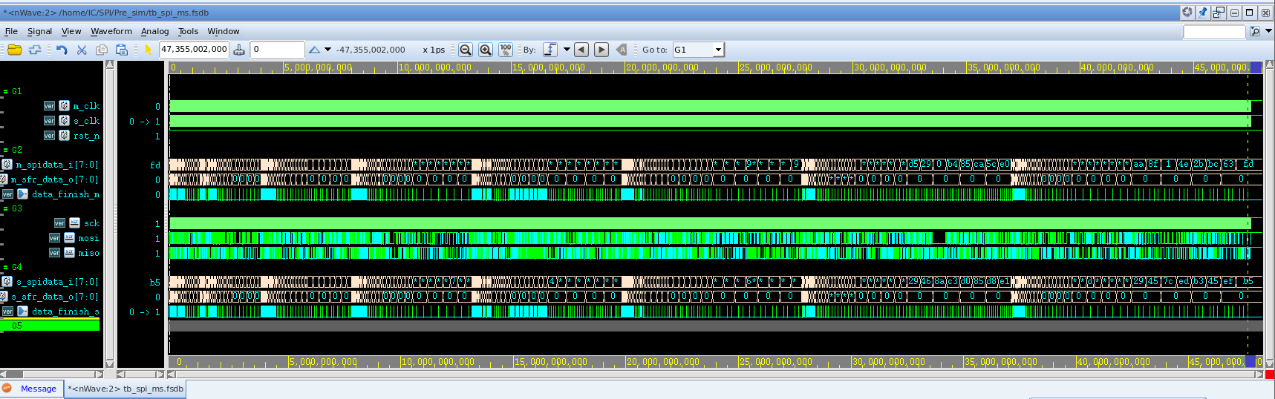

### 覆盖率测试

对于翻转，分支等覆盖率进行测试：



# DC综合

## 约束参数

|  |  |  |  |  |
| --- | --- | --- | --- | --- |
| SPI |  |  |  |  |
|  | MIN | TYP | MAX | UNIT |
|  |  |  |  |  |
| f_clk | 24 |  |  | MHz |
| source latency |  |  | 0.5 | ns |
| uncertainty(setup) |  |  | 0.6 | ns |
| uncertainty(hold) |  |  | 0.5 | ns |
| clock_transition |  |  | 0.4 | ns |
|  |  |  |  |  |
| input_delay | 0 |  | 500 | ns |
| output_delay | 0 |  | 500 | ns |
|  |  |  |  |  |
| driving cell | CLKBUFV2_7TV50 | | |  |
| loading cell | CLKBUFV8_7TV50 | | |  |

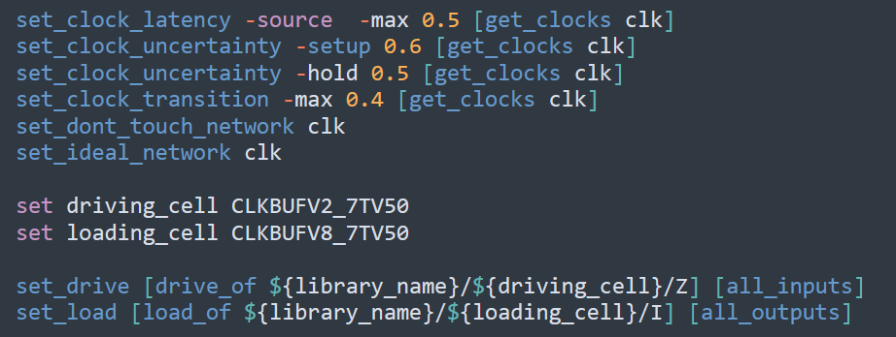

## 时序报告

时间裕量满足条件：

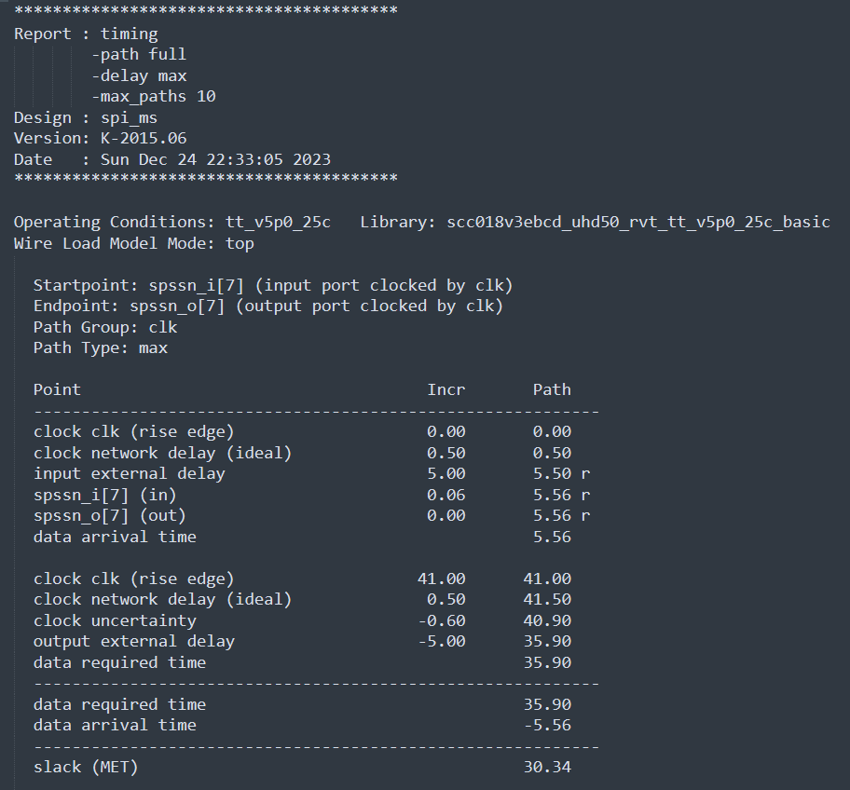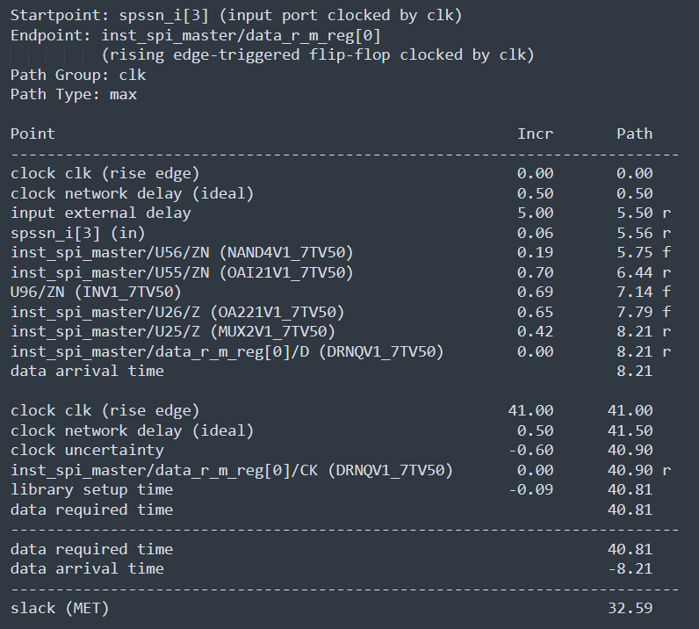

# 后端

对应三种条件的部分进行仿真：分别为ss，tt，ff，分别添加三种库文件。

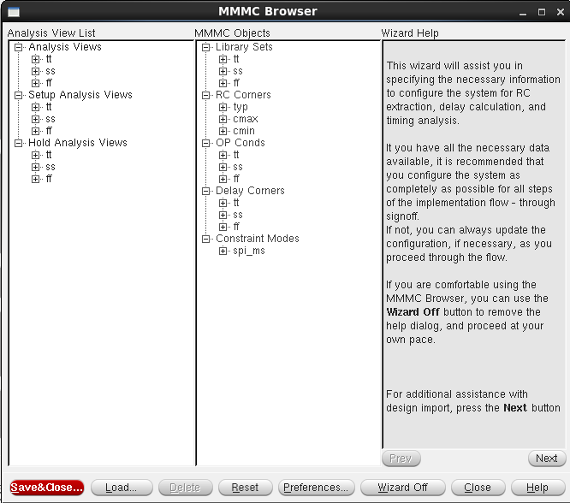

布好线之后的后端版图：

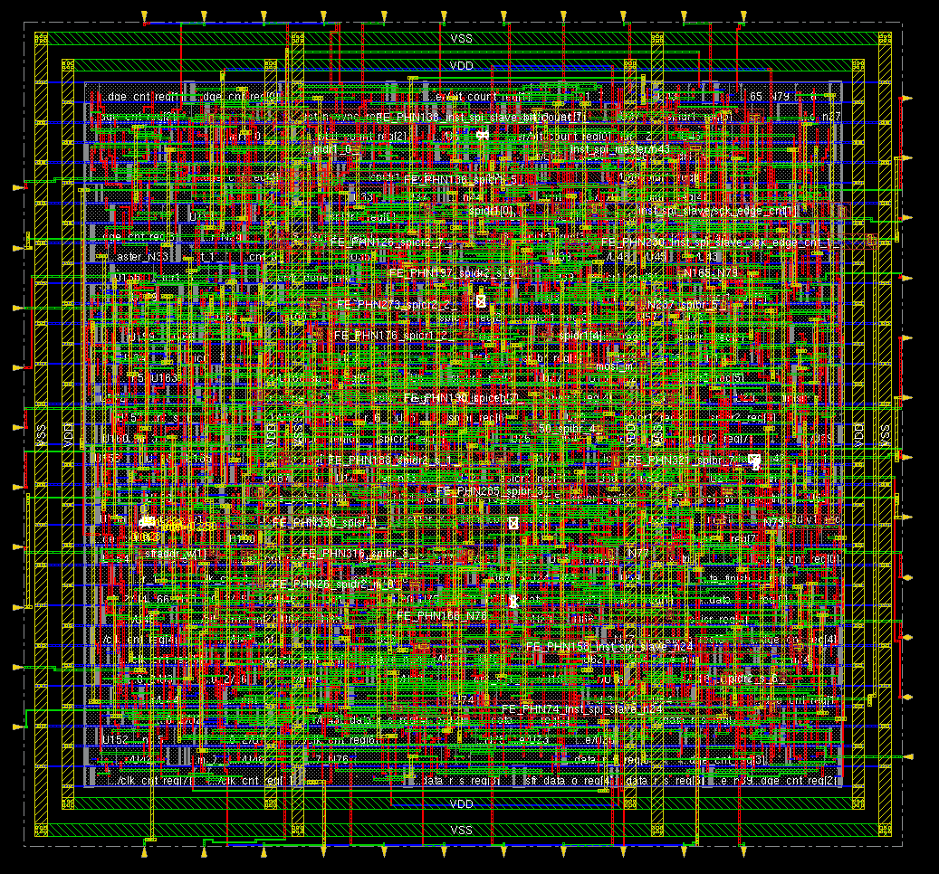

IO文件部分

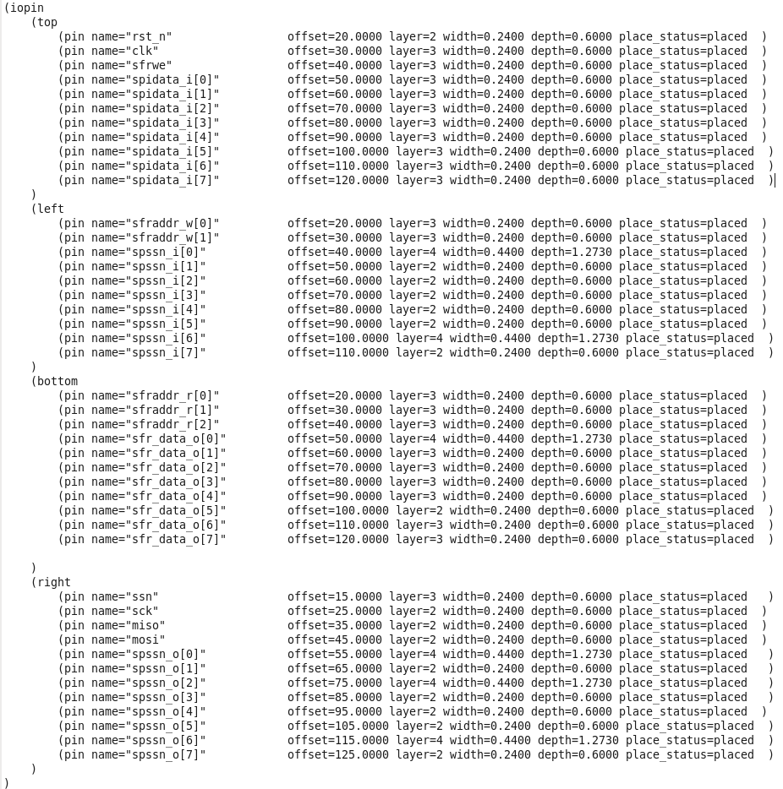

进行连接检查：

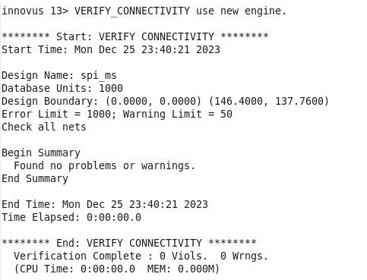

进行DRC与几何检查：

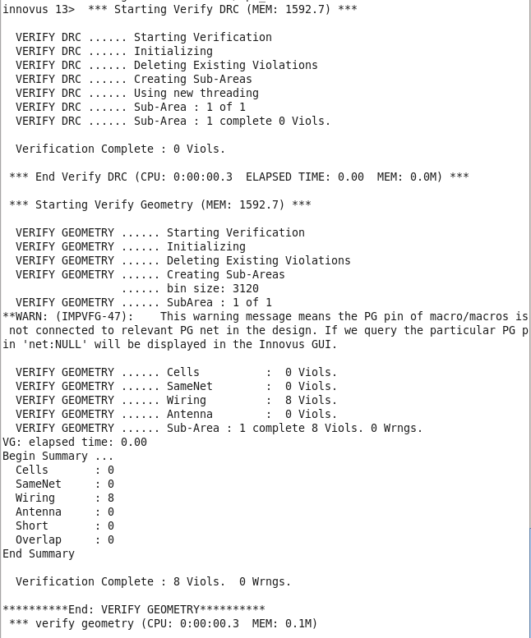

对于保持时间与建立时间进行检查：

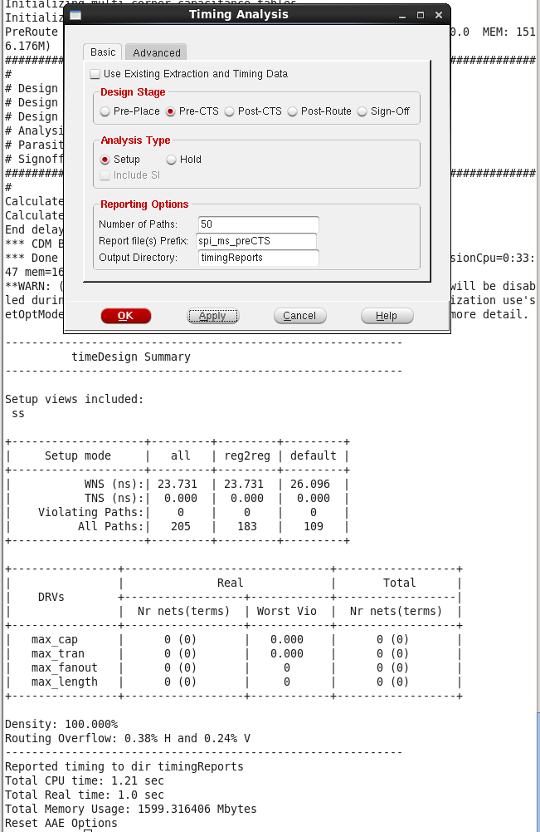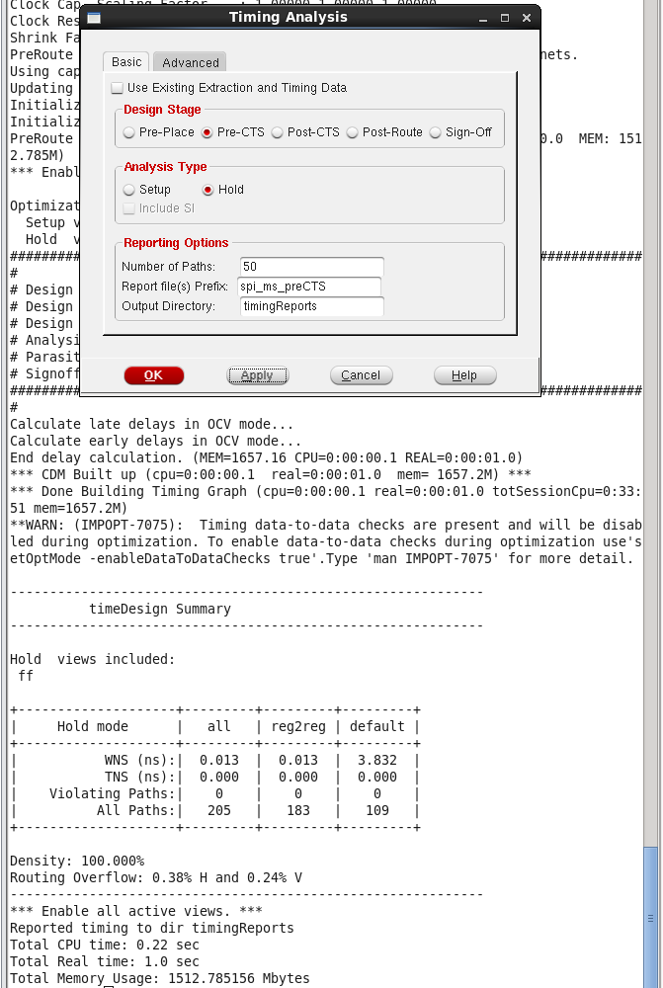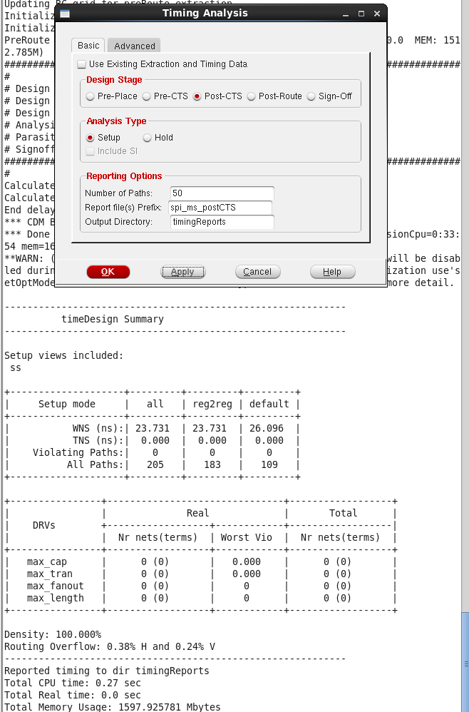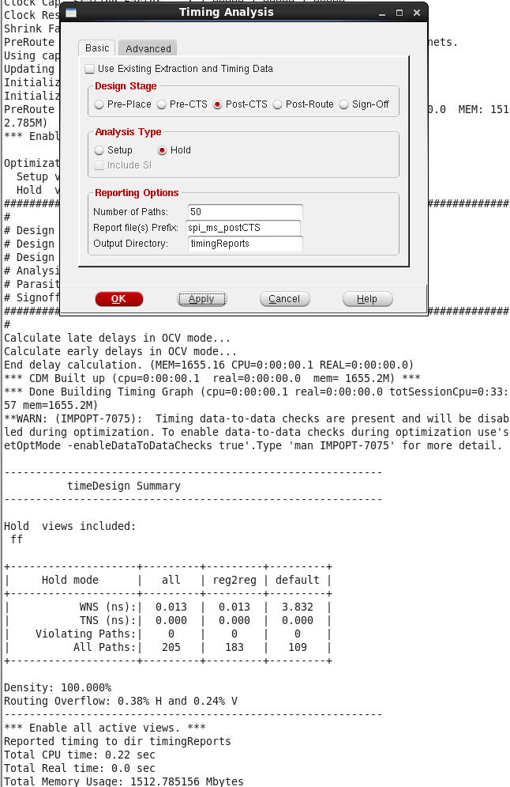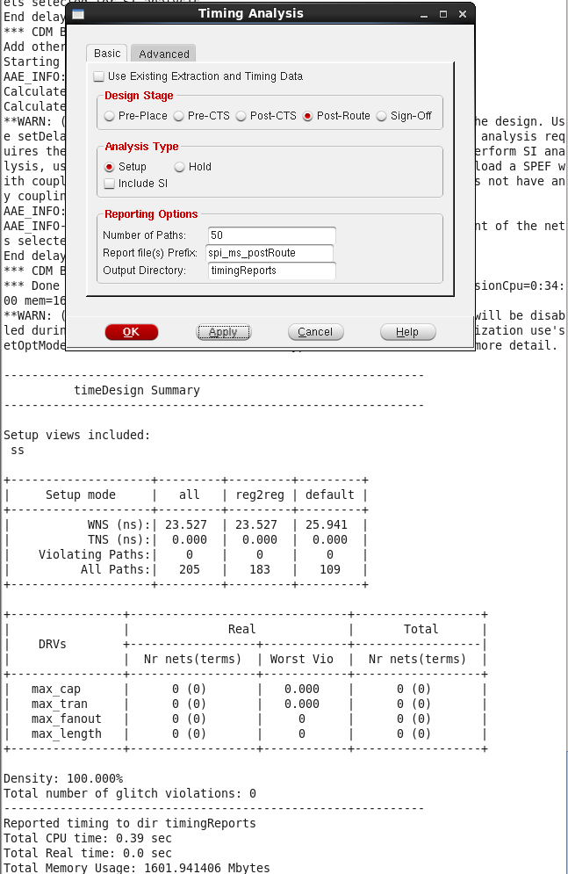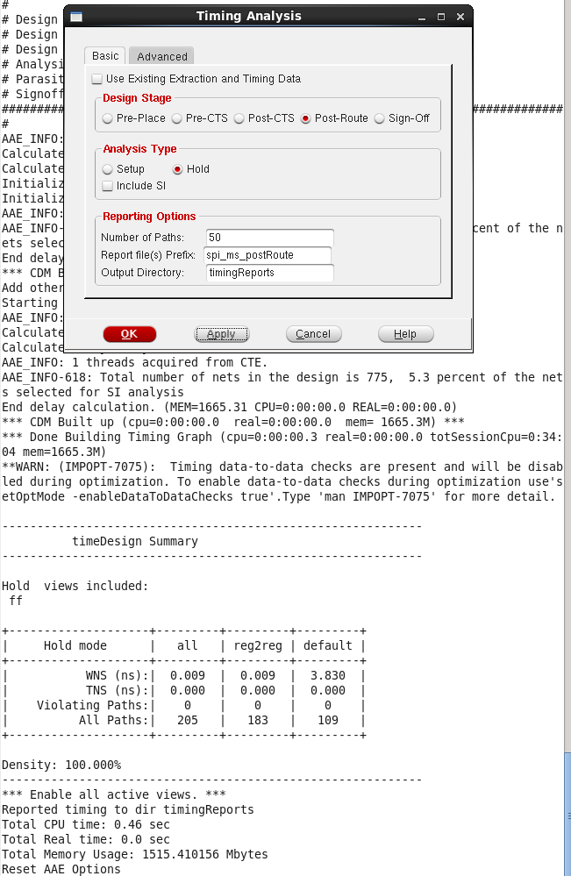

后仿部分：

功能实现与前仿一致，至此，设计完成，部分需进行后续修改微调。

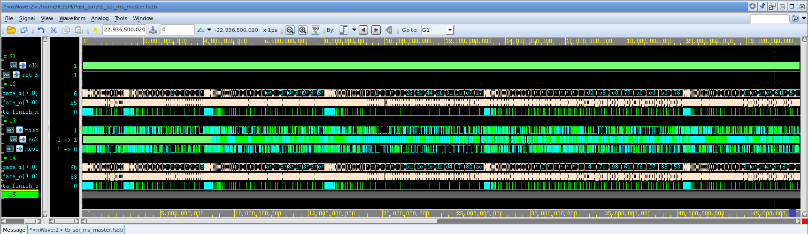

优化方面：

1. clk与sck的采样问题需要进行修改。
2. 对于位宽已经其他参数进行参数化书写，可以进行修改配置。