Resource Central: Understanding and Predicting Workloads for Improved Resource Management in Large Cloud Platforms

1. 创新点与贡献：

* Azure VM工作负载行为的详细特征；（VM Type[First Party + services, Third Party], Virtual resource usage[CPU利用率], VM size[CPU cores/VM, Memory Size/VM], Maximum deployment size[Max number of VMs in each deployment], VM lifetime, Workload class[interactive, Delay-insensitive], VM inter-arrival times）
* VM的行为特征可以被准确地预测；
* Resource Central: 一个用于大规模VM行为数据采集、存储、离线预测、反馈决策的大型系统；【在客户端缓存预测结果、模型、特征数据】
* Azure VM Scheduler 如何利用预测结果进行宿主服务器的选择(Server Selection)；
* 展示了Resource Central和修改后的VM Scheduler的评估结果；
* 公开了Azure VM数据集。

1. 结论：

Cloud Provider可以探索其云平台工作负载(workload)的行为特征，并利用机器学习技术改善资源管理。

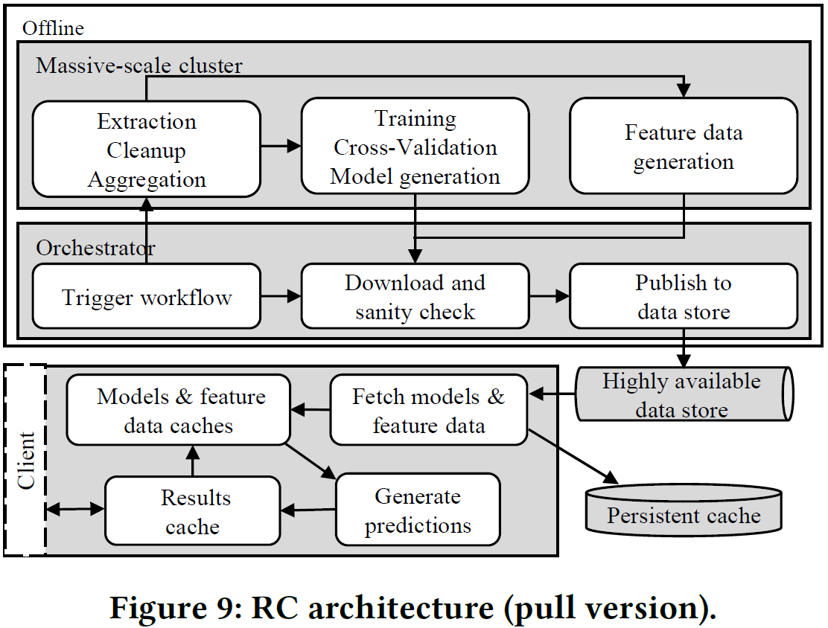

Multi-Path Transport for RDMA in Datacenters

**Abstract**

* Problem: current RDMA remains a single path transport and falls short to utilize the rich parallel paths in datacenters. This paper mainly focus on a multi-path transport for RDMA in datacenters.
* Challenge: limited RDMA NICs on-chip memory size.
* Methods and Innovations:
  + a multi-path ACK-clocking mechanism to distribute traffic in a congestion-aware manner without incurring per-path states;
  + an out-of-order aware path selection mechanism to control the level of out-of-order delivered packets, to minimizes the meta data required to them;
  + a synchronise mechanism to ensure in-order memory update whenever needed.
* Shortcomings:
* Future Work:

1. Introduction

* Swapping data between on-chip memory and host memory has a cost and frequent swapping would significantly downgrades performance.
* Key design goal: minimize the memory footprint, related challenges:
  + a multi-path transport should track the congestion states on each path, for congestion-aware load distribution;
  + multi-path will cause packets to arrive out-of-order at the receiver.
  + Receiver NIC does not have enough memory to buffer out-of-order packets but has to place them into host memory as they arrive. Retaining the memory updating order requires careful design in multi-path RDMA.

1. Background and Motivation
2. MP-RDMA design
3. Implementation
4. Evaluation
5. Related Work
6. Conclusion

References: