Introduction
In this lab, we will explore the concept of database normalization, which helps in minimizing redundancy and improving data integrity. You will work with an unnormalized dataset, apply normalization steps to achieve Third Normal Form (3NF), and write SQL queries to work with the resulting tables.
What is Normalization in SQL?
Normalization is the process of organizing data within a database (relational database) to eliminate data anomalies, such as redundancy. In simpler terms, it involves breaking down a large, complex table into smaller and simpler tables while maintaining data relationships. Normalization is commonly used when dealing with large datasets.
Ensuring data integrity is crucial in database design and management. Normalization is a powerful technique that helps organize data efficiently, minimize redundancy, and maintain consistency.
Translating an ER Diagram into Relations
An ER diagram in which all many-to-many relationships have been transformed into one-to-many relationships, through the introduction of composite entities. To do so:
▪ Create one table for each entity.
▪ For each entity that is only at the “one” end of one or more relationships, and not at the “many” end of any relationship, create a single-column primary key, using an arbitrary unique identifier if no natural primary key is available.
▪ For each entity that is at the “many” end of one or more relationships, include the primary key of each parent entity (those at the “one” end of the relationships) in the table as foreign keys.
▪ If an entity at the “many” end of one or more relationships has a natural primary key (for example, an order number or an invoice number), use that single column as the primary key. Otherwise, concatenate the primary key of its parent with any other column or columns needed for uniqueness to form the table’s primary key.
The most used normal forms are:
First Normal Form (1NF):
Eliminates duplicate data by organizing information into separate tables with unique identifiers.
In the first normal form, each column must contain only one value. No table should store repeating groups of related data. The easiest way to follow the first normal form is to inspect the database table horizontally.
A table is in first normal form (1NF) if it meets the following criteria:
- The data are stored in a two-dimensional table.
- There are no repeating groups.
The key to understanding 1NF therefore is understanding the nature of a repeating group of data.

Understanding Repeating Groups
A repeating group is an attribute that has more than one value in each row of a table. For example, assume that you were working with an employee relation, and needed to store the names and birthdates of the employees’ children. Because each employee can have more than one child, the names of children and the children’s birthdates each form a repeating group.
Note: A repeating group is directly analogous to a multivalued attribute in an ER diagram.
There is actually a very good reason why repeating groups are disallowed. To see what might happen if they were present, look at the following table, an instance of an employee table containing repeating groups.
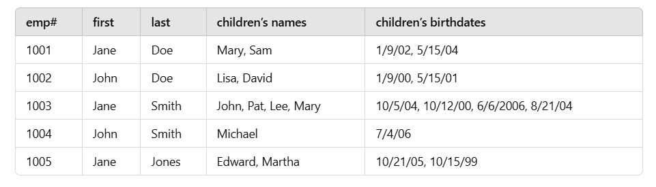
Note: The table is not a legal relation, because it contains those repeating groups. Therefore, we should not call it a relation.
Notice that there are multiple values in a single row in both the children’s names and children’s birthdates columns. This presents two major problems:
▪ There is no way to know exactly which birthdate belongs to which child. It is tempting to say that we can associate the birthdates with the children by their positions in the list, but there is nothing to ensure that the relative positions will always be maintained.
▪ Searching the table is very difficult. If, for example, we want to know which employees have children born before 2005, the DBMS will need to perform data manipulation to extract the individual dates themselves. Given that there is no way to know how many birthdates there are in the column for any specific row, the processing overhead for searching becomes even greater.
The solution to these problems, of course, is to get rid of the repeating groups altogether.
Handling Repeating Groups
There are two ways to get rid of repeating groups to bring a table into conformance with the rules for first normal form—a right way and a wrong way. We will look first at the wrong way so you will know what not to do.
In the following table you can see a relation that handles repeating groups by creating multiple columns for the multiple values. This example includes three pairs of columns for a child’s name and birthdate.
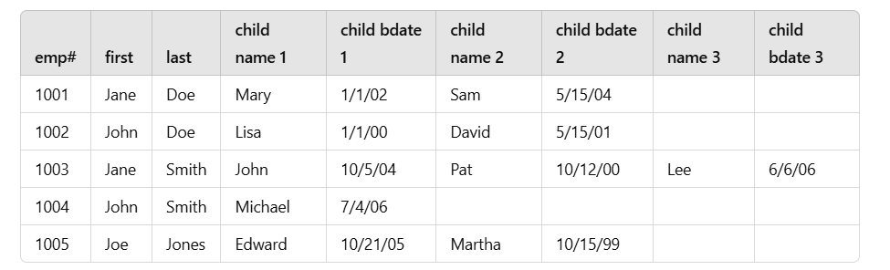
The relation in the table shown above does meet the criteria for first normal form. The repeating groups are gone and there is no problem identifying which birthdate belongs to which child. However, the design has introduced several problems of its own:
▪ The relation is limited to three children for any given employee. This means that there is no room to store Jane Smith’s fourth child. Should you put another row for Jane Smith into the table? If so, then the primary key of this relation can no longer be just the employee number. The primary key must include one child’s name as well.
▪ The relation wastes space for people who have less than three children. Given that disk space is one of the least expensive elements of a database system, this is probably the least of the problems with this relation.
▪ Searching for a specific child becomes very clumsy. To answer the question “Does anyone have a child named Lee?” the DBMS must construct a query that includes a search of all three child name columns because there is no way to know in which column the name might be found.
The right way to handle repeating groups is to create another table (another entity) to handle multiple instances of the repeating group. In the example we have been using, we would create a second table for the children, producing something like the one shown below.

Employee table:
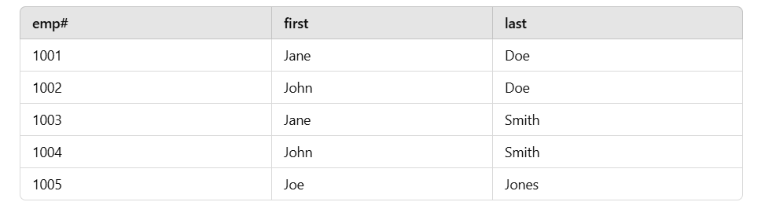
Children table:
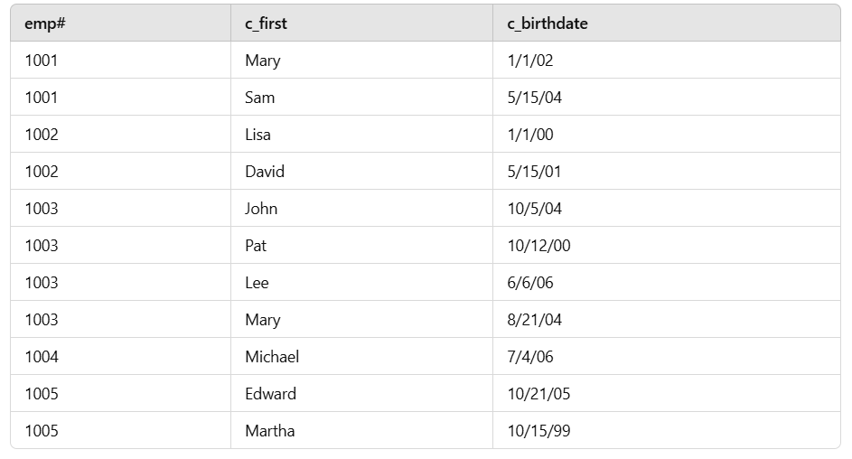
Task:
Create a database called normalization_lastnameInitial_firstname

Create the final first normalized tables Employees and Children and insert values as shown in the tables above. Submit a screenshot of the result grid by querying both the tables to display all the values in the tables. The screenshots (one for Employees and the other for Children) should be labelled as 01(a)_normalization_FNF_Employees and 01(b)_normalization_FNF_Children
Neither of the two new tables contains any repeating groups and this form of the design avoids all the problems of the preceding solution:
▪ There is no limit to the number of children that can be stored for a given employee. To add another child, you simply add another row to the children table.
▪ There is no wasted space. The children table uses space only for data that are present.
▪ Searching for a specific child is much easier because children’s names are found in only one column.
Problems with First Normal Form
Although first normal form relations have no repeating groups, they are full of other problems. To see what these problems are, we will look at the table below.
orders (customer_numb, first_name, last_name, street,
city, state, zip, phone, order_numb, order_date,
item_numb, title, price, has_shipped?)
The first thing we need to do is determine the primary key for this table. The customer number alone will not be sufficient, because the customer number repeats for every item ordered by the customer. The item number will also not suffice, because it is repeated for every order on which it appears. We cannot use the order number, because it is repeated for every item on the order. The only solution is a concatenated key, in this example, the combination of the order number and the item number.
Create a table called orders as described above (use the appropriate primary keys - a composite primary key with order number and item number).
Given that the primary key is made up of the order number and the item number, there are two important things we cannot do with this relation:
▪ We cannot add data about a customer until the customer places at least one order because, without an order and an item on that order, we do not have a complete primary key.
Trying to insert a customer without an order.
Since the orders table requires both order_numb and item_numb to be present (due to the composite primary key), the following INSERT will fail:

INSERT INTO normalization_r_akila.orders (customer_numb, first_name, last_name, street, city, state, zip, phone) VALUES (2001, 'Alice', 'Brown', '123 Maple St', 'New York', 'NY', '10001', '123-456-7890');
Task:
Error message
Label: 02_normalization_insertion_error1
Even if we add NULL for order_numb and item_numb, it will still fail because PRIMARY KEY fields cannot be NULL.
▪ We cannot add data about a merchandise item we are carrying without that item being ordered. There must be an order number to complete the primary key.

Trying to Insert an Item Without an Order
INSERT INTO normalization_r_akila.orders (item_numb, title, price)
VALUES (5001, 'Wireless Mouse', 29.99);
Task:
Capture the error message and submit – like the previous one
Label: 03_normalization_insertion_error2
The preceding are insertion anomalies, a situation that arises when you are prevented from inserting data into a relation because a complete primary key is not available. (Remember that no part of a primary key can be null.)
Note: To be strictly correct, there is a third insertion anomaly in the orders relation. You cannot insert an order until you know one item on the order. In a practical sense, however, no one would enter an order without there being an item ordered.
Insertion anomalies are common in first normal form relations that are not also in any of the higher normal forms. In practical terms, they occur because there are data about more than one entity in the relation. The anomaly forces you to insert data about an unrelated entity (for example, a merchandise item) when you want to insert data about another entity (such as a customer).
First normal form relations can also give us problems when we delete data. Consider, for example, what happens if a customer cancels the order of a single item and the business rules state that cancelled items and orders are to be deleted:
Task
Insert the following values into the orders table:
Submit a screenshot: Label: 04_Orders_insertion
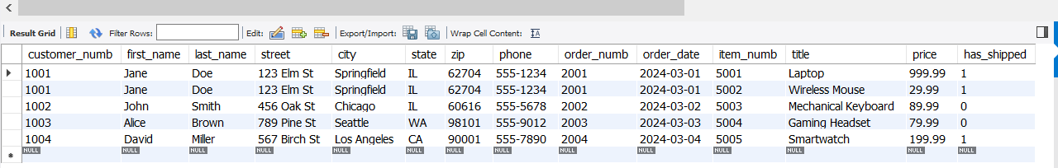
▪ In cases where the deleted item was the only item on the order, you lose all data about the order.
Deleting an order that had only one item (Losing Order Data)
Problem: If John Smith cancels his order (order_numb = 2002), the entire order disappears since he only ordered one item.
DELETE FROM orders WHERE order_numb = 2002;
After executing the query,
- The entire order is lost, including the order date and status.
- We lose order history for John Smith.
Deleting an order that was the only one containing a specific item (Losing Item Data)
Problem: If Alice Brown cancels her order (order_numb = 2003), and item_numb = 5004 (Gaming Headset) does not appear in any other order, we lose all record of the item.
DELETE FROM orders WHERE order_numb = 2003;
After executing the query,
- order_numb = 2003 is removed.
- Item 5004 (Gaming Headset) no longer exists in any order, meaning its sales history is lost.
▪ In cases where the deleted item was the item ordered by a customer you lose all data about the customer.
Deleting an order that was the only one associated with a customer (Losing Customer Data)
Problem: If David Miller cancels his order (order_numb = 2004), and it was his only order, we lose all record of him.
DELETE FROM orders WHERE customer_numb = 1004;
After executing the query,
- The order and all customer information for David Miller are gone.
- There’s no record that David Miller was ever a customer.
Execute each of the above queries and observe the changes to the table.
Task

Take a screenshot of the table values after all the three queries are executed
Label: 05_normalization_deletion_anomaly
These deletion anomalies occur because part of the primary key of a row becomes null when the merchandise item data are deleted, forcing you to remove the entire row. The result of a deletion anomaly is the loss of data that you would like to keep. In practical terms, you are forced to remove data about an unrelated entity when you delete data about another entity in the same table.
Note: Moral to the story: More than one entity in a table is a bad thing.
One of the most important things to keep in mind about insertion and deletion anomalies is that they affect entire entities. If you want to insert customer data but can’t because the customer has not placed an order, for example, you can’t insert any customer data. The anomaly does not just prevent you from entering a primary key value, but also anything else you want to store about an instance of the customer entity.
There is a final type of anomaly in the orders relation that is not related to the primary key: a modification, or update, anomaly. The orders relation has a great deal of unnecessary duplicated data, in particular, information about customers. When a customer moves, then the customer’s data must be changed in every row for every item on every order ever placed by the customer. If every row is not changed, then data that should be the same are no longer the same. The potential for these inconsistent data is the modification anomaly.
Update Anomaly in the Orders Table
The update anomaly occurs when we try to update customer information but need to do it in multiple rows, leading to potential inconsistencies.
Scenario:
Suppose Jane Doe (customer_numb = 1001) moves to a new address. Since her address is stored in multiple rows (one for each item she has ordered), we must update every row where she appears.
Update Query:
We need to update all rows where customer_numb = 1001, otherwise, we risk having inconsistent data for Jane Doe.
UPDATE orders
SET street = '789 New Ave', city = 'Boston', state = 'MA', zip = '02108', phone = '555-9876'
WHERE customer_numb = 1001;
- This updates Jane Doe’s address in all rows, ensuring consistency.
- If we forget to update some rows, her data becomes inconsistent (some orders still show the old address).
Demonstration of Anomaly (Partial Update)
If we mistakenly update only one row, her address becomes inconsistent across different orders:
Let’s assume that Jane Doe goes back to her previous address.
UPDATE orders
SET street = '123 Elm street', city = 'Springfield', state = 'IL', zip = '62704', phone = '555-9876'
WHERE order_numb = 2001 AND item_numb = 5001;
One order is updated, but others still show the old address.
- Jane Doe appears to live in two different places in different rows.
- Data inconsistency occurs, leading to reporting and operational errors.

Task:

Submit a screenshot of the table values with an update anomaly
Label: 06_normalization_update_anomaly
Second Normal Form
The solution to anomalies in a first normal form relation is to break the relation down so that there is one relation for each entity in the 1NF relation. The orders relation, for example, will break down into four relations (customers, items, orders, and line items). Such relations are in at least second normal form (2NF).
In theoretical terms, second formal form relations are defined as follows:
▪ The relation is in first normal form.
▪ All non-key attributes are functionally dependent on the entire primary key.
The new term in the preceding is functionally dependent, a special relationship between attributes.
Understanding Functional Dependencies
A functional dependency is a one-way relationship between two attributes, such that at any given time, for each unique value of attribute A, only one value of attribute B is associated with it throughout the relation. For example, assume that A is the customer number from the orders relation. Each customer number is associated with one customer first name, one last name, one street address, one city, one state, one zip code, and one phone number. Although the values for those attributes may change at any moment, there is only one.
We therefore can say that first name, last name, street, city, state, zip, and phone are functionally dependent upon the customer number. This relationship is often written:
and read “customer number determines first name, last name, street, city, state, zip, and phone.” In this relationship, customer number is known as the determinant (an attribute that determines the value of other attributes).
Notice that the functional dependency does not necessarily hold in the reverse direction. For example, any given first or last name may be associated with more than one customer number. (It would be unusual to have a customer table of any size without some duplication of names.)
The functional dependencies in the orders table are:
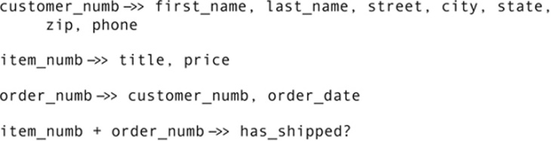

Notice that there is one determinant for each entity in the relation and the determinant is what we have chosen as the entity identifier. Notice also that, when an entity has a concatenated identifier, the determinant is also concatenated. In this example, whether an item has shipped depends on the combination of the item and the order.
Using Functional Dependencies to Reach 2NF
If you have correctly identified the functional dependencies among the attributes in a database environment, then you can use them to create second normal form relations. Each determinant becomes the primary key of a relation. All the attributes that are functionally dependent upon it become non-key attributes in the relation.
The four relations into which the original orders relation should be broken are:
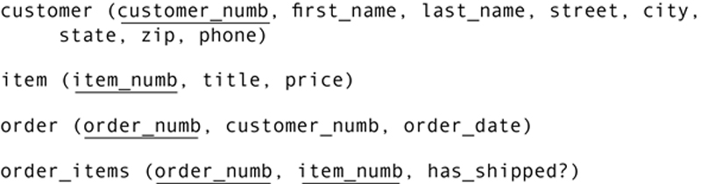
Each of these should, in turn, correspond to a single entity in your ER diagram.
Note: When it comes to deciding what is driving database design—functional dependencies or entities—it is really a “chicken and egg” situation. What is most important is that there is consistency between the ER diagram and the functional dependencies you identify in your relations. It makes no difference whether you design by looking for functional dependencies or for entities. In most cases, database design is an iterative process in which you create an initial design, check it, modify it, and check it again. You can look at either functional dependencies and/or entities at any stage in the process, checking one against the other for consistency.
The relations we have created from the original orders relation have eliminated the anomalies present in the original:
▪ It is now possible to insert data about a customer before the customer places an order.
▪ It is now possible to insert data about an order before we know an item on the order.
▪ It is now possible to store data about merchandise items before they are ordered.
▪ Line items can be deleted from an order without affecting data describing that item, the order itself, or the merchandise item.
▪ Data describing the customer are stored only once and therefore any change to those data needs to be made only once. A modification anomaly cannot occur.
After identifying the functional dependencies, create tables (use the correct primary and foreign keys) and insert into the tables based on the normalized schema from the above image:
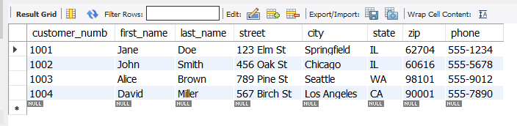
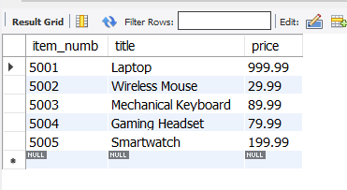
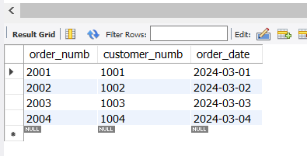
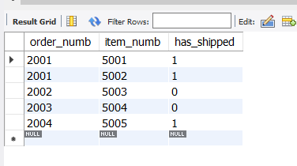
Task:

After creating and inserting the values, take screenshots of each of the tables with all the values
Labels:
07(a)_normalization_2NF_Customers
07(b)_normalization_2NF_Items
07(c)_normalization_2NF_Orders
07(d)_normalization_2NF_OrderItems

Benefits of This Normalized Structure:
Avoids Update Anomalies:
- Customer details are stored once in the customer table.
- Changing an address requires updating only one row instead of every order.
Prevents Deletion Anomalies:
- Deleting an order does not remove customer data.
- Items exist in the item table independently of orders.
Supports Data Integrity:
- order_items properly associates orders and items.
- Foreign keys enforce relationships and prevent orphaned records.
Problems with 2NF Relations
Although second normal form eliminates problems from many relations, you will occasionally run into relations that are in second normal form, yet still exhibit anomalies. Assume, for example, that each new DVD title that Antique Opticals carries comes from one distributor, and that each distributor has only one warehouse, which has only one phone number. The following relation is therefore in second normal form:
For each item number, there is only one value for the item’s title, distributor, and warehouse phone number. However, there is one insertion anomaly—you cannot insert data about a distributor until you have an item from that distributor—and a deletion anomaly—if you delete the only item from a distributor, you lose data about the distributor. There is also a modification anomaly: the distributor’s warehouse phone number is duplicated for every item the company gets from that distributor. The relation is in second normal form, but not third.
Third Normal Form
Third normal form is designed to handle situations like the one you just read about in the preceding section. In terms of entities, the item relation does contain two entities: the merchandise item and the distributor. That alone should convince you that the relation needs to be broken down into two smaller relations, both of which are now in third normal form:
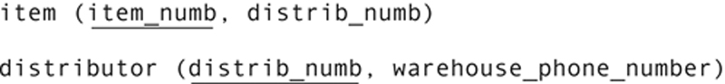
The theoretical definition of third normal form says:
▪ The relation is in second normal form.
▪ There are no transitive dependencies.
The functional dependencies found in the original relation are an example of a transitive dependency.
Transitive Dependencies
A transitive dependency exists when you have the following functional dependency pattern:
This is precisely the case with the original items relation. The only reason that the warehouse phone number is functionally dependent on the item number is because the distributor is functionally dependent on the item number, and the phone number is functionally dependent on the distributor. The functional dependencies are really:
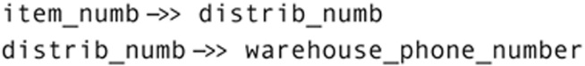
Note: Transitive dependencies take their name from the transitive property in mathematics, which states that if a > b and b > c, then a > c.
There are two determinants in the original items relation, each of which should be the primary key of its own relation. However, it is not merely the presence of the second determinant that creates the transitive dependency. What really matters is that the second determinant is not a candidate key (could be used as a primary key) for the relation.
Consider, for example, this relation:
The item number is an arbitrary number that Antique Opticals assigns to each merchandise item. The UPC is an industry-wide code that is unique to each item as well. The functional dependencies in this relation are:
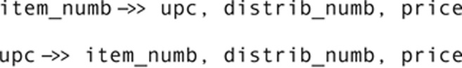
Is there a transitive dependency here? No, because the second determinant is a candidate key. (Antique Opticals could just as easily have used the UPC as the primary key.) There are no insertion, deletion, or modification anomalies in this relation; it describes only one entity—the merchandise item.
A transitive dependency therefore exists only when the determinant that is not the primary key is not a candidate key for the relation. For example, in the items table we have been using as an example, the distributor is a determinant, but not a candidate key for the table. (There can be more than one item coming from a single distributor.)
When you have a transitive dependency in a 2NF relation, you should break the relation into two smaller relations, each of which has one of the determinants in the transitive dependency as its primary key. The attributes determined by the determinant become nonkey attributes in each relation. This removes the transitive dependency—and its associated anomalies—and places the relation in third normal form.
Note: A second normal form relation that has no transitive dependencies is, of course, automatically in third normal form.
Let’s now try to normalize a student enrollments table that violates the 3NF
Problem: Unnormalized Student Enrollment Table
We have a badly designed enrollments table that violates 3NF:
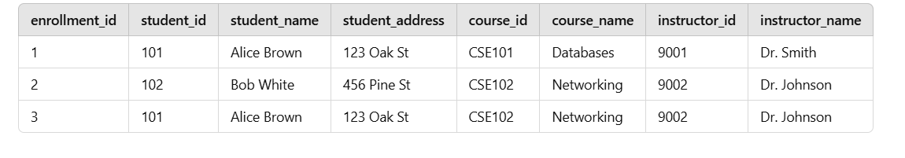
Problems in This Table (Not 3NF)
- Transitive Dependencies:
- student_name and student_address depend on student_id, not on enrollment_id.
- course_name depends on course_id, and instructor_name depends on instructor_id, not on enrollment_id.
- Data Redundancy:
- Alice Brown's name and address repeat in multiple rows.
- The course name and instructor details are duplicated.
Solution: Normalize to 3NF by Breaking it into Three Tables!
3NF-Compliant Schema
Task:
Create the appropriate tables that are compliant with the 3NF
You should have four tables created:
Students table: student_id, student_name, student_address (Why? This table stores student details once, avoiding redundant data.)
Courses table: course_id, course_name, instructor_id (Why? Stores course details separately.)
Instructors Table: instructor_id, instructor_name (Why? Stores instructor details separately.)
Enrollments Table (Bridging Table): enrollment_id, student_id, course_id,
FOREIGN KEY (student_id) REFERENCES students(student_id), FOREIGN KEY (course_id) REFERENCES courses(course_id) (Why? Avoids repeating student and course details, Links students to courses.)
Insert values into all the four tables and take screenshots of all the four tables with all the values in each of them
Labels:
08(a) – normalization_3NF_Students and 08(b) – normalization_3NF_Instructors
08(c) – normalization_3NF_Courses and 08(d) – normalization_3NF_Enrollmenments

Submission:
All the screenshots should be placed inside a pdf file and submitted.
Please do not submit individual screenshots

