PWC Azure China Private DNS Automation
Deployment, operation, and troubleshooting guide
Automates Private DNS operations for PWC on Azure China:
- Sync-PrivateEndpointPrivateDns syncs supported Private Endpoint DNS zones from a source subscription to the default destination subscription.
- Repair-AksPrivateDnsLinks links AKS private DNS zones to the default FCS VNet.
Both runbooks are deployed by Deploy-SyncPrivateEndpointPrivateDnsAutomation.ps1.

Defaults
Setting | Default
Destination subscription | 65a9c0da-4f85-47ba-ac0f-7401cbe43205
AKS target VNet | /subscriptions/65a9c0da-4f85-47ba-ac0f-7401cbe43205/resourceGroups/RGP-P0001-CN-AZ-FCS-0005/providers/Microsoft.Network/virtualNetworks/vNet-P0001-CN-AZ-FCS-0005
AKS private DNS suffix | .cx.prod.service.azk8s.cn

Override these only when needed.

1. Install local modules
Install-Module Az.Accounts -Scope CurrentUser
Install-Module Az.Resources -Scope CurrentUser
Install-Module Az.Automation -Scope CurrentUser
If Az.Automation requires a newer Az.Accounts, update the modules and start a new PowerShell session.

2. Deploy both Automation runbooks
.\Deploy-SyncPrivateEndpointPrivateDnsAutomation.ps1 `
-SubscriptionId "<automation-account-subscription-id>" `
-ResourceGroupName "rg-dns-sync-automation" `
-AutomationAccountName "aa-dns-sync-cn-prod" `
-Location "chinaeast2" `
-SourceSubscriptionId "<default-source-subscription-id>" `
-UserAssignedManagedIdentityResourceId "/subscriptions/<identity-subscription-id>/resourceGroups/<identity-resource-group>/providers/Microsoft.ManagedIdentity/userAssignedIdentities/<identity-name>"
This publishes:
- Sync-PrivateEndpointPrivateDns
- Repair-AksPrivateDnsLinks
The deploy script also saves Automation variables for the default source subscription, destination subscription, managed identity client ID, and AKS target VNet.

Optional deployment overrides
-DestinationSubscriptionId "<destination-subscription-id>"
-AksTargetVirtualNetworkResourceId "/subscriptions/<subscription-id>/resourceGroups/<resource-group>/providers/Microsoft.Network/virtualNetworks/<vnet-name>"

3. Optional: assign recommended RBAC
Run this only if the managed identity does not already have the required permissions.
.\Deploy-SyncPrivateEndpointPrivateDnsAutomation.ps1 `
-SubscriptionId "<automation-account-subscription-id>" `
-ResourceGroupName "rg-dns-sync-automation" `
-AutomationAccountName "aa-dns-sync-cn-prod" `
-Location "chinaeast2" `
-SourceSubscriptionId "<default-source-subscription-id>" `
-UserAssignedManagedIdentityResourceId "/subscriptions/<identity-subscription-id>/resourceGroups/<identity-resource-group>/providers/Microsoft.ManagedIdentity/userAssignedIdentities/<identity-name>" `
-AssignRecommendedRoles `
-GrantSourceNetworkContributor `
-GrantDestinationContributor
Recommended roles:
- Source subscription: Reader; optional Network Contributor for private endpoint zone-group linking.
- Destination subscription: Private DNS Zone Contributor; optional Contributor if the runbook may create missing resource groups.

4. Run from Azure Portal

Step 1: Open the Automation Account
In the Azure China portal, open Automation Accounts and select the Automation Account where the runbooks were deployed, for example nga-automation-dns-sync.
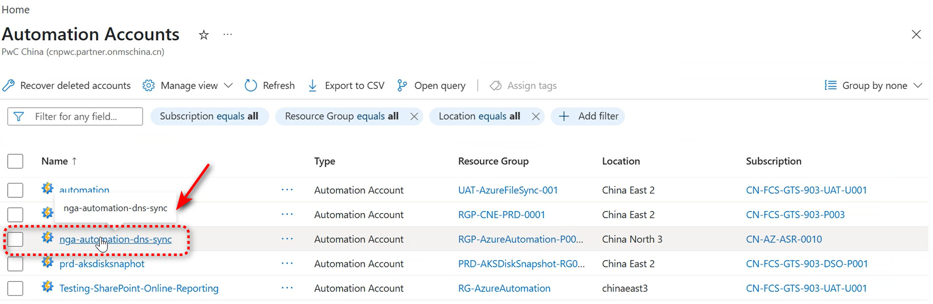
Select the Azure Automation Account

Step 2: Select the runbook
Under Process Automation, select Runbooks, and then select the published runbook for the required operation:
Runbook | Use it for
Repair-AksPrivateDnsLinks | Repairing AKS private DNS virtual network links.
Sync-PrivateEndpointPrivateDns | Handling other supported Azure China PaaS private endpoint DNS zones, including PostgreSQL.

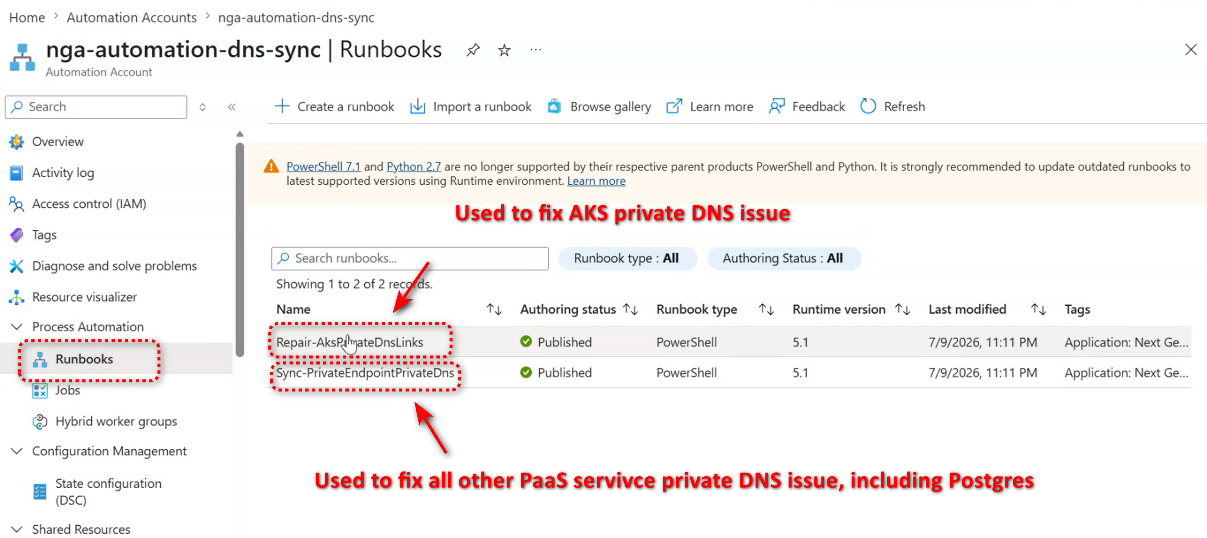
Select the AKS repair or private endpoint DNS sync runbook

Step 3: Enter the source subscription and start
Select Start, enter the source workload subscription ID in SourceSubscriptionId, and then select Start at the bottom of the parameters pane. This is the subscription containing the private endpoints, private DNS zones, or AKS resources that the runbook must process.
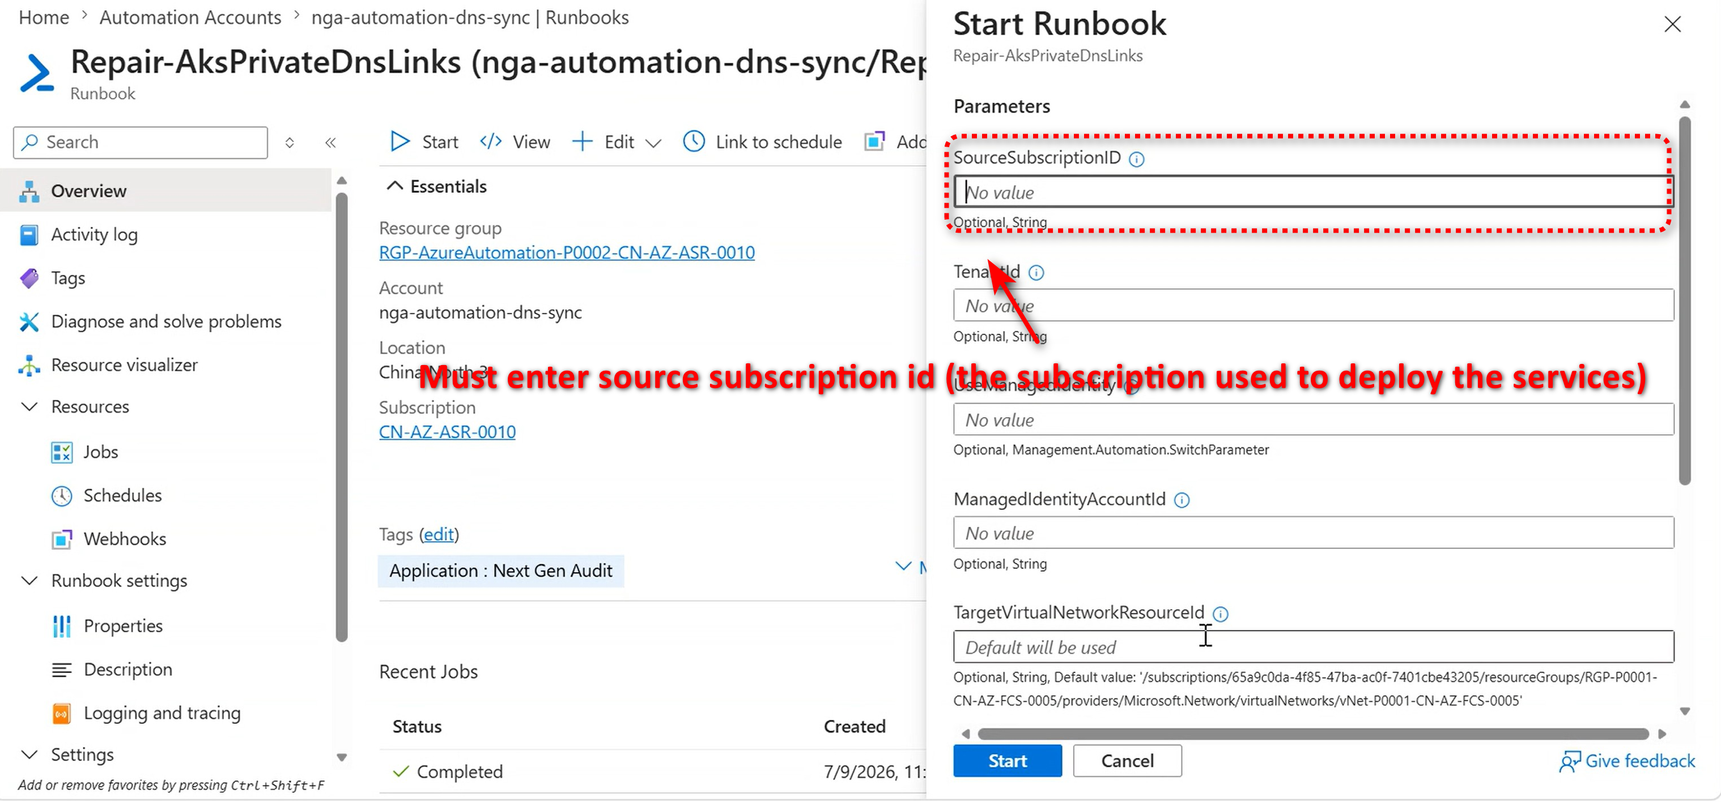
Enter SourceSubscriptionId and start the runbook
After the job starts, open the job details to review its Output, Warning, Error, and Verbose streams. The deployment script enables verbose logging for the published runbooks so that stage counts, operation summaries, and completion duration are retained.
For multiple source subscriptions, start the relevant runbook once per source subscription.

5. Schedule the sync runbook
New-AzAutomationSchedule `
-ResourceGroupName "rg-dns-sync-automation" `
-AutomationAccountName "aa-dns-sync-cn-prod" `
-Name "daily-private-endpoint-dns-sync" `
-StartTime (Get-Date).AddHours(1) `
-DayInterval 1
Register-AzAutomationScheduledRunbook `
-ResourceGroupName "rg-dns-sync-automation" `
-AutomationAccountName "aa-dns-sync-cn-prod" `
-RunbookName "Sync-PrivateEndpointPrivateDns" `
-ScheduleName "daily-private-endpoint-dns-sync"
For multiple source subscriptions, register one scheduled run per source:
Register-AzAutomationScheduledRunbook `
-ResourceGroupName "rg-dns-sync-automation" `
-AutomationAccountName "aa-dns-sync-cn-prod" `
-RunbookName "Sync-PrivateEndpointPrivateDns" `
-ScheduleName "daily-private-endpoint-dns-sync" `
-Parameters @{ SourceSubscriptionId = "<source-subscription-id>" }

What the sync runbook does
Sync-PrivateEndpointPrivateDns processes all supported Azure China private DNS zones.
For each source DNS A record:
- If a matching source private endpoint exists, the runbook links that private endpoint to the destination private DNS zone.
- If no matching private endpoint exists, the runbook directly syncs the destination A record.
- For directly synced records, it writes a provenance TXT record.
- If the source record or source zone later disappears, stale destination records/IPs previously managed by this script are removed.
Cleanup is safe by design: it only touches destination records with this script's provenance TXT marker and matching SourceSubscriptionId, source zone, and source record metadata. Unmanaged IPs are preserved.
If source and destination tenants differ, the runbook automatically uses direct DNS record sync because private endpoint zone-group linking requires a single tenant.

What the AKS repair runbook does
Repair-AksPrivateDnsLinks scans AKS private DNS zones ending with .cx.prod.service.azk8s.cn in the source subscription and ensures each matching zone is linked to the target VNet.
Local preview:
.\Repair-AksPrivateDnsLinks.ps1 -WhatIf
Override source subscription locally:
.\Repair-AksPrivateDnsLinks.ps1 `
-SourceSubscriptionId "<source-subscription-id>"

Local sync preview
.\Sync-PrivateEndpointPrivateDns.ps1 `
-SourceSubscriptionId "<source-subscription-id>" `
-WhatIf

Troubleshooting
Both runbooks emit timestamped tracing logs for:
- subscription selection
- zone and record counts
- private endpoint matching
- stale cleanup checks
- deleted/pruned destination record names and IPs
- operation summaries
- duration
- unhandled error details
Import or verify Az.Accounts and Az.Resources in the Automation Account before running the runbooks.

