| **The Link Your Class** | **<[https://bbs.csdn.net/forums/MUEE308FZU202201](https://bbs.csdn.net/forums/MUEE308FZU202201" \t "https://bbs.csdn.net/topics/_blank) >** |
| --- | --- |
| The Link of Requirement of This Assignment | [https://bbs.csdn.net/topics/608734907](https://bbs.csdn.net/topics/608734907" \t "https://bbs.csdn.net/topics/_blank) |
| The Aim of This Assignment | Solve the problem lab1_2 |
| MU STU ID and FZU STU ID | <20122616_832001208> |

# **1 PSP form**

| **Personal Software Process Stages** | **Estimated Time/minutes** | **Completed Time/minutes** |
| --- | --- | --- |
| Planning | 30 | 30 |
| Estimate | 20 | 25 |
| Development | 30 | 30 |
| Analysis | 90 | 90 |
| Design Spec | 80 | 80 |
| Design Review | 30 | 30 |
| Coding Standard | 30 | 30 |
| Design | 30 | 30 |
| Coding | 30 | 30 |
| Code Review Planning | 40 | 40 |
| Test | 20 | 25 |
| Reporting | 35 | 40 |
| Test Report | 70 | 80 |
| Size Measurement | 30 | 40 |
| Postmortem&Process Improvement | 30 | 30 |
| total | 595 | 630 |
|  |  |  |

# ****2.GitHub repository****

https://github.com/huangzichenNIUBI233/huangzichenN233N233

# **3. Problem-solving ideas**

From all the programming languages I have learned, I think the ideal programming language is c++. Because the code is readable. Good reusability. Portable. C++ is designed to eliminate the need for complex programming environments. High operation efficiency, high efficiency and safety. The language is concise and the writing style is free. The standard library stl is provided. Object oriented mechanism. Many excellent programming frameworks including Boost, Qt, MFC, OWL, wxWidgets, and WTL use C++.

# **4. Design and implementation process && code description**

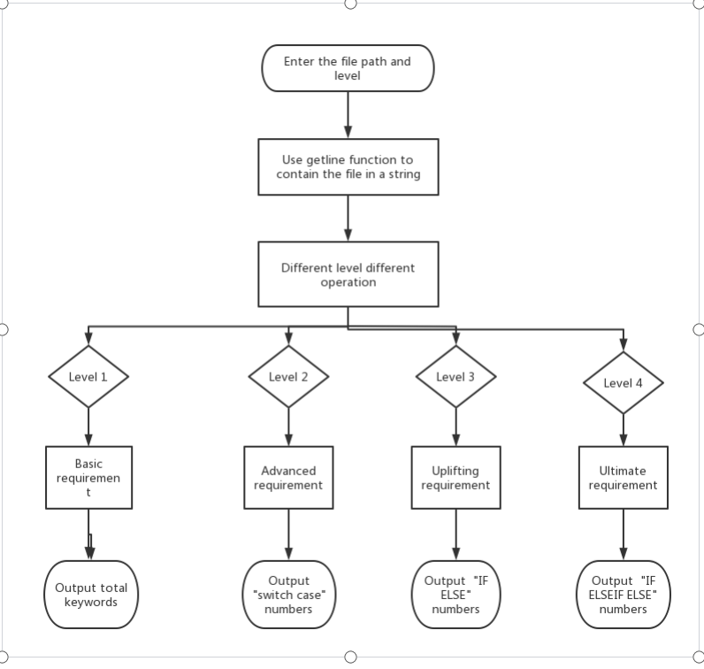

1. ****Open the C file****

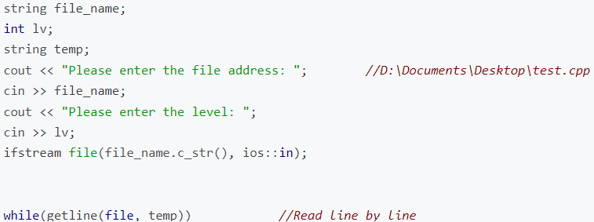

1. ****Verity function****

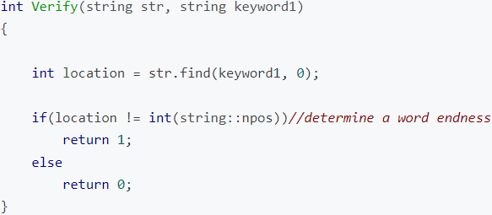

1. ****String required for Basic Requirements and Advanced Requirements****

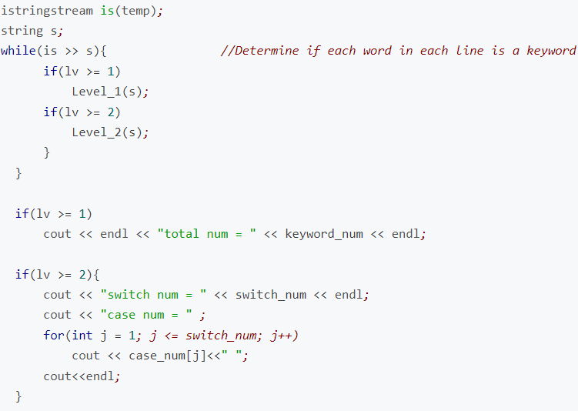

1. ****String needed to Uplifting and Ultimate requirements****

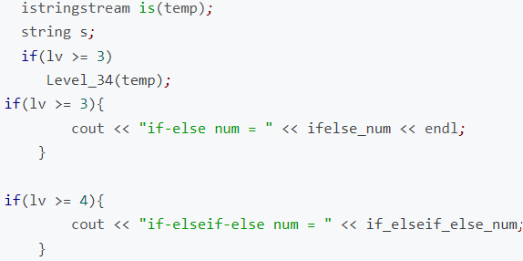

**Basic requirement**

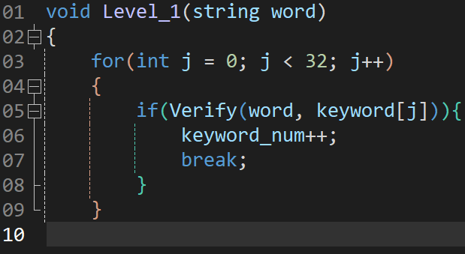

## ****Advanced requirement****

## ****Uplifting requirement and Ultimate requirement****

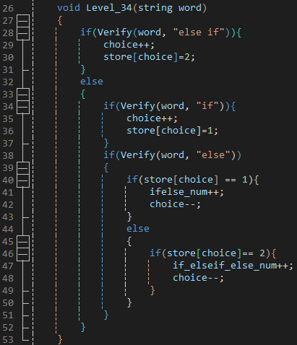

Output

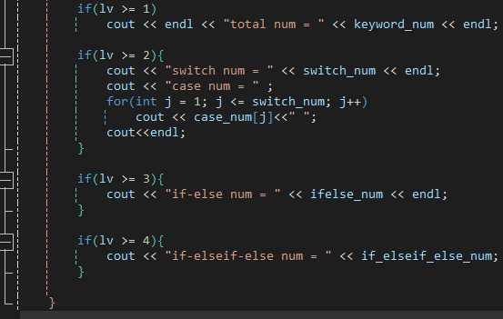

# **5.Test screenshots and description**

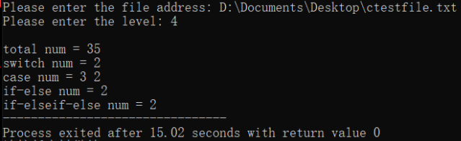

**6.summary**

**The result are all the correct with the reference ,Using regular expressions can simplify the code as much as possible.This is the first time in my life I've ever used a PSP form. I find that the actual completion time is almost always longer than my estimated time, so I think my ability needs to be improved, which needs training. I use c++ because I have a good command of it. The use of flow chart has given me great benefits, I can clearly understand the before and after and logical relationship between the steps. I searched for a lot of relevant code, which helped me with my programming to, but I still need to compile and revise the code to achieve the desired effect.**