AI Assisted Implementation and Evaluation of
Density Aware Evidential Deep Learning
CISC3024 Pattern Recognition
AI Assignment #2
October 2026
Prepared through an AI-assisted workflow with Codex

1 Introduction
Image classifiers produce probability-like scores, but a high maximum score does not by itself show that the model knows when it may be wrong. This assignment used Codex to identify, implement, and evaluate a recent probability-based recognition method. The selected method was Density Aware Evidential Deep Learning (DAEDL), published at ICML 2024 [1].
The research question was: how does DAEDL compare with a conventional Softmax classifier in classification performance, calibration, prediction-error uncertainty, and out-of-distribution uncertainty in an assignment-scale CIFAR-10 experiment?
The three-seed results show a limited trade-off rather than an overall DAEDL advantage. Softmax achieved higher accuracy (0.9013 ± 0.0004 versus 0.8902 ± 0.0012) and better NLL and Brier score. DAEDL achieved lower ECE in every seed (0.0261 ± 0.0030 versus 0.0463 ± 0.0031). Both methods assigned greater entropy to mistakes, while Softmax had a small error-AUROC advantage. SVHN OOD rankings changed by seed, so the experiment did not establish a stable OOD winner.

2 AI Assisted Algorithm Search and Selection
Codex was asked to find a recent classification or recognition algorithm grounded in probability or Bayesian theory. It filtered candidates using publication date, relevance to computer-vision classification, access to a primary paper and implementation, computational feasibility on a laptop, and whether the method supported a clear comparison with a conventional baseline.
DAEDL met these criteria because it predicts a Dirichlet distribution, models density in learned feature space, and reports classification, calibration, error detection, and OOD experiments [1]. It was recent, directly relevant to image recognition, and small enough to adapt into a controlled CIFAR-10 study.
Codex checked the official PMLR record, the paper, and the authors' repository. It did not treat the repository as a ready-made solution: the audit found CUDA assumptions, incomplete environment information, missing released checkpoints, and reproducibility gaps. A clean implementation was therefore used, with the official code serving as a method reference [7]. Conventional evidential deep learning [2] and calibration work [3] supplied the background needed to interpret the method and metrics.

3 Algorithm Description

3.1 Softmax classification
A neural classifier maps an input image x to class logits. Softmax exponentiates and normalizes those logits to obtain one probability vector. The largest entry determines the predicted class. The operation guarantees non-negative probabilities summing to one, but it does not model a distribution over possible probability vectors.
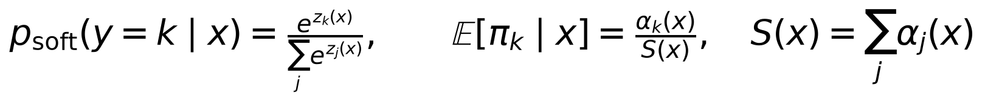
The second expression above is the evidential counterpart. A Dirichlet random variable π represents uncertainty over categorical probability vectors, and its mean gives the predictive class probability. The total concentration S controls how tightly the Dirichlet mass is concentrated.

3.2 Evidential training
Conventional EDL converts non-negative evidence into Dirichlet concentrations and trains a deterministic neural network to predict evidence [2]. DAEDL changes the training parameterization to an exponential of each logit. Once normalized by total strength, these concentrations produce exactly the Softmax probabilities during training. The loss combines expected squared classification error, predictive variance, and a KL regularizer that suppresses misleading evidence.
The local implementation averages the complete per-example objective. This scales every component by the same batch-size factor, so the relative weight λ=0.05 is unchanged. Logits are clamped only at ±30 when exponentiated as an overflow guard.

3.3 Feature density
After neural-network training, DAEDL extracts the 128-dimensional penultimate feature h(x) for every training image. A full-covariance Gaussian is fitted to each class, and the empirical class proportions form a mixture density. Training log-density extrema define a clipped score s(x) between zero and one.
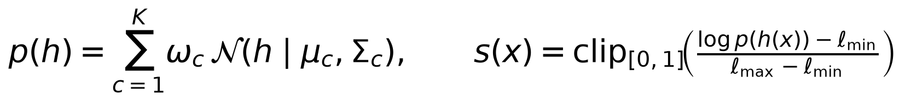
A test embedding near the fitted training features receives a larger density score. A distant embedding receives a smaller score. Because full covariance and log-density calculations are sensitive to numerical precision, the implementation performs this stage on CPU in float64 and adds scale-relative diagonal jitter when Cholesky factorization requires it.

3.4 Density aware prediction
At inference, DAEDL multiplies each logit by the density score before constructing the Dirichlet concentrations. This is equivalent to an input-dependent temperature. As the score approaches zero, all concentrations approach one and the expected probabilities approach the uniform distribution.
This project used normalized predictive entropy as the primary common uncertainty score. The normalization places entropy in [0,1] for both methods, so the same error-detection and OOD metric code can be used.
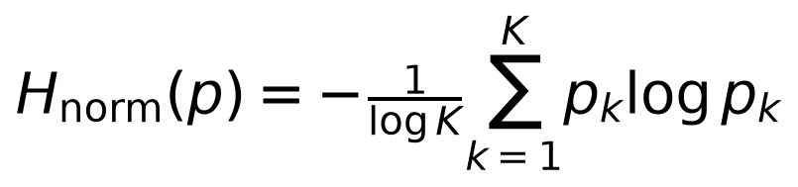
Figure 1. DAEDL inference pipeline used in this project. The diagram is original and was generated from the implemented method.
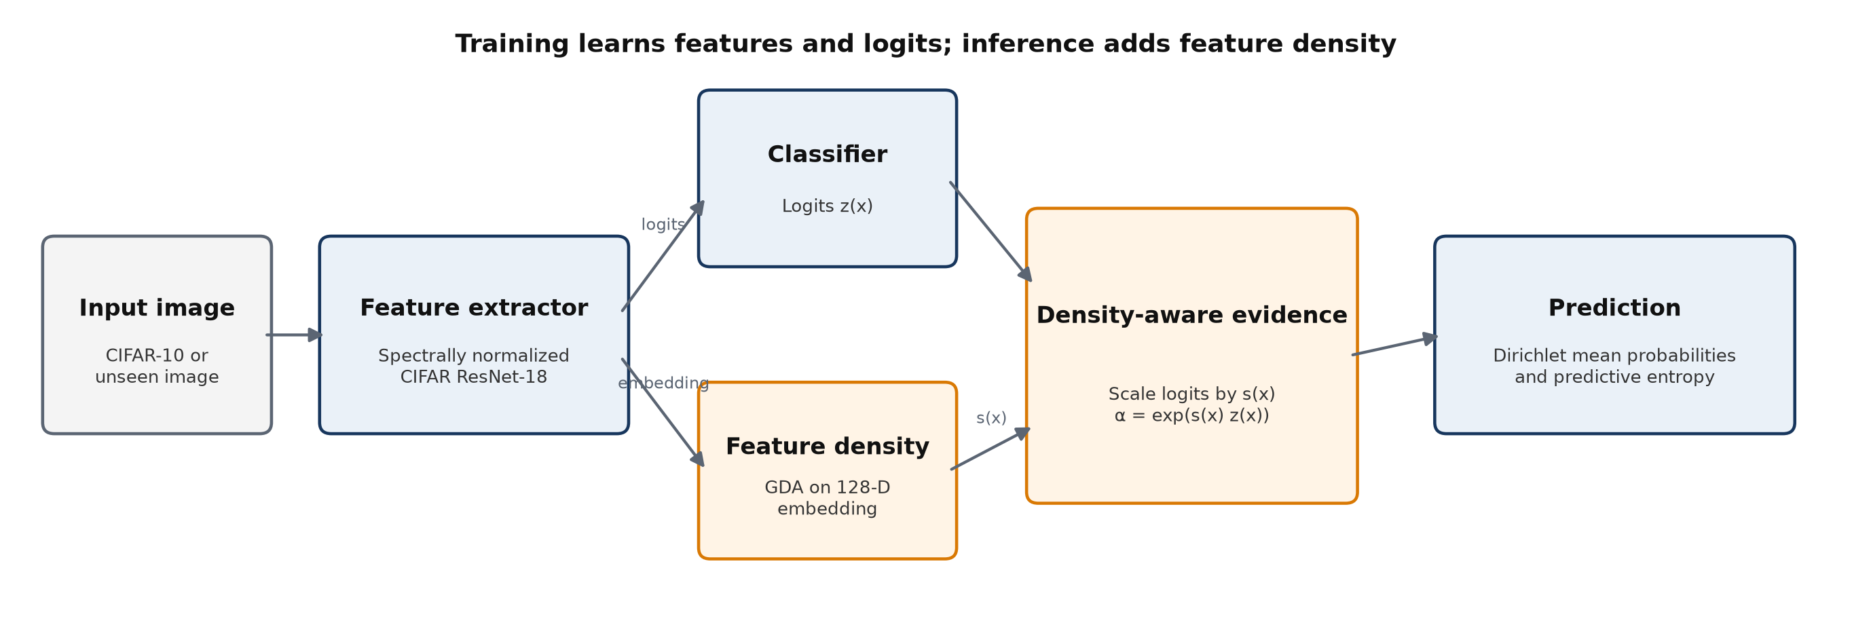

4 AI Assisted Implementation
Codex inspected the paper and official code, created an isolated Python 3.11 environment, and implemented the complete project. The code includes fixed stratified splits, indexed datasets, train-only augmentation, a CIFAR-adapted ResNet-18, Softmax cross-entropy, the DAEDL objective, CPU GDA, evaluation metrics, artifact logging, and plotting. Automated tests cover probability normalization, DAEDL gradients, calibration metrics, score direction, GDA fitting, split reproducibility, and model output shapes.
The pilot exposed a PyTorch MPS issue: reloaded spectral-normalized models could produce non-finite outputs during the observed post-training evaluation path, although CPU evaluation of the same checkpoint was finite. Final training therefore used MPS, while checkpoint evaluation and feature extraction used CPU. PyTorch documents that MPS cannot store float64 tensors, which independently requires the GDA stage to run on CPU [6].
Full-covariance matrices were rank deficient because some ReLU embedding coordinates were constant. The implementation used scale-relative diagonal loading and recorded global rank, per-class rank, jitter, training density range, and non-finite fraction. It did not change the architecture after seeing seed-3024 results. A training-only sensitivity check on that seed showed that removing globally constant dimensions did not materially change the primary outputs.
For experimental validity, Codex applied identical splits to both models within each seed, selected checkpoints by minimum validation NLL, saved both selected and final checkpoints, kept the test set out of model selection, and defined OOD as the positive class. Every final probability row, checkpoint label, metric, and density diagnostic was checked. The six-run audit and all 16 automated tests passed.

5 Experimental Setup
CIFAR-10 provided 45,000 training images, 5,000 validation images, and the untouched official 10,000-image test set [4]. SVHN supplied 10,000 deterministically selected OOD test images [5]. Both models used the same backbone, spectral normalization, augmentation, optimizer, schedule, epoch budget, and checkpoint rule. Seeds 3024, 3025, and 3026 controlled the stratified split and training randomness. The replicate unit is a training seed and model run; results are mean ± sample SD across three seeds.
Table 1. Frozen experimental configuration.
Setting | Value
Models | Softmax and DAEDL
Backbone | Spectrally normalized CIFAR ResNet-18, base width 32
Embedding | 128 dimensions
Split | 45,000 train / 5,000 validation / 10,000 test
Seeds | 3024, 3025, 3026
Optimizer | AdamW; initial LR 1e-3; weight decay 5e-4
Schedule | Cosine decay to 1e-5 over 30 epochs
Batch size | 64
Selection | Minimum validation NLL
Hardware | Apple M5 MacBook Air; 16 GB unified memory
Devices | MPS training; CPU evaluation and float64 GDA
OOD protocol | CIFAR-10 ID; SVHN OOD; normalized entropy; OOD positive
Classification uses accuracy and Macro F1. Calibration uses negative log-likelihood (NLL), 15-bin expected calibration error (ECE), and multiclass Brier score. Error detection and OOD detection use normalized predictive entropy with AUROC and average precision (AUPR). Lower values are preferable for NLL, ECE, and Brier; higher values are preferable for accuracy, F1, AUROC, and AUPR.

6 Results

6.1 Classification and calibration
Table 2. Clean CIFAR-10 classification and calibration. Values are mean ± sample SD across three training seeds.
Metric | Softmax | DAEDL | Preferred direction
Accuracy | 0.9013 ± 0.0004 | 0.8902 ± 0.0012 | Higher
Macro F1 | 0.9012 ± 0.0004 | 0.8899 ± 0.0011 | Higher
NLL | 0.3367 ± 0.0059 | 0.4328 ± 0.0017 | Lower
ECE-15 | 0.0463 ± 0.0031 | 0.0261 ± 0.0030 | Lower
Brier score | 0.1504 ± 0.0014 | 0.1718 ± 0.0005 | Lower
Softmax was consistently about one percentage point more accurate. Its accuracy exceeded DAEDL by 0.0099, 0.0130, and 0.0105 at seeds 3024, 3025, and 3026. Macro F1 followed the same pattern. Both methods nevertheless reached close to 89–90% accuracy in the compact 30-epoch setup.
DAEDL had lower ECE in every seed, but NLL and Brier score favored Softmax in every seed. The calibration metrics therefore do not all support the same ranking. ECE summarizes binned agreement between confidence and observed accuracy. NLL and Brier score are proper scoring rules that evaluate the complete predictive distribution and respond differently to probability sharpness and errors.
Figure 2. Three-seed headline comparison. Points show individual seeds; black bars show mean ± sample SD.
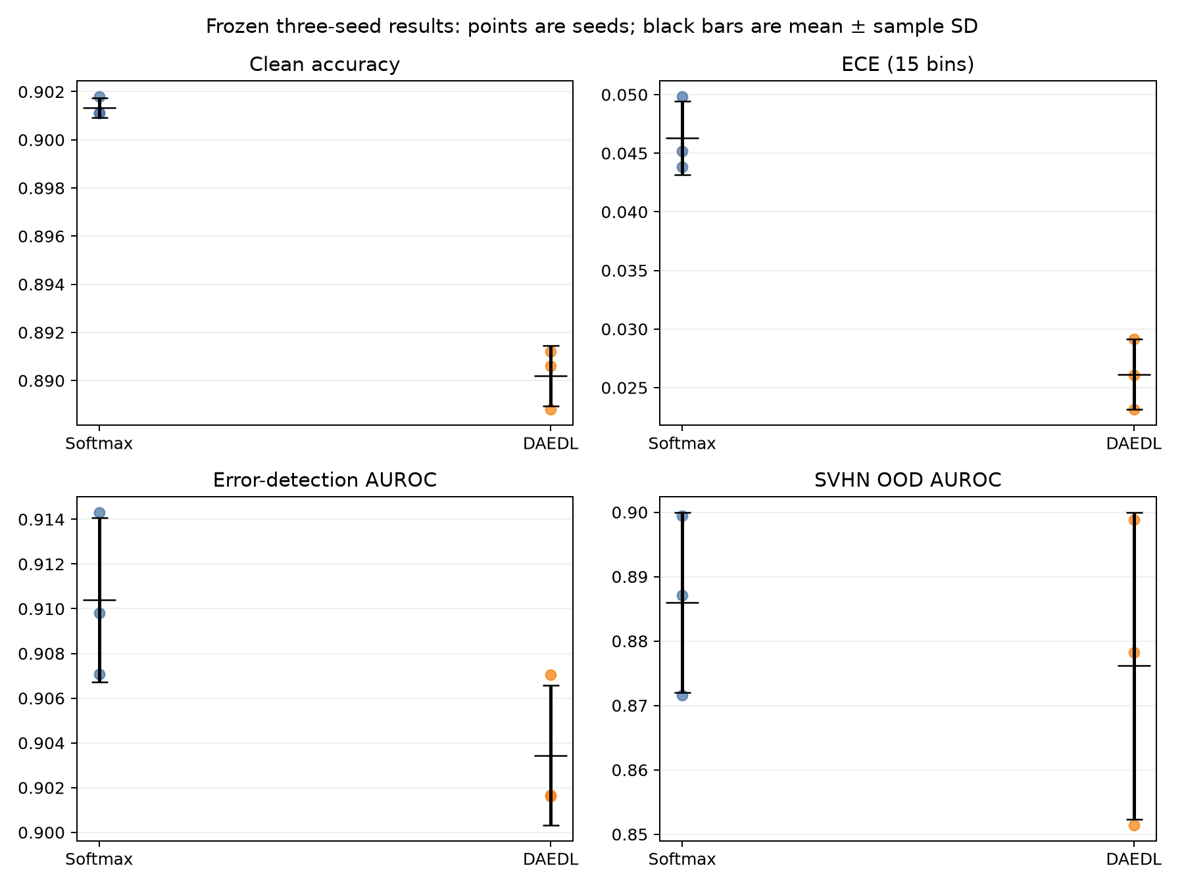

6.2 Reliability
The seed-3024 reliability diagram illustrates why a single calibration summary needs context. DAEDL tracks the ideal diagonal more closely in several high-confidence bins, consistent with its lower ECE. The plot is illustrative rather than aggregate: bins with fewer than 50 test examples are suppressed for readability, but ECE is still calculated from all 15 equal-width bins.
Figure 3. CIFAR-10 reliability at the predefined representative seed 3024.
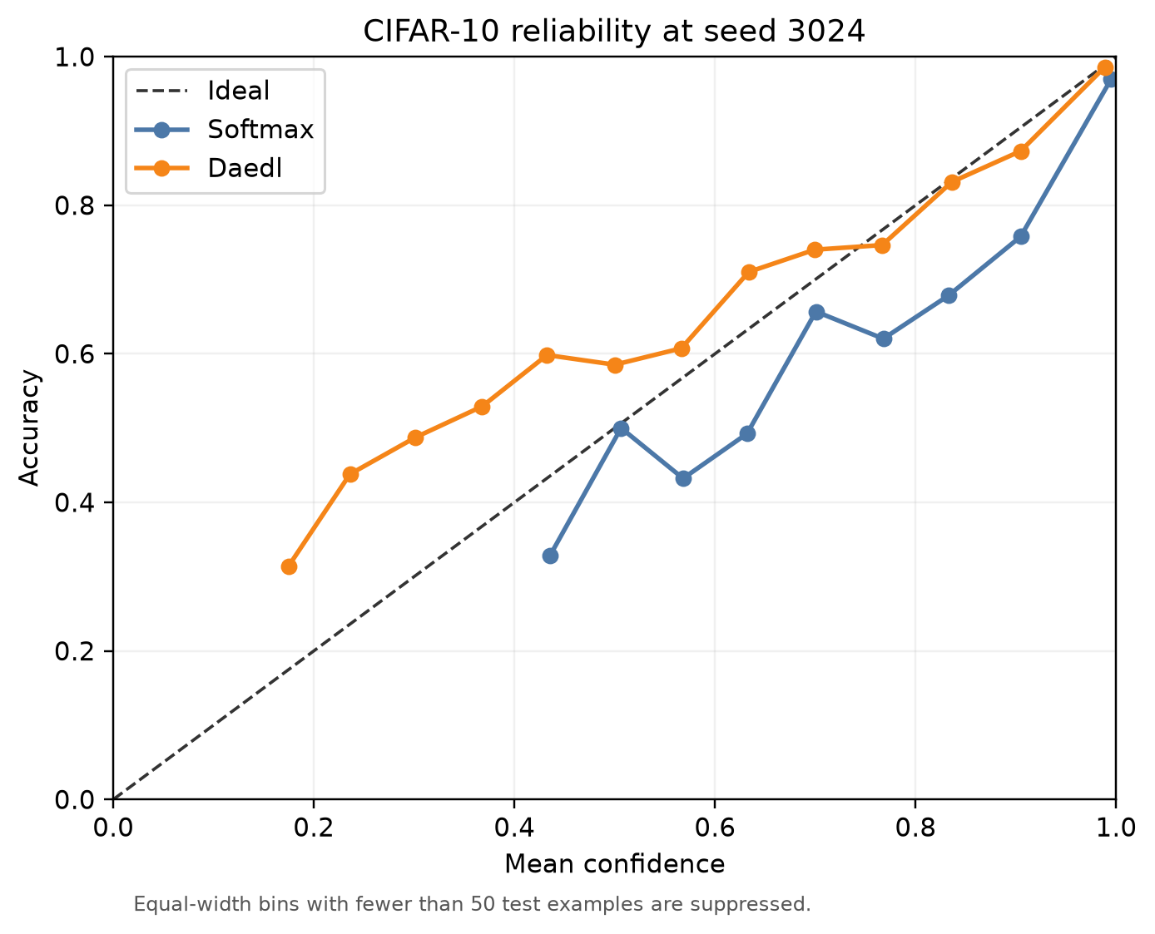

6.3 Prediction error uncertainty
Both methods assigned substantially greater normalized entropy to incorrect predictions. Across seeds, Softmax's correct and incorrect mean entropies were 0.0412 ± 0.0028 and 0.2658 ± 0.0102; DAEDL's were 0.1501 ± 0.0030 and 0.6515 ± 0.0052. The distributions therefore contain useful information about mistakes for both methods.
DAEDL's larger absolute entropy does not automatically mean better error detection. AUROC evaluates how well uncertainty ranks incorrect above correct predictions. Softmax had a small consistent AUROC advantage at every seed, while AUPR changed paired direction. The most defensible conclusion is that both methods detected errors well and Softmax ranked them slightly better under AUROC.

6.4 SVHN out of distribution uncertainty
Table 3. Error and SVHN OOD detection using normalized predictive entropy. Values are mean ± sample SD across three seeds.
Metric | Softmax | DAEDL
Error AUROC | 0.9104 ± 0.0037 | 0.9034 ± 0.0031
Error AUPR | 0.4926 ± 0.0202 | 0.4958 ± 0.0081
SVHN OOD AUROC | 0.8860 ± 0.0140 | 0.8762 ± 0.0238
SVHN OOD AUPR | 0.8296 ± 0.0234 | 0.7964 ± 0.0377
DAEDL consistently assigned greater entropy to SVHN than to CIFAR-10: its ID and OOD mean entropies were 0.2052 ± 0.0016 and 0.6840 ± 0.0657. Softmax showed the same direction at a lower absolute scale. However, method ranking was seed dependent. Softmax had higher OOD AUROC at seeds 3024 and 3026, while DAEDL was higher at seed 3025. The aggregate values therefore do not establish a stable OOD winner.
DAEDL's secondary density-only uncertainty also lacked a consistent advantage over its entropy score. Density AUROC was 0.8641, 0.8420, and 0.8498 at seeds 3024–3026. It exceeded DAEDL entropy only at seed 3024. This negative result is retained because the evaluation protocol was frozen before the replications.
Figure 4. Normalized predictive-entropy distributions at seed 3024. Numeric conclusions use all three seeds.
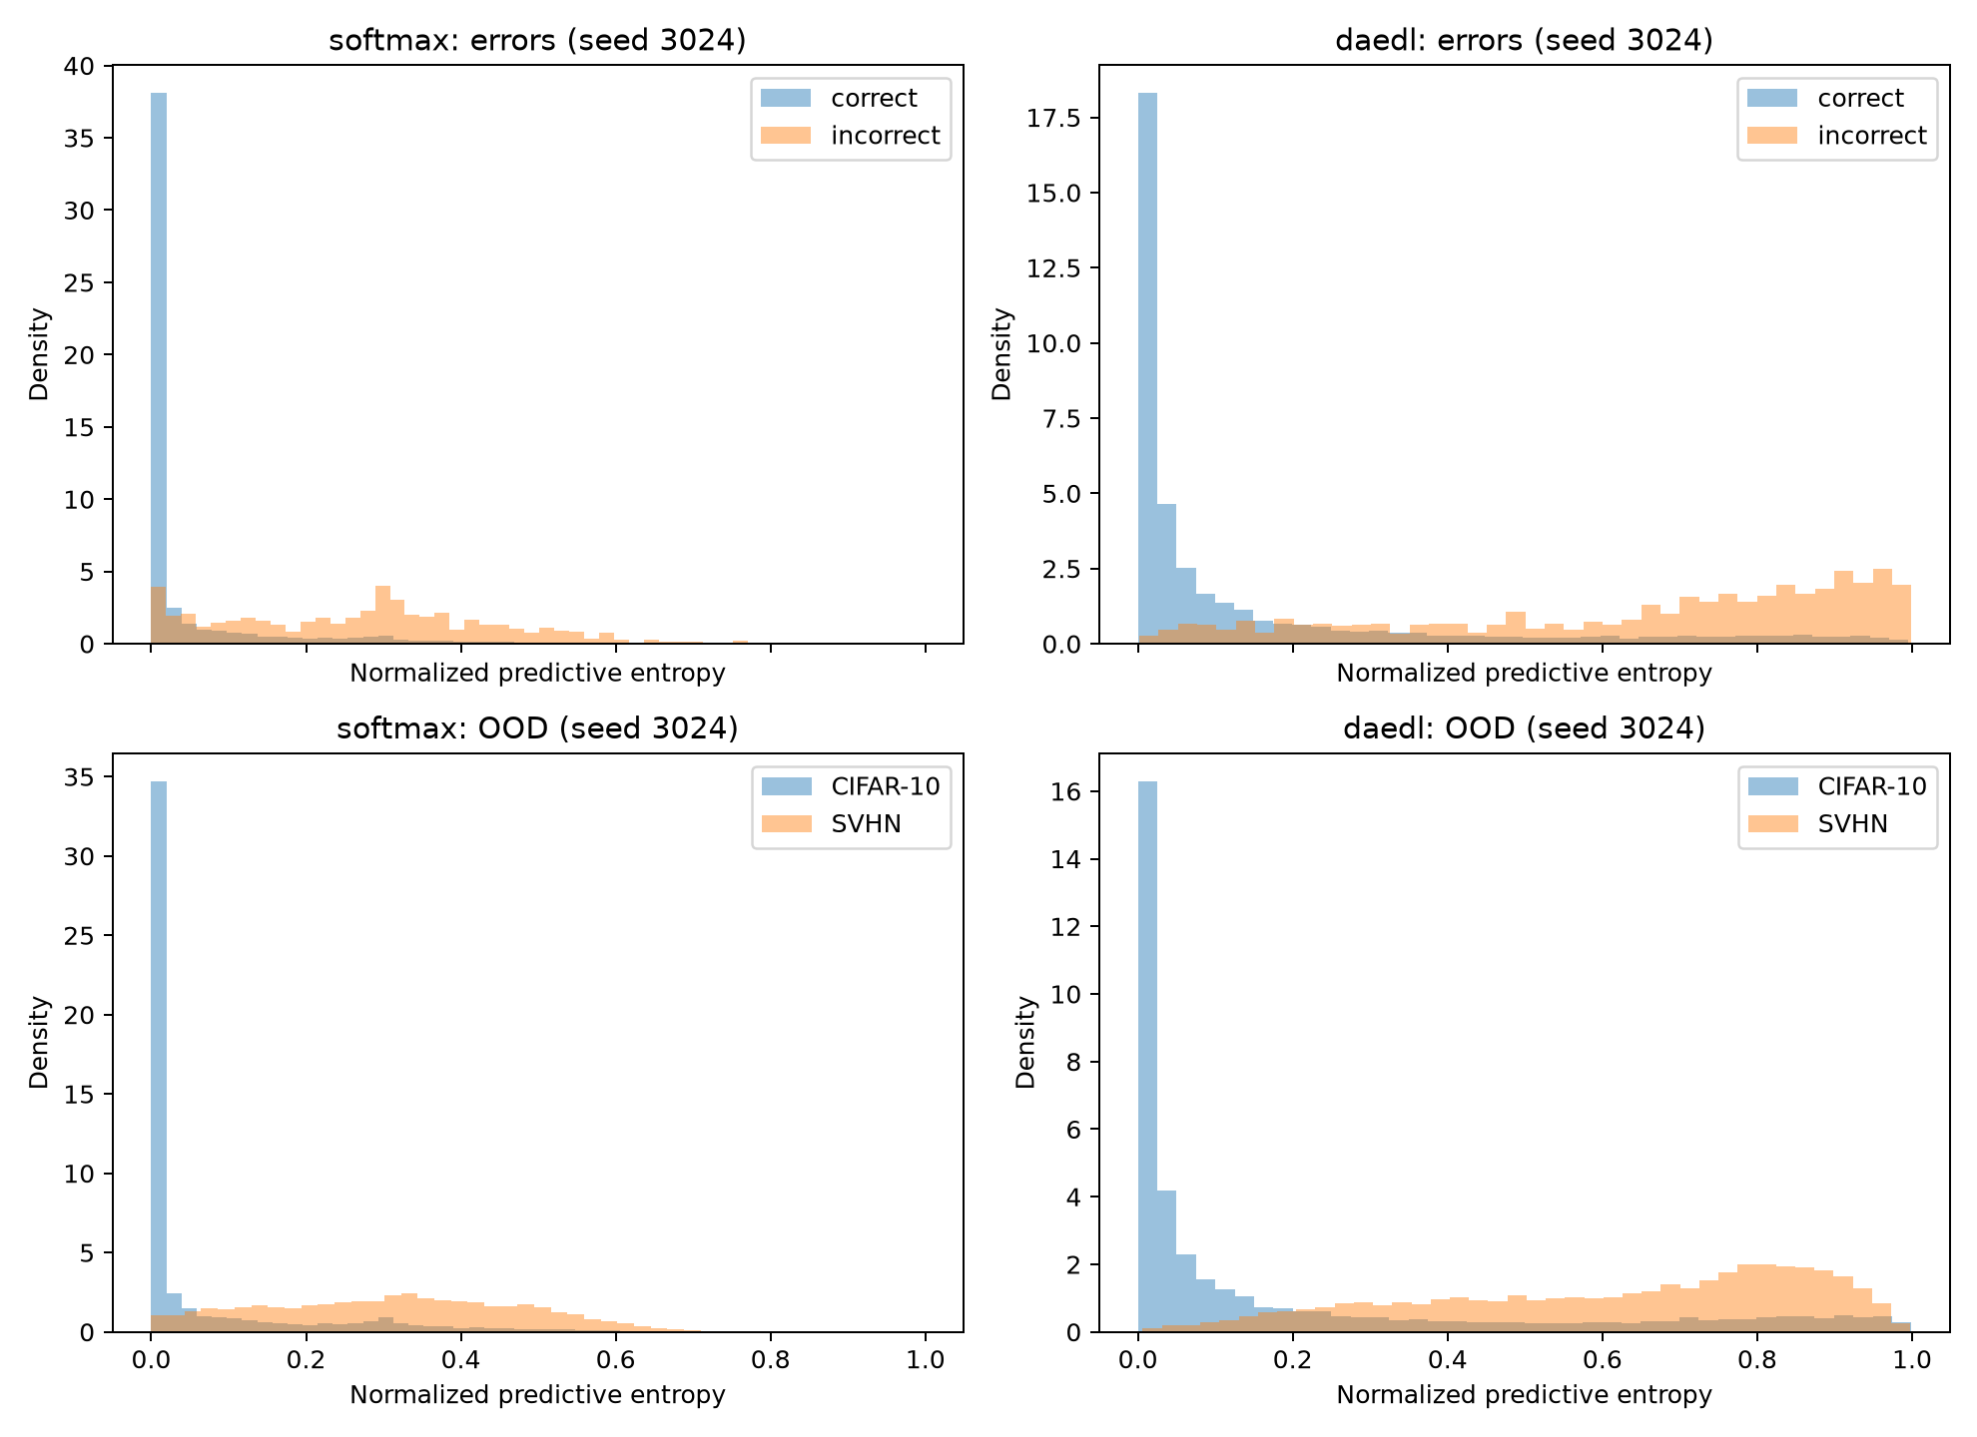

7 Discussion

7.1 Accuracy and uncertainty
DAEDL added a structured probabilistic representation without improving clean classification in this setup. This is not an implementation failure: every run completed, checkpoint validation passed, and the classification differences repeated across seeds. The result shows that a dedicated uncertainty mechanism does not guarantee a better classifier.

7.2 Calibration is multi dimensional
DAEDL's ECE advantage and Softmax's NLL/Brier advantages coexist because the metrics measure different properties. Reporting only ECE would make DAEDL appear generally better calibrated, while reporting only NLL would hide its more favorable binned confidence-frequency agreement. The accurate statement is narrower: DAEDL improved ECE, while Softmax remained stronger under the two proper scoring rules.

7.3 Magnitude and usefulness
DAEDL produced higher entropy for correct, incorrect, ID, and OOD samples. That wider numerical range made mistakes and SVHN inputs visibly uncertain, but it did not reliably improve discrimination AUROC. The practical question is whether a score ranks risky inputs consistently, not simply whether its numeric value is larger.

7.4 Seed dependence
Multiple seeds materially changed the OOD interpretation. Seed 3024 alone suggested a clear Softmax advantage; seed 3025 reversed the ranking. The three-seed aggregate favors Softmax numerically, but the change in direction prevents a stable superiority claim. No significance test was added because three runs support descriptive consistency, not a persuasive estimate of a sampling distribution.

7.5 Assignment scale adaptation
The original DAEDL work used a different architecture and larger training setup [1]. This project used a compact ResNet-18, 128-dimensional embeddings, 30 epochs, and laptop hardware so that a matched three-seed comparison was feasible. It is an implementation and evaluation of the method's central ideas, not an exact reproduction of the paper's headline results.

8 Limitations
The evaluation uses one in-distribution dataset, one OOD dataset, and three seeds. It does not cover every corruption, architecture, or evidential baseline. No exhaustive hyperparameter search was performed, and settings were frozen before replications to avoid tuning to seed 3024. MPS and CPU adaptations differ from the authors' CUDA-oriented environment. The DAEDL feature space was rank deficient even though covariance stabilization remained finite.
Global centered embedding rank was 93, 99, and 101 out of 128, while constant dimensions were 35, 29, and 27. Per-class covariance ranks spanned 76–95. Jitter remained around 1e-8 to 1e-7 and every non-finite fraction was zero, so the density results are usable but the reduced-rank representation should remain visible as a limitation.
No corruption experiment was added after the three-seed study. This was a deliberate stopping decision: the core assignment questions were already answered, and adding another analysis after reviewing outcomes would have expanded the scope without resolving the seed-sensitive OOD ranking.

9 What I Learned
Before this assignment, I tended to read a classifier's probability as a direct statement of confidence. The experiment showed me that uncertainty needs separate evidence. A model can be accurate and still assign probabilities that do not match how often it is correct.
I learned that calibration is not a single number. DAEDL had lower ECE in every seed, which initially looks like a clear calibration advantage. NLL and Brier score gave the opposite ranking. This result helped me understand that ECE depends on confidence bins, while proper scoring rules evaluate the full probability distribution and penalize confident errors differently. I should therefore explain which calibration property a metric measures instead of using ‘better calibrated’ without qualification.
I also expected a method designed for uncertainty to outperform Softmax clearly on OOD detection. The seed results showed that this expectation was too simple. Softmax was better at seed 3024, DAEDL was better at seed 3025, and Softmax was better again at seed 3026. Had I stopped after the first run, I would have described the OOD comparison too confidently. Repeating the experiment did not merely make the result look more reliable; it changed the conclusion I was allowed to make.
The project also taught me that a larger uncertainty value is not automatically more useful. DAEDL produced much greater entropy on incorrect and SVHN inputs, but Softmax had slightly better error AUROC and a higher mean OOD AUROC. The separation between groups matters more than the absolute scale. This distinction is especially important when comparing models whose uncertainty scores arise from different parameterizations.
Using Codex did not remove the need for validation. Codex wrote the code and ran the experiments, but the workflow still needed tests for formulas and metrics, matched baselines, fixed checkpoint rules, checks for OOD score direction, probability normalization, and independent recomputation from saved predictions. The most useful AI behavior was not rapid code generation alone. It was the ability to inspect failures, record what changed, and preserve negative or mixed results rather than tuning them away.
Finally, I learned how theory meets hardware and numerical constraints. MPS could train the networks but not run float64 covariance calculations, and reloaded spectral-normalized checkpoints required CPU evaluation in this environment. Rank-deficient embedding covariances required adaptive diagonal loading and diagnostics. Reproducibility and numerical checks were therefore part of the experiment, not optional software details.

10 Conclusion
Codex successfully implemented DAEDL and compared it with a matched Softmax baseline across three CIFAR-10 seeds. DAEDL consistently reduced ECE, while Softmax remained stronger in accuracy, Macro F1, NLL, Brier score, and error-detection AUROC. Both methods assigned greater uncertainty to mistakes, and DAEDL assigned greater entropy to SVHN than CIFAR-10, but the OOD method ranking was not stable. The exercise demonstrated both the potential and limits of probabilistic uncertainty methods and showed why AI-generated implementation still requires careful experimental validation.

References
[1] Yoon, T., and Kim, H. (2024). “Uncertainty Estimation by Density Aware Evidential Deep Learning.” Proceedings of the 41st International Conference on Machine Learning, PMLR 235, 57217–57243. https://proceedings.mlr.press/v235/yoon24a.html
[2] Sensoy, M., Kaplan, L., and Kandemir, M. (2018). “Evidential Deep Learning to Quantify Classification Uncertainty.” Advances in Neural Information Processing Systems 31. https://papers.nips.cc/paper/2018/hash/a981f2b708044d6fb4a71a1463242520-Abstract.html
[3] Guo, C., Pleiss, G., Sun, Y., and Weinberger, K. Q. (2017). “On Calibration of Modern Neural Networks.” Proceedings of the 34th International Conference on Machine Learning, PMLR 70, 1321–1330. https://proceedings.mlr.press/v70/guo17a.html
[4] Krizhevsky, A. (2009). Learning Multiple Layers of Features from Tiny Images. Technical report, University of Toronto. https://www.cs.toronto.edu/~kriz/learning-features-2009-TR.pdf
[5] Netzer, Y., Wang, T., Coates, A., Bissacco, A., Wu, B., and Ng, A. Y. (2011). “Reading Digits in Natural Images with Unsupervised Feature Learning.” NIPS Workshop on Deep Learning and Unsupervised Feature Learning. https://ufldl.stanford.edu/housenumbers/nips2011_housenumbers.pdf
[6] PyTorch Contributors. “MPS backend.” PyTorch documentation. https://docs.pytorch.org/docs/main/notes/mps.html
[7] Yoon, T., and Kim, H. “DAEDL official implementation.” GitHub. https://github.com/TaeseongYoon/DAEDL

