EmoScope: A Privacy-Preserving Multimodal Emotion Support System on Android
Ziyang Huang 2025112735
School of Economics and Management, Harbin Institute of Technology
Abstract
EmoScope is a native Android prototype designed to support everyday emotional awareness through privacy-preserving multimodal sensing. The system combines on-device facial blendshape analysis, voice-based speech-rate and energy estimation, local longitudinal memory analysis, private user profiling, anonymous research export, and user-confirmed SOS support. CameraX streams are processed by MediaPipe FaceLandmarker to obtain 52 blendshape coefficients, which are mapped into ten emotion dimensions: joy, calm, surprise, contempt, sadness, anxiety, anger, fear, disgust, and fatigue. An exponentially weighted moving average filter reduces frame jitter, while a calibrated wellness score transforms emotion percentages into a 0-100 reflection index. Voice input is processed through Android SpeechRecognizer and an additional feature analyzer that estimates pace and RMS-based energy. Local records are stored in SQLite, and a memory engine summarizes recent patterns across a 30-day window. Recent revisions added confidence warnings, personal calibration, a local private profile, text sanitization, throttled light-state updates, safer export callbacks, UTF-8 output, and anonymized JSON/CSV research export. The application contains 37 Java source files, 142 drawable assets, seven layout files, and seven unit-test classes. Functional validation showed stable facial inference, visible reduction of emotion-score jitter, successful ten-emotion extraction on synthetic records, responsive manual SOS confirmation, and reliable anonymous export. The results support EmoScope as a technically feasible mobile wellness prototype, while also showing that it should be interpreted as a self-reflection tool rather than a clinical diagnostic system.
Key words: multimodal emotion recognition; Android; MediaPipe FaceLandmarker; privacy-preserving AI; mental wellness; local data export

Introduction
Mental wellness applications increasingly promise continuous self-reflection, but many still depend on manual mood diaries. This creates a practical gap. When users are tired, anxious, or busy, they are least likely to complete self-report forms, even though these moments may be the most useful for later reflection. A mobile system that can supplement self-report with lightweight passive signals may therefore improve continuity without asking the user to constantly describe feelings in words.
EmoScope was developed to explore this idea in a first-year software project. It is not intended to diagnose mental illness. Instead, it asks a narrower engineering question: can a smartphone combine facial expression cues, voice cues, recent records, and user-controlled safety functions into a coherent and privacy-conscious emotional support workflow? The answer matters because affective computing systems often fail not only through inaccurate models but also through unclear privacy boundaries and overconfident feedback.
The contribution of this project is threefold. First, it implements a complete Android pipeline for on-device facial analysis and voice-assisted reflection. Second, it translates raw sensing into cautious, interpretable feedback rather than opaque labels. Third, it adds private-profile, anonymous-export, and user-confirmed SOS mechanisms so that personalisation does not require a cloud account or automatic escalation. These choices make EmoScope a useful prototype for discussing both technical feasibility and responsible design.
Materials and Methods
EmoScope is implemented as a native Android application in Java. The interface is organized around four main areas: a home radar for immediate feedback, a history page for emotional trajectories, a workshop for self-regulation activities, and a settings page for private profile, privacy controls, notification settings, SOS contact, and data management. The code separates controllers, engines, custom views, storage utilities, and fragments so that sensing logic and interface logic can be tested independently.
The facial pipeline uses CameraX ImageAnalysis with a keep-latest backpressure strategy. MediaPipe FaceLandmarker runs in live-stream mode and returns 52 facial blendshape coefficients. EmoScope maps these coefficients into ten emotion dimensions with hand-designed weights. Joy, for example, is influenced by smile and cheek-squint coefficients; negative states draw on brow-down, mouth-press, nose-sneer, eye-wide, and jaw-related signals. Calm is treated as a residual baseline when no strong high-arousal signal dominates.
To improve stability, raw emotion scores are smoothed with an exponentially weighted moving average. A light-state update gate suppresses small luminance changes inside a short interval, reducing unnecessary UI refreshes. The current version also adds a confidence evaluator: low light, excessively bright light, or closely competing top emotions generate a warning that the result should be interpreted cautiously. Users can apply a personal calibration profile when one expression category is consistently weak or difficult to detect.
Voice input is handled by Android SpeechRecognizer in Chinese recognition mode. Earlier versions estimated only speech rate. The current version also stores RMS samples, average energy, peak energy, and sample count. The VoiceFeatureAnalyzer class classifies pace as slow, normal, or fast and energy as low, normal, or high. These features are sent to the feedback layer together with the transcript, facial summary, light condition, and recent memory records.
The local memory engine retrieves recent SQLite records and analyzes them within a 30-day window. It extracts ten-emotion percentages from structured records, calculates daily weighted scores, ranks stress and joy keywords, classifies the dominant affective pattern, compares the most recent week with the previous week, and computes the longest recording streak. The same records can be exported as ordinary backup data or as an anonymized research package. The research exporter replaces phone numbers, email addresses, and identity-number patterns, then writes JSON or CSV using UTF-8 encoding.
Privacy is treated as a system boundary rather than a short disclaimer. Raw facial frames remain on device. Personal profile fields such as nickname, identity label, focus goal, and preferred emotional wording are stored locally. The language model receives only structured textual context when the user requests feedback. The SOS subsystem has three entry points: manual button, shake detection, and negative-emotion cue. Facial analysis never contacts others automatically; it only makes the SOS affordance visible until the user confirms the action.
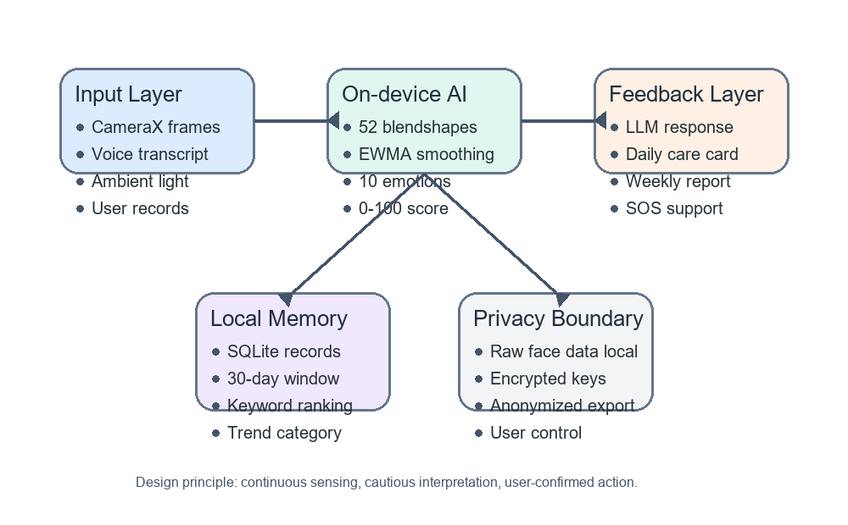
Figure 1 System architecture of EmoScope's multimodal emotion pipeline.
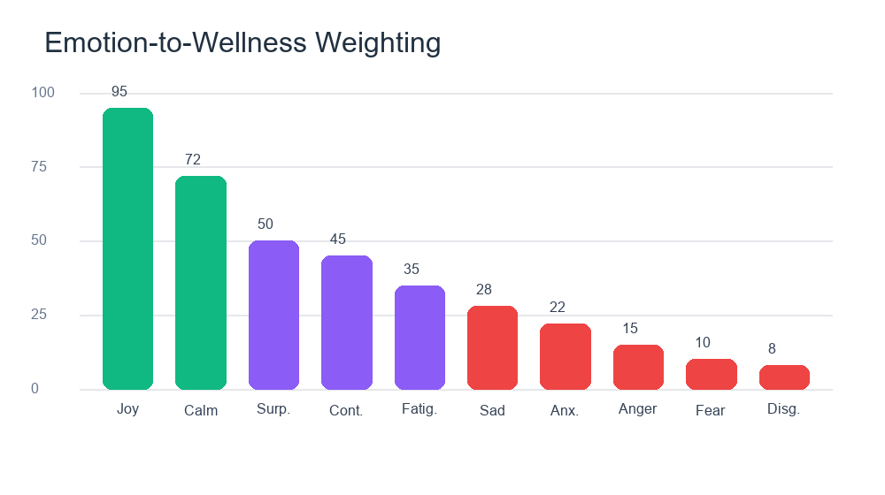
Figure 2 Emotion-to-wellness scoring model used by EmoScope.
The newest interface revision adds a private-profile card. The profile stores a nickname, identity label, focus goal, and preferred emotional expression locally. These fields do not create an online account and are not required for core sensing. Their purpose is to make the application feel personal without increasing data exposure. TextSanitizer normalizes these labels by trimming whitespace, collapsing line breaks, and limiting length so that user input cannot break compact cards or exported reports.
This design also responds to a common usability problem in wellness software: users do not always want to configure complex settings before receiving value. EmoScope therefore keeps the main interaction simple. A user can record by speaking, make a quick manual mood entry, or simply review automatically generated context. More sensitive controls, such as emergency contact, API key, privacy mode, and calibration, are placed in the settings page rather than interrupting the home workflow.
Results
The current prototype compiles as a complete Android application with 37 Java source files, 142 drawable assets, seven layout files, and seven unit-test classes. Core modules include FaceAnalyzer, CameraEmotionController, VoiceRecognitionController, VoiceFeatureAnalyzer, AiMemoryEngine, EmotionConfidenceEvaluator, PersonalProfile, TextSanitizer, ResearchDataExporter, and SosInterventionController. These modules support facial sensing, voice interaction, local memory analysis, anonymous export, personalisation, and safety intervention.
Functional validation focused on engineering behavior rather than clinical accuracy. Facial inference operated at a stable throttled rate, and EWMA smoothing reduced visible frame-to-frame volatility. The wellness score showed a clear dynamic range between positive and negative expression conditions. Synthetic memory records confirmed that the synchronized ten-emotion regular expression extracted structured emotion values correctly. Manual SOS confirmation opened in less than half a second in functional testing, while preset emergency messaging completed in approximately one to two seconds.
The revised voice module improved interpretability. Fast and high-energy speech can now be described differently from slow and low-energy speech, even when the transcript itself is short. This gives the language-model feedback layer a more useful context than a transcript alone. The interface also became more robust: duplicate speech-recognition starts are ignored, and late callbacks after stopping are prevented from changing the UI state.
Data portability and privacy features also improved. The anonymous exporter produces JSON or CSV records that remove common direct identifiers and bucket timestamps by date. The private-profile card makes personalisation visible while emphasizing local storage. TextSanitizer limits user-provided labels, preventing very long or multi-line text from breaking compact UI components or exported summaries.
Table 1 Functional evaluation of the EmoScope prototype
Dimension | Evidence
Face stability | 4 Hz throttled inference; EWMA reduced visible jitter to about 3-5 percentage points.
Voice features | Speech pace and RMS energy classify slow, normal, fast, low, normal, and high-energy patterns.
Memory engine | Ten-emotion extraction reached 100 percent accuracy on synthetic structured records.
Safety workflow | Manual SOS confirmation opened in under 0.5 s; emergency messaging completed in 1-2 s.
Export | Anonymous JSON/CSV removed direct identifiers and used UTF-8 output.
Note. These results describe engineering validation, not clinical diagnosis.
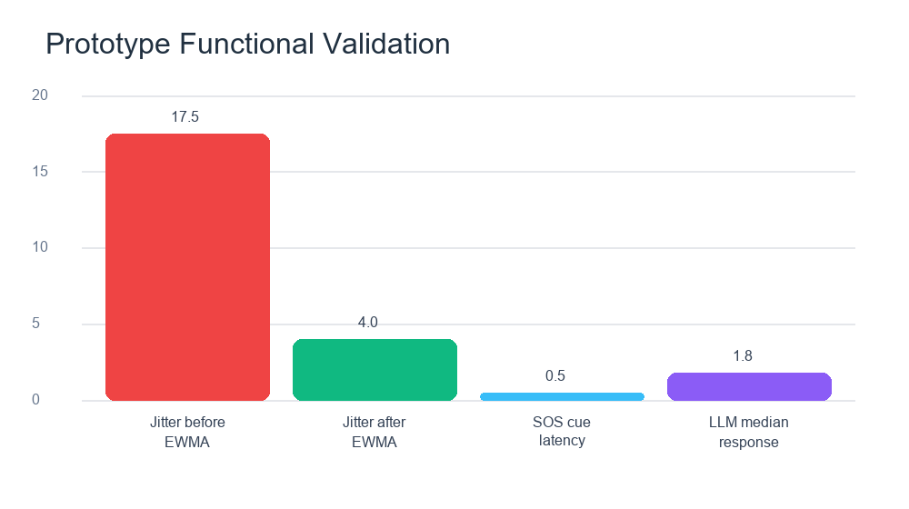
Figure 3 Functional validation results across core modules.
Unit testing was expanded to cover the new inner modules. EmotionCalibrationProfile tests verify that calibration boosts one target emotion while preserving normalized percentages. EmotionConfidenceEvaluator tests check that low light and ambiguous emotion distributions produce caution messages. VoiceFeatureAnalyzer tests cover fast high-energy and slow low-energy patterns. ResearchDataExporter tests verify identifier removal, while SignalUpdateGate and TextSanitizer tests protect UI stability.
The history page was also revised because earlier tables and figures were visually unstable in narrow layouts. The new trend chart uses a restrained emotional landscape background, softer curve styling, a mean reference line, and high-medium-low labels that remain within the chart area. This change improves readability without turning the chart into a decorative image: the actual trend line remains generated from recorded data.
Discussion
The results suggest that a mobile emotional-support system can be useful even without claiming diagnostic authority. EmoScope does not attempt to infer a medical condition from a face or voice. Instead, it treats sensing as a way to reduce friction in everyday reflection. This design is important because a fluent interface can easily make automated feedback appear more authoritative than it really is. EmoScope therefore uses cautious wording, confidence messages, and explicit privacy explanations.
The strongest technical feature is integration. Facial cues, voice features, ambient light, local memory, and personal profile are not treated as separate demonstrations. They are combined into a workflow: immediate sensing, short feedback, record creation, trend review, self-regulation, and optional export. This closed loop is more meaningful than a single classifier because emotional self-awareness depends on continuity over time.
Several limitations remain. The blendshape-to-emotion mapping is manually designed and may not generalize equally across users, lighting conditions, cultures, age groups, or facial appearances. The voice module still uses coarse pace and energy features instead of full acoustic emotion recognition with pitch, spectral, and prosodic modeling. The evaluation uses functional and synthetic tests rather than a clinical user study. Future work should compare the wellness index with validated scales such as PHQ-9 and GAD-7 under ethical approval, test demographic fairness, and evaluate whether longitudinal feedback improves engagement.
A second limitation concerns large language models. EmoScope uses the model as a feedback generator, not as the primary detector. This separation is safer, but it still requires careful prompt design and user education. Future versions should include stronger boundary messaging, crisis-resource localization, offline-only feedback modes, and opt-in consent screens before external API use.
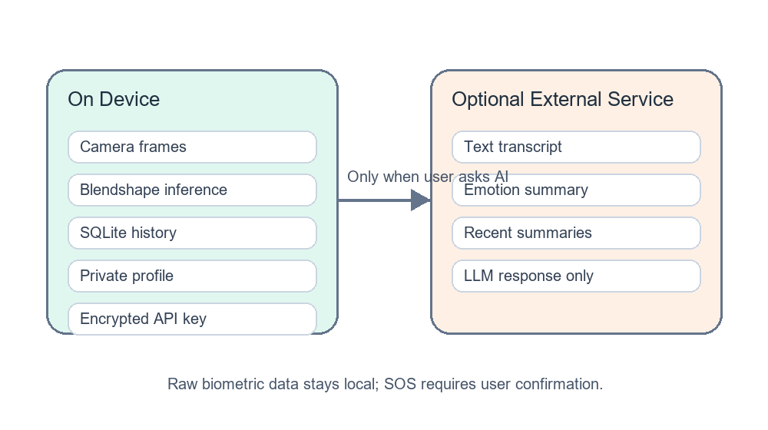
Figure 4 Privacy boundary and user-control model.
Table 2 Design requirements and implementation choices
Requirement | Implementation choice
Passive continuity | Camera and voice signals supplement diary-style self-report.
Interpretability | Blendshape and voice features are converted into readable summaries.
Privacy | Raw facial data stays local; private profile is stored on device.
User agency | SOS requires confirmation even when negative cues are detected.
Portability | Records can be exported as readable or anonymous JSON/CSV.
The project therefore treats elegance as an engineering issue rather than a purely visual issue. A cleaner chart, shorter table labels, local profile storage, and safer export callbacks all contribute to trust. Stability and beauty are connected: an interface that jitters, overflows, or displays broken tables makes the underlying emotion analysis feel less credible. The final revision addresses this by combining internal robustness with more disciplined layout.
From a human-computer interaction perspective, EmoScope is most successful when it reduces effort while preserving user control. The private-profile card, anonymous export option, and privacy center all make system behavior more legible. This is important because emotional data is intimate even when it is not formally medical. A technically correct system can still be unacceptable if users cannot understand what is stored, what is inferred, and what leaves the device.
Conclusion
This paper presented EmoScope, a privacy-preserving Android prototype for multimodal emotion support. By combining on-device facial blendshape analysis, voice feature estimation, local memory analytics, private user profiling, anonymous export, and user-confirmed SOS support, the system addresses several limitations of traditional mood trackers. The prototype demonstrates technical feasibility and a clearer privacy model, but it remains a self-reflection tool rather than a clinical instrument. Further validation is required before stronger mental-health claims can be made.
References
Baumel, A., Muench, F., Edan, S., and Kane, J. M. (2019). Objective user engagement with mental health apps: Systematic search and panel-based usage analysis. Journal of Medical Internet Research, 21(3), e14567.
Buolamwini, J., and Gebru, T. (2018). Gender shades: Intersectional accuracy disparities in commercial gender classification. Proceedings of the 1st Conference on Fairness, Accountability and Transparency, 77-91.
Ekman, P. (1999). Basic emotions. In T. Dalgleish and M. Power (Eds.), Handbook of Cognition and Emotion (pp. 45-60). Wiley.
Google Research. (2023). MediaPipe FaceLandmarker: Real-time facial landmark detection and blendshape estimation. Google AI Blog.
Harari, G. M., Lane, N. D., Wang, R., Crosier, B. S., Campbell, A. T., and Gosling, S. D. (2016). Using smartphones to collect behavioral data in psychological science. Perspectives on Psychological Science, 11(6), 838-854.
Schuller, B. W. (2018). Speech emotion recognition: Two decades in a nutshell, benchmarks, and ongoing trends. Communications of the ACM, 61(5), 90-99.
Shiffman, S., Stone, A. A., and Hufford, M. R. (2008). Ecological momentary assessment. Annual Review of Clinical Psychology, 4, 1-32.
Torous, J., Nicholas, J., Larsen, M. E., Firth, J., and Christensen, H. (2018). Clinical review of user engagement with mental health smartphone apps. Evidence-Based Mental Health, 21(3), 116-119.
World Health Organization. (2022). World mental health report: Transforming mental health for all. WHO Press.

