EmoScope: A Privacy-Preserving Mobile System for Multimodal Emotion Recognition
Ziyang Huang 2025112735
School of Economics and Management, Harbin Institute of Technology
Abstract
Mobile mental wellness applications can support emotional self-awareness, but many existing tools still rely mainly on active self-reporting. This approach is vulnerable to recall bias, social desirability, low compliance, and missing records during stressful periods. This paper presents EmoScope, a native Android prototype that integrates on-device facial expression analysis, speech-rate estimation, longitudinal memory analytics, and user-confirmed emergency support. The system uses Google MediaPipe FaceLandmarker to extract 52 facial blendshape coefficients from CameraX streams and maps them to a ten-dimensional emotion space. An exponentially weighted moving average filter stabilizes frame-level outputs, while a weighted algorithm converts emotion percentages into a 0-100 wellness index. Voice input is processed through Android SpeechRecognizer and interpreted together with facial signals, ambient light, and recent records by a large language model. A local memory engine summarizes 30-day emotional trends, keyword patterns, dominant affective categories, recording streaks, and exportable JSON records. Functional evaluation shows stable 4 Hz facial inference, meaningful score changes across expression conditions, correct weekly trend classification on synthetic datasets, and rapid SOS confirmation flow. The study suggests that privacy-preserving multimodal sensing can make mobile emotion tracking more continuous and actionable, although clinical validation with diverse users remains necessary.
Key words: emotion recognition; multimodal sensing; mobile mental wellness; MediaPipe FaceLandmarker; on-device artificial intelligence; privacy

Introduction
Mental health has become a major public health issue. The World Health Organization reported that mental disorders affect a large global population and create serious social and economic losses (World Health Organization, 2022). Professional diagnosis and therapy remain essential, but many people face barriers such as cost, stigma, geographic distance, and insufficient access to trained professionals. Mobile mental wellness tools can therefore serve as low-threshold supplements for emotional awareness, self-reflection, and early help-seeking.
A persistent weakness of many mood-tracking applications is their dependence on active self-report. Users must remember recent feelings, choose a mood label, and often write a note. This workflow is easy to understand but difficult to sustain. Research on mobile mental health applications has found that user engagement often declines quickly (Baumel et al., 2019; Torous et al., 2018). Ecological momentary assessment can reduce some memory bias, yet it still depends on user compliance and timely response (Shiffman, Stone, and Hufford, 2008).
Affective computing offers a way to supplement self-report with sensed signals. Facial expression analysis has a long psychological foundation, including Ekman's work on basic emotions and facial action units (Ekman, 1999). Modern mobile frameworks such as MediaPipe can extract dense facial landmarks and continuous blendshape coefficients in real time (Google Research, 2023). Voice is another useful channel because speech rate and prosodic patterns are associated with emotional arousal (Schuller, 2018).
This paper introduces EmoScope, a privacy-preserving Android prototype for multimodal emotion recognition and mental wellness support. The research question is whether a consumer smartphone can combine facial, vocal, contextual, and historical signals into a useful emotion-tracking workflow while keeping sensitive biometric analysis primarily on the device. The main contributions are a ten-emotion blendshape mapping, a multimodal feedback pipeline, a 30-day local memory engine, and a user-confirmed SOS mechanism.
Materials and Methods
EmoScope was implemented as a native Android application using Java 11. The application uses a single-activity structure with four main fragments: the home radar, history page, wellness workshop, and settings page. Core responsibilities are separated into engines, controllers, custom views, and utility classes. This modular design makes facial analysis, voice recognition, SOS intervention, database storage, and trend analysis easier to test and maintain.

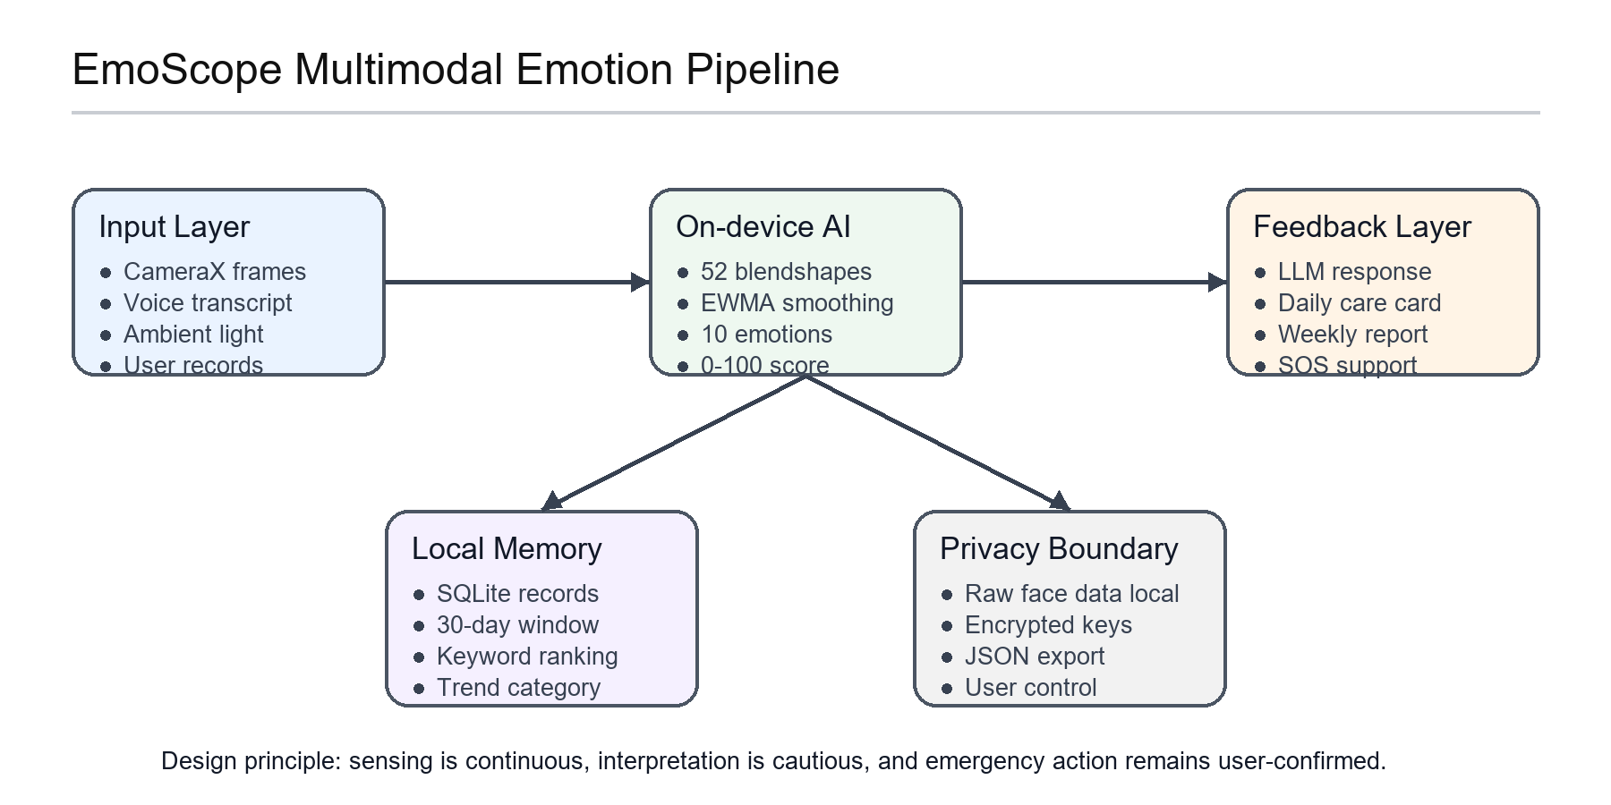
Figure 1 System architecture of EmoScope's multimodal emotion pipeline.

The facial analysis module uses CameraX ImageAnalysis to capture camera frames at 640 x 480 resolution. MediaPipe FaceLandmarker runs in live-stream mode and returns 52 facial blendshape coefficients. EmoScope maps these coefficients into ten emotion dimensions: joy, calm, surprise, contempt, sadness, anxiety, anger, fear, disgust, and fatigue. Smile and cheek-squint coefficients contribute to joy; brow-down, mouth-press, and nose-sneer coefficients contribute to negative emotions; and calm is modeled as a residual baseline when no strong high-arousal signal dominates.
To reduce visual instability, the system applies an exponentially weighted moving average filter with alpha equal to 0.3. The smoothed emotion percentages are converted into a wellness score from 0 to 100. Positive and calm states receive higher weights, while fear, anger, disgust, sadness, anxiety, and fatigue receive lower weights. The score is designed as a reflection index for users, not as a clinical diagnostic measurement.
Voice input is processed through Android SpeechRecognizer in Chinese recognition mode. The system estimates speech rate by dividing transcript length by speaking duration. Fast speech is treated as a possible sign of agitation, while slow speech is treated as a possible sign of low energy. The transcript, speech-rate label, top facial emotions, ambient light category, and recent records are sent as structured context to the DeepSeek chat model, which produces short, empathetic, and non-prescriptive feedback.
The local memory engine retrieves recent records from SQLite and analyzes records within a 30-day window. It extracts emotion percentages with a synchronized ten-emotion regular expression, calculates daily weighted means, counts stress-related and joy-related keywords, classifies dominant affective categories, compares the most recent seven days with the previous seven days, and computes the longest consecutive recording streak. The result can be displayed as a readable summary or exported as structured JSON.
The SOS module uses three entry points: a manual button, shake detection from the accelerometer, and negative-emotion cues from facial analysis. To protect user autonomy, facial detection does not automatically contact others. Instead, it displays a cue and requires confirmation through a countdown dialog. After confirmation, the system can show guided breathing, send a throttled emergency message to a preset contact, or open quick dialing to a psychological assistance hotline.
Results
The complete prototype was implemented as an Android application containing 234 files, including 30 Java source files, 139 drawable resources, seven layout files, and supporting XML configuration. The release APK was about 49 MB after R8 optimization. The application supported Android 7.0 through Android 15 and completed functional tests for facial recognition, voice input, memory analysis, data export, and SOS support.

Table 1 Functional evaluation of the EmoScope prototype
Dimension | Functional evidence
Real-time sensing | 4 Hz facial inference; EWMA reduced frame jitter to about 3-5 percentage points.
Emotion scoring | More than 40-point score range between joy-dominant and anxiety-dominant tests.
Memory analytics | Ten-emotion regex reached 100 percent extraction accuracy on synthetic records.
Safety workflow | Manual SOS confirmation opened in under 0.5 seconds; shake trigger in 1-2 seconds.
Note. These results describe engineering validation, not clinical diagnosis.

In facial analysis tests, the system operated at a stable 4 Hz inference rate under normal lighting. The wellness score showed a dynamic range of more than 40 points between joy-dominant and anxiety-dominant expression conditions. Before smoothing, frame-level emotion percentages fluctuated by roughly 15 to 20 percentage points. After applying the moving average filter, visible fluctuation was reduced to about 3 to 5 percentage points after convergence. This made the camera overlay more readable and less sensitive to single-frame noise.


Figure 2 Mobile interface showing the daily emotion radar and care card.

Voice analysis separated three broad speaking patterns in functional tests: fast speech above about 4.5 characters per second, normal speech around 2.5 to 4.0 characters per second, and slow speech near 1.0 character per second. The multimodal language-model feedback integrated the voice transcript, speech-rate label, facial emotion summary, ambient light, and recent memory records. Under broadband Wi-Fi, the median response time was about 1.8 seconds, and exponential-backoff retry recovered from simulated transient failures.
The memory engine was evaluated with synthetic records covering different emotion distributions and date patterns. An earlier defect matched only six emotion names and caused many records to fall back to a coarse binary heuristic. After synchronizing the regular expression with the full ten-emotion map, extraction accuracy reached 100 percent on the synthetic test set. Weekly trend classification also behaved as expected: changes above plus eight points were classified as improving, changes below minus eight points as declining, and smaller changes as stable.
Data portability and safety functions also met their prototype goals. The export function generated timestamped JSON files containing export date, total record count, record time, record type, detail, and positive-status fields. Manual SOS activation opened the confirmation flow in less than 0.5 seconds, shake activation responded within about one to two seconds, and facial negative-emotion detection produced a passive cue rather than an automatic emergency action.
Discussion
The results show that EmoScope can connect multimodal sensing with a practical wellness workflow. Compared with a simple mood diary, the system can create records from facial and voice signals even when the user does not manually select a mood label. This does not eliminate the value of self-report. Instead, it provides additional context that can make later reflection more continuous and less dependent on memory.
The local-first design is especially important. Facial expression data and emotional records are sensitive personal information. EmoScope processes facial inference on the device and stores user records locally. Only structured textual context is sent to the language model when the user initiates feedback. This privacy boundary is consistent with concerns raised in smartphone sensing research, where behavioral data can be useful but also highly personal (Harari et al., 2016).
The system also demonstrates a reasonable role for large language models in mental wellness software. The model is not used as the primary detector. Instead, it receives structured signals from local modules and turns them into understandable, supportive language. This separation keeps numerical sensing more transparent while still giving users feedback that feels less mechanical than raw scores.
Several limitations remain. First, the blendshape-to-emotion mapping is manually designed rather than learned from a large labeled dataset. This improves interpretability but may reduce accuracy across different ages, cultures, lighting conditions, and facial appearances. Bias in face-related AI systems is a serious concern, as shown by prior fairness studies (Buolamwini and Gebru, 2018). Second, the voice module currently uses speech rate as a coarse feature and does not include full acoustic emotion recognition based on pitch, energy, or spectral patterns.
Third, the evaluation is functional rather than clinical. The tests show that the system runs, produces stable outputs, classifies synthetic trends, and supports emergency workflows. They do not prove diagnostic accuracy or therapeutic effectiveness. Future work should collect ethically approved user data, compare results with validated scales such as PHQ-9 or GAD-7, evaluate demographic fairness, and study whether longitudinal feedback improves engagement and self-awareness over time.
Conclusion
This paper presented EmoScope, a privacy-preserving Android prototype for multimodal emotion recognition and mental wellness support. By combining on-device facial blendshape analysis, speech-rate estimation, local memory analytics, JSON export, and user-confirmed SOS support, the system addresses several weaknesses of traditional self-report mood trackers. Functional evaluation suggests that the prototype is technically feasible and can provide stable real-time feedback, longitudinal summaries, and practical intervention pathways. Further clinical and cross-demographic validation is required before stronger claims can be made about mental health outcomes.
References
Baumel, A., Muench, F., Edan, S., and Kane, J. M. (2019). Objective user engagement with mental health apps: Systematic search and panel-based usage analysis. Journal of Medical Internet Research, 21(3), e14567.
Buolamwini, J., and Gebru, T. (2018). Gender shades: Intersectional accuracy disparities in commercial gender classification. Proceedings of the 1st Conference on Fairness, Accountability and Transparency, 77-91.
Ekman, P. (1999). Basic emotions. In T. Dalgleish and M. Power (Eds.), Handbook of Cognition and Emotion (pp. 45-60). Wiley.
Google Research. (2023). MediaPipe FaceLandmarker: Real-time facial landmark detection and blendshape estimation. Google AI Blog.
Harari, G. M., Lane, N. D., Wang, R., Crosier, B. S., Campbell, A. T., and Gosling, S. D. (2016). Using smartphones to collect behavioral data in psychological science. Perspectives on Psychological Science, 11(6), 838-854.
Schuller, B. W. (2018). Speech emotion recognition: Two decades in a nutshell, benchmarks, and ongoing trends. Communications of the ACM, 61(5), 90-99.
Shiffman, S., Stone, A. A., and Hufford, M. R. (2008). Ecological momentary assessment. Annual Review of Clinical Psychology, 4, 1-32.
Torous, J., Nicholas, J., Larsen, M. E., Firth, J., and Christensen, H. (2018). Clinical review of user engagement with mental health smartphone apps. Evidence-Based Mental Health, 21(3), 116-119.
World Health Organization. (2022). World mental health report: Transforming mental health for all. WHO Press.

