
五邑大学实验报告

移动终端课程
2016~2017年度 第1学期

专业： 计算机科学与技术
班级： 140802
学号： 3114002475
姓名： 黄宗贵

任课教师： 洪智勇 成绩评定：

完成日期：2016年 12 月 14 日
“通讯录”项目说明文档

1、项目背景
许多人都有这样的经历：手机联系人没有整理，找一个联系人都很难，而且有时候当换手机了又要重新存储联系人。而我现在做的这个通讯录包括了增删改查的功能，还可以将通讯录里的联系人备份成文件格式，但手机换了也可以在另外一个手机了还原这个联系人的信息。

2、使用的技术
开发语言：JAVA、sql
开发平台：IntelliJ IDEA
运行环境：android4.1及后续版本
实现方式：利用手机自带的sqlite数据库建立一个contact数据库、利用一个user数据表记录用户的头像、姓名、电话等等所有的信息，备份时将插入用户的sql语句保存到一个文件中，当还原的时候就读取文件中的sql语句，然后向数据库的表中插入数据。

3、功能说明
所有功能：添加联系人的联系方式、删除联系人、修改联系人的详细信息、通过关键字查询联系人、备份批量联系人和还原批量联系人、查看私密联系人及所有的增删改查功能：
- 添加联系人的联系方式：通过点击添加按钮然后进行联系方式等信息的填写即可保存一个联系人。
- 删除联系人：通过长按一个或者多个联系人再点击删除按钮即可删除联系人。
- 修改联系人：通过点击一个联系人进到详细信息里再点击修改即可修改一个联系人。
- 查询联系人：通过点击查询按钮再输入查询条件即可查询联系人。
- 备份联系人：点击菜单按钮再点击备份数据，即可批量备份联系人。
- 还原联系人：点击菜单按钮再点击还原数据，即可进行添加或者覆盖的批量还原联系人。
- 查看私密联系人：点击菜单按钮，再点击私密通讯录，再输入账号密码既可进入私密联系人（目前的账号密码写死都为：admin）。

4 、亮点和缺点
1、联系人有头像，更加的美观
2、可批量备份还原联系人
3、可对联系人加密
缺陷：界面不够美观、存在一些小bug、私密的通讯录账号密码写死，不能修改。

5、项目有待改进计划
后期将将界面美化，修复bug，将私密的通讯录改为多个账号和可改密码的，添加更加实用的功能。

6、 系统实现

6.1 添加联系人功能实现
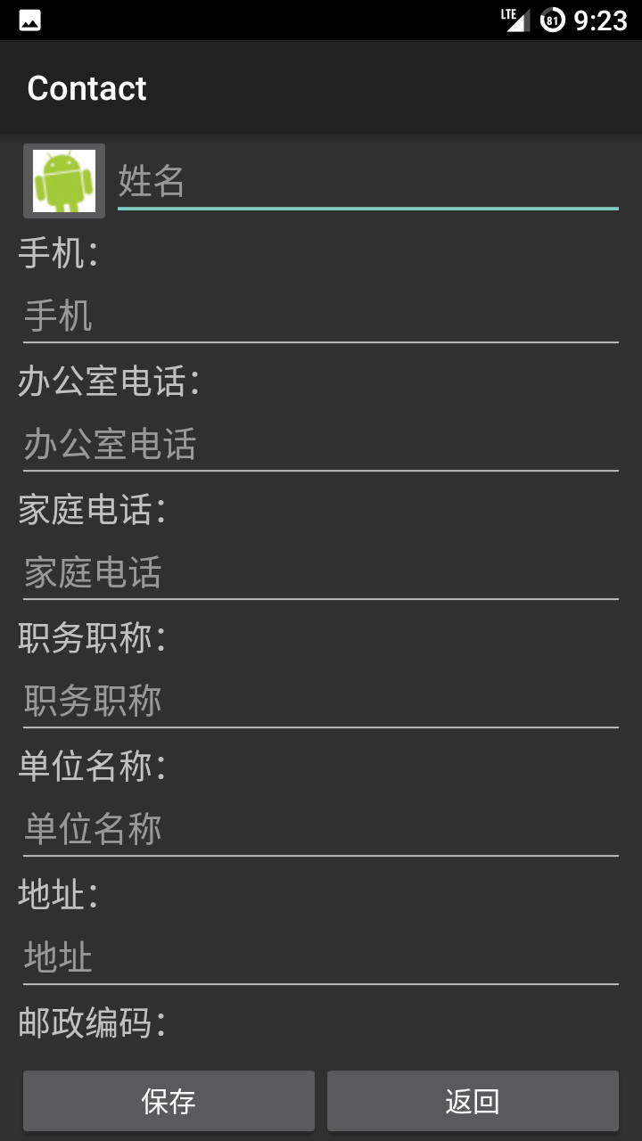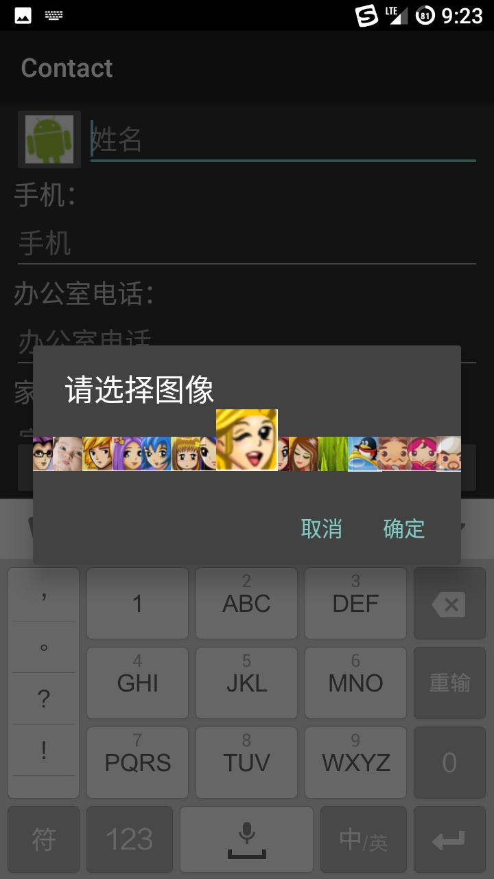
实现的主要代码；
btn_save.setOnClickListener(new View.OnClickListener() {
@Override
public void onClick(View v) {
//判断姓名是否为空，不能为空
String name = et_name.getText().toString();
if (name.trim().equals("")) {
Toast.makeText(AddNewActivity.this, "姓名不能为空", Toast.LENGTH_SHORT).show();
return;
}
//从表单上获取数据
User user = new User();
user.userName = name;
user.address = et_address.getText().toString();
user.company = et_company.getText().toString();
user.email = et_email.getText().toString();
user.familyPhone = et_familyPhone.getText().toString();
user.mobilePhone = et_mobilePhone.getText().toString();
user.officePhone = et_officePhone.getText().toString();
user.otherContact = et_otherContact.getText().toString();
user.position = et_position.getText().toString();
user.remark = et_remark.getText().toString();
user.zipCode = et_zipCode.getText().toString();
//判断头像是否改变，若改变则用当前的位置，若没有改变，则用前一回的位置
if (imageChanged) {
user.imageId = images[currentImagePosition % images.length];
} else {
user.imageId = images[previousImagePosition % images.length];
}
//用户类型
user.privacy = privacy;
//创建数据库帮助类
DBHelper helper = new DBHelper(AddNewActivity.this);
//打开数据库
helper.openDataBase();
//把user存储到数据库在里
long result = helper.insert(user);
//判断插入是否成功
if (result == -1) {
Toast.makeText(AddNewActivity.this, "添加失败", Toast.LENGTH_SHORT).show();
} else {
Toast.makeText(AddNewActivity.this, "添加成功", Toast.LENGTH_SHORT).show();
setTitle("用户添加成功！");
}
setResult(3);//设置返回结果码，表示需要刷新（调用MainActivity方法中的OnActivityResult）
finish();//销毁当前视图,返回到上一个Activity,也就是Main.activity;
}
});

6.2 删除联系人
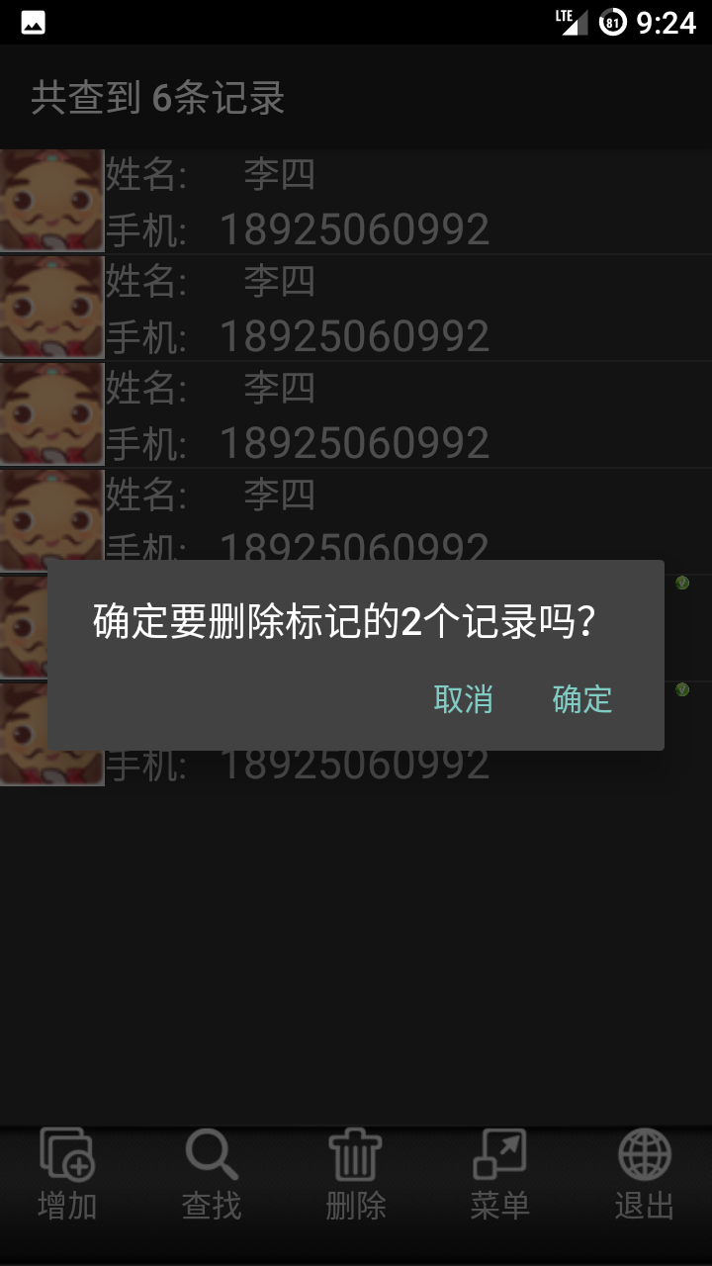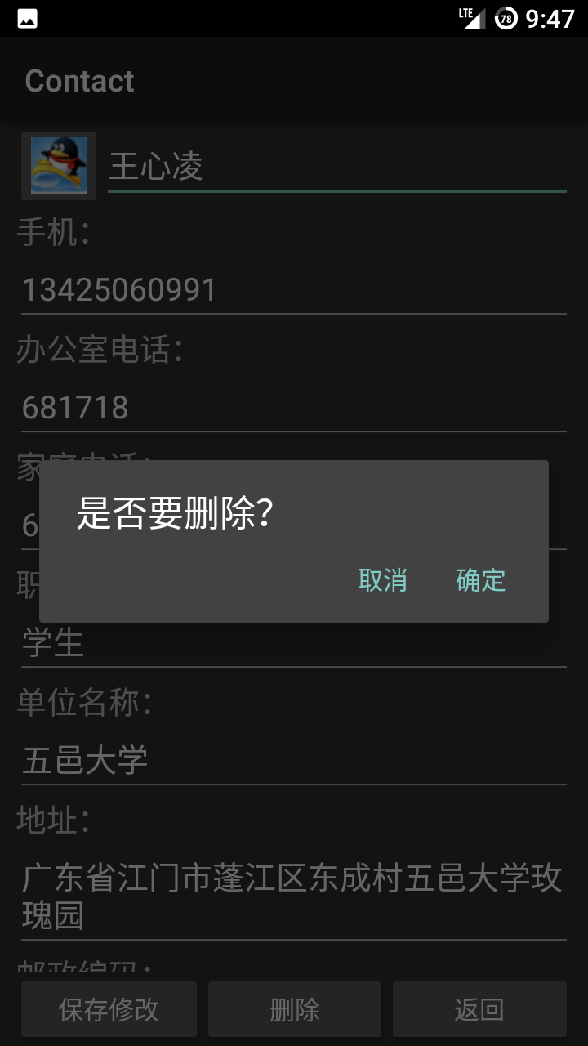
实现的核心代码：
btn_delete.setOnClickListener(new View.OnClickListener() {
@Override
public void onClick(View v) {
new AlertDialog.Builder(UserDetail.this).setPositiveButton("确定", new DialogInterface.OnClickListener() {
@Override
public void onClick(DialogInterface dialog, int which) {
delete();
setResult(4);
finish();
}
}).setNegativeButton("取消", new DialogInterface.OnClickListener() {
@Override
public void onClick(DialogInterface dialog, int which) {
}
}).setTitle("是否要删除？").create().show();
}
});
public void delete() {
DBHelper helper = new DBHelper(this);
helper.openDataBase();
helper.delete(user._id);
}
删除标记的：
new AlertDialog.Builder(MainActivity.this)
.setTitle("确定要删除标记的" + deleteId.size() + "个记录吗？")
.setPositiveButton("确定", new DialogInterface.OnClickListener() {
@Override
public void onClick(DialogInterface dialog, int which) {
//链接数据库，删除标记的user
// helper = new DBHelper(MainActivity.this);
// helper.openDataBase();
for (int i = 0; i < deleteId.size(); i++) {
int _id = deleteId.get(i);
helper.delete(_id);
}
//重置视图
list = helper.getAllUser(privacy);
adapter = new SimpleAdapter(
MainActivity.this, list,
R.layout.item_list,
new String[]{"imageid", "name", "mobilephone"},
new int[]{R.id.user_image, R.id.tv_name, R.id.tv_mobilephone});
lv_user.setAdapter(adapter);
deleteId.clear();
}
})
.setNegativeButton("取消", null)
.create()
.show();
数据库中删除：
public void delete(int _id) {
dbInstance.delete(DB_TABLENAME, "_id=?", new String[]{String.valueOf(_id)});
}
//删除所有
public void deleteAll() {
dbInstance.delete(DB_TABLENAME, null, null);
}

6.3 修改联系人
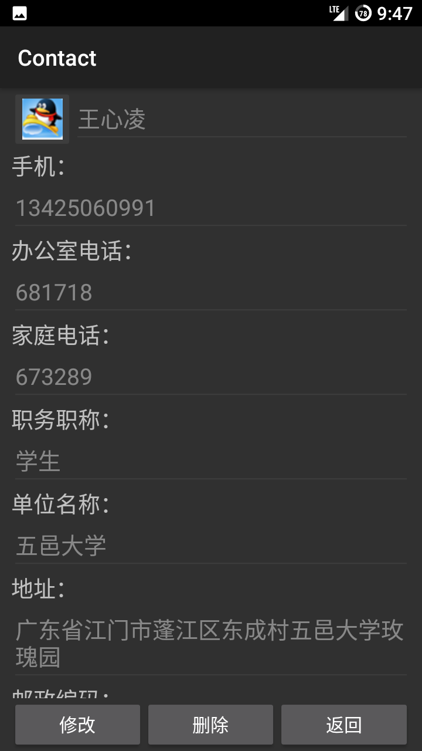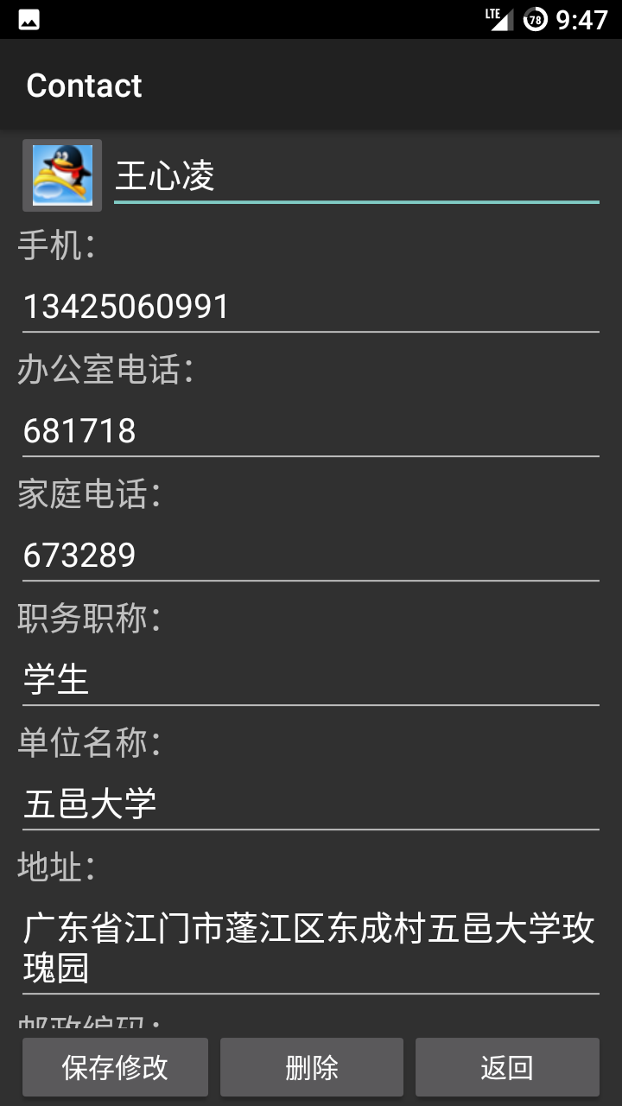

实现的主要代码：
//修改数据:获得最新数据，创建DBHelper对象，更新数据库
private void modify() {
user.userName = et_name.getText().toString();
user.address = et_address.getText().toString();
user.company = et_company.getText().toString();
user.email = et_email.getText().toString();
user.familyPhone = et_familyPhone.getText().toString();
user.mobilePhone = et_mobilePhone.getText().toString();
user.officePhone = et_officePhone.getText().toString();
user.otherContact = et_otherContact.getText().toString();
user.position = et_position.getText().toString();
user.remark = et_remark.getText().toString();
user.zipCode = et_zipCode.getText().toString();
if (imageChanged) {
user.imageId = images[currentImagePosition % images.length];
}
DBHelper helper = new DBHelper(this);
helper.openDataBase();
helper.modify(user);
isDataChanged = true;
}
数据库中修改的核心代码：
//修改user
public void modify(User user) {
ContentValues values = new ContentValues();
values.put("name", user.userName);
values.put("mobilephone", user.mobilePhone);
values.put("officephone", user.officePhone);
values.put("familyphone", user.familyPhone);
values.put("address", user.address);
values.put("othercontact", user.otherContact);
values.put("email", user.email);
values.put("position", user.position);
values.put("company", user.company);
values.put("zipcode", user.zipCode);
values.put("remark", user.remark);
values.put("imageid", user.imageId);
//根据主键来修改
dbInstance.update(DB_TABLENAME, values, "_id=?", new String[]{String.valueOf(user._id)});
}

6.4 查询联系人

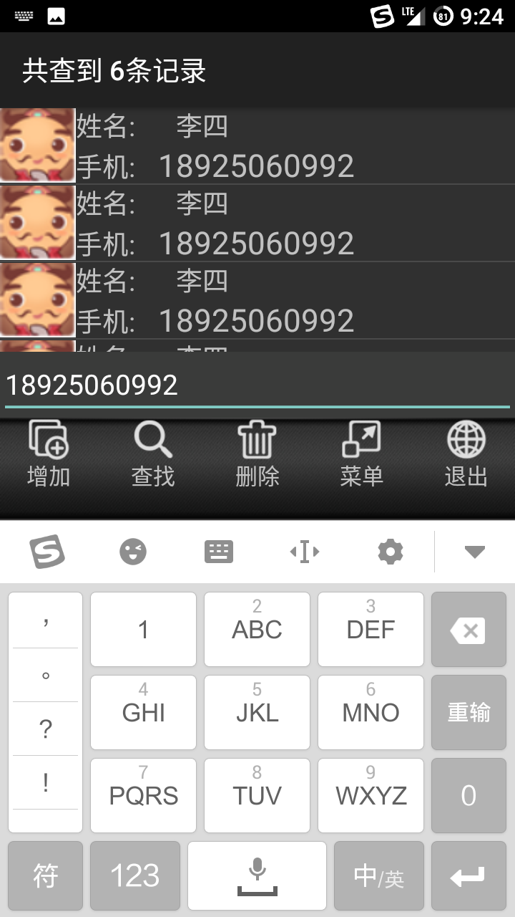
实现的核心代码：
点击事件：
case 1: {
loadSearchLinearLayout();//加载出搜索框，并对其监听
//下面searchLinearLayout不为空是因为上面这个方法加载了这个控件
if (searchLinearLayout.getVisibility() == View.VISIBLE) {
lv_user.setAdapter(adapter);
//既然重新载入了user那么相应的标志也会去掉，那么就要清空deleteId
if (deleteId != null) {
deleteId.clear();
}
searchLinearLayout.setVisibility(View.GONE);
} else {
searchLinearLayout.setVisibility(View.VISIBLE);
et_search.requestFocus();//把输入焦点放在搜索框这个控件上
//et_search.selectAll();//选择全部
et_search.setText("");//将搜索框中的所有text选中
}
break;
}
加载搜索框：
//点击查找的时候响应的方法，搜索框
private void loadSearchLinearLayout() {
if (searchLinearLayout == null) {
searchLinearLayout = (LinearLayout) findViewById(R.id.ll_search);
et_search = (EditText) findViewById(R.id.et_search);
et_search.setOnKeyListener(new View.OnKeyListener() {
@Override
public boolean onKey(View v, int keyCode, KeyEvent event) {
String condition = et_search.getText().toString();//获得搜索条件
// if (condition.equals("")) {
// lv_user.setAdapter(adapter);//为了当没有填查询条件的时候，ListView中就显示所有信息,但是在下面的查询方法中的查询语句中的where 1=1已经带有这个功能了，在这里没必要
// }
list = helper.getUserBySearch(condition, privacy);
SimpleAdapter searchAdapter = new SimpleAdapter(MainActivity.this, list, R.layout.item_list, new String[]{"imageid", "name", "mobilephone"}, new int[]{R.id.user_image, R.id.tv_name, R.id.tv_mobilephone});
lv_user.setAdapter(searchAdapter);//将查到整合后的用户信息展示出来
if (deleteId != null) {
deleteId.clear();
}
if (list.size() == 0) {
//没有数据,设置背景图片
Drawable nodata_bg = getResources().getDrawable(R.drawable.nodata_bg);
mainLinearLayout.setBackgroundDrawable(nodata_bg);
setTitle("没有查到任何数据");
} else {
setTitle("共查到 " + list.size() + "条记录");
mainLinearLayout.setBackgroundDrawable(null);
}
return false;
}
});
}
}
数据库查找：
//通过搜索找到user
public ArrayList getUserBySearch(String condition, boolean privacy) {
ArrayList list = new ArrayList();
String strSelection = "";
if (privacy) {
strSelection = "and privacy = 1";
} else {
strSelection = "and privacy = 0";
}
//select * from user where 1=1 and (name like '%condition%' or mobilephone like '%condition%' or officephone like '%condition%')
//1=1是为了避免其他查询为空时,这条查询语句报错.不是l是1
//就是条件永远为真，查出所有数据来
String sql = "select * from " + DB_TABLENAME +
" where 1=1 and (name like '%" + condition + "%' or mobilephone like '%" + condition + "%' or officephone like '%"
+ condition + "%')" + strSelection;
Log.i("hzg", sql);//在logcat中打印出sql查看是否有错
Cursor cursor = dbInstance.rawQuery(sql, null);
while (cursor.moveToNext()) {
HashMap map = new HashMap();
map.put("_id", cursor.getInt(cursor.getColumnIndex("_id")));
map.put("imageid", cursor.getInt(cursor.getColumnIndex("imageid")));
map.put("name", cursor.getString(cursor.getColumnIndex("name")));
map.put("mobilephone", cursor.getString(cursor.getColumnIndex("mobilephone")));
map.put("officephone", cursor.getString(cursor.getColumnIndex("officephone")));
map.put("familyphone", cursor.getString(cursor.getColumnIndex("familyphone")));
map.put("address", cursor.getString(cursor.getColumnIndex("address")));
map.put("othercontact", cursor.getString(cursor.getColumnIndex("othercontact")));
map.put("email", cursor.getString(cursor.getColumnIndex("email")));
map.put("position", cursor.getString(cursor.getColumnIndex("position")));
map.put("company", cursor.getString(cursor.getColumnIndex("company")));
map.put("zipcode", cursor.getString(cursor.getColumnIndex("zipcode")));
map.put("remark", cursor.getString(cursor.getColumnIndex("remark")));
list.add(map);
}
return list;
}
6.5 备份联系人

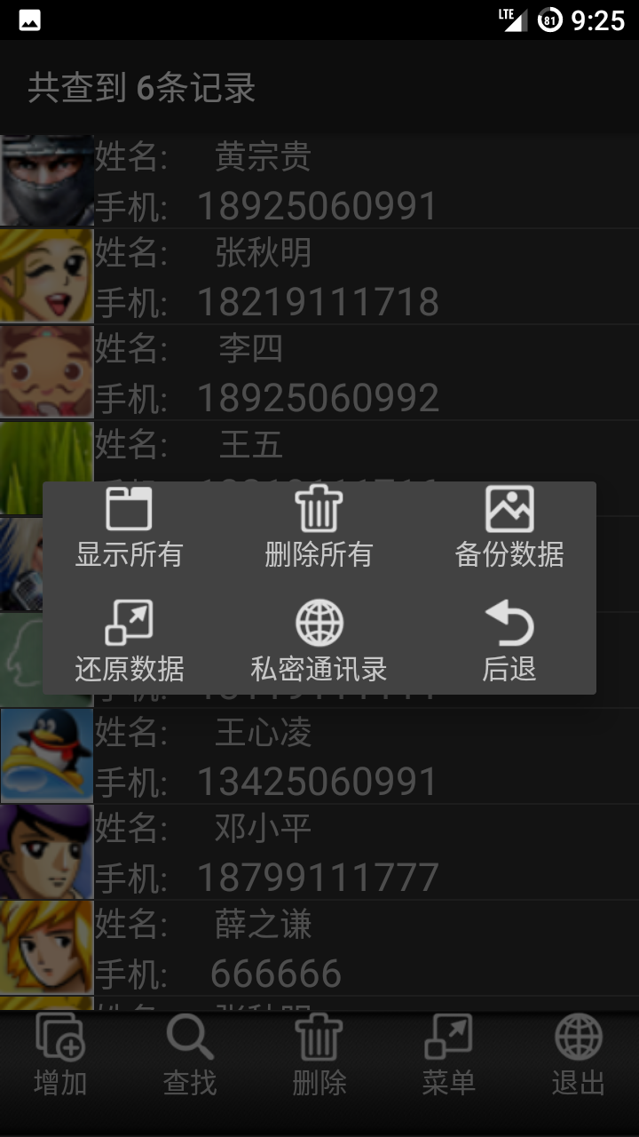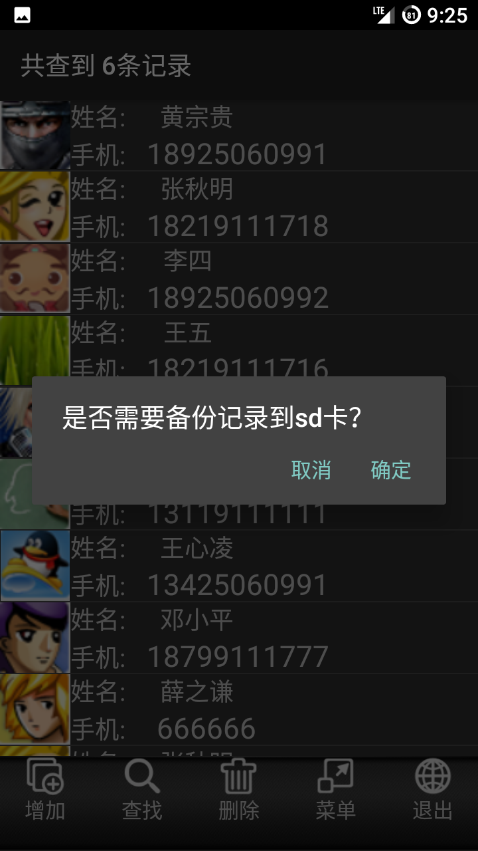

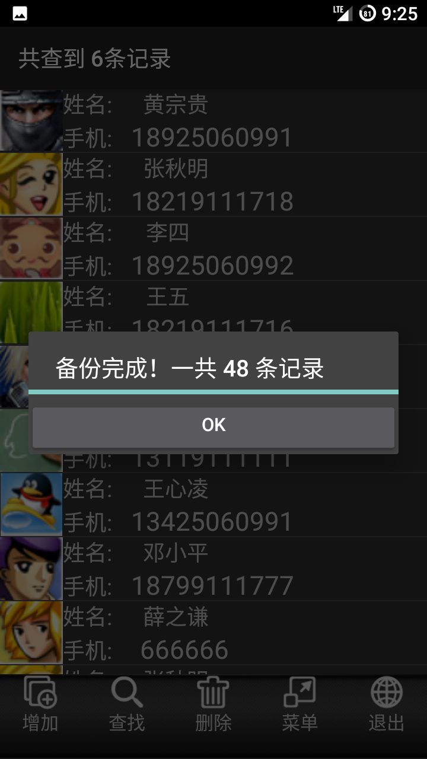
实现的核心代码：
new AlertDialog.Builder(MainActivity.this)
.setTitle("是否需要备份记录到sd卡？")
.setPositiveButton("确定", new DialogInterface.OnClickListener() {
@Override
public void onClick(DialogInterface dialog, int which) {
LayoutInflater li = LayoutInflater.from(MainActivity.this);
View backup_view = li.inflate(R.layout.backup_progress, null);
progressDialog = new AlertDialog.Builder(MainActivity.this)
.setTitle("备份正在进行中...")
.setView(backup_view)
.create();
progressDialog.show();
helper.backupData(privacy);//保存到文件中
ProgressBar bar = (ProgressBar) backup_view.findViewById(R.id.pb_backup);
Button btn_backup_ok = (Button) backup_view.findViewById(R.id.btn_backup_ok);
bar.setMax(list.size());
for (int i = 0; i <= list.size(); i++) {
bar.setProgress(i);//设置进度条
}
progressDialog.setTitle("备份完成！一共 " + list.size() + " 条记录");
btn_backup_ok.setVisibility(View.VISIBLE);
btn_backup_ok.setOnClickListener(new View.OnClickListener() {
@Override
public void onClick(View v) {
progressDialog.dismiss();
mainMenuDialog.dismiss();
}
});
}
})
.setNegativeButton("取消", null)
.create().show();
数据库保存文件:
//备份
public void backupData(boolean privacy) {
StringBuffer sqlBackup = new StringBuffer();
Cursor cursor;
if (privacy) {
cursor = dbInstance.query(DB_TABLENAME,
new String[]{"_id", "name", "mobilephone", "officephone", "familyphone", "address", "othercontact", "email", "position", "company", "zipcode", "remark", "imageid,privacy"},
"privacy=1",
null,
null,
null,
null);
} else {
cursor = dbInstance.query(DB_TABLENAME,
new String[]{"_id", "name", "mobilephone", "officephone", "familyphone", "address", "othercontact", "email", "position", "company", "zipcode", "remark", "imageid,privacy"},
"privacy=0",
null,
null,
null,
null);
}
while (cursor.moveToNext()) {
sqlBackup.append("insert into " + DB_TABLENAME + "(name,mobilephone,officephone,familyphone,address,othercontact,email,position,company,zipcode,remark,imageid,privacy)")
.append(" values ('")
.append(cursor.getString(cursor.getColumnIndex("name"))).append("','")
.append(cursor.getString(cursor.getColumnIndex("mobilephone"))).append("','")
.append(cursor.getString(cursor.getColumnIndex("officephone"))).append("','")
.append(cursor.getString(cursor.getColumnIndex("familyphone"))).append("','")
.append(cursor.getString(cursor.getColumnIndex("address"))).append("','")
.append(cursor.getString(cursor.getColumnIndex("othercontact"))).append("','")
.append(cursor.getString(cursor.getColumnIndex("email"))).append("','")
.append(cursor.getString(cursor.getColumnIndex("position"))).append("','")
.append(cursor.getString(cursor.getColumnIndex("company"))).append("','")
.append(cursor.getString(cursor.getColumnIndex("zipcode"))).append("','")
.append(cursor.getString(cursor.getColumnIndex("remark"))).append("',")
.append(cursor.getInt(cursor.getColumnIndex("imageid"))).append(",")
.append(cursor.getInt(cursor.getColumnIndex("privacy")))
.append(");").append("\n");
Log.i("hzg", sqlBackup.toString());
}
saveDataToFile(sqlBackup.toString(), privacy);
}
//将数据保存到文件
private void saveDataToFile(String strData, boolean privacy) {
String fileName;
if (privacy) {
fileName = "priv_data.bk";
} else {
fileName = "comm_data.bk";
}
try {
String SDPATH = Environment.getExternalStorageDirectory() + "/";
File fileParentPath = new File(SDPATH + "hzgContactBackup/");
fileParentPath.mkdirs();//创建文件夹
File file = new File(SDPATH + "hzgContactBackup/" + fileName);
file.createNewFile();
Log.i("hzg", "the file path = " + file.getAbsolutePath().toString());
FileOutputStream fos = new FileOutputStream(file);
fos.write(strData.getBytes());
fos.flush();
} catch (IOException e) {
e.printStackTrace();
}
}

6.6 还原联系人
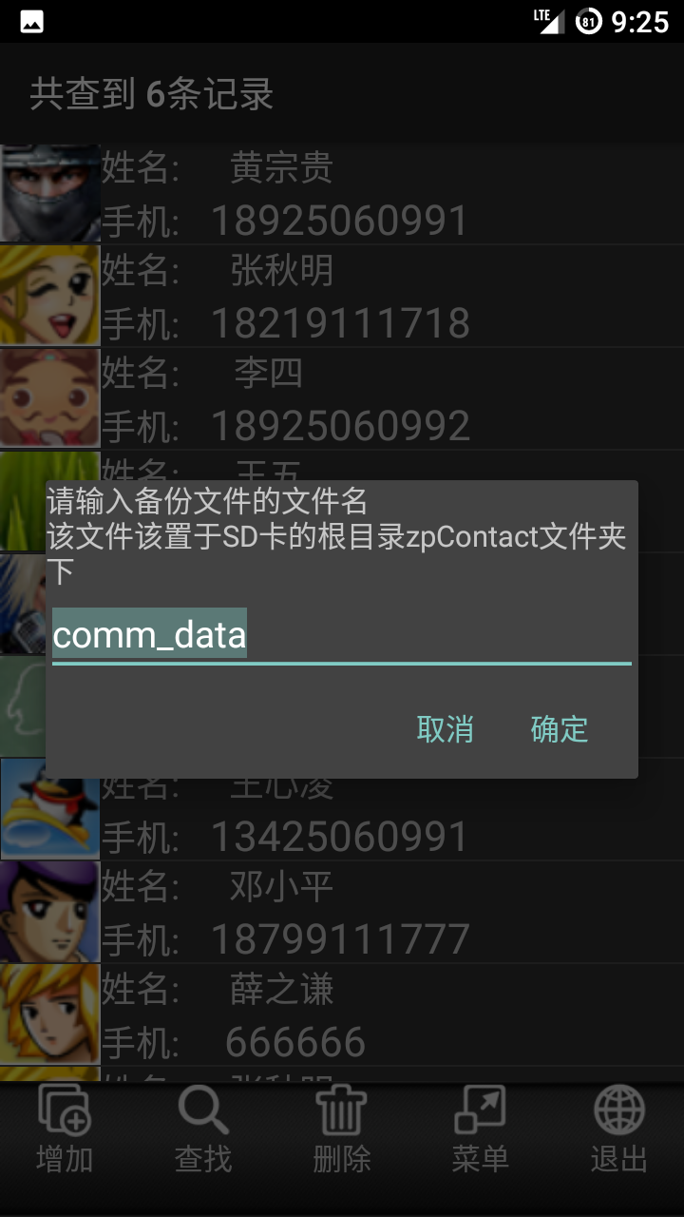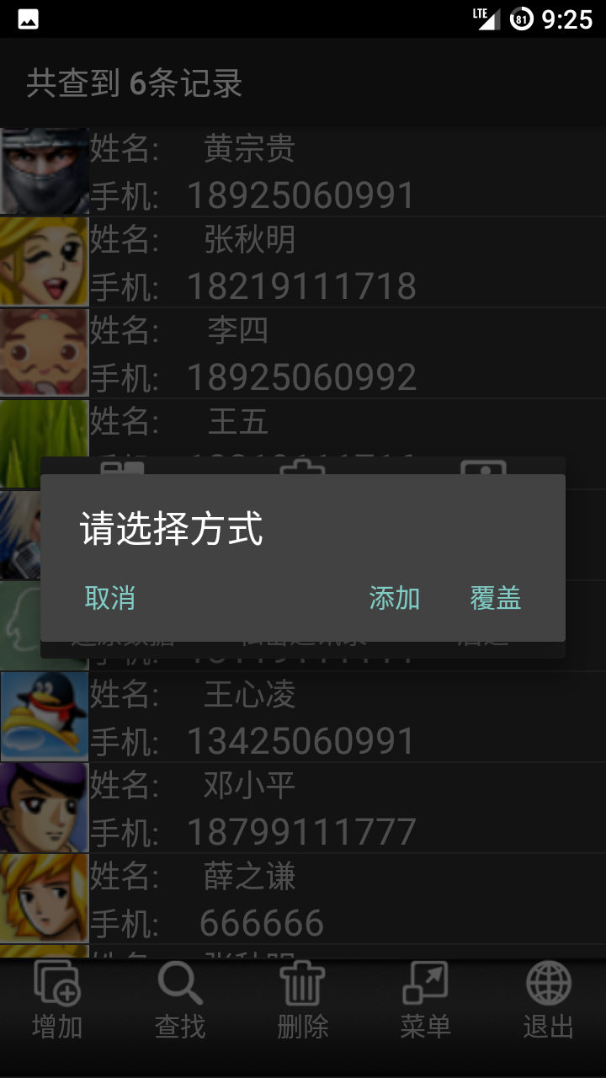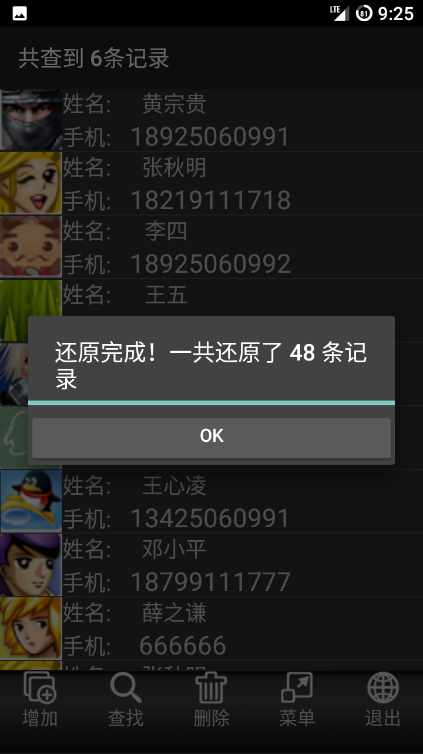

实现的核心代码：
LayoutInflater li = LayoutInflater.from(MainActivity.this);
final View enterFileNameView = li.inflate(R.layout.enter_filename, null);
enterFileNameDialog = new AlertDialog.Builder(MainActivity.this)
.setView(enterFileNameView).setNegativeButton("取消", null)
.setPositiveButton("确定", new DialogInterface.OnClickListener() {
@Override
public void onClick(DialogInterface dialog, int which) {
fileName = et_enter_file_name.getText().toString();
if (helper.findFile(fileName)) {
new AlertDialog.Builder(MainActivity.this).setTitle("请选择方式")
.setPositiveButton("覆盖", new DialogInterface.OnClickListener() {
@Override
public void onClick(DialogInterface dialog, int which) {
helper.deleteAll();//覆盖就要删除再添加
helper.restoreData(fileName);
list = helper.getAllUser(privacy);
adapter = new SimpleAdapter(MainActivity.this,
list,
R.layout.item_list,
new String[]{"imageid", "name", "mobilephone"},
new int[]{R.id.user_image, R.id.tv_name, R.id.tv_mobilephone});
LayoutInflater li = LayoutInflater.from(MainActivity.this);
View backup_view = li.inflate(R.layout.backup_progress, null);
progressDialog = new AlertDialog.Builder(MainActivity.this).setTitle("正在还原数据")
.setView(backup_view).create();
progressDialog.show();
ProgressBar bar = (ProgressBar) backup_view.findViewById(R.id.pb_backup);
Button btn_backup_ok = (Button) backup_view.findViewById(R.id.btn_backup_ok);
bar.setMax(list.size());
for (int i = 0; i <= list.size(); i++) {
bar.setProgress(i);
}
progressDialog.setTitle("还原完成！一共还原了 " + (list.size()) + " 条记录");
btn_backup_ok.setVisibility(View.VISIBLE);
btn_backup_ok.setOnClickListener(new View.OnClickListener() {
@Override
public void onClick(View v) {
progressDialog.dismiss();
mainMenuDialog.dismiss();
if (list.size() != 0) {
mainLinearLayout.setBackgroundDrawable(null);
}
lv_user.setAdapter(adapter);
}
});
}
})
.setNegativeButton("添加", new DialogInterface.OnClickListener() {
@Override
public void onClick(DialogInterface dialog, int which) {
int preNum = list.size();
helper.restoreData(fileName);
list = helper.getAllUser(privacy);
adapter = new SimpleAdapter(MainActivity.this,
list,
R.layout.item_list,
new String[]{"imageid", "name", "mobilephone"},
new int[]{R.id.user_image, R.id.tv_name, R.id.tv_mobilephone});
LayoutInflater li = LayoutInflater.from(MainActivity.this);
View backup_view = li.inflate(R.layout.backup_progress, null);
progressDialog = new AlertDialog.Builder(MainActivity.this).setTitle("正在还原数据")
.setView(backup_view).create();
progressDialog.show();
ProgressBar bar = (ProgressBar) backup_view.findViewById(R.id.pb_backup);
Button btn_backup_ok = (Button) backup_view.findViewById(R.id.btn_backup_ok);
bar.setMax(list.size());
for (int i = 0; i <= list.size(); i++) {
bar.setProgress(i);
}
progressDialog.setTitle("还原完成！一共还原了 " + (list.size() - preNum) + " 条记录");
btn_backup_ok.setVisibility(View.VISIBLE);
btn_backup_ok.setOnClickListener(new View.OnClickListener() {
@Override
public void onClick(View v) {
progressDialog.dismiss();
mainMenuDialog.dismiss();
lv_user.setAdapter(adapter);
}
});
}
})
.setNeutralButton("取消", null)
.create().show();
} else {
Toast.makeText(enterFileNameDialog.getContext(), "找不到备份文件", Toast.LENGTH_SHORT).show();
}
}
})
.create();
et_enter_file_name = (EditText) enterFileNameView.findViewById(R.id.et_enter_file_name);
et_enter_file_name.setText("comm_data");
et_enter_file_name.requestFocus();
et_enter_file_name.selectAll();
enterFileNameDialog.show();
操作数据库的核心代码：
//通过记录着sql语句的文件来插入数据
public void restoreData(String fileName) {
try {
String SDPATH = Environment.getExternalStorageDirectory() + "/";
File file;
if (fileName.endsWith(".bk")) {
file = new File(SDPATH + "hzgContactBackup/" + fileName);
} else {
file = new File(SDPATH + "hzgContactBackup/" + fileName + ".bk");
}
BufferedReader br = new BufferedReader(new FileReader(file));
String str;
while ((str = br.readLine()) != null) {
dbInstance.execSQL(str);
}
} catch (Exception e) {
e.printStackTrace();
}
}

6.7 查看私密联系人
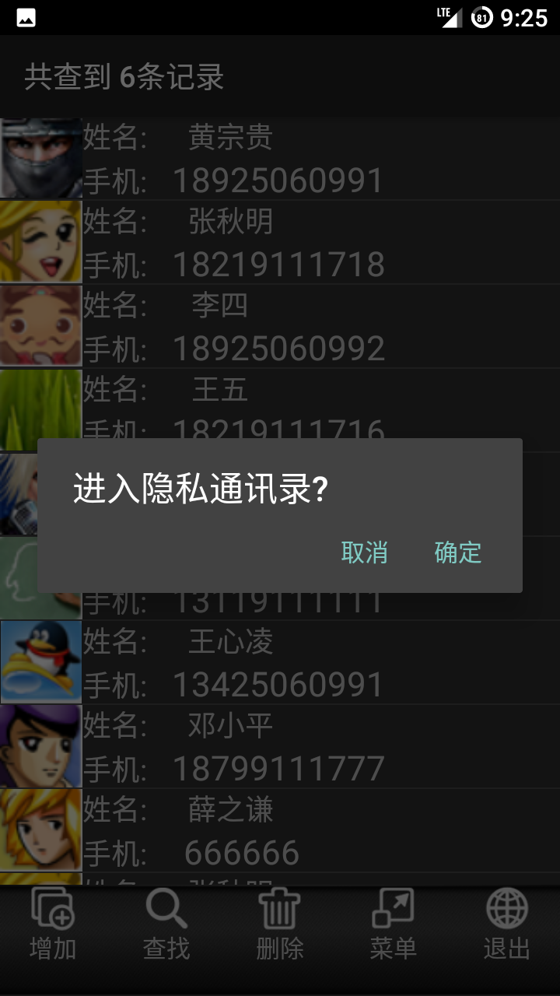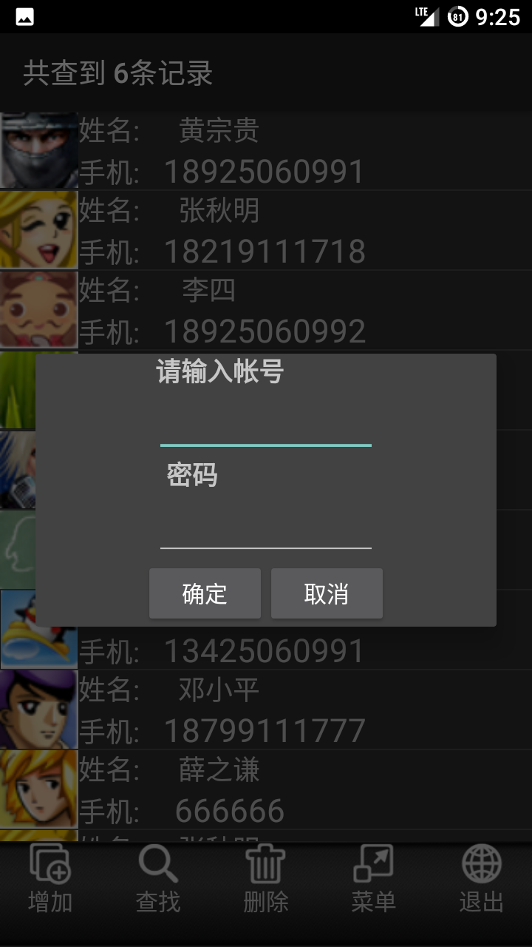
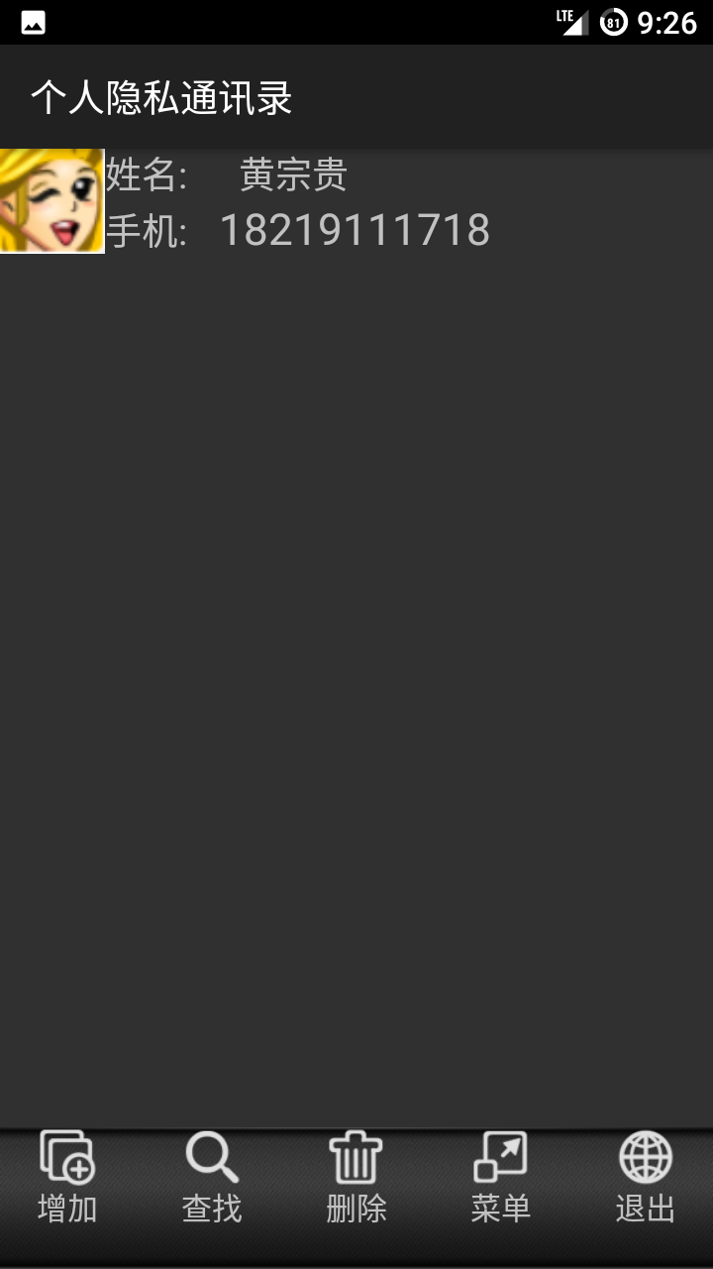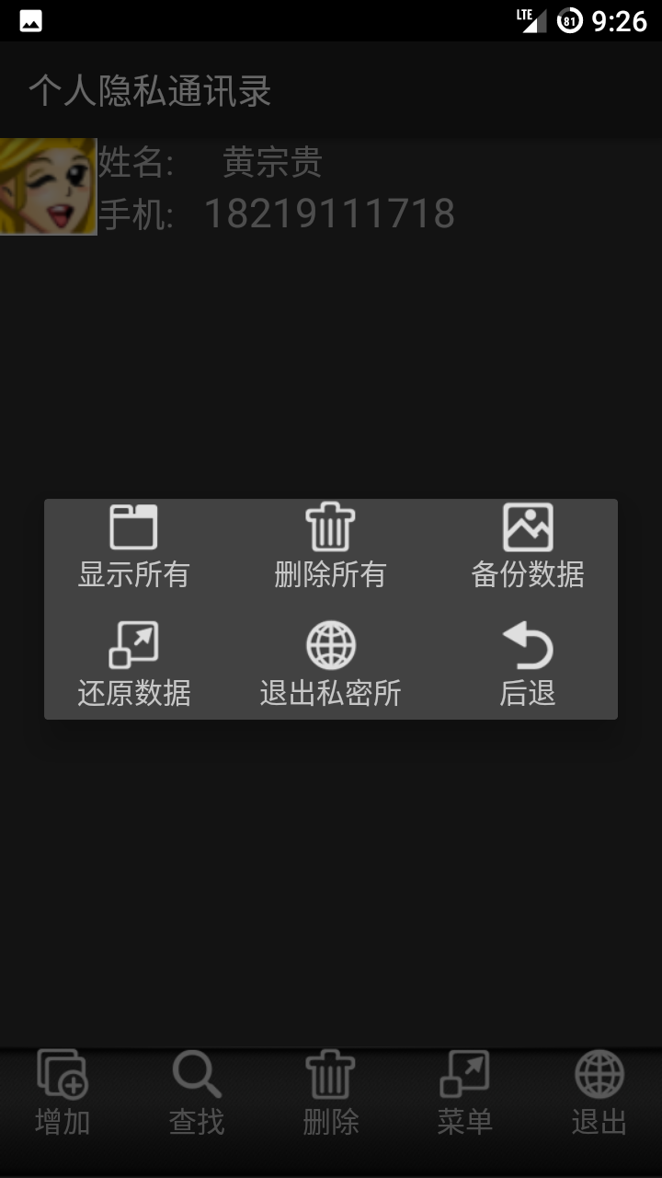
实现的核心代码：
mainMenuDialog.dismiss();
new AlertDialog.Builder(MainActivity.this).setTitle("进入隐私通讯录?").setPositiveButton("确定", new DialogInterface.OnClickListener() {
@Override
public void onClick(DialogInterface dialog, int which) {
//新建一个activity出来
LayoutInflater li = LayoutInflater.from(MainActivity.this);
loginView = li.inflate(R.layout.login, null);
Button btn_login_ok = (Button) loginView.findViewById(R.id.btn_login_ok);
Button btn_login_cancel = (Button) loginView.findViewById(R.id.btn_login_cancel);
final EditText et_account = (EditText) loginView.findViewById(R.id.et_account);
final EditText et_password = (EditText) loginView.findViewById(R.id.et_password);
btn_login_ok.setOnClickListener(new View.OnClickListener() {
@Override
public void onClick(View v) {
if (et_account.getText().toString().equals("admin") && et_password.getText().toString().equals("admin")) {
et_account.setText("");
et_password.setText("");
loginDialog.dismiss();
Intent intent = new Intent(MainActivity.this, MainPrivacyActivity.class);
startActivity(intent);
} else {
Toast.makeText(MainActivity.this, "失败", Toast.LENGTH_LONG).show();
}
}
});
btn_login_cancel.setOnClickListener(new View.OnClickListener() {
@Override
public void onClick(View v) {
loginDialog.dismiss();
}
});
if (loginDialog == null) {
loginDialog = new AlertDialog.Builder(MainActivity.this).setView(loginView).create();
}
loginDialog.show();
}
})
.setNegativeButton("取消", null)
.create()
.show();

