**Table of Contents**

Table of Contents…………………………………………………….1

Make BFD file to manage coffee bill………………………………...2

Data normalization 0NF, 1NF, 2NF, 3NF……………………………3

Create a SQL Script file (database, table)…….……………………...4

Create a CoffeeShop project by Visual Studio 2013/2015…………...5

Clone and synchorize code (clone, commit, pushing code)………….6

1. **Make BFD file to manage coffee bill:**

* Go from general function to child function
* Numbering by rank

3.Quản lí hóa đơn (Mức 1)

3.1 Xuất hóa đơn

3.2 Thống kế

2.Quản lí danh mục sản phẩm (Mức 1)

2.1 Thêm thức uống

2.2 Sửa thức uống

2.3 Xóa thức uống

1.Quản lí bàn (Mức 1)

Quản lí Cafe (Mức 0)

1.1 Thêm bàn

1.2 Sửa bàn

1.3 Xóa bàn

Form 1. BFD Function Chart of coffee bill management

1. **Data normalization 0NF, 1NF, 2NF, 3NF**

* Standard for division: 0NF, 1NF, 2NF, 3NF:

1. 0NF:
   * Removes unnecessary attributes of the entity set
   * Determine the key of the entity set
2. 1NF:
   * Define a repeating single entity set
   * Single attribute is an attribute with only one value at a time (invoice number).
   * Lock = lock of 0NF + lock of defined entity set just split
3. 2NF:
   * Define the entity set of 1NF> = 2 key properties
4. 3NF:
   * Removing transitive dependent attributes from the relationship and separating them into private key relationships is a transitive attribute.
   * The remaining attributes form a key relationship that is the primary key.

|  |  |  |  |
| --- | --- | --- | --- |
| **0NF** | **1NF** | **2NF** | **3NF** |
| # SoHoaDon  NgayXuat  SoBan  TenBan  MaSanPham  TenSanPham  DonGia  SoLuong  MaDanhMuc  TenDanhMuc | #SoHoaDon  NgayXuat  SoBan  TenBan | #SoHoaDon  NgayXuat  SoBan  TenBan | #SoHoaDon  NgayXuat  SoBan |
| #SoHoaDon  #MaSanPham  SoLuong | #SoBan  TenBan |
| #SoHoaDon  #MaSanPham  TenSanPham  DonGia  SoLuong  MaDanhMuc  TenDanhMuc |
| #SoHoaDon  #MaSanPham  SoLuong |
| #MaSanPham  TenSanPham  DonGia  MaDanhMuc  TenDanhMuc |
| #MaSanPham  TenSanPham  DonGia |
| #MaDanhMuc  TenDanhMuc |

Form 2. Standardize the data 0NF, 1NF, 2NF, 3NF of coffee bill management

1. **Create a SQL Script file (database, table)**

* using the database was standard 3NF to create SQL

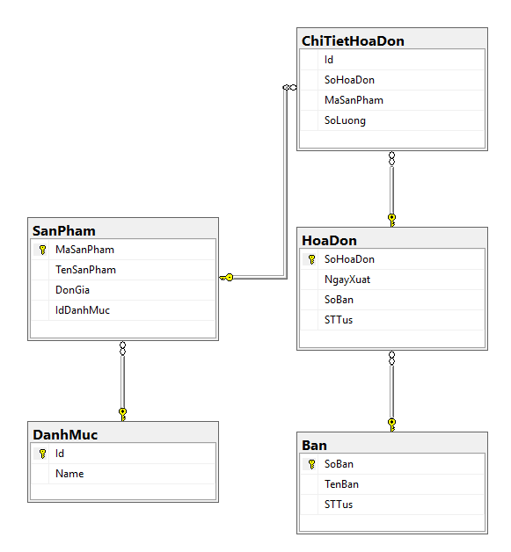

Form 3. Database diagram of coffee bill management

1. **Create a CoffeeShop project by Visual Studio 2013/2015**

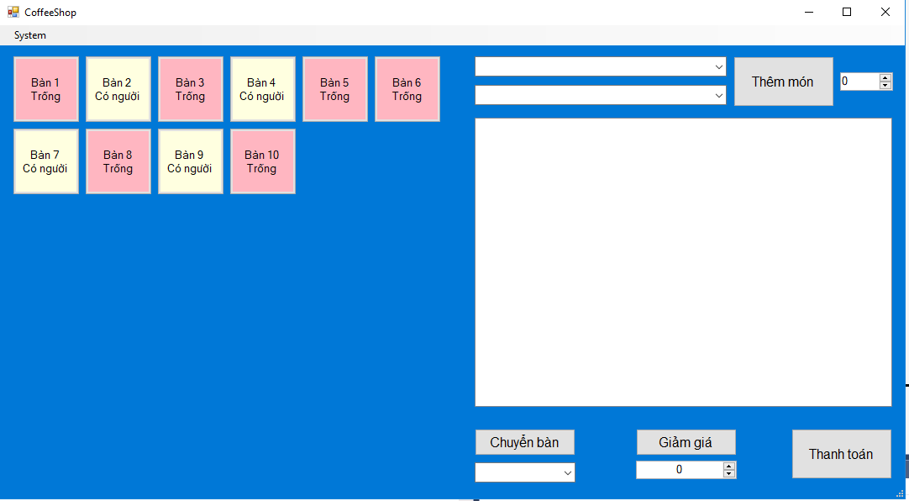

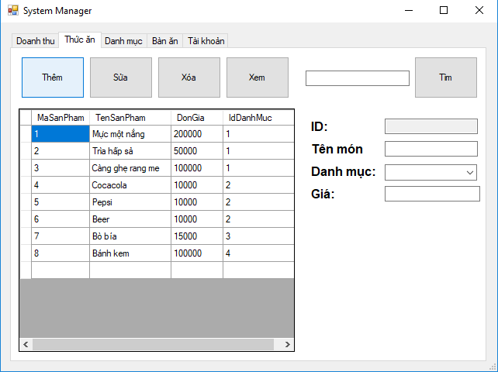

Form 4. CoffeeShop project by Visual Studio 2017

1. **Clone and Push code**

**-** Register GitHub at github.com and new your repositories

**-** Installing GitHub Desktop

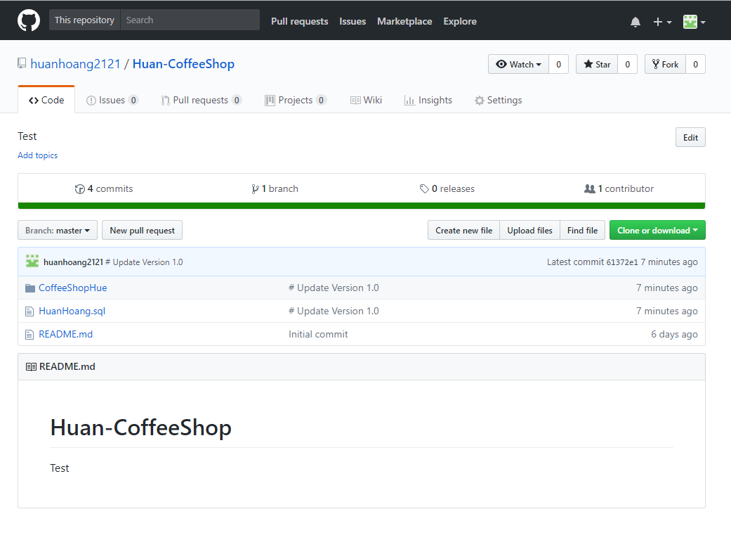

Form 5. Register GitHub at github.com

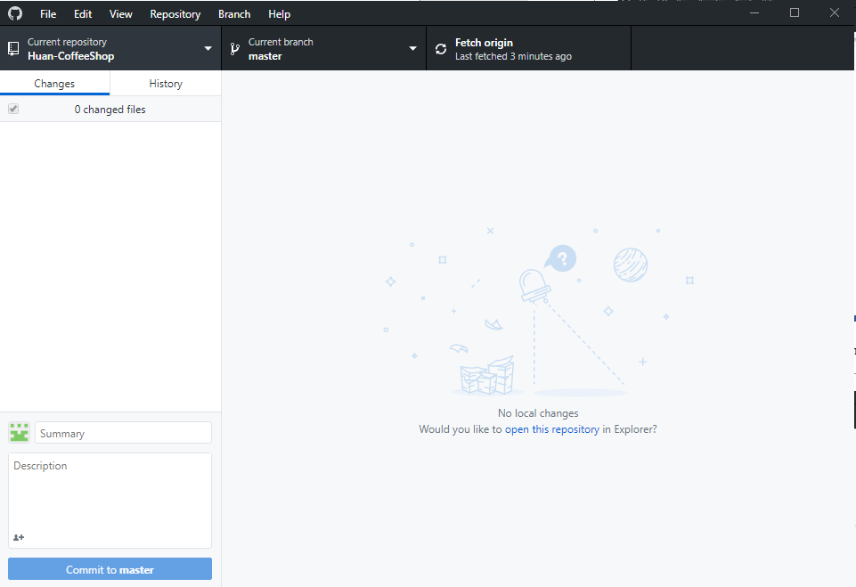

Form 6. Installing GitHub Desktop and Push code

1. **Result**

Link : <https://github.com/huanhoang2121/Huan-CoffeeShop>

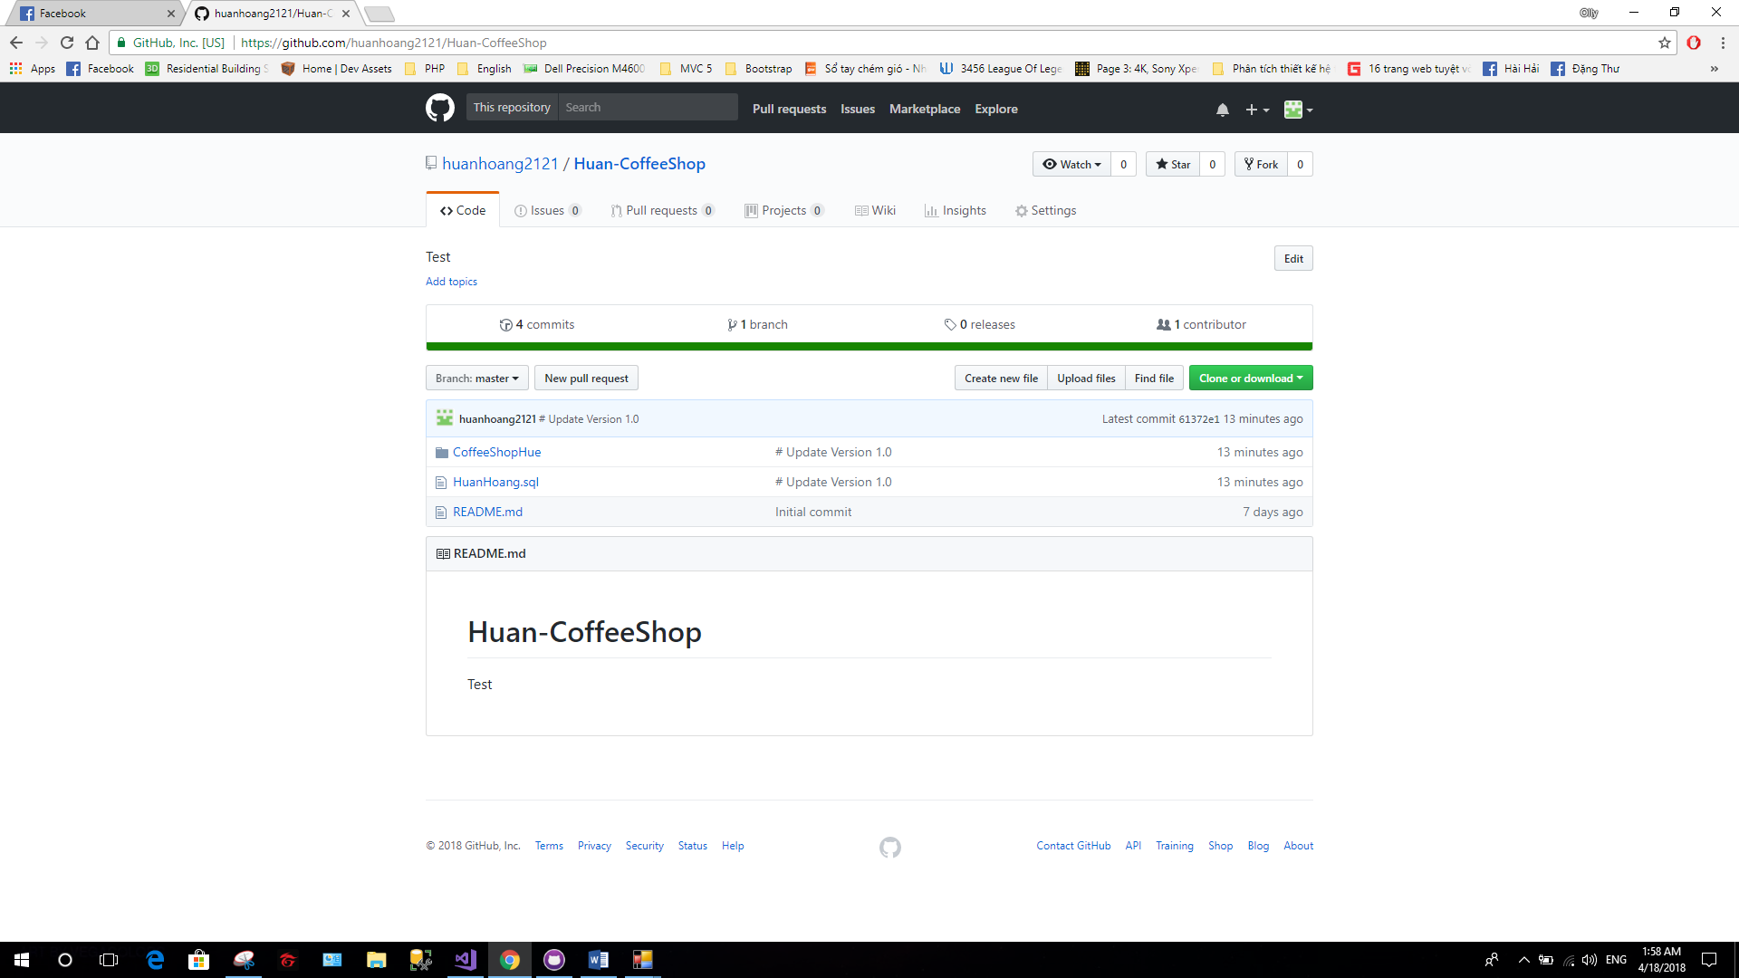

Form 7. Code at Github.