# Creating an application Reading this tutorial

<http://www.entityframeworktutorial.net/code-first/entity-framework-code-first.aspx>

# Crea data Model

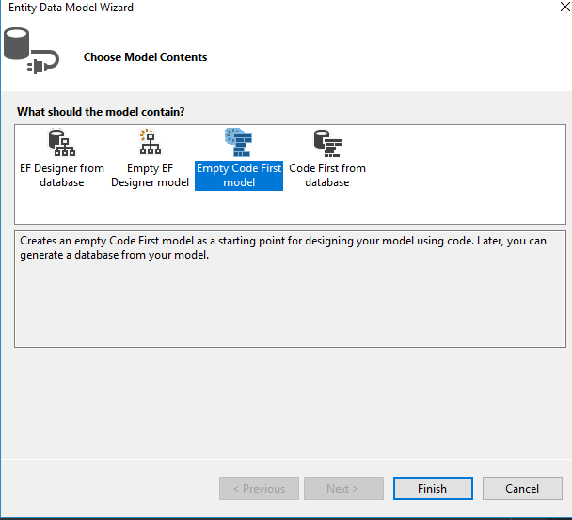

# [**How to connect to LocalDB in Visual Studio Server Explorer?**](http://stackoverflow.com/questions/21563940/how-to-connect-to-localdb-in-visual-studio-server-explorer)

<http://stackoverflow.com/questions/21563940/how-to-connect-to-localdb-in-visual-studio-server-explorer>

OK, answering to my own question.

Steps to connect LocalDB to Visual Studio Server Explorer

1. Open command prompt
2. Run SqlLocalDB.exe start v11.0
3. Run SqlLocalDB.exe info v11.0
4. Copy the **Instance pipe name** that starts with np:\...
5. In Visual Studio select TOOLS > Connect to Database...
6. For Server Name enter (localdb)\v11.0. If it didn't work, use the **Instance pipe name** that you copied earlier. You can also use this to connect with SQL Management Studio.
7. Select the database on next dropdown list
8. Click OK

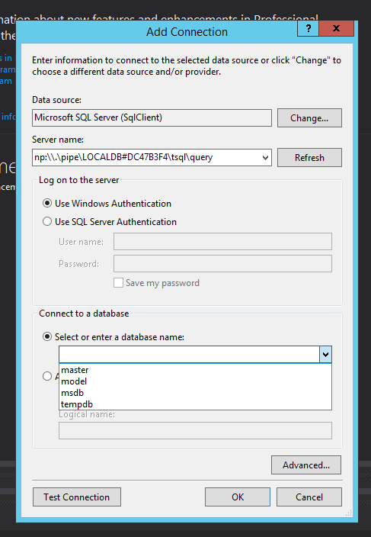

|  |  |
| --- | --- |
| [share](http://stackoverflow.com/a/21565688/4251534)[edit](http://stackoverflow.com/posts/21565688/edit) | [edited Jun 13 '14 at 21:23](http://stackoverflow.com/posts/21565688/revisions) |