# Shortest Path

To resolve the shortest path problem, we use a priority queue to record all the reachable destination with the distance from the starting point. The priority queue should be as least first (we can use negative value in C++).

Everytime we fetch a node X from the priority queue with the shortest distance from start and visit all its neighbors, and calculate the new distance from start to this neighbor Y, which should be distance (start, X) + distance (X, Y). If Y is already visited, we only need to revisit Y when a shorter path to Y is discovered.

The whole process is a BFS process.

## 407. Trapping Rain Water II

Hard

Given an m x n matrix of positive integers representing the height of each unit cell in a 2D elevation map, compute the volume of water it is able to trap after raining.

**Note:**

Both *m* and *n* are less than 110. The height of each unit cell is greater than 0 and is less than 20,000.

**Example:**

Given the following 3x6 height map:

[

[1,4,3,1,3,2],

[3,2,1,3,2,4],

[2,3,3,2,3,1]

]

Return 4.

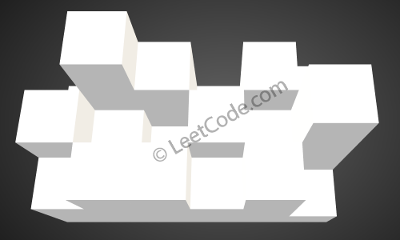

The above image represents the elevation map [[1,4,3,1,3,2],[3,2,1,3,2,4],[2,3,3,2,3,1]] before the rain.

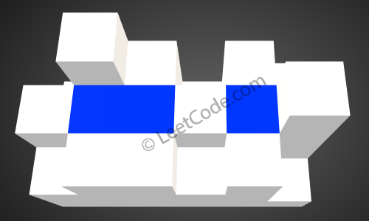

After the rain, water is trapped between the blocks. The total volume of water trapped is 4.

### Analysis:

We first push all the edge nodes in the priority queue, and pick the lowest one, and check their neighbors, if we found any node which is lower than current one, we fill in water and raise the level as current. We run this process until end.

/// <summary>

/// Leet code #407. Trapping Rain Water II

///

/// Given an m x n matrix of positive integers representing the height of each unit cell

/// in a 2D elevation map, compute the volume of water it is able to trap after raining.

///

/// Note:

/// Both m and n are less than 110. The height of each unit cell is greater than 0 and is less than 20,000.

/// Example:

/// Given the following 3x6 height map:

/// [

/// [1,4,3,1,3,2],

/// [3,2,1,3,2,4],

/// [2,3,3,2,3,1]

/// ]

/// Return 4.

/// </summary>

int LeetCode::trapRainWater(vector<vector<int>>& heightMap)

{

int result = 0;

if (heightMap.empty() || heightMap[0].empty()) return 0;

priority_queue<vector<int>> search;

vector<vector<int>> visited(heightMap.size(), vector<int>(heightMap[0].size()));

for (size_t i = 0; i < heightMap.size(); i++)

{

vector<int> pos = { -heightMap[i][0], (int)i, 0 };

search.push(pos);

visited[i][0] = 1;

int max_col = heightMap[i].size() - 1;

if (max_col > 0)

{

pos = { -heightMap[i][max_col], (int)i, max_col };

search.push(pos);

visited[i][max_col] = 1;

}

}

for (size_t i = 0; i < heightMap[0].size(); i++)

{

vector<int> pos = { -heightMap[0][i], 0, (int)i };

search.push(pos);

visited[0][i] = 1;

int max_row = heightMap.size() - 1;

if (max_row > 0)

{

pos = { -heightMap[max_row][i], max_row, (int)i };

search.push(pos);

visited[max_row][i] = 1;

}

}

while (!search.empty())

{

vector<int> pos = search.top();

search.pop();

int floor_level = -pos[0];

vector<vector<int>> directions = { {-1, 0 }, {1, 0}, {0, -1}, {0, 1} };

for (size_t i = 0; i < directions.size(); i++)

{

int row = pos[1] + directions[i][0];

int col = pos[2] + directions[i][1];

if ((row < 0) || (row >= (int)heightMap.size()) ||

(col < 0) || (col >= (int)heightMap[0].size()))

{

continue;

}

if (visited[row][col] == 1)

{

continue;

}

if (heightMap[row][col] < floor_level)

{

result += floor_level - heightMap[row][col];

search.push({ -floor_level, row, col });

}

else

{

search.push({ -heightMap[row][col], row, col });

}

visited[row][col] = 1;

}

}

return result;

}

## 505. The Maze II

Medium

There is a **ball** in a maze with empty spaces and walls. The ball can go through empty spaces by rolling **up**, **down**, **left** or **right**, but it won't stop rolling until hitting a wall. When the ball stops, it could choose the next direction.

Given the ball's **start position**, the **destination** and the **maze**, find the shortest distance for the ball to stop at the destination. The distance is defined by the number of **empty spaces** traveled by the ball from the start position (excluded) to the destination (included). If the ball cannot stop at the destination, return -1.

The maze is represented by a binary 2D array. 1 means the wall and 0 means the empty space. You may assume that the borders of the maze are all walls. The start and destination coordinates are represented by row and column indexes.

**Example 1:**

**Input 1:** a maze represented by a 2D array

0 0 1 0 0

0 0 0 0 0

0 0 0 1 0

1 1 0 1 1

0 0 0 0 0

**Input 2:** start coordinate (rowStart, colStart) = (0, 4)

**Input 3:** destination coordinate (rowDest, colDest) = (4, 4)

**Output:** 12

**Explanation:** One shortest way is : left -> down -> left -> down -> right -> down -> right.

The total distance is 1 + 1 + 3 + 1 + 2 + 2 + 2 = 12.

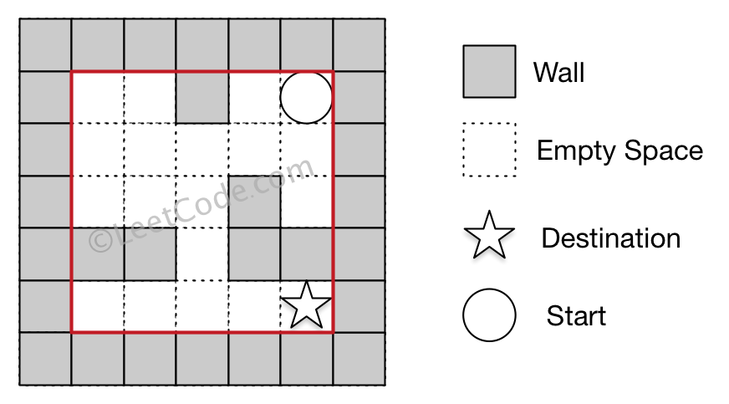

**Example 2:**

**Input 1:** a maze represented by a 2D array

0 0 1 0 0

0 0 0 0 0

0 0 0 1 0

1 1 0 1 1

0 0 0 0 0

**Input 2:** start coordinate (rowStart, colStart) = (0, 4)

**Input 3:** destination coordinate (rowDest, colDest) = (3, 2)

**Output:** -1

**Explanation:** There is no way for the ball to stop at the destination.

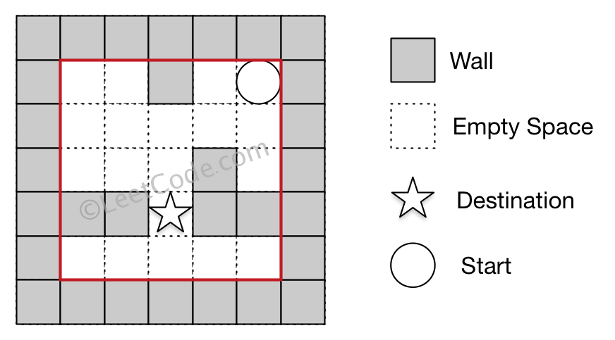

**Note:**

1. There is only one ball and one destination in the maze.
2. Both the ball and the destination exist on an empty space, and they will not be at the same position initially.
3. The given maze does not contain border (like the red rectangle in the example pictures), but you could assume the border of the maze are all walls.
4. The maze contains at least 2 empty spaces, and both the width and height of the maze won't exceed 100.

### Analysis:

Find the next shortest stop from the starting point and then continue to explorer from there.

/// <summary>

/// Leet code #505. The Maze II

///

/// There is a ball in a maze with empty spaces and walls. The ball can

/// go through empty spaces by rolling up, down, left or right, but it

/// won't stop rolling until hitting a wall. When the ball stops, it could

/// choose the next direction.

///

/// Given the ball's start position, the destination and the maze, find the

/// shortest distance for the ball to stop at the destination. The distance

/// is defined by the number of empty spaces traveled by the ball from the

/// start position (excluded) to the destination (included). If the ball

/// cannot stop at the destination, return -1.

///

/// The maze is represented by a binary 2D array. 1 means the wall and 0 means

/// the empty space. You may assume that the borders of the maze are all walls.

/// The start and destination coordinates are represented by row and column

/// indexes.

///

/// Example 1

/// Input 1: a maze represented by a 2D array

///

/// 0 0 1 0 0

/// 0 0 0 0 0

/// 0 0 0 1 0

/// 1 1 0 1 1

/// 0 0 0 0 0

/// Input 2: start coordinate (rowStart, colStart) = (0, 4)

/// Input 3: destination coordinate (rowDest, colDest) = (4, 4)

///

/// Output: 12

/// Explanation: One shortest way is :

/// left -> down -> left -> down -> right -> down -> right.

/// The total distance is 1 + 1 + 3 + 1 + 2 + 2 + 2 = 12.

///

/// Example 2

/// Input 1: a maze represented by a 2D array

///

/// 0 0 1 0 0

/// 0 0 0 0 0

/// 0 0 0 1 0

/// 1 1 0 1 1

/// 0 0 0 0 0

/// Input 2: start coordinate (rowStart, colStart) = (0, 4)

/// Input 3: destination coordinate (rowDest, colDest) = (3, 2)

/// Output: -1

/// Explanation: There is no way for the ball to stop at the destination.

///

/// Note:

/// 1.There is only one ball and one destination in the maze.

/// 2.Both the ball and the destination exist on an empty space,

/// and they will not be at the same position initially.

/// 3.The given maze does not contain border (like the red rectangle in the

/// example pictures), but you could assume the border of the maze are all

/// walls.

/// 4.The maze contains at least 2 empty spaces, and both the width and height

/// of the maze won't exceed 100.

/// </summary>

int LeetCode::shortestDistance(vector<vector<int>>& maze, vector<int>& start, vector<int>& destination)

{

if (maze.empty() || maze[0].empty()) return -1;

vector<vector<int>> visited(maze.size(), vector<int>(maze[0].size(), INT_MAX));

visited[start[0]][start[1]] = 0;

priority_queue<pair<int, vector<int>>> process_queue;

process_queue.push(make_pair(0, start));

while (!process_queue.empty())

{

start = process_queue.top().second;

process_queue.pop();

if (start == destination) break;

shortestDistance(maze, visited, start, process_queue);

}

int shortest_distance = visited[destination[0]][destination[1]];

if (shortest_distance == INT_MAX) return -1;

else return shortest_distance;

}

/// <summary>

/// Leet code #505. The Maze II

/// </summary>

void LeetCode::shortestDistance(vector<vector<int>>& maze, vector<vector<int>>& visited,

vector<int>& start, priority_queue<pair<int, vector<int>>> &process_queue)

{

vector<vector<int>> next_list;

int distance = visited[start[0]][start[1]];

vector<vector<int>> directions = { {-1, 0}, {1,0}, {0, -1}, {0,1} };

for (size_t i = 0; i < 4; i++)

{

int step = 0;

vector<int> pos = start;

while (true)

{

pos[0] += directions[i][0];

pos[1] += directions[i][1];

if ((pos[0] >= 0) && (pos[0] < (int)maze.size()) &&

(pos[1] >= 0) && (pos[1] < (int)maze[0].size()) &&

(maze[pos[0]][pos[1]] == 0))

{

step++;

}

else

{

pos[0] -= directions[i][0];

pos[1] -= directions[i][1];

break;

}

}

if (pos == start) continue;

if (visited[pos[0]][pos[1]] > distance + step)

{

visited[pos[0]][pos[1]] = distance + step;

process_queue.push(make_pair(-visited[pos[0]][pos[1]], pos));

}

}

}

## 882. Reachable Nodes In Subdivided Graph

Hard

Starting with an **undirected** graph (the "original graph") with nodes from 0 to N-1, subdivisions are made to some of the edges.

The graph is given as follows: edges[k] is a list of integer pairs (i, j, n) such that (i, j) is an edge of the original graph,

and n is the total number of **new** nodes on that edge.

Then, the edge (i, j) is deleted from the original graph, n new nodes (x_1, x_2, ..., x_n) are added to the original graph,

and n+1 new edges (i, x_1), (x_1, x_2), (x_2, x_3), ..., (x_{n-1}, x_n), (x_n, j) are added to the original graph.

Now, you start at node 0 from the original graph, and in each move, you travel along one edge.

Return how many nodes you can reach in at most M moves.

**Example 1:**

**Input:** edges = [[0,1,10],[0,2,1],[1,2,2]], M = 6, N = 3

**Output:** 13

**Explanation:**

The nodes that are reachable in the final graph after M = 6 moves are indicated below.

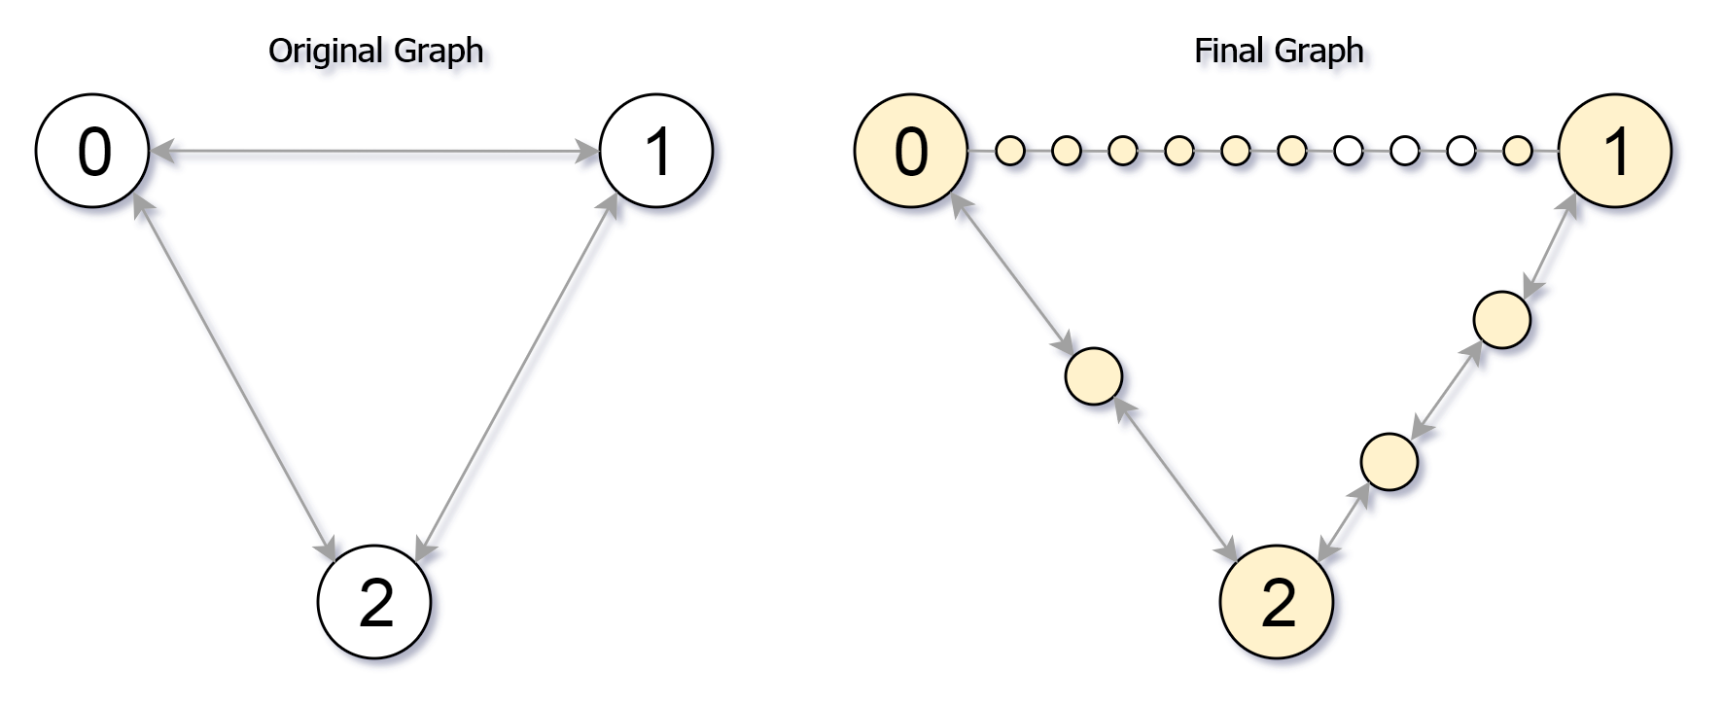

**Example 2:**

**Input:** edges = [[0,1,4],[1,2,6],[0,2,8],[1,3,1]], M = 10, N = 4

**Output:** 23

**Note:**

1. 0 <= edges.length <= 10000
2. 0 <= edges[i][0] < edges[i][1] < N
3. There does not exist any i != j for which edges[i][0] == edges[j][0] and edges[i][1] == edges[j][1].
4. The original graph has no parallel edges.
5. 0 <= edges[i][2] <= 10000
6. 0 <= M <= 10^9
7. 1 <= N <= 3000
8. A reachable node is a node that can be travelled to using at most M moves starting from node 0.

### Analysis:

Seach from the next node with modest unused steps.

/// <summary>

/// Leet code #882. Reachable Nodes In Subdivided Graph

///

/// Starting with an undirected graph (the "original graph") with nodes from

/// 0 to N-1, subdivisions are made to some of the edges.

///

/// The graph is given as follows: edges[k] is a list of integer pairs

/// (i, j, n) such that (i, j) is an edge of the original graph,

///

/// and n is the total number of new nodes on that edge.

///

/// Then, the edge (i, j) is deleted from the original graph, n new nodes

/// (x_1, x_2, ..., x_n) are added to the original graph,

///

/// and n+1 new edges (i, x_1), (x_1, x_2), (x_2, x_3), ..., (x_{n-1}, x_n),

/// (x_n, j) are added to the original graph.

///

/// Now, you start at node 0 from the original graph, and in each move, you

/// travel along one edge.

///

/// Return how many nodes you can reach in at most M moves.

///

/// Example 1:

///

/// Input: edges = [[0,1,10],[0,2,1],[1,2,2]], M = 6, N = 3

/// Output: 13

/// Explanation:

/// The nodes that are reachable in the final graph after M = 6 moves are

/// indicated below.

///

/// Example 2:

///

/// Input: edges = [[0,1,4],[1,2,6],[0,2,8],[1,3,1]], M = 10, N = 4

/// Output: 23

///

/// Note:

///

/// 1. 0 <= edges.length <= 10000

/// 2. 0 <= edges[i][0] < edges[i][1] < N

/// 3. There does not exist any i != j for which edges[i][0] == edges[j][0] and

/// edges[i][1] == edges[j][1].

/// 4. The original graph has no parallel edges.

/// 5. 0 <= edges[i][2] <= 10000

/// 6. 0 <= M <= 10^9

/// 7. 1 <= N <= 3000

/// 8. reachable node is a node that can be travelled to using at most M moves

/// starting from node 0.

/// </summary>

int LeetCode::reachableNodes(vector<vector<int>>& edges, int M, int N)

{

int result = 0;

unordered_map<int, unordered_map<int, int>> edge_nodes;

vector<int> visited(N);

for (size_t i = 0; i < edges.size(); i++)

{

edge_nodes[edges[i][0]][edges[i][1]] = edges[i][2];

edge_nodes[edges[i][1]][edges[i][0]] = edges[i][2];

}

priority_queue<pair<int, int>>search;

search.push(make_pair(M, 0));

while (!search.empty())

{

pair<int, int> pos = search.top();

search.pop();

int node = pos.second;

int step = pos.first;

if (visited[node] == 1) continue;

result++;

visited[node] = 1;

for (auto itr : edge_nodes[node])

{

int target_node = itr.first;

int nodes_in_middle = itr.second;

if (nodes_in_middle + 1 <= step)

{

result += nodes_in_middle;

if (visited[target_node] == 0)

{

search.push(make_pair(step - nodes_in_middle - 1, target_node));

edge_nodes[node][target_node] = 0;

edge_nodes[target_node][node] = 0;

}

}

else

{

result += step;

edge_nodes[node][target_node] -= step;

edge_nodes[target_node][node] -= step;

}

}

}

return result;

}

## 847. Shortest Path Visiting All Nodes

Hard

An undirected, connected graph of N nodes (labeled 0, 1, 2, ..., N-1) is given as graph.

graph.length = N, and j != i is in the list graph[i] exactly once, if and only if nodes i and j are connected.

Return the length of the shortest path that visits every node. You may start and stop at any node, you may revisit nodes multiple times, and you may reuse edges.

**Example 1:**

**Input:** [[1,2,3],[0],[0],[0]]

**Output:** 4

**Explanation**: One possible path is [1,0,2,0,3]

**Example 2:**

**Input:** [[1],[0,2,4],[1,3,4],[2],[1,2]]

**Output:** 4

**Explanation**: One possible path is [0,1,4,2,3]

**Note:**

1. 1 <= graph.length <= 12
2. 0 <= graph[i].length < graph.length

### Analysis:

This is a typical salesman problem. It may be too difficult for 45 minutes interview.

A user can start from any node and travel to next node. When user end up any node, given the nodes he already visited, we call it a state, for any state, we will only remember the shortest path.

Please refer to the following detailed explanation.

<https://simple.wikipedia.org/wiki/Travelling_salesman_problem>

The travelling salesman is to say for a list of given cites, the distances between the cities, the sales man need to travel all the cities at least once, what is the shortest way.

This an NP hard problem, so the time complexity is exponential. We should make our code pattern clean, short and easy to understand.

Please think how you handle the following issues in this problem.

1. How to search the path?

This can be a Breadth First Search, but it will not search once, you need to start from every city. But generally speaking, it is similar.

1. How to mark the current state?

During the search you need to represent what is the current state. For travelling salesman problem, the current state is which city the salesman currently reached (last visited), plus all the cities the salesman has already visited.

1. How to mark the cities already travelled?

We can use a bitmap, (a long integer will cover for 64), each bit represents the city is already visited or not.

1. How to optimize the algorithm by cutting branches?

For any state above, you only need to remember the shortest distance.

/// <summary>

/// Leet code #847. Shortest Path Visiting All Nodes

///

/// An undirected, connected graph of N nodes (labeled 0, 1, 2, ..., N-1)

/// is given as graph.

///

/// graph.length = N, and j != i is in the list graph[i] exactly once, if

/// and only if nodes i and j are connected.

///

/// Return the length of the shortest path that visits every node. You may

/// start and stop at any node, you may revisit nodes multiple times, and

/// you may reuse edges.

///

/// Example 1:

///

/// Input: [[1,2,3],[0],[0],[0]]

/// Output: 4

/// Explanation: One possible path is [1,0,2,0,3]

///

/// Example 2:

///

/// Input: [[1],[0,2,4],[1,3,4],[2],[1,2]]

/// Output: 4

/// Explanation: One possible path is [0,1,4,2,3]

///

///

/// Note:

/// 1. 1 <= graph.length <= 12

/// 2. 0 <= graph[i].length < graph.length

/// </summary>

int LeetCode::shortestPathLength(vector<vector<int>>& graph)

{

size_t size = graph.size();

vector<vector<int>> dp(1 << size, vector<int>(size, -1));

queue<pair<int, int>> search;

// we start from each node

for (size_t i = 0; i < size; i++)

{

int cover = 1 << i;

dp[cover][i] = 0;

// make the current node as last node

search.push(make_pair(cover, i));

}

while (!search.empty())

{

pair<int, int> route = search.front();

search.pop();

// we check from current last node what are next nodes to travel

for (size_t i = 0; i < graph[route.second].size(); i++)

{

int next = graph[route.second][i];

// Normally we need to check if we have already visited the

// next node, however the distance check will save us this

// effort, if the node is already visited, visit again will

// give us no chance to shorten the path

int cover = route.first | (1 << next);

if (dp[cover][next] == -1 ||

dp[cover][next] > dp[route.first][route.second] + 1)

{

dp[cover][next] = dp[route.first][route.second] + 1;

search.push(make_pair(cover, next));

}

}

}

int full = (1 << size) - 1;

int result = dp[full][0];

// starting from every node, look for shortest path

for (size_t i = 1; i < size; i++)

{

result = min(result, dp[full][i]);

}

return result;

}

## 943. Find the Shortest Superstring

Hard

Given an array A of strings, find any smallest string that contains each string in A as a substring.

We may assume that no string in A is substring of another string in A.

**Example 1:**

**Input:** ["alex","loves","leetcode"]

**Output:** "alexlovesleetcode"

**Explanation:** All permutations of "alex","loves","leetcode" would also be accepted.

**Example 2:**

**Input:** ["catg","ctaagt","gcta","ttca","atgcatc"]

**Output:** "gctaagttcatgcatc"

**Note:**

1. 1 <= A.length <= 12
2. 1 <= A[i].length <= 20

### Analysis:

This is another salesman problem, the only difference is that you care which words are visited which are not, and you do not care which is the last word.

/// <summary>

/// Leet code #943. Find the Shortest Superstring

/// </summary>

string LeetCodeGraph::calculateOverlapString(string& string1, string& string2)

{

int prefix = min(string1.size(), string2.size());

string result = string1 + string2;

while (prefix > 0)

{

if (string1.substr(string1.size() - prefix) == string2.substr(0, prefix))

{

result = string1 + string2.substr(prefix);

break;

}

else if (string2.substr(string2.size() - prefix) == string1.substr(0, prefix))

{

result = string2 + string1.substr(prefix);

break;

}

prefix--;

}

return result;

}

/// <summary>

/// Leet code #943. Find the Shortest Superstring

///

/// Given an array A of strings, find any smallest string that contains each

/// string in A as a substring.

///

/// We may assume that no string in A is substring of another string in A.

///

/// Example 1:

/// Input: ["alex","loves","leetcode"]

/// Output: "alexlovesleetcode"

/// Explanation: All permutations of "alex","loves","leetcode" would also be

/// accepted.

///

/// Example 2:

/// Input: ["catg","ctaagt","gcta","ttca","atgcatc"]

/// Output: "gctaagttcatgcatc"

///

/// Note:

/// 1. 1 <= A.length <= 12

/// 2. 1 <= A[i].length <= 20

/// </summary>

string LeetCodeGraph::shortestSuperstring(vector<string>& A)

{

vector<string> dp(1 << A.size());

int bit_full = (1 << A.size()) - 1;

queue<int> search;

search.push(0);

while (!search.empty())

{

int bit = search.front();

search.pop();

for (size_t i = 0; i < A.size(); i++)

{

int bit_set = 1 << i;

if ((bit & bit_set) == 0)

{

bit_set = bit | bit_set;

if (dp[bit_set].empty()) search.push(bit_set);

string cand = calculateOverlapString(dp[bit], A[i]);

if (dp[bit_set].empty() || dp[bit_set].size() > cand.size())

{

dp[bit_set] = cand;

}

}

}

}

return dp[bit_full];

}

## 1066. Campus Bikes II

Medium

On a campus represented as a 2D grid, there are N workers and M bikes, with N <= M. Each worker and bike is a 2D coordinate on this grid.

We assign one unique bike to each worker so that the sum of the Manhattan distances between each worker and their assigned bike is minimized.

The Manhattan distance between two points p1 and p2 is Manhattan(p1, p2) = |p1.x - p2.x| + |p1.y - p2.y|.

Return the minimum possible sum of Manhattan distances between each worker and their assigned bike.

**Example 1:**

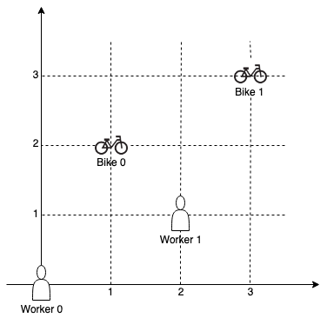

**Input:** workers = [[0,0],[2,1]], bikes = [[1,2],[3,3]]

**Output:** 6

**Explanation:**

We assign bike 0 to worker 0, bike 1 to worker 1. The Manhattan distance of both assignments is 3, so the output is 6.

**Example 2:**

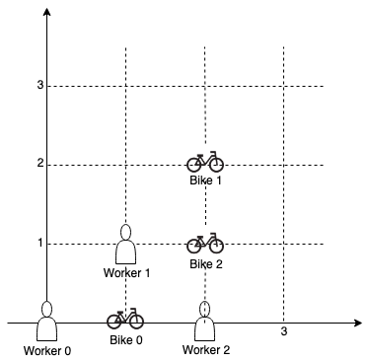

**Input:** workers = [[0,0],[1,1],[2,0]], bikes = [[1,0],[2,2],[2,1]]

**Output:** 4

**Explanation:**

We first assign bike 0 to worker 0, then assign bike 1 to worker 1 or worker 2, bike 2 to worker 2 or worker 1. Both assignments lead to sum of the Manhattan distances as 4.

**Note:**

1. 0 <= workers[i][0], workers[i][1], bikes[i][0], bikes[i][1] < 1000
2. All worker and bike locations are distinct.
3. 1 <= workers.length <= bikes.length <= 10

### Analysis:

We can do simply backtracking, but using shortest path will optimize the algorithm, if we have select the same people, same bikes we should only choose the least total distance.

/// <summary>

/// Leet code #1066. Campus Bikes II

/// </summary>

int LeetCode::assignBikesII(vector<vector<pair<int, int>>> &worker_distance, int worker,

vector<int> &visited, int sum, unordered_map<int, int>& cache, int& result)

{

if (worker == worker_distance.size())

{

result = min(sum, result);

return result;

}

for (size_t i = 0; i < worker_distance[worker].size(); i++)

{

int bike = worker_distance[worker][i].second;

if (visited[bike] == 1) continue;

visited[bike] = 1;

sum += worker_distance[worker][i].first;

int key = 0;

for (size_t j = 0; j < visited.size(); j++)

{

key = (key << 1) | visited[j];

}

if (cache.count(key) == 0 || cache[key] > sum)

{

cache[key] = sum;

result = assignBikesII(worker_distance, worker + 1, visited, sum, cache, result);

}

sum -= worker_distance[worker][i].first;

visited[bike] = 0;

}

return result;

}

/// <summary>

/// Leet code #1066. Campus Bikes II

///

/// On a campus represented as a 2D grid, there are N workers and M bikes,

/// with N <= M. Each worker and bike is a 2D coordinate on this grid.

///

/// We assign one unique bike to each worker so that the sum of the

/// Manhattan distances between each worker and their assigned bike is

/// minimized.

///

/// The Manhattan distance between two points p1 and p2 is

/// Manhattan(p1, p2) = |p1.x - p2.x| + |p1.y - p2.y|.

///

/// Return the minimum possible sum of Manhattan distances between each

/// worker and their assigned bike.

///

/// Example 1:

/// Input: workers = [[0,0],[2,1]], bikes = [[1,2],[3,3]]

/// Output: 6

/// Explanation:

/// We assign bike 0 to worker 0, bike 1 to worker 1. The Manhattan

/// distance of both assignments is 3, so the output is 6.

///

/// Example 2:

/// Input: workers = [[0,0],[1,1],[2,0]], bikes = [[1,0],[2,2],[2,1]]

/// Output: 4

/// Explanation:

/// We first assign bike 0 to worker 0, then assign bike 1 to worker 1

/// or worker 2, bike 2 to worker 2 or worker 1. Both assignments lead

/// to sum of the Manhattan distances as 4.

///

/// Note:

/// 1. 0 <= workers[i][0], workers[i][1], bikes[i][0], bikes[i][1] < 1000

/// 2. All worker and bike locations are distinct.

/// 3. 1 <= workers.length <= bikes.length <= 10

/// </summary>

int LeetCode::assignBikesII(vector<vector<int>>& workers, vector<vector<int>>& bikes)

{

vector<vector<pair<int, int>>> worker_distance(workers.size());

for (size_t i = 0; i < workers.size(); i++)

{

for (size_t j = 0; j < bikes.size(); j++)

{

int distance = std::abs(workers[i][0] - bikes[j][0]) +

std::abs(workers[i][1] - bikes[j][1]);

worker_distance[i].push_back(make_pair(distance, j));

}

sort(worker_distance[i].begin(), worker_distance[i].end());

}

vector<int> visited(bikes.size());

int sum = 0;

int result = INT_MAX;

unordered_map<int, int> cache;

assignBikesII(worker_distance, 0, visited, sum, cache, result);

return result;

}