Practical Examination

Subject code: SDN302

Duration: 90 minutes

Exam: Karaoke Room Management System

Requirements

You are tasked with building a karaoke room management system. The system will include storing information about karaoke rooms, room usage status, customer information, and handling room booking and payment operations. Follow the steps below to complete the task.

Create a new project directory named <name>_karaoke and navigate into this directory

Create a schema and model for the karaoke rooms: You are provided with a sample dataset below. Create a roomModel.js file to define the schema and model for the karaoke rooms. (1 mark)
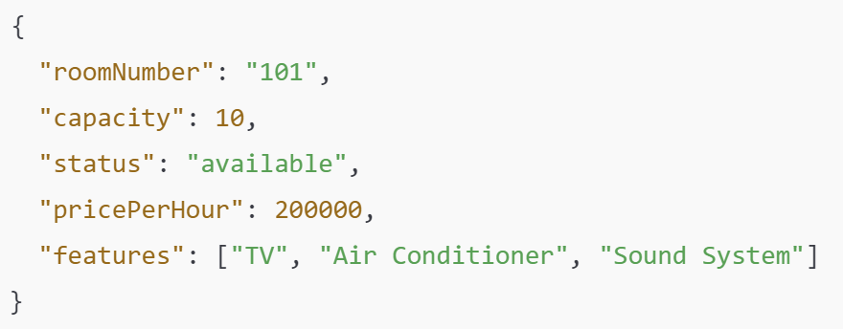
The room data includes:
- roomNumber: Karaoke room number (String).
- capacity: Room capacity (Number).
- status: Room status (available, occupied, maintenance) (String).
- pricePerHour: Hourly rental price (Number).
- features: Room amenities (Array).

- Create a schema and model for room bookings: Create a bookingModel.js file to define the schema and model for room bookings. A sample dataset for a booking is as follows: (1 mark)
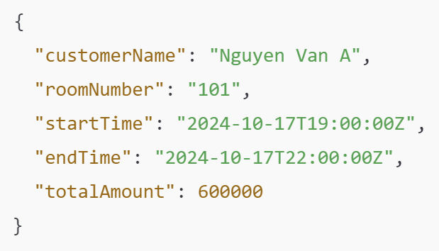
Booking data includes:
- customerName: Customer's name (String).
- roomNumber: Booked room number (String).
- startTime: Room rental start time (Date).
- endTime: Room rental end time (Date).
- totalAmount: Total amount to be paid (Number).
- Build EJS pages to manage bookings:
  - Create booking.ejs file as shown in figure 1 below to:
  - Retrieve the list of room bookings. (1.5 mark)
  - Delete a booking by bookingId. (1.5 mark)
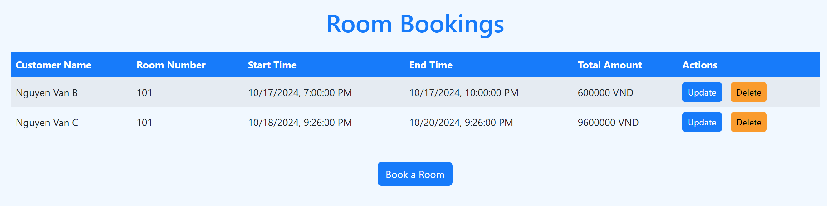
Figure 1. Booking list

  - Create bookRoom.ejs file as shown in figure 2 below to Add a new room booking. (1.5 mark)
The constraint is that only booking rooms that already exist in the system (0.5 mark)
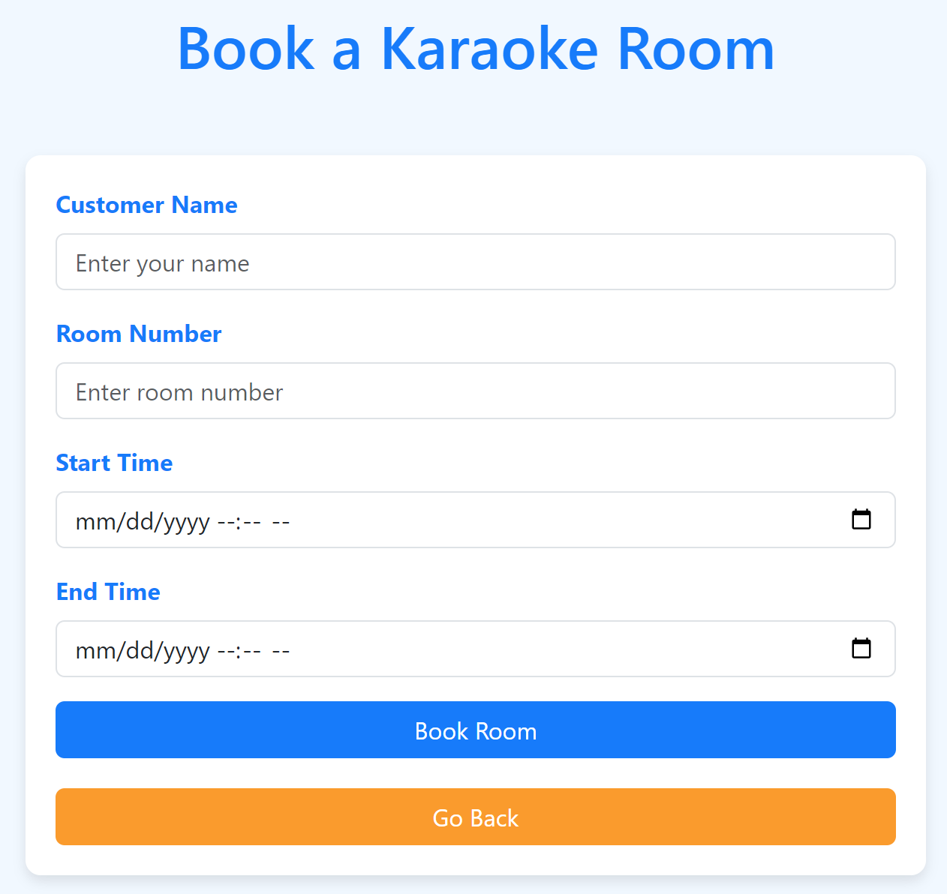
Figure 2. Add new booking room
  - Create updateRoom.ejs file as shown in figure 3 to Update booking information by bookingId. (1.5 mark)
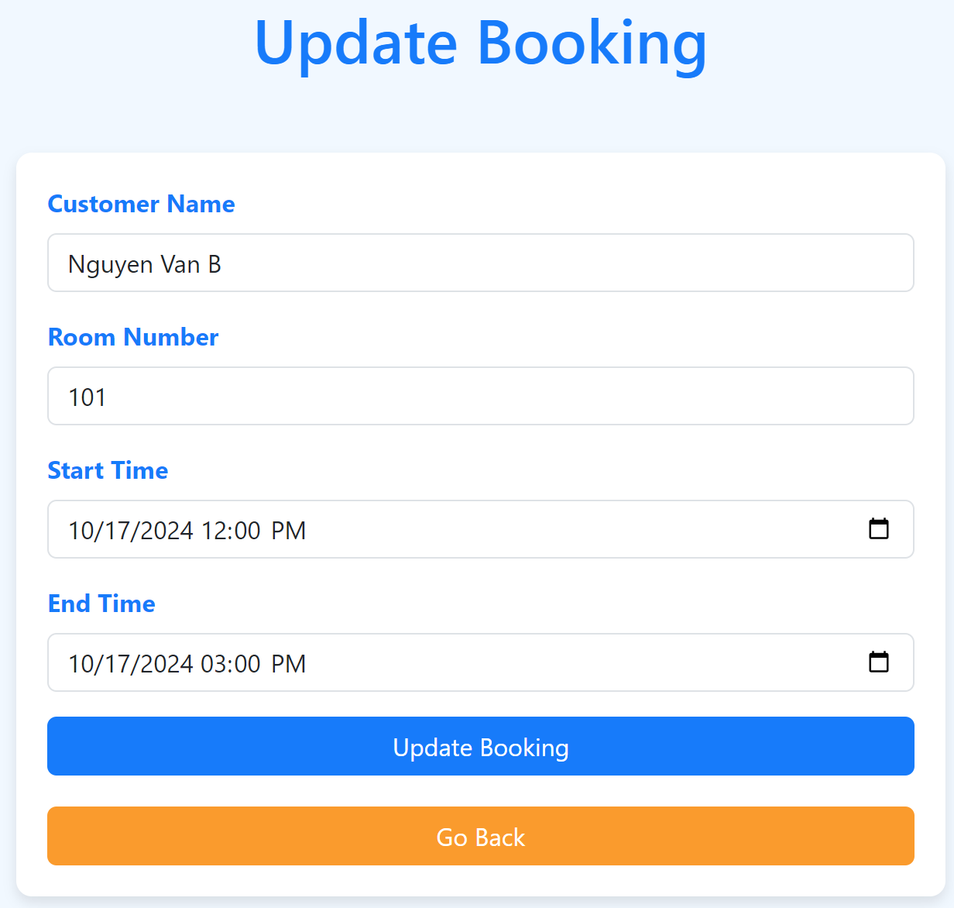
Figure 3. Update booking room
The total payment (Total Amount) should be displayed for each booking. The system must automatically calculate the total amount based on the number of hours the room was booked and the hourly rental price when adding a new booking room. (0.5 mark)
- Organize the project according to the Model-View-Controller (MVC) structure. (0.5 mark)
- Meets UX/UI standards based on the sample interface figure 1,2,3 (0.5 mark)

Submission Requirements:
- Include the package.json file and all source files, including roomModel.js, bookingModel.js, and EJS files.
- Provide a README.md file with instructions on how to run the project and use the system.

