Lab 5: About React Router
Build an online quiz application:
- Use React Router to create routes for the home page, news page, about page, contact page and quiz page.
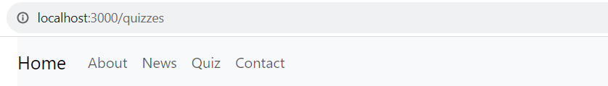
- Display slide on the home page.
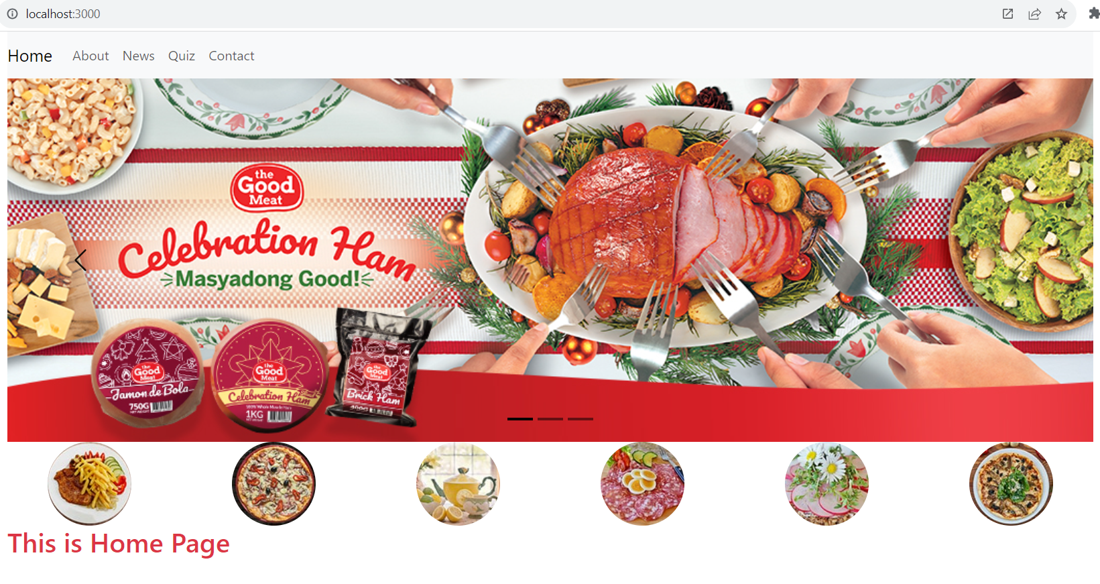
- Display the list of news on the News page.
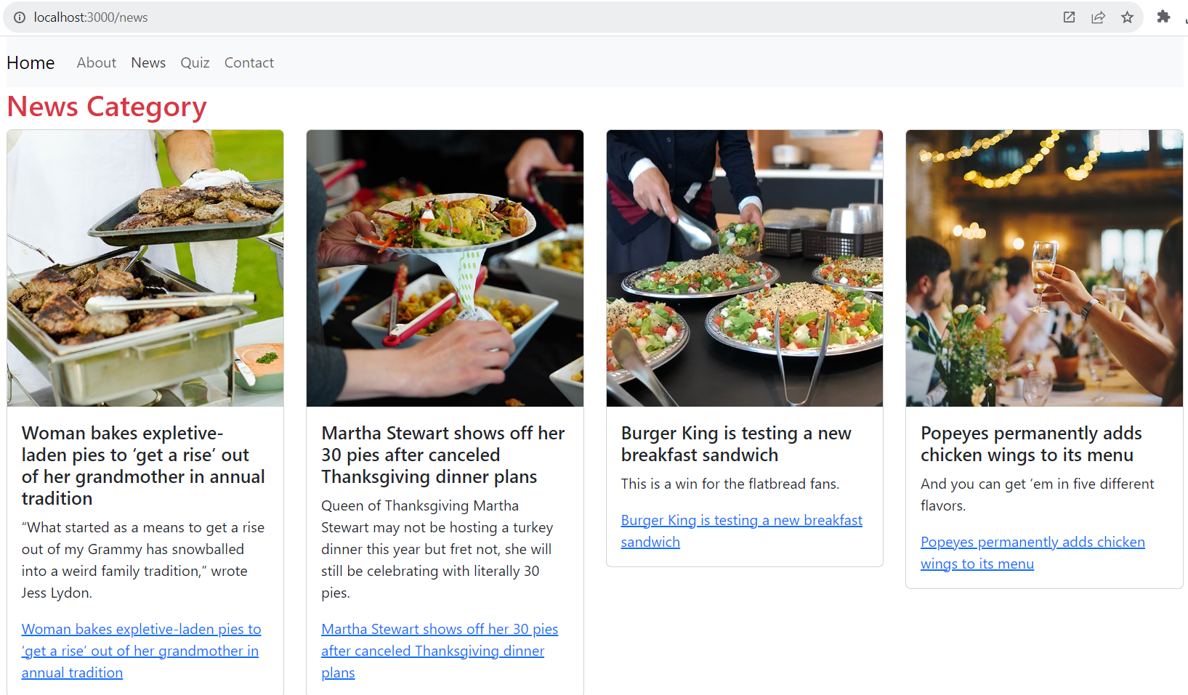
Note: Use an array to store information about News
const newLists = [
{ id: 1, title: 'Woman bakes expletive-laden pies to ‘get a rise’ out of her grandmother in annual tradition', description: '“What started as a means to get a rise out of my Grammy has snowballed into a weird family tradition,” wrote Jess Lydon.', images: 'images/event-1.jpg' },
{ id: 2, title: 'Martha Stewart shows off her 30 pies after canceled Thanksgiving dinner plans', description: 'Queen of Thanksgiving Martha Stewart may not be hosting a turkey dinner this year but fret not, she will still be celebrating with literally 30 pies.', images: 'images/event-2.jpg' },
{ id: 3, title: 'Burger King is testing a new breakfast sandwich', description: 'This is a win for the flatbread fans.', images: 'images/event-3.jpg' },
{ id: 4, title: 'Popeyes permanently adds chicken wings to its menu', description: 'And you can get ’em in five different flavors.', images: 'images/event-4.jpg' },
{ id: 5, title: 'Top salmon with a sizzling mix of aromatics and spices', description: 'Tadka is a ubiquitous South Asian technique that adds a dramatic last-minute coat of flavor.', images: 'images/event-5.jpg' },
{ id: 6, title: '80 Christmas dinner ideas for the ultimate holiday feast', description: 'Build the perfect Christmas menu with these delicious recipes.', images: 'images/event-6.jpg' },
{ id: 7, title: 'How to make the easiest prime rib roast for the holidays', description: 'Use these tips and tricks to make a juicy and amazingly delicious prime rib roast.', images: 'images/event-7.jpg' },
{ id: 8, title: 'Turn leftover turkey into a flavorful Waldorf salad', description: 'This light, bright turkey salad is the best post-Thanksgiving lunch.', images: 'images/event-8.jpg' },
];
- Quiz page: Display the questions and options for the user to answer. You can use an array to store information about the questions and options, and use a separate component to display each question(as Lab 4).
- Contact page: Display the contact Form with react-bootstrap component
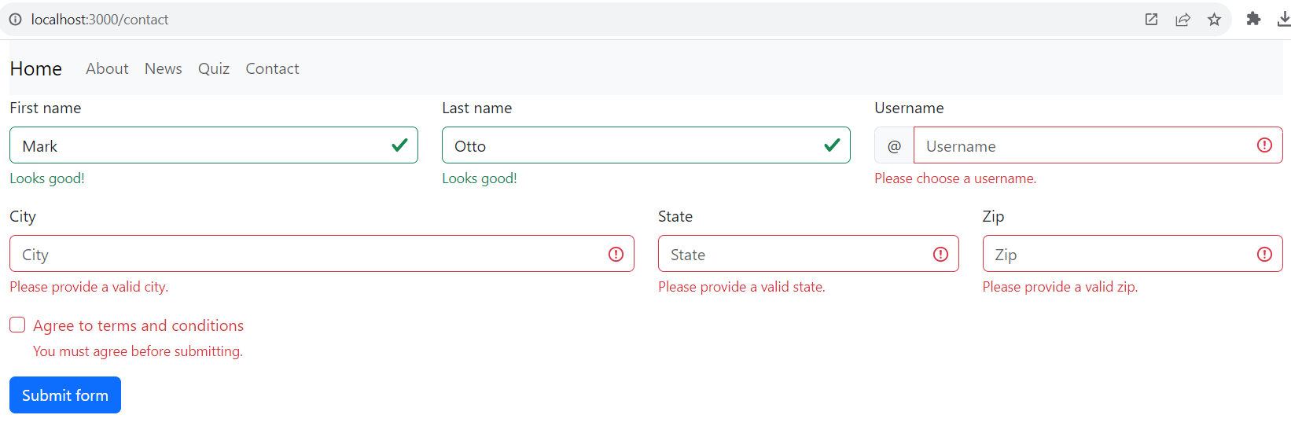
- Define routes: In the root component (App), define the routes using BrowserRouter and Link from React Router.
- In the Home and QuizList components, use Link from React Router to create links to the respective pages.
More Reference: https://react-bootstrap.netlify.app/docs/getting-started/introduction
Images Resource: images.zip

