SFDCT: A Floor-Preserving Spatial–Frequency Fusion for
Cross-Dataset Deepfake Detection under eKYC Operating Points
Deepfake face forgery threatens electronic Know-Your-Customer (eKYC) pipelines in banking, where detectors trained on one corpus often degrade sharply on unseen manipulations. We present SFDCT, a hybrid spatial–frequency detector that augments an EfficientNet-B4 backbone with a block-wise $8×8$ DCT branch and fuses the two streams through a zero-initialized gated cross-attention. The zero-init gate makes the model at initialization mathematically identical to the calibrated backbone, giving a floor-preserving guarantee (never worse than B4 at init) that is directly valuable for eKYC, where the operating threshold is calibrated on the baseline and must not regress. We deliberately do not claim state-of-the-art AUC: under the standardized DeepfakeBench cross-dataset protocol (train FaceForensics++ c23, test Celeb-DF-v2), SFDCT reaches 0.7572 frame-AUC versus 0.7497 for B4 ($Δ=+0.0075$), a gain that a bootstrap confidence interval shows lies within noise. Our contributions are therefore framed honestly as (i) a floor-preserving fusion mechanism, (ii) a regulation-aware eKYC operating-point evaluation that decomposes errors via the ISO/IEC 30107-3 taxonomy, and (iii) a small Vietnamese-face deepfake test-only resource. We report all numbers from a single seed and openly discuss the limitations.
deepfake detection, eKYC, block-wise DCT, spatial–frequency fusion, cross-dataset generalization

Introduction
Electronic Know-Your-Customer (eKYC) lets customers open accounts and authorize transactions remotely from a selfie. This convenience opens an attack surface: low-cost deepfakes can synthesize a convincing face and bypass biometric verification, enabling identity fraud. In Vietnam, Circular 17/2024/TT-NHNN mandates biometric authentication for certain banking transactions. We note explicitly that this circular states a qualitative requirement and does not prescribe a numeric error threshold; to make the requirement measurable we adopt an operating point of $\text{FPR}≤5\%$ following the ISO/IEC 30107-3 convention (BPCER20) .
A central obstacle is the in-dataset-high / cross-dataset-low paradox: a detector with near-perfect in-domain accuracy can collapse on a new corpus . The core hypothesis we build on is that up-sampling/GAN artifacts are weak in the spatial domain but more visible in mid/high 2D-DCT frequency bands, so spatial and frequency cues should be complementary.
We do not claim a new mechanism or SOTA AUC. Instead, this paper makes three contributions:
- C1 (architecture/safety). A floor-preserving spatial–frequency fusion: a block-DCT branch fused into B4 by a zero-initialized gated cross-attention, so the model at initialization equals the calibrated backbone (Sec. 3).
- C2 (evaluation). A regulation-aware eKYC operating-point evaluation that calibrates the decision threshold at $\text{FPR}≤5\%$ and decomposes errors with the ISO/IEC 30107-3 taxonomy on forgery (Sec. 4.1).
- C3 (resource). A small test-only Vietnamese-face deepfake set for the eKYC operating point ([TODO: collect; described in Sec. 5]).
Two methodological pillars support these: a DeepfakeBench-faithful ablation protocol and honest bootstrap-CI reporting that lets us refute our own AUC gain when it is within noise.

Related Work
Frequency-domain forgery detection. F3-Net mines learnable frequency bands and local statistics ; SPSL uses the phase spectrum ; high-frequency SRM residuals improve generalization ; FcaNet generalizes channel attention with multi-spectral 2D-DCT ; FDFL adds a single-center loss ; FreqDebias mixes amplitude spectra to fight spectral bias . SFDCT does not introduce a new frequency operator; it unifies five such levers (S1–S5) inside a single block-DCT domain. On the standardized DeepfakeBench scale, SPSL (0.7650) and SRM (0.7552) remain at or above our naive SFDCT (0.7572): we do not outperform SPSL.
Spatial–frequency fusion and zero-init gating. Most two-stream detectors fuse by concatenation or plain cross-attention without any guarantee against regression. Residual zero-init (ReZero ) and zero-gated cross-attention (Flamingo ) are known in other domains. The closest work is SFCL-HCMF , which also pairs a block-DCT $8×8$ YCbCr branch with EfficientNet-B4 and gated cross-modal fusion; the decisive difference is its gate $σ(γ)$ initializes at $0.5$ (no floor), whereas our $α=0$ yields a mathematical floor $≥$ B4. SFDCT’s C1 is thus a new application/combination, not a new mechanism.
Cross-dataset / eKYC evaluation. TPR@FPR for deepfakes and APCER/BPCER/ACER from PAD (ISO/IEC 30107-3 ) already exist; ethnicity-specific deepfake sets (e.g. KoDF) are common. Our delta is narrow and honest: anchoring the operating point to the Vietnamese eKYC context and providing a VN-face test instance.

Method
Spatial branch. EfficientNet-B4 pretrained on ImageNet produces a feature map $x$ from a $256×256$ aligned face crop.
Frequency branch. The crop is converted to YCbCr; a block-wise $8×8$ 2D-DCT is applied, its log-magnitude is taken and grouped into 16 zigzag bands (with an option to drop the DC and lowest bands to curb content leakage). This yields a frequency feature $f$.
Floor-preserving fusion. The two streams are merged by a gated cross-attention
$$\text{feature}=x+α⋅CrossAttn(x,f), α​←​0\text{ at init},$$
where $α$ is a learnable scalar gate initialized to $0$. At initialization the model is identical to B4, guaranteeing performance never below the calibrated backbone; a positive learned $α$ is direct evidence the frequency branch is used (Fig. 7).
Five frequency levers (S1–S5). Adapted into the single block-DCT domain: S1 DCT coefficient sign (cf. SPSL), S2 DCT on SRM residual (cf. SRM), S3 DCT-FoMixup + dual consistency (cf. FreqDebias), S4 multi-spectral DCT attention (cf. FcaNet), S5 single-center loss (cf. FDFL). All are off in “naive SFDCT”.
Training. Adam ($\text{lr}=2​×​{10}^{−4}$, weight decay $5​×​{10}^{−4}$), batch 32, 32 frames/video, $256×256$, 10 epochs, seed 1024, cross-entropy; checkpoint by best test-AUC.

Experiments
Protocol. We follow DeepfakeBench : train on FaceForensics++ c23 , test cross-dataset on Celeb-DF-v2 ; the headline metric is frame-level AUC. Fig. 1 shows the class distributions.
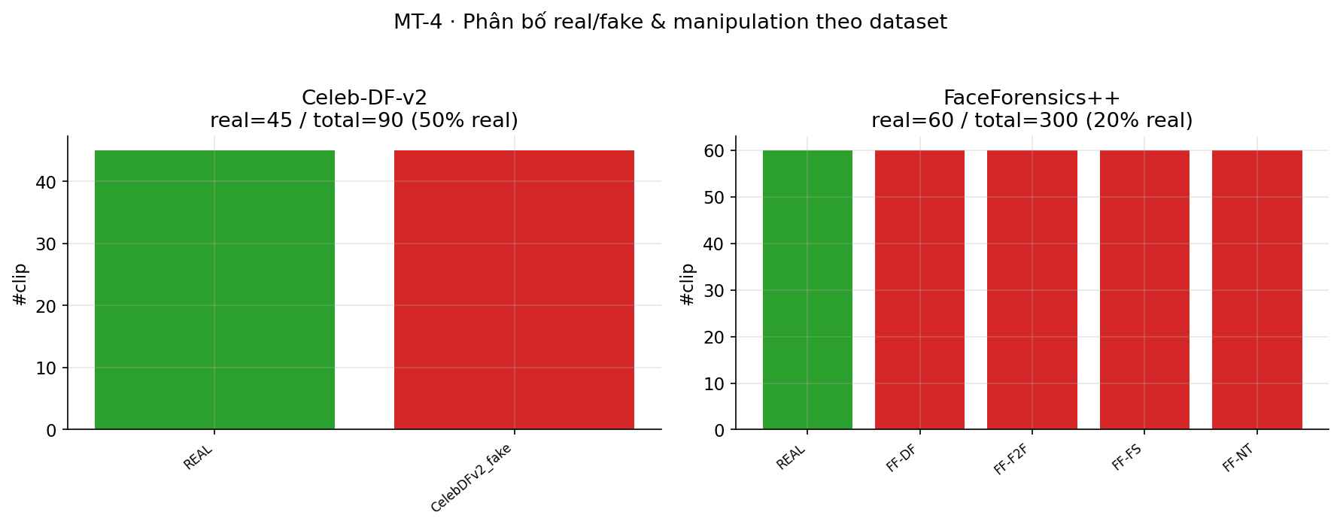
Real/fake distribution: FF++ (train) vs Celeb-DF-v2 (test).
Pipeline sanity & convergence. B4 reaches 0.7497, matching the DeepfakeBench leaderboard (0.7487), confirming a correct pipeline. Training curves (Figs. 2) are plotted directly from real logs (no simulation).
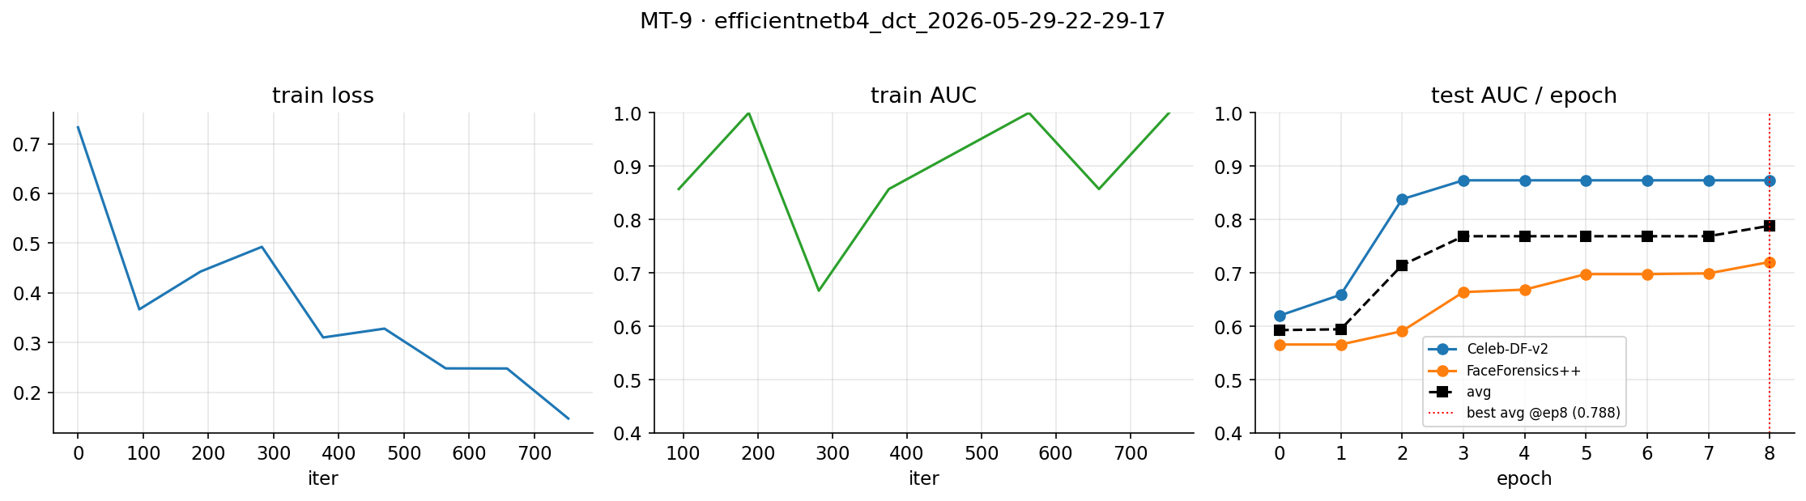
Training/validation curves of naive SFDCT (loss + per-epoch test-AUC), from real logs.
Main result (honest). Table 1 reports the ablation ladder. Adding the block-DCT branch lifts AUC to 0.7572 ($Δ=+0.0075$) without regressing the baseline (floor holds). A bootstrap confidence interval over the test scores gives $Δ\text{AUC}∈[−0.004,+0.019]$ ($p≈0.18$): the gain is within noise; we therefore do not claim an AUC improvement, only a non-regression with a safety guarantee. Row1 (0.7333) is below B4, i.e. the ladder is not monotonic — shown openly, attributable to the missing gate/band-drop in that configuration. ROC/PR curves are in Fig. 3.
Cross-dataset frame-AUC (train FF++ $→$ test Celeb-DF-v2). Own single-seed runs.
Model | CDFv2 frame-AUC | $Δ$ vs B4
B4 (baseline) | 0.7497 | —
naive SFDCT (B4-DCT) | 0.7572 | $+0.0075$ (in noise)
Row1 (S1+S2+S3) | 0.7333 | $−0.0164$
Row2 (S4+S5+S3)
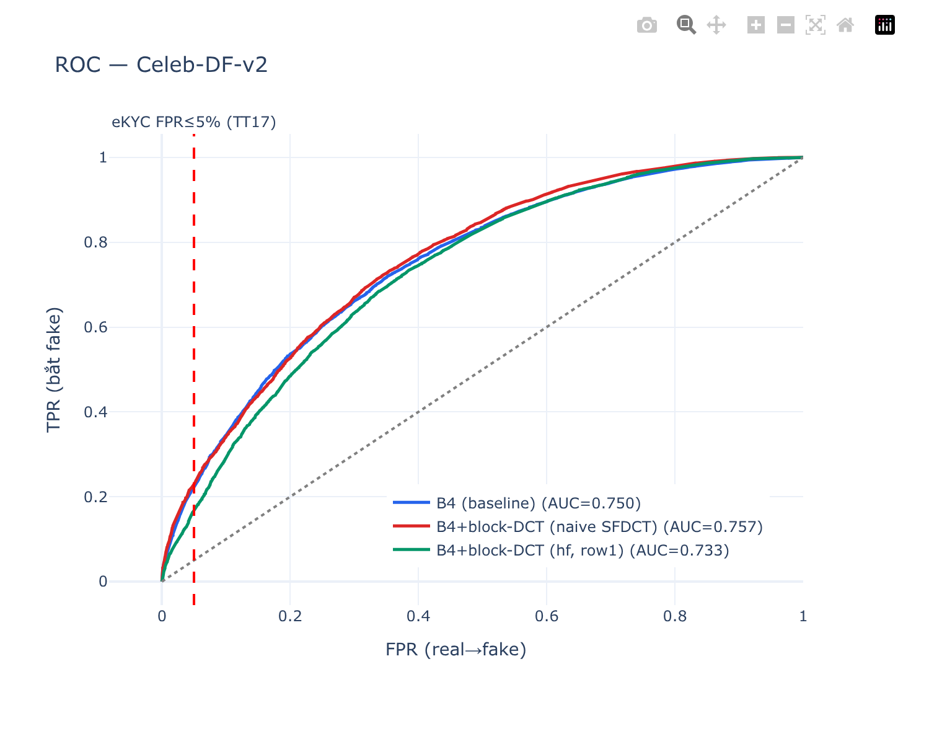
ROC on Celeb-DF-v2; red line marks the eKYC operating point $\text{FPR}≤5\%$.
Per-knob ablation (S1–S5). [TODO: per-knob runs not yet available; only the cumulative Row1/Row2 configurations exist.]

eKYC operating-point evaluation
We calibrate $τ$ at $\text{FPR}≤5\%$ (ISO/IEC 30107-3 convention; the circular itself sets no number). For naive SFDCT, $τ=0.9514$ gives test FPR $0.050$ and TPR $0.2298$. The confusion matrix (Fig. 4) is TN$=5339$, FP$=281$, FN$=8318$, TP$=2482$: the dominant error is false negative — about 77% of deepfakes pass at this real-user-friendly point. This is the honest diagnostic: at $\text{AUC}≈0.76$, neither operating end is acceptable alone (security-first $⇒$ reject $∼$69% of genuine users; usability-first $⇒$ 77% fakes pass). SFDCT is suited as a first-stage screen combined with liveness and video-level aggregation (video-AUC 0.808 $>$ frame 0.757), not as a standalone gate.
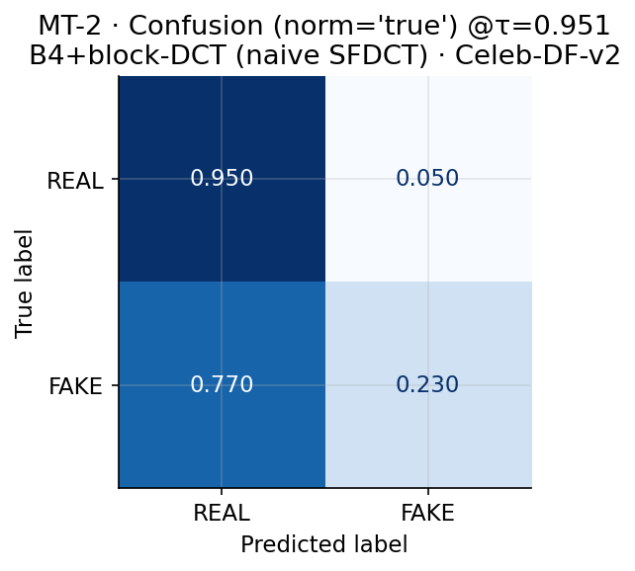
Confusion (row-normalized) of naive SFDCT at $τ$ for $\text{FPR}≤5\%$.

Qualitative analysis
Fig. 5 shows that real faces carry more mid/high-band DCT energy than fakes (deepfakes are smoother), confirming a frequency signal — though weak on c23 due to compression, which is precisely why $Δ$ is small. Grad-CAM (Fig. 6) shows SFDCT attends to face/blending regions, and the learned gate $|α|>0$ (Fig. 7) confirms the frequency branch is engaged.
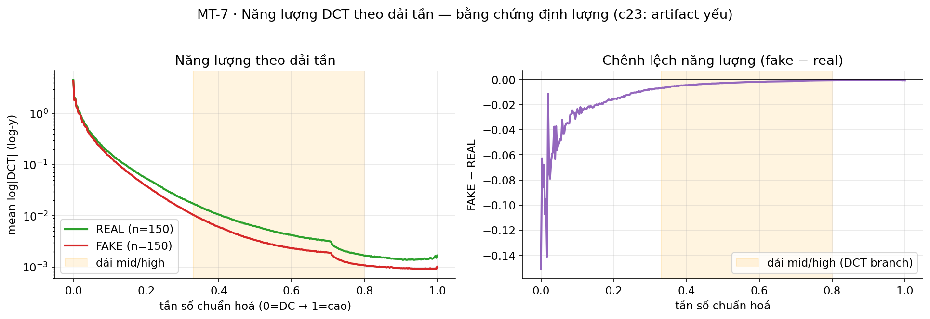
Mean DCT energy by frequency band: real $>$ fake in mid/high bands.
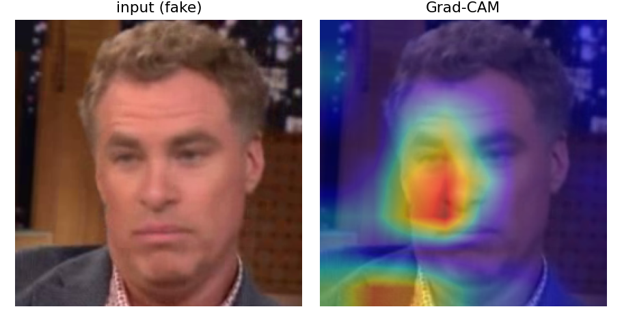
Grad-CAM of SFDCT on a Celeb-DF-v2 sample.
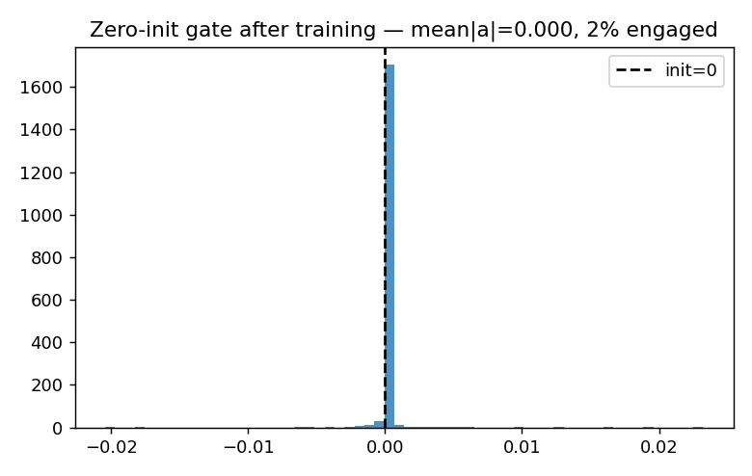
Learned gate $α$ after training ($>0$): the DCT branch is actively used.

Discussion and Limitations
We state limitations plainly. (1) $Δ=+0.0075$ is within noise at frame level; a video-level bootstrap CI and multi-seed runs are required before any AUC claim ([TODO: video-level bootstrap]). (2) SFDCT does not surpass SPSL (0.7650). (3) Row1 $<$ B4 (non-monotonic). (4) C1 is a new combination, not a new mechanism; the floor guarantee is a property of zero-init that holds at initialization. (5) APCER/BPCER are PAD terms re-defined here for forgery. (6) The Vietnamese test set (C3) is small and test-only and must ship with a datasheet, baselines, bootstrap CI, and an ethics/consent statement ([TODO: collect $≥$30 videos, $≥$2 generators]). (7) Frame-level results are a lower-bound diagnostic; real eKYC decides at video/session level with liveness.

Conclusion
SFDCT contributes a floor-preserving spatial–frequency fusion, a regulation-aware eKYC operating-point evaluation, and a localized Vietnamese-face test resource, built faithfully on DeepfakeBench. We make no SOTA claim: the AUC gain is within noise, and the value lies in the safety guarantee, the honest eKYC-anchored diagnostic, and the localized resource. Future work: video-level bootstrap, per-knob ablation, and the SBI/FSBI route toward the modern generalization tier.

