Problem 1 (author Kandaskalov D.V.)
- a) The zinc electrode will dissolve in nitric acid; b) Due to the lack of inert metals on the island, you can try to look for graphite. (0.25 points for each correct answer, 0.5 point in total)
- (1) "jar", (2) "tube", (3) "positive", (4) "negative" (0.25 points for each correct answer, 1 point in total)
- а) The Gibbs energy of the final transition NO₃⁻ → NO is the sum of these quantities for intermediate transitions: ΔG = ΔG₁ + ΔG₂ + … + ΔG_{k} or −nEF = −n₁E₁F − n₂E₂F − … − n_{k}E_{k}F, where n_{i} − the number of electrons involved in the corresponding transition. Hence E_{x} = (n₁E₁ + n₂E₂ + … + n_{k}E_{k})/n. Applying the obtained formula, we find the desired potentials (1 point):
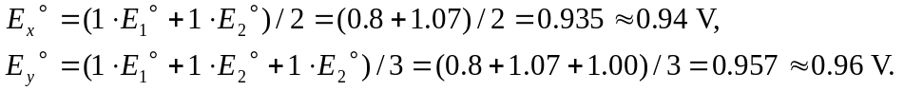
b) Let’s write the Nernst equation 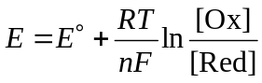, where n – the number of electrons involved in the reaction. Considering that at 25°C RT/F = 0.02569, and lnx = ln10⋅lgx, we write:
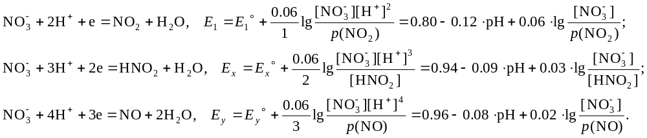
(0.25 points for each potential)
c) At [NO₃⁻] = [HNO₂] = 1 mol/L, p(NO₂) = p(NO) = 1 bar, we get three linear functions of pH. In the range of positive pH values, the lines do not intersect, and the last line lies entirely under the others. That is, under these conditions, the latter process is thermodynamically favorable. (1 point, 3.5 points in total)
- The jar contains ions H⁺ and NO₃⁻, which can be restored, and water, which can oxidize. The tube contains potash (K₂CO₃). Potassium and carbonate ions are inactive, as they have a low oxidizing potential. Thus, an electrochemical reaction occurs with water (oxidation or reduction). Considering that the process in the battery is spontaneous, the only process that can take place is the reduction of nitrate ions to nitrogen oxide, and in the tube, the oxidation of water. The role of the potash is to raise the pH of the solution in order to increase the EMF of the battery. Thus, the anode is a plate in a tube, the cathode is a plate in a jar. (0.5 point for cathode and anode, 0.25 points for full reaction, 0.75 points in total)
Cathode (+): NO₃⁻ + 4H⁺ +3e = NO + 2H₂O,
Anode (−): 2H₂O = O₂ + 4e +4H⁺,
Full reaction: 4NO₃⁻ + 4H⁺= 4NO + 2H₂O + 3O₂.
- Again we compose the Nernst equations for the reactions written above, assuming in them [NO₃⁻] = [H⁺] = 10⁻² mol/L, p(NO) = p(O₂) = 1 bar (2 points in total):
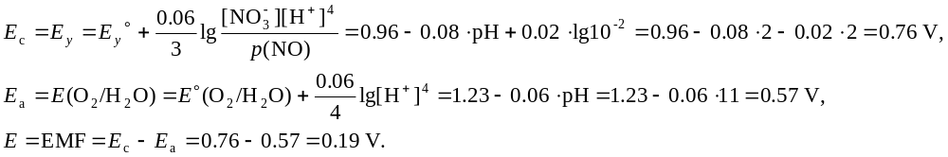
- When current sources are connected in series, electromotive forces add up, therefore N = 4.5/0.19 = 23.68 = 24 batteries (0.25 points in total)
- Standard potential of the battery E° = 0.96 – 1.23 = −0.27 V, then (1 point for each correct answer, 2 points in total)
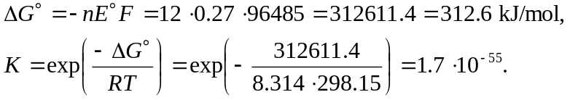

Problem 2 (author Karpushkin E.A.)
- Concentration of the alcohol in pure water c = 0, hence σ = K – Lln(1) = K, i.e. 72.8 mN/m (1 point)
- If the surface tension is measured with accuracy ±2%, minimal deviation of the value for pure water to be reliably detected is 72.8 ∙ 0.02 = 1.46 mN/m. The alcohol concentration in such solution can be calculated using the Szyszkowski equation: 72.8 – 1.46 = 72.8 – 16.7ln(1 + 66c), c = 1.38 mmol/L (2 points)
- Comparison of the equations shows that Γ_{max} = $\frac{L}{RT}$. Substituting with the numerical values and accounting for J = Nm, one gets Γ_{max} = 6.74 μmol/m². This amount corresponds to 6.74∙10⁻⁶∙6.02∙10²³ = 4.06∙10¹⁸ of the molecules, hence the area per a molecule is 1/4.06∙10¹⁸ = 2.46∙10⁻¹⁹ m² (1 point)
- Plugging the numerical values the Szyszkowski equation affords the equilibrium concentrations of the alcohol upon its adsorption:
σ = 72.8 – 16.7ln(1 + 66c) ⇒ c = $\frac{exp(\frac{72.8 – σ}{16.7}) – 1}{66}$.
Since the obtained values are in mol/L, the solution volume is 0.025 L, and the carbon specimen mass is 1 g, the adsorption in each experiment is numerically equal to (c₀ − c)/40 (2 points)
c₀, mol/L | σ, mN/m | c, mol/L | Γ, mol/g
0.05 | 59.4 | 0.0186 | 7.85∙10⁻⁴
0.10 | 50.8 | 0.0414 | 1.465∙10⁻³
0.15 | 44.2 | 0.0688 | 2.03∙10⁻³
0.2 | 38.9 | 0.1000 | 2.5∙10⁻³

- The points in the plot given below show a linear dependence. To derive its parameters, let us transform the Gibbs equation: Γ = $\frac{Γmax∙Mc}{1 + Mc}$ ⇒ Γ(1 + Mc) = Γ_{max}∙Mc ⇒ $\frac{1 + Mc}{Γmax∙M}$ = $\frac{c}{Γ}$ ⇒ $\frac{c}{Γ}$ = $\frac{\frac{c}{Γmax + 1}}{Γmax∙M}$
From the latter equation it is to be seen that the line slope equals 1/Γ_{max}. From the plot (or coordinates of any pair of the points), 1/Γ_{max} ≈ 200 and therefore Γ_{max} = 0.005 mol/g (3 points)  - The maximum adsorption Γ_{max} value shows that 1 g of the carbon can accommodate 5 mmol (3.01∙10²¹ molecules) of the alcohol. Since each molecule occupies 2.46∙10⁻¹⁹ m², the surface area of 1 g of the carbon equals 2.46∙10⁻¹⁹ ∙ 3.01∙10²¹ = 740 m²/g (1 point) | 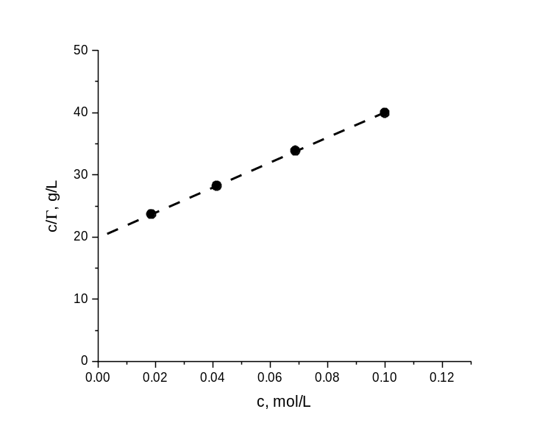

Problem 3 (author Kandaskalov D.V.)
- Based on the molecular formulas of substances X and Y, one can conclude that elimination of two CO₂ molecules takes place in the second stage. The first step is the double Mannich reaction. The formation of a bicyclic structure proceeds using methylamine which "crosslinks" the cycle. This way we get structures X and Y (1 point)
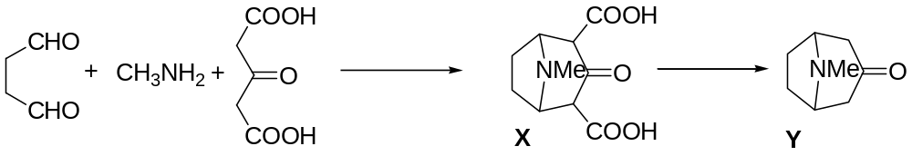
- Let's start deciphering the scheme from substance A. No by-products are released during its formation (C₅H₈O₄ + C₃H₄O = C₈H₁₂O₅) to indicate an addition reaction. The presence of a band in the IR spectrum at 1720 cm⁻¹ indicates the presence of a carbonyl group. Therefore, 1,4-addition to acrolein occurs. Then the aldol is formed from aldehyde and methanol, while the number of carbon atoms is preserved, 4 new hydrogen atoms appear and one oxygen atom disappears in compound B. Oxygen cannot leave in the form of water, then it must probably leave in the form of carbon dioxide, which leads followed by the removal of the COOMe group. This assumption is confirmed by the molecular formula of B (1 point)
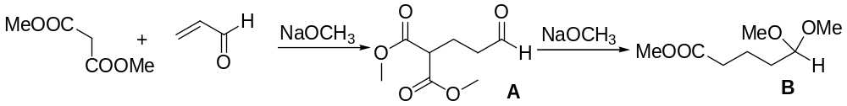
An almost doubling of carbon atoms in the third stage indicates the condensation of two B molecules. An ester condensation occurs, and then, similarly to the A → B transformation, ketoester C turns into ketone D.
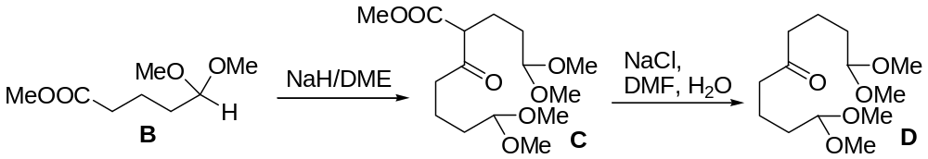
Based on the ¹H NMR spectrum and the ratio of integral intensities of D, it could be concluded that D is a symmetrical substance. Based on the gross formula, E should be an amine. An oxygen atom is lost and NH₃ is added. We also see that the next step in the reaction is a Robinson-Schepf reaction, with E playing a dual role providing the carbonyl and amine components. Given the latter fact, the reaction product must be tricyclic. The formula of F:
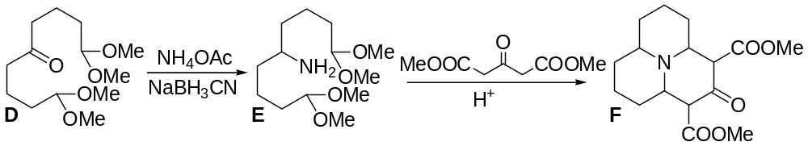
The molecule of F (С₁₆Н₂₃NO₅) undergoes a double decarboxylation reaction, turning into ketoamine G (С₁₂Н₁₉NO). The subsequent Wittig reaction results in the replacement of the carbonyl oxygen with a methylene group, and the reduction of the double bond gives I.
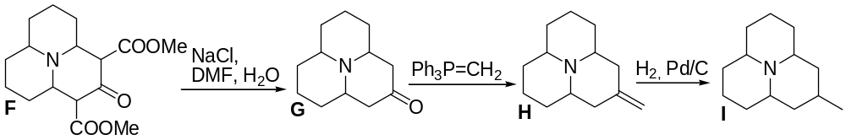
The last step is oxidation. The only atom (group) that can be oxidized is nitrogen. Thus, we get the structure of J. (1 point for the C – J structures)
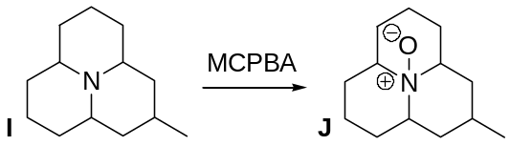

Problem 4 (author Bakhtin S.G.)
- Chiral centers are marked with an asterisk:
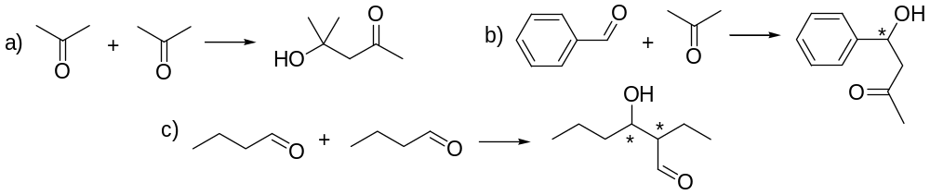
Other answers satisfying the conditions are also accepted (1.5 points)
- Both A and B contain ethyl group which appears in the ¹H NMR spectrum as quadruplet (2Н) and triplet (3Н). The remaining singlet (9H) corresponds to the protons of the tert-butyl group.
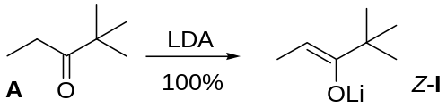
Following exactly the same logic, R₂ of ketone B contains in the spectrum three singlets of 2H, 3H, and 6H. According to the condition, B can be obtained by the Friedel-Crafts reaction. Therefore, some of signals correspond to aromatic protons, while others correspond to side chain protons. At the same time, the singlet with intensity 6H hardly corresponds to the aromatic, most likely it is 2CH₃. A singlet (3Н) also cannot correspond to benzene protons, since it is difficult to have 3 equivalent aromatic hydrogen atoms in the compound C₂H₅C(O)–Ar by symmetry. Hence, this signal is another CH₃. Only the last singlet of 2 equivalent H atoms remains for aromatics, i.e. the ring in the ketone contains 4 substituents. There are two ways to put it all together:
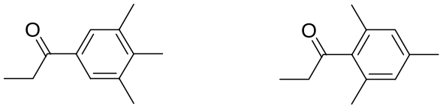
However, only the second ketone can be obtained regioselectively by the Friedel-Crafts reaction. (2 points)
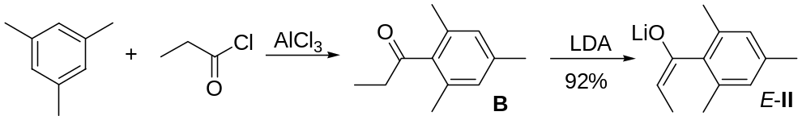
- Fragments of the initial carbonyl component (benzaldehyde) and lithium enolate are easily detected in the TS structure:
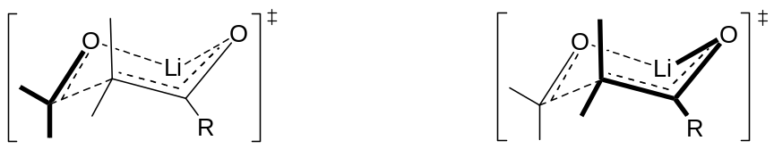
To add substituents, it is necessary to take into account the fact that, according to the condition, the phenyl substituent will take the equatorial position, and the hydrogen atom will take the axial position. Substituents in the enolate are determined based on the geometry of the enolate – Z/E. Based on this, the structures of the condensation products can be established. In both cases, the products are formed along with their enantiomers (racemate) (2 points)
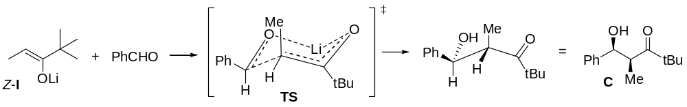
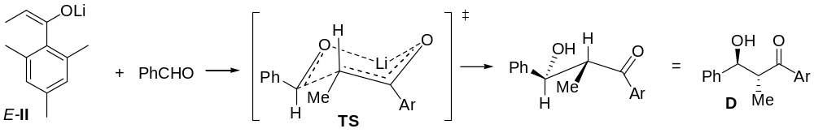
- The results of p. 3 allow us to conclude that the syn-diastereomer is formed from the Z-enolates, and the anti-diastereomer is formed from the E-enolates (1 point)
- The configuration of the chiral centers of C. If its enantiomer has been depicted, then the configuration indices will be opposite (1 point)
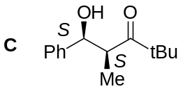
- Aldol condensation of E (C_{n}H_{m}O) with isobutyric aldehyde occurs according to the equation: C_{n}H_{m}O + C₄H₈O = C_{n+4}H_{m+8}O₂ (F). Since F contains 2 oxygen atoms, then М_{F} = 32/0.2051 = 156. Hence M_{E} = 156 – M_{C4H8O} = 84. This condition is satisfied only by the only option when n = 5, m = 8, C₅H₈O. Then 8H atoms and two signals of the same intensity in the ¹H NMR spectrum indicate the presence of 2CH₂ and 2CH₂ groups, which unambiguously allows us to conclude that this is cyclopentanone. E-enolate is formed from the cyclic ketone, which means that, taking into account step 4, the condensation product will be an anti-diastereomer (2.5 points)
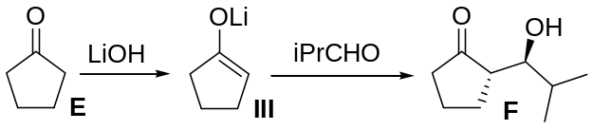

Problem 5 (author Garifullin B.N.)
- The total molar mass of three R₁ and two R₂ groups equals 131 g/mol (it is needed to subtract the molar mass of the known fragment from that of Y). There is no reason to consider the molar ratios of the elements e1:e2:e3:e4 multiple of 2:3:3:9 (e.g. 4:6:6:18), since the average value for e1 – e3 (if e4 = H) in the latter case would be less than 7 g/mol. The set of substituents can be arranged in two variants: R₁=(e2)(e3)(e4) and R₂=(e1)(e4)₃ or R₁=(e2)(e3)(e4)₃ and R₂=e1. There are no reasonable combinations of four elements for the former variant, whereas the latter one can be deciphered, if R₂=e1=Hal. The molar mass left for R₁ is 31 g/mol in the case of fluorine, and 20 g/mol in the case of chlorine. Thus, it is fluorine with the total atomic mass of e2 and e3 of 28 g/mol, which corresponds to С and O. Thus, two structures of Y are possible (0.5 point for each correct substituent, 1.5 point in total):
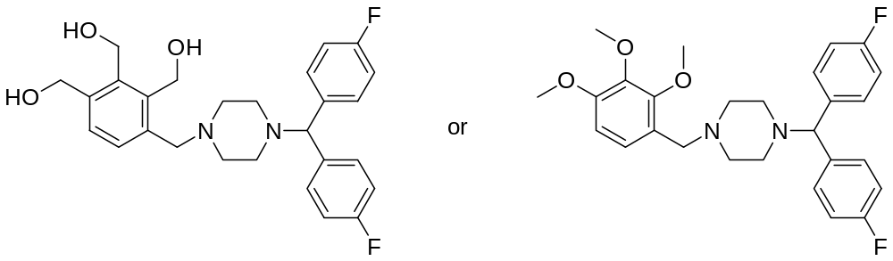
- Comparison of the spectral data of X and Z reveals that one and the same fragment of Lomerizine is being lost as result of their destruction. With due respect to protonation and ionization of the initial/resulting molecules, the fragment has the molar mass of 86–2=84 g/mol (according to the task conditions, the charge of any ionized particle equal +1, thus m/z transforms into m). Such a fragment must be located in the center of the molecule and should contain two similar moieties serving as targets for one and the same enzyme. Piperazine residue (С₄H₈N₂) turns out to be the only possible variant. Then the enzyme (Е) and the ionization source of the mass-spectrometer (MS) sequentially act upon both C–N bonds in the Lomerizine molecule leading to the X₁⁺ и Z₁⁺ ions according to the scheme (1.5 point):
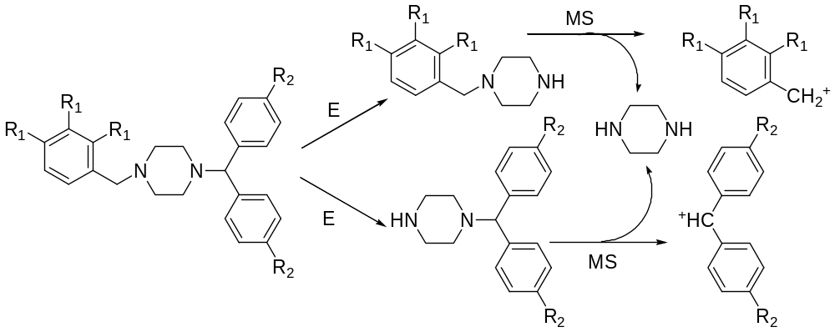
Thus, the total molecular mass of X and Z equals 468 + 86 = 554 g/mol. It is not yet possible to exactly attribute the structures on the scheme (X or Z).
- The fluorine containing fragment of the Lomerizine molecule is highly symmetric. Taking into account the presence of О atom in Z₂ and high abundance of hydrolases, the following structures can be proposed for Z and Z₂ (1 point for each structure, 2 points in total):
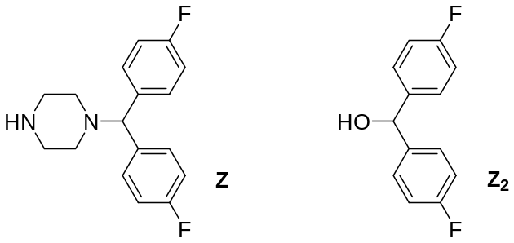
- The variant of the structure of Y with three hydroxyl groups (see above) is already quite hydrophilic, and no modifications described for Y₁ – Y₄ can be proposed for it. Such variant can be put forward for the other variant of the structure of Y, including hydrolysis of any of the methoxy groups affording the hydroxyl one (formation of Y₁ – Y₃) as well as oxidation (e.g. of a C atom of the benzene ring) leading to an additional hydroxyl group (Y₄). Note that the retained methoxy group and the additional O atom totally increase the molecular mass (compared to Y₁) by 14+16=30 g/mol (0.75 point for Y₁, 1 point for Y₄, 1.75 point in total).
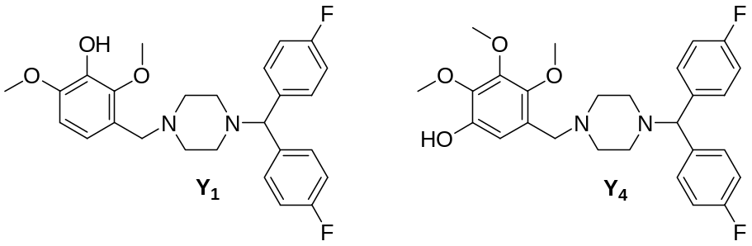
- The structure of Trimetazidine is (1 point):
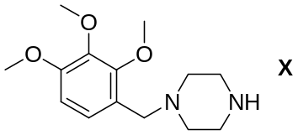
- The difference of the m/z values of the protonated X₁ molecule and the common ionic product formed as a result of fragmentation equals 253-167=86 g/mol, which suggests that the piperazine fragment is metabolically unchanged. Then, the transition from Trimetazidine (М=266 g/mol) to X₁ leads to the loss of 266-252=14 g/mol, which is due to (see above) hydrolysis of a methoxy group on the way from X to X₁. The difference of the m/z values of X₁ and X₂ equals 333–253=80 g/mol. With due account for further increase of hydrophilicity and readiness of a sulfo group elimination as a result ionization in the mass-spectrometer, formation of Desmethyl trimetazidine-O-sulfate can be proposed (one of three variants of each compound in given below) (0.75 point X₁, 1.5 point X₂, 2.25 point in total):
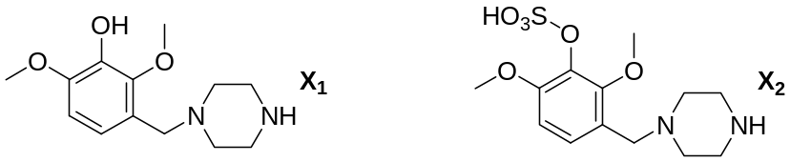

Problem 6 (author Shved A.M.)
- The molar concentration of iodine in saturated solution (1 point):
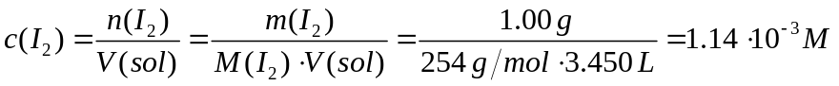
- The expression for K_{D} is directly related to the ratio of mass fractions of iodine (1 point):
- According to VSEPR theory: AX₂E₃ has a linear structure, I–I–I angle is 180° (0.5 points per index in AX_{n}E_{m} and 0.5 points for the angle, 1.5 points in total).  - Reaction equations (0.5 points per reaction, 1 point in total):  I₂ + 2S₂O₃^{2–} = 2I– + S₄O₆^{2–} | 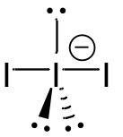
I₃– + 2S₂O₃^{2–} = 3I– + S₄O₆^{2–}
- From the readings of titrations, it is possible to determine the total concentrations of iodine in the organic (0.5 points) and aqueous phases (0.5 points):
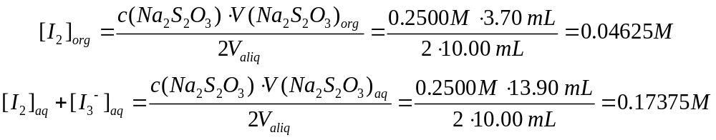
Then the initial chemical amount of iodine in the Lugol’s solution (0.5 points):
And its mass fraction (1 point):
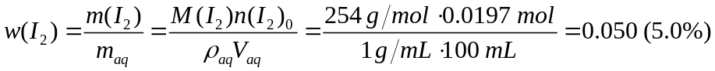
Knowing the iodine distribution constant and its concentration in the organic phase, it is possible to find the equilibrium concentration of I₂ in the aqueous phase (0.5 points):
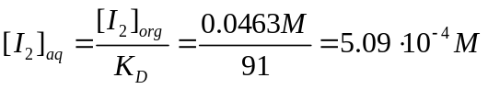
Then the concentration of the complex (0.5 points):
It remains to find the concentration of free iodide ions in the solution via the initial molar concentration of potassium iodide (0.5 points) and the concentration of the resulting complex (0.5 points):
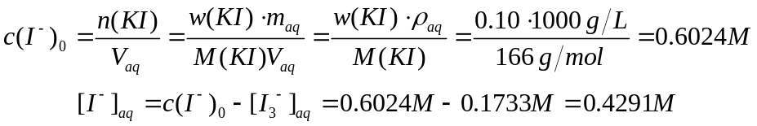
Finally, the constant of formation of the complex I₃– (1 point):
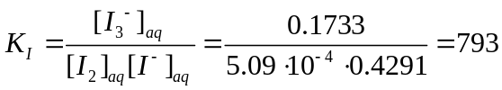.
In the case of using K_{D} = 150:
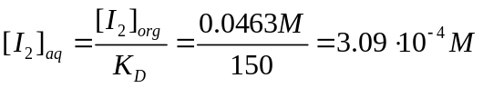
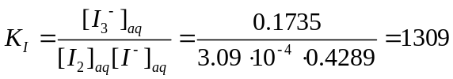

Problem 7 (author Khvalyuk V.N.)
- Black iron(II,III) oxide is formed due to the reaction equation (0.5 points):
3Fe + 2O₂ = Fe₃O₄
- The mass fraction of oxygen in iron (II) and (III) oxalates is less than the value given in the task condition. It can be assumed that is the crystalline hydrate of the composition FeC₂O₄∙xH₂O.
M_{r}(O) = 16.00; M_{r}(FeC₂O₄) = 143.9; M_{r}(H₂O) = 18.01;
0.5336 = $\frac{16.00 ∙ (4 + x)}{143.9 + x ∙ 18.01}$
Solving this equation, we get х = 2. А – FeC₂O₄∙2H₂O (1.0 point)
- Since the authors believed that "iron" was obtained, they gave the following reaction equation:
FeC₂O₄∙2H₂O = 2H₂O + 2CO₂ + Fe (0.5 points)
- If the composition of the gas mixture corresponded to the above equation (2 mol CO₂ + 2 mol H₂O, molar mass 31.0 g/mol), then the density of the gas mixture at 280°C and 110.8 kPa would be equal to:
M(H₂O) = 18.01 g/mol; M(CO₂) = 44.01 g/mol;
$\frac{110.8 ∙ (2 ∙ 18.01 + 2 ∙ 44.01)}{(2 + 2) ∙ 8.314 ∙ (273 + 280)}$ = 0.747 g/dm³.
This value is more than indicated in the problem condition. It means that the composition of the mixture does not correspond to the stoichiometrical ratio of the given reaction. Therefore, it should be concluded that there is one more component (or several) with a molar mass less than 31.0 g/mol. Based on the elemental composition, such substances could be H₂ and CO, and the additional oxygen atoms could be associated with iron atoms. The presence of CO seems more likely, since the ability to remove oxygen from iron is higher for hydrogen. We will assume that the mixture consists of 2 mol H₂O, (2 – y) mol CO₂, and y mol CO. M(CO) = 28.01 g/mol. The molar mass of a real gas mixture is:
$\frac{ρRT}{p}$ = $\frac{0.6507 ∙ 8.314 ∙ (273 + 280)}{110.8}$ = 27.00 g/mol.
Knowing the molar composition of the mixture, we can make an equation:
M = $\frac{m}{n}$ = $\frac{2 ∙ 18.01 + (2 – y) ∙ 44.01 + y ∙ 28.01}{2 + (2 – y) + y}$ = 27.00 g/mol.
Solving this equation, we get y = 1.00. In the gas mixture there is 1 mole of CO₂ and 1 mol of CO per 2 moles of H₂O.
Molar fractions of components are: H₂O – 50.0 %, CO₂ – 25.0 % and CO – 25.0 % (4.0 points)
- The decomposition reaction of А (2.0 points):
FeC₂O₄∙2H₂O = FeO + 2H₂O + CO₂ + CO
- The burning of "pyrophoric iron" (1.0 points):
6FeO + O₂ = 2Fe₃O₄
- The reason for the high activity of the obtained product is the very small particle size (FeO nanoparticles are formed) (1.0 point)

Problem 8 (author Likhanov M.S.)
- The unknown element X – phosphorus, which can be determined from the knowledge of its chemical properties, as well as by confirming the calculations. For example, from the mass fraction of water in A2, it is not difficult to calculate its molar mass:
M(A2·2H₂O) = 2·18/0.1818 = 198 g/mol, аnd M(A2) = 162 g/mol.
Since A2 and A3 are isomers, and there are two nonequivalent X atoms in the NMR spectrum of A3, we can assume the following composition of acids A2 and A3 as H_{a}X₂O_{z}. Since the X atom is in a tetrahedral environment, the acid can contain a maximum of 6 oxygen atoms, then the H_{a}X₂ fragment accounts for 162 – 6·16 = 66 g/mole. Phosphorus is closest in mass, so the composition of acids A2 and A3 can be written as H₄P₂O₆.
Thus, X is P, the composition of A2 and A3 is H₄P₂O₆.
White phosphorus dissolves in alkali to form phosphine and hypophosphite:
P₄ + 3NaOH + 3H₂O = PH₃ + 3NaH₂PO₂
G – PH₃, B1 – NaH₂PO₂. Then A1 – H₃PO₂.
Red phosphorus is oxidized with sodium chlorite or hydrogen peroxide to form hypophosphoric acid:
2P + 2NaClO₂ + 2H₂O = Na₂H₂P₂O₆ + 2HCl
2P + 4H₂O₂ + 2NaOH = Na₂H₂P₂O₆ + 4H₂O
(any of the reactions is counted as correct; it is possible to record salt in the form of Na₄P₂O₆).
B2 – Na₂H₂P₂O₆ or Na₄P₂O₆.
When hypophosphoric acid A2 is heated, it isomerizes into iso-hypophosphoric acid A3, and also disproportionates:
2H₄P₂O₆ = H₄P₂O₅ + H₄P₂O₇
Acid containing a smaller number of oxygen atoms A4 – H₄P₂O₅ –pyrophosphorous acid, and A5 – H₄P₂O₇ – pyrophosphoric acid (0.4 points for each compound and equation of the reaction, 4.4 points in total)
- H₃PO₂ – has a distorted tetrahedral structure – in the center with a phosphorus atom, and two hydrogen atoms are attached directly to phosphorus, as a result of which this acid is monobasic.
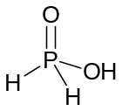
In A2, the two phosphorus atoms are also in a tetrahedral environment, with the phosphorus atoms directly bonded to each other. Then with each phosphorus atom there should be a double bond with oxygen and two more single bonds with –OH groups. Taking into account the presence of an inversion center, a 2-fold rotation axis, and a mirror plane perpendicular to it, two –PO(OH)₂ groups should be located relative to each other in a staggered conformation:
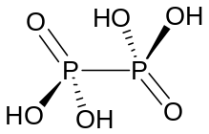
In this molecule, the inversion center lies in the middle of the P–P bond, the 2-fold rotation axis passes through the inversion center perpendicular to the figure plane, and the mirror plane lies in the pattern plane and contains the P–P bond and oxygen atoms (from P=O).
In acid A3, which has a composition similar to A2, there are no symmetry elements; therefore, it can be assumed that one of the oxygen atoms has become a bridge between phosphorus atoms. Due to the presence of one P–H bond, symmetry is lost::
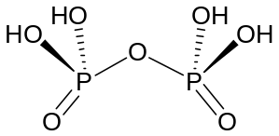
A4 and A5 also contain a bridging oxygen atom, however, due to the fact that A4 has two P–H and two P–OH bonds, the molecule is less symmetrical than A5, in which the P–H bonds are replaced by P–OH:
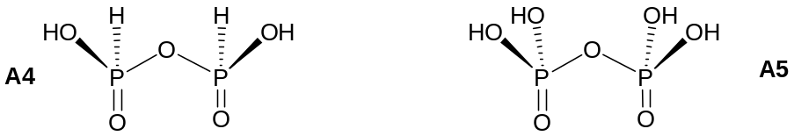
In A4, the mirror plane runs perpendicular to the pattern plane through the bridging oxygen atom. In A5, an additional mirror plane appears, which lies in the plane of the figure and contains phosphorus atoms. (0.5 points for each structure, 2.5 points in total)
- To calculate the composition of salts, we denote their composition by the following formulas:
B6 – Na_{x}P_{y}O_{z}, B7 – Na_{x}P_{y}O_{z+1}, B8 – Na_{x}P_{y}O_{z+2}.
Then it is possible to compose a system of two equations for the mass fractions of oxygen. M is the molar mass of B6:
16z/M = 0.3810 and (16z + 16)/(M + 16) = 0.4091.
z = 8, M = 336 g/mol.
Thus, the composition of B6 is Na_{x}P_{y}O₈, M(Na_{x}P_{y}¹⁶⁺) = 208 g/mol. The only reasonable solution by iterating is x = 5, y = 3.
Thus, B6 – Na₅P₃O₈, B7 – Na₅P₃O₉, B8 – Na₅P₃O₁₀.
(0.2 points for each compound, 1 point for calculations, 1.6 points in total)
- It is easy to assume the structure of the anionic residue B6 – all phosphorus atoms are connected in a chain, the terminal phosphorus atoms contain one P=O bond and two P–O– bonds each, and the middle phosphorus atom has one double bond P=O and one P–O– bond. Only in this way is the condition of the tetrahedral environment of phosphorus and the presence of at least one P=O bond fulfilled. Further, when moving to B7 and B8, the basicity of the acid does not change, but one oxygen atom is added. It is logical to assume that an additional oxygen atom is successively inserted between phosphorus atoms, becoming a bridge (0.5points for each structure, 1.5 point in total)
