Section I. Physical chemistry

Problem 1
One of the topical areas of energy is thermonuclear fusion. In 2007, the development of a thermonuclear reactor was launched in France, the goal of which is to show by 2025 the possibility of controlling thermonuclear reactions and creating a thermonuclear station for generating energy. Artificial nuclear fusion is based on the interaction of a stable nucleus X with a radioactive nucleus Y with the formation of a stable nucleus Z and one neutron. The nuclei X and Y are isotopes. Synthesis takes place at high temperatures (T ~ 10⁸ K) in plasma, which is held by a magnetic field in the shape of a toroid (see Fig. 1).
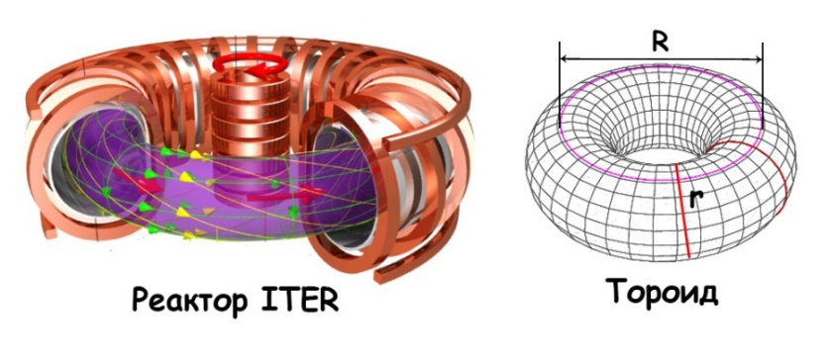
The content of Y nuclei on our planet is very low, they are formed under the action of cosmic radiation on ¹⁴N atoms (interaction with a neutron), but are not able to accumulate due to the short half-life t_{1/2} ~ 10−16 years. Artificially, Y nuclei are synthesized by irradiating a stable target A with neutrons (one neutron bombards one A nucleus). In addition to the Y nucleus, only Z nuclei are formed. The specific activity of the Y nuclei is 9650 Ci/g. A sample containing 2.82∙10²¹ nuclei loses 14.475 Ci of activity in 2 years. The cost of producing Y nuclei is quite high: $30 million/kg. Keep in mind that all stable nuclei have the same number of protons and neutrons.
Toroid
ITER reactor
Fig.1
Fig.2
- Calculate the exact half-life of the nuclei Y.
- Calculate the financial losses for 2 months of storage of 600 g of Y nuclei.
- а) Decipher the nuclei X, Y, Z and A; b) Write three nuclear reactions: fusion of Y nuclei from ¹⁴N, artificial synthesis of Y and reaction in a thermonuclear reactor.
The energy released during the effective collision of X and Y nuclei is 3·10⁻¹² J.
- What quantity (mol) of the propane-butane (1:1) mixture burned is energetically equivalent to the reaction of the same number of X and Y nuclei with a total concentration of 10¹⁶ particles/L?
Δ_{f}Н(СO₂) = −393.5 kJ/mol, Δ_{f}Н(H₂O) = −285.8 kJ/mol,
Δ_{f}Н(C₃H₈) = −103.9 kJ/mol, Δ_{f}Н(C₄H₁₀) = −126.2 kJ/mol,
Toroid volume V = 2π²R²r. Assume R = 9 m, r = 52 cm.
The high temperature of the reaction medium is necessary to overcome the electrostatic repulsion between the nuclei. One of the main problems is the thermal stability of the reactor walls, for which two materials are tested − metal M and its binary compound N = AM. Metal M has a cubic lattice (without specifying which of the three) with a parameter of 3.16 Å and an atomic mass of more than 140 g/mol. The lattice of the N compound is hexagonal (see Fig. 2). The mass fraction of metal M is more than 50%. The compound density N is 1.23 times less than the density of pure metal M. Cell parameters: a = b= 2.92 Å, c = 2.82 Å.
- Using the given data, decipher M and N.

Problem 2
Anation reactions (substitution of Н₂О by Х⁻) in easily hydrolyzed complexes
[Me(H₂O)₆]³⁺ ⇄ [Me(H₂O)₅OH]²⁺ + H⁺ (K_{a}) roceed along two routes (k₁ and k₂) at a rate of
r = (k₁[Me³⁺] + k₂[MeOH²⁺])·C(Х⁻).
- For [Me(H₂O)₆]³⁺ + X⁻ →, using its short form (Me³⁺ + X⁻ →), write down the reaction equations for the indicated two routes.
Connick and Coppel showed that if Х⁻ is an anion of strong acid, then k_{obs} = (k₁[H⁺] + k₂K_{a})/([H⁺]+K_{a}) and the rate increases with decrease of [X⁻]. Pouli and Smith established that for the weak acids НХ
k'_{obs} = (k₃[H⁺] + k₄K_{a})/K, rate decreases with reducing [X⁻] and there action proceeds via two routes:
Fe³⁺ + HX ⇄ FeX²⁺ + X⁻ (k₃, k₋₃, K = k₃/k₋₃) and FeOH²⁺ + HX ⇄ FeX²⁺ + H₂O (k₄, k₋₄). For the anation reactions of Fe³⁺with participation of Cl⁻and HN₃ at 25 C it was obtained:
[H⁺], mol/L | 1.0 | 0.5 | 0.1 | 0.05 | 0.01
k_{obs}, L/mol⋅s | 83.60 | 156.9 | 709.2 | 1325.2 | 4458.0
k'_{obs}, L/mol⋅s | 85.15 | 81.76 | 79.05 | 78.71 | 78.44

- Derive the kinetic equation for the reaction rate of Fe³⁺ + Cl⁻ →, assuming that the ions Fe³⁺and FeOH²⁺are in equilibrium. The concentrations of chloride complexes can be neglected ([Fe³⁺] and [FeOH²⁺] >> [FeСl²⁺] and [FeOHCl⁺]), and C(Fe) = [Fe³⁺] + [FeOH²⁺]. Calculate k₁, k₂ and K_{a} for
[H⁺] ˂ 0.5 mol/L, using the table data.
- Derive the kinetic equation for the reaction rate of Fe(H₂O)₆³⁺ + HN₃ ⇄ and the expression for k'_{obs}, if the rate of the forward reaction is the same as in the case of [Cl⁻], and the sum k₋₃[H⁺] + k₋₄ for the reverse reaction can be obtained from the equilibrium condition (r = 0). Note that at equilibrium r₊ = r₋, and С (FeN₃²⁺) = [FeN₃²⁺]. Consider the concentrations C(HN₃) = [HN₃] and C(Fe) ˃˃ C(FeN₃) and C(FeOHN₃). Calculate k₃, k₄ and k₋₃ for [H⁺] ˂ 0.5 mol/L.
It was established that in the case of anions of weak acids, the anation mechanism Fe(H₂O)₆³⁺ + N₃⁻ includes two stages: reversible with formation of HN₃ and constant of K_{x} and irreversible with k₄, and k''_{obs} does not depend on pH.
- Give the reaction mechanism and expression for k''_{obs}. Calculate K_{x} and k''_{obs}, if thnd e dissociation constant of HN₃ K_{a1} = 1.9´10⁻⁵. For the reaction Fe(H₂O)₆³⁺ with Cl⁻ at 40ºC and рН = 0, k₁ = 275.9.
- Calculate the activation energy (Е_{а}) for Fe(H₂O)₆³⁺ + Cl⁻ → Fe(H₂O)₅Cl²⁺ + H₂O.
In the reaction mechanism of Fe(H₂O)₆³⁺ + X⁻ the first stage depends on the strength of the acid НХ and can proceed in two ways: either with the formation of a trigonal bipyramid (C. N. = 5), or an ion pair in the form of an octahedral wedge (C.N. = 7).
- Describe a two-stage mechanism in the case of Cl⁻and N₃⁻.

Problem 3
Smart materials can significantly increase the effectiveness of athletes. At the 2008 Olympiad games, some swimmers used swimming suits created with participation of NASA. As a result, 94% of gold medals were received by athletes in this sportswear. The key to success was the cross-linking of polymer fibers with a unique composition that reduces water resistance, which increased the speed of swimmers by 4%.
- From the structures below, select two examples of polymers that could be used in such effective swimsuits.
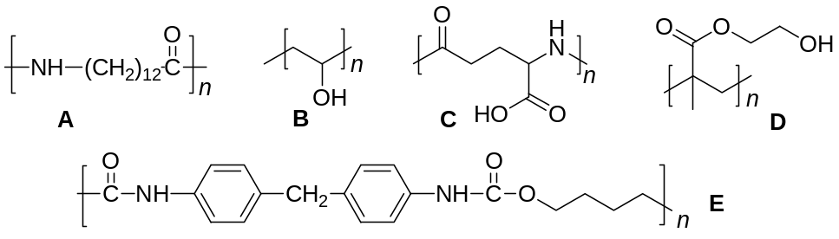
Sewing microcapsules from materials with a reversible phase transition coated with a hydrophobic shell into the fibers of the fabric allows for the body's thermoregulation during intensive training, both indoors and outdoors. Such materials are capable of absorbing heat with its subsequent release upon returning to the initial temperature and phase state. One of example of such materials is polymer F (t_{melt} = 38°С) obtained by cationic polymerization of G at low temperatures. G is released in the composition of an equimolar gas mixture with М_{av} = 44 g/mol during the thermal decomposition of ethylene carbonate. Cationic polymerization of G is carried out according to the scheme:
1) initiation | H⁺A⁻ + G → M⁺A⁻ | k_{i} = 9.5·10⁻³ L/mol∙s,
2) propagation | M⁺A⁻ +G → F_{i+1}⁺A⁻ | k_{p} = 0.94 L/mol∙s,
3) chain transfer | M⁺A⁻ +G → P | k_{tr} = 8.0·10⁻³ L/mol∙s,
4) termination | M⁺A⁻ → M_{i} + H⁺A⁻ | k_{term} = 7.5·10⁻² s⁻¹,
where H⁺A⁻ − polymerization initiator, M⁺A⁻ – active site of the growing chain, k_{j} – the rate constants of the corresponding stages.
- а) Determine F and G; b) Using the approximation V_{i} = V_{t}, get the expression for the rate of cationic polymerization; c) Get an expression for the average degree of polymerization
X_{av} = V_{р}/(V_{term} + V_{tr}).
- а) Calculate the value of heat a runner releases into the surrounding space, exercising on a treadmill for 1 hour, if the change in internal energy is −3.38 MJ and the power generated is 235 W. b) By how many degrees does a runner raise the temperature of the surrounding air while exercising in a room with area of 2500 m² and a ceiling height of 5 m? ρ_{air} = 1.165 kg/m³, heat capacity c_{air}= 1.005 kJ/kg·K.
- а) What amount of microcapsules of polymer F with a diameter of 40 μm can be obtained by polymerization of 2.15 mol of G in 1 L of the reaction mixture if the reaction yield is 95%? Take ρ_{F} = 1200 kg/m³.
If You didn’t determine the degree of polymerization, accept M(F) = 500 g/mol.
b) What proportion of the heat generated by a runner can be absorbed by sportswear containing all the obtained microcapsules of polymer F? A runner's skin temperature is 34°C at the start of a workout and 40°C at the end.
с(F, s) = 8.48·10⁻¹¹ kJ/microsphere∙K, с(F, l) = 6.28·10⁻¹¹ kJ/microsphere∙K,
Δ_{melt}Н(F) = 6.11·10⁻⁹ kJ/microsphere.
Assume that heat is distributed evenly from all area and clothing covers 80% of the body.
The implementation of tribo-, piezo- and thermoelectric materials into clothing allows sports to use mechanical energy and heat generated to operate vital signs sensors or more complex wearable electronics. For example, a 30 μm thick film of piezoelectric polymer K, placed in a runner's sneakers, is capable of generating power W = 1 mW. Output voltage U = γPh/εε₀, where γ – piezoelectric coefficient, P – applied pressure, h – film thickness, ε – the dielectric constant, ε₀ – electrical constant.
- а) Determine the current that can be generated while running if the mass of the runner is 55 kg, and the area of the sneakers is 189 cm². Accept γ(K) = 49.6·10⁻¹² С/N, ε(K) = 10; b) How many percent can runner charge a heart rate sensor with a 130 mA∙h battery in 1 hour of running? с) Identify polymer K and monomer L if the last one is known to be an unsaturated halogenated hydrocarbon containing 37.5% C and 3.1% H. The electron impact ionization mass spectrum of L (containing both molecular and fragment positive ions) contains intense peaks with the ratio masses of ions to their charge m/z = 64, 63, 50 and 14.
Physical constants: electrical constant ε₀ = 8.85∙10⁻¹² F/m, gravitational acceleration g = 9.8 m/s².

Section II. Organic chemistry

Problem 1
Some carbon compounds, in particular, CO and CO₂ oxides, are considered in the framework of inorganic chemistry. However, there are quite a lot of oxygen compounds of carbon related to organic substances. Such “carbon oxides” X1 – X11 will be considered in the present problem. In the mild ozonolysis of a elementary substance A, a compound X1 with an oxygen mass fraction of 6.24% is formed. When heated or photolyzed, it loses the oxygen molecule and forms the compound X2.
- Give the molecular formulas of A, X1, and X2. Support the answer with calculations.
Oxygen-containing carbon compounds X3 – X6 are unstable substances of the cyclic structure. X3 and X6 decompose to form the same gas with a higher density than air. Substance X4 is formally a dimer of compound X5. When X4 decomposes, an equimolar mixture of two gases and substance X5 is first formed, which then decomposes to form a mixture of gases of the same density. The simplest dicarboxylic acid B can be used to obtain X3 – X5, while X6 can be synthesized from isobutyraldehyde:
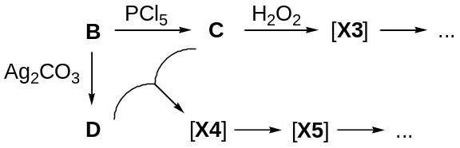
- Give the structural formulas of B – G and X3 – X6.
- The adjacent homolog of substance B also forms a “carbon oxide” when heated with phosphorus(V) oxide. Give a reaction equation providing the structural formulas of organic substances.
Oxygen compounds X7 – X9 have the same empirical formula, corresponding to the lightest carbon oxide, containing two, three, and four cycles in their structures, respectively. All the substances H – K have 1 signal each in ¹H NMR spectra, and in ¹³C NMR spectra there are 4 signals for substance H, 2 signals each for compounds I and J, and just 1 signal for K.
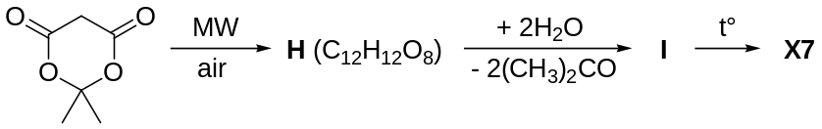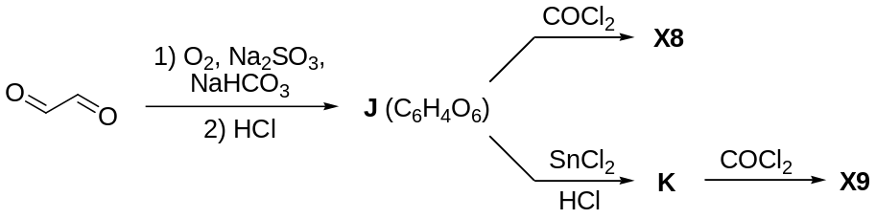
- Give the structural formulas of H – K and X7 – X9.
- Adding substance C to J and K, two more “carbon oxides” X10 and X11 can be obtained. They have the same empirical formula as X7 – X9 and contain 10 and 12 carbon atoms, respectively. Give the structural formulas of X10 and X11.

Problem 2
Ideal organic synthesis involves the selective production of only one product.
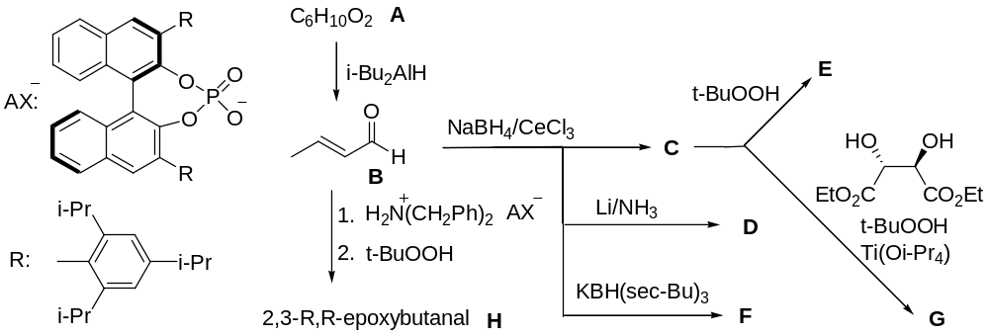
- Decode A-J if ¹H NMR spectra of A and B differ in the absence of a doublet (δ ≈ 10 ppm) and the presence of a triplet and a quadruplet. In the IR spectrum of C, F, E and J there is a broad band (3500 cm^{–1}); B and D are isomers.
- Give spatial structures of H and G (S,S-isomer).
- Which reactions in the above scheme are chemoselective (preferably proceed through one functional group of the substrate); regioselective (selectively proceed according to a certain position); stereoselective (preferably one of the diastereomers is formed), enantioselective (preferably one enantiomer is formed)?
For their achievements in the field of organocatalysis, List and MacMillan received the Nobel Prize in 2021. Organocatalysis was used in the synthesis of Neuroprostan X, a potential drug for lung ventilation.
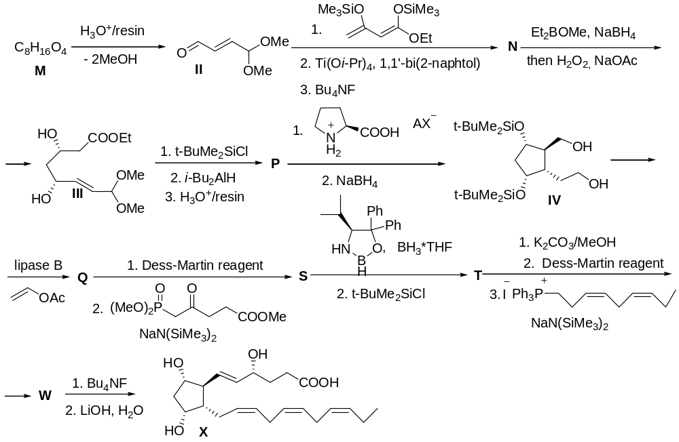
- Decode M, N, P, Q, S, T, W.
- For the oxidation of Q to S, the Dess-Martin reagent is used, which is obtained in two stages from ortho-iodobenzoic acid. The first stage of its synthesis is the oxidation with the KBrO₃-H₂SO₄ system, the second stage of the synthesis is the interaction of the product, obtained at the first stage, with acetic anhydride. Give the structure of the Dess-Martin reagent and its precursor.

Problem 3
In 1972, the structures of polycyclic compounds were proposed, where the sp3 carbon atom should be flattened for steric reasons.
Such compounds are called fenestranes (from Latin window) because its representative [4,4,4,4]-fenestrane (C₉H₁₂) resembles a window (in the case of a completely flat central carbon atom). Due to strong steric hindrance [4,4,4,4]-fenestrane has not been synthesized, although its analog [4,4,4]-fenestrane (C₈H₁₂) – “broken window” exists. | 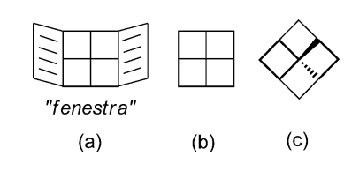
- Draw the structures of [4,4,4]-fenestrane, [4,5,4,5]-fenestrane and [4,4,5,5]-fenestrane.
[2+2]-Cycloaddition A (C₁₂H₁₆O) followed by Kizhner-Wolf reduction of cycloadduct B is used in the synthesis of fenestrane Х.
- Suggest the structures of substances A, B, X, if there are double bonds in structure A.
Below are two syntheses of fenestrane Z. An attempt to prepare Y was unsuccessful.
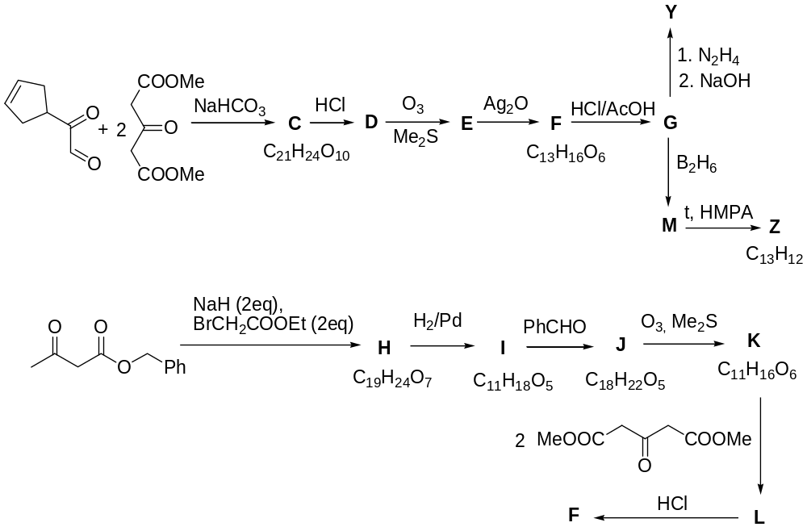
- Decode С – K, Z.

Section III. Life Sciences and Polymers

Problem 1
SARS-CоV-2, a member of the family of coronaviruses (RNA viruses), was behind the COVID-19 pandemic. Several treatment patterns have been elaborated as the pandemic response, and other (initially developed to cure different virus diseases) were redesigned. Most approaches are based on the nucleosides with the structures so similar to those of the natural compounds that they and their derivatives act as substrates of the enzymes involved into the virus replication.
- Correlate the potential anti-COVID-19 drugs given in the Table hereunder with the nucleoside analogs formed by the major nitrogenous bases (A, C, G and U).
Drug | Developer | Formula
Remdesivir | Gilead Sciences | 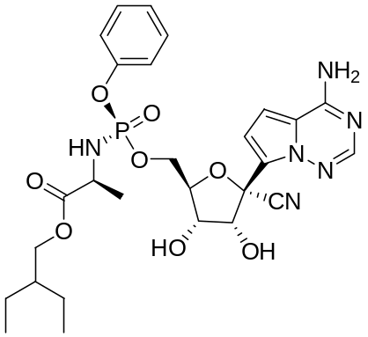
AT-527 | Atea Pharmaceuticals | 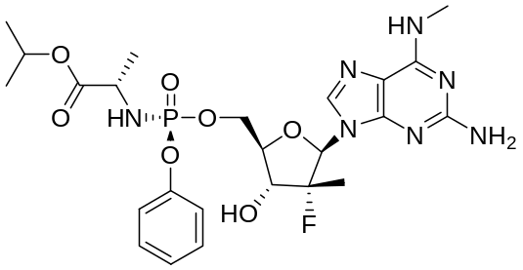
Paxlovid | Pfizer | 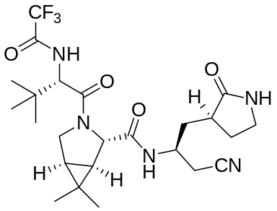

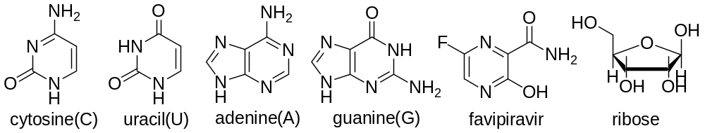
The drug Favipiravir is capable of complementary overlapping with A, C, G, and U with the same number of hydrogen bonds as in the native pairs. The energies and lengths of the hydrogen bonds in all the artificial pairs are comparable.
- Indicate potential donors (D) and acceptors (A) of hydrogen bonds in the Favipiravir molecule:
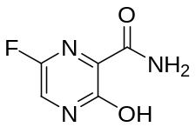
- Draw complementary pairs between Favipiravir and pyrimidine bases (use dashed lines to show the hydrogen bonds).
The skeleton of the compound Х (C₁₁H₁₅N₅O₃), previously used in therapy for viral hepatitis C and later implemented in treatment of COVID-19, is given on the fig. Some atoms or group of atoms are encoded as R₁ – R₆, and the multiple bonds in the heterocycle are omitted. The molar masses of R₁ – R₆, if rounded to integers, are the terms of an arithmetic sequence with the initial term of 12.  - Decipher R₁ – R₆. Draw the structure of Х. | 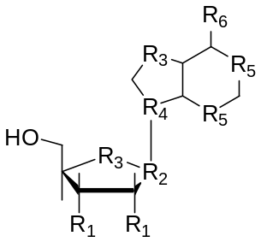
Molnupiravir causes mutations in the RNA virus during its amplification without preterm termination of replication due to the formation of complimentary pairs with both A and G depending on the tautomeric form. The (-)RNA is synthesized at replication using a coronavirus single strain (+)RNA as the matrix. In turn, the (-)RNA becomes the matrix affording new copies of (+)RNA. Only (+)RNA can be the matrix RNA for biosynthesis of viral proteins.
- Consider the fragment …AGAACUU… of a single strain (+)RNA, which undergoes several cycles of replication from the initial RNA towards daughter (+)RNAs in a cell in the presence of Molnupiravir. Propose the sequences of all possible secondary (+)RNA fragments.
Nucleoside Y is an isomer of one of the major nucleosides. Y is the key component of some mRNA vaccines used for the preventive care of COVID-19. Analysis of Y using liquid chromatography–mass spectrometry (LC-MS) reveals a characteristic signal m/z of 164, which is due to the ionic forms (M⁺) of two isomeric products (Y1 and Y2) of the destruction of Y. The common formula of the immediate precursor of Y1 and Y2 (the MS intermediate; the detailed image of the nitrogenous base missing) with the schemes of its fragmentation is:
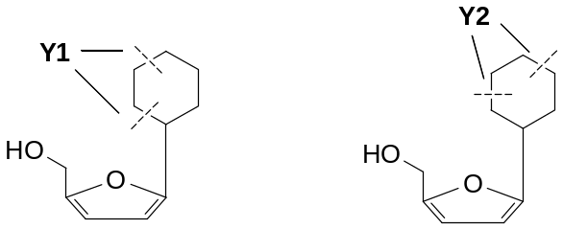
- Deduce the structure of Y, if the residues of the nitrogenous base in Y1 and Y2 are formed by seven atoms each.
- Choose one correct statement explaining why Y is widely used for the development of mRNA vaccines instead of its native analog:
- The nitrogenous base found in Y forms more hydrogen bonds with its complementary partner (as compared to its major analog), which results in a higher rate of translation.
- The nitrogenous base found in Y forms fewer hydrogen bonds with its complementary partner (as compared to its major analog), which results in a higher rate of translation
- The nucleoside Y is more resistant towards biodegradation in organism as compared to its major analog.
- The nucleoside Y present in the vaccine undergoes isomerization into its major analog in organism.

Problem 2
Phenylketonuria is a genetic disease that leads to phenylalanine (Phe) metabolism abnormalities caused by mutations in the gene encoding the enzyme phenylalanine-4-hydroxylase (PAH). As a result of the disease, Phe and toxic products of its transformations accumulate in the body. The biosynthesis of some of the metabolites is shown in the scheme.
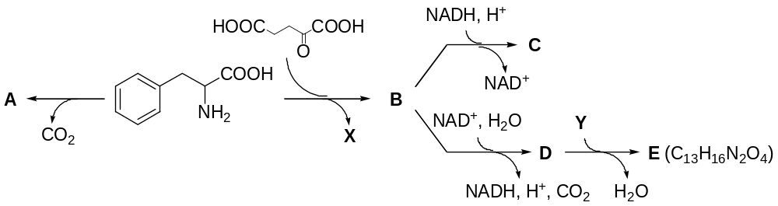
- Draw the structures of A – E, X and Y, if С is a hydroxycarboxylic acid, X and Y are canonical amino acids with 5 carbon atoms each, and the hydrolysis of Y gives X.
One of the mutations in the gene (R408W) responsible for phenylketonuria is associated with a single nucleotide substitution. This leads to a change in the triplet and synthesis of PAH with another amino acid. To determine which amino acid has been substituted, two pentapeptides were isolated and sequenced (determination of the amino acid sequence). The pentapeptides were the fragments of healthy (peptide I) and diseased (peptide II) human proteins.
а) The action of phenylisothiocyanate (PhNCS) resulted in the following products (the Edman degradation):
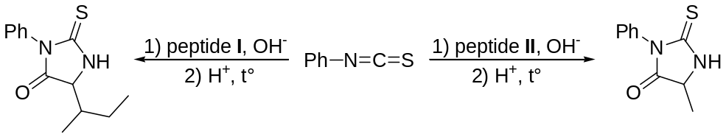
б) The Bergmann degradation is a multi-step process. First, the peptides are treated with diphenyl phosphoryl azide (DPPA), affording acyl azides. The latter undergo the Curtius rearrangement. Subsequent treatment with benzyl alcohol gives carbamates, and the hydrogenolysis removes the benzyl protecting group. Finally, acid hydrolysis leads to aldehydes containing the side chain of a terminal amino acid:
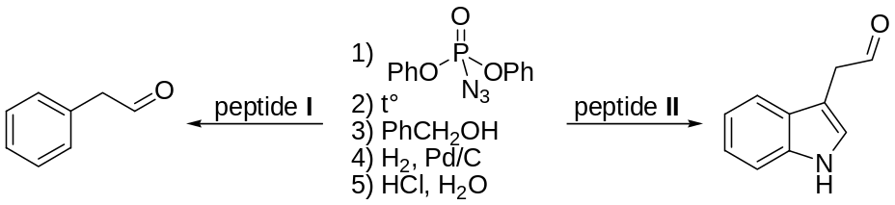
- Which of the above methods allows determination of the N-terminal, and which one of the C-terminal amino acids? Draw the structures of the intermediates at each step and the final products, denoting the N- and C-terminuses as follows:
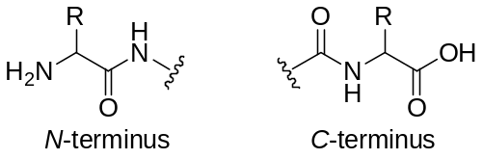
The Edman degradation:
-terminus | 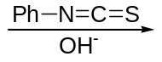 |  | 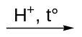

+
The Bergmann degradation:
-terminus | 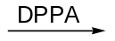 |  | 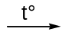

 |  | 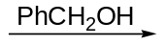 |  | 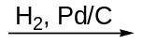

 |  | 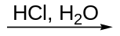 |  | +
- Determine the N- and C-terminal amino acids of the peptides I and II.
After the cleavage of the N- and C-terminal amino acids in the peptides I and II according to the above methods, the tripeptides I’ and II’ formed were partially hydrolyzed. The resulting mixtures were analyzed by soft ionization mass spectrometry (ESI–MS). The m/z values (the mass to charge ratio of an ion) of the protonated molecular ions for the mixtures obtained after hydrolysis of I’ were 136.5 and 185; and those of II’ were 229, 233, and 330. Consider that all the analyzed oligopeptides contain a free amino group at the N-terminus and a free carboxyl group at the C-terminus.
- Based on the mass spectrometric data, propose all possible variants of the amino acid sequences in I’ and II’ (use designations).
- Decipher the structures of I and II by writing the designations of the amino acids from N- to C-terminus. Indicate which amino acid substitution occurs as a result of the R408W mutation.
Reference data:
Name | Designation | Molecular mass (M_{r}) |  | Name | Designation | Molecular mass (M_{r})
Glycine | Gly | 75 |  | Aspartic acid | Asp | 133
Alanine | Ala | 89 |  | Glutamine | Gln | 146
Serine | Ser | 105 |  | Lysine | Lys | 146
Proline | Pro | 115 |  | Glutamic acid | Glu | 147
Valine | Val | 117 |  | Methionine | Met | 149
Threonine | Thr | 119 |  | Histidine | His | 155
Cysteine | Cys | 121 |  | Phenylalanine | Phe | 165
Isoleucine | Ile | 131 |  | Arginine | Arg | 174
Leucine | Leu | 131 |  | Tyrosine | Tyr | 181
Asparagine | Asn | 132 |  | Tryptophan | Trp | 204

Problem 3
The interaction of poly(methyl acrylate) (assume the head-to-tail connection of the repeat units) with methylamine at heating leads to the formation of units X (10.07 wt% of N) in the polymer.
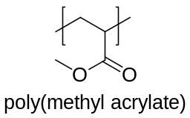
- Draw the reaction scheme leading to X. Calculate the degree of polymerization (the number of the repeat units) of the sample prepared by the above reaction from poly(methyl acrylate) with the molar mass of 25000 g/mol, if the conversion of the methyl acrylate units equals 40%. Calculate the resulting loss of mass.
Alkaline hydrolysis of the units A (26.40 wt% of N) of some polymer leads to the formation of copolymers containing additionally units B and C (19.71 and 0 wt% of N, respectively). One of such hydrolysis products (polymer P) contains 7.35 wt% of N, 28.29 wt% of O, and 15.98 wt% of Na.
- Elucidate the structures of A, B, and C.
- Determine the molar fractions of A, B, and С in P.
Heating of P after its treatment with dilute hydrochloric acid, washing with water, and drying leads to the formation of the units Y homologous to Х. The transformation occurs stepwise: first at 90°C without a mass loss and then at 160°C with a mass loss.
- Elucidate the structure of Y. Draw the schemes of the described reactions (use the A, B, C, Y to denote the repeat units). Calculate the mass loss of the sample (%) at the second step assuming the maximum conversion at both steps of the process. If you have failed to answer the previous question, give the answer in the general form denoting the molar fractions of A, B, and C in P as a, b, and c, respectively.
- A copolymer similar to P, still of arbitrary composition has been prepared. Let us denote the molar fractions of A, B, and C in this copolymer as a, b, and c, respectively. At which ratios between a, b, and c the second step is still possible, if the first step has been conducted to the maximum possible conversion.
The compositions of several copolymers analogous to P are given hereunder.
P1: a = b = 0.5, c = 0,
P2: a = b = c,
P3: a = 0.2, b = 0.3, c = 0.5
P4: a = 0.2, b = 0, c = 0.8, random arrangement of the units in the chain
P5: a = 0.2, b = 0, c = 0.8, block arrangement of the units in the chain
- Arrange those in the order of increasing the content of Y in the products of their thermal treatment (heating) assuming that the reactions described in this task are conducted to the maximum possible conversion.

Section IV. Inorganic Chemistry

Problem 1
«I often think that the night is more alive and more richly colored than the day.»
Vincent Van Gogh
A lot of inorganic compounds, especially of transition metals, have various colors, what can be used to create dyes and pigments. Important properties of inorganic dyes are their high resistance to light, high temperatures, corrosion, and also good coloring ability. Some popular inorganic dyes encrypted below are used by modern industry, others have remained only in historical references and in paintings of the great artists.
Nowadays, titanium or zinc white is often used as a white pigment, however, that was not always the case. Pigment A is a basic carbonate. The oldest method of producing A was as follows: thin sheets of metal were placed in special pots, on the bottom of which a small amount of acetic acid was poured. The pots were buried in horse manure, which released a large amount of carbon dioxide during rotting. As a result, a white layer of basic carbonate formed on the metal surface. Then it was cleaned off and used in the manufacture of paint.
- Determine A, if the thermal decomposition results in the mass loss of 13.7%. A does not contain crystallization water.
A stands out for its pure white color and excellent hiding power, yet A is hardly used today due to its high toxicity. In addition, it slowly darkens in air due to interaction with hydrogen sulfide. One way to restore such a "spoiled" white color is to treat it with hydrogen peroxide.
- Write down the chemical reactions equations of the last two processes.
A mixed iron oxide is usually used as a black pigment, as well as substance C, which is formed during the incomplete combustion of a hydrogen compound with a density of 0.714 g/L (under normal conditions).
- Determine C and write down the chemical reaction equation for its preparation.
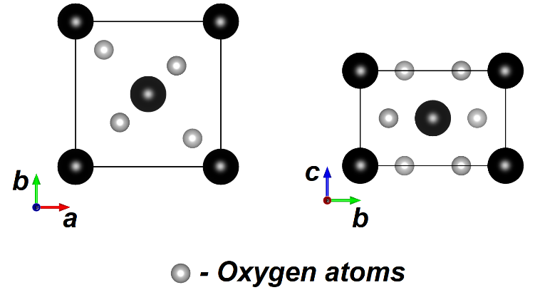
The crystal structure of D, a metal oxide, is shown in the figure as projections of a tetragonal unit cell onto different planes (unit cell parameters are a = b = 4.395Å, c = 2.875Å, d = 5.20 g/cm³). Oxide D itself is included in the composition of such pigments as ocher, sienna, umber, the simplified composition of which can be written as aFe₂O₃·bD·cSiO₂·dAl₂O₃·eH₂O. Furthermore, an increase in the mass fraction of D leads to a color change from yellow to yellow-orange and brown. In nature, D is also found as a distinct mineral.
- Determine the composition of D and the metal coordination environment in its crystal structure: tetrahedral, octahedral, square, trigonal prismatic, or cubic.
Thénard's blue is an extremely stable blue pigment used in paints, ceramics, and jewelry. It is obtained by sintering of aluminum oxide or sodium aluminate with salts of an unknown transition metal (nitrates, chlorides, hydrocarbonates, etc.). Thénard's blue belongs to the spinel group, and the effective magnetic moment of the transition metal atom is 3.87 mB.
- Determine the composition of Thénard's blue and write down the chemical reaction equation of its preparation from an unknown metal chloride and sodium aluminate.
- From the d-orbitals splitting diagrams of an unknown metal given hereunder, choose the correct one and depict the distribution of electrons in the orbitals.
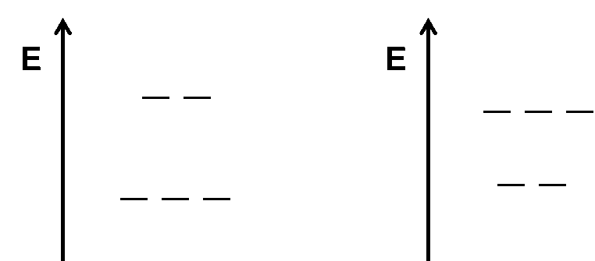
The most popular green dye is produced from the chromium compounds. The scheme presents the way of processing of iron chromite and obtaining the final product.
- Decipher the scheme and write down all chemical reactions equations.

Problem 2
The element X is part of a large number of compounds and substances that have been used by humanity since ancient times. Most of these compounds under normal conditions are solid, crystalline, non-volatile substances, but there are examples of compounds whose melting points are below room temperature.
An elementary substance X1 with slight heating can actively react with a gaseous, slightly colored substance A1, forming compound Y1. When heated, this substance is able to sublimate, which is often used to separate compounds which are similar in their composition. In parallel with the transition into the gas phase, Y1 undergoes partial decomposition with the formation of compound Y2 and an elementary substance. Substance Y2, being crystalline, does not pass into the gas phase, but it is hygroscopic like Y1. Y2 can be obtained in other ways, for example, by the reaction of X1 with Y1, or by the reaction of X1 with the binary compound A2, the latter includes the lightest element. The molar fractions of element A in Y2 and A2 differ by 1.334 times, and its mass fraction differ by 1.7377 times.
- Determine the element X and the composition of the compounds Y1, Y2, A1 and A2. Confirm your conclusion with calculations. Write down the equations of mentioned reactions. Draw the structure of the Y1 molecule in the gas phase.
In addition to crystalline Y1 and Y2, the element X may be contained in the substances Y3 and Y4 liquid under ambient conditions.
The compound Y3 can be obtained by the reaction of Y2 with aluminum and a gaseous substance, the latter is isoelectronic to nitrogen molecule. The molecular fragment of the Y3 has one 3-fold axis of symmetry, three 2-fold axes, four mirror planes, but the inversion center is absent. This compound is diamagnetic. Under the hard UV radiation it can form a diamagnetic compound Y5, in which the mass fraction of the element X is 1.077 times more than the mass fraction in Y3. The molecular fragment of the Y5 compound has two mirror planes of symmetry, one 2-fold axis. The compound Y3 is soluble in many organic solvents. When action of A1 excess on a solution Y3 in tetrachloromethane Y1 is formed.
- Determine the compounds Y3 and Y5. Confirm your conclusion with calculations. Write down the equations of these reactions. Draw structural formulas of molecular fragments, indicating all bonds.
Y4 is used as polar solvent, catalyst, electrolyte in electrochemical devices. The scheme of obtaining the compound Y4 is presented below in the scheme.
- Write down the equations of the corresponding reactions, draw the structural formulas of compounds I, II, Y4. Give an example of an inorganic compound containing the same anion as in Y4.
- For what reason are the compounds Y3 and Y4 fluids at ambient temperature and pressure? Select the answer from the proposed options. Which of these compounds can pass into the gas phase?
Y3 is liquid under ambient conditions due to:
□ molecular structure, weak intermolecular interactions
□ ionic structure, asymmetrical anion
□ atomic type of crystal structure
□ asymmetry of structural molecular fragment
□ low oxidation state of the element Х
Y4 is liquid under ambient conditions due to:
□ molecular structure, weak intermolecular interactions
□ asymmetrical cation and charge delocalization in anion
□ atomic type of crystal structure
□ asymmetry of structural molecular fragment
□ low oxidation state of the element Х
The following compound can pass to the gas phase:
□ Y3
□ Y4
□ Y3 and Y4
□ none of the compounds can pass to the gas phase

Problem 3
The compound A₂O_{n} which plays an important role in the transmission of nerve signals, is obtained in the form of a bluish gas by the action of Cr₂O₃ on a mixture of potassium salts (3KAO₂ + KAO₃). Pure A₂O_{n} is colorless paramagnetic gas with l_{A–O}= 0.115 nm, which condenses below –164°C into a colorless diamagnetic solid mixture of isomers B: B1 (l_{A–O}=0.112 и 0.240 nm) and В2 (l_{A–O}= 0.112 nm; l_{A–А}= 0.218 nm; cis-isomer). In 1978 Laane obtained red modification В3 (l_{A–O}= 0.119 nm and 0.174 nm, ∠АОА = 107°) by A₂O_{n} condensation in the presence of Lewis acids.
- Decode A, A₂O_{n} and В, if the mass fraction w_{A} in KAO₂ and KAO₃ differs by 2.61%. Write down the equation for the A₂O_{n} synthesis reaction and the reaction explaining the bluish color of the gas.
- Calculate the content of В (mol. %) in the gas at 25°C and 1 atm, if ∆_{f}G°, kJ/mol: 12.35 (A₂O_{n}) and 39.00 (В). Draw the structural formulas of A₂O_{n} (MO method) and modifications of В.
Being in complexes monodentate A₂O_{n} can donate an electron to the central Me atom and act as either σ-donor (1), or both σ-donor and π-acceptor (2), forming linear (X) fragment MеAO (170-180°), and can be one-electron (3), forming bent (Y) fragment МеАО (120-140°).
Complex | ∠МеАО | l_{Ме–А}, nm | l_{A–O}, nm | ν cm^{–1} in IR-spectrum
[Fe(CN)₅A₂O_{n}]²⁻ | 178 | 0.166 | 0.112 | 1935
[IrCl(CO)(PPh₃)₂A₂O_{n}]⁺ | 124 | 0.197 | 0.119 | 1680
[RuCl(PPh₃)₂(A₂O_{n})₂]⁺ | 178; 138 | 0.186; 0.172 | 0.118; 0.114 | 1845; 1687

- Draw fragments 1-3 and the structural formulas of the complexes given in the table, assuming that Me in d²sp³ and d_{х2-у2}sp³ hybridization, ∠Ме(PPh₃)₂ ~ 180°, and one ligand A₂O_{n} is in the axial position.
In 1979, Schoonover and Eisenberg showed that there is equilibrium X ⇄ Y in solution. If A₂O_{n} is passed through a solution of green MeCl₃ (3.73 g) in CH₃OH + N(C₂H₅)₃ until complete sedimentation of CH₃OAO, PPh₃ (0.025 mol) is added until a brown-red solution of the E⁺ cation (7.82 g, yield 80%,
w_{Cl} = 4.54%), then salts of EAn would be obtained by the action of BF₄– and PF₆–. In their solution in THF at 0°C, Cl– can be replaced with C₃H₅– by action of Sn(C₃H₅)₄ with formation of light brown salt DPF₆ (ν = 1763 cm^{–1}) and red-brown one DBF₄ (ν = 1631 cm^{–1}).
- Decode mononuclear cations Е⁺ and D⁺ in the salts and depict the structural formulas of D⁺ (PPh₃ – triphenylphosphine, C₃H₅ – trihaptoligand η³-).
In a solution of any of the salts with D⁺ at 25°C, bands 1760 and 1630 cm^{–1} of the same intensity are fixed (I), at 0°C the intensity of the 1760 cm^{–1} band increases by 31%, and the sum of the intensities of the two bands does not depend on temperature.
- Estimate ∆_{r}Н° of the transition Y ⇄ X, using the intensities in the IR spectrum and the Van't Hoff equation.

Section V. Analytical chemistry

Problem 1
Art is the highest manifestation of power in man.
L.N. Tolstoy (1828-1890)
An important and interesting application of chemical analysis is painting. Paints contain a pigment (most often it is an inorganic mineral) and a binder (oil in the case of oil paints). Analysis of paints is necessary for the purpose of restoration or verification of authenticity of a painting.
The main white pigments in paints are white lead paint Pb₂(OH)₂CO₃, zinc white paint ZnO and barium white BaSO₄. To determine the type of white paint, it is sufficient to dissolve it in a strong acid: two out of the three paints dissolve, and the insoluble one can be dissolved by fusion with sodium carbonate.
- Arrange the white paints in the descending order of solubility in 0.1 M strong acid. Confirm this sequence by calculating the solubility S of each of the three paints in acid, assuming that pH = 1 and it is not changing during dissolution: K_{S}(BaSO₄)=1.1∙10^{–10}, pK_{a1}(H₂SO₄)=–6.3, pK_{a2}(H₂SO₄)=1.9, K_{S}(Pb₂(OH)₂CO₃)=3.5∙10^{–46}, pK_{a1}(H₂СO₃)=6.35, pK_{a2}(H₂СO₃)=10.35, K_{S}(Zn(OH)₂)=1.2∙10^{–17}.
After the dissolution of white paints, the following reagents can be used to recognize them: K₂Cr₂O₇ (a yellow precipitate forms, and its amount increases when sodium acetate is added), KI (a yellow precipitate forms that dissolves easily in hot water; if the solution is cooled, the precipitate forms again, sometimes it is called "golden rain"), (NH₄)₂[Hg(SCN)₄] + CuSO₄ (violet precipitate).
- Match the identified cations and reagents, write down the corresponding reaction equations.
- Why does the amount of the first yellow precipitate increase with the addition of sodium acetate?
Knowing the nature of the white paint is important for restoring paintings or verifying their authenticity. For example, despite the beautiful color of white lead, it will eventually turn gray and even black in air (the presence of traces of a gas with a close molecular weight to oxygen). To restore the white color, restorers use a solution of hydrogen peroxide.
- Write the appropriate reaction equations.
In the 16th-17th centuries, paints often contained such harmful elements as lead (in white paints and pigments) and arsenic, which was a component of such infamous wallpaper paints as "Scheele green" or "Paris Green" with an amazing green tint but very toxic due to arsine release in a humid atmosphere.
- Paris Green is a mixed salt, it is obtained by the interaction of pigment “Verdigris” (CuAc₂) with arsenic(III) oxide.
a) Write down the reaction of Paris Green formation, if both components of the mixed salt contain copper(II) as cation.
b) When alkali are added, the Paris Green suspension changes color to red-orange. Write down the redox reaction equation, circle the compound(s) responsible for the color of the mixture.
c) Determine the formula of Paris Green if the amount of copper in the product obtained after treatment with alkali is equal to the amount of arsenite. The redox reaction is quantitative.
The amount of arsenic can be determined by the following method: a wallpaper sample (100 cm²) is dissolved in fuming nitric acid, the volume of the solution is adjusted to 500 mL, and an aliquot of the solution (100 mL) is titrated with sodium bromate of a concentration of 0.002 M to the equivalence point (1.65 mL).
- Determine what fold the amount of arsine exceeds the maximum permissible concentration (0.1 mg/m³) in a room with the wall area of 50 m², if the volume of the room is 60 m³, assuming that 1/1000 of all arsenic has turned into arsine.
Other component of paints are oils, esters of glycerol, characterized by the ability to dry, which in turn is related to the number of C=C bonds in the oil: the more of them, the faster the paint dries due to polymerization. The number of C=C bonds is characterized by the iodine number (the mass of iodine reacting with 100 g of oil). With the iodine number less than 115, the oil does not dry out, 115–130 it is semi-drying and more than 130 – well drying.
The iodine number can be determined by iodometric titration: a sample of oil (1.500 mL, ρ=0.92 g/mL) is diluted with chloroform, and a known amount of bromine is added in excess. After the reaction is completed, potassium iodide is added to the mixture, the resulting iodine is titrated with a solution of sodium thiosulfate prepared using 24.81 g of salt pentahydrate in 500 mL of solution. A similar blank experiment is carried out without oil. For the titration of the first solution, 6.75 mL of thiosulfate solution was used, and for the titration of the blank sample, 56.25 mL of the same solution was spent.
- Write down all the equations of the reactions that take place; instead of oil, write R–CH=CH–R for simplicity.
- Calculate the iodine number and judge the suitability of the oil for use in a paint formulation.

Problem 2
The spectroscopic properties of dyes (absorption of light, fluorescence, etc.) can change markedly when interacting with surfactants. For example, carbocyanine Z in the presence of sodium n-dodecyl sulfate (SDS) changes its absorption spectrum as follows (1 - in the presence of SDS, 2 - without SDS):
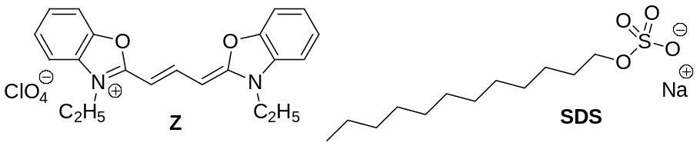 | 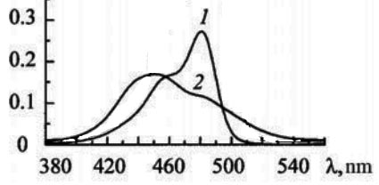
Dodecyl sulfate does not absorb in this range of the spectrum.
- Choose the wavelength at which it is most convenient to observe the complexation of the dye with the surfactant.
To describe the equilibrium in solution, it is sufficient to apply the mass action law (the expression for the constant K of the corresponding equilibrium), the law of conservation of matter (material balance) and the Bouguer-Lambert-Beer law А = ε[X]l, where А is absorbance, ε is the molar absorption coefficient of X; [X] is the equilibrium concentration of Х (mol/L), l is the optical path of the cell (cm).
- а) For the complexation reaction presented in the form: Z + nSDS = Z(SDS)_{n}, write down the expression for the equilibrium constant. Designate the total concentration Z as c(Z) and the equilibrium concentration as [Z]. Write down the expression for the material balance of the dye (Ignore the material balance for SDS, because the surfactant concentration is significantly higher than the dye concentration.)
б) Write the experimental value of absorbance A as the absorbance of the Z(SDS)_{n} complex according to the Bouguer–Lambert–Beer law for a cell with l = 1 cm (neglect the absorbance of the free dye).
- а) From the written equations, obtain an expression relating the optical density A, the molar absorption coefficient of the complex ε, the total concentrations of the dye c(Z) and dodecyl sulfate c(SDS) and the complex formation constant K.
б) Bring the resulting expression to the form y = y₀ + Bx, where y = 1/А, and х = 1/с(SDS)^{n}.
- The following values of absorbances were obtained experimentally in the presence of various concentrations of SDS (l = 1 cm; the total dye concentration c(Z) is constant and equal to 1∙10^{–5} М):
c_{SDS}, M | 2.0∙10^{–4} | 2.9∙10^{–4} | 3.8∙10^{–4} | 6.0∙10^{–4}
А | 0.10 | 0.20 | 0.33 | 0.67
a) Plot the graphs 1/A – 1/(c_{SDS})^{n} for n = 1, 2, and 3.
b) Determine the composition of the complex.
c) How to calculate the value of the complex formation constant? Give the formula (do not give a numerical value).

Problem 3
Extraction is a method of separating substances based on their different distribution between two immiscible solvents (phases). For example, when iodine is extracted from the aqueous phase with an organic solvent, an equilibrium described by the distribution constant is established:
I_{2(aq)} ⇄ I_{2(org)} 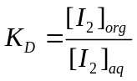.
The following organic substances were added to the saturated aqueous iodine solution: tetrachloromethane, cyclohexene, benzene, ethyl alcohol, starch, isoamyl alcohol.
- Assign the added organic substance with the observed effect: a) separation into two phases, the upper one is colored purple; b) separation into two phases, the lower one is colored purple; c) dark blue solution; d) brown solution; e) separation into two phases, the upper one is colored brown; f) separation into two phases, the upper one turns purple, which fades over time, and the third phase forms on the bottom.
The iodine solubility in water is increased in the presence of halide ions due to the formation of complex ions of type I₂X–, where X = F, Cl, Br, I, according to the equation:
I_{2(aq)} + X–_{(aq)} ⇄ I₂X–_{(aq)} 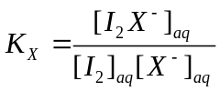.
The D_{X} distribution coefficient is the ratio of the sums of all forms concentrations of the extracted substance in the organic phase to the aqueous. When extracting an iodine solution in the presence of halide ions, only neutrally charged iodine molecules are transferred into the organic phase.
- Get an expression that explains the linear correlation 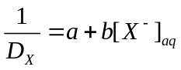. How are the constants K_{D} and K_{X} related to coefficients a and b?
To determine the equilibrium constants K_{D} and K_{X}, a series of experiments was conducted to extract iodine from some organic solvent into aqueous solutions of potassium halides with a known salt concentration. After separating the phases, the iodine concentrations were determined by titration with a standard sodium thiosulfate solution.
- Derive the expression for the relation of D_{X} to the volumes of thiosulfate V(Na₂S₂O₃)_{aq} and V(Na₂S₂O₃)_{org}, which went to titration of aliquots of the aqueous and organic phases with volumes V_{aq} and V_{org}, respectively.
The graph shows the dependencies of 1/D_{X} on the initial concentration of three halide ions in the aqueous phase (cases A – C). It is known that the stability of I₂X– complexes increases in the series of I₂F– < I₂Cl– < I₂Br– < I₃–, and in the case of one of the halides (case D), dependence 1/D_{X} from [X–]₀ stops to be linear. | 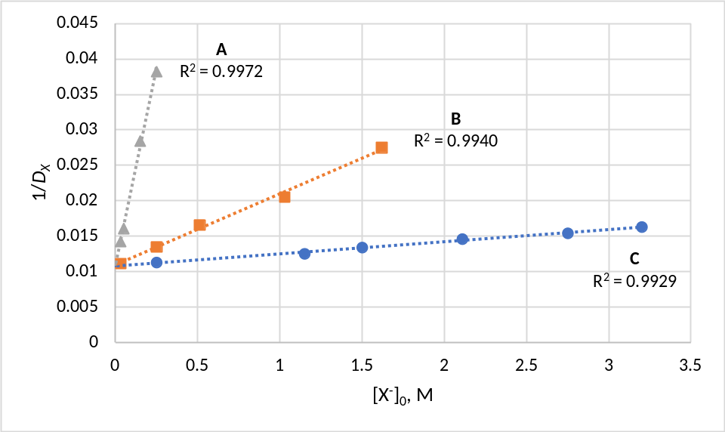
- What approximation should be allowed for the expression in question 2 to explain the linear dependence of 1/D_{X} also on [X–]₀? Please provide your calculations.
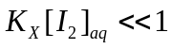 | 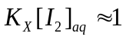 | 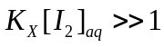
- Assign the cases A – D to the corresponding halides F–, Cl–, Br– and I–.
- Estimate the values of K_{D} and K_{X} for the three halides A – C.

