Theoretical tour 1
Problem 1
Natural carbonated water has been known for a long time. The effort to produce artificial sparkling water (SW) using bicarbonates or dissolving CO₂ under pressure was successful in 1740–1760. Due to the widespread demand, industrial production began in 1783. The dissolution of CO₂ in water is described by Henry's law, which states that the molar concentration of a gas in a liquid is directly proportional to the partial pressure of that gas above the solution: С = k_{H}∙P, where k_{H} – Henry's temperature-dependent constant according to Arrhenius' law:
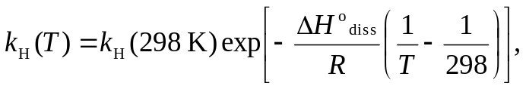
where ΔH°_{diss} – enthalpy of dissolution equal to for CO₂ in water −19.9 kJ⋅mol⁻¹, k_{H}(298 K) = 3.3∙10⁻² М⋅atm⁻¹.
Artificial SW contains considerably more gas than natural, and is divided into low-, medium- and high-gas content by mass CO₂ content in the ranges of 0.2−0.3, 0.3−0.4 and >0.4%, respectively.
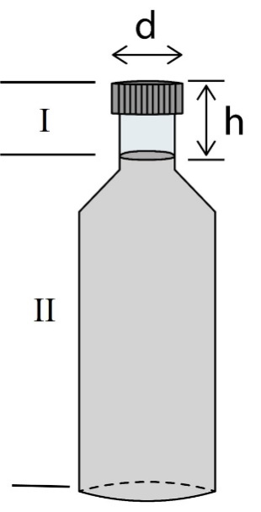
Figure 1
1. Determine the category of a 500 mL SW that is saturated with carbon dioxide at a pressure of 2 atm and temperature 5°C.
2. Obtain an expression for the pressure of CO₂ in the closed bottle shown in Fig. 1. Region I has volume V_{gas} and is filled with ideal gas, region II is carbonated water with volume V_{liq} and the concentration of carbon dioxide is determined by Henry's law. The total amount (mol) of CO₂ is determined by the contribution of gaseous and aqueous phases: n∑ = n_{gas}+n_{liq}.
3. Using the expression obtained in step 2, calculate the pressure of carbon dioxide in a closed bottle (Fig. 1) containing 500 mL of SW at 25°C. The diameter of the bottle neck
d = 28 mm, h = 4 cm, take n∑ (СО₂) to be 45 mmol.
4. Calculate the pH of pure water at 25°C in contact with air. Partial pressure of CO₂ in the air 3.0∙10⁻⁴ atm. Accept that
[H⁺] ≈ [HCO₃⁻], and do not take into account the contribution to the pH value of the dissociation of the carbonic acid in the second step.
СО₂ + Н₂О ↔ Н₂СО₃ | K = 3.3∙10⁻²М⋅atm⁻¹,
Н₂СО₃↔ Н⁺ + НСО₃⁻ | k_{a1} (H₂CO₃) = 4.3∙10⁻⁷.
5. How will the radius of a carbon dioxide bubble rising from the bottom of a natural spring 30 m deep increase? The hydrostatic pressure increases linearly with depth: Р = P_{atm} + ρ_{H2O}gh. The initial bubble radius is 0.4 mm. Assume that the temperatures at the bottom and the surface of the spring are the same.
Physical constants: R = 8.314 J⋅mol⁻¹∙K⁻¹, g = 9.8 m⋅с⁻².

Problem 2
One of the popular areas of organic chemistry awarded with the 2022 Nobel Prize is click chemistry.
1. Decipher the transformations shown in the diagram if the interaction of A and X is an addition reaction, C and D are isomers. Which of them is more stable C or D? Circle the structure in the answer shits.
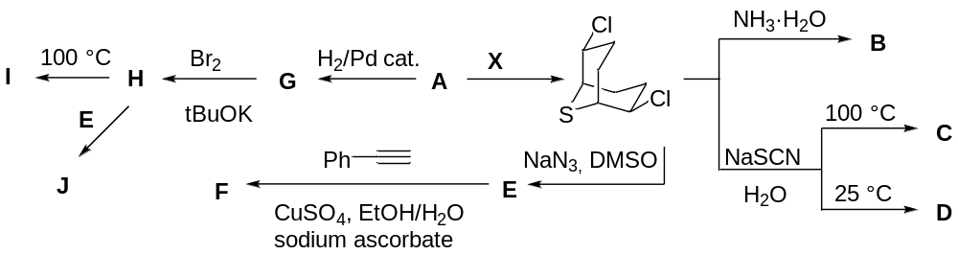

Problem 3
Two-dimensional particles are characterized by thickness as well as length and width (size in the particle plane). Other important parameters of the particles are specific surface area (the ratio between the particle surface area and its mass) and dispersity (the ratio between the particle surface area and its volume).
1. For a flat square (length is equal to width) particle, write the expressions relating its specific surface area S_{sp} and dispersity D with the thickness d, square side length a, and the particle density ρ.
2. At which a/d ratios dispersity of the flat square particle is independent of the length and width (the difference in the dispersities calculated accounting for and neglecting a does not exceed 1%)?
Study of adsorption at flat graphite particles revealed that the maximum amount of the adsorbate per 1 g of graphite is 10^{–3} mol. Length of the C–C bond in the graphite layer is 0.142 nm, graphite density is 2.15 g⋅cm⁻³. Cross-section area of the adsorbate molecule is 0.025 nm².
3. Calculate specific surface area of graphene (a single graphite layer), available for the adsorption.
4. Calculate maximum amount of the adsorbate which can be bound by 1 g of graphene. If you have failed to get numeric answer in question 3, denote the corresponding value as x.
5. Write the equation relating the maximum amount of the adsorbate which can be bound by 1 g of multilayered graphite with the number of the layers in the nanoparticles n. If you have failed to get numeric answer in question 4, denote the corresponding value as y. Calculate the number of layers in the considered graphite nanoparticles. Neglect the adsorption at the side surface and penetration of the adsorbate between the graphite layers.
6. Determine the thickness of the considered graphite nanoparticles. If you have failed to get numeric answer in question 5, denote the corresponding value as z.

Problem 4
Elements X and Y are located in the same period of the Periodic Table. Both the simple substance of X and one of the allotropic modifications of Y have characteristic red-orange colors. Hydrolysis of the binary compound of Al with Y leads to the emission of poisonous gas Y1 with a strong unpleasant odor. Y1 exhibits reducing properties. Thus, when Y1 is passed into a solution of a salt obtained by heating X in concentrated sulfuric acid, a colored precipitate X1 is formed among the reaction products. Combustion of Y1 in an excess of oxygen leads to the production of a white crystalline (NC) substance Y2, which is highly soluble in water to form a solution of Y3. A concentrated hydrogen peroxide solution oxidizes the Y3 solution to Y4.
Y2 can also be obtained by oxidizing Y substance with gas G (D_{He} = 11.5) under heating. Fusion of equal amounts of Y2 with an oxide of X element, in which the mass fraction of oxygen is 4 times less than the mass fraction of X, leads to the formation of X2 substance, which occurs in nature as a mineral. X2 reacts with ammonia gas under heating to form X3. X3 – a binary compound of X and Y.
1. Identify unknown substances X, X1 – X3, Y, Y1 – Y4, G, and also write down the equations of chemical reactions. It is known that the qualitative composition of X1 and X3 is the same.
Gradual dehydration of Y4 with phosphorus oxide P₂O₅ first leads to the formation of acid Y5 (ω(O) = 0.4117, ω(Y) = 0.5809), and Y6 is formed at the final stage. Y6 has a molecular structure, the molar mass of its structural unit lies in the range of 400-520 g/mol.
2. Identify the composition of Y5 and Y6, and also draw their structure.

Problem 5
A weight of slaked lime, stored for some time in air, was dried at 80°C to a constant weight and a sample weighing 34.85 g was obtained, which was completely dissolved in 85.00 cm³ of nitric acid solution (density 1138 g/dm³). The resulting solution was evaporated double by weight and cooled to 0°C. In this case, a precipitate of substance A was formed weighing 24.98 g. The resulting filtrate weighing 40.02 g was again evaporated by a quarter and after cooling to 0 ° C, an additional 26.64 g of A was obtained. The resulting portions of A were combined and kept for a long time at 220 °C drying oven, as a result of which the mass decreased by 30.50% and substance B was formed.
Half of the obtained substance B was placed in a quartz ampoule and heated at a rate of 10 °C/min to 580 °C and kept at this temperature until the mass change ceased. In this case, 26.52 dm³ of gas was obtained (the volume was measured at 580 °C and 102.3 kPa). With the second half of B, the same experiment was carried out, but the final temperature was 600 °C. In this case, 22.99 dm³ of gas was released (the volume was measured at 600 °C and 103.5 kPa). In each of the experiments, the mass of the final solid residue C was 34.2% of the initial one.
1. Give the equations of the reaction that occurs when a sample of lime is dissolved in nitric acid.
2. Establish the composition of substances A, B and C.
3. Calculate the mass fraction of impurities in the dry lime sample.
4. Make the reaction equations that occur when B is heated to 580 °C and 600 °C. Bring your calculations.

Problem 6
Nafion is a polymer characterized by both ion-exchange properties and chemical resistance. It is thus used as a material for production of semipermeable membranes, which let through the molecules of low-molecular compounds and retain polymers. The equivalent weight (mass of the material per 1 mol of ionic groups) depending on the | 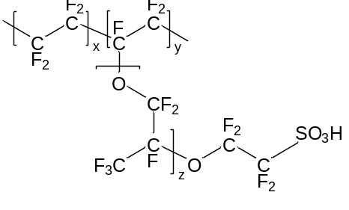
content (y) and length (z) of the pendant substituents is an important parameter of Nafion.
1. Calculate the equivalent weight of Nafion at x = 100, y = 50, z = 3.
2. Nafion with the equivalent weight of 1100 g/mol and z = 1 is most suitable for the membranes production. Calculate the average polymerization degree of the backbone of such macromolecules, if each contains 55 ionic groups.
Once swollen in water, the membrane described in i. 2 contains 30% of Н₂О by mass with the density of 1.45 g/cm³. The membrane is prepared via casting of the 15% polymer solution in an alcohol with the density of 1.1 g/cm³.
3. Calculate the solution volume needed to prepare the swollen membrane of A4 size (210×297 mm) with the thickness of 120 μm.
The prepared membrane was used to remove the salt present in a solution of lysozyme (globular protein, M 14300 g/mol) by dialysis. To do so, 100 mL of the starting lysozyme solution with the protein concentration of 1 mmol/L and sodium chloride concentration of 4 mol/L was separated from 1 L of distilled water (take the salt concentration in the latter as 0) by a piece of the Nafion membrane with the diameter of 10 cm.
4. Calculate the fraction of the sodium chloride (referred to the starting mixture with the protein) removed after 5 min of dialysis (assume that the sodium chloride flow across the membrane is constant and equals 10⁻⁶ mol/(cm²·s).
5. Calculate the mass fraction of sodium chloride in the dried mixture with the protein after three cycles of dialysis (each time the dialysis was conducted until equilibrium followed by an exchange of the obtained solution of the salt with 1 L of distilled water). Neglect both the water flux across the membrane and the salt content inside it.
High price turns out to be a serious drawback of Nafion. If an enhanced chemical resistance of the membrane is not important, Nafion can be substituted by a cheaper, still less stable analog. Synthesis of such an alternative material B is given on the scheme below. The polymer A was obtained by polymerization of 4,4'-difluorobenzophenone with hydroquinone in the presence of Na₂CO₃, and the polymer B by treatment of A with concentrated H₂SO₄.
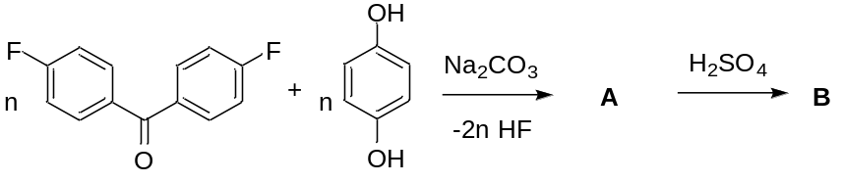
6. Draw the structure of the repeat unit of A.
7. Calculate the equivalent weight of B (neglect the terminal groups), if the mass fraction of sulfur in it equals 2.13%.

Problem 7
Bromatometric titration is used to determine amounts of anilines and phenols. The method is based on the bromination of these compounds into the aromatic ring. For example, when aniline is brominated, 2,4,6-tribromaniline is formed.
1. Write the equation for this reaction, indicate the amount of bromine consumed per mole of aniline.
2. When disubstituted derivatives are brominated, the result depends on the mutual arrangement of the substituents. Thus, aqueous solutions of 1,3- and 1,4-dihydroxybenzenes (resorcinol and hydroquinone) containing potassium bromide and acid were titrated with a bromate solution until a non-vanishing color of bromine appeared, after which an excess of KI was introduced and the released iodine was titrated with thiosulfate. It was found that one of the isomers absorbed 3 mol of bromine per mol of analyte (case a), while in the case of the other isomer, the consumption of bromine was significantly lower (case b). Which of the cases refers to resorcinol, and which one to hydroquinone? Write down the structures of their bromination products.
3. Predict the products of a titration with a bromide-bromate mixture of 2,4-dimethylaniline and 2,5-dimethylaniline. Specify the amount of bromine consumed per mole of analyte for these compounds.
4. Para-substituted anilines and phenols react with bromine in more complicated way. The conditions for quantitative determination have been found (control of temperature, acidity, and interaction time). Thus, 4-aminobenzenesulfonic acid (sulfanilic acid) reacts with 2 mol of bromine at 0°С, and with 3 mol at 20–25°С. In the latter case, the sulfo group is replaced by bromine. Give the structures of bromination products for 0°С and 20–25°С.
5. Bromatometry is used for the analysis of pharmaceutical preparations. To determine sulfapyridine (Fig.), one of the first sulfanilamide antibiotics, an excess of potassium bromide, 5.0 ml of a 1.00 M potassium bromate solution and acid were added to the analyte solution placed in a 50.0 ml flask. The flask was closed with a stopper, after 5 min an aliquot of 5.0 ml was taken. | 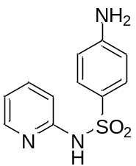
Next, an excess of KI was added to the aliquon and it was titrated with a 0.100 M solution of thiosulfate. Determine the initial mass of sulfapyridine if 12.0 ml of titrant was used. It is known that sulfapyridine is brominated similarly to sulfanilic acid, and the reaction proceeds with strict observance of stoichiometry. Write down the structure of the sulfapyridine bromination product.

Problem 8
Lead-acid batteries are the most common type of car batteries. The operation of such batteries is based on the electrochemical transformation of lead metal present in the cathode plates and powdered lead dioxide placed in the anode plates, in the presence of an electrolyte, an aqueous solution of sulfuric acid.
1. Write down half-reactions for the main processes occurring at the cathode and anode and the overall reaction during discharge.
2. At the end of battery charging, when insufficient lead compounds are available and current continues to flow through the battery, there can be a so-called "boiling" of the battery, which is dangerous and may result in explosion. What processes correspond to "boiling" and a potential explosion? Write down the reactions.
3. One of the significant problems of such batteries is sulfation – the accumulation of insoluble precipitate during non-optimal charge-discharge cycles, which has a negative effect on the electrochemical processes. What is this precipitate?
4. The technical service of such batteries includes desulfation for removing the precipitate. For example, this can be done by draining the electrolyte from the battery, rinsing it with water, and filling it with a solution which can be prepared by diluting 45 mL of 25% (w/w) ammonia and 20 g of Trilon B (EDTA, Na₂H₂Y) with water to yield 1 L of solution. What chemical reaction is this method based on? Write down the main equilibria that exist in such a system.
5. Calculate the solubility of the sulfation-causing precipitate in the described desulfation solution.
6. How much precipitate can be removed from the battery plates by a single application of this solution?
For reference: Solubility product of lead sulfate: K_{s}⁰ = 2.2·10^{–8}. The complexation constant of lead with EDTA: β=[PbY²⁻]/([Pb²⁺][Y⁴⁻])=1·10¹⁸; K_{b}(NH₃)=1.76·10⁻⁵. Density of 25 w/w % solution of ammonia: 0.9070 g/mL. The molar weight of EDTA: 336 g/mol. Mole fractions of the EDTA Y^{4–}form:
pH | α(Y^{4–}) | pH | α(Y^{4–}) | pH | α(Y^{4–})
10.00 | 0.36 | 10.75 | 0.76 | 11.50 | 0.95
10.25 | 0.49 | 11.00 | 0.85 | 11.75 | 0.97
10.50 | 0.64 | 11.25 | 0.91 | 12.00 | 0.98

