Theoretical tour 2
Organic chemistry
Problem 1
Thio- (I) and dithiocarboxylic (II) acids are sulfur-containing analogs of carboxylic acids in which one or two oxygen atoms of the carboxyl group are replaced by sulfur. Thiocarboxylic acids exist as a mixture of tautomers Ia and Ib.
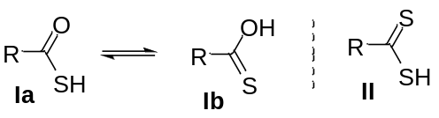
- Using toluene and only reagents 1–6, propose the synthesis of acids I and II (all reagents are to be used).
1. 1) СS₂; 2) H₃O⁺ | 2. SOCl₂ | 3. Br₂/h
4. NaSH | 5. KMnO₄/H₃O⁺/t | 6. Mg/ether
The Wilgerodt-Kindler (WK) reaction allows to obtain compounds containing a thiocarbonyl group. One of the reactants in the WK reaction is D which is obtained according to the scheme: 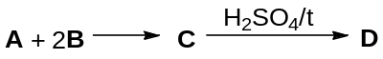
- Determine the structures of A–D if in C, w_{C} = 45.71%, w_{H} = 10.48%, w_{N} = 13.33%; ¹H NMR spectra of both A and B contain only one signal; D exists as a chair conformation.

The WK reaction can be demonstrated by the example of the interaction of ketone E (C_{n}H_{n}O) with D in the presence of sulfur. Compound G, which is homologue of E, reacts similarly. The aliphatic part of the ¹H NMR spectrum of F contains a singlet (2H) and two multiplets each of 4H, and H contains two triplets of 2H and two multiplets of 4H; there are no singlets in the ¹H NMR spectrum of G.
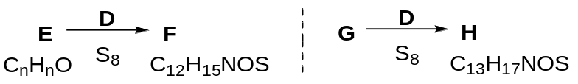
- Determine structures E–H.
The WK reaction was used in the synthesis of debromoaplysin X, a natural antioxidant:
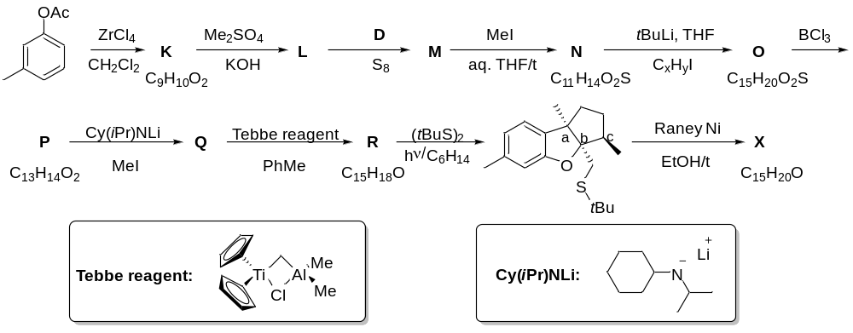
- Determine the structures the of K–R, X, C_{x}H_{y}I.
- Indicate configurations (R/S) of chiral centers a–c in the given structure of precursor of X.

Problem 2
Natural ambergris is a waste product of cachalots, highly valued in perfumery and used as an odor retention agent. One of the key components responsible for the smell of ambergris is the natural terpenoid ambroxide X, which was obtained from the essential clary sage oil component sclareolide Y.
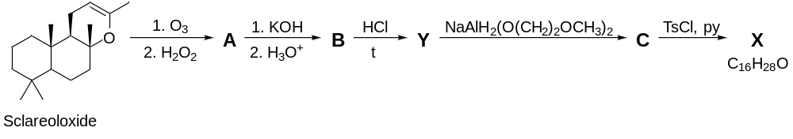
1. Give the structural formulas of A – С, sclareolide Y, and ambroxide X.
Later a synthetic scheme for the production of ambroxide from carvone was proposed.
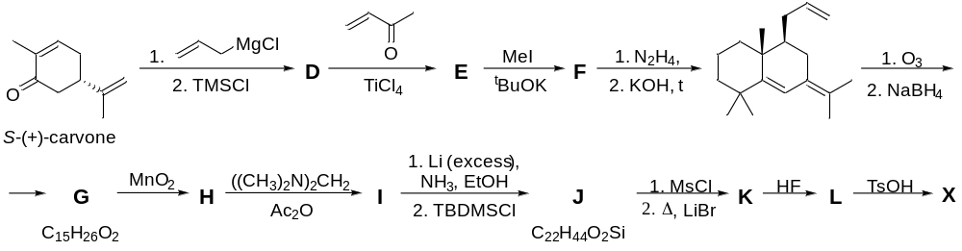
2. Decode D – L. Note that the molecule of substance F contains three chiral centers.

Problem 3
Visualizing single molecules in living cells has tremendous applications in deciphering biochemical pathways as well as understanding diseases. Fluorescent dyes are used for this aim. The general synthetic scheme of some classes of dyes are given below.
1. Decode A-F if F belongs to the class of cyanine dyes. F contains fragments C and D.
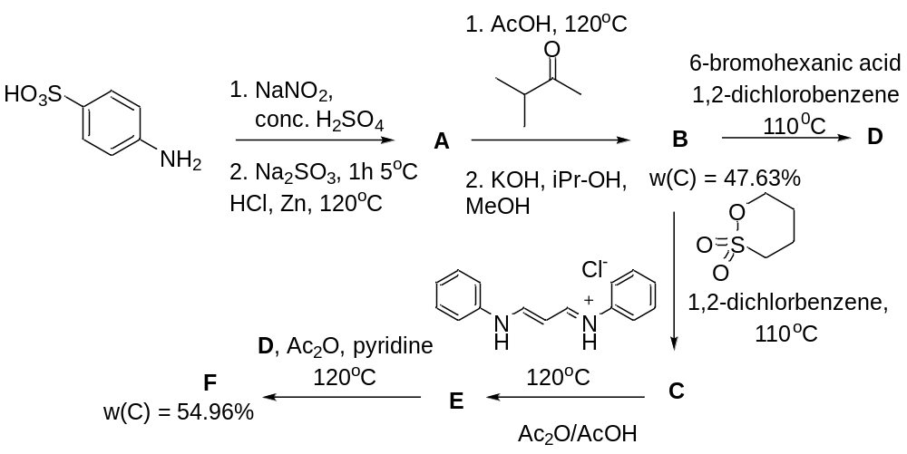
Fluorescein is another popular and historically important dye. In the 1800s, 80 tons of fluorescein were used to confirm that the Danube and Rhein river intersect each other. It can be prepared using one-step procedure. A fluorescein-structurally similar type of dye is rhodamine dye JF549, which is nowadays popular for live-cell microscopy.
2. Decode H, I and JF549; propose one-step synthesis of fluorescein from phthalic anhydride.
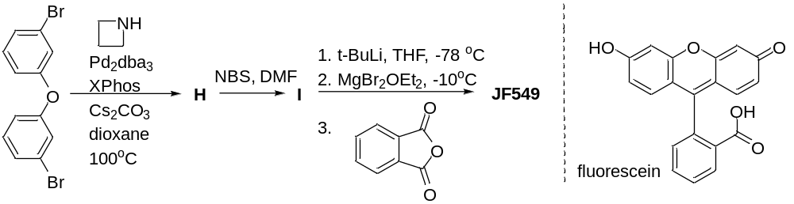
Attractive types of fluorophores are BODIPY and aza-BODIPY. The synthesis of the BODIPY used for bio-conjugation is given below.

3. Decode K, L and M and propose two step synthesis of aza-BODIPY from 2,4-diphenylpyrrole.
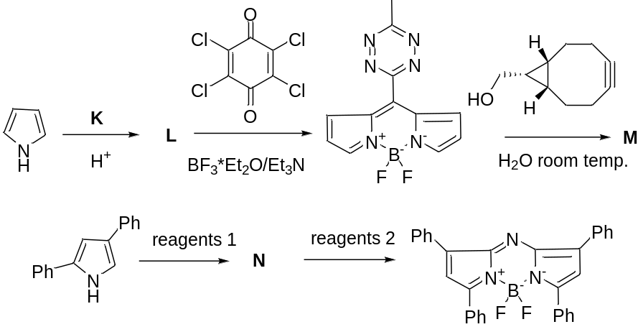

Physical chemistry
Problem 1
Isomerization cis-Me(en)₂Cl₂⁺ ⇆ trans-Me(en)₂Cl₂⁺ can be carried out according to the scheme: green A → violet B → green D → green A.
1. Decipher chlorides A and B if they contain 42% ethylendiamine (en), cation А has the element of symmetry I (center of inversion), but B has no such symmetry element.
Drew and Patt suggested that the Me‒N bond is broken during isomerization and D contains the en‒Н⁺ cation. But the XRD and ¹H NMR methods showed the presence of another cation in solid D − Н₅О₂⁺.
2. Decipher D, if after the loss of 10% HCl and H₂O, it turns into А.
Later, Brown established that an ion pair is formed during isomerization, and the observed constant (k_{obs}) at [Cl‒] > 0.1 mol⋅l^{‒1} does not depend on [Cl‒]. In 1965 Bosnich, Ingold and Tobe studied isomerization in СН₃ОН at 35°C, [Cl‒] = 0 - 0.1 mol⋅l⁻¹ and found that k_{obs} depends on [Cl‒] (Table).
[Cl‒]·10², mol⋅l^{‒1} | 0 | 0.5 | 1.0 | 5.0 | 7.5 | 10
k_{obs}·10³, min^{‒1} | 3.2 | 5.5 | 6.1 | 6.9 | 7.0 | 7.1
They proposed an equation k_{obs} = (k_{o} + k_{ip}K[Cl‒])/(1 + K[Cl‒]) describing the two stream mechanism of isomerization:
1st stream: cis-Me(en)₂Cl₂⁺ → trans-Me(en)₂Cl₂⁺ (k_{o});
2st stream: cis-Me(en)₂Cl₂⁺ + Cl‒ ⇆ cis-Me(en)₂Cl₂⁺,Cl‒ (K);
cis-Me(en)₂Cl₂⁺,Cl‒ → trans-Me(en)₂Cl₂⁺,Cl‒ (k_{ip});
trans-Me(en)₂Cl₂⁺,Cl‒ → trans-Me(en)₂Cl₂⁺ + Cl‒ (k₁).
3. Calculate k_{o}, k_{ip}, K using [Cl‒] = 0.5·10⁻² and 7.5 10⁻² mol⋅l^{‒1}.
4. State the conditions under which k_{obs} matches Brown’s data. Confirm this by calculating k_{obs} for [Cl‒] = 0.5 and 1.0 mol⋅l^{‒1}.
The calculated value of K turned out to be too large for an ion pair with z = |1|, overlooked by Bosnich, Ingold и Tobe. The value of K can be estimated from the equation
ΔG° = (z₊·z‒·e²·N_{A})/(4π·ε_{o}·ε·r) = ‒RTlnK, where e = 1.602·10^{‒19} C, ε_{o} = 8.854·10^{‒12} F⋅m^{‒1} − the electric constant, ε = 32 – the dielectric constant of СН₃ОН, r = 6.2·10^{‒10} m – distance between ions in a pair.
5. Calculate ΔG° and K for Me(en)₂Cl₂⁺,Cl‒ and Me(en)₂Cl²⁺,Cl‒ at 35°C and indicate which of K best describes the experiment.
The experimental results without changing the equation for k_{obs} can be described using the Me(en)₂Cl²⁺,Cl‒ ion pair and the complete dissociation of Me(en)₂Cl₂⁺ in the mechanism.
6. Suggest your own two stream mechanism if it is similar to the one proposed by Bosnich, Ingold and Tobe but with the ion pair Me(en)₂Cl²⁺,Cl‒.
7. Use the method of stationary approximations to derive an equation for k_{obs}, using the mole fractions of Me(en)₂Cl²⁺ and Me(en)₂Cl²⁺,Cl‒ and your mechanism.

Problem 2
The ionic model is based on the assumption that spherical ions with certain charges are located at the nodes of the crystal lattice. The model often works well even for polyatomic ions. A common cation of this kind is the ammonium ion NH₄⁺. The idea of the radii of polyatomic ions made it possible to introduce the theory of Kapustinsky, who in 1956 proposed a universal formula for the energy of the crystal lattice (T = 0 K):
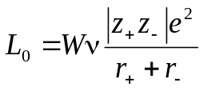, (1)
where ν − number of ions in one molecule, r± − ion radii, z± − charge numbers, e – elementary charge, W = 1.079⋅10⁵ kJ⋅pm⋅mol⁻¹ – constant.
Table 1. Enthalpies of formation of ammonium and rubidium salts, kJ⋅mol⁻¹
X⁻ | −Δ_{f}H°(NH₄X, s) |  |  |  |  | −Δ_{f}H°(RbX, s) |  |  |  |  | Difference
Cl⁻ | 314 |  |  |  |  | 435 |  |  |  |  | 121
Br⁻ | 271 |  |  |  |  | 394 |  |  |  |  | 123
I⁻ | 201 |  |  |  |  | 333 |  |  |  |  | 132
NO₃⁻ | 366 |  |  |  |  | 494 |  |  |  |  | 128
ClO₄⁻ | 295 |  |  |  |  | 434 |  |  |  |  | 139
Table 2. Crystalline radii of some ions, pm
Li⁺ |  |  | Na⁺ |  | K⁺ |  |  | NH₄⁺ |  | Rb⁺ |  |  | Cs⁺
74 |  |  | 102 |  | 138 |  |  | 146 |  | 149 |  |  | 170
Table 3. Enthalpies of formation of some compounds at 298.15 K, kJ⋅mol⁻¹
RbOH(s) |  | RbNH₂(s) |  | RbH(s) |  |  | NH₃(g) |  | NH₃⋅H₂O(l) |  |  | NH₄⁺(g) |  | Rb⁺(g)
−418.4 |  | −109.6 |  | −47.7 |  |  | −46.1 |  | −361.2 |  |  | 619 |  | 490
Table 1 compares the enthalpies of formation of a number of ammonium salts and their rubidium analogues. It can be seen that the difference is almost constant, and with a good approximation we can assume that it is equal to 128 kJ⋅mol⁻¹.
1. Analyzing equation (1) and the data in Table 2, explain why a constant difference is not observed when comparing ammonium and sodium salts.
2. a) Calculate Δ_{f}H°(298.15 K) of the solid ammonium compounds NH₄⁺OH⁻, NH₄⁺NH₂⁻ and NH₄⁺H⁻, using the above difference and the data in Table 3;
b) Which compounds are unstable with respect to their constituent elements?
3. For the three compounds in question 2, predict a reasonable decomposition path at 298.15 K other than decomposition into elements, and calculate Δ_{r}H° of the corresponding reactions using the data in Table 3.
At 194.2 K molar mixture (1 : 1) water and ammonia solidifies to form a hydrate NH₃⋅H₂O (melting temperature 201.7 K). At 110 K crystals of this hydrate belong to the rhombic (orthogonal) system corresponding to the point group D_{2h}. Unit cell parameters: a = 451 pm, b = 558.7 pm, c = 970 pm with four molecules NH₃⋅H₂O per unit. It is known that the molar volume NH₄⁺OH⁻(s) at 110 K equals to 27.8 cm³⋅mol⁻¹.
4. a) What is the geometric shape of the cell (draw)?
b) Specify the location of nodes in the drawing;
c) For reaction NH₃⋅H₂O(s) = NH₄⁺OH⁻(s) calculate the change in molar volume Δ_{r}V_{m} (cm³⋅mol⁻¹) at 110 K.
According to literature data Δ_{f}H°(NH₃⋅H₂O, s, 110 K) = −368.9 kJ⋅mol⁻¹.
5. Assuming that Δ_{f}H°(NH₄⁺OH⁻, s) is independent of temperature, use the estimation from question 2 to calculate Δ_{r}G° of the reaction NH₃⋅H₂O(s) = NH₄⁺OH⁻(s) at 110 K. Accept Δ_{r}S° = 0.
6. Assuming that ΔV_{m} calculated in question 4, is independent of pressure, determine the pressure at which NH₄⁺OH⁻(s) becomes the stable phase at 110 K. Use the relation dG = −SdT + VdP and the result from question 5. If you have no solvution of this question, write a formula for the isothermal change in Δ_{r}G° with increasing pressure by ΔP.
7. On which planets of the Solar system can a stable phase NH₃⋅H₂O(s) exist under natural conditions?
Mercury Venus Earth Mars
Jupiter Saturn Uranus Neptune

There are some estimates of the stability of metallic ammonium NH₄(s). For example, the enthalpy of the process NH₄(s) = NH₄⁺(g) + e⁻(g) Δ_{r}H° = 500 kJ⋅mol⁻¹ is estimated.
8. a) Use this result to calculate Δ_{f}H°(NH₄, s); b) Determine Δ_{r}H° of reaction
NH₄(s) = NH₃(g) + ½H₂(g) and determine whether the metal is stable under standard conditions (25°C, 1 atm); c) How will the answer change if the entropy factor is taken into account for the reaction.
Physical constants: Avogadro’s number N_{A} = 6.022⋅10²³ mol⁻¹; standard atmosphere P° = 101325 Pa.

Problem 3
Carbon nanoparticles (CNP) exhibit pronounced fluorescence. Upon absorption of UV radiation, they pass into excited state, and the reverse transition into the ground state is accompanied by emission of visible-range light. Part of the absorbed energy is lost in the nonradiative processes.
1. A CNP sample emits light with wavelength 550 nm upon excitation with 365 nm light. Calculate a) the energy difference between the ground and excited states of the CNP and b) fraction of energy lost in the nonradiative processes.
Intensity of CNP fluorescence is changed upon binding of heavy metal ions, which allows the use of CNP for their sensing and determination. Intensity of the CNP fluorescence (F) measured in the presence of different concentrations of mercury(II) is given below.
c_{Hg}, nmol⋅L⁻¹ | F, arb.un.
0 | 12000
10 | 11483
30 | 10573
60 | 9449
90 | 8541
2. Assuming that the fluorescence intensity follows the Stern–Volmer equation
$\frac{F(c_{Hg}=0)}{F(c_{Hg})}=1+K_{SV}c_{Hg}$, calculate the quenching constant K_{SV}.
3. Calculate the limit of mercury(II) detection using the above method assuming that accuracy of measurement of F is 5%.
In another experiment, it was determined that intensity of the CNP fluorescence was decreased by 40% of the initial value upon addition of an iron(III) salt. In that case, the fluorescence was weakened due to absorption of the exciting light by iron(III) ions, not due to their interaction with CNP.
4. Assuming that fluorescence intensity is directly proportional to intensity of the exciting light, and the light absorption by aqua complexes of iron(III) obeys the Beer’s law ( = 2000 L∙mol⁻¹∙cm⁻¹at  = 365 nm), determine the concentration of iron(III) in the solution. Consider that the intensity of the emitted light was measured at direction perpendicular to the exciting light direction and the optical cell was a cylinder with diameter of 2 cm.
To eliminate the influence iron(III), it was bound in a colorless citrate complex. The resulting intensity of fluorescence was 97% of the initial value for CNP in the absence of iron.
5. Calculate the amount of citric acid added to 100 mL of the sample if the solution pH was 3.8 and the stability constant of the complex prevailing under those conditions, Fe(OH)(Citr), is 10^{8.5}.
6. Calculate the limit of the mercury(II) detection in the presence of iron(III) ions masked with citric acid as described above.
Another possibility to mask iron(III) is its binding into colorless fluoride complex. However, fluoride ions also react with mercury(II) which makes its determination impossible.
7. Write the reaction between fluoride ions and mercury(II) in an aqueous solution.
Reference data: $E=\frac{hc}{λ}$, h = 6.63∙10⁻³⁴J∙s, $A=εlc$
Inorganic chemistry
Problem 1
The silver-white metal M tarnishes in air, becoming covered with a black film. M dissolves well in acids, for instance, in formic acid to form M(+1) formate. A solution of a mixture of M(+1) formate and M(+1) malonate was first obtained by the Italian geologist E. Clerici. This liquid has a high density, which is highly dependent on the composition of the solution and temperature. This allowed the solution to be used in mineralogy to determine the density of minerals and separate them. The refractive index of such solution depends almost linearly on the density (g/cm³): n = 0.1152·d + 1.2078.
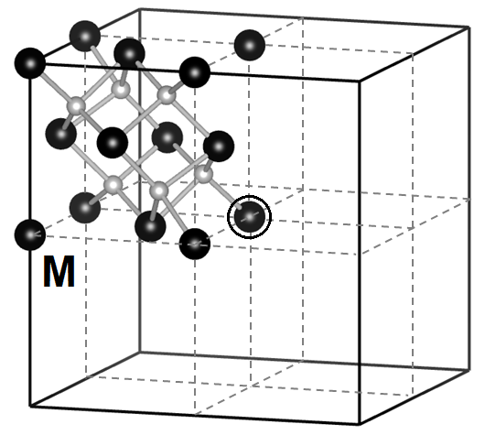
- Calculate the density of the Clerici solution if the measured refractive index is n = 1.6305. From the minerals hereunder, select those that will float on the surface of such solution:
garnet (3.48 g/cm³), spinel (3.72 g/cm³), corundum (4.10 g/cm³), quartz (2.62 g/cm³), diamond (3.55 g/cm³), mirabilite (1.49 g/cm³).
If an ammonium sulfide solution is added to a solution of M(+1) formate, a black precipitate A will form. In addition to the basic oxidation state +1, compounds can also be obtained in a higher oxidation state, which is unstable. Thus, the oxidation of M(+1) nitrate with chlorine in an alkali results in the formation of dark brown oxide B, which has a centrosymmetric cubic unit cell. The figure shows 1/8 part (octant) of an elementary cell, the center of the cube is separately highlighted - it is also the center of inversion.
- Calculate the gross composition of B, and the number of formula units in one elementary cell.
When B reacts with a concentrated solution of hydrochloric acid, a yellow-green gas is emitted and a solution is formed, upon dilution of which a white precipitate of salt C precipitates. Salt C can be oxidized with chlorine to a higher chloride – D. When a mixture of a concentrated solution of D and precipitate C is heated, a chemical reaction occurs. On slow cooling, lemon-yellow crystals of substance E (ω(Cl) = 20.7%) crystalizes from the solution.
- Identify all unknown substances M, A – E, and also write down the equations of chemical reactions.
- Indicate the real composition of E and write the equation for its electrolytic dissociation in water.
- Arrange in a row in order of increasing electrical conductivity aqueous solutions of E, NaCl and CaCl₂ of the same concentrations. Assume that the degree of dissociation of all salts is 100%.
An alternative way to obtain E is the oxidation of C with ozone in POCl₃. However, if brownish-yellow poisonous gas F (density is 3.88 at N.C.) is used as an oxidizing agent, POCl₃ also participate in the reaction to form G (ω(P) = 15.35 %). The M cation in G is in an octahedral environment. G has a molecular structure, has two optical isomers, and no geometric isomers.
- Set the composition of F and G, write down the reaction equations, and also draw the structure of the G molecule. It is known that only two elements change their oxidation states in the reaction of obtaining G.
- Suggest a method for obtaining F gas.

Problem 2
As it turned out, "pyrophoric iron" is actually not even iron at all. It has been shown that the process of its production includes in several stages. The products composition on each stage depends on the temperature, composition of the gas atmosphere, and etc. In the problem we will consider the processes that occur when dried precipitate A, obtained by mixing aqueous solutions of ferrous sulfate and potassium oxalate, is heated in an evacuated sealed reactor in an atmosphere of its decomposition products. On the first stage (at 170-230 ^{о}С) А loses about 20 % of its mass and converts to B.
- Write down the equation of the reaction conversion A to B.
On the second stage (at 230-360 ^{о}С) B partially decomposes producing gaseous mixture and substance C with the mass of about 53.5 % from that of decomposed part of B. At 360-415 ^{о}С undecomposed part of B reacts with one of the components of the gaseous mixture to form a solid binary substance D, whose mass is approximately on 58 % less the mass of decomposed part of B.
- Establish the formulas of C and D and write down the equations of the reactions taking place on the second stage.
At the third stage (415–535 °C) partial decomposition of D leads to elementary substances. Above 535 °C substance C transforms into the final pyrophoric product E.
- Write down the equations of the reactions taking place in the third stage.
The solid final product has the NaCl structure and a non-stoichiometric composition. The mass fraction of oxygen in one of the investigated samples of E is equal to 23.36 %, and its density is equal to 5.70 g/cm³.
- Establish the possible formulas of the investigated non-stoichiometric Е.
- Establish the formula of the investigated sample Е, if according to X-ray data unit cell parameter is equal to 0.4307 nm.

Problem 3
The compounds of metal М in uncharacteristic oxidation state (ox. st. = +n) are the strong oxidants, oxidizing even Н₂О in an acidic media: М^{n+} + (n‒2)ē = М^{(n-1)+} E₁⁰ =1.52 V;
O₂ + 4H⁺+4ē = 2Н₂О E₂⁰ =1.23 V.
In high-spin complexes М^{n+} (µ = [2S (2S + 2)]^{1/2} = 4.90 μ_{B}, where S ‒ total spin) О‒donor ligands (L), including О^{2‒}, stabilize М^{n+}. Thus, when alkali is added to the М^{(n-1)+} solution, 4.45 g of a slightly pinkish precipitate first forms, which eventually loses 0.45 g of H₂O and turns into 4.40 g of a brown precipitate containing the stabilizing group MO and М^{+n}.
1. Calculate n, the number of unpaired electrons at М^{n+} and give two possible variants of valence electrons at М. Decoding metal М.
2. Estimate difference of logarithms of formation constants
β_{х} (М^{n+} + хL‒ = МL_{х}^{(n-х)+}) and β_{y} (М^{(n-1)+} + хL‒ = МL_{х}^{(n-х-1)+}), sufficient to prevent oxidation
МL_{х}^{(n-х)+} + Н₂О.
Bridging O,О‒donor CH₃COO‒ forms polynuclear complexes with formula М_{a}О_{b} and stabilize uncharacteristic oxidation state (ox. st.), including mixed. In 1987 Vincent obtained a brown solution from solution M(CH₃COO)_{n‒1}·4H₂O (7.35 g) in mixture of C₂H₅OH, pyridine (Py) and CH₃COOH by under the action of (Bu₄N)МО₄, then using NaClO₄ solution he isolated brown crystals of АClO₄ (yield 60 %). When evaporating the solution of АClO₄ in CH₃CN he isolated black crystals В (3.01 g, yield 65 %). Compositions of carboxylates А⁺ and В are the same, the whole M is in М_{a}О_{b}, and ν_{CH3COO‒} = 2ν_{М} = 2ν_{Py}. In М_{a}О_{b} all angles are close to 120º, and the bond distances l_{М‒О} are equal to 1.83 Å in А⁺; 1.82 Å and 2.15 Å in В.
3. Calculate a and b, decoding А⁺ and В and specify ox. st. of M in them. Write down ionic equation of formation of А⁺ in brown solution. Draw structure of М_{a}О_{b} in complex В.
When produced crystals dissolve in CH₃CN, then acting by bipyridine (bipy) the whole Py in them is equimolarly replaced by bipy and a day later from a solution АClO₄ red crystals of DClO₄ isolated, and dark-red crystals E isolated from solution В, both have group М_{d}О_{2b} in composition.
4. Decoding formula D⁺ (19.4 % mass. М; 7.41 % N; 22.6 % O) and E (20.5 % mass. М; 7.82 % N ; 20.9 % O). Define ox. st. of М in them.
5. Draw structure of fragment М_{d}О_{2b}, if both in D⁺, and in E it is based on a polygon with l_{М‒О} = 1.88 Å and angles МОМ 97º and ОМО 83º. In E planar fragment М_{d}О_{2b} has bonds with l_{М‒О} = 2.10 Å, included in angles О…ОМ 180º, and in D⁺ non-planar fragment М_{d}О_{2b} included in angles О…ОМ 130º . E has inversion center, but not D⁺.

Life sciences and polymers
Problem 1
Compounds containing an element X are toxic for mammals. Still, these can be involved into metabolic processes in a number of marine microorganisms. An acid H₃A is the major X containing substance in sea water.
1. Deduce the prevailing form of H₃A (pK_{a1}=2.22, pK_{a2}=6.98, pK_{a3}=11.53) in sea water at pH~8. Prove by calculations.
In cells, H₃A undergoes transformation involving seven successive enzymatic reactions finally leading to the formation of the substance B (62.42% of X by mass). After each step, the oxidation state (OS) of the sole atom of X present in the metabolite changes (either increases or decreases) be two, i.e. |ΔOS_{X}|=2. The total sum of OS values of X in all the compounds within the H₃A→B pathway (including the starting and final ones) equals 32.
2. Deduce all theoretically possible OS values of X in H₃A. Note that any of deduced values must be found in three (beside H₃A) metabolites.
3. Based on the above information, decide in which group(s) of the Periodic table of elements one can find X, if odd OS values are characteristic of it.
Organic acids C and D are neighboring intermediates of the H₃A→B pathway. The information about C and D is given in the table.
Compound | Mass fraction of X, % | Molar fraction of X, %
С | 61.41 | 9.09
D | 54.29 | 8.33
4. Deduce the structures of С and D.
The number of the involved enzymes is significantly lower than that of reactions within the H₃A→B pathway.
5. Draw the H₃A→B pathway, giving the structures of all the compounds.
The H₃A acid enters the intracellular space of marine microorganisms via the transmembrane channel, which is mainly responsible for the transport of a vitally important compound E from the sea water.
6. Propose the molecular formula of E.
An X containing drug Y used to cure tsetse-fly disease has been developed in early 20th century. The one-step process affording Y was based on the reaction of the compound Z (С₆H₆O₆NX) with sodium dithionite. Z is a polysubstituted benzene. Numerical locants of each substituent in the benzene ring of Z were multiplied by the atomic number of the element, atom of which is directly linked to the carbon atom of the benzene ring. The total sum of the products equals 86.
7. А) What atoms can be involved in bond formation with the C atoms of the benzene ring;
В) Prove that Z contains the С-N and/or С-X bonds. Note that this question is independent of the answers to the previous ones.
8. Deduce the structure of Z, if it contains the С-X bond.
It was commonly agreed that Y has the structure with the molecular weight of 366 g/mol (Y₁). However, recent mass spectrometry studies that it is not completely true: the peaks of the protonated molecule ([Y+H]⁺) prevailing in the spectrum have m/z of 550 (Y₂) and 916 (Y₃)
9. Draw the structures of Y₁-Y₃, if in each of these the atoms of X are equivalent.

Problem 2
The carcinogenic compound X is the final product of biodegradation of hundreds of substances used by man, including those affording better results of athletes. In June 2021, the International Ski and Snowboard Federation as well as International Biathlon Union imposed a ban on any products containing X.
Bacterial biodegradation of an organic compound A by P. oleovorans affording X is shown on the Scheme. The numerical designation for the substances of this class as well as the molecular masses rounded to integer (g/mol, after the comma) are given next to the metabolite symbols. All the reactions in the Scheme are catalyzed by enzymes; each of the unbranched compounds A-G contain no more than 15 carbon atoms.
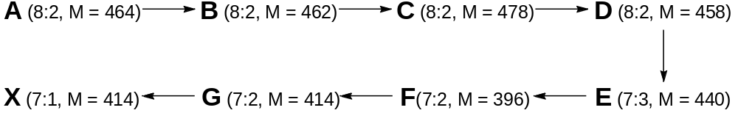
1. For the A→C transformation, propose two sets of interconverting functional groups (fragments of the molecules), if the changes of the molecular masses within A-C are only due to biotransformation of these groups.
E is the only substrate of the enzyme catalyzing the E→F step, the other product (beside F), being a gaseous (under normal conditions) substance.
2. Determine the molar fraction of carbon (in % with the accuracy to integer) in D, E, and F, if it is one and the same for all the three compounds.
3. It is possible to unambiguously calculate the degree of unsaturation of F (by contrast to that of D) based on the above information. Perform the calculation.
In each of the C→D and D→E transformations, the number of atoms of only two elements (El₁ and El₂) is changed. D is composed of atoms of four elements.
4. Decipher El₁ and El₂, if A_{r}(El₁)>A_{r}(El₂). Prove by calculations.
5. Determine the molecular formulae of A-F.
One can disclose the principles behind the system of numerical designations of the compounds of this class based on the analysis of the molecular formulae of A-F (8:2, 7:3, and 7:2).
6. Demonstrate the principles by writing the designation of any structural isomer of A.
The oxidation of G leading to X is catalyzed by several successively acting enzymes.
7. Draw all possible structures of A, D-G, and X (without stereochemical details).
8. Choose the statements explaining the reasons for using the X derivatives (mostly esters) at skiing competitions and why their use should be prohibited:
The reason for using X
The ingestion of the X derivatives contributes to an enhanced endurance of athletes in cyclic sports including cross-country skiing (doping)
The ingestion of the X derivatives contributes to a lowered arm tremor in biathlon shooting and skate skiing (doping)
The X derivatives are used as ski waxes
The X derivatives are used to prepare a ski-track profile
The reason for banning X
X is not subjected to biodegradation due to its structural distinction, thus being accumulated in water and soil and penetrating in mammals with food
X being subjected to bacterial biodegradation in soil produces a colorless gas (at STP) toxic for mammals
X being subjected to bacterial biodegradation in soil produces a colored gas (at STP) toxic for mammals
Penetrating in atmosphere, X contributes to ozone depletion as a part of the Earth stratosphere

Problem 3
A novel metabolic pathway affording unusual α-amino acids 4 and 7 in Streptomyces cattleya was reported in Nature in 2019. The scheme leading to these substances from the canonical amino acid lysine (Lys, see structure below) is shown hereunder:

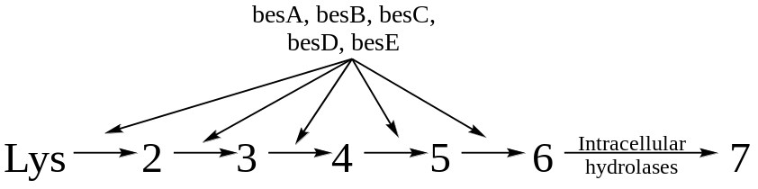

The bacterial genome contains a cluster of genes (besA-besE) encoding the enzymes of the pathway. To determine the enzyme sequence, the researchers designed bacterial lines with knockout genes (ΔbesA-ΔbesE) by deleting a single gene of the cluster in each line (denoted by Δ). This led to the following metabolic changes in the lines lacking specific enzymes. The relative quantities (0 to 10) of 2-7 found in each line are given hereunder.

 | 2 | 3 | 4 | 5 | 6 | 7
ΔbesA | 0 | 0 | 10 | 4 | 4 | 10
ΔbesB | 0 | 10 | 0 | 0 | 0 | 0
ΔbesC | 10 | 0 | 0 | 0 | 0 | 0
ΔbesD | 0 | 0 | 0 | 0 | 0 | 0
ΔbesE | 0 | 0 | 8 | 10 | 0 | 0

1. Decipher the sequence of action of the enzymes besA-besE.

2. Choose one correct statement concerning the metabolic pathway:
1. | The reaction catalyzed by the enzyme besA can also be catalyzed by non-specific γ-glutamyl transpeptidases
2. | The relative content of a metabolite equal to 0 indicates that the rates of its formation and consumption are equal
3. | Accumulation of the metabolites 4 and 5 in the ΔbesA line suggests that besA uses both metabolites as its substrate
4. | Addition of a solution of the metabolite 2 to the ΔbesD line will result in a stable increase in the relative content of 2

The detailed scheme (all steps are chemical equations) affording 4 and 7 is given below:

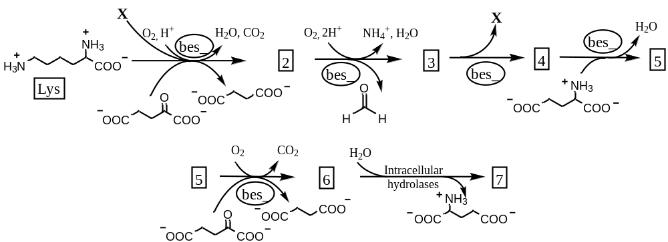

The mass spectrum (A) and ¹H NMR spectrum (B) were recorded to identify 2: 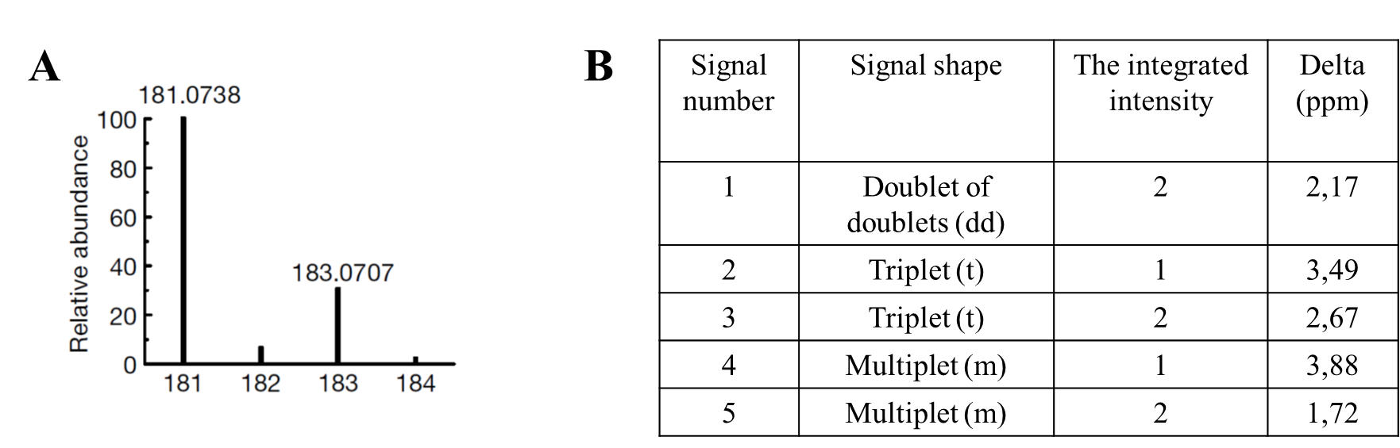
3. Determine X and 2. Draw the structure of 2.
4. Calculate (in % to the nearest integer) the ratio of intensities referring to the peaks of the protonated molecule ([2+H]⁺) with m/z of 181 and 183.
5. Draw the structures of 3-7.

While studying the 2 → 3 reaction, the substrate concentration was found to start decreasing before introduction of the enzyme. It turned out that 2 is capable of non-enzymatic cyclization via nucleophilic substitution giving lactone 8 and lactam 9.

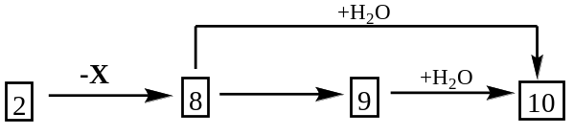
6. Draw the structures of 8-10.
The ammonia solution of acetoacetone was used to detect the formaldehyde produced in the transformation of 2 to 3. The solution taken in the molar ratio of 2:1 to formaldehyde, it affords a symmetric heterocyclic fluorescent product Y (С₁₁Н₁₅NO₂) via a number of condensation:
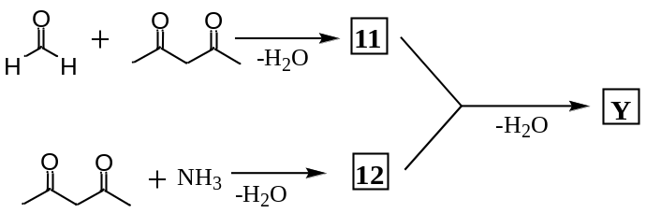
7. Draw the structures of 11, 12, and Y.

Analytical chemistry
Problem 1
For the extraction-photometric determination of the concentration of mercury in an aqueous solution, a certain amount of a mercury(II) salt and 1 mL of 0.5 M potassium bromide are added to a separating funnel, some acid is added, and the aqueous phase is brought to 10 mL with water (solution 1). Then, 10 mL of 0.001 M toluene solution of tri-n-octylammonium methyl orangeate was added followed by shaking. After phase separation (extract 2, aqueous solution 3), the concentration of mercury in solution 1 is determined by the light absorption of methyl orange released into aqueous phase 3 after adding 1 mL of 1 M NaOH.
1. Write down the equation for the ion-exchange extraction reaction. Designate the tri-n-octylammonium cation as R₃NH⁺, the methyl orange anion as MO–; consider that mercury is extracted in the form of a singly charged tribromide complex. Indicate the phase in which the compound is located in the subscript: _{(о)}, _{(aq)}.
2. KBr is added in a large excess to prevent an undesired reaction; write its equation.
3. Mercury is determined by the light absorption of the red or the yellow form of methyl orange? Which of the substances mentioned in the task indicates this?
4. If a preparation of tri-n-octylammonium methyl orangeate contains an admixture of free tri-n-octylammonium, then the result of mercury determination will be: a) still correct, b) overestimated, c) underestimated. Write the equation for the reaction(s) involving tri-n-octylamine (R₃N).
5. Copper(II) is extracted by 10% with the same reagent R₃NH⁺МО– in the form of anion CuBr₃–. What absolute error in the determined concentration of mercury in solution 1 should be introduced by the presence of 1·10^{–5} М copper in it?
6. To experimentally determine the error introduced by the presence of copper, organic extract 2 was shaken with 10 mL of a 0.05 M KBr solution and the concentration of copper in the resulting aqueous solution 4 was determined by another method, obtaining a value of 2.0·10^{–6} M. Assume that the distribution of copper between the phases depends only on the concentration of ammonium salt in the organic phase, which does not change.
a) Write the equation for the process that occurs when extract 2 is washed.
b) What was the concentration of copper in solution 1?
Assume that all extraction equilibria are established quickly.
7. In tasks 1–6, you should have neglected the side process, which is now proposed to be taken into account: R₃NH⁺МО–_{(о)} + Br–_{(aq)} = R₃NH⁺Br–_{(о)} + МО–_{(aq)}
What should be the equilibrium constant of this reaction K₁ so that the error in the determination of 5·10^{–6} M mercury in the aqueous phase would not exceed 5%? Consider that the extraction of mercury proceeds completely, copper(II) and free R₃N are absent, and trioctylammonium bromide is formed only by the indicated reaction.

Problem 2
For applying bronze coatings, electrolytes containing tin(II and IV) and copper(II) salts, hydrochloric acid, and some additives described below are used. The concentration of Sn(II) in these solutions is determined by iodatometric titration.
1. At the beginning of titration with iodate, the solution turns brown. Write down the equation for this reaction.
2. By the end of titration, all the iodine has converted to iodine monochloride and the solution becomes light green.
a) Write the final equation for the tin(II) titration reaction.
b) Which substance(s) determine(s) the yellow-green color of solution at the titration end point?
3. The components of the electrolyte would enter some undesirable reactions with each other if tin were not bound into an oxalate complex. Write down:
a) the undesired reaction and
b) the complexation reaction if a doubly charged oxalate complex is formed. Oxalate is not oxidized with iodate under these conditions.
c) When oxalic acid is added to a weakly acidic electrolyte, not only the tin oxalate complex is formed, but also a blue precipitate, soluble in a large excess of oxalate. Write down the equations for the formation and dissolution of this precipitate.
4. To determine tin(IV), it is reduced to tin(II) with aluminum granules and titrated as described above.
a) Due to the side reaction in which aluminum enters, it is required to introduce its excess. Write down the side reaction.
b) In parallel with the reduction of Sn(IV) contained in the electrolyte by aluminum, a soluble copper-containing product P is formed. Write down the equation for this reaction (copper is in excess).
c) How can the formation of product P be experimentally detected by a chemical method? Write down one reaction equation.
d) Product P will interfere with the determination of tin(II) by the titrimetric method. Confirm this by writing down the equation for the reaction involving product P.
e) Which of the reactions that you should have written above can be used as the basis for a method for eliminating the interfering effect of copper(II) on the determination of tin(IV) due to the formation of product P? Write it down.
5. Calculate the concentrations of tin(II) and tin(IV) in the electrolyte, if 7.2 mL of a 0.0500 M potassium iodate solution was used to titrate 10.00 mL of the electrolyte without reduction, and the same volume of iodate was used to titrate a 5.00 mL aliquot after reduction with aluminum. (If any precipitates formed, they were separated before titration.)

Problem 3
The salt Na₂X is well soluble in water and forms yellow solutions. When acid is added to such a solution, the color changes to orange. The original yellow color can be returned by adding an alkali. It is assumed that the transition in an acidic medium is carried out according to the following mechanism:
X^{2–} + H⁺ ⇄ Y– (K₁) 2Y– ⇄ Z^{2–} + H₂O (K₂)
1. Give the structural formulas of anions X^{2–}, Y–, and Z^{2–}.
2. Write the total reaction equation for the transition of X^{2–} into Z^{2–}. Express the corresponding equilibrium constant K₃ in terms of the equilibrium constants of the individual steps K₁ and K₂.
3. Does the mole fraction of X^{2–}, Y–, and Z^{2–} species at a certain pH value depend on the initial concentration (с₀) of Na₂X? Confirm your answer by: a) expressing the equilibrium concentration of Y– ([Y–]) in terms of с₀, [H⁺] and equilibrium constants; b) getting the expression for the mole fraction of Y– in terms of [Y–].
For the spectrophotometric determination of K₃, the transmittance (T = 10^{–A}·100%,
A – absorbance) was measured for the solutions of 1.50·10^{–4} M Na₂X at various pH values and wavelengths 352 (λ₁) and 373 nm (λ₂) in cuvettes with an optical path length l = 1 cm.
pH | T₁, % | T₂, %
1.0 | 59.7 | 68.1
6.0 | 49.3 | 41.9
11 | 32.3 | 15.9
4. Calculate the molar extinction coefficients (ε_{λ} = A/(lc), c – molar concentration) for X^{2–} and Z^{2–} at 352 и 373 nm. Specify the units. As an approximation in solving this question, assume that the concentration and absorbance due to the intermediate species Y– are negligible.
5. Calculate the equilibrium constants K₁, K₂, and K₃.
Hint: You can use the intermediate results in question 5 to check the expression you got in question 3.

