From Wikipedia, the free encyclopedia

In [numerical linear algebra](http://en.wikipedia.org/wiki/Numerical_linear_algebra), the **tridiagonal matrix algorithm**, also known as the **Thomas algorithm** (named after [Llewellyn Thomas](http://en.wikipedia.org/wiki/Llewellyn_Thomas)), is a simplified form of [Gaussian elimination](http://en.wikipedia.org/wiki/Gaussian_elimination) that can be used to solve [tridiagonal systems of equations](http://en.wikipedia.org/wiki/Tridiagonal_matrix). A tridiagonal system for *n* unknowns may be written as

where  and .

For such systems, the solution can be obtained in  operations instead of  required by [Gaussian elimination](http://en.wikipedia.org/wiki/Gaussian_elimination). A first sweep eliminates the 's, and then an (abbreviated) backward substitution produces the solution. Examples of such matrices commonly arise from the discretization of 1D [Poisson equation](http://en.wikipedia.org/wiki/Poisson_equation) (e.g., the 1D[diffusion problem](http://en.wikipedia.org/wiki/Heat_equation)) and natural cubic [spline interpolation](http://en.wikipedia.org/wiki/Spline_interpolation); similar systems of matrices arise in [tight binding physics](http://en.wikipedia.org/wiki/Tight_binding) or [nearest neighbor](http://en.wikipedia.org/wiki/Nearest_neighbor) effects models.

Thomas' algorithm is not [stable](http://en.wikipedia.org/wiki/Numerical_stability) in general, but is so in several special cases, such as when the matrix is [diagonally dominant](http://en.wikipedia.org/wiki/Diagonally_dominant) or [symmetric positive definite](http://en.wikipedia.org/wiki/Symmetric_positive_definite);[[1]](http://en.wikipedia.org/wiki/Tridiagonal_matrix_algorithm#cite_note-Niyogi2006-1)[[2]](http://en.wikipedia.org/wiki/Tridiagonal_matrix_algorithm#cite_note-Datta2010-2) for a more precise characterization of stability of Thomas' algorithm, see Higham Theorem 9.12.[[3]](http://en.wikipedia.org/wiki/Tridiagonal_matrix_algorithm#cite_note-Higham2002-3) If stability is required in the general case, [Gaussian elimination](http://en.wikipedia.org/wiki/Gaussian_elimination) with [partial pivoting](http://en.wikipedia.org/wiki/Partial_pivoting)(GEPP) is recommended instead.[[2]](http://en.wikipedia.org/wiki/Tridiagonal_matrix_algorithm#cite_note-Datta2010-2)

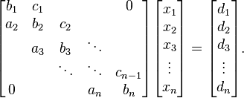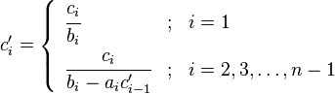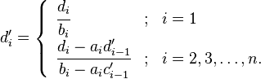未命名:private:var:folders:nn:jvkbyw3n2r1_jkwky3tyrz_40000gn:T:TemporaryItems:447fa09a1cd3798610131a736da3375e.png未命名:private:var:folders:nn:jvkbyw3n2r1_jkwky3tyrz_40000gn:T:TemporaryItems:a9251786d6b75944cf7f336497bc7c64.png