# A fuel consumption study of Stata’s auto dataset

We conduct a study of the fuel consumption of cars in Stata’s auto dataset.

. sysuse auto, clear

(1978 Automobile Data)

## Perform data transformation

We generate a variable, **fuel**, that measures the fuel consumption rate in the unit of Gallons per 100 Miles.

. generate fuel = 100/mpg

. label variable fuel "Fuel consumption (Gallons per 100 Miles)"

We use Gallons per 100 Mile which is a better measurement than Miles per Gallon. Going from a 10 Miles per Gallon car to a 20 Miles per Gallon car saves 5 Gallons per 100 Miles when Miles per Gallon increases 10. Going from a 20 Miles per Gallon car to a 40 Miles per Gallon car *only* saves 2.5 Gallons per 100 Miles when Miles per Gallon increases 20.

## Examine the variables

We examine variables for possible errors in the data.

. describe fuel weight

storage display value

variable name type format label variable label

--------------------------------------------------------------------------------

fuel float %9.0g Fuel consumption (Gallons per 100

Miles)

weight int %8.0gc Weight (lbs.)

. summarize weight

Variable | Obs Mean Std. Dev. Min Max

-------------+---------------------------------------------------------

weight | 74 3019.459 777.1936 1760 4840

The variable **weight** has minimum value 1760.00, maximum value 4840.00, and range 3080.00.

## Plot fuel consumption and vehicle weight

. twoway lfitci fuel weight || scatter fuel weight, mcolor(%20) scheme(538)

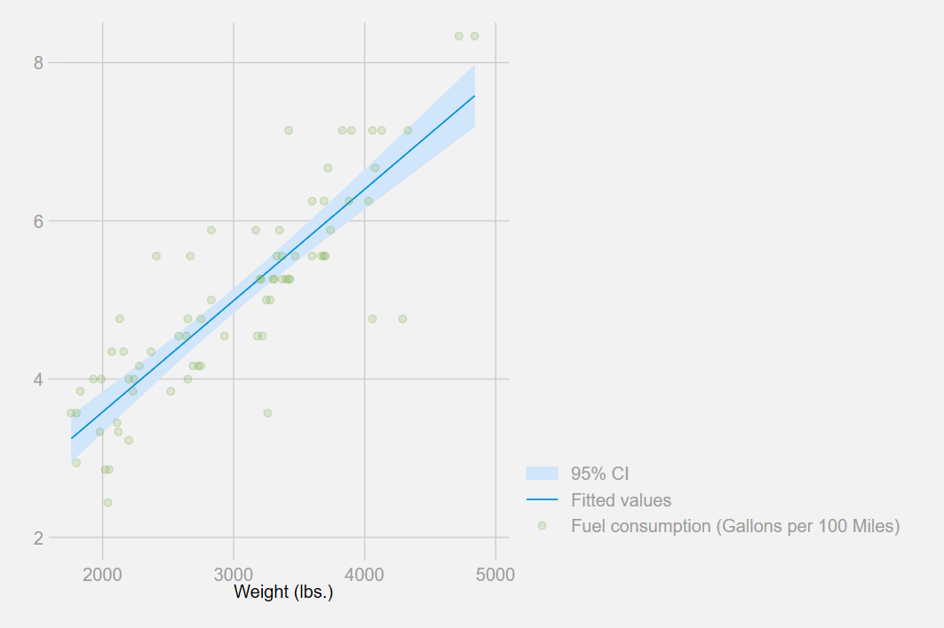

## Explore relationship between fuel consumption and vehicle weight - linear regression

. regress fuel weight

Source | SS df MS Number of obs = 74

-------------+---------------------------------- F(1, 72) = 194.71

Model | 87.2964969 1 87.2964969 Prob > F = 0.0000

Residual | 32.2797639 72 .448330054 R-squared = 0.7300

-------------+---------------------------------- Adj R-squared = 0.7263

Total | 119.576261 73 1.63803097 Root MSE = .66957

------------------------------------------------------------------------------

fuel | Coef. Std. Err. t P>|t| [95% Conf. Interval]

-------------+----------------------------------------------------------------

weight | .001407 .0001008 13.95 0.000 .001206 .0016081

_cons | .7707669 .3142571 2.45 0.017 .1443069 1.397227

------------------------------------------------------------------------------

The regression shows that for every unit increase in weight, a 0.0014 unit increase in fuel consumption is predicted.

## Produce an HTML table from regression results

. _coef_table, markdown

| **fuel** | **Coef.** | **Std. Err.** | **t** | **P>|t|** | **[95% Conf. Interval]** | |
| --- | --- | --- | --- | --- | --- | --- |
| weight | .001407 | .0001008 | 13.95 | 0.000 | .001206 | .0016081 |
| _cons | .7707669 | .3142571 | 2.45 | 0.017 | .1443069 | 1.397227 |

## Produce a table from **estimates table**

. quietly regress fuel weight gear turn

. estimates store model1

. quietly regress fuel weight gear turn foreign

. estimates store model2

. estimates table model1 model2, b(%7.4f) stats(N r2_a) star

----------------------------------------

Variable | model1 model2

-------------+--------------------------

weight | 0.0014*** 0.0013***

gear_ratio | 0.1706 -0.3367

turn | 0.0243 0.0613

foreign | 0.8650***

_cons | -0.5814 -0.4661

-------------+--------------------------

N | 74 74

r2_a | 0.7218 0.7637

----------------------------------------

legend: * p<0.05; ** p<0.01; *** p<0.001

. estimates table model1 model2, varlabel b(%7.4f) stats(N r2_a) star markdown

| **Variable** | **model1** | **model2** |
| --- | --- | --- |
| Weight (lbs.) | 0.0014*** | 0.0013*** |
| Gear Ratio | 0.1706 | -0.3367 |
| Turn Circle (ft.) | 0.0243 | 0.0613 |
| Car type |  | 0.8650*** |
| Constant | -0.5814 | -0.4661 |
| N | 74 | 74 |
| r2_a | 0.7218 | 0.7637 |

legend: * p<0.05; ** p<0.01; *** p<0.001

## Produce a table from community-contributed **esttab**

. eststo : quietly regress fuel weight gear turn

(est1 stored)

. eststo : quietly regress fuel weight gear turn foreign

(est2 stored)

. esttab using esttab_ex.html, label ///

> width(80%) nogaps ///

> mtitles("Model 1" "Model 2") ///

> title(Regression table using -esttab-)

(output written to esttab_ex.html)

|  |  |  |
| --- | --- | --- |
| *Regression table using -esttab-* | | |
|  | | |
|  | (1) | (2) |
|  | Model 1 | Model 2 |
|  | | |
| Weight (lbs.) | 0.00136*** | 0.00126*** |
|  | (6.09) | (6.06) |
| Gear Ratio | 0.171 | -0.337 |
|  | (0.64) | (-1.19) |
| Turn Circle (ft.) | 0.0243 | 0.0613 |
|  | (0.70) | (1.81) |
| Car type |  | 0.865*** |
|  |  | (3.66) |
| Constant | -0.581 | -0.466 |
|  | (-0.38) | (-0.33) |
|  | | |
| Observations | 74 | 74 |
|  | | |
| *t* statistics in parentheses  * *p* < 0.05, ** *p* < 0.01, *** *p* < 0.001 | | |

The community-contributed **esttab** is available on the Boston College Statistical Software Components (SSC) archive; see [ssc install](https://www.stata.com/support/ssc-installation/) for details.