<img height="1" width="1" style="display:none" src="https://www.facebook.com/tr?id=306951239700519&amp;ev=PageView&amp;noscript=1">

[](https://www.stata.com/new-in-stata/truly-reproducible-reporting//)

# Stata: Data Analysis and Statistical Software

[](https://www.stata.com/new-in-stata/truly-reproducible-reporting//store/checkout/cart/)     [](https://www.stata.com/new-in-stata/truly-reproducible-reporting//store/customer/account/login/)

|  |  |  |  |  |  |  |  |
| --- | --- | --- | --- | --- | --- | --- | --- |
|  | [PRODUCTS](https://www.stata.com/new-in-stata/truly-reproducible-reporting//products/)  [Stata](https://www.stata.com/new-in-stata/truly-reproducible-reporting//why-use-stata/)  [Why Stata?](https://www.stata.com/new-in-stata/truly-reproducible-reporting//why-use-stata/) [Features](https://www.stata.com/new-in-stata/truly-reproducible-reporting//features/) [New in Stata 16](https://www.stata.com/new-in-stata/truly-reproducible-reporting//new-in-stata/) [Disciplines](https://www.stata.com/new-in-stata/truly-reproducible-reporting//disciplines/) [Stata/MP](https://www.stata.com/new-in-stata/truly-reproducible-reporting//statamp/) [Which Stata is right for me?](https://www.stata.com/new-in-stata/truly-reproducible-reporting//products/which-stata-is-right-for-me/) [Supported platforms](https://www.stata.com/new-in-stata/truly-reproducible-reporting//products/compatible-operating-systems/)  [Bookstore](https://www.stata.com/new-in-stata/truly-reproducible-reporting//bookstore/)  [Stata Press books](https://www.stata.com/new-in-stata/truly-reproducible-reporting//bookstore/stata-press-books/) [Books on Stata](https://www.stata.com/new-in-stata/truly-reproducible-reporting//bookstore/books-on-stata/) [Books on statistics](https://www.stata.com/new-in-stata/truly-reproducible-reporting//bookstore/title/)  [Stata Journal](https://www.stata.com/new-in-stata/truly-reproducible-reporting//bookstore/stata-journal/) [Stata Press](https://www.stata.com/new-in-stata/truly-reproducible-reporting///www.stata-press.com/) [Gift Shop](https://www.stata.com/new-in-stata/truly-reproducible-reporting//giftshop/) | [PURCHASE](https://www.stata.com/new-in-stata/truly-reproducible-reporting//order/)  [Order Stata](https://www.stata.com/new-in-stata/truly-reproducible-reporting//order/) [Request a quote](https://www.stata.com/new-in-stata/truly-reproducible-reporting//order/request-price-quote/) [Purchasing FAQs](https://www.stata.com/new-in-stata/truly-reproducible-reporting//order/purchasing-faqs/) [Bookstore](https://www.stata.com/new-in-stata/truly-reproducible-reporting//bookstore/)  [Stata Press books](https://www.stata.com/new-in-stata/truly-reproducible-reporting//bookstore/stata-press-books/) [Books on Stata](https://www.stata.com/new-in-stata/truly-reproducible-reporting//bookstore/books-on-stata/) [Books on statistics](https://www.stata.com/new-in-stata/truly-reproducible-reporting//bookstore/title/)  [Stata Journal](https://www.stata.com/new-in-stata/truly-reproducible-reporting//bookstore/subscribe-stata-journal/) [Gift Shop](https://www.stata.com/new-in-stata/truly-reproducible-reporting//giftshop/) | [LEARN](https://www.stata.com/new-in-stata/truly-reproducible-reporting//learn/)  [NetCourses](https://www.stata.com/new-in-stata/truly-reproducible-reporting//netcourse/) [Classroom and web training](https://www.stata.com/new-in-stata/truly-reproducible-reporting//training/classroom-and-web/) [On-site training](https://www.stata.com/new-in-stata/truly-reproducible-reporting//training/onsite-training/) [Webinars](https://www.stata.com/new-in-stata/truly-reproducible-reporting//training/webinar/) [Video tutorials](https://www.stata.com/new-in-stata/truly-reproducible-reporting//links/video-tutorials/) [Third-party courses](https://www.stata.com/new-in-stata/truly-reproducible-reporting//meeting/short-courses/) [Web resources](https://www.stata.com/new-in-stata/truly-reproducible-reporting//links/) [Teaching with Stata](https://www.stata.com/new-in-stata/truly-reproducible-reporting//teaching-with-stata/) | [SUPPORT](https://www.stata.com/new-in-stata/truly-reproducible-reporting//support/)  [Ready. Set. Go Stata.](https://www.stata.com/new-in-stata/truly-reproducible-reporting//training/webinar/ready-set-go-stata/) [Installation Guide](https://www.stata.com/new-in-stata/truly-reproducible-reporting//install-guide/) [Updates](https://www.stata.com/new-in-stata/truly-reproducible-reporting//support/updates/) [FAQs](https://www.stata.com/new-in-stata/truly-reproducible-reporting//support/faqs/) [Documentation](https://www.stata.com/new-in-stata/truly-reproducible-reporting//support/documentation/) [Register Stata](https://www.stata.com/new-in-stata/truly-reproducible-reporting//register/) [Technical services](https://www.stata.com/new-in-stata/truly-reproducible-reporting//support/tech-support/)  [Policy](https://www.stata.com/new-in-stata/truly-reproducible-reporting//support/tech-support/policy/) [Contact](https://www.stata.com/new-in-stata/truly-reproducible-reporting//support/tech-support/contact/)  [Video tutorials](https://www.stata.com/new-in-stata/truly-reproducible-reporting//links/video-tutorials/) [Free webinars](https://www.stata.com/new-in-stata/truly-reproducible-reporting//training/webinar/) [Publications](https://www.stata.com/new-in-stata/truly-reproducible-reporting//publications/)  [Bookstore](https://www.stata.com/new-in-stata/truly-reproducible-reporting//bookstore/) [Stata Journal](https://www.stata.com/new-in-stata/truly-reproducible-reporting//bookstore/stata-journal/) [Stata News](https://www.stata.com/new-in-stata/truly-reproducible-reporting//stata-news/)  [Author Support Program](https://www.stata.com/new-in-stata/truly-reproducible-reporting//publications/author-support-program/) [Editor Support Program](https://www.stata.com/new-in-stata/truly-reproducible-reporting//publications/editor-support-program/) [Teaching with Stata](https://www.stata.com/new-in-stata/truly-reproducible-reporting//teaching-with-stata/) [Examples and datasets](https://www.stata.com/new-in-stata/truly-reproducible-reporting//links/examples-and-datasets/) [Web resources](https://www.stata.com/new-in-stata/truly-reproducible-reporting//links/) [Training](https://www.stata.com/new-in-stata/truly-reproducible-reporting//learn/) [Conferences and meetings](https://www.stata.com/new-in-stata/truly-reproducible-reporting//meeting/)  [Stata Conference](https://www.stata.com/new-in-stata/truly-reproducible-reporting//meeting/philadelphia20/)  [Upcoming meetings](https://www.stata.com/new-in-stata/truly-reproducible-reporting//meeting/) [Proceedings](https://www.stata.com/new-in-stata/truly-reproducible-reporting//meeting/proceedings/)  [The Stata Blog](https://www.stata.com/new-in-stata/truly-reproducible-reporting///blog.stata.com/) [Statalist](https://www.stata.com/new-in-stata/truly-reproducible-reporting//statalist/) [Social media](https://www.stata.com/new-in-stata/truly-reproducible-reporting//links/social-media/) [Email alerts](https://www.stata.com/new-in-stata/truly-reproducible-reporting//alerts/) [Disciplines](https://www.stata.com/new-in-stata/truly-reproducible-reporting//disciplines/) | [COMPANY](https://www.stata.com/new-in-stata/truly-reproducible-reporting//company/)  [Announcements](https://www.stata.com/new-in-stata/truly-reproducible-reporting//news/) [StataCorp](https://www.stata.com/new-in-stata/truly-reproducible-reporting//company/)  [Contact us](https://www.stata.com/new-in-stata/truly-reproducible-reporting//company/contact/) [Hours of operation](https://www.stata.com/new-in-stata/truly-reproducible-reporting//company/hours/)  [Customer service](https://www.stata.com/new-in-stata/truly-reproducible-reporting//customer-service/)  [Register Stata online](https://www.stata.com/new-in-stata/truly-reproducible-reporting//register/) [Change registration](https://www.stata.com/new-in-stata/truly-reproducible-reporting//customer-service/change-registration/) [Change address](https://www.stata.com/new-in-stata/truly-reproducible-reporting//customer-service/change-address/) [Subscribe to Stata News](https://www.stata.com/new-in-stata/truly-reproducible-reporting//customer-service/stata-news/) [Subscribe to email alerts](https://www.stata.com/new-in-stata/truly-reproducible-reporting//customer-service/alerts/)  [International resellers](https://www.stata.com/new-in-stata/truly-reproducible-reporting//worldwide/) [Careers](https://www.stata.com/new-in-stata/truly-reproducible-reporting//careers/) [Our sites](https://www.stata.com/new-in-stata/truly-reproducible-reporting//company/our-sites/)  [Statalist](https://www.stata.com/new-in-stata/truly-reproducible-reporting///www.statalist.org/) [The Stata Blog](https://www.stata.com/new-in-stata/truly-reproducible-reporting///blog.stata.com/) [Stata Press](https://www.stata.com/new-in-stata/truly-reproducible-reporting///www.stata-press.com/) [Stata Journal](https://www.stata.com/new-in-stata/truly-reproducible-reporting///www.stata-journal.com/) | [](https://www.stata.com/new-in-stata/truly-reproducible-reporting//search/)    [Advanced search](https://www.stata.com/new-in-stata/truly-reproducible-reporting//search/advanced/) | [](https://www.stata.com/new-in-stata/truly-reproducible-reporting//store/checkout/cart/)     [](https://www.stata.com/new-in-stata/truly-reproducible-reporting//store/customer/account/login/) |



[Stata: home](https://www.stata.com/new-in-stata/truly-reproducible-reporting//)



[Purchase](https://www.stata.com/new-in-stata/truly-reproducible-reporting//order/)   
[Products](https://www.stata.com/new-in-stata/truly-reproducible-reporting//products/)   
[Training](https://www.stata.com/new-in-stata/truly-reproducible-reporting//training/)   
[Support](https://www.stata.com/new-in-stata/truly-reproducible-reporting//support/)   
[Company](https://www.stata.com/new-in-stata/truly-reproducible-reporting//company)

   Â»   [Home](https://www.stata.com/new-in-stata/truly-reproducible-reporting//) Â»   [Products](https://www.stata.com/new-in-stata/truly-reproducible-reporting//products/) Â»   [Stata 16](https://www.stata.com/new-in-stata/truly-reproducible-reporting//new-in-stata/) Â»   Truly reproducible reporting

Reproducible and automated reporting

[New in Stata 16](https://www.stata.com/new-in-stata/truly-reproducible-reporting//order/)  
[ORDER](https://www.stata.com/new-in-stata/truly-reproducible-reporting//order/)   [UPGRADE](https://www.stata.com/new-in-stata/truly-reproducible-reporting//order/)

**Highlights**

* Reproducible reports in
  + Word
  + Excel
  + PDF
  + HTML
* Dynamic documents
  + Update reports as data change
  + Rerun one command or do-file to automatically change full document
* Intermix formatted text and Stata results
* New
  + Create Word documents from Markdown
  + Include headers, footers, and page numbers in Word documents
  + Convert HTML to Word and Word to PDF

[See all features](https://www.stata.com/new-in-stata/truly-reproducible-reporting//features/reporting/)

Stata's commands for report generation allow you to create complete WordÂ®, ExcelÂ®, PDF, and HTML documents that include formatted text, as well as summary statistics, regression results, and graphs produced by Stata.

Stata's commands for creating reports come in two varieties:

1. Dynamic document commands

These commands create text files, HTML files, and Word documents that incorporate the full output from Stata commands. You can use the Markdown text-formatting language to customize the look of your report.

1. put* commands â€” **putdocx**, **putpdf**, and **putexcel**

These commands create Word documents, PDFs, and Excel files that insert results from Stata commands into formatted text and tables in your document.

We will illustrate the differences in these commands below.

Whether you choose the dynamic document commands or the put* commands, you can create documents that are

* Reproducible

Stata makes reproducible research easy. For instance, use the **version 16** command, and any commands you run today will produce the same results 10, 20, or more years from now. With the **datasignature** command, you can verify that your data have not changed. By incorporating these tools for reproducibility into the do-files or text files that create your reports, those reports are also reproducible. Rerun your commands at any time and re-create your report.

* Dynamic

Perhaps you need to run the same report monthly, updating the results based on new data. Simply rerun the commands that created the report with the updated dataset. All Stata results in the report are updated automatically.

In Stata 16, we have made it even easier for you to generate your reports. Specifically, we have added the following:

* The **dyndoc** and **markdown** commands now create Word documents in addition to the HTML documents they previously created. Now you can easily incorporate full Stata output and graphs with Markdown-formatted text to create customized Word documents.
* The Do-file Editor now provides syntax highlighting for Markdown language elements.
* The **putdocx** command now lets you include headers, footers, and page numbers. It also makes it easier to write large blocks of text.
* The **html2docx** command converts HTML documents, including CSS, to Word documents.
* The **docx2pdf** command converts Word documents to PDFs.

What's more, all of Stata's new and previously existing reporting features are now documented in a new [*Stata Reporting Reference Manual*](https://www.stata.com/new-in-stata/truly-reproducible-reporting//manuals/rpt.pdf). The manual includes many new examples that demonstrate workflows and provide guidance on customizing the Word, PDF, Excel, and HTML documents you create using Stata.

## Let's see it work

To see how easy it is to create reports, we will show each of the commands in action and demonstrate new features along the way.

* Dynamic document commands
  + Creating HTML documents
  + Creating Word documents
  + Change the CSS to change the style
* The put* commands 
  + Creating Word documents
  + Creating PDFs
  + Creating Excel files

## Dynamic document commands

To create a report with one of the dynamic document commands, we first write a text file that includes Stata code and the text to be written in the document.

We use dynamic tags to process Stata code and embed the resulting Stata output in a text file, HTML file, or Word document. We can modify the output by using attributes with the dynamic tags. For example, we can embed the Stata output while suppressing the command. When we combine these dynamic tags with Markdown-formatted text, we can create nicely formatted reports in HTML or Word.

### Creating HTML documents

To demonstrate, we create a report on high blood pressure in which we include output from a logistic regression and a graph of the expected probabilities created with **marginsplot**. Below is our text file with Stata dynamic tags that look something like **<<dd ...>>** and Markdown-formatted text.

**<<dd_version: 2>>**

**<<dd_include: header.txt>>**

**<<dd graph: ...>**

**Blood pressure report**

**===============================================================**

**We use data from the Second National Health and Nutrition Examination Survey**

**to study the incidence of high blood pressure.**

**<<dd_do:quietly>>**

**webuse nhanes2, clear**

**<</dd_do>>**

**##Logistic regression results**

**We fit a logistic regression model of high blood pressure on**

**weight, age group, and the interaction between age group and sex.**

**~~~**

**<<dd_do>>**

**logistic highbp weight agegrp##sex, nopvalues vsquish**

**<</dd_do>>**

**~~~**

**##Interaction plot**

**<<dd_do:quietly>>**

**margins agegrp#sex**

**marginsplot, title(Age Group and Sex Interaction)**

**ytitle(Expected Probability of High Blood Pressure)**

**legend(ring(0) bplacement(seast) col(1))**

**<</dd_do>>**

**<<dd_graph: saving("interaction.png") replace height(400)>>**

At the top of the text file, we specified the minimum version required to convert the text file. We also included the **header.txt** file, which contains HTML code used to format the document.

We used equal signs (**===**) to denote the title of the report and a double pound sign (**##**) for the section headings. Additionally, we used the **<<dd_do>>** dynamic tag for Stata commands that we want to execute, but we specified the **quietly** attribute to suppress the output from **webuse** and **margins**.

To generate our report in HTML format, we type

. **dyndoc dyndoc.txt**

This creates the following file, **dyndoc.html**:

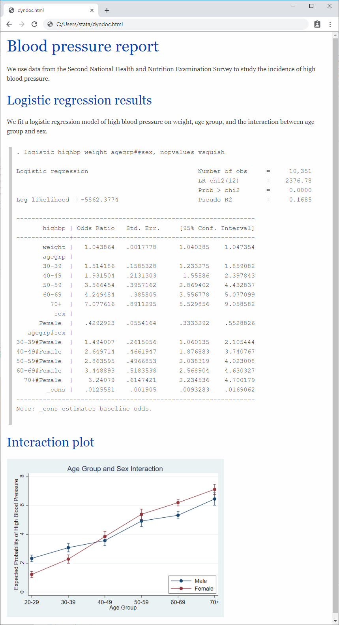

### Creating Word documents

We can instead create a Word document from our text file by typing

. **dyndoc dyndoc.txt, docx**

This creates the following file, **dyndoc.docx**:

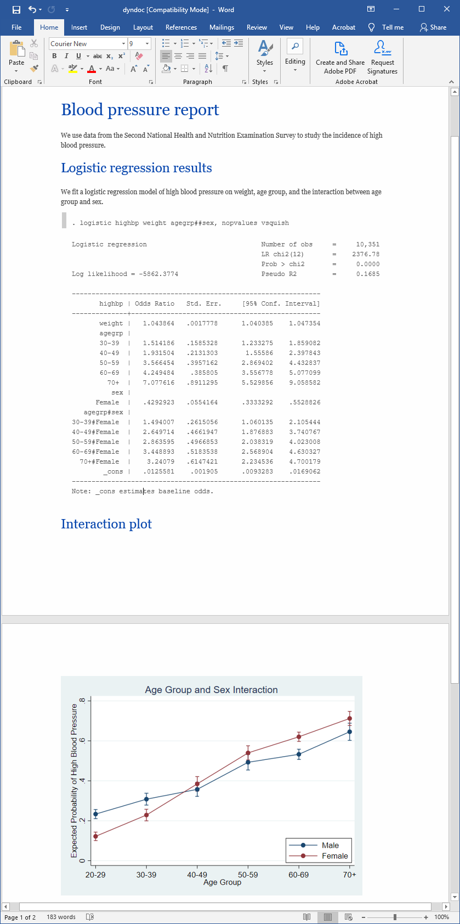

### Change the CSS and change the style

Above, **dyndoc.html** uses a CSS style sheet, **stmarkdown.css**, to control the look and feel of various HTML elements. This look and feel is also preserved in **dyndoc.docx**.

We can easily change the style of **dyndoc.html**â€“for instance, alignment of headings, code block, and imagesâ€“by changing **stmarkdown.css**. After changing **stmarkdown.css**, simply refresh **dyndoc.html** in your browser.

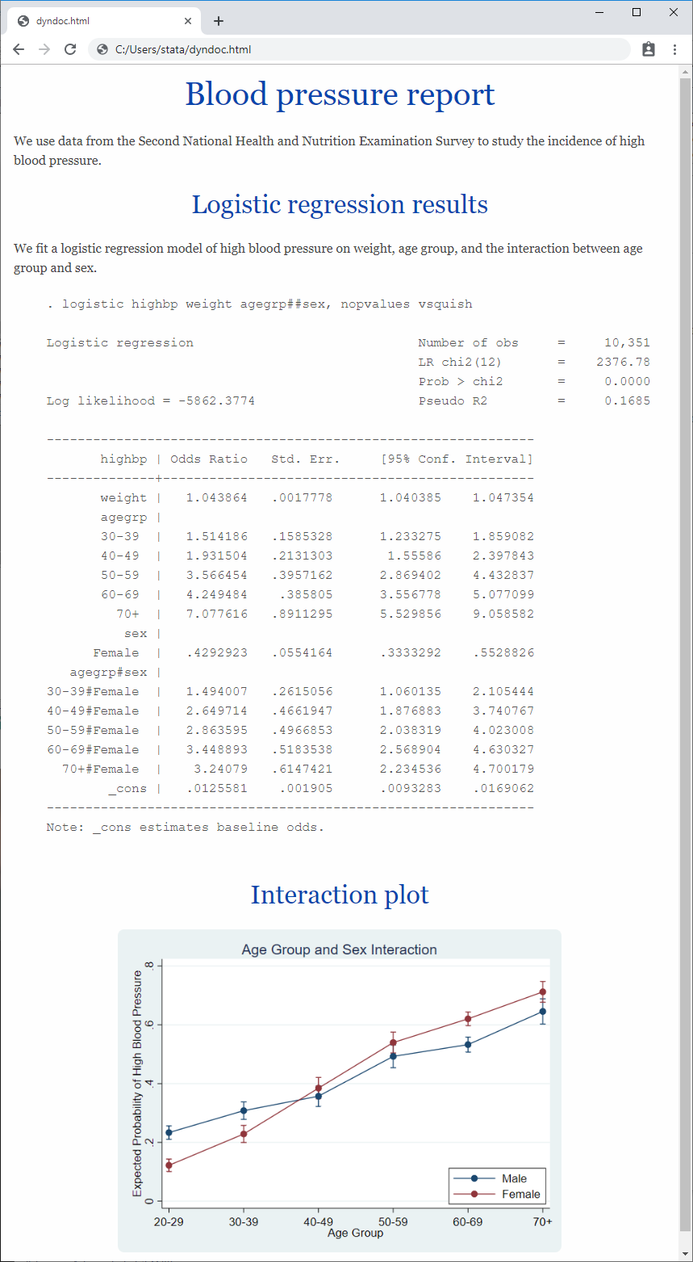

To produce the **dyndoc.docx** with new look, we could run

. **dyndoc dyndoc.txt, docx replace**

or we could directly convert our HTML file by typing

. **html2docx dyndoc.html, replace**

To learn more about how to embed Stata output in text, HTML, and Word documents, see [[RPT] Dynamic documents intro](https://www.stata.com/new-in-stata/truly-reproducible-reporting//manuals/rptdynamicdocumentsintro.pdf).

## The put* commands

The **putdocx**, **putpdf**, and **putexcel** suites can be used to create customized reports in Word, PDF, and Excel. These commands allow you to format the layout and content of the tables and text being exported.

Let's begin by creating a Word document.

### Creating Word documents

We can create a Word document with the same content as the one we created above by running the commands in the following do-file:

**webuse nhanes2, clear**

**putdocx begin**

**// Add a title**

**putdocx paragraph, style(Title)**

**putdocx text ("Blood pressure report")**

**putdocx textblock begin**

**We use data from the Second National Health and Nutrition Examination Survey**

**to study the incidence of high blood pressure.**

**putdocx textblock end**

**// Add a heading**

**putdocx paragraph, style(Heading1)**

**putdocx text ("Logistic regression results")**

**putdocx textblock begin**

**We fit a logistic regression model of high blood pressure on**

**weight, age group, and the interaction between age group and sex.**

**putdocx textblock end**

**logistic highbp weight agegrp##sex, nopvalues vsquish**

**// Add the coefficient table from the last estimation command**

**putdocx table results = etable**

**putdocx paragraph, style(Heading1)**

**putdocx text ("Interaction plot")**

**margins agegrp#sex**

**marginsplot, title(Age Group and Sex Interaction)**

**ytitle(Expected Probability of High Blood Pressure)**

**legend(ring(0) bplacement(seast) col(1))**

**graph export interaction.png, replace**

**putdocx paragraph, halign(center)**

**// Add the interaction plot**

**putdocx image interaction.png**

**putdocx save report1, replace**

Individual **putdocx** commands begin the creation of the document, add titles and other text, include estimation results, and add graphs. When we run them, we create **report1.docx**.

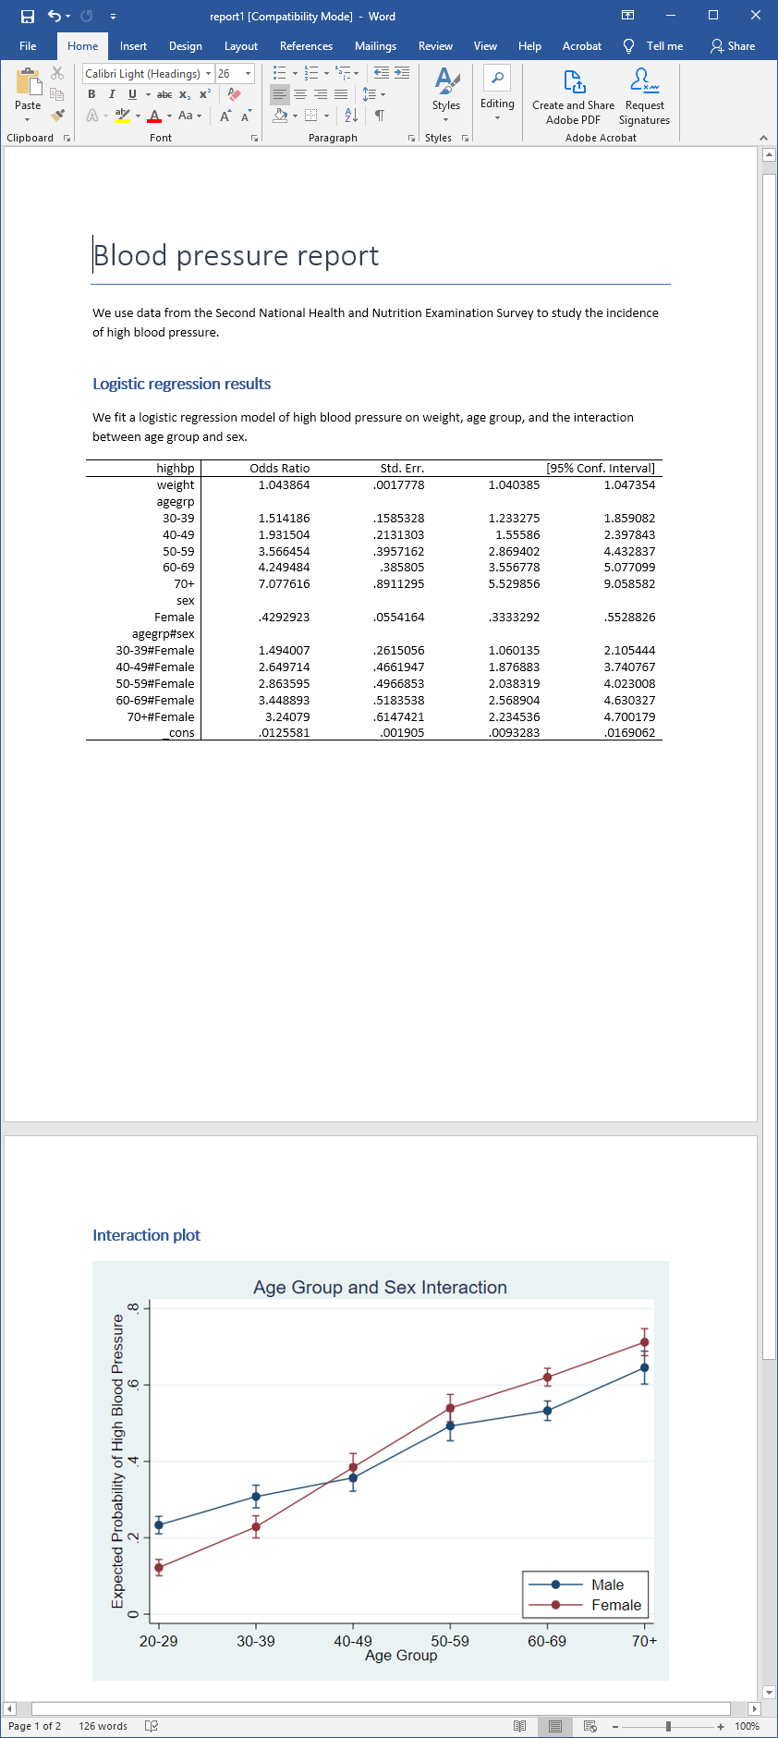

We might want to further customize our document. With additional **putdocx** commands, we can create a document complete with a header, footer, page numbers, titles, subtitles, and sections with different formatting. Additionally, we can append multiple files and interact Stata's features with Word's features.

For example, to create a modified version of **report1.docx** with a header, page numbers, and a formatted table of regression results, we created the following do-file:

**webuse nhanes2, clear**

**// Create a document with a header**

**putdocx begin, header(head)**

**// Define the header content, and include page numbers**

**putdocx paragraph, toheader(head) font(,14)**

**putdocx text ("Blood pressure report: ")**

**putdocx pagenumber**

**putdocx paragraph, style(Heading1)**

**putdocx text ("Data")**

**putdocx textblock begin**

**We use data from the Second National Health and Nutrition Examination Survey**

**to study the incidence of high blood pressure.**

**putdocx textblock end**

**putdocx paragraph, style(Heading1)**

**putdocx text ("Logistic regression results")**

**putdocx textblock begin**

**We fit logistic regression models of high blood pressure on**

**weight, age group, and the interaction between age group and sex.**

**putdocx textblock end**

**logistic highbp weight agegrp##sex, nopvalues vsquish**

**putdocx table results = etable**

**// Add a background color to alternating rows of the table**

**putdocx table results(3 5 7 9 11 13 15 17,.), shading(lightgray)**

**// Format the estimation results to have three decimal places**

**putdocx table results(2/17,2/5), nformat(%5.3f)**

**putdocx table results(1,1) = ("High BP")**

**putdocx paragraph, style(Heading1)**

**putdocx text ("Interaction plot")**

**margins agegrp#sex**

**marginsplot, title(Age Group and Sex Interaction)**

**ytitle(Expected Probability of High Blood Pressure)**

**legend(ring(0) bplacement(seast) col(1))**

**graph export interaction.png, replace**

**putdocx paragraph, halign(center)**

**// Specify the height of the image to be 5 inches**

**putdocx image interaction.png, height(5 in)**

**putdocx save report2, replace**

When we run this do-file, we produce the following Word document:

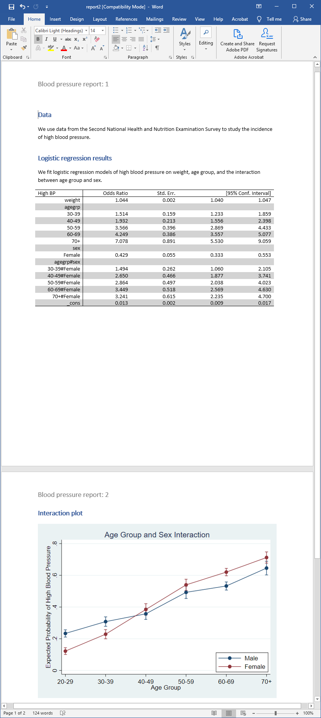

To learn more about creating Word documents with the **putdocx** suite, see [[RPT] putdocx intro](https://www.stata.com/new-in-stata/truly-reproducible-reporting//manuals/rptputdocxintro.pdf).

### Creating PDFs

We can create a PDF with the same content as **dyndoc.docx**. We'll modify our previous **docx1.do file**, replacing **putdocx** with **putpdf** and making other minor edits:

**version 16**

**webuse nhanes2, clear**

**// Create a PDF document for export**

**putpdf begin**

**// Add a title, and center it horizontally**

**putpdf paragraph, font(,20) halign(center)**

**putpdf text ("Blood pressure report")**

**putpdf paragraph**

**putpdf text ("We use data from the Second National Health and Nutrition ")**

**putpdf text ("Examination Survey to study the incidence of high blood pressure.")**

**putpdf paragraph, font(,16)**

**putpdf text ("Logistic regression results")**

**putpdf paragraph**

**putpdf text ("We fit a logistic regression model of high blood pressure on ")**

**putpdf text ("weight, age group, and the interaction between age group and sex.")**

**logistic highbp weight agegrp##sex, nopvalues vsquish**

**// Export the table of estimation results**

**putpdf table results = etable**

**// Begin the following content on a new page**

**putpdf pagebreak**

**putpdf paragraph, font(,16)**

**putpdf text ("Interaction plot")**

**margins agegrp#sex**

**marginsplot, title(Age Group and Sex Interaction)**

**ytitle(Expected Probability of High Blood Pressure)**

**legend(ring(0) bplacement(seast) col(1))**

**graph export interaction.png, replace**

**// Add the interaction plot and center the image**

**putpdf paragraph, halign(center)**

**putpdf image interaction.png**

**putpdf save report, replace**

When we execute this do-file, we obtain the following document, report.pdf:

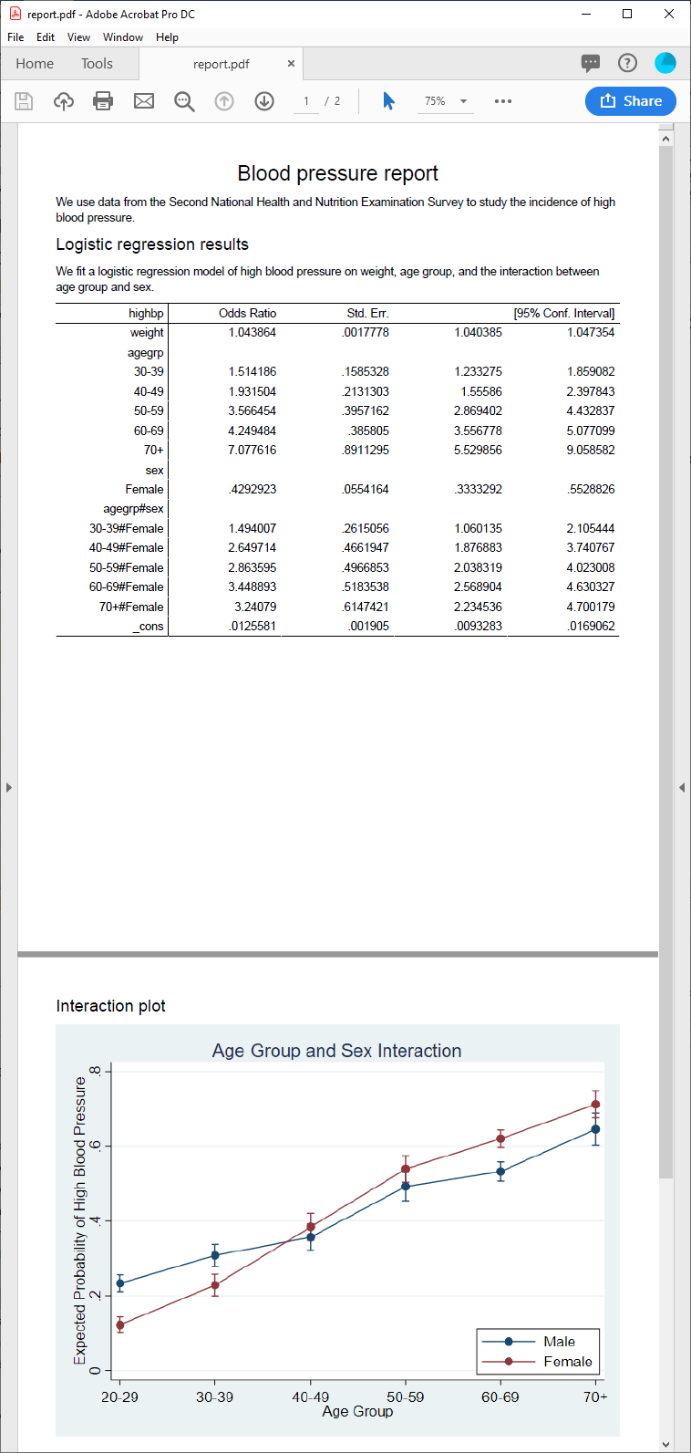

You'll note that the **putpdf** commands are very similar to the **putdocx** commands; the suite includes commands for exporting text, tables, and images.

With the **putpdf** suite, you can set the page margins for your document and the margin size for any tables you export. Additionally, you can change the graph sizes and divide your document into sections with different layouts.

To learn more about creating reports in PDF format, see [[RPT] putpdf intro](https://www.stata.com/new-in-stata/truly-reproducible-reporting//manuals/rptputpdfintro.pdf).

### Creating Excel files

Finally, we demonstrate how to export Stata results and graphs to Excel files. We can use the do-file below to create a version of our blood pressure report in the Excel format:

**version 16**

**webuse nhanes2, clear**

**// Set the report.xlsx workbook for export**

**putexcel set report.xlsx, replace**

**// Add a title**

**putexcel A1 = "Blood pressure report", bold**

**putexcel A1:E1, border(bottom, thick) merge hcenter**

**putexcel A3 = "We use data from the Second National Health and "**

**putexcel A4 = "Nutrition Examination Survey to study the "**

**putexcel A5 = "incidence of high blood pressure."**

**// Add a heading for the regression results**

**putexcel A7 = "Logistic regression results"**

**putexcel A7:E7, border(bottom, double)**

**putexcel A9 = "We fit a logistic regression model of high blood"**

**putexcel A10 = "pressure on weight, age group, and the "**

**putexcel A11 = "interaction between age group and sex."**

**logistic highbp weight agegrp##sex, nopvalues vsquish**

**// Export the table of estimation results**

**putexcel A13 = etable**

**putexcel D13:E13, merge**

**putexcel G7 = "Interaction plot"**

**putexcel G7:I7, border(bottom, double)**

**margins agegrp#sex**

**marginsplot, title(Age Group and Sex Interaction)**

**ytitle(Expected Probability of High Blood Pressure)**

**legend(ring(0) bplacement(seast) cols(1))**

**graph export interaction.png, replace width(550) height(400)**

**// Export the interaction plot**

**putexcel G9 = image(interaction.png)**

**putexcel save**

With the **putexcel** commands, specify the cells in which our text and results should appear. We also add instructions to format table elements such as cell borders.

After executing the do-file shown above, the following Excel file is produced:

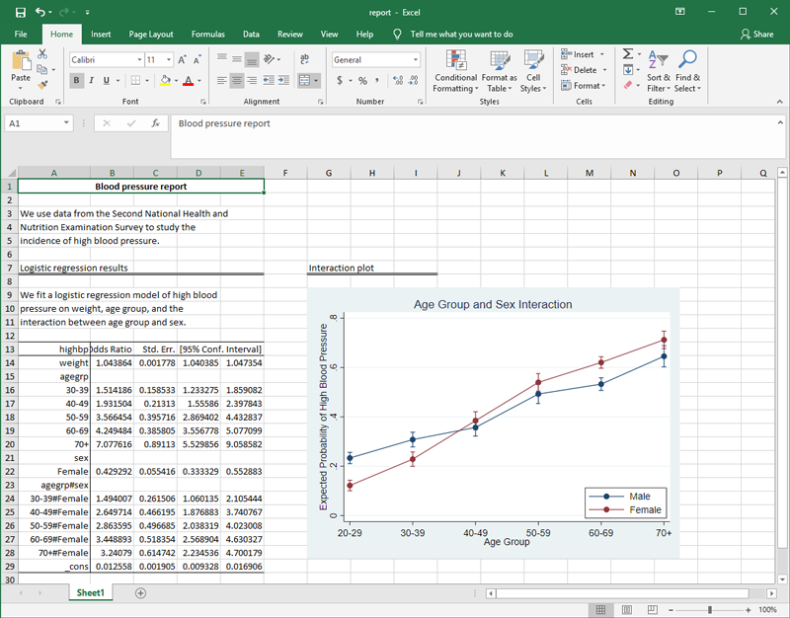

We can further customize this document by formatting the statistics, modifying the column labels, changing the alignment of the font, and more. With a few additional **putexcel** commands, we can customize our final report completely from within Stata.

In the do-file shown below, we specify **font("Arial Narrow", 11)** to use a different font type and size, mainly to address the long labels for the interaction terms. We also include the **nformat(number_d2)** option to format the estimation results to have two decimal places.

**webuse nhanes2, clear**

**version 16**

**putexcel set report2.xlsx, replace**

**putexcel A1 = "Blood pressure report", bold**

**putexcel A1:E1, border(bottom, thick) merge hcenter**

**putexcel A3 = "We use data from the Second National Health and "**

**putexcel A4 = "Nutrition Examination Survey to study the "**

**putexcel A5 = "incidence of high blood pressure."**

**putexcel A7 = "Logistic regression results"**

**putexcel A7:E7, border(bottom, double)**

**putexcel A9 = "We fit a logistic regression model of high blood"**

**putexcel A10 = "pressure on weight, age group, and the "**

**putexcel A11 = "interaction between age group and sex."**

**// Specify the font type and size**

**putexcel A1:A11, font("Arial Narrow",11)**

**logistic highbp weight agegrp##sex, nopvalues vsquish**

**// Export the table of estimation results**

**putexcel A13 = etable**

**// Format statistics to have two decimal places**

**putexcel B14:E29, nformat(number_d2)**

**putexcel A13:E29, font("Arial Narrow",9)**

**putexcel A15, left**

**putexcel A21, left**

**putexcel A23, left**

**// Merge columns with the C.I. label.**

**putexcel D13:E13, merge**

**putexcel G7 = "Interaction plot", font("Arial Narrow",11)**

**putexcel G7:I7, border(bottom, double)**

**margins agegrp#sex**

**marginsplot, title(Age Group and Sex Interaction)**

**ytitle(Expected Probability of High Blood Pressure)**

**legend(ring(0) bplacement(seast) cols(1))**

**graph export interaction.png, replace width(550) height(400)**

**// Export the interaction plot**

**putexcel G9 = image(interaction.png)**

**putexcel save**

After executing this do-file, we obtain report2.xlsx:

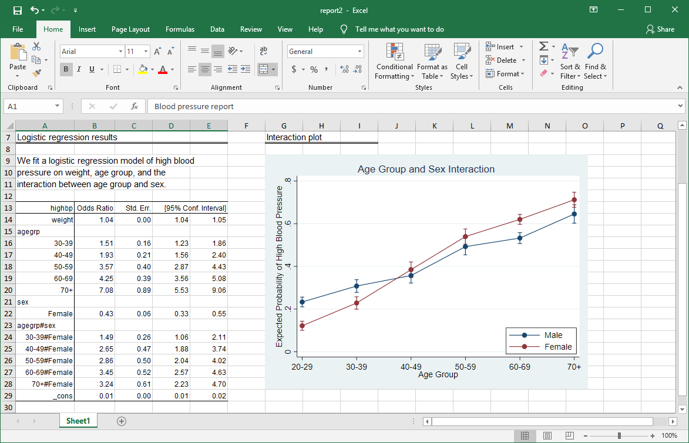

To learn more about exporting Stata results and graphs to an Excel file, see [[RPT] putexcel](https://www.stata.com/new-in-stata/truly-reproducible-reporting//manuals/rptputexcel.pdf).

## Tell me more

Whether you are creating a report using Word, HTML, PDF, or Excel, Stata's reporting features allow you to run commands and simultaneously write a customized report with the results.

Learn more in the [*Stata Reporting Reference Manual*](https://www.stata.com/new-in-stata/truly-reproducible-reporting//manuals/rpt.pdf).

[ORDER STATA](https://www.stata.com/new-in-stata/truly-reproducible-reporting//order/)   [UPGRADE NOW](https://www.stata.com/new-in-stata/truly-reproducible-reporting//order/)

[Back to the highlights](https://www.stata.com/new-in-stata/truly-reproducible-reporting/../.)

### [Stata](https://www.stata.com/new-in-stata/truly-reproducible-reporting//why-use-stata/)

[New in Stata](https://www.stata.com/new-in-stata/truly-reproducible-reporting//new-in-stata/)

[Why Stata?](https://www.stata.com/new-in-stata/truly-reproducible-reporting//why-use-stata/)

[All features](https://www.stata.com/new-in-stata/truly-reproducible-reporting//features/)

[Features by disciplines](https://www.stata.com/new-in-stata/truly-reproducible-reporting//disciplines/)

[Stata/MP](https://www.stata.com/new-in-stata/truly-reproducible-reporting//statamp/)

[Which Stata is right for me?](https://www.stata.com/new-in-stata/truly-reproducible-reporting//products/which-stata-is-right-for-me/)

[Order Stata](https://www.stata.com/new-in-stata/truly-reproducible-reporting//order/)

### [Shop](https://www.stata.com/new-in-stata/truly-reproducible-reporting//products/)

[Order Stata](https://www.stata.com/new-in-stata/truly-reproducible-reporting//order/)

[Bookstore](https://www.stata.com/new-in-stata/truly-reproducible-reporting//bookstore/)

[Stata Press books](http://www.stata-press.com/)

[Stata Journal](http://www.stata-journal.com/)

[Gift Shop](https://www.stata.com/new-in-stata/truly-reproducible-reporting//giftshop/)

### [Support](https://www.stata.com/new-in-stata/truly-reproducible-reporting//support/)

[Training](https://www.stata.com/new-in-stata/truly-reproducible-reporting//training/)

[Video tutorials](https://www.stata.com/new-in-stata/truly-reproducible-reporting//links/video-tutorials/)

[FAQs](https://www.stata.com/new-in-stata/truly-reproducible-reporting//support/faqs/)

[Statalist: The Stata Forum](http://www.statalist.org/)

[Resources](https://www.stata.com/new-in-stata/truly-reproducible-reporting//links/)

[Technical support](https://www.stata.com/new-in-stata/truly-reproducible-reporting//support/tech-support/)

[Customer service](https://www.stata.com/new-in-stata/truly-reproducible-reporting//customer-service/)

### [Company](https://www.stata.com/new-in-stata/truly-reproducible-reporting//company/)

[Contact us](https://www.stata.com/new-in-stata/truly-reproducible-reporting//company/contact/)

[Customer service](https://www.stata.com/new-in-stata/truly-reproducible-reporting//customer-service/)

[Announcements](https://www.stata.com/new-in-stata/truly-reproducible-reporting//news/)

[Search](https://www.stata.com/new-in-stata/truly-reproducible-reporting//search/)

|  |  |  |  |  |  |
| --- | --- | --- | --- | --- | --- |
| [The Stata Blog: Not Elsewhere Classified](http://blog.stata.com/) | [Find us on Facebook](http://www.facebook.com/StataCorp) | [Follow us on Twitter](http://twitter.com/stata) | [LinkedIn](http://www.linkedin.com/company/statacorp) | [YouTube](http://www.youtube.com/user/statacorp) | [Instagram](https://www.instagram.com/statacorp/) |

Â© Copyright 1996â€“2019 StataCorp LLC   â€¢   [Terms of use](https://www.stata.com/new-in-stata/truly-reproducible-reporting//terms-of-use/)   â€¢   [Privacy](https://www.stata.com/new-in-stata/truly-reproducible-reporting//privacy-policy/)   â€¢   [Contact us](https://www.stata.com/new-in-stata/truly-reproducible-reporting//company/contact/)

Ã— Learn more Â»

 