# Using Support Vector Machine to classify car type in Stata’s auto dataset

In Stata 16, you can embed and execute Python code from within Stata. Stata’s new **python** command provides a suite of subcommands allowing you to easily call Python from Stata and output Python results within Stata.

We will build a classifier using the Support Vector Machine (SVM) classifier within the **scikit-learn** Python package to detect if a car in Stata’s auto dataset is foreign or domestic built.

Note that you need to install the Matplotlib, sklearn, and NumPy packages in your current Python installation to run the following example.

. set seed `seed'

. sysuse auto, clear

(1978 Automobile Data)

. gen train = 0

. replace train = 1 if runiform() < `percent'/100

(18 real changes made)

. frame put if train==0, into(predict)

. keep if train==1

(56 observations deleted)

## Scatter plot of train data

We produce a 3d scatter plot of the trainning data. The points are color coded for different type (foreign or domestic).

python:

import numpy as np

from sfi import Platform

import matplotlib

if Platform.isWindows():

matplotlib.use('TkAgg')

import matplotlib.pyplot as plt

from sfi import Data

import imageio as io

import os

from mpl_toolkits.mplot3d import Axes3D

X = np.array(Data.get("foreign mpg price weight"))

fig = plt.figure()

ax = Axes3D(fig, elev=-155, azim=105)

ax.scatter(X[:, 1], X[:,2], X[:, 3], c=X[:,0]<0.1, marker='o')

plt.savefig("train_for.png")

plt.close()

end

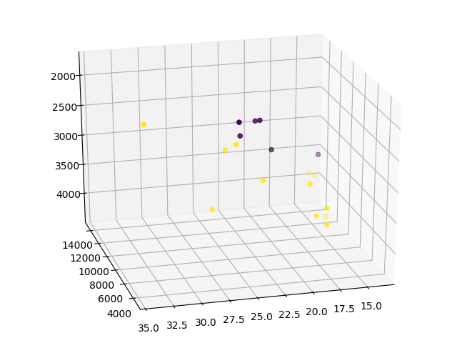

## Scatter plot of production data

Now We produce the same 3d scatter plot for the prediction data.

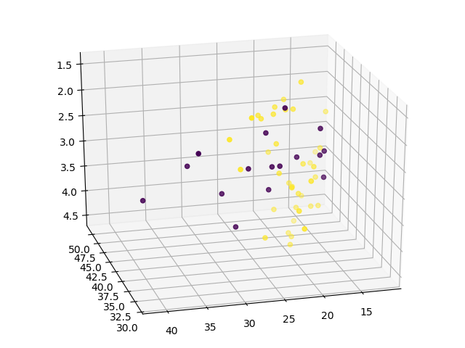

## SVM

Now we train the SVM classifier using the trainning data, then predict the type using the prediction data.

. frame change default

. pysvm2 foreign mpg turn headroom

note: training finished successfully

. frame change predict

. pysvm2predict for2

. label values for2 origin

. tabulate foreign for2, nokey

| for2

Car type | Domestic Foreign | Total

-----------+----------------------+----------

Domestic | 38 2 | 40

Foreign | 12 4 | 16

-----------+----------------------+----------

Total | 50 6 | 56

## References

1. [Python integration in Stata 16](https://www.stata.com/new-in-stata/python-integration/)
2. [pysvm2 and pysvm2predict](https://huapeng01016.github.io/chicago19/#/upgrade)