# A quick study of auto dataset

We will use the auto dataset. It includes variable price:

. sysuse auto, clear  
(1978 Automobile Data)  
  
. summarize price  
  
 Variable | Obs Mean Std. Dev. Min Max  
-------------+---------------------------------------------------------  
 price | 74 6165.257 2949.496 3291 15906

The mean of price is 6165.257. We will also check the relationship between **mpg** and **weight** visually.

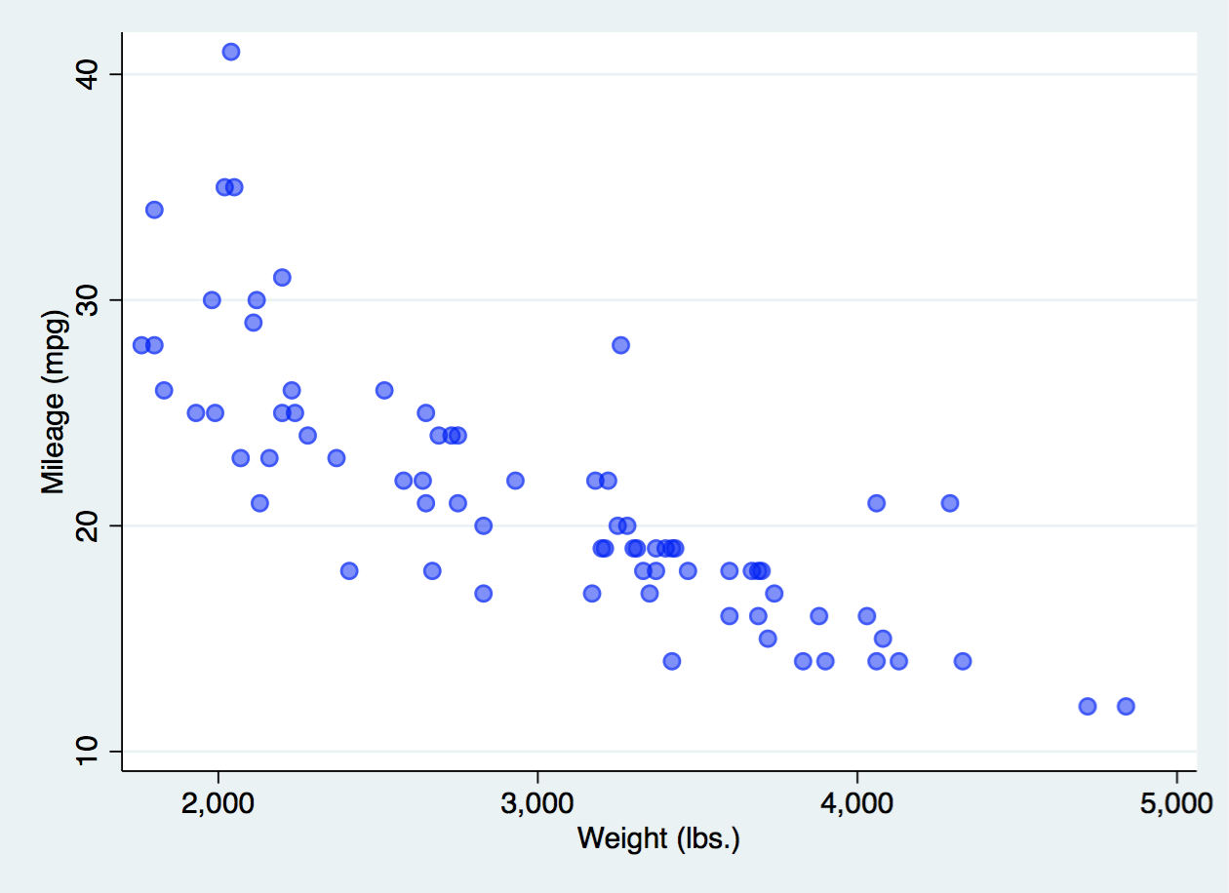

and via a linear regression:

. regress mpg weight  
  
 Source | SS df MS Number of obs = 74  
-------------+---------------------------------- F(1, 72) = 134.62  
 Model | 1591.9902 1 1591.9902 Prob > F = 0.0000  
 Residual | 851.469256 72 11.8259619 R-squared = 0.6515  
-------------+---------------------------------- Adj R-squared = 0.6467  
 Total | 2443.45946 73 33.4720474 Root MSE = 3.4389  
  
------------------------------------------------------------------------------  
 mpg | Coef. Std. Err. t P>|t| [95% Conf. Interval]  
-------------+----------------------------------------------------------------  
 weight | -.0060087 .0005179 -11.60 0.000 -.0070411 -.0049763  
 _cons | 39.44028 1.614003 24.44 0.000 36.22283 42.65774  
------------------------------------------------------------------------------