# A fuel consumption study of Stata's auto dataset

We conduct a study of the fuel consumption of cars in Stata's auto dataset.

. sysuse auto, clear  
(1978 Automobile Data)

## Perform data transformation

We generate a variable, **fuel**, that measures the fuel consumption rate in the unit of Gallons per 100 Miles.

. generate fuel = 100/mpg  
  
. label variable fuel "Fuel consumption (Gallons per 100 Miles)"

## Examine the variables

We examine variables for possible errors in the data.

. describe fuel weight  
  
 storage display value  
variable name type format label variable label  
--------------------------------------------------------------------------------  
fuel float %9.0g Fuel consumption (Gallons per 100  
 Miles)  
weight int %8.0gc Weight (lbs.)

. summarize weight  
  
 Variable | Obs Mean Std. Dev. Min Max  
-------------+---------------------------------------------------------  
 weight | 74 3019.459 777.1936 1760 4840

The variable **weight** has minimum value 1760.00, maximum value 4840.00, and range 3080.00.

## Plot fuel consumption and vehicle weight

. scatter fuel weight, mcolor(blue%50)

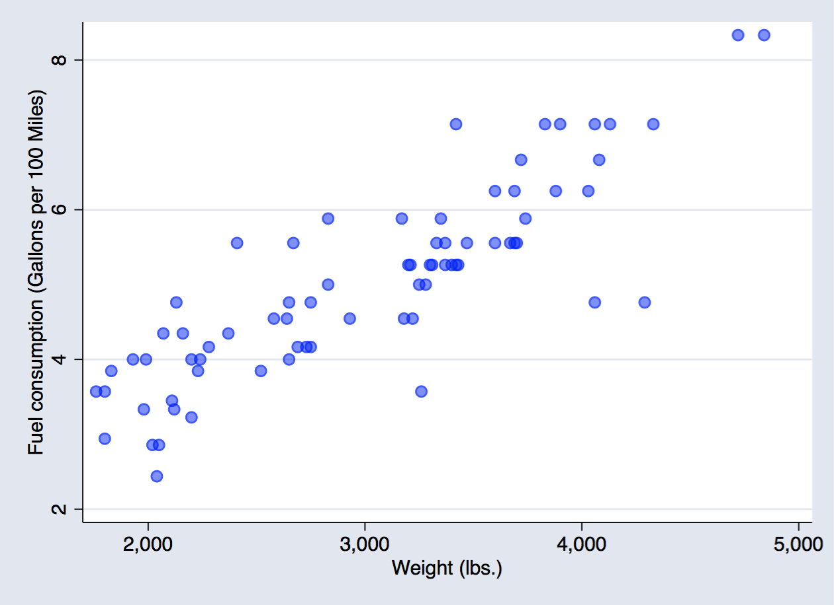

scatter fuel weight

## Explore relationship between fuel consumption and vehicle weight - linear regression

. regress fuel weight  
  
 Source | SS df MS Number of obs = 74  
-------------+---------------------------------- F(1, 72) = 194.71  
 Model | 87.2964969 1 87.2964969 Prob > F = 0.0000  
 Residual | 32.2797639 72 .448330054 R-squared = 0.7300  
-------------+---------------------------------- Adj R-squared = 0.7263  
 Total | 119.576261 73 1.63803097 Root MSE = .66957  
  
------------------------------------------------------------------------------  
 fuel | Coef. Std. Err. t P>|t| [95% Conf. Interval]  
-------------+----------------------------------------------------------------  
 weight | .001407 .0001008 13.95 0.000 .001206 .0016081  
 _cons | .7707669 .3142571 2.45 0.017 .1443069 1.397227  
------------------------------------------------------------------------------

The regression shows that for every unit increase in weight, a 0.0014 unit increase in fuel consumption is predicted.