# A fuel consumption study of Stata's auto dataset

We conduct a study of the fuel consumption of cars in Stata's auto dataset.

## Perform data transformation

We generate a variable, **fuel**, in the unit of Gallons per 100 Miles based on the variable **mpg**.

. generate fuel = 100/mpg  
. label variable fuel "Fuel consumption (Gallons per 100 Miles)"

## Examine the variables

We examine variables for possible errors in the data.

### Describe the variables

|  |  |  |  |  |
| --- | --- | --- | --- | --- |
| Name | Storage type | Display format | Value label | Variable label |
| fuel | float | %9.0g |  | Fuel consumption (Gallons per 100 Miles) |
| weight | int | %8.0gc |  | Weight (lbs.) |

### Summarize the variables

|  |  |  |  |  |  |
| --- | --- | --- | --- | --- | --- |
| Variable | Observations | Mean | Standard Deviation | Min | Max |
| fuel | 74 | 5.019 | 1.28 | 2.439 | 8.333 |
| weight | 74 | 3019 | 777.2 | 1760 | 4840 |

The variable **weight** has minimum value 1760.00, maximum value 4840.00, and range 3080.00.

## Plot fuel consumption and vehicle weight

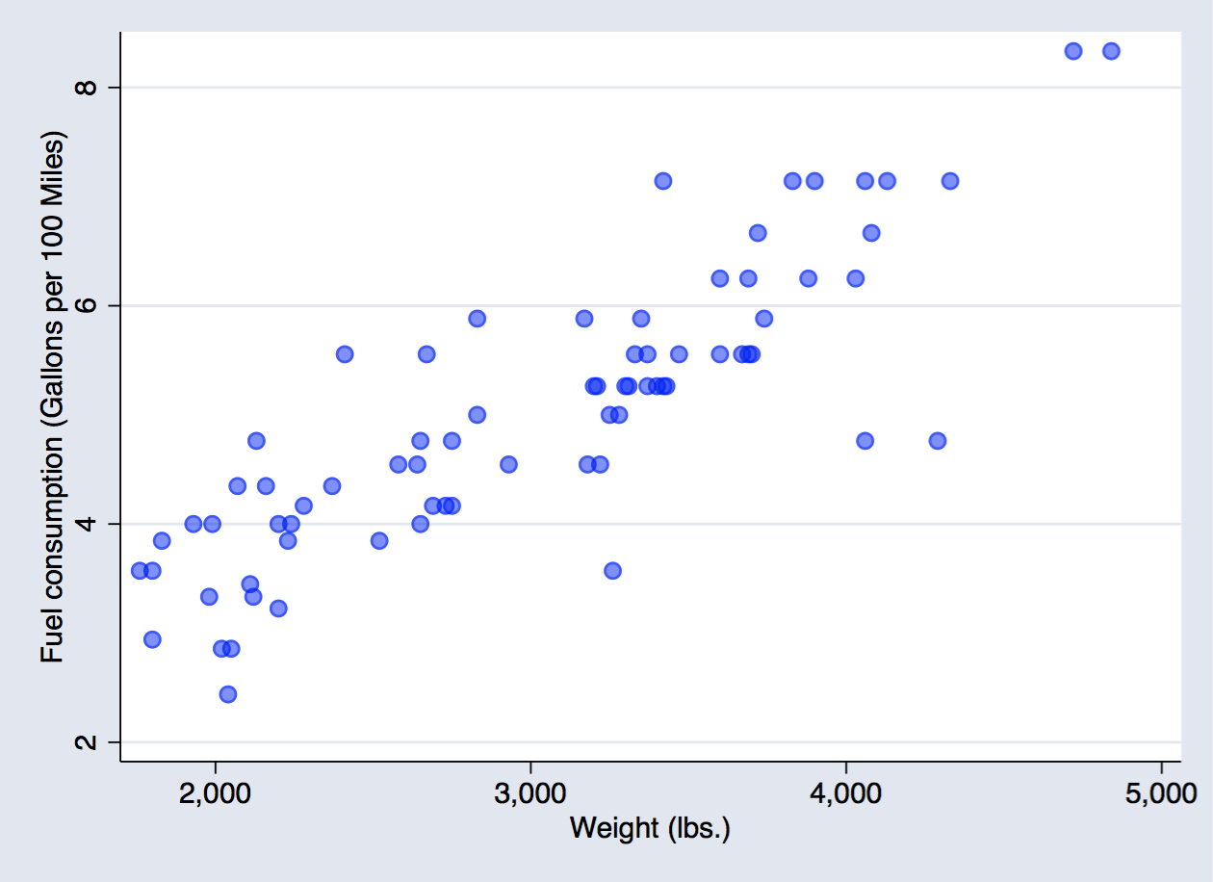  
**Figure 1: scatter plot fuel consumption and weight**

## Explore relationship between fuel consumption and vehicle weight - linear regression

|  |  |  |  |  |  |  |
| --- | --- | --- | --- | --- | --- | --- |
| fuel | Coef. | Std. Err. | t | P>|t| | [95% Conf. Interval] | |
| weight | .001407 | .0001008 | 13.95 | 0.000 | .001206 | .0016081 |
| _cons | .7707669 | .3142571 | 2.45 | 0.017 | .1443069 | 1.397227 |

The regression shows that for every unit increase in weight, a 0.0014 unit increase in fuel consumption is predicted.

## Produce a table from -estimates table-

We list the results from two regressions.

|  |  |  |
| --- | --- | --- |
| Variable | model1 | model2 |
| Weight (lbs.) | 0.0014*** | 0.0013*** |
| Gear Ratio | 0.1706 | -0.3367 |
| Turn Circle (ft.) | 0.0243 | 0.0613 |
| Car type |  | 0.8650*** |
| Constant | -0.5814 | -0.4661 |
| N | 74 | 74 |
| r2 | 0.7332 | 0.7767 |
| r2_a | 0.7218 | 0.7637 |

## Produce a table from community-contributed -esttab-

We list the results from the same two regressions as above using -esttab- and -putdocx-. -esttab- is a popular community-contributed command which generates tables for report.

|  |  |  |
| --- | --- | --- |
| Regression table using -esttab- | | |
|  | Fuel consumption | Fuel consumption |
|  | b/t | b/t |
| Weight (lbs.) | 0.001*** | 0.001*** |
|  | (6.09) | (6.06) |
| Gear Ratio | 0.171 | -0.337 |
|  | (0.64) | (-1.19) |
| Turn Circle (ft.) | 0.024 | 0.061 |
|  | (0.70) | (1.81) |
| Car type |  | 0.865*** |
|  |  | (3.66) |
| Constant | -0.581 | -0.466 |
|  | (-0.38) | (-0.33) |
| Observations | 74 | 74 |
| R-squared | 0.73 | 0.78 |
| Adjusted R-squared | 0.72 | 0.76 |
| *t statistics in parentheses* | | |
| *\* p<0.05, ** p<0.01, *** p<0.001* | | |

## Relationship based on car type - a nested table

|  |  |
| --- | --- |
| Foreign | Domestic |
| |  |  |  |  |  |  | | --- | --- | --- | --- | --- | --- | |  | Observations | Mean | Standard Deviation | Min | Max | | fuel | 22 | 4.313 | 1.144 | 2.439 | 7.143 | | weight | 22 | 2316 | 433 | 1760 | 3420 | | |  |  |  |  |  |  | | --- | --- | --- | --- | --- | --- | |  | Observations | Mean | Standard Deviation | Min | Max | |  | 52 | 5.318 | 1.224 | 2.941 | 8.333 | |  | 52 | 3317 | 695.4 | 1800 | 4840 | |
|  |  |
| |  |  |  |  |  | | --- | --- | --- | --- | --- | |  | b | t | b | t | | Weight (lbs.) | 0.002** | (3.49) | 0.001*** | (5.07) | | Gear Ratio | -0.577 | (-1.12) | -0.234 | (-0.72) | | Turn Circle (ft.) | 0.205 | (1.67) | 0.066 | (1.92) | | Constant | -4.478 | (-1.00) | -0.640 | (-0.43) | | Observations | 22 |  | 52 |  | | R-squared | 0.73 |  | 0.78 |  | | Adjusted R-squared | 0.69 |  | 0.77 |  | | |