Task 3 Figure Set 2: Five Sequence Diagrams for UC02, UC03, UC06, UC10 and UC11
Team 4 · Improved University Course Registration System · Task 3
Object-Oriented Requirements Analysis: sequence diagrams for the five use cases assigned to Member B
Prepared by Zhang Yikai (Member B), student no. 1240007611
Delivered to Zhang Yuhua (report assembly) · Term review Zhang Yikai · Date 5 November 2026
Scope: UC02, UC03, UC06, UC10 and UC11 only, following the URS of Task 2

This file contains my part of Task 3: one sequence diagram for each of my five use cases, with a short description of what each diagram shows. The use case diagram submitted in Task 2 is reused without change, so it is not redrawn here, and no use case has been merged, renamed or dropped. All object names follow the class model the team has already agreed on, which means the five figures can go straight into the report next to the object diagram and the enrollment sequence diagram. The submitted use case diagram itself is kept by the group rather than by me, so it is not included in this package.

1. What this file contains
My five use cases are the student query side and the two teacher list use cases. Every figure below follows the rule the team fixed for Task 3: a trigger, the messages exchanged and a return, with the failure path drawn inside the alt frame rather than described in text only.
Table 1. Figures delivered in this file
No. | Use case | What the figure shows | Status
Fig. B1 | UC02 Search / View Courses | Keyword search on code, title or teacher name; either a matched list or an explicit empty result. The teaching-class detail sits inside the opt frame, so it runs only when a course is picked from that list. | Complete
Fig. B2 | UC03 View Available Seats | Class lookup first: an unknown id ends with RecordNotFound; for an existing class the capacity is read, the active count is added and remaining seats are computed on read. | Complete
Fig. B3 | UC06 View Timetable | Active enrollments of the student, loop over their schedules, weekly grid; empty timetable when the student has no active enrollment. | Complete
Fig. B4 | UC10 View Enrollment Count | Role and class-ownership check, active count and remaining seats for the owning teacher; PermissionDenied otherwise. | Complete
Fig. B5 | UC11 View Student List | Same ownership check, roster built from active enrollments only; PermissionDenied for another teacher's class. | Complete

2. How to read the diagrams
Sequences are read from top to bottom. A solid arrow is a synchronous call, a dashed arrow is a return, and the alt and loop frames hold the failure branches and the repetition. In each figure the failure path sits in the second operand of the alt frame, so the success and the rejection of the same request can be compared side by side. One word is used for one thing: active enrollment means an enrollment record whose status is Active, which is the same name the code uses (EnrollmentStatus::Active). A dropped record stays in the store as history but takes no seat. Wherever enrolled named that status it has been replaced by active, so my figures and the other members' figures now read the same.

3. The five figures

3.1 UC02 Search / View Courses
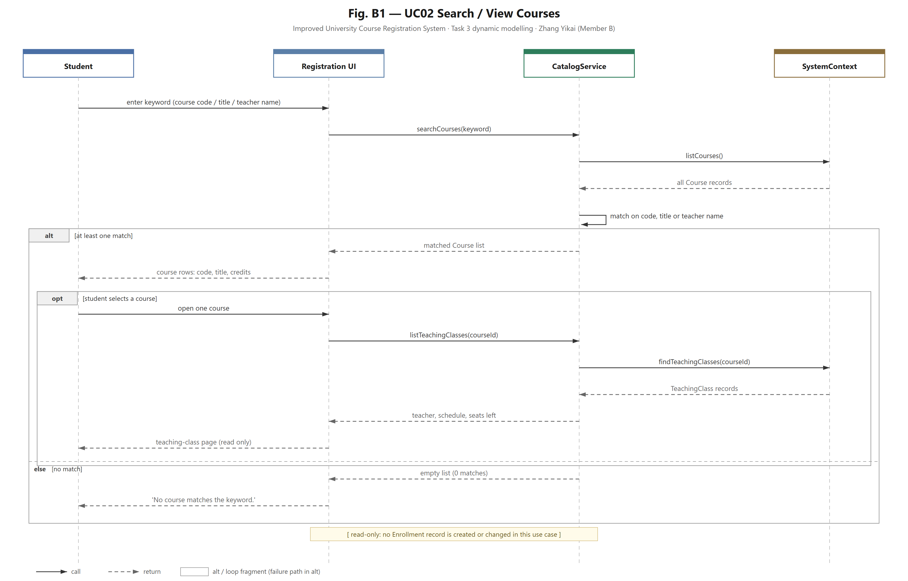
Fig. B1 — UC02 Search / View Courses
The student types a keyword and the page passes it to CatalogService, which searches the catalogue and keeps only the courses whose code, title or teacher name contains the keyword. The alt frame holds the two outcomes: a matched list with code, title and credits, or an empty result together with an explicit message instead of a blank page. Opening one course is drawn inside the matched branch as an opt frame, because the detail page can only be reached by picking a course from the result list; when nothing matches, the flow stops at the message and no detail page is opened. Nothing is written in this use case; the page only reads the catalogue.

3.2 UC03 View Available Seats
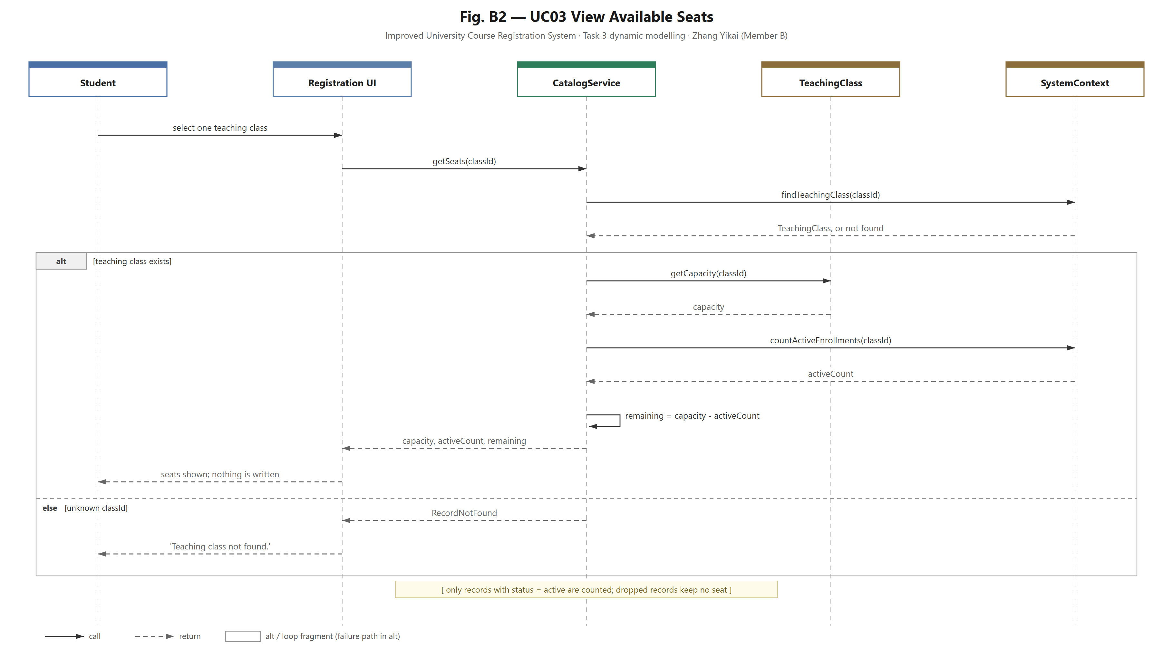
Fig. B2 — UC03 View Available Seats
The page asks CatalogService for one teaching class, and the first thing the service does is look the class up in SystemContext. That order matters: without a class there is no capacity to read, so the existence check has to come before the numbers. When the class is unknown the service returns RecordNotFound and the page shows 'Teaching class not found.', and the query ends there. Only for an existing class does it read the capacity from TeachingClass, count the active enrollments in SystemContext and compute the remaining seats as capacity minus activeCount. The seats are computed on the spot rather than kept as a second counter, so the number a student sees is the same number the enrollment check uses, and a dropped enrollment never takes a seat.

3.3 UC06 View Timetable
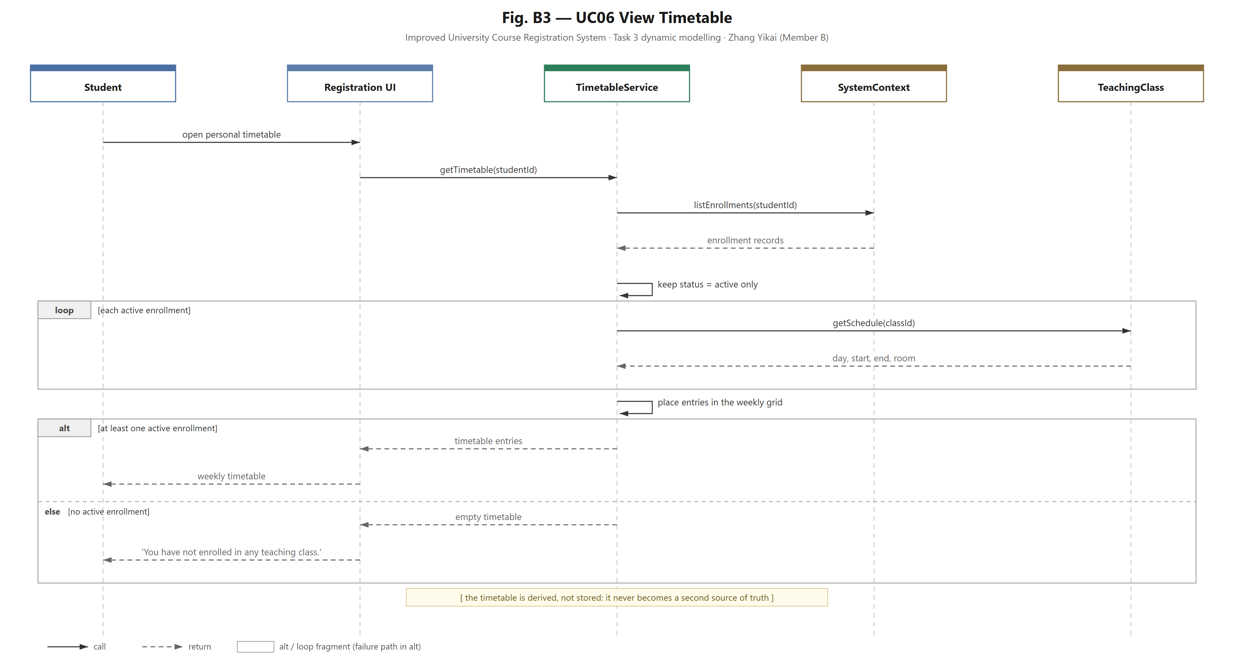
Fig. B3 — UC06 View Timetable
TimetableService reads every enrollment of the student, keeps only the records with status active and asks each teaching class for its schedule, then assembles the weekly grid from those entries. Because the timetable is derived on every request, a new enrollment or a drop shows up immediately and there is no second copy of the data to keep in step. When the student has no active enrollment, the alt frame returns an empty timetable and the page shows an explicit message rather than an empty grid.

3.4 UC10 View Enrollment Count
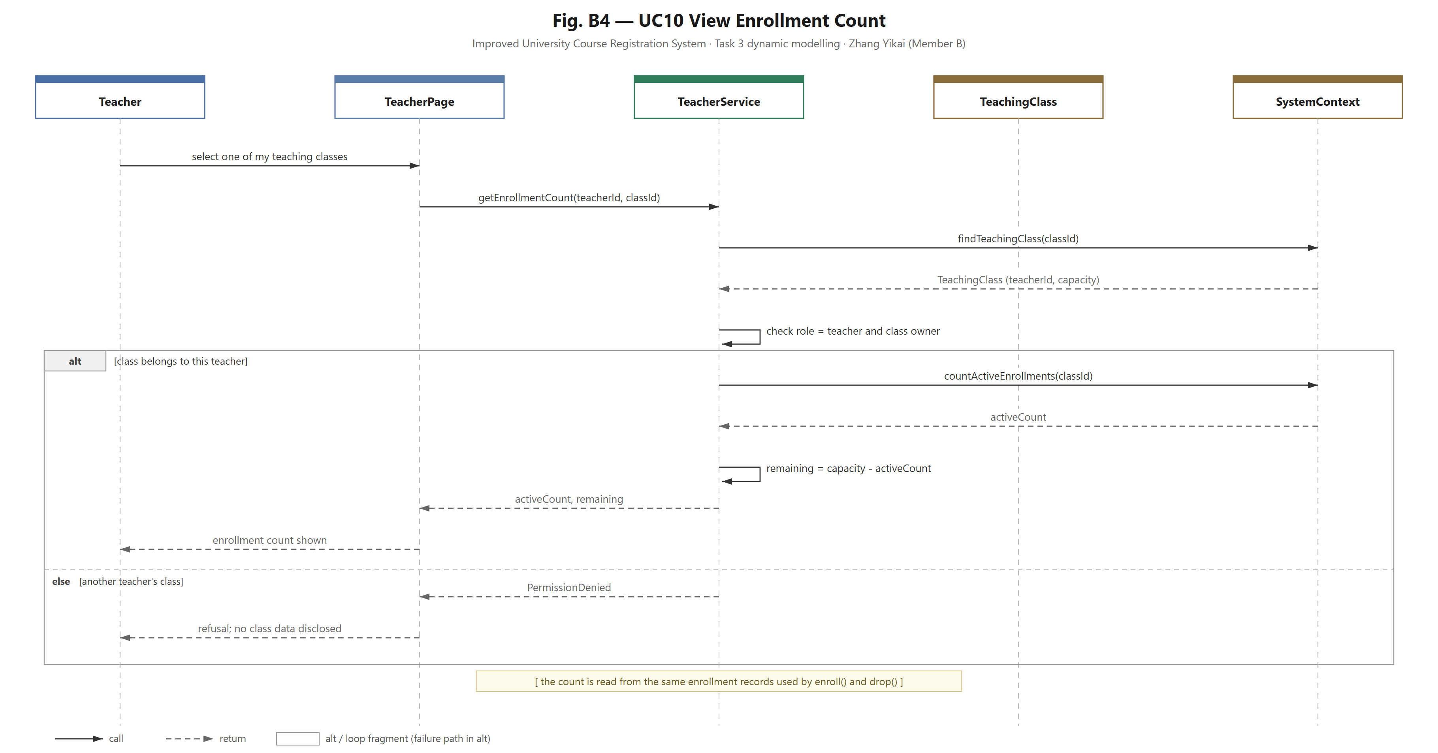
Fig. B4 — UC10 View Enrollment Count
After the teacher opens one of the teaching classes, TeacherService checks the role and then whether the class really belongs to this teacher, using the owner stored in the class. For the owner, the service counts the active enrollments and derives the remaining seats from the capacity, so the teacher sees the same figure as the student page. A request for another teacher's class returns PermissionDenied, and the page reports the refusal without disclosing any class content.

3.5 UC11 View Student List
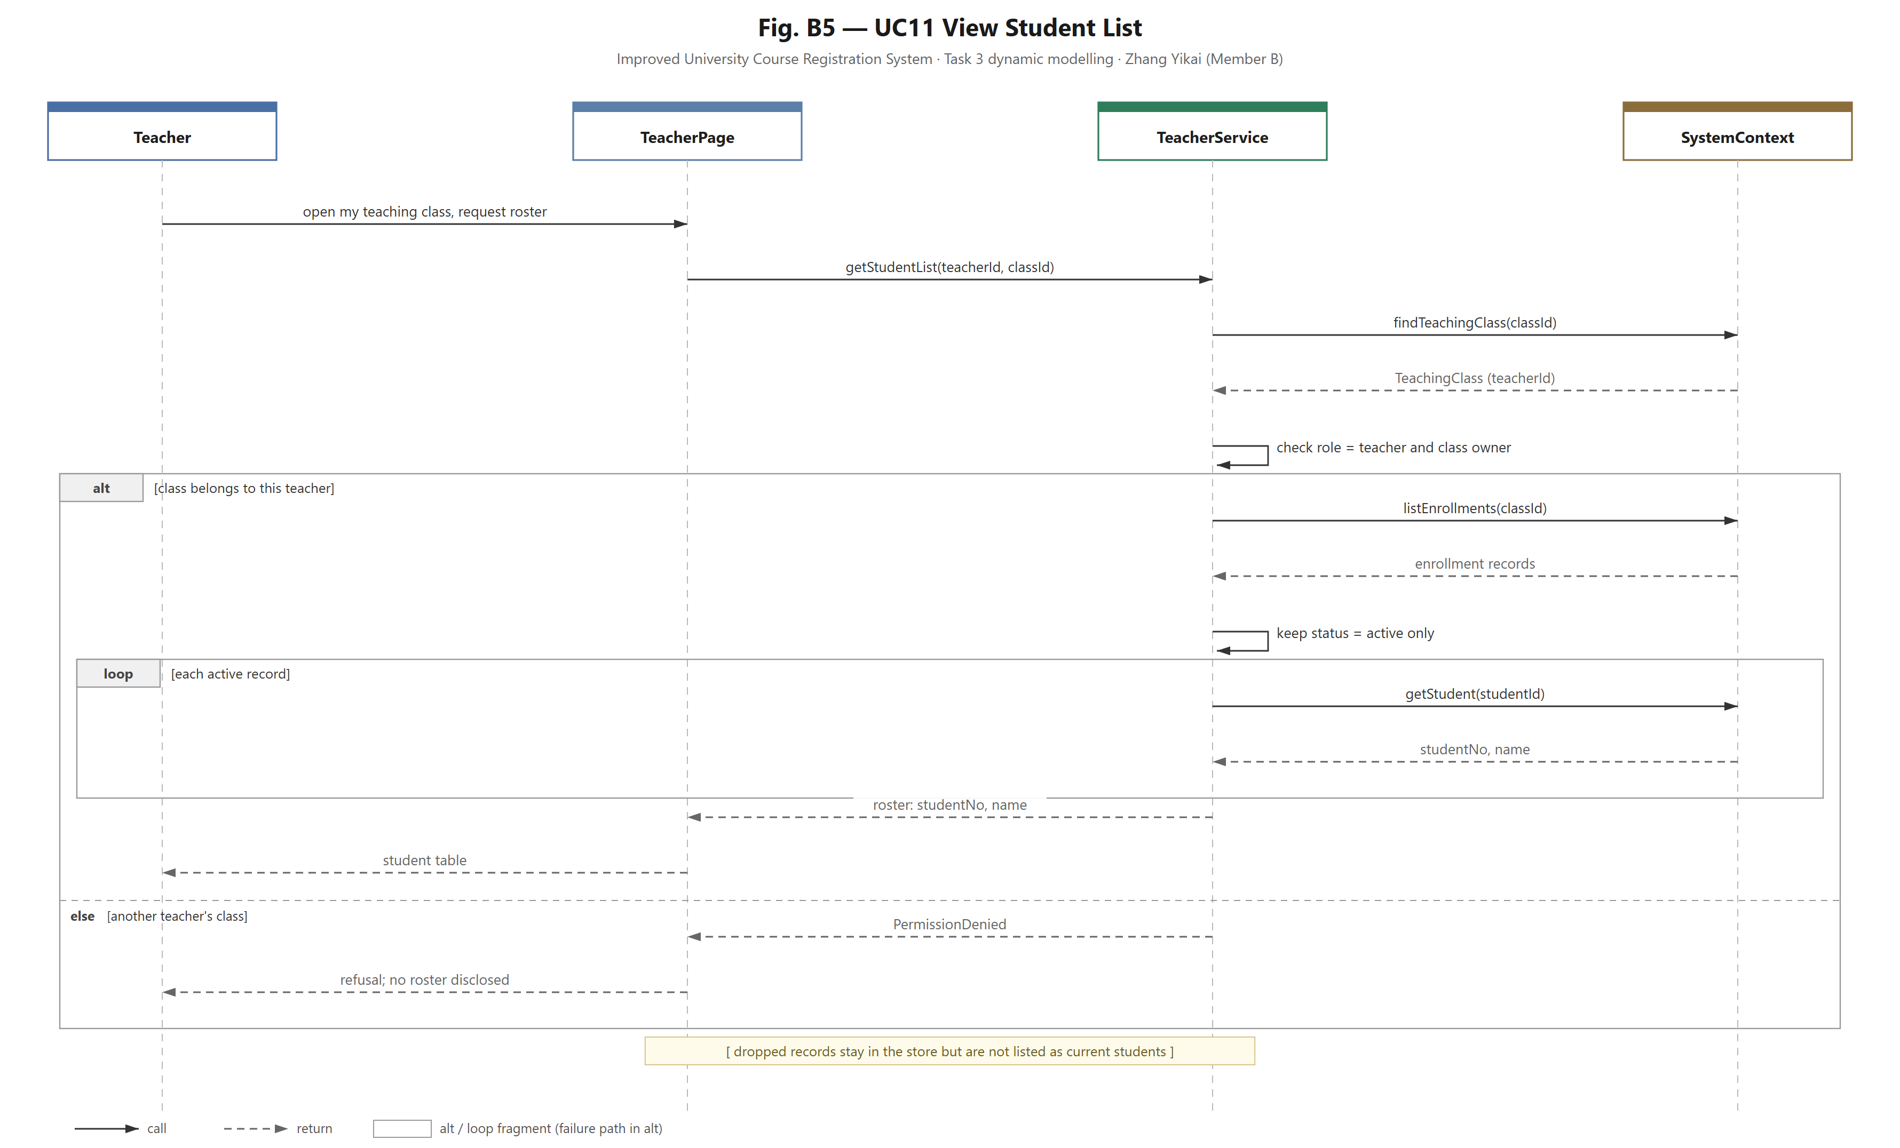
Fig. B5 — UC11 View Student List
The roster follows the same access rule as UC10: the role and the class ownership are checked before any enrollment record is read. For the owner, the service keeps only enrollments with status active and resolves each student into student number and name; the roster entry type holds exactly those two fields, so the figure does not show an enrollment date. Dropped records stay in the store but are not listed as current students, and a request for another teacher's class returns PermissionDenied.

4. Consistency with the team model
The five figures use the same four domain objects as the class diagram and the object diagram: Course is the catalogue entry, TeachingClass is what a student actually enrolls in, Enrollment is the record of that choice, and SystemContext is the store that answers queries for all services. My figures add only the query side: CatalogService, TimetableService, TeacherService and the two pages, and none of these names conflicts with the enrollment sequence diagram or with the teacher figures prepared by Zhu Ziliang.
Three rules are kept identical across the whole set. Seats are never stored twice, because remaining seats are always capacity minus the active count, computed at read time. The timetable is derived from active enrollments and never becomes a second source of truth. Teacher-facing data is limited to the teacher's own classes, and a refusal returns PermissionDenied without content, which matches UC09. All five figures are read-only: no Enrollment record is created, changed or removed, so they cannot interfere with the five-step check inside the enrollment use case.

5. Open items before hand-over
Two items in my part of the task depend on material that is not in this package, so they are listed here instead of being guessed.
Table 2. Items to close with the group
Item | Status | What is still needed
Use case diagram (Task 2) | Not held by Member B | The diagram is reused unchanged and not redrawn, and it is not in this package either. The original has to be taken from the Task 2 submission (leader or Member A) and placed in the report.
FR-01 to FR-19 mapping | Pending | The FR list is in the URS; the mapping table is filled from it, not from memory.
Figure numbers | Provisional B1 to B5 | The leader assigns final numbers during assembly so they do not collide with the object diagram and the teacher figures.
Editable sources | Delivered | SVG and 2x PNG of all five figures are in the same folder as this document.

6. Changes made after the review
The first version was reviewed on 5 November. Two of the comments were real errors in the order and the placement of the steps and are fixed below; the mixed terminology was a naming issue that also touched the labels, and the remaining question was a confirmation request about material that is not in my hands. Figures B1, B2 and B5 were re-exported, and the descriptions in section 3 were rewritten to match.
UC03, order of the steps. The first version read the capacity and counted the enrollments before checking that the class exists, which cannot work: a class that is not in the store has no capacity to read. The figure now looks the class up first, ends with 'Teaching class not found.' when the id is unknown, and only for an existing class reads the capacity, counts the active enrollments and computes the remaining seats. The same order is used by the query in the code, so the figure and the implementation no longer disagree.
UC02, position of the detail flow. The first version drew 'open one course' after the alt frame, which reads as if a course could be opened even when the search returned nothing. The detail flow is now an opt frame inside the matched branch, guarded by 'student selects a course', and the no-match branch stops at the message.
Terminology. enrolled and active were both used for the current valid enrollment. active is kept, because that is the status name in the code and in interfaces.md 3.5; the figures, this text and Table 1 now use active only, and enrolled no longer appears.
One further item came out of my own check while making these changes. Figure B5 returned studentNo, name and enrolledOn for the roster, but the roster entry type in the code holds only student number and name, so the third field was removed from the figure.
The roster and the use case diagram both stay as they are otherwise. No use case was merged, renamed or dropped while making these changes.

Prepared by Zhang Yikai (Member B). Questions on these five figures can go to me directly; the use case diagram and the FR table are the two items that need material from the leader or from the URS before they can be closed.

