**2022.09.02 BM52 数组中只出现一次的两个数字**

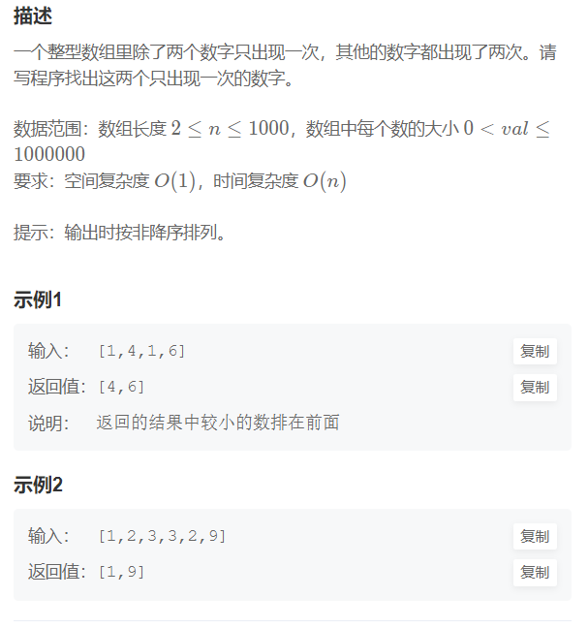

**解法一：异或运算（以前没见过）**

[数组中只出现一次的两个数字_牛客题霸_牛客网 (nowcoder.com)](https://www.nowcoder.com/practice/389fc1c3d3be4479a154f63f495abff8?tpId=295&tqId=1375231&ru=/exam/oj&qru=/ta/format-top101/question-ranking&sourceUrl=%2Fexam%2Foj)

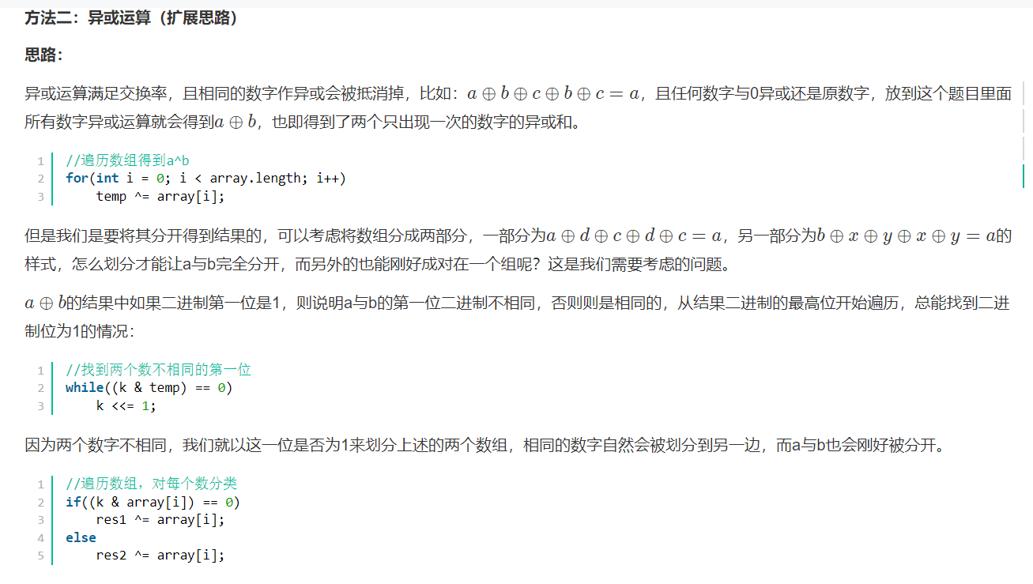

class Solution {

public:

vector<int> FindNumsAppearOnce(vector<int>& array) {

vector<int> res(2, 0);

int temp = 0;

//遍历数组得到a^b

for(int i = 0; i < array.size(); i++)

temp ^= array[i];

int k = 1;

//找到两个数不相同的第一位

while((k & temp) == 0)

k <<= 1;

for(int i = 0; i < array.size(); i++){

//遍历数组，对每个数分类

if((k & array[i]) == 0)

res[0] ^= array[i];

else

res[1] ^= array[i];

}

//整理次序

if(res[0] < res[1])

return res;

else

return {res[1], res[0]};

}

};