2022.08.19
今天是简单题，不用多说
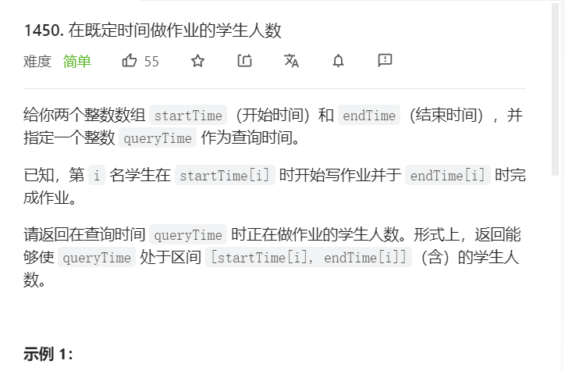
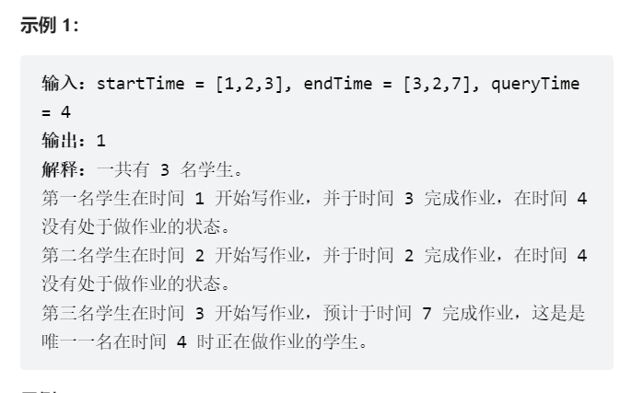
class Solution {
public:
int busyStudent(vector<int>& startTime, vector<int>& endTime, int queryTime) {
int n = startTime.size();
int maxEndTime = *max_element(endTime.begin(), endTime.end());
if (queryTime > maxEndTime) {
return 0;
}
vector<int> cnt(maxEndTime + 2);
for (int i = 0; i < n; i++) {
cnt[startTime[i]]++;
cnt[endTime[i] + 1]--;
}
int ans = 0;
for (int i = 0; i <= queryTime; i++) {
ans += cnt[i];
}
return ans;
}
};

