StaffList

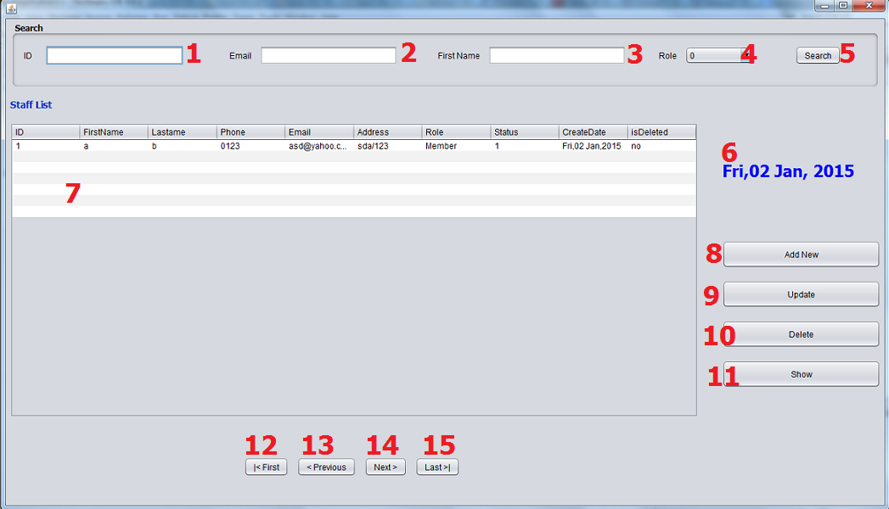

|  |  |  |  |  |
| --- | --- | --- | --- | --- |
| **No** | **Item** | **Type** | **Validation** | **Description** |
| 1 | ID | Text Field |  | ID for filter |
| 2 | Author | Text Field |  | Book Author for filter |
| 3 | Publisher | Text Field |  | Book Publisher for filter |
| 4 | Status | Text Field |  | Book Status for filter |
| 5 | Search Button | Button |  | Display search result at list Book below |
| 6 | Category list | Tree |  | Display all Category of Book |
| 7 | Add Category | Button |  | Load Add Category Form (admin Role only) |
| 8 | New Book | Button |  | Load Add Book Form |
| 9 | Book List | Table |  | Display list of Book |
| 10 | First | Button |  | Go to the First Page |
| 11 | Previous | Button |  | Go to Previous Page |
| 12 | Next | Button |  | Go to Next Page |
| 13 | Last | Button |  | Go to Last Page |
| 14 | Display Book Detail Info |  |  | Display detail of a Book: Title, Image, Author, Category, Publisher, Number of copies, Description |
| 15 | Update | Button |  | Load Update Form |
| 16 | Add Copy | Button |  | Load Copy List Form |
| 17 | Delete | Button |  | Delete a Book (Update isDelete field) |