|  |  |  |
| --- | --- | --- |
| D:\Aptech - FPT\semester 2\eProject\documentation\LogoAptech.png | D:\Aptech - FPT\semester 2\eProject\documentation\LogoAptech.png | D:\Aptech - FPT\semester 2\eProject\documentation\LogoAptech.png |

Center Name: ACE-HCMC-2-FPT (VN.033).

Address: 590 Cach Mang Thang 8 Street, District 3, Ho Chi Minh City, Vietnam.



**LIBRARY MANAGEMENT SYSTEM**

**Design Document**

|  |  |  |  |
| --- | --- | --- | --- |
| **Faculty:** |  | **Ms. Dao Ngoc Anh** |  |
| **Batch No:** |  | **F2131405T0** |  |
| **Group No.:** |  | **3** |  |
| **Students:** |  | **Fullname** | **Roll No.** |
|  | 1. | Hua Tran Huu Trung | Student812912 |
|  | 2. | Tra Phuc Vinh Uy | Student800173 |
|  | 3. | To Thanh Dat | Student813016 |

**Dec, 2014**

# 

# REVIEW 1

1. **Introduction**

The main objective of the Library Management system project is discipline of the planning, organizing and managing the library tasks. Our project aims at making the task of library easy.

Library Management is entering the records of new book and retrieving the details of book available in the library. We can issue book to the library member and maintain their records and can also checks how many book are issued and stock available in the library. In the project we can maintain the late fine of library member who return the issued book after the due date.

1. **Existing Scenario**

* Currently in library, all records are managed on paper. It is hardly for Staffs to manage them when somebody issues or returns the books, how many total of books in each category, etc.
* Each of the staffs of separate department handle the different duties in library such as Book account: manage the books in library, IR account: manage issuing/returning the books. Member account: manage members of library. Accounting account: manage fine fee. Admin account: manage staff account and all functions in system.
* Managers have to maintain list of books along with details such as author name, book’s title, book’s category, etc. When the books are to be issued, they have to manually search for that book and again for issuing book they have to maintain a register which will have details of book issued such as book’s title, staff’s detail, date of issue, date of return, etc.

1. **Proposed Solution**

Proposed system is an automated Library Management System. Through our software, user can add members, add books or search books, search members with multi conditionals or edit member’s information, edit book’s information, borrow and return books in quick time. Our proposed system has the following advantages:

* + - User friendly interface
    - Fast access to database
    - Less error
    - More Storage Capacity
    - Look and Feel Environment
    - Quick transaction

All the manual difficulties in managing the Library have been rectified by implementing computerization.

1. **Function Of Application**
2. Login/Logout: allow Users (Staffs in Library) login/logout into System. For each level of user, there will be the respective rights.
3. Change Password: allow Users can change their Password.
4. Management Member’s account: allow Member account manages member’s information.
5. Management Staff’s account: allow Admin account manages Staff’s information.
6. Management Book: allow Book account manages books in library.
7. Management Category: allow Admin account manages categories of Book.
8. Issue Book: allow IR account can issues books for member who has requested if those books are available.
9. Return Book: allow IR account can accept returned book from member. And check due date of that book is legal or not. If it is not legal, member must pay fee fine depend how many days pass over.
10. Accept fine: allow Accounting account can accept fine fee from member, and update status member paid fee for library, and can continue for being issued books later.
11. Generate report for Book account: this will provide how many books depend on their category and total books which the Library has.
12. Generate report for Member account: This will provide the details of issuing member as member name, book’s title, book’s id, issue date, return date.
13. Generate report for IR account: This will provide the details of issuing/returning book as book’s ISBN, book’s title, total issue, total return.
14. Generate report for Accounting account: This will provide the details of paying member as member name, book’ title, book’s id, issue date, return date, amount day later, amount fine fee, fine status.
15. Search: The user will be able to perform search multi conditionals based on member’s name, book’s id, book’s title, issue date, returning date, category....
16. **The Roles of Application**
17. **All member:**

* Login.
* Change Password.

1. **Admin Account:**

* Staff Management (View, Insert, Update).
* Category’s book Management (View, Insert, Update, Lock).
* Create/View all report.
* View all other functions
* Search by all.

1. **Book Account:**

* Book Management (View, Insert, Update, Lock).
* Create/View Category-Book report.
* Search by Book’s Id, title, category…

1. **Member Account:**

* Member Management (View, Insert, Update, Lock).
* Create/View Member-Issue report.
* Search by Member’s Id, name.

1. **IR Account:**

* Issue Management (View, Issue, Update).
* Return Management (View, Return, Update).
* Create/View Book-Issue-Return report.
* Search by Member’s Id, Book’s Id, Issue’s date, Issue’s Id.

1. **Accounting Account:**

* Fine Management (View, Update)
* Create/View Member-Issue/Return-Fine report.
* Search by Member’s Id, name, Issue’s date, Issue’s Id.

1. **Function Diagram**
2. **Admin function**



1. **Book Account function**



1. **Member Account function**



1. **IR Account function**



1. **Accounting Account function**



1. **Hardware/Software Requirements**
2. **Hardware**

* A minimum computer system that will help you access all the tools in the courses is a Pentium 4 or better
* 512 MB of RAM or better
* HDD 10G free space available or better

1. **Software**

* Operating system: Windows XP (or higher if possible)
* Netbeans 8.0.1
* JDK 1.7
* SQL Server 2012
* JDBC Driver 4

1. **Task sheet**

|  |  |  |  |  |  |  |
| --- | --- | --- | --- | --- | --- | --- |
| **Project Ref.No: 3** | | **Project Title:**  **Library Management System** | **Date of Preparation of Activity Plan** | | | |
| **Sr. No.** | **Task** | | **Actual Start Date** | **Actual Days** | **Team Member Names** | **Status** |
| 01 | Introduction | | Dec, 22, 2014 | 4 | All Members | Completed |
| 02 | Exiting Scenario | | All Members | Completed |
| 03 | Proposed Solution | | All Members | Completed |
| 04 | Function Of Application and The Roles of Application | | All Members | Completed |
| 05 | Function Diagram | | All Members | Completed |
| 06 | Hardware/Software Requirements | | All Members | Completed |
| 07 | Task sheet | | All Members | Completed |

|  |  |  |
| --- | --- | --- |
|  | Prepare By: Group 3 | Approved By: Faculty |
| Date: Dec, 2014 | Team Leader  **Hua Tran Huu Trung** | **Dao Ngoc Anh** |

# 

# REVIEW 2

**Architecture and Design of Project**

Tier 1

Presentation

Tier 3

Data Access

Tier 2

Business Logic

Three-Tier Architecture of the Project

1. **Data Flow Diagram**

**Definition:** Data Flows Diagram (DFD) describes the information flow in the system. The next step of system analysis is to consider in detail the information necessary for the implementation for functions discussed above and the one necessary for the improvement of the functions. Modeling tool frequently used for this purpose is DFD. DFD will support 4 main activities:

* **Analysis:** DFD is used to determine requirement of users.
* **Design:** DFD is used to map out plan and illustrate solution to analysis and users while designing a new system.
* **Communication:** one of the strength of DFD is its simplicity and ease to understand to analysts and users;

**Document:** DFD is used to provide special description of requirement and system design. DFD provide an overview of key functional components of the system but it does not provide any detail on these components. We have to use other tools like database dictionary, process specification to get an idea of which information will be exchanged and how.

**The main components of Context Diagram:**

**External**

**The process**: Show the common function of system.

**The external factors**: External factors can be a person, a group of persons or an organization that are sources of information for the systems and are where system products are transferred to.

**The data flow**: Describe the movement of information from one part of the system to another.

**The data store**: The Data Store is used to model a collection of data packets at rest. A store is represented graphically by two parallel lines. The name of a Data Store that identifies the store is the plural of the name of the packets that are carried by flows into and out of the Data Store.

Data Flow

External

Process

Data Store

**DFD level 0 – Context Diagram**



**DFD – Login**



**DFD – Admin**













1. **Database Design**

**Entity Relationship Diagram (ERD)**



**Entity and Properties**

1. Members



1. Staffs



1. Categories



1. Books



1. Copies



1. IRBooks



1. IRBookDetails



1. Fines



**Database Relationship Diagram (DRD)**

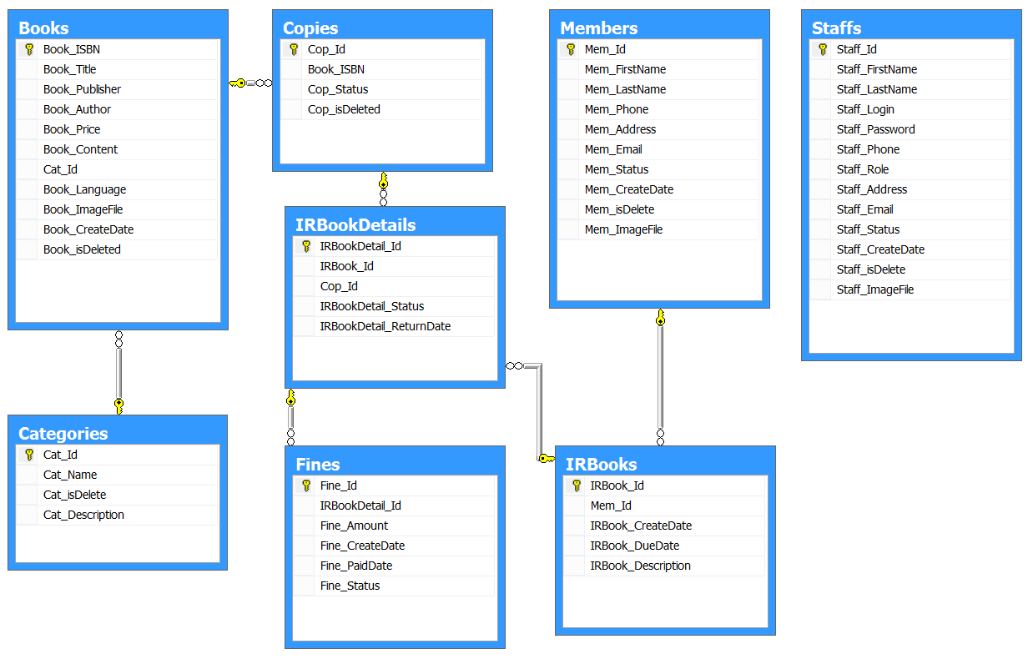

**Database Structure**

|  |  |  |  |  |  |  |
| --- | --- | --- | --- | --- | --- | --- |
| **Members** | | | | | | |
| **Column Name** | **Data Type** | **Allow Null** | **Default Value** | **Key** | **Validation** | **Description** |
| Mem_Id | char(36) | No | newid() | Primary |  | ID of Member |
| Mem_No | char(8) | No |  |  | Unique | No of Member |
| Mem_FirstName | nvarchar(30) | No |  |  |  | First Name of Member |
| Mem_LastName | nvarchar(50) | No |  |  |  | Last Name of Member |
| Mem_Phone | varchar(20) |  |  |  |  | Phone of Member |
| Mem_Address | nvarchar(200) |  |  |  |  | Address of Member |
| Mem_Email | varchar(50) | No |  |  | Unique | Email of Member |
| Mem_Status | bit | No | 1 |  |  | Status of Member |
| Mem_CreateDate | datetime | No | getdate() |  |  | Create date of Member |
| Mem_ImageFile | varchar(255) | No | “/image/noavatar.png” |  |  | Path file image of Member |
| Mem_isDelete | bit | No | 0 |  |  | Record status is deleted or not |

|  |  |  |  |  |  |  |
| --- | --- | --- | --- | --- | --- | --- |
| **Staffs** | | | | | | |
| **Column Name** | **Data Type** | **Allow Null** | **Default Value** | **Key** | **Validation** | **Description** |
| Staff_Id | Char(36) | No | newid() | Primary |  | ID of Staff |
| Staff_FirstName | nvarchar(30) | No |  |  |  | First name of Staff |
| Staff_LastName | nvarchar(50) | No |  |  |  | Last name of Staff |
| Staff_Login | varchar(25) | No |  |  | Unique | Login name of Staff |
| Staff_Password | varchar(50) | No |  |  |  | Password of Staff |
| Staff_Phone | varchar(20) |  |  |  |  | Phone of Staff |
| Staff_Role | varchar(15) | No |  |  |  | Role of Staff |
| Staff_Address | nvarchar(200) |  |  |  |  | Address of Staff |
| Staff_Email | varchar(50) | No |  |  | Unique | Email of Staff |
| Staff_Status | bit | No | 1 |  |  | Status of Staff (0: Banned,1:Active) |
| Staff_CreateDate | datetime | No | getdate() |  |  | Create date of Staff |
| Staff_ ImageFile | varchar(255) | No | “/image/noavatar.png” |  |  | Path file image of Staff |
| Staff_isDelete | bit | No | 0 |  |  | Record status is deleted or not |

|  |  |  |  |  |  |  |
| --- | --- | --- | --- | --- | --- | --- |
| **Categories** | | | | | | |
| **Column Name** | **Data Type** | **Allow Null** | **Default Value** | **Key** | **Validation** | **Description** |
| Cat_Id | char(36) | No | newid() | Primary |  | ID of Category |
| Cat_Name | nvarchar(30) | No |  |  | Unique | Name of Category |
| Cat_Description | nvarchar(100) |  |  |  |  | Description of Category |
| Cat_isDelete | bit | No | 0 |  |  | Record status is deleted or not |

|  |  |  |  |  |  |  |
| --- | --- | --- | --- | --- | --- | --- |
| **Books** | | | | | | |
| **Column Name** | **Data Type** | **Allow Null** | **Default Value** | **Key** | **Validation** | **Description** |
| Book_ISBN | varchar(13) | No |  | Primary |  | ISBN of Book |
| Book_Title | nvarchar(50) | No |  |  |  | Title of Book |
| Book_Publisher | nvarchar(50) |  |  |  |  | Publisher of Book |
| Book_Author | nvarchar(50) |  |  |  |  | Author of Book |
| Book_Price | money | No |  |  |  | Price of Book |
| Book_Content | nvarchar(1000) | No | “ ” |  |  | Content of Book |
| Cat_Id | char(36) | No |  | Foreign |  | ID of Category |
| Book_Language | varchar(7) | No |  |  |  | ID of Language |
| Book_ImageFile | varchar(255) | No | “/imgBook/nocover.png” |  |  | Path file image of Book |
| Book_CreateDate | datetime | No | getdate() |  |  | Create date of Book |
| Book_isDeleted | bit | No | 0 |  |  | Record status is deleted or not |

|  |  |  |  |  |  |  |
| --- | --- | --- | --- | --- | --- | --- |
| **Copies** | | | | | | |
| **Column Name** | **Data Type** | **Allow Null** | **Default Value** | **Key** | **Validation** | **Description** |
| Cop_Id | char(36) | No |  | Primary |  | ID of Copy |
| Cop_No | char(8) | No |  |  | Unique | No of Copy |
| Book_ISBN | varchar(13) | No |  | Foreign |  | ISBN of Book |
| Cop_Status | bit | No | 1 |  |  | Status of Copy |
| Cop_isDeleted | bit | No | 0 |  |  | Record status is deleted or not |

|  |  |  |  |  |  |  |
| --- | --- | --- | --- | --- | --- | --- |
| **IRBooks** | | | | | | |
| **Column Name** | **Data Type** | **Allow Null** | **Default Value** | **Key** | **Validation** | **Description** |
| IRBook_Id | char(36) | No | newid() | Primary |  | ID of IRBook |
| Mem_Id | char(36) | No |  | Foreign |  | ID of Member |
| IRBook_CreateDate | datetime | No | getdate() |  |  | Create date of IRBook |
| IRBook_DueDate | datetime | No |  |  |  | Due date of IRBook |
| IRBook_Description | nvarchar(100) |  |  |  |  | Description by Staff(IR Account) |

|  |  |  |  |  |  |  |
| --- | --- | --- | --- | --- | --- | --- |
| **IRBookDetails** | | | | | | |
| **Column Name** | **Data Type** | **Allow Null** | **Default Value** | **Key** | **Validation** | **Description** |
| IRBookDetail_Id | char(36) | No | newid() | Primary |  | ID of IRBookDetail |
| IRBook_Id | char(36) | No |  | Foreign |  | ID of Order |
| Cop_Id | varchar(16) | No |  | Foreign |  | ID of IRBook |
| IRBookDetail_Status | bit | No | 0 |  |  | Status of IRBookDetail |
| OrderDetail_ReturnDate | datetime |  |  |  |  | Return date of IRBookDetail |

|  |  |  |  |  |  |  |
| --- | --- | --- | --- | --- | --- | --- |
| **Fines** | | | | | | |
| **Column Name** | **Data Type** | **Allow Null** | **Default Value** | **Key** | **Validation** | **Description** |
| Fine_Id | char(36) | No | newid() | Primary |  | ID of Fine |
| IRBookDetail _Id | char(36) | No |  | Foreign |  | ID of IRBookDetail |
| Fine_Amount | money | No |  |  | >=0 | Amount money of Fine |
| Fine_CreateDate | datetime | No | getdate() |  |  | Create date of Fine |
| Fine_PaidDate | datetime |  |  |  |  | Paid date of Fine |
| Fine_Status | bit | No | 0 |  |  | Status of Fine |

1. **Algorithms**

* **Issue Book**



* **Return Book and Paid Fine**



1. **Task Sheet**

|  |  |  |  |  |  |  |
| --- | --- | --- | --- | --- | --- | --- |
| **Project Ref.No: 3** | | **Project Title:**  **Library Management System** | **Date of Preparation of Activity Plan** | | | |
| **Sr. No.** | **Task** | | **Actual Start Date** | **Actual Days** | **Team Member Names** | **Status** |
| 01 | Data Flow Diagram | | Dec, 27, 2014 | 6 | All Members | Completed |
| 02 | Entity Relationship Diagram (ERD) | | All Members | Completed |
| 03 | Entity and Properties | | All Members | Completed |
| 04 | Database Relationship Diagram (DRD) | | All Members | Completed |
| 05 | Database Structure | | All Members | Completed |
| 06 | Algorithms | | All Members | Completed |
| 07 | Task sheet | | All Members | Completed |

|  |  |  |
| --- | --- | --- |
|  | Prepare By: Group 3 | Approved By: Faculty |
| Date: Dec, 2014 | Team Leader  **Hua Tran Huu Trung** | **Dao Ngoc Anh** |

# 

# REVIEW 3

1. **Graphical User Interface**
2. **Login**

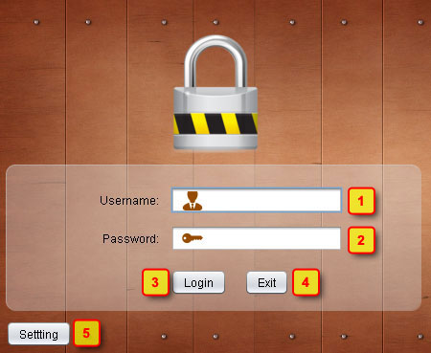

|  |  |  |  |  |
| --- | --- | --- | --- | --- |
| **No** | **Item** | **Type** | **Validation** | **Description** |
| 1 | Username | Text Field | Not Blank | Default tab after login. |
| 2 | Password | Password Field | Not Blank | Member Management menu(only for Member Account role and Admin) |
| 3 | Login | Button |  | Check Account and Password. If correct, login form will be closed, Main Form will be opened. **Go to 3** |
| 4 | Exit | Button |  | Exit program. |
| 5 | Setting | Button |  | Show and focus the Server Setting form, Login form will not be enabled. **Go to 2** |

1. **Setting**

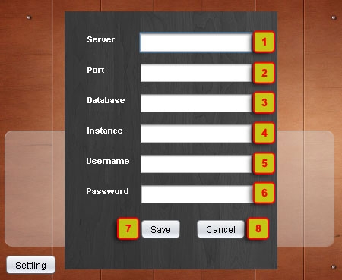

|  |  |  |  |  |
| --- | --- | --- | --- | --- |
| **No** | **Item** | **Type** | **Validation** | **Description** |
| 1 | Server | Text Field | Not blank | Server name: default localhost |
| 2 | Port | Text Field | Not blank, a number | Port:default 1433 |
| 3 | Database | Text Field | Not blank | Database name: default LMS; |
| 4 | Instance | Text Field | Not blank | Instance name of Database(let blank if not have instance) |
| 5 | Username | Text Field | Not blank | Username login database:default sa |
| 6 | Password | Text Field | Not blank | Password login database: abc@123 |
| 7 | Save | Button |  | Check validation if OK Setting save and close. Login form is enabled. |
| 8 | Cancel | Button |  | Close Setting form and Login form is enabled |

1. **Main Form**

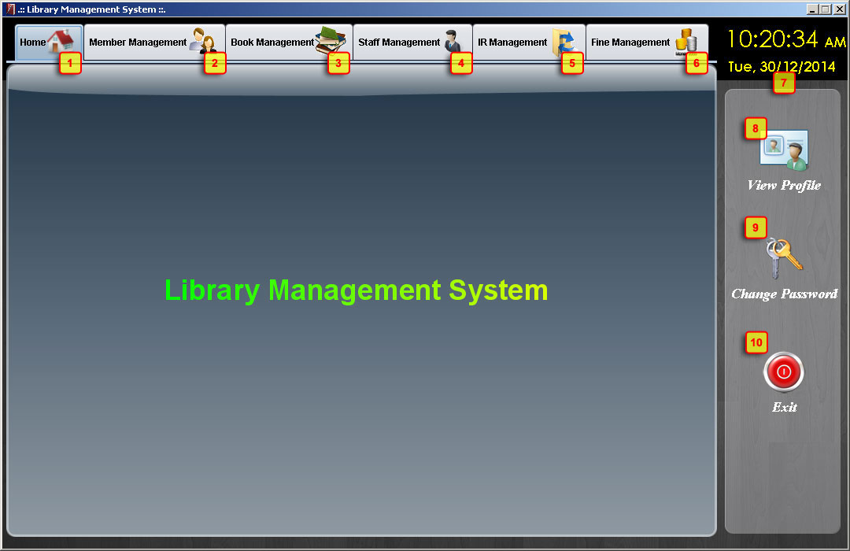

|  |  |  |  |  |
| --- | --- | --- | --- | --- |
| **No** | **Item** | **Type** | **Validation** | **Description** |
| 1 | Tab Home | Tab item |  | Default tab after login successful. |
| 2 | Tab Member Management | Tab item |  | Member Management menu(only for Member Account role and Admin) **Go to 6** |
| 3 | Tab Book Management | Tab item |  | Book Management menu(only for Book Account role and Admin) **Go to 7** |
| 4 | Tab Staff Management | Tab item |  | Staff Management menu(only for Admin) **Go to 8** |
| 5 | Tab IR Management | Tab item |  | Issue/Return Management(only for IR Account and Admin) **Go to 9** |
| 6 | Tab Fine Management | Tab item |  | Fine Management(only for Accounting Account and Admin) **Go to 10** |
| 7 | Current Datetime | Label |  | Show current Date time of system. |
| 8 | View Profile | Label |  | Click to show current user’s informations form. **Go to 4** |
| 9 | Change password | Label |  | Click to show change password form. **Go to 5** |
| 10 | Exit | Label |  | Exit program. |

1. **View Profile**

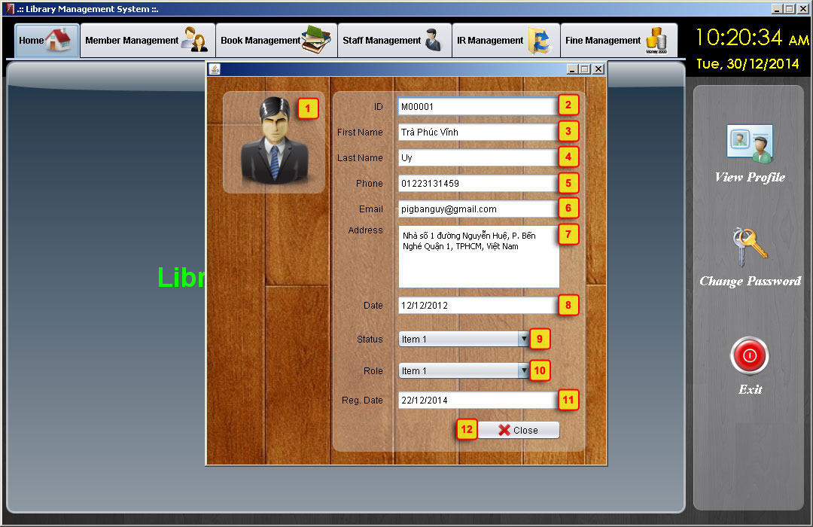

|  |  |  |  |  |
| --- | --- | --- | --- | --- |
| **No** | **Item** | **Type** | **Validation** | **Description** |
| 1 | Avatar | Image |  | Image avatar of Staff |
| 2 | ID | Text Field |  | Staff’s ID |
| 3 | First Name | Text Field |  | Staff’s first name. |
| 4 | Last Name | Text Field |  | Staff’s last name. |
| 5 | Phone | Text Field |  | Staff’s phone. |
| 6 | Email | Text Field |  | Staff’s email. |
| 7 | Address | Text Field |  | Staff’s address. |
| 8 | Date | Text Field |  | Staff’s date. |
| 9 | Status | Combobox |  | Staff’s status. |
| 10 | Role | Combobox |  | Staff’s role. |
|  | Register date | Text Field |  | Staff’s registered date. |
|  | Close | Button |  | Click to close profile form. |

1. **Change Password**

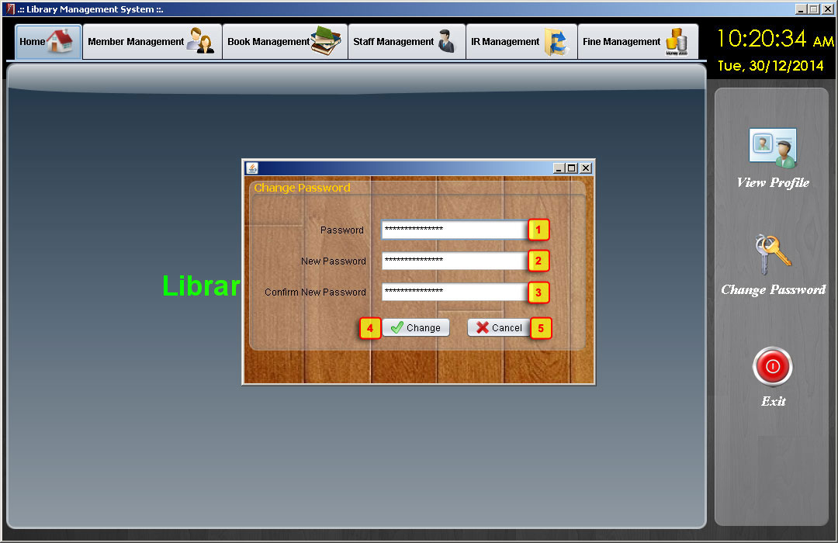

|  |  |  |  |  |
| --- | --- | --- | --- | --- |
| **No** | **Item** | **Type** | **Validation** | **Description** |
| 1 | Password | Text Field | Not blank | Server name: default localhost |
| 2 | New Password | Text Field | Not blank | Port:default 1433 |
| 3 | Confirm New Password | Text Field | Not blank | Database name: default LMS; |
| 4 | Change | Button |  | Click to check validation if OK password is changed. |
| 5 | Cancel | Button |  | Click to close change password form. |

1. **Member Management**

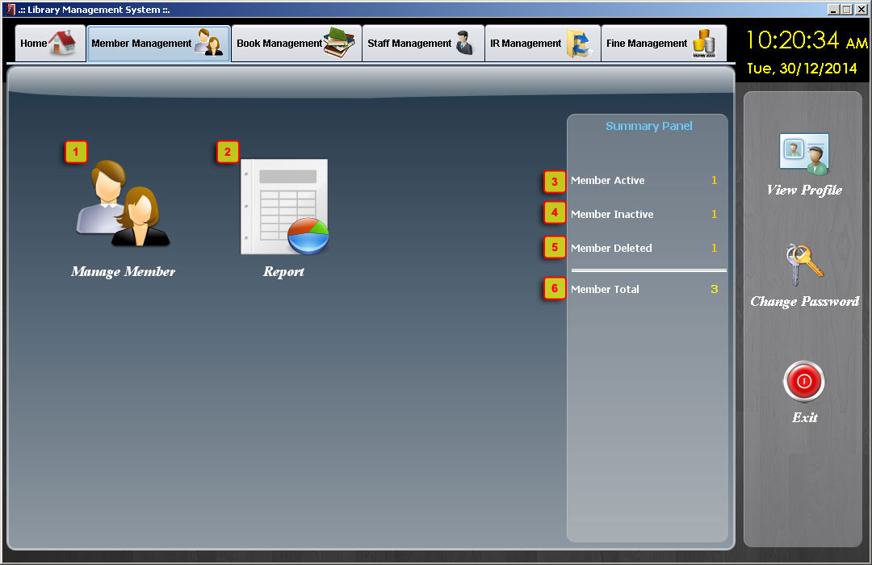

|  |  |  |  |  |
| --- | --- | --- | --- | --- |
| **No** | **Item** | **Type** | **Validation** | **Description** |
| 1 | Manage Member | Icon |  | Load Member List form |
| 2 | Report | Icon |  | Load report form |
| 3 | Member Active | Text Label |  | Display total member Active |
| 4 | Member Inactive | Text Label |  | Display total member Inactive |
| 5 | Member Deleted | Text Label |  | Display total member Deleted |
| 6 | Member Total | Text Label |  | Display total member |

1. **Book Management**

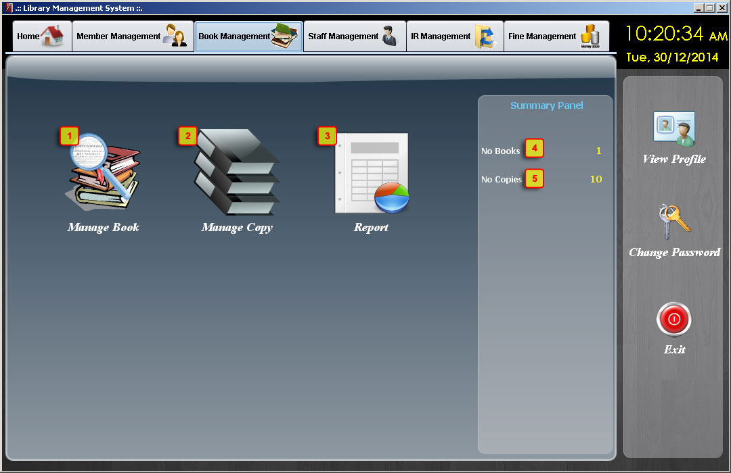

|  |  |  |  |  |
| --- | --- | --- | --- | --- |
| **No** | **Item** | **Type** | **Validation** | **Description** |
| 1 | Manage Book | Icon |  | Load Book List form |
| 2 | Manage Copy | Icon |  | Load Copy List form |
| 3 | Report | Icon |  | Load report form |
| 4 | No Books | Text Label |  | Display total Book |
| 5 | No Copies | Text Label |  | Display total Copy |

1. **Staff Management**

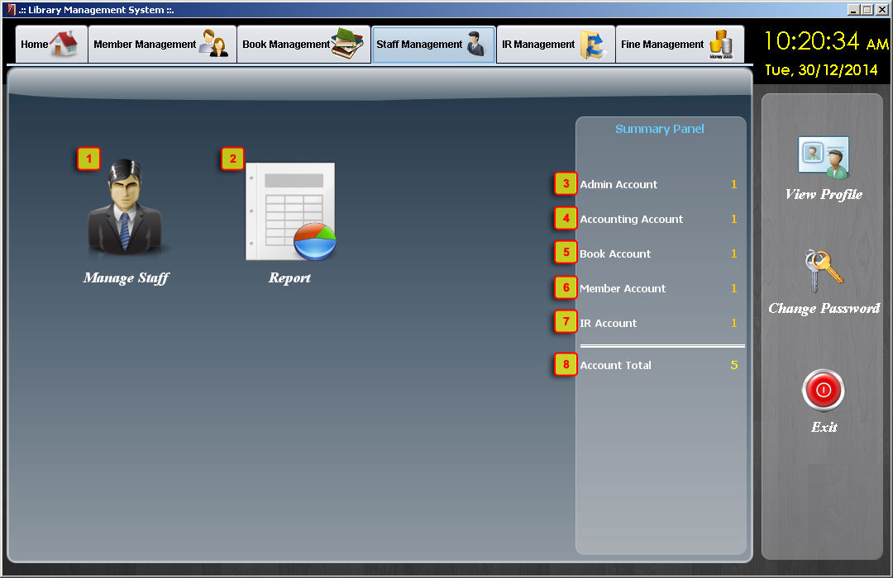

|  |  |  |  |  |
| --- | --- | --- | --- | --- |
| **No** | **Item** | **Type** | **Validation** | **Description** |
| 1 | Manage Staff | Icon |  | Load Staff List form |
| 2 | Report | Icon |  | Load Report form |
| 3 | Admin Account | Text Label |  | Display total Admin Account |
| 4 | Acounting Account | Text Label |  | Display total Accounting Account |
| 5 | Book Account | Text Label |  | Display total Book Account |
| 6 | Member Account | Text Label |  | Display total Member Account |
| 7 | IR Account | Text Label |  | Display total IR Account |
| 8 | Account Total | Text Label |  | Display total Staff |

1. **IR Management**

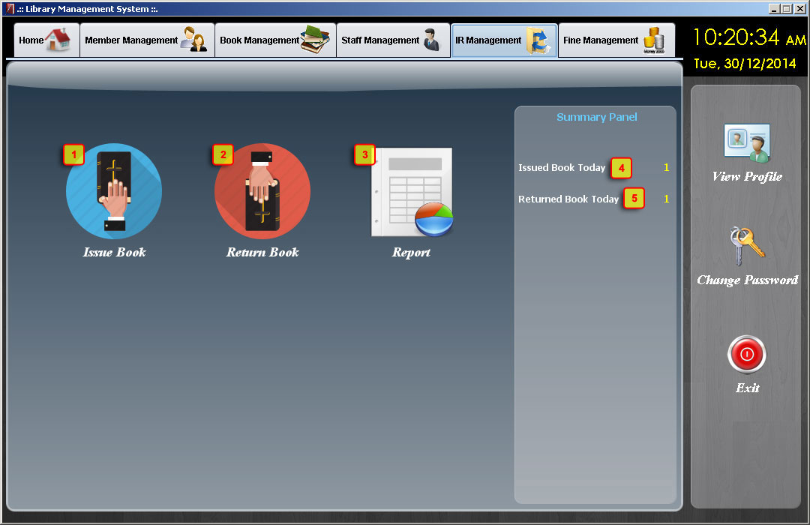

|  |  |  |  |  |
| --- | --- | --- | --- | --- |
| **No** | **Item** | **Type** | **Validation** | **Description** |
| 1 | Issue Book | Icon |  | Load Issue Book form |
| 2 | Return Bool | Icon |  | Load Return Book form |
| 3 | Report | Icon |  | Load Report form |
| 4 | Issue Book Today | Text Label |  | Display Total Issue in current day |
| 5 | Return Book Today | Text Label |  | Display Total Return in current day |

1. **Fine Management**

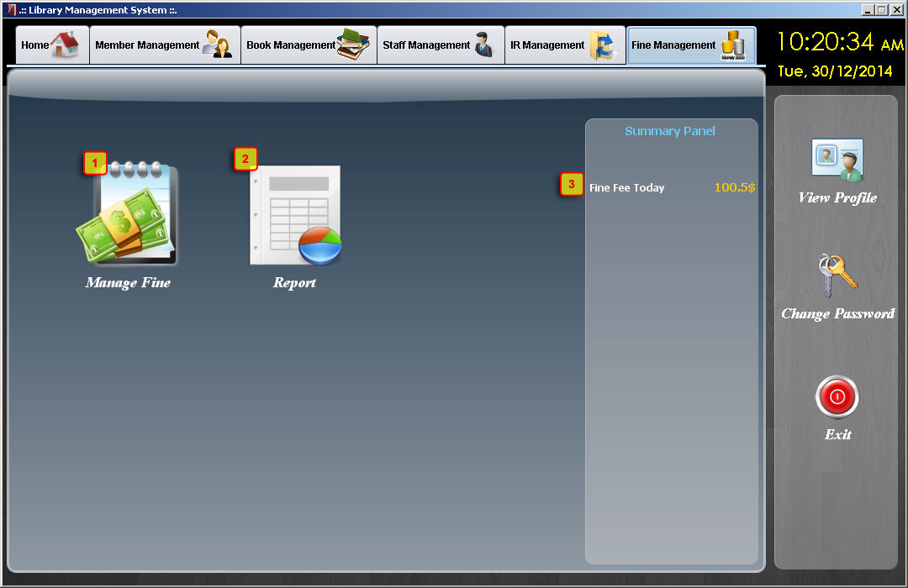

|  |  |  |  |  |
| --- | --- | --- | --- | --- |
| **No** | **Item** | **Type** | **Validation** | **Description** |
| 1 | Manage Fine | Icon |  | Load Fine Management form |
| 2 | Report | Icon |  | Load Report form |
| 3 | Fine Fee Today | Text Label |  | Display Total Fine Fee in current day |

1. **Member List**

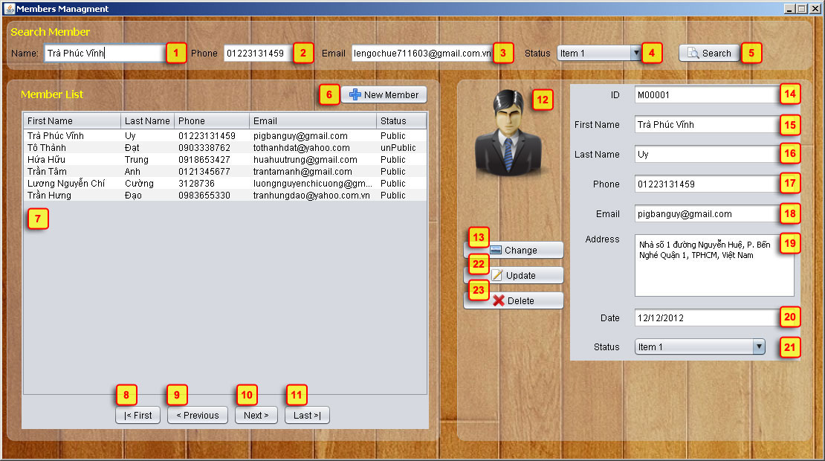

|  |  |  |  |  |
| --- | --- | --- | --- | --- |
| **No** | **Item** | **Type** | **Validation** | **Description** |
|  | Name | Text Field |  | Member’s name for filter |
|  | Phone | Text Field |  | Member’s phone for filter |
|  | Email | Text Field |  | Member’s email for filter |
|  | Status | ComboBox |  | Member’s status for filter |
|  | Search button | Button |  | Click to search and display result in the table below |
|  | Add New Member button | Button |  | In the right side, form add member will be reset all field and Update button change to Save button |
|  | Member list | Table |  | Display member list. Default all member  When select a record, Update button and Delete button is enabled |
|  | First | Button |  | Go to the First Page |
|  | Previous | Button |  | Go to Previous Page |
|  | Next | Button |  | Go to Next Page |
|  | Last | Button |  | Go to Last Page |
|  | Member avatar | Image |  | In Update mode, display member avatar. In Add New mode, display no avatar image |
|  | Change Cover button | Button |  | Open File Chooser control |
|  | ID | Text Field | Not Blank | Can not edit. Auto generate ID |
|  | First name | Text Field | Not Blank, Text, 30 |  |
|  | Last name | Text Field | Not Blank, Text, 50 |  |
|  | Phone | Text Field | Number 20 |  |
|  | Email | Text Field | Not Blank 50 |  |
|  | Address | Text Area |  |  |
|  | Date | Text Field | Not Blank | Add New mode: Get current date  Update mode: display data only |
|  | Status | Combobox |  |  |
|  | Update button | Button |  | Default is disable.  When clicked, Update button change to Save button |
|  | Delete button | Button |  | Default is disable.  When clicked, delete the record selected in table. |

1. **Book List**

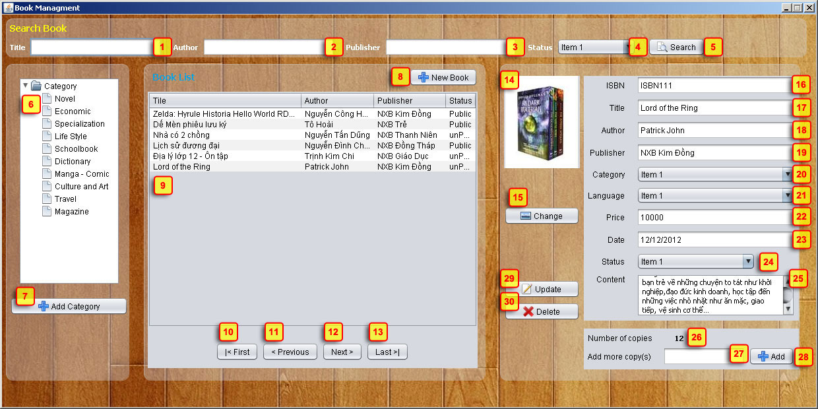

|  |  |  |  |  |
| --- | --- | --- | --- | --- |
| **No** | **Item** | **Type** | **Validation** | **Description** |
| 1 | Title | Text Field |  | Book Title for filter |
| 2 | Author | Text Field |  | Book Author for filter |
| 3 | Publisher | Text Field |  | Book Publisher for filter |
| 4 | Status | Text Field |  | Book Status for filter |
| 5 | Search Button | Button |  | Display search result at list Book below |
| 6 | Category list | Tree |  | Display all Category of Book |
| 7 | Add Category | Button |  | Load Add Category Form (admin Role only) |
| 8 | New Book | Button |  | In the right side, form Add Book will be reset all field and Update button change to Save button |
| 9 | Book List | Table |  | Display list of Book |
| 10 | First | Button |  | Go to the First Page |
| 11 | Previous | Button |  | Go to Previous Page |
| 12 | Next | Button |  | Go to Next Page |
| 13 | Last | Button |  | Go to Last Page |
| 14 | Cover image | Image |  | In Update mode, display book cover.  In Add New mode, display no cover image |
| 15 | Change button | Button |  | Open File Chooser control |
| 16 | ISBN | Text Field | Not null, format | In update mode, can not edit |
| 17 | Book Title | Text Field | Not null, max 50 |  |
| 18 | Author | Text Field | Not null, max 50 |  |
| 19 | Publisher | Text Field | Not null, max 50 |  |
| 20 | Category |  | Not null |  |
| 21 | Language |  | Not null |  |
| 22 | Price | Text Field | Not null, >=0 |  |
| 23 | Date |  | Not null | Add New mode: Get current date  Update mode: display data only |
| 24 | Status | Combobox | Not null |  |
| 25 | Content |  |  |  |
| 26 | Number of Copy | Label |  | Display current number of copies |
| 27 | Input Number of Copy | Text Field | Not null, >0, int | Input number of copy |
| 28 | Add Copy | Button |  | Insert n records copy to database |
| 29 | Update | Button |  | Default is disable.  When clicked, Update button change to Save button |
| 30 | Delete | Button |  | Default is disable.  When clicked, delete the record selected in table. |

* Note:

- If current page is first page, First button and Previous button is disabled.

- If current page is last page, Last button and Next button is disabled.

1. **Category List**

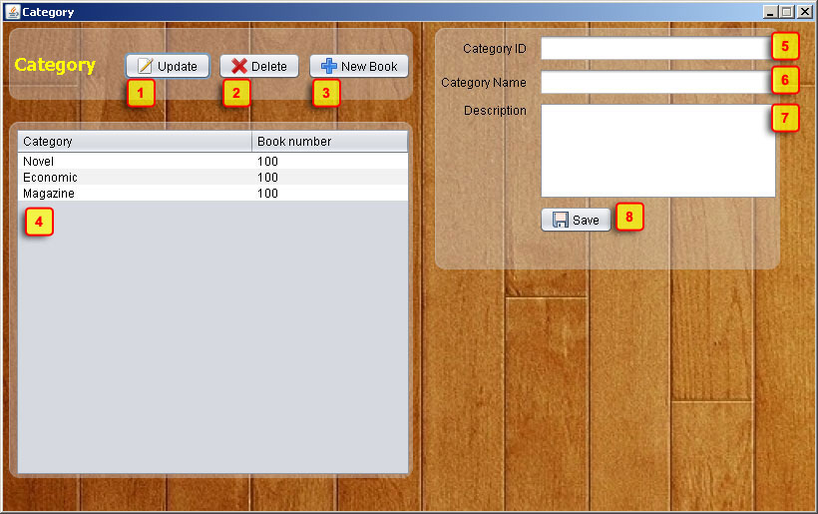

|  |  |  |  |  |
| --- | --- | --- | --- | --- |
| **No** | **Item** | **Type** | **Validation** | **Description** |
| 1 | Update | Button |  | Default is disable, enable if click an item on category list, and enable form update |
| 2 | Delete | Button |  | Default is disable, enable if click an item on category list. Click to disable that item. |
| 3 | New Book | Button |  | Click to clear text and enable insert form. |
| 4 | Category List | Table |  | Instance name of Database(let blank if not have instance) |
| 5 | Category ID | Text Field |  | Default is disable, ID auto generate |
| 6 | Category Name | Text Field | Not blank | Category’s name. |
| 7 | Description | Text Field |  | Category’s description. |
| 8 | Save | Button |  | Click to insert new item or update chosen item on category list. |

1. **Staff List**

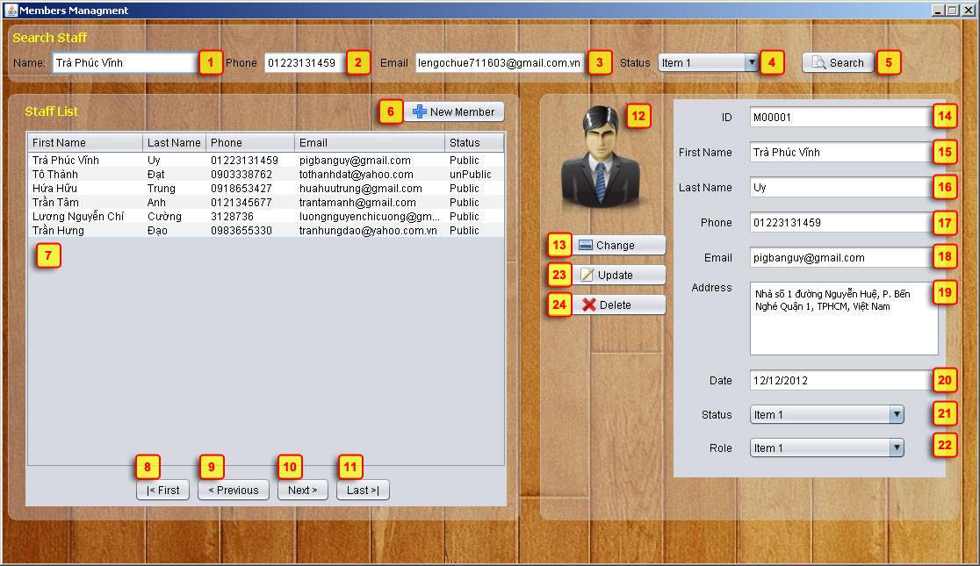

|  |  |  |  |  |
| --- | --- | --- | --- | --- |
| **No** | **Item** | **Type** | **Validation** | **Description** |
| 1 | Name | Text Field |  | Staff Name for filter |
| 2 | Phone | Text Field |  | Staff Phone for filter |
| 3 | Email | Text Field |  | Staff Email for filter |
| 4 | Status | Text Field |  | Book Status for filter |
| 5 | Search Button | Button |  | Display search result at list Staff below |
| 6 | New Member | Button |  | Add new Member(admin Role only) |
| 7 | Staff List | Table |  | Display list of Staff |
| 8 | First | Button |  | Go to the first page |
| 9 | Previous | Button |  | Go to the previous page |
| 10 | Next | Button |  | Go to the next page |
| 11 | Last | Button |  | Go to the last page |
| 12 | Cover image | Image | Not null | In New Member mode, display no cover image |
| 13 | Change | Button |  | Display change cover image of staff |
| 14 | ID | Text Field | Not null, max 36 | ID of staff |
| 15 | First Name | Text Field |  | First name of Staff |
| 16 | Last Name | Text Field |  | Last name of Staff |
| 17 | Phone | Text Field |  | Phone of Staff |
| 18 | Email | Text Field | Not null, max 50 | Email of Staff |
| 19 | Address | Text Field |  | Address of Staff |
| 20 | Date | Text Field | Not null | Create Date of Staff |
| 21 | Status | ComboBox |  | Status of Staff |
| 22 | Role | ComboBox |  | Role of Staff |
| 23 | Update | Button |  | Display Update Staff mode (admin role only) |
| 24 | Delete | Button |  | Display Delete Staff(admin role only) |

1. **Issue**

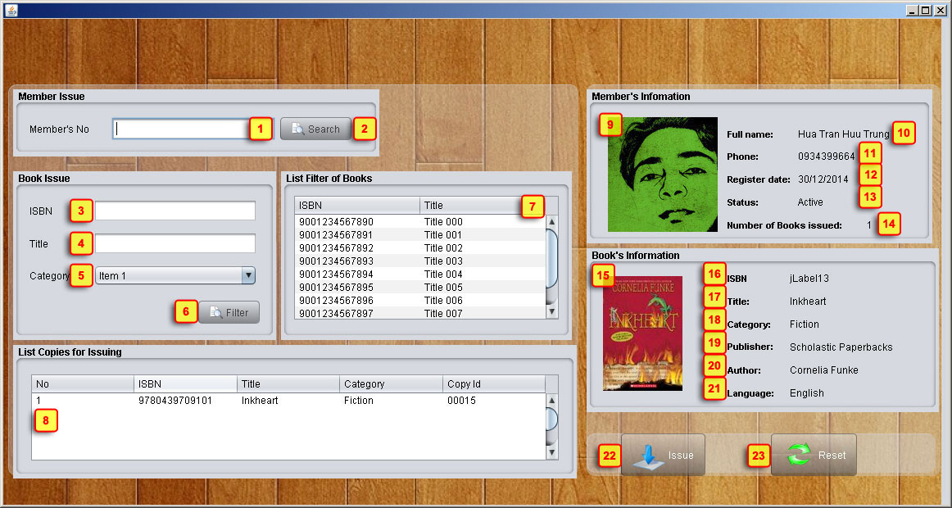

|  |  |  |  |  |
| --- | --- | --- | --- | --- |
| **No** | **Item** | **Type** | **Validation** | **Description** |
| 1 | Member No | Text Field | Not Blank | Member’s Number code. |
| 2 | Search | Button |  | Show member search box, disable issue form. **Go to 16** |
| 3 | ISBN | Text Field |  | Book’s ISBN to filter, let blank to skip search by ISBN. |
| 4 | Title | Text Field |  | Book’s title to filter, let blank to skip search by title. |
| 5 | Category | ComboBox |  | Book’s category to filter, choose item “All” to skip search by category. |
| 6 | Filter | Button |  | Click to show list filter of book by ISBN,Title,Category. |
| 7 | List filter of Book | Table |  | Result list filter of book. Double click to insert List copy for issuing. |
| 8 | List Copy for Issuing | Table |  | Result list copy for issuing . Double click item to remove. |
| 9 | Member Avatar | Image |  | Member’s image. |
| 10 | Full name | Label |  | Member’s full name. |
| 11 | Phone | Label |  | Member’s phone. |
| 12 | Register date | Label |  | Member’s register date. |
| 13 | Status | Label |  | Member’s status. |
| 14 | Number of Books issued | Label |  | Member’s books was issued which have not returned yet. |
| 15 | Book cover | Image |  | Book’s cover image. |
| 16 | ISBN | Label |  | Book’s ISBN |
| 17 | Title | Label |  | Book’s title |
| 18 | Category | Label |  | Book’s category |
| 19 | Publisher | Label |  | Book’s publisher |
| 20 | Author | Label |  | Book’s author. |
| 21 | Language | Label |  | Book’s language |
| 22 | Issue | Button |  | Click to validate, if OK then process for issuing. |
| 23 | Cancel | Button |  | Click to close issue form. |

1. **Member search box**

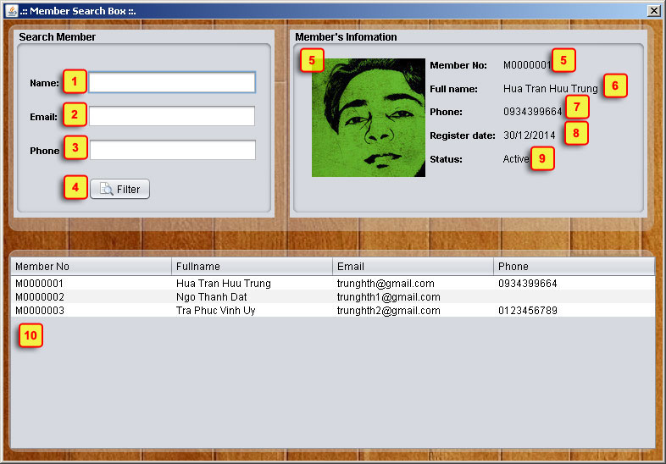

|  |  |  |  |  |
| --- | --- | --- | --- | --- |
| **No** | **Item** | **Type** | **Validation** | **Description** |
| 1 | Name | Text Field |  | Member’s Name to filter(first or last name), let blank to skip search by name |
| 2 | Email | Text Field |  | Member’s email to filter, let blank to skip search by email |
| 3 | Phone | Text Field |  | Member’s phone to filter, let blank to skip search by phone |
| 4 | Filter | Button |  | Click to filter member by Name, Email, Phone. |
| 5 | Member No | Label |  | Member’s number code. |
| 6 | Full name | Label |  | Member’s full name. |
| 7 | Phone | Label |  | Member’s phone. |
| 8 | Register date | Label |  | Member’s register date. |
| 9 | Status | Label |  | Member’s status. |
| 10 | List filter of member | Table |  | List member by filtering |

1. **Return**

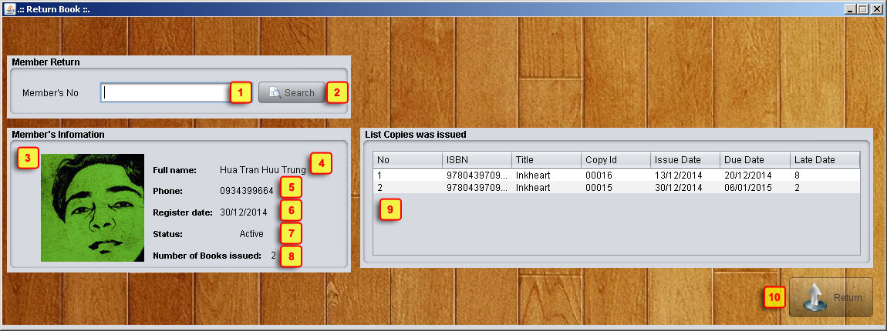

|  |  |  |  |  |
| --- | --- | --- | --- | --- |
| **No** | **Item** | **Type** | **Validation** | **Description** |
| 1 | Member No | Text Field | Not Blank | Member’s Number code. |
| 2 | Search | Button |  | Show member search box, disable return form. **Go to 16** |
| 3 | Member Avatar | Image |  | Member’s image. |
| 4 | Full name | Label |  | Member’s full name. |
| 5 | Phone | Label |  | Member’s phone. |
| 6 | Register date | Label |  | Member’s register date. |
| 7 | Status | Label |  | Member’s status. |
| 8 | Number of Books issued | Label |  | Member’s books was issued which have not returned yet. |
| 9 | List Copy was issued | Table |  | List detail of books was issued which have not returned yet |
| 10 | Return | Button |  | Click to process return all books were issued |

1. **Fine**

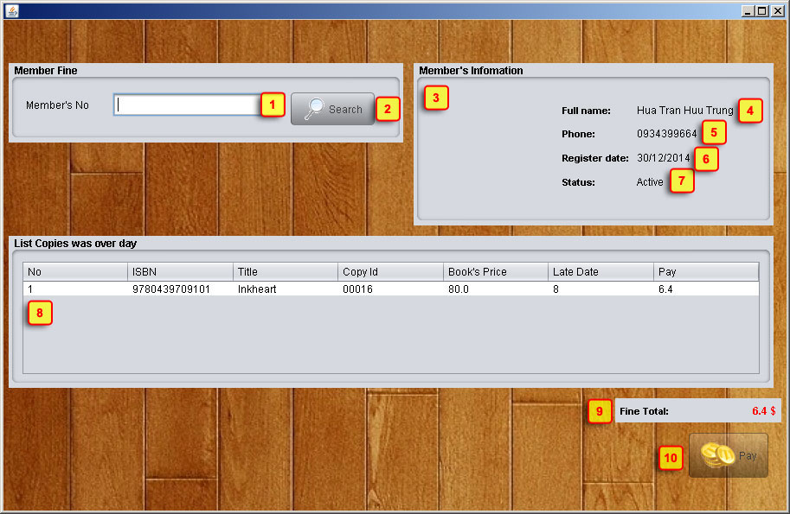

|  |  |  |  |  |
| --- | --- | --- | --- | --- |
| **No** | **Item** | **Type** | **Validation** | **Description** |
| 1 | Member No | Text Field | Not Blank | Member’s Number code. |
| 2 | Search | Button |  | Show member search box, disable fine form. **Go to 16** |
| 3 | Member Avatar | Image |  | Member’s image. |
| 4 | Full name | Label |  | Member’s full name. |
| 5 | Phone | Label |  | Member’s phone. |
| 6 | Register date | Label |  | Member’s register date. |
| 7 | Status | Label |  | Member’s status. |
| 8 | Number of Books issued | Label |  | Member’s books was issued which have not returned yet. |
| 9 | List Copy was issued | Table |  | List detail of books was issued which have not returned yet |
| 10 | Return | Button |  | Click to process return all books were issued |

1. **Task Sheet**

|  |  |  |  |  |  |  |
| --- | --- | --- | --- | --- | --- | --- |
| **Project Ref.No: 3** | | **Project Title:**  **Library Management System** | **Date of Preparation of Activity Plan** | | | |
| **Sr. No.** | **Task** | | **Actual Start Date** | **Actual Days** | **Team Member Names** | **Status** |
| 01 | View Profile, Change Password | | Jan, 02, 2015 | 7 | Tô Thành Đạt | Completed |
| 02 | Member Management, Staff Management | | Completed |
| 03 | Login, Setting Server | | Tra Phuc Vinh Uy | Completed |
| 04 | Book Management, Copy Management, Category Management | | Completed |
| 05 | Main form, Member search box, | | Hua Tran Huu Trung | Completed |
| 06 | Issue Book, Return Book, Fine Management | | Completed |

|  |  |  |
| --- | --- | --- |
|  | Prepare By: Group 3 | Approved By: Faculty |
| Date: Jan, 2015 | Team Leader  **Hua Tran Huu Trung** | **Dao Ngoc Anh** |