|  |  |  |
| --- | --- | --- |
| D:\Aptech - FPT\semester 2\eProject\documentation\LogoAptech.png | D:\Aptech - FPT\semester 2\eProject\documentation\LogoAptech.png | D:\Aptech - FPT\semester 2\eProject\documentation\LogoAptech.png |

Center Name: ACE-HCMC-2-FPT (VN.033).

Address: 590 Cach Mang Thang 8 Street, District 3, Ho Chi Minh City, Vietnam.



**LOAN PROCESSING SYSTEM**

**Design Document**

|  |  |  |  |
| --- | --- | --- | --- |
| **Faculty:** |  | **Ms. Dao Ngoc Anh** |  |
| **Batch No:** |  | **F21405-T0** |  |
| **Group No.:** |  | **3** |  |
| **Students:** |  | **Fullname** | **Roll No.** |
|  | 1. | Hứa Trần Hữu Trung | Student812912 |
|  | 2. | Tô Thành Đạt | Student813016 |
|  | 3. | Trà | student740223 |
|  |

**Dec, 2014**

## Member List

## 

|  |  |  |  |  |
| --- | --- | --- | --- | --- |
| **No** | **Item** | **Type** | **Validation** | **Description** |
| 1 | First Name | Text Field |  | Member first name for filter |
| 2 | Last Name | Text Field |  | Member last name for filter |
| 3 | Phone | Text Field |  | Member phone for filter |
| 4 | Email | Text Field |  | Member email for filter |
| 5 | Status | ComboBox |  | Member status for filter |
| 6 | Search button | Button |  | Click to search and display result in the table below |
| 7 | Add New Member button | Button |  | In the right side, form add member will be reset all field and Update button change to Save button |
| 8 | Member list | Table |  | Display member list. Default all member  When select a record, Update button and Delete button is enabled |
| 9 | First | Button |  | Go to the First Page |
| 10 | Previous | Button |  | Go to Previous Page |
| 11 | Next | Button |  | Go to Next Page |
| 12 | Last | Button |  | Go to Last Page |
| 13 | Member avatar | Image |  | In Update mode, display member avatar. In Add New mode, display no avatar image |
| 14 | Change Cover button | Buttom |  | Open File Chooser control |
| 15 | ID | Text Field | Not null | Can not edit. Auto generate ID |
| 16 | First name | Text Field | Not null, Text, 30 |  |
| 17 | Last name | Text Field | Not null, Text, 50 |  |
| 18 | Phone | Text Field | Number 20 |  |
| 19 | Email | Text Field | Not null 50 |  |
| 20 | Address | Text Area |  |  |
| 21 | Date | Text Field | Not null | Add New mode: Get current date  Update mode: display data only |
| 22 | Status | Combobox | Not null |  |
| 23 | Update button | Button |  | Default is disable.  When clicked, Update button change to Save button |
| 24 | Delete button | Button |  | Default is disable.  When clicked, delete the record selected in table. |

## Book List

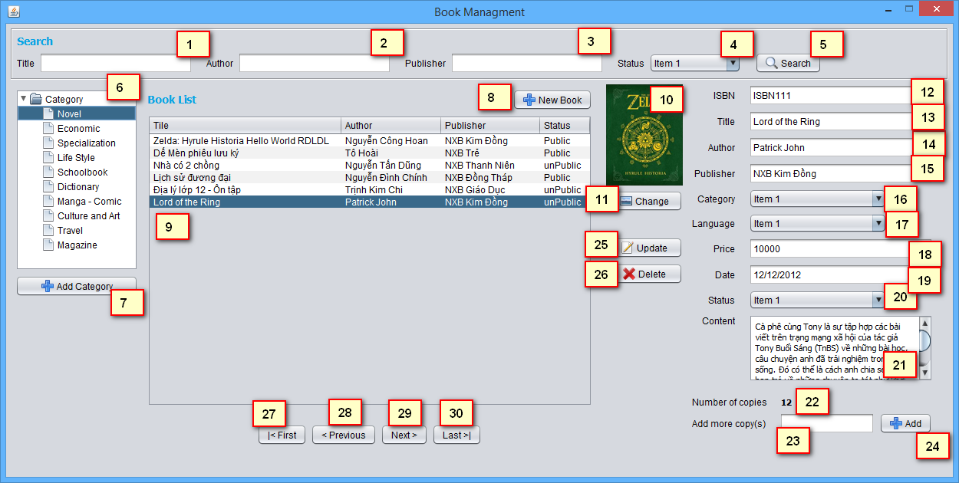

|  |  |  |  |  |
| --- | --- | --- | --- | --- |
| **No** | **Item** | **Type** | **Validation** | **Description** |
| 1 | Title | Text Field |  | Book Title for filter |
| 2 | Author | Text Field |  | Book Author for filter |
| 3 | Publisher | Text Field |  | Book Publisher for filter |
| 4 | Status | Text Field |  | Book Status for filter |
| 5 | Search Button | Button |  | Display search result at list Book below |
| 6 | Category list | Tree |  | Display all Category of Book |
| 7 | Add Category | Button |  | Load Add Category Form (admin Role only) |
| 8 | New Book | Button |  | In the right side, form Add Book will be reset all field and Update button change to Save button |
| 9 | Book List | Table |  | Display list of Book |
| 10 | Cover image | Image |  | In Update mode, display book cover.  In Add New mode, display no cover image |
| 11 | Change button | Button |  | Open File Chooser control |
| 12 | ISBN | Text Field | Not null, format | In update mode, can not edit |
| 13 | Book Title | Text Field | Not null, max 50 |  |
| 14 | Author | Text Field | Not null, max 50 |  |
| 15 | Publisher | Text Field | Not null, max 50 |  |
| 16 | Category |  | Not null |  |
| 17 | Language |  | Not null |  |
| 18 | Price | Text Field | Not null, >=0 |  |
| 19 | Date |  | Not null | Add New mode: Get current date  Update mode: display data only |
| 20 | Status | Combobox | Not null |  |
| 21 | Content |  |  |  |
| 22 | Number of Copy | Label |  | Display current number of copies |
| 23 | Input Number of Copy | Text Field | Not null, >0, int | Input number of copy |
| 24 | Add Copy | Button |  | Insert n records copy to database |
| 25 | Update | Button |  | Default is disable.  When clicked, Update button change to Save button |
| 26 | Delete | Button |  | Default is disable.  When clicked, delete the record selected in table. |
| 27 | First | Button |  | Go to the First Page |
| 28 | Previous | Button |  | Go to Previous Page |
| 29 | Next | Button |  | Go to Next Page |
| 30 | Last | Button |  | Go to Last Page |

* Note:

- If current page is first page, First button and Previous button is disabled

- If current page is last page, Last button and Next button is disabled

## Copies List

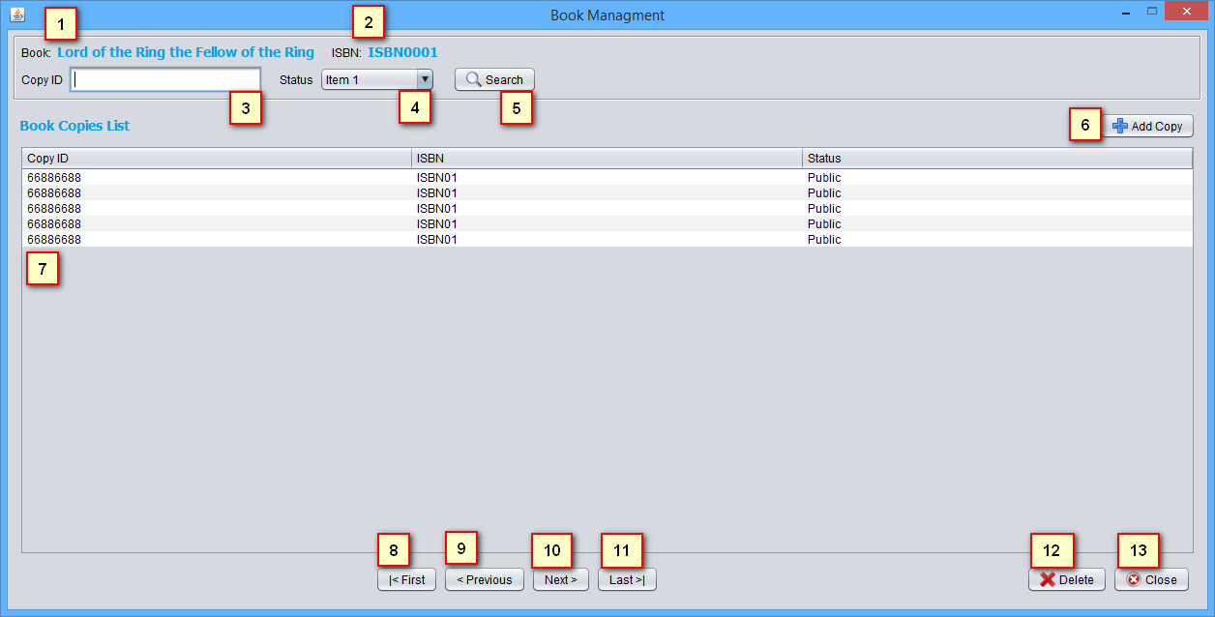

|  |  |  |  |  |
| --- | --- | --- | --- | --- |
| **No** | **Item** | **Type** | **Validation** | **Description** |
| 1 | Book Title | Label |  | Display current book Title |
| 2 | Book ISBN | Label |  | Display current book ISBN |
| 3 | CopyID | Text Field |  | Copy ID for filter |
| 4 | Status | Combo box |  | Copy Status for filter |
| 5 | Search button | Button |  | Display search result at Copy list below |
| 6 | Add Copy button | Button |  | Load Add Copy form |
| 7 | Copy list | Table |  | Display list copy of current Book |
| 8 | First | Button |  | Go to the First Page |
| 9 | Previous | Button |  | Go to Previous Page |
| 10 | Next | Button |  | Go to Next Page |
| 11 | Last | Button |  | Go to Last Page |
| 12 | Delete button | Button |  | Delete selected copy |
| 13 | Close | Button |  | Close Form |

* Note:

- If current page is first page, First button and Previous button is disabled

- If current page is last page, Last button and Next button is disabled