## Login

## 

## Setting

## 

## Main Form

## 

|  |  |  |  |  |
| --- | --- | --- | --- | --- |
| **No** | **Item** | **Type** | **Validation** | **Description** |
| 1 | Home | Tab |  | Select Home tab |
| 2 | Member Management | Tab |  | Select Member Management tab |
| 3 | Book Management | Tab |  | Select Book Management tab |
| 4 | Staff Management | Tab |  | Select Staff Management tab |
| 5 | IR Management | Tab |  | Select IR Management tab |
| 6 | Fine Management | Tab |  | Select Fine Management tab |
| 7 | Current  Date – Time | Text Label |  | Display current Date – Time |
| 8 | View Profile | Icon |  | Load Staff Profile form |
| 9 | Chang Password | Icon |  | Load Chang Password form |
| 10 | Exit | Icon |  | Exit Application |

## 

|  |  |  |  |  |
| --- | --- | --- | --- | --- |
| **No** | **Item** | **Type** | **Validation** | **Description** |
| 1 | Manage Member | Icon |  | Load Member List form |
| 2 | Report | Icon |  | Load report form |
| 3 | Member Active | Text Label |  | Display total member Active |
| 4 | Member Inactive | Text Label |  | Display total member Inactive |
| 5 | Member Deleted | Text Label |  | Display total member Deleted |
| 6 | Member Total | Text Label |  | Display total member |

## 

|  |  |  |  |  |
| --- | --- | --- | --- | --- |
| **No** | **Item** | **Type** | **Validation** | **Description** |
| 1 | Manage Book | Icon |  | Load Book List form |
| 2 | Manage Copy | Icon |  | Load Copy List form |
| 3 | Report | Icon |  | Load report form |
| 4 | No Books | Text Label |  | Display total Book |
| 5 | No Copies | Text Label |  | Display total Copy |

## 

|  |  |  |  |  |
| --- | --- | --- | --- | --- |
| **No** | **Item** | **Type** | **Validation** | **Description** |
| 1 | Manage Staff | Icon |  | Load Staff List form |
| 2 | Report | Icon |  | Load Report form |
| 3 | Admin Account | Text Label |  | Display total Admin Account |
| 4 | Acounting Account | Text Label |  | Display total Accounting Account |
| 5 | Book Account | Text Label |  | Display total Book Account |
| 6 | Member Account | Text Label |  | Display total Member Account |
| 7 | IR Account | Text Label |  | Display total IR Account |
| 8 | Account Total | Text Label |  | Display total Staff |

## 

|  |  |  |  |  |
| --- | --- | --- | --- | --- |
| **No** | **Item** | **Type** | **Validation** | **Description** |
| 1 | Issue Book | Icon |  | Load Issue Book form |
| 2 | Return Bool | Icon |  | Load Return Book form |
| 3 | Report | Icon |  | Load Report form |
| 4 | Issue Book Today | Text Label |  | Display Total Issue in current day |
| 5 | Return Book Today | Text Label |  | Display Total Return in current day |

## 

|  |  |  |  |  |
| --- | --- | --- | --- | --- |
| **No** | **Item** | **Type** | **Validation** | **Description** |
| 1 | Manage Fine | Icon |  | Load Fine Management form |
| 2 | Report | Icon |  | Load Report form |
| 3 | Fine Fee Today | Text Label |  | Display Total Fine Fee in current day |

## View Profile

## 

## Change Password

## 

## Member List

## 

|  |  |  |  |  |
| --- | --- | --- | --- | --- |
| **No** | **Item** | **Type** | **Validation** | **Description** |
| 1 | First Name | Text Field |  | Member first name for filter |
| 2 | Last Name | Text Field |  | Member last name for filter |
| 3 | Phone | Text Field |  | Member phone for filter |
| 4 | Email | Text Field |  | Member email for filter |
| 5 | Status | ComboBox |  | Member status for filter |
| 6 | Search button | Button |  | Click to search and display result in the table below |
| 7 | Add New Member button | Button |  | In the right side, form add member will be reset all field and Update button change to Save button |
| 8 | Member list | Table |  | Display member list. Default all member  When select a record, Update button and Delete button is enabled |
| 9 | First | Button |  | Go to the First Page |
| 10 | Previous | Button |  | Go to Previous Page |
| 11 | Next | Button |  | Go to Next Page |
| 12 | Last | Button |  | Go to Last Page |
| 13 | Member avatar | Image |  | In Update mode, display member avatar. In Add New mode, display no avatar image |
| 14 | Change Cover button | Buttom |  | Open File Chooser control |
| 15 | ID | Text Field | Not null | Can not edit. Auto generate ID |
| 16 | First name | Text Field | Not null, Text, 30 |  |
| 17 | Last name | Text Field | Not null, Text, 50 |  |
| 18 | Phone | Text Field | Number 20 |  |
| 19 | Email | Text Field | Not null 50 |  |
| 20 | Address | Text Area |  |  |
| 21 | Date | Text Field | Not null | Add New mode: Get current date  Update mode: display data only |
| 22 | Status | Combobox | Not null |  |
| 23 | Update button | Button |  | Default is disable.  When clicked, Update button change to Save button |
| 24 | Delete button | Button |  | Default is disable.  When clicked, delete the record selected in table. |

## Report Book Isues History

## 

## History Report

|  |  |  |  |  |
| --- | --- | --- | --- | --- |
|  | Member ID: 9858475Member Name: Tran Hung Dao | | | |
| Issue Date | Book Name | Author | Return Date | Fine |
| 12/12/2014 | Taken 3 | Liam Neeson | 13/12/2014 | 5000 |
| 12/12/2014 | Lord of the Ring | Tokyo Dekhi | 13/12/2014 |  |
| 12/12/2014 | Last Summer | Harley Davinson | 13/12/2014 |  |
| 12/12/2014 | Nicolas | Cate Wilson | 13/12/2014 |  |
| 12/12/2014 | Look Around | Liam Neeson | 13/12/2014 | 5000 |
| 12/12/2014 | Taken 3 | Liam Neeson | 13/12/2014 |  |
|  |  |  | Print Date: | 22/12/2014 |

## Book List

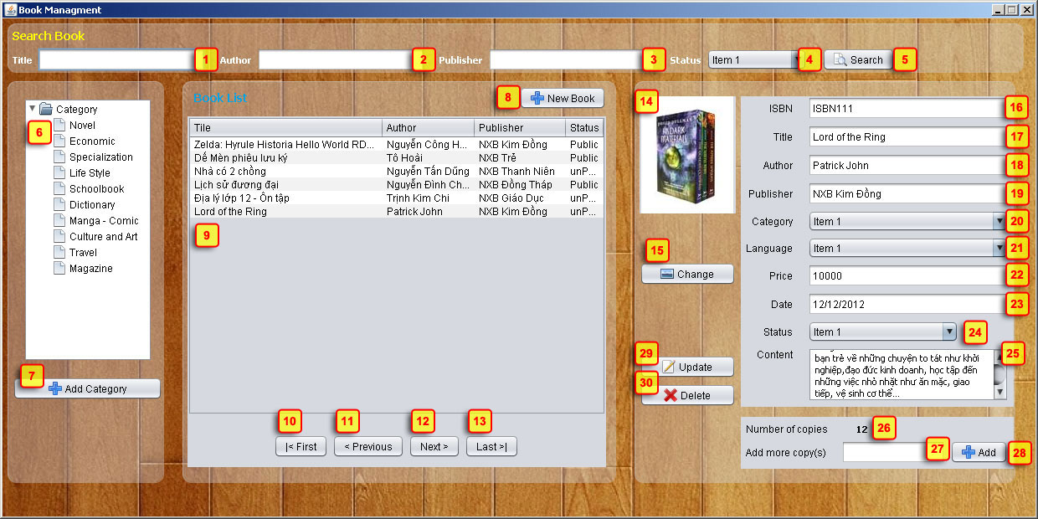

|  |  |  |  |  |
| --- | --- | --- | --- | --- |
| **No** | **Item** | **Type** | **Validation** | **Description** |
| 1 | Title | Text Field |  | Book Title for filter |
| 2 | Author | Text Field |  | Book Author for filter |
| 3 | Publisher | Text Field |  | Book Publisher for filter |
| 4 | Status | Text Field |  | Book Status for filter |
| 5 | Search Button | Button |  | Display search result at list Book below |
| 6 | Category list | Tree |  | Display all Category of Book |
| 7 | Add Category | Button |  | Load Add Category Form (admin Role only) |
| 8 | New Book | Button |  | In the right side, form Add Book will be reset all field and Update button change to Save button |
| 9 | Book List | Table |  | Display list of Book |
| 10 | Cover image | Image |  | In Update mode, display book cover.  In Add New mode, display no cover image |
| 11 | Change button | Button |  | Open File Chooser control |
| 12 | ISBN | Text Field | Not null, format | In update mode, can not edit |
| 13 | Book Title | Text Field | Not null, max 50 |  |
| 14 | Author | Text Field | Not null, max 50 |  |
| 15 | Publisher | Text Field | Not null, max 50 |  |
| 16 | Category |  | Not null |  |
| 17 | Language |  | Not null |  |
| 18 | Price | Text Field | Not null, >=0 |  |
| 19 | Date |  | Not null | Add New mode: Get current date  Update mode: display data only |
| 20 | Status | Combobox | Not null |  |
| 21 | Content |  |  |  |
| 22 | Number of Copy | Label |  | Display current number of copies |
| 23 | Input Number of Copy | Text Field | Not null, >0, int | Input number of copy |
| 24 | Add Copy | Button |  | Insert n records copy to database |
| 25 | Update | Button |  | Default is disable.  When clicked, Update button change to Save button |
| 26 | Delete | Button |  | Default is disable.  When clicked, delete the record selected in table. |
| 27 | First | Button |  | Go to the First Page |
| 28 | Previous | Button |  | Go to Previous Page |
| 29 | Next | Button |  | Go to Next Page |
| 30 | Last | Button |  | Go to Last Page |

* Note:

- If current page is first page, First button and Previous button is disabled

- If current page is last page, Last button and Next button is disabled

## Category List

## 

## Staff List

## 

## Book Issue

## 

## 

## Book Return

## 

## Fine

## 