DEMO 1:

CLUSTER INFORMATION :-
ONOS instances (username:onos, password: root ) | Ip address
ONOS instance 1 | 172.19.37.52
ONOS instance 2 | 172.19.37.53
ONOS instance 3 | 172.19.37.54

TOPOLOGY DEVICE :-
Device's | Ip address
RT1 | 172.19.37.161(user/pwd : telnet_admin/Huawei@123)
RT2 | 172.19.37.162(user/pwd : telnet_admin/Huawei@123)

DEMO 2:

CLUSTER INFORMATION :-
ONOS instances (username:onos, password: root ) | Ip address
ONOS instance 1 | 172.19.37.250
ONOS instance 2 | 172.19.37.253
ONOS instance 3 | 172.19.37.254

TOPOLOGY DEVICE :-
Device's | Ip address
RT1 | 172.19.37.179(user/pwd : telnet_admin/Huawei@123)
RT2 | 172.19.37.180(user/pwd : telnet_admin/Huawei@123)

Step2:-(https://github.com/huawei-adarsh/Demo1/tree/master/Final_json)
Import Demo1.postman_collection.json to postman.
Import Demo2.postman_collection.json to postman.

Step3:-
Demo operation steps (on ONOS and Devices).

Start VPN(one time on PC):(https://github.com/huawei-adarsh/Demo1/blob/master/ARRAY_VPN_CLIENT.tar)
Copy Array_vpn:
cd /ARRAY_VPN_CLIENT
./hacakathon_vpn_server_connect.py

Start ONOS(if onos is not started):

Demo 1 Env:
ssh onos@172.19.37.52 (pwd:root)
tar -zxvf onos.tar.gz
cd onos-1.10.0-SNAPSHOT/apache-karaf-3.0.8/bin
./karaf clean
ssh onos@172.19.37.53
tar -zxvf onos.tar.gz
cd onos-1.10.0-SNAPSHOT/apache-karaf-3.0.8/bin
./karaf clean
ssh onos@172.19.37.54
tar -zxvf onos.tar.gz
cd onos-1.10.0-SNAPSHOT/apache-karaf-3.0.8/bin
./karaf clean

Demo 2 Env:
ssh onos@172.19.37.250 (pwd:root)
tar -zxvf onos.tar.gz
cd onos-1.10.0-SNAPSHOT/apache-karaf-3.0.8/bin
./karaf clean
ssh onos@172.19.37.253
tar -zxvf onos.tar.gz
cd onos-1.10.0-SNAPSHOT/apache-karaf-3.0.8/bin
./karaf clean
ssh onos@172.19.37.254
tar -zxvf onos.tar.gz
cd onos-1.10.0-SNAPSHOT/apache-karaf-3.0.8/bin
./karaf clean

Send below command to form cluster in your local onos

Demo 1:
. tools/package/bin/onos-form-cluster 172.19.37.52 172.19.37.53 172.19.37.54

Demo 2:
. tools/package/bin/onos-form-cluster 172.19.37.250 172.19.37.253 172.19.37.254

Recovery steps for Cluster failure:
1> Ssh to the respective Env device.
2> Run below command,
#!/bin/bash
KARAF_PIDS=`ps -aef | grep karaf | grep -v kill-karafs | grep -v grep | awk -F" " {'print $2'}`
if [ "$KARAF_PIDS" != "" ]
then
echo "Killing karaf processes: $KARAF_PIDS"
kill -9 $KARAF_PIDS
fi
3> remove onos-1.10.0-SNAPSHOT and then redo start onos step or run the below commands on all onos devices.
cd home/onos/
rm -rf onos-1.10.0-SNAPSHOT/
tar -zxvf onos.tar.gz
cd onos-1.10.0-SNAPSHOT/apache-karaf-3.0.8/bin/
./karaf clean

Wait for onos to start, check UI

Demo 1:
check GUI http://172.19.37.52:8181/onos/ui

Demo 2:
check GUI http://172.19.37.250:8181/onos/ui

Step4:- Device's connection with onos
A) Device config post requests(deviceconfig) on to one of the onos instance via postman.
B) Devices can be seen on onos gui.

Step5:- Link discovery
A) Send link config post requests(linkconfig) on to one of the onos instance via postman.
B) Link between the devices can be observed on onos gui.
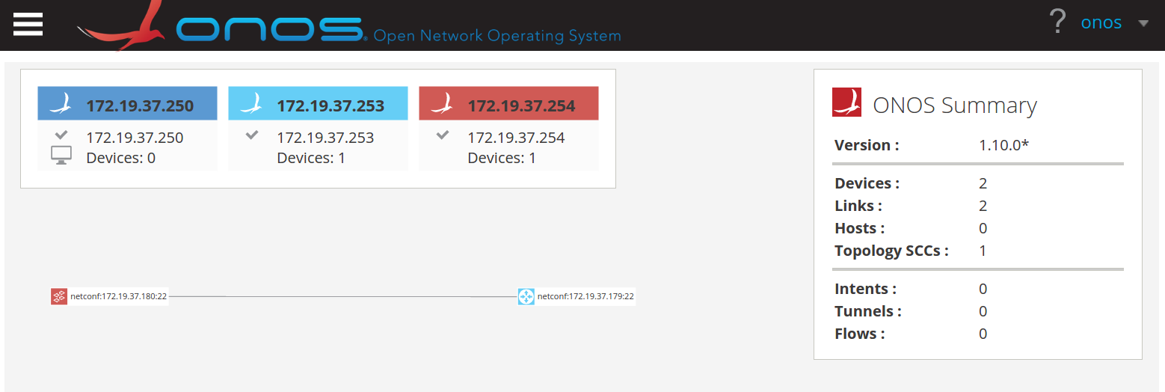
Note :- Below step are common for DEMO1 and DEMO2
only difference is json request should be sent from postman demo2-collection for demo2.

Steps 6:-
Pre-Observations:-
Ping should not work between devices.
Demo 1:
start ping on RT1 using: ping -c 10000 -s 8000 -vpn-instance vrf1 10.1.1.2
Demo 2:
start ping on RT1 using: ping -c 10000 -s 8000 -vpn-instance vpna 50.1.1.2
Step 7:-
Send create via postman
A. Send instance create post requests(RT1/RT2 create VPN) on both devices.
B. Send interface create post requests(RT1/RT2 create interface) on both devices.
C. Send get request(GetAll) to verify post in store.
D. Check Routers’ configuration:
ssh telnet_admin@172.19.37.161
sys
display current-configuration

Vpn instance and interface should be configured on device as shown below:
ip vpn-instance vrf1
description vrfDescription
ipv4-family
route-distinguisher 100:1
vpn-target 100:1 export-extcommunity
vpn-target 100:1 import-extcommunity
#
and
interface Ethernet3/0/4
undo shutdown
ip binding vpn-instance vrf1
ip address 10.1.1.1 255.255.255.0
#

same apply to Router 2 (172.19.37.162)
Observation points :-
A. Ping should work between devices.
B. Traffic flow can be observed between device ports.
C. To check packet stats on link press 'a' three times.

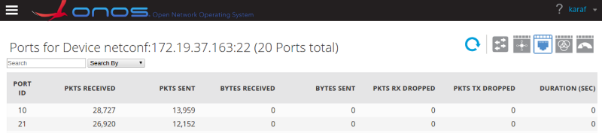
Step8:-
A. Send delete request(deleteAll) for both the devices.
B. Send get request(GetAll) to verify delete in store.
Limitations :
In step 7 instance create post should be sent always before interface create post.

Recovery Steps :
1>To restart the demo at any point without restarting onos run the below commands on all Routers and send deleteall json.
Cmd :
undo ip vpn-instance vpna
undo ip vpn-instance vrf1
commit
2> To restart the router just give “reboot” already the pre-configuration cfg file is stored for next startup.
<RT2>display startup
MainBoard:
Configured startup system software: cfcard:/VRPV800R012C10B51a.cc
Startup system software: cfcard:/VRPV800R012C10B51a.cc
Next startup system software: cfcard:/VRPV800R012C10B51a.cc
Startup saved-configuration file: NULL
Next startup saved-configuration file: cfcard:/reset_demo_env.cfg
Startup paf file: default
Next startup paf file: default
Startup patch package: NULL
Next startup patch package: NULL
<RT2>

