# How to use aws-discovery-export tool for AWS Inventory Collection?

|  |  |  |  |  |  |
| --- | --- | --- | --- | --- | --- |
| No. | Version | Date | Description | Modified By | Document Name |
| 1 | V1.0 | 2023/09/10 | Create the document | Liushaowei | FAQ-How_to_use_aws-discovery-export_tool_for_AWS_Inventory_Collection-v1.0.docx |

## First, please check the original guide from the repository and initialize the environment.

<https://github.com/GoogleCloudPlatform/aws-discovery-export>

## Second, collect the virtual machine collection

For virtual machine collection

# python3 stratozone-aws-export.py --resources=basic --collection_mode=VirtualMachine



~/aws-to-stratozone-export/vm-aws-import-files.zip



## Third, collect the Managed service inventory

For RDS and/or managed service collection

# python3 stratozone-aws-export.py -m ManagedService

~/aws-to-stratozone-export/services-aws-import-files.zip



Use some formation tool to convert json string to CSV or Excel file.

For example, <https://www.convertcsv.com/json-to-csv.htm>

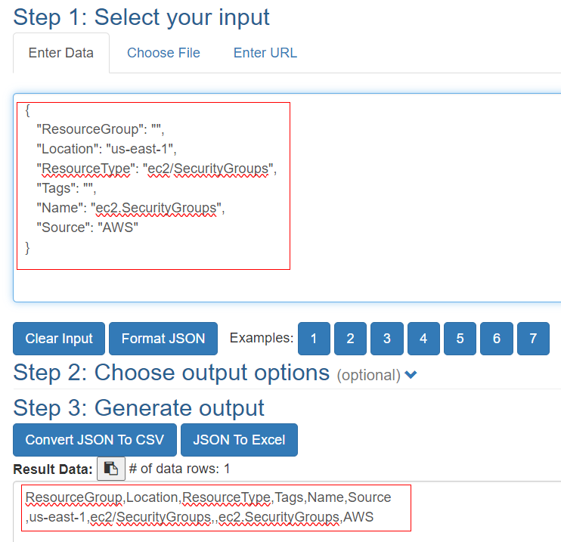

## FAQ

When I tried this tool to discover the managed service, but failed.

Currently, the root cause hasn’t been located yet.

