How to install and use FastCopy?

|  |  |  |  |  |  |
| --- | --- | --- | --- | --- | --- |
| No. | Version | Date | Description | Modified By | Document Name |
| 1 | V0.1 | Sep 19 2023 | Draft version | Marco Jiménez | How to install and use FastCopy. |

FastCopy is a fast-free program for copying and deleting data on windows. With this program you can be assured of 100% data integrity when you copy and delete files.

**Link to install FastCopy**

<https://fastcopy.jp/archive/FastCopy5.3.1_installer.exe>

Step 1: Download the FastCopy Installer

Step 2: Install FastCopy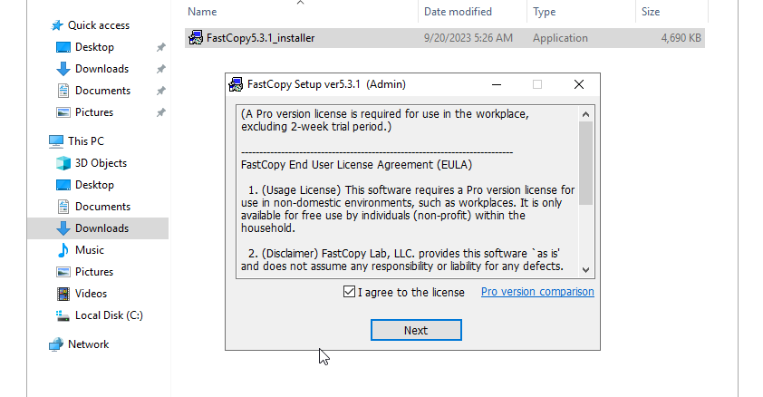

Step 3: Select the path were fast copy will be installed

Step 4: Sets default configuration

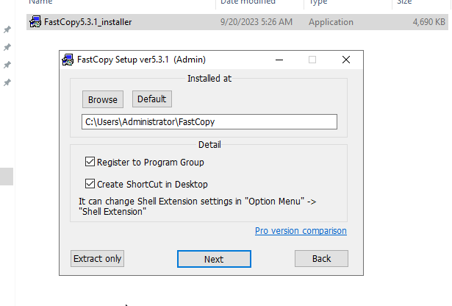

Step 5: The program was successfully installed

**FastCopy Test**

Step 6 Open the tool and choose the path to be copied

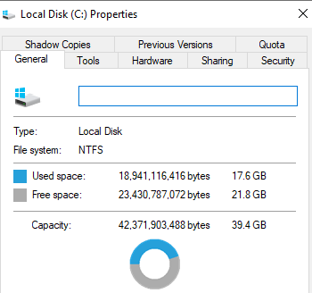

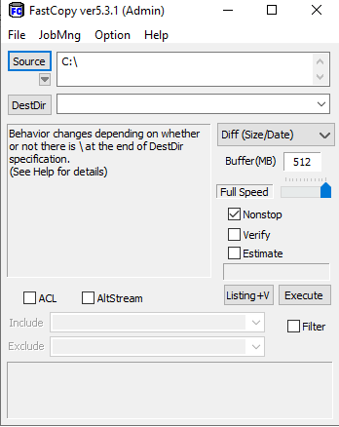

Step 7: Select the path Target and click on execute

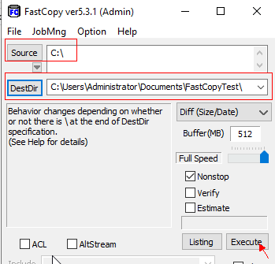

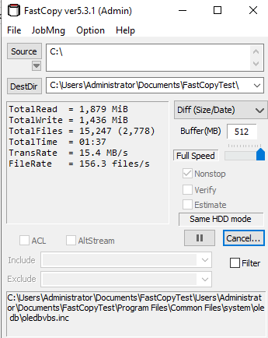

Step 7: When the task ends we can check if the content was copied correctly

