How to install and use rclone?

|  |  |  |  |  |  |
| --- | --- | --- | --- | --- | --- |
| No. | Version | Date | Description | Modified By | Document Name |
| 1 | V0.1 | Sep 25 2023 | Draft version | Marco Antonio Jimenez Cornejo | How to install and use Rclone. |

Step 1: Create an ECS and test file.



Step 2: Create an SFS or SFS Turbo file system and obtained the mounting address of the file.



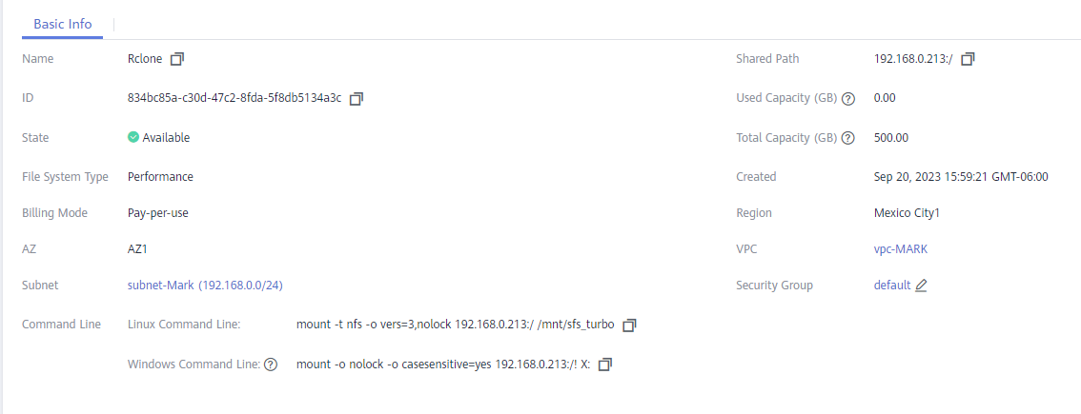

Step 3: Log in to the crated Windows ECS to access both the local EVS storage and the SFS or SFS Turbo file system on the cloud.

Step 4: Download rclone for Windows from the official website.

<https://rclone.org/downloads/>

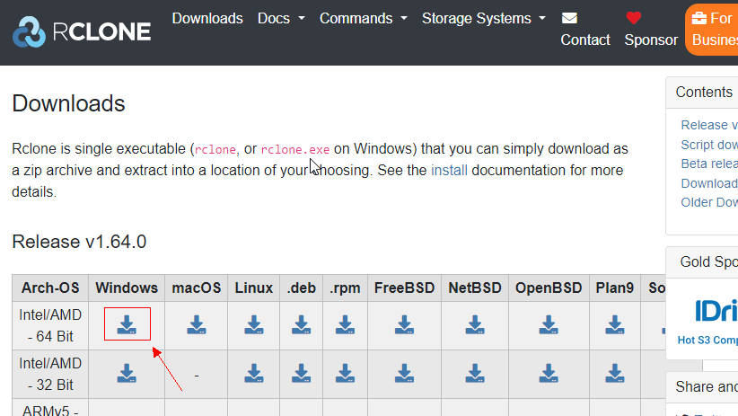

Step 5: Download & decompress the package to an English path.

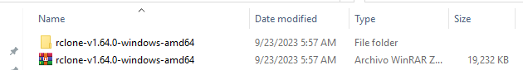

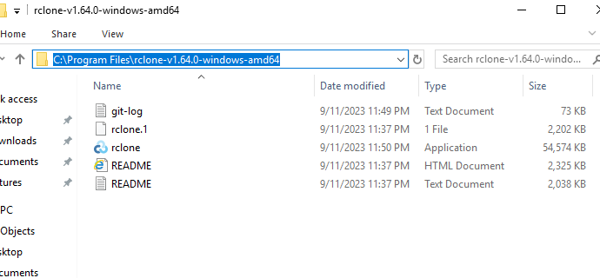

Step 6: Mount SFS storage to the source end.

1. Click Server Manager in the lower left corner and click Add roles and features.

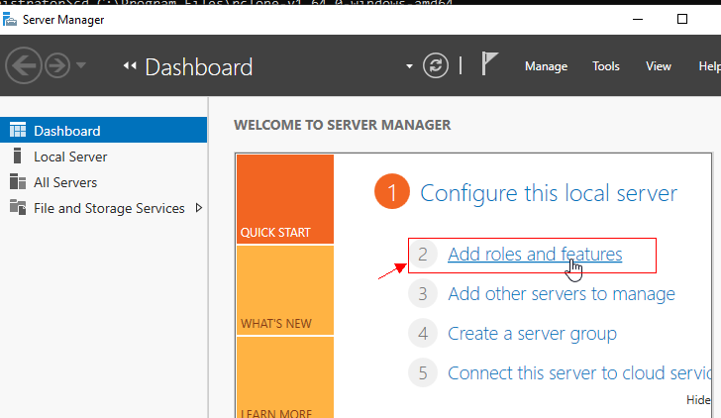

1. Click Next as prompted. On the Server Roles page, select Server for NFS.

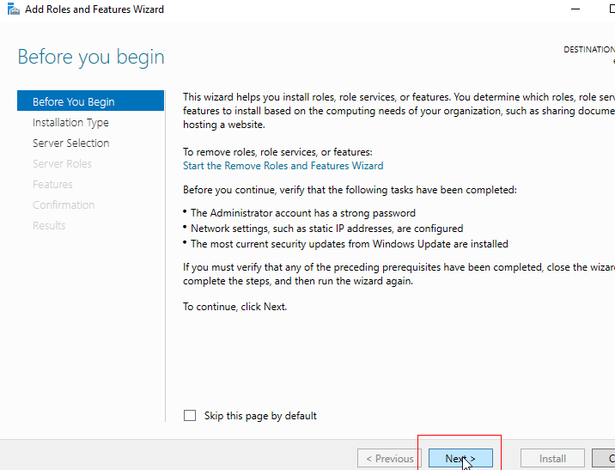

1. Click Next. In the features page, select Client for NFS and click Next. Confirm the settings and click install.

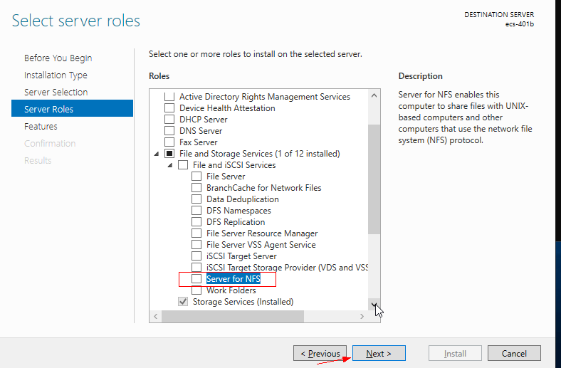

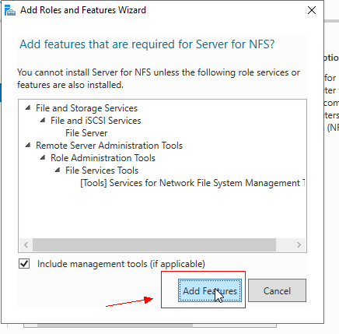

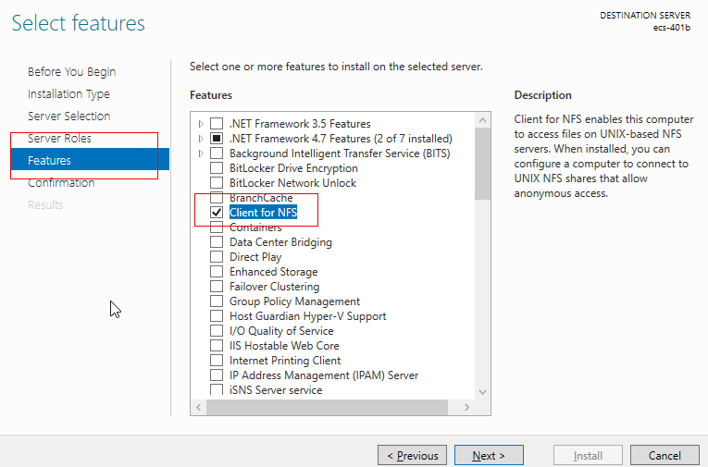

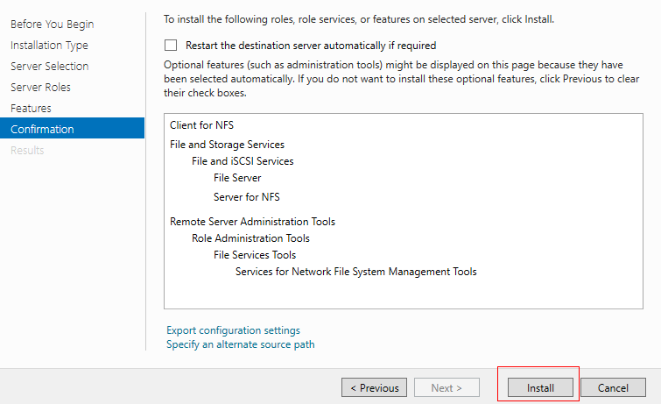

1. After the installation is complete, restart the client and log in to the ECS again as prompted.

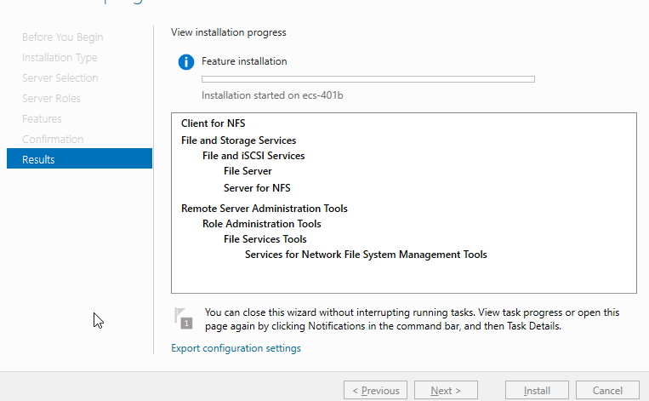

1. Modify the NFS transfer protocol

Control Panel>System and Security>Administrative Tools > Services for Network File System (NFS)

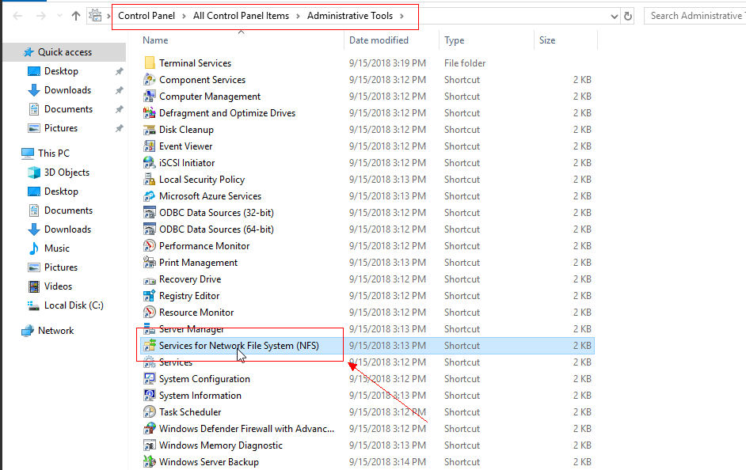

1. Right -click for NFS, choose Properties, change the transport protocol to TCP, and select Use hard mounts.

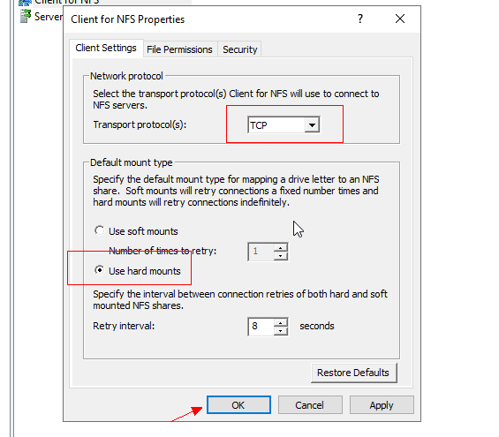

1. Run the following command in the command prompt of windows to mount the SFS.

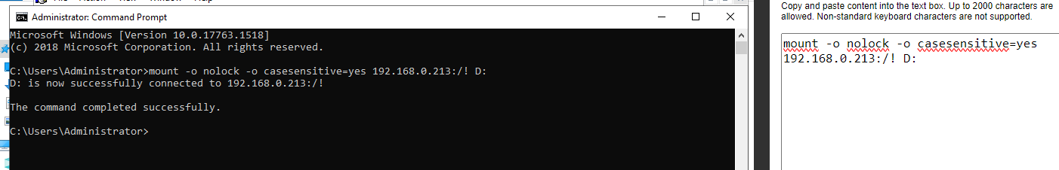

1. We can check that the SFS was mounted correctly.

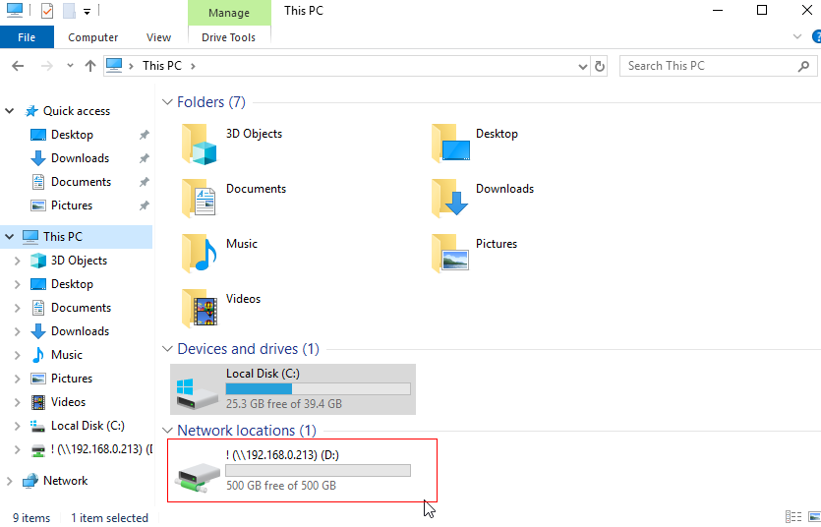

Step 9: Configuring Environment Variables for Rclone.

1. Control Panel > System > Advanced System Settings > Environment variables.
2. Find path in the system variable and add the decompressed path.

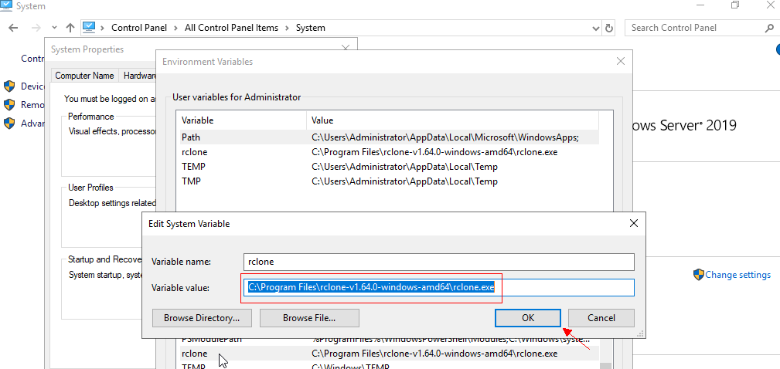

1. We restart the ECS and check if rclone is successful installed. You can open cmd and enter “rclone –version”, if the following information is displayed, the installation has been successful.

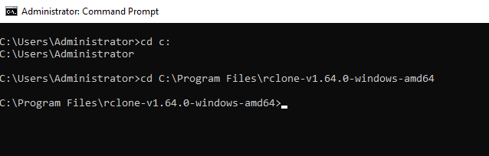

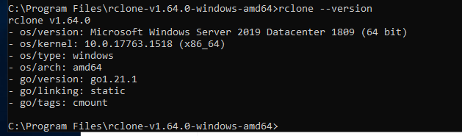

Step 10: Run the following command to synchronize the data from local disk C:\ to your previously mounted SFS.

>rclone copy C:\ D:\Rclone_Test -P

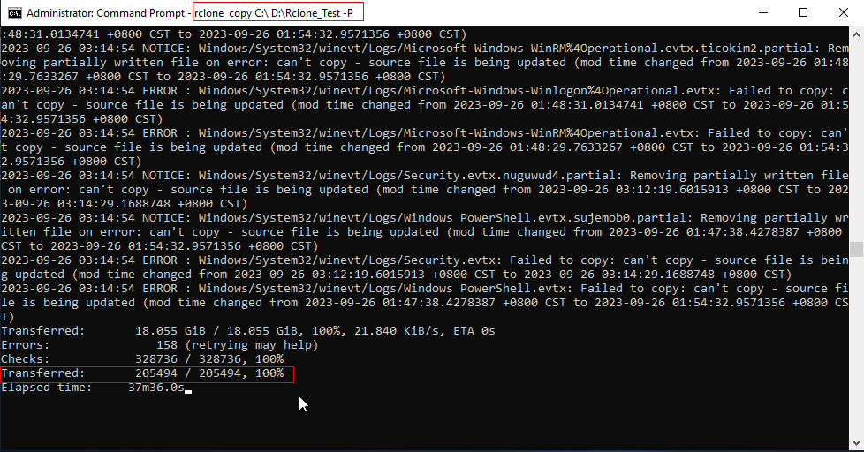

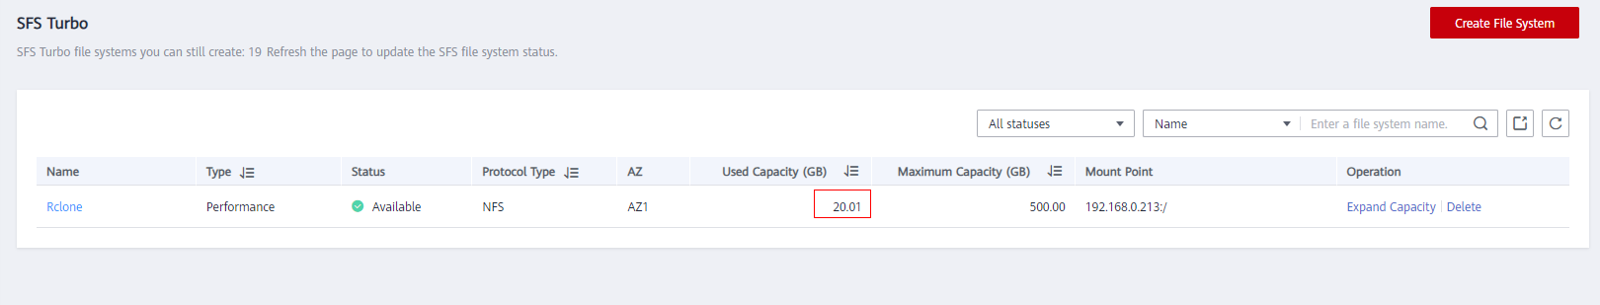

**Storage Migration Between Local EVSs**

Migrate data between different drive letters on cloud Windows System.

Step 1: Buy and mounting a local EVS on Windows ECS.



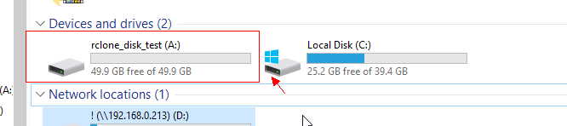

Step 2: It is necessary to have the previous steps.

Step 3: Log in to the source host and run the full migration command.

>rclone copy C:\Users\Administrator\Downloads\ A:\DST\ --transfers 5 –checkers 10 -P

Description:

Transfers: Indicates the number of concurrent files transferred.

Checkers: Number of concurrent files transferred.

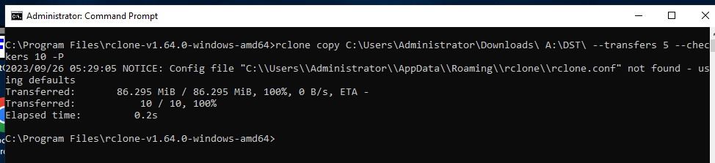

C:\Users\Administrator\Downloads

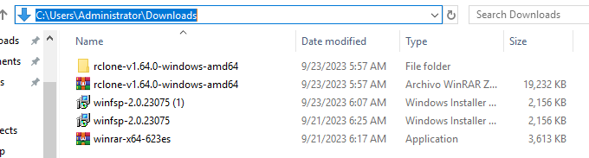

A: \DST

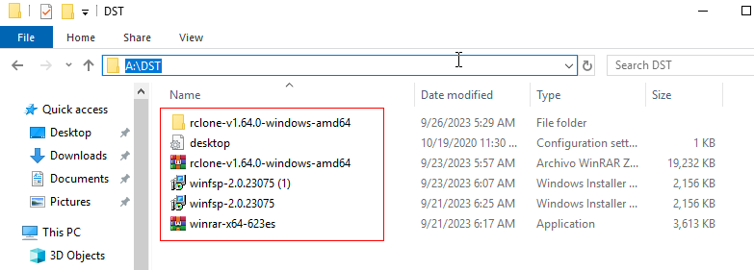

Step 4: Incremental Migration

After the full migration, simulate the real environment and add 10 data records to the source end.

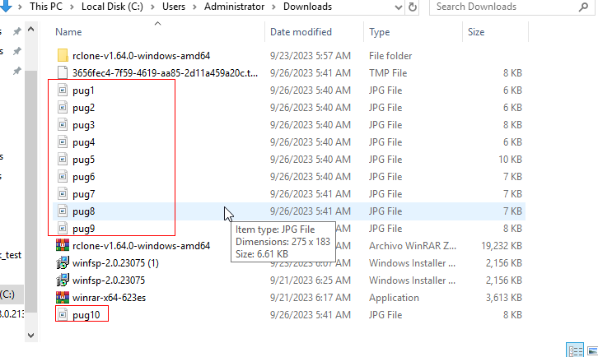

Run the following command to check the number of data records on the target.

>rclone sync C:\Users\Administrator\Downloads\SRC\ A:\DST\ --transfers 5 –checkers 10 -P

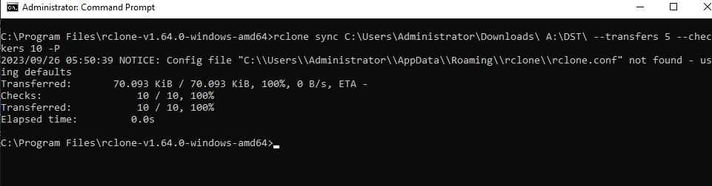

You can make sure that the data verification is complete.

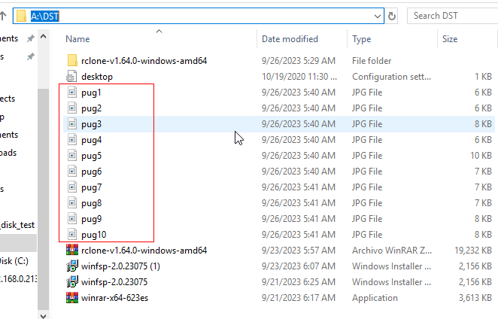

Optional Step: Run the following command to check the number of data records on the target.

>rclone sync C:\Users\Administrator\Downloads\ A:\DST\ --checkers 10 -P

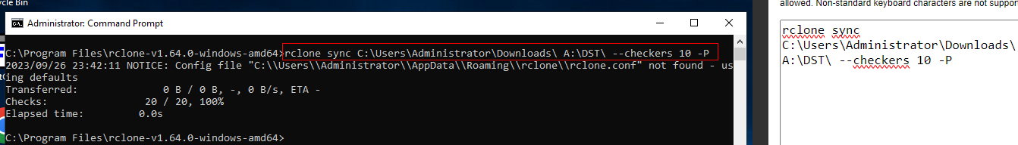

In this case the checks item contains 20 data records or rclone check.

Description:

* The “rclone check” command is used to compare the number of data on the source and target. If there are any differences, a message is displayed in Errors.
* The “rclone sync/copy” command also compares data during the migration. Therefore, this command can also be used as data verification command.

**Migrating Local EVS Data to SFS**

**Scenario:** Data migration from drive D on Windows OS to SFS storage in the same region.

Step 1: It is necessary to have the previous steps.

Step 2: Log in to the source host and mount the SFS.

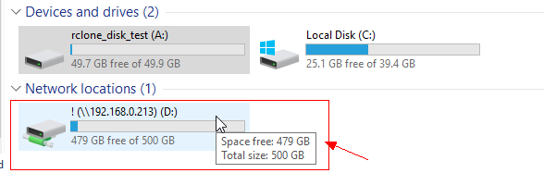

Step 3: Manually create the destination directory DST on the target.

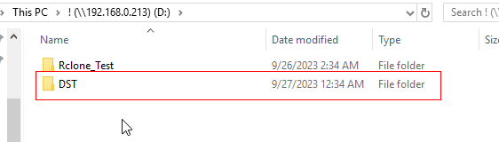

Step 4: Run the full migration command.

>rclone copy A:\DST\ D:\DST\ --transfers 5 --checkers 10 -P

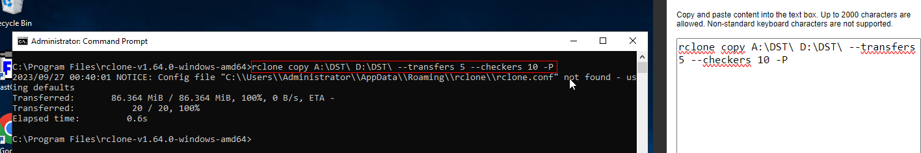

You can make sure that the data verification is complete.

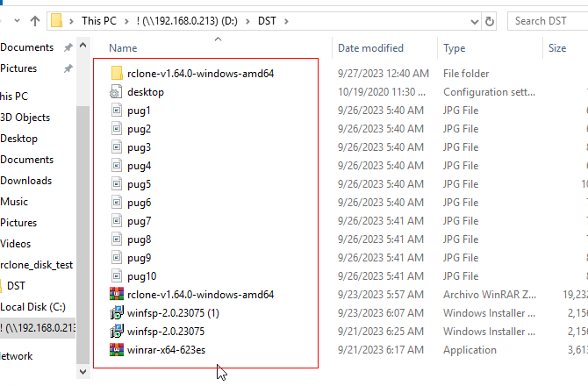

Optional Step: Data validation

Run the following command to check the number of data records on the target.

>rclone check A:\DST\ D:\DST\ --checkers 10 -P

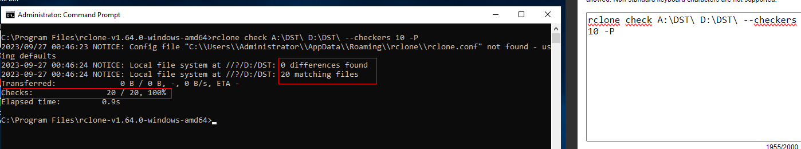

A:\DST\

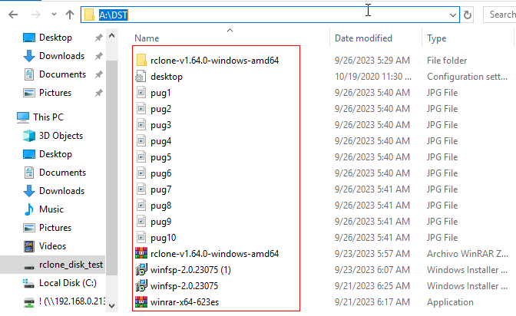

D:\DST\

